HumSaadhak 2.0
Architecture: HLD, LLD, Database Design and Functional Flows

As of 25 October 2026
Spring Boot 4.1 modular monolith, React 19 frontend, Python semantic-search service, PostgreSQL 16 with pgvector.
21 sections · 30 diagrams · every table, endpoint and rule taken from the code.

Contents
1. Overview
2. HLD: System context
3. HLD: Containers and deployment
4. HLD: Technology stack and cross-cutting concerns
5. LLD: Backend structure
6. LLD: Module designs
7. LLD: Search service
8. LLD: Frontend
9. API catalogue
10. Database design: Entity-relationship diagrams
11. Database design: Table dictionary
12. Database design: Indexes, migrations and data protection
13. Functional flows: Accounts
14. Functional flows: Approvals, purposes and needs, verification
15. Functional flows: Documents and matching
16. Functional flows: Donations and recurring giving
17. Functional flows: Dashboards, reports and exports
18. Functional flows: Import, access, notifications and history
19. Functional flows: Legacy migration and secure start-up
20. Non-functional requirements and operations
21. Open decisions and next steps

1. Overview
HumSaadhak 2.0 matches what donors want to fund (purposes) with what schools and NGOs need (causes and projects), records the money that flows between them, and proves where it went. It is two services: a Spring Boot modular monolith with a React frontend, and a Python semantic-search service that ranks matches. Everything runs behind one HTTPS proxy on PostgreSQL with pgvector and S3-compatible storage.
Who uses it
Group | Legacy name | Typical users | What they do
Individual donors | Benefactor (individual) | People giving in their own name | Describe purposes, give, track their giving, request documents
Corporate donors | Benefactor (corporate) | CSR teams, foundations, trusts | Same as individual donors, usually larger and recurring
Direct beneficiaries | DB | Schools | Publish causes, upload documents, receive money, run reports
Indirect beneficiaries | IB | NGOs | Publish projects, upload documents, receive money, run reports
HumSaadhak staff | Admin, manager, associate | Super admins, managers, operations associates | Approve, match, record donations, import, administer

Scope of this document
- High-level design (HLD): context, containers, deployment, technology and cross-cutting concerns (sections 2 to 4).
- Low-level design (LLD): backend structure, every module, the search service, the frontend and the API (sections 5 to 9).
- Database design: entity-relationship diagrams, the table dictionary, indexes, migrations and data protection (sections 10 to 12).
- Functional flows: a flowchart for each functionality (sections 13 to 19).
- Non-functional requirements and open decisions (sections 20 and 21).
Glossary
Term | Meaning
Purpose | What a donor wants to fund: sector, description, commitment amount, periodicity
Need | A cause (school) or project (NGO): target amount, raised amount, periodicity
Match | A confirmed purpose-to-need pairing with a priority, chosen by staff from ranked candidates
Maker-checker | Every record is made by one person and approved by a different one
Verified organisation | An organisation whose mandatory documents for its type are all reviewed
Reference number | Human-readable id kept from the legacy system, e.g. DB100021, PR100219, PU100302
Financial year | 1 April to 31 March; quarters Q1 = April to June

Source of truth: the code in humsaadhak.zip and humsaadhak-search.zip as of the date above; every table, endpoint and rule below is taken from it.

2. HLD: System context
Every person reaches HumSaadhak only through HTTPS in a browser; the platform reaches out only to Microsoft Graph for email and Let's Encrypt for certificates, and reads the legacy database once during migration.
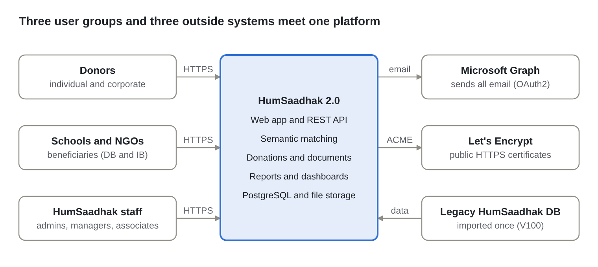
Figure: System context · 3 user groups, 3 outside systems
External system | Direction | Protocol and authentication | Used for
Microsoft Graph | Outbound | HTTPS, OAuth2 client credentials (tenant id, client id, secret) | Invitations, password resets, approval and donation notices, instalment reminders
Let's Encrypt | Outbound from the proxy | ACME over HTTPS | Certificates for DOMAIN and FILES_DOMAIN, renewed automatically
Legacy HumSaadhak database | Inbound, one time | Loaded into a legacy schema; migration V100 copies it | Users, organisations, purposes, causes, projects, matches, donations, documents
AWS S3 (optional) | Outbound | HTTPS, IAM credentials | Document storage when not self-hosting MinIO
Hugging Face model hub | Build time only | HTTPS | Qwen3 model weights are baked into the search image; nothing is downloaded at run time

3. HLD: Containers and deployment
Six containers make up a deployment (plus pgAdmin, an optional database console bound to 127.0.0.1), defined in deploy/compose.yaml and run with deploy/deploy.sh (DEPLOYMENT.md has the complete steps: setup, backups, updates with automatic rollback, legacy migration); only the Caddy proxy publishes ports, and every connection between containers is TLS with certificate and hostname checks.
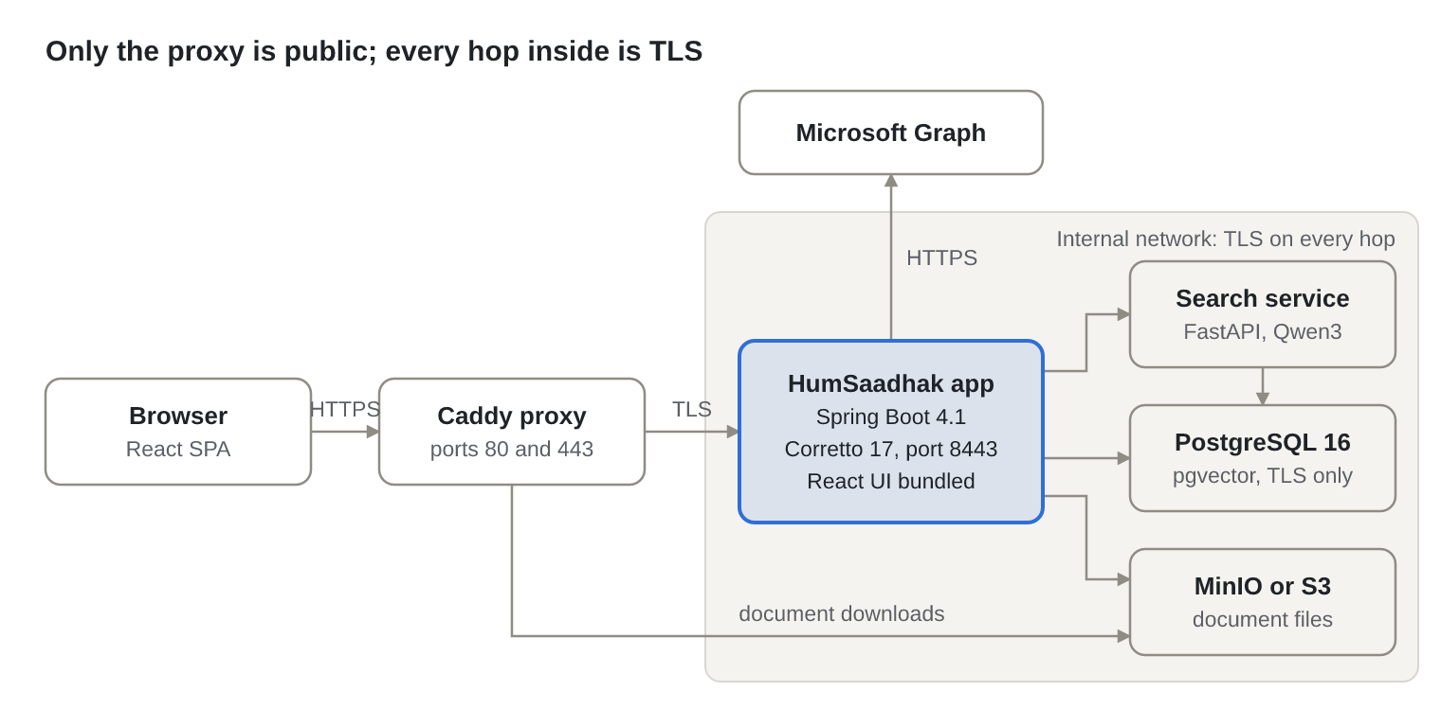
Figure: Containers and deployment · 6 containers, 8 encrypted connections
Container | Image | Listens on | Responsibility | Scales by
proxy | caddy:2.8.4 | 80, 443 (public) | HTTPS for DOMAIN and FILES_DOMAIN, HTTP to HTTPS redirect, re-encrypts to the app and storage | One instance; a cloud load balancer replaces it on AWS
app | built from Dockerfile (Amazon Corretto 17 on Amazon Linux 2023, user 10001) | 8443 (internal) | REST API, React UI, business rules, scheduled jobs | Horizontally: sessions are in PostgreSQL, jobs use ShedLock
search | built from humsaadhak-search (Python 3.12, user 10002) | 8000 (internal) | Embedding, retrieval, reranking, calibration | Vertically (memory, GPU), then horizontally behind the app
db | pgvector/pgvector:pg16 | 5432 (internal) | All data, sessions, events, vector index | Managed PostgreSQL (RDS) in production
storage | built from MinIO's source, release 2025-10-15 at a verified commit (MinIO no longer publishes free Docker images) | 9000 (internal) | Document files | AWS S3 in production
pgadmin (optional) | dpage/pgadmin4:9.18, profile pgadmin | 127.0.0.1:5050 only (SSH tunnel on a server) | Database console; the database pre-registered with sslmode=verify-full | Off unless switched on
tls-init | busybox:1.36.1 | none | Copies each service's private key into a volume owned by that service (mode 0400), then exits | Runs once per start

Connections and their protection (TLS 1.3 or 1.2 on every hop)
From | To | Protocol | Server verified by
Browser | proxy | HTTPS, HSTS one year | Let's Encrypt certificate
proxy | app | HTTPS | Internal CA, name app
proxy | storage (FILES_DOMAIN) | HTTPS | Internal CA, name storage
app | db, search to db | PostgreSQL TLS, sslmode=verify-full | Internal CA, name db; non-TLS connections rejected by pg_hba.conf
app | search | HTTPS with bearer service token | Internal CA, name search
app | storage | HTTPS (S3 API) | Internal CA plus public CAs
app | Microsoft Graph | HTTPS | Public CAs

Managed database variant (production, deploy/.env.prod). Production uses the previous project's DigitalOcean managed PostgreSQL cluster (Bangalore) instead of the db container: COMPOSE_PROFILES is empty, so the container does not start, and the app and search service connect to the cluster's direct port 25060 with sslmode=verify-full against DigitalOcean's CA certificate (DB_CA_FILE). The new system has its own database, humsaadhak, on the cluster, which deploy/deploy.sh --prod up creates. The old database is only read once, by dump-legacy, for the legacy migration; the script refuses to build the new schema inside it.
AWS variant. The same images run on ECS or EKS: an Application Load Balancer with an ACM certificate replaces Caddy, RDS for PostgreSQL 16 with the pgvector extension and rds.force_ssl=1 replaces the db container, S3 with a bucket policy denying aws:SecureTransport = false replaces MinIO, and secrets come from AWS Secrets Manager as environment variables.

4. HLD: Technology stack and cross-cutting concerns
The stack is mainstream and long-supported: Java 17 (Amazon Corretto) with Spring Boot 4.1 for the core, React 19 for the browser, Python 3.12 for the models, and PostgreSQL 16 for all data including vectors.
Technology stack
Layer | Technology | Version | Why
Backend runtime | Java (Amazon Corretto) | 17 LTS | AWS's OpenJDK with long-term support, the same runtime in the image, in CI and on AWS; UTF-8 pinned (Java 17's default charset follows the locale)
Application framework | Spring Boot, Spring Modulith | 4.1.1 | Module boundaries checked in tests, transactional event outbox
Security | Spring Security, Spring Session JDBC | Boot-managed | Server-side sessions, CSRF, method security
Persistence | Spring Data JPA, Hibernate, Envers, JdbcClient | Boot-managed | Entities with full audit history; plain SQL for reports
Schema | Flyway | Boot-managed | Versioned migrations V1 to V6, legacy V100
Jobs | Spring scheduling, ShedLock | Boot-managed | Daily reminders run once across instances
Files and Excel | AWS SDK for Java (S3, Apache client), Apache POI | 2.31.0, 5.4.1 | S3/MinIO storage, bulk import templates
Email | Microsoft Graph REST, Thymeleaf templates | v1.0 API | Organisation already on Microsoft 365
Frontend | React, TypeScript, Vite, Bootstrap, TanStack Query, React Router, Recharts | 19, 5, 7, 5.3.8, 5, 7, 3 | Typed SPA; responsive layout on Bootstrap's grid; cached server state and charts
Report exports | ExcelJS, jsPDF with jspdf-autotable | 4.4, 4.2.1, 5 | Excel and PDF built in the browser, loaded on demand
Search service | Python, FastAPI, Pydantic, uvicorn, NumPy, psycopg 3 | 3.12 | Model ecosystem lives in Python
Models | Qwen3-Embedding-0.6B, Qwen3-Reranker-0.6B | 0.6B parameters, Apache 2.0 | Multilingual (English, Hindi, Marathi), small enough for CPU
Database | PostgreSQL with pgvector (HNSW index) | 16 | One database for records, vectors and sessions
Edge | Caddy | 2.8.4 | Automatic HTTPS with Let's Encrypt

Cross-cutting concerns
Concern | Design | Where in the code
Authentication | Email and password; Spring Session cookie that is HttpOnly, Secure and SameSite=Lax, 30-minute idle timeout; sessions stored in PostgreSQL | identity/controller/AuthController, identity/config/SecurityConfig
Passwords | Delegating encoder (BCrypt); at least 12 characters, not containing the email; no temporary passwords, only single-use links (invitation 72 hours, reset 30 minutes) | identity/util/PasswordPolicy, identity/service/AccountService
Lockout | Five failed sign-ins lock the account for 15 minutes | identity/entity/AppUser, identity/service/AuthService
Authorisation | Role grants permissions (editable by super admins); endpoints check perm:<code> authorities; services scope data by account type (staff see all, others only their organisation) | @PreAuthorize on controllers, identity/service/AccessService
CSRF | Cookie-to-header token (XSRF-TOKEN cookie, X-XSRF-TOKEN header) on every state-changing request | SecurityConfig, frontend/src/shared/api/client.ts
Maker-checker | Every purpose, cause, project, user and organisation approval is made by one person and decided by another | workflow module
Audit | Every user action recorded in the append-only audit_event table (who, what, which record, when, IP address, browser, outcome) in the same transaction as the change; refused and failed attempts recorded too; Envers field changes linked to the action by request id; the trail shown on the page where the change is made (section 18.6) | @AuditAction on every controller method, audit module, migration V7
Events | Spring Modulith application events stored in event_publication (outbox), delivered after commit; anything unfinished is delivered again when the application next starts | @ApplicationModuleListener in each module
Errors | RFC 9457 problem details with a machine-readable code and a plain-language message | shared/exception/ApiErrorHandler
Encryption at rest | Bank account numbers AES-256-GCM encrypted in the column (HUMSAADHAK_FIELD_KEY); disks encrypted by the platform | shared/util/FieldEncryptor, shared/entity/EncryptedStringConverter
Encryption in transit | TLS 1.3/1.2 on every hop, certificates and hostnames verified, production refuses to start otherwise | shared/util/TlsSupport, shared/config/TransportSecurityCheck
Browser protection | Content-Security-Policy with frame-ancestors 'none' and upgrade-insecure-requests, HSTS one year | SecurityConfig
Uploads | PDF, PNG, JPEG or MP4 only, checked by content signature, at most 20 MB; downloads by signed links valid 5 minutes | documents/util/UploadPolicy, DocumentService
Idempotency | Donations require an Idempotency-Key; a repeat returns the first result | giving/service/DonationService
Configuration | Secrets only from environment variables; profiles tls, legacy-migration, test | application*.yml
Observability | Actuator health, liveness, readiness and Prometheus metrics | management.* settings

Events between modules (published inside the transaction, delivered after commit)
Event | Published by | Handled by | Effect
UserRegistered | identity | (published for other modules) | Account registered; the approval itself is opened by a direct call to the workflow API
ApprovalDecided | workflow | identity, catalogue | Activates the user, or marks the purpose or need approved
UserActivated | identity | notifications | Emails a set-password link
PasswordResetRequested | identity | notifications | Emails a reset link
PurposeIndexable, NeedIndexable | catalogue | matching | Sends the card to the search index
DocumentReviewed | documents | registry | Re-checks whether the organisation is verified
MandatoryRulesChanged | documents | registry | Re-checks every organisation of the affected types
OrganisationVerified | registry | (published for other modules) | Organisation became verified
MatchesConfirmed | matching | notifications | Tells the donor and beneficiaries
LabelsCaptured | matching | matching | Sends reviewer decisions to the search service as training labels
ShareRequested, ShareDecided | documents | notifications | Emails the school or NGO, then the donor
DonationRecorded | giving | (published for other modules) | Donation recorded
InstalmentDue | giving | notifications | Reminds the donor of an instalment

5. LLD: Backend structure
The backend is one Spring Boot application split into 13 business modules; inside every module the code sits in the same layer packages, and dependencies only point downwards.
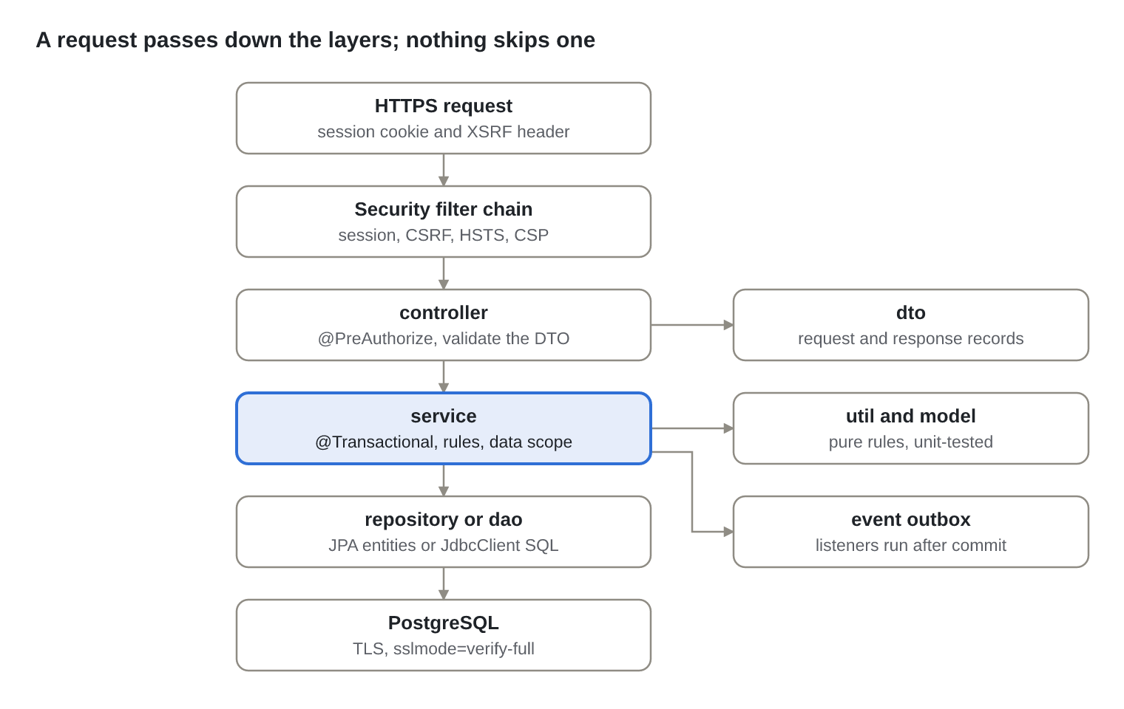
Figure: Request lifecycle · 6 layers, 3 shared parts
A controller only checks the permission, validates the request DTO and calls one service. The service owns the transaction, applies the rules (often in a pure util class), scopes data to the caller and publishes events. Repositories (Spring Data JPA) and DAOs (SQL through JdbcClient) are the only code that touches the database.
Layer packages (org.humsaadhak.<module>.<layer>)
Package | Contains | Rule
api | Facades, events and shared types other modules may use | The only package another module may import
controller | @RestController classes | Calls services only; never repositories, DAOs, entities or SQL
service | @Service classes, listeners, schedulers | Owns transactions; never imports controllers
repository | Spring Data JPA interfaces | Used by services only
dao | @Repository classes with SQL, query builders | All SQL lives here; never imports services
dto | Request and response records | No logic beyond shape and validation annotations
entity | JPA entities | Private fields, getters and setters; no imports from upper layers
model | Enums and domain types | Shared by the module's layers
util | Pure rule and helper classes | No Spring, unit-tested
client | Calls to other systems (S3, Graph, search) | Behind an interface where there is more than one implementation
config | Spring configuration | Security, TLS, bootstrap

Modules and their dependencies (each arrow is to the other module's api package only)
Module | Owns | Depends on
shared | Exceptions, base entity, page DTO, periodicity, reference numbers, CSV, rupee formatting, field encryption, TLS, current user | none (open to all)
identity | Users, sessions, tokens, roles and permissions, preferences, user administration | registry, workflow
workflow | Maker-checker approvals for every record type | none
registry | Organisations, contacts, bank accounts, verification | documents
catalogue | Purposes, causes and projects | workflow
documents | Uploads, review, sharing, document types and mandatory rules, legacy file copy | catalogue, matching
matching | Match runs, candidates, review, confirmed matches, search client | catalogue
giving | Donations, recurring plans, instalments, reminders | catalogue, matching
notifications | Email for every event that needs one | documents, giving, identity, matching
reporting | Dashboards, drill-downs, beneficiary reports, lookups, counters, CSV exports | none (reads through its own SQL)
audit | Revision history | none
importer | Bulk Excel import | catalogue, registry
referencedata | Sectors, states, periodicities, document type options | none

The module graph has no cycles. LayeredArchitectureTest (layers, SQL only in DAOs, api-only access between modules) and Spring Modulith's ModularityTests fail the build if either rule is broken.

6. LLD: Module designs
Each module below lists its classes by layer and the rules it enforces; the flows in sections 13 to 19 show these classes at work.

6.1 identity
Users, sign-in, single-use links, roles and permissions, personal preferences and user administration.
Layer | Classes
api | UserDirectory, InvitationLinks, Theme, events UserRegistered, UserActivated, PasswordResetRequested
controller | AuthController, AdminUserController, AccessController, PreferencesController
service | AccountService (registration, links, set password), AuthService (lockout), AppUserDetailsService (sign-in principal), UserAdminService, AccessService, SessionRevoker, PreferencesService, AppUserDirectory
repository / dao | AppUserRepository, OneTimeTokenRepository / AccessDao, SessionDao
entity, model, util | AppUser, OneTimeToken; UserStatus; PasswordPolicy, RolePolicy, TokenHasher
config | SecurityConfig, BootstrapAdmin (first super admin on an empty database)

- Tokens are stored as SHA-256 hashes, single use, expiring (invitation 72 hours, reset 30 minutes).
- The signed-in principal is a serialisable snapshot (id, account type, role, permission codes), never the entity.
- A role change or a change to a role's permissions deletes the affected people's sessions, so new rights apply at once.
- The Super admin role always keeps admin.users and admin.roles; built-in roles and permissions cannot be deleted.

6.2 workflow
One maker-checker engine for users, organisations, purposes, causes and projects.
Layer | Classes
api | Approvals (open, submit, reopen after edit), ApprovalStatus, SubjectType, event ApprovalDecided
controller / service | ApprovalController / ApprovalService
repository, entity | ApprovalRequestRepository, ApprovalStepRepository; ApprovalRequest, ApprovalStep
dto, util | ApprovalRow, StepRow, DecisionBody; ApprovalPolicy (allowed transitions)

- States: DRAFT, SUBMITTED, APPROVED, REJECTED. The checker must not be the maker; a rejection needs a comment.
- Editing an approved record reopens its request as a new revision; every step is kept in approval_step.

6.3 registry
Organisations of all four types, their contacts and bank accounts, and verification.
Layer | Classes
api | Organisations (summary, find or create), OrganisationType, event OrganisationVerified
controller / service | OrganisationController / OrganisationProfileService, OrganisationService, OrganisationDirectoryAdapter
repository, entity | OrganisationRepository, OrgContactRepository, BankAccountRepository; Organisation, OrgContact, BankAccount
dto, util | ProfileBody, ContactBody, ContactRow, BankBody, BankRow; MandatoryDocumentPolicy

- Verified means every document mandatory for the organisation's type is reviewed; re-checked on every document review and every rule change.
- Bank account numbers are encrypted in the column and only ever returned masked.

6.4 catalogue
Purposes (donors) and needs (causes of schools, projects of NGOs).
Layer | Classes
api | Catalogue (views, payments, import), NeedKind, events PurposeIndexable, NeedIndexable
controller / service | CatalogueController / CatalogueService
repository, entity, dto | PurposeRepository, NeedRepository; Purpose, Need; PurposeBody, NeedBody, PurposeInput, NeedInput, Created

- A need's target must be positive; it completes when the raised amount reaches the target.
- Approval sets need.approved_at and the purpose's commitment_date, then sends the card to the search index.

6.5 documents
Uploads, review, versions, sharing with donors, document types and mandatory rules.
Layer | Classes
api | OrganisationDirectory, DocumentStates, events DocumentReviewed, MandatoryRulesChanged, ShareRequested, ShareDecided
controller | DocumentController, DocumentTypeAdminController
service | DocumentService (upload, review, share, links), DocumentQueryService, DocumentTypeAdminService, LegacyFileCopier
repository / dao | DocumentRepository, DocumentTypeRepository, DocumentTypeRuleRepository, ShareRequestRepository / LegacyDocumentDao
entity, util, client | Document, DocumentType, DocumentTypeRule, ShareRequest; UploadPolicy, DocumentAccessPolicy, MandatoryRuleChange; StorageGateway, S3StorageGateway

- A new upload of the same type supersedes the previous version; only the newest is reviewed.
- Donors see a shareable document only after the owner approves their share request.

6.6 matching
Engine runs, candidate review, confirmed matches with priorities, suggested donors.
Layer | Classes
api | Matches, event MatchesConfirmed
controller / service | MatchingController / MatchingService
repository, entity | MatchRunRepository, MatchCandidateRepository, MatchBatchRepository, MatchRepository; MatchRun, MatchCandidate, MatchBatch, Match
dto, util, client | RunBody, CandidateRow, DecisionsBody, MatchRow, SuggestedBenefactor, Created; CandidateDecisionValidator; SearchClient

- Candidates scoring at least 40 are stored, at least 50 are shown, top 25 per purpose (all configurable).
- Every shown candidate must be decided; approved ones get priorities 1..n with no gaps; decisions become training labels.

6.7 giving
Donations, recurring plans, instalments and reminders.
Layer | Classes
api | events DonationRecorded, InstalmentDue
controller / service | GivingController / DonationService, InstalmentScheduler
repository, entity | DonationRepository, RecurringPlanRepository, InstalmentRepository; Donation, RecurringPlan, Instalment
dto, util | DonationBody, DonationCommand, DonationResult, DonationRow; DonationCalculator

- Paid and pledged amounts are kept separately; a payment never exceeds what the need still needs.
- Recurring purposes get a plan and a next instalment; the reminder job runs daily at 07:00 IST, once across instances.

6.8 notifications
Layer | Classes
service | NotificationListeners (one listener per event that needs an email)
client | MailGateway, GraphMailGateway (Microsoft Graph), LoggingMailGateway (development)

- Emails are sent after the transaction commits; a failed one stays in the outbox and is sent again when the application next starts; outside production every email can be redirected to one inbox.

6.9 reporting
Layer | Classes
controller | DashboardController, DetailController, BeneficiaryReportController, ReportController, LookupController, CountersController
service | DashboardService, DetailService, BeneficiaryReportService, CsvExportService, LookupService, CountersService
dao | DashboardDao, DetailDao, DetailQuery, BeneficiaryReportDao, BeneficiaryReportQuery, CsvExportDao, LookupDao, CountersDao
dto, util | 25 records (Dashboard, Kpi, Donut, Slice, BarChart, Bar, Drill, DetailTable, ReportResult, …); BeneficiaryTerms, ReportFormat

- Every query is fixed and parameterised; user choices (report columns, chart filters) are matched against allow-lists, never pasted into SQL.
- Scope is applied in SQL: staff see everything, donors their giving, schools and NGOs their own records.

6.10 audit, importer, referencedata
Module | Classes
audit | AuditController, HistoryController; AuditRecorder, AuditMethodInterceptor, AuditRequestInterceptor, AuditTrailService, HistoryService; AuditDao, HistoryDao; AuditEntry, NewAuditEvent, AuditFilter, Actor, HistoryEntry, HistoryChange; AuditRevision, UsernameRevisionListener; Outcome, AuditedType; AuditActions, AuditVisibility, AuditTrailMerge, HistoryDiff; AuditConfig
importer | ImportController, ImportService, ImportJobRepository, ImportRowErrorRepository, ImportLookupDao, ImportJobView, ImportErrorView, ImportJob, ImportRowError, ImportType, RowValidator, WorkbookIO
referencedata | ReferenceController, SectorAdminController, ReferenceDataService, SectorService, ReferenceDataDao, SectorDao, Option, DocumentTypeOption, SectorRow, SectorCreateBody, SectorUpdateBody

- Every audited action is written with its change in one transaction, refused and failed attempts on their own; audit_event cannot be updated or deleted. History hides password hashes and lockout counters; only allow-listed audit tables can be read.
- Imports are all or nothing: any row error rejects the whole file and every error is reported by row and column.
- A sector in use is never renamed or deleted; it can be switched off.

6.11 shared
Layer | Classes
config | InternalTlsConfig, TransportSecurityCheck, JpaAuditingConfig
security | CurrentUser, Role (account type), Permission, InternalTls, AuditAction (annotation), AuditContext (per-request audit data), AuditOwnership (who may see a record's trail)
exception | ApiErrorHandler, DomainException, NotFoundException
entity, dto, model | AuditedEntity, EncryptedStringConverter; PageResponse; Periodicity, AuditTarget
util | RefNo, Codes, Csv, IndianRupees, FieldEncryptor, TlsSupport, TransportSecurityPolicy
controller | SpaForwardController (serves the React app for browser routes)

7. LLD: Search service
The search service ranks causes and projects for a purpose (and donors for a need) in four stages and returns a calibrated 0 to 100 score with the reasons for it; it owns no business records, only the index and the training labels.
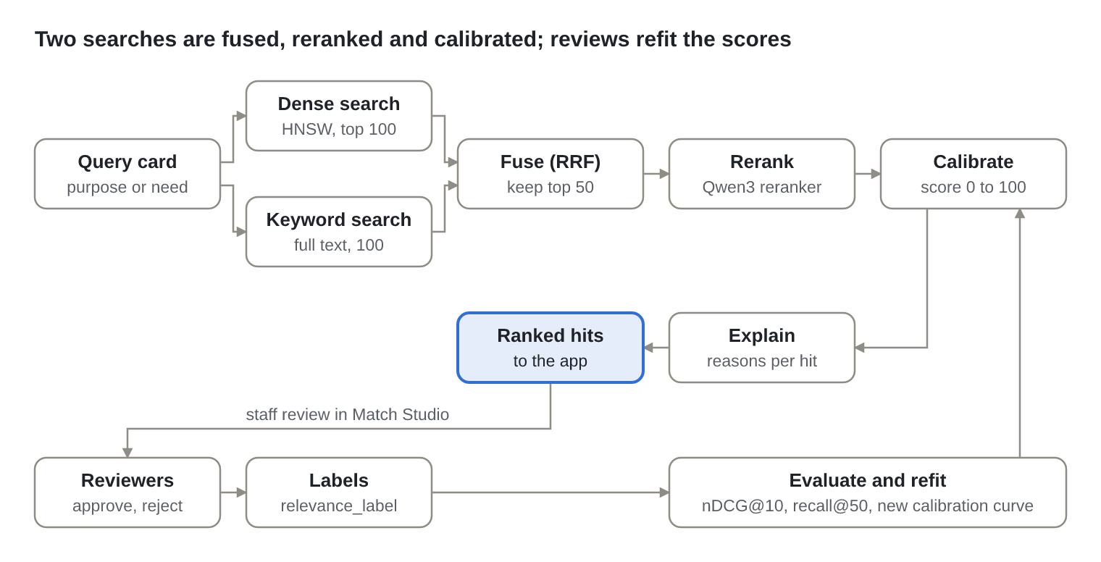
Figure: Search pipeline · 4 stages and the learning loop
- Retrieve. The query card is embedded with an instruction for its direction; dense search (pgvector HNSW, cosine) and keyword search (PostgreSQL full text) each return up to 100 ids, optionally filtered by sector.
- Fuse. Reciprocal rank fusion (k = 60) merges the two lists; the top 50 go on.
- Rerank. Qwen3-Reranker scores each pair; a same-sector pair gets +0.05.
- Calibrate and explain. An isotonic curve fitted on staff decisions maps the score to 0 to 100; each hit carries same-sector, shared terms and the best-matching sentence.
Layers (humsaadhak-search/app)
Package | Contains
controller | health_controller, index_controller, match_controller, feedback_controller, dependencies (bearer token check)
service | SearchService (the pipeline), MatchService, IndexService, FeedbackService
repository | VectorStore protocol, InMemoryStore (tests), PgVectorStore (production)
dto, model | MatchRequest, MatchResponse, HitOut, FreeTextRequest, LabelIn; Card, StoredDoc, Label, Hit
ml, util | Qwen3 embedder and reranker plus test stand-ins; fusion, calibration, explain, text
config, exception | Settings (environment, TLS check), server (HTTPS launcher); ServiceError

API (all except health need Authorization: Bearer <SEARCH_TOKEN>)
Method and path | Purpose
GET /v1/health | Liveness
GET /v1/models | Active model version (embedder, reranker, calibration)
POST /v1/index/upsert | Index or re-index a purpose or need card; skipped when the text is unchanged
DELETE /v1/index/{type}/{id} | Remove from the index
POST /v1/match/purpose-to-needs | Ranked needs for a purpose, with sector filter and exclusions
POST /v1/match/need-to-purposes | Ranked purposes for a need (suggested donors)
POST /v1/search | Free-text search over needs
POST /v1/feedback | Store reviewer decisions as labels
POST /v1/admin/reindex | Re-embed everything after a model upgrade

Settings: RETRIEVE_K 100, RERANK_K 50, SECTOR_BOOST 0.05, EMBEDDING_DIM 1024, CALIBRATION_PATH, TLS_CERT_FILE, TLS_KEY_FILE, REQUIRE_TLS. The app keeps candidates scoring at least 40 and shows those scoring at least 50, top 25 per purpose. A new model or calibration is promoted only when offline evaluation (training/evaluate.py) beats the active one; calibration needs at least 200 labelled pairs (training/fit_calibration.py).

8. LLD: Frontend
The frontend is a single-page React 19 application in TypeScript, built by Vite into the backend JAR and served from the same origin, so there is no CORS and the session cookie works unchanged.
Structure (frontend/src)
Folder | Contains
app/ | App.tsx (routes and guards), Shell.tsx (sticky side panel, live counters), auth.tsx (signed-in person and can(permission)), theme.tsx (four themes applied before first paint)
shared/api/ | client.ts (fetch wrapper: CSRF header, RFC 9457 errors), types.ts (47 response types matching the Java records), reference.ts (cached lookups), demo*.ts (demo backend, excluded from production builds)
shared/ui/ | DonutCard, BarCard, chartLayout, DetailDialog, Dialog, Drawer, FilePicker, AuditTrail (record trail button, page activity panel), Kpi, SearchSelect, States, StatusPill, colors
shared/ | csv.ts (CSV with formula protection), reportExport.ts (Excel and PDF), format.ts (Indian rupee formatting)
features/ | One folder per area: auth, dashboards, approvals, matching, catalogue, giving, documents, organisation, reports, admin, settings
styles/ | themes.css (colour tokens per theme, contrast-tested), bootstrap-theme.css (Bootstrap's variables taken from the theme tokens), global.css (layout and components)

Routes
Path | Screen | Shown to
/signin, /signup, /set-password, /forgot-password | Sign in, three-step registration, set or reset password | Everyone
/ | Dashboard for the person's account type, with chart drill-downs | Signed in
/approvals | Approval queue with history and inline reject | record.approve
/matching | Match Studio: run, review candidates, set priorities | match.decide
/purposes, /needs | Create, edit and submit purposes, causes and projects | purpose.edit, need.edit
/donate, /giving | Record a donation; my giving | donation.record, share.request
/documents, /share-requests | Upload and review documents; share requests | Signed in
/organisation | Profile, contacts, bank accounts | Signed in
/reports | Donation, match, project or cause and customize reports; CSV exports for staff | Schools, NGOs, staff
/imports | Bulk Excel import with templates | import.run
/admin/users, /admin/roles, /admin/reference, /admin/audit | Users; roles and permissions; sectors and document types; the audit log | admin.users, admin.roles, reference.manage, audit.view
/settings | Theme and account details | Signed in

State and data. Server state lives in TanStack Query caches keyed by endpoint; mutations invalidate the keys they affect (for example the side-panel counters after an approval). Forms keep local state and validate with the same rules as the server (pure functions such as features/catalogue/forms.ts and features/auth/passwordRules.ts), and the server's problem code and message are shown when it disagrees.
Guards. A route is shown only when can(permission) is true for the signed-in person; the server checks the same permission again, so hiding a link is a convenience, not the protection.
Responsive layout (Bootstrap 5.3). Every page works from a 360-pixel phone to a wide desktop. Bootstrap 5.3.8 provides the grid, buttons, forms, tables, alerts and the off-canvas menu (its CSS only; React drives the menu and dialogs, so Bootstrap's JavaScript is not loaded). bootstrap-theme.css sets Bootstrap's variables from the theme tokens, so all four themes apply, and Night switches on Bootstrap's dark mode (data-bs-theme).
Screen width | Layout
992 px and wider (Bootstrap lg) | Fixed side panel; the page fills the rest of the monitor's width with no fixed maximum (checked at 1,280, 1,366, 1,536, 1,920 and 2,560 px, never wider than the screen); headline figures four across; up to three charts per row; Organisation's profile and bank accounts side by side
576 to 991 px (tablets) | Top bar with a menu button; the side panel slides in as an off-canvas menu and closes on a link, Escape or a tap outside; figures two by two
Below 576 px (phones) | Same menu; one card per row; wide tables scroll sideways inside .table-responsive; drawers and dialogs take the full width

Buttons and fields keep 44-pixel touch targets, each page opens at its top, and rows of equal cards never leave one card alone (cardColumns in chartLayout.ts).
Exports. Excel (ExcelJS) and PDF (jsPDF) files are built in the browser from the API's rows; both libraries load only when someone exports.
Demo mode. npm run demo swaps the API client for an in-memory backend with the same rules, used by the published preview and by the 88 end-to-end tests (Vitest and Testing Library).

9. API catalogue
The API has 93 operations under /api/v2, all JSON over HTTPS; reading needs a signed-in session, every state-changing call also needs the X-XSRF-TOKEN header, and "own" means the caller's organisation unless the caller is staff. The live OpenAPI description is at /v3/api-docs (Swagger UI at /swagger-ui).
Method | Path | Permission | Purpose
POST | /auth/login | public | Sign in; starts a new session
POST | /auth/logout | signed in | End the session
POST | /auth/password-reset | public | Email a reset link (always answers the same)
POST | /auth/set-password | public, single-use token | Set a password from an invitation or reset link
POST | /registrations | public | Register a donor, school or NGO account (waits for approval)
GET | /me | signed in | Who am I: account type, role, permissions, theme
GET, PUT | /me/preferences | signed in | Read or save the theme
GET | /reference/periodicities, /reference/sectors, /reference/states, /reference/document-types | public | Form choices (active only)
GET | /dashboards/me | signed in | The dashboard for the caller's account type
GET | /dashboards/details | signed in, scoped | Records behind a chart slice or bar
GET | /dashboards/me/counters | signed in | Side-panel badges
GET | /lookups/open-needs | donors and staff | Open causes and projects for the donation form
GET | /lookups/organisations | staff | Donors or beneficiaries for pickers
GET | /approvals | record.approve, user.approve or org.approve | Approval queue, oldest first
GET | /approvals/{id}/history | same | Every step of one request
POST | /approvals/{id}/approve, /approvals/{id}/reject | same; checker is not the maker | Decide; reject needs a comment
GET | /history/{type}/{id} | record.approve, dashboard.platform or admin.users | Readable change history of a record
GET, POST | /purposes | signed in; create needs purpose.edit | List own purposes; create one
PUT | /purposes/{id} | purpose.edit | Edit (an approved purpose goes back for approval)
POST | /purposes/{id}/submit | purpose.edit | Submit for approval
GET, POST | /needs | signed in; create needs need.edit | List own causes or projects; create one
GET | /needs/{id}, /needs/open | signed in | One need; approved open needs
PUT | /needs/{id} | need.edit | Edit (an approved need goes back for approval)
POST | /needs/{id}/submit | need.edit | Submit for approval
POST | /match-runs | match.run | Run the engine for approved purposes
GET | /purposes/{id}/candidates | match.decide | Candidates to review
POST | /purposes/{id}/candidates/decisions | match.decide | Approve, reject and prioritise; creates matches
GET | /purposes/{id}/matches | signed in, own | Confirmed matches in priority order
GET | /needs/{id}/suggested-benefactors | staff or the owning school or NGO | Donors whose purposes fit a need
POST | /donations | donation.record, Idempotency-Key header | Record a payment
GET | /donations | signed in, own | My donations
POST | /documents | document.upload | Upload (multipart, at most 20 MB)
GET | /documents | signed in, own | Current documents
GET | /documents/pending | document.review | Review queue
GET | /documents/{id}/download-url | owner, staff, or donor with an approved share | Signed link valid 5 minutes
POST | /documents/{id}/review, /documents/{id}/reject | document.review | Accept or reject with a reason
GET, POST | /share-requests | signed in; request needs share.request | List; ask a school or NGO to share
POST | /share-requests/{id}/approve, /share-requests/{id}/reject | share.decide | Owner decides
GET | /organisations | dashboard.platform | All organisations, filtered and paged
GET | /organisations/me, /organisations/{id} | signed in, own | Organisation summary
PUT | /organisations/{id}/profile | signed in, own | Name, city, state
GET, PUT | /organisations/{id}/contacts | signed in, own | Contacts (PUT replaces the list)
GET, POST | /organisations/{id}/bank-accounts | signed in, own | Masked list; add an account
GET | /beneficiary-reports/options | schools, NGOs, staff | Causes or projects, financial years, custom columns
POST | /beneficiary-reports/{type} | schools, NGOs, staff | Donation, match, needs or custom report, paged or all rows
GET | /reports/donations.csv, /reports/organisations.csv, /reports/needs.csv | dashboard.platform | Whole-table CSV exports
POST, GET | /imports | import.run | Upload an Excel file; recent jobs
GET | /imports/{id}, /imports/templates/{type} | import.run | Job with row errors; empty template
GET | /admin/users | admin.users | Search users
PUT | /admin/users/{id}/role | admin.users; not self | Assign a role that fits the account
POST | /admin/users/{id}/disable, /enable, /invite | admin.users | Disable, enable, resend invitation
GET | /admin/access/roles | admin.roles or admin.users | Roles with permissions and people
POST, PUT, DELETE | /admin/access/roles, /admin/access/roles/{code} | admin.roles | Create, edit permissions, delete unused custom role
GET, POST, PUT, DELETE | /admin/access/permissions, /admin/access/permissions/{code} | admin.roles | List; create, edit or delete custom permissions
GET | /admin/access/kinds, /admin/access/changes | admin.roles | Account types for new roles; change log
GET, POST, PUT | /admin/sectors, /admin/sectors/{code} | reference.manage | Sectors
GET, POST, PUT | /admin/document-types, /admin/document-types/{id} | reference.manage | Document types and mandatory rules
GET | /audit/trail | anyone who may see the record | One record's audit trail with the fields each action changed
GET | /audit/activity | signed in, scoped | Recent actions in a page's area, or the person's own
GET | /audit/events, /audit/events.csv | audit.view | The full audit log with filters; CSV export (itself recorded)
POST | /admin/users | admin.users | Add a staff member (staff role only); they are emailed a set-password link

Errors use RFC 9457 problem details: HTTP 422 with code (for example lockout, role-does-not-fit, bad-report, in-use) for rule violations, 403 for missing permission or scope, 404 for unknown records, 409 when someone else changed the record first (optimistic locking on every entity's version), and 400 with per-field messages for invalid input.

10. Database design: Entity-relationship diagrams
One PostgreSQL 16 database holds 29 application tables (plus supporting tables for audit history, sessions, the event outbox and job locks) in the public schema and 2 in the search schema; every table backed by a JPA entity has a surrogate id, audit columns (created_at, created_by, updated_at, updated_by) and an optimistic-locking version, inherited from AuditedEntity.
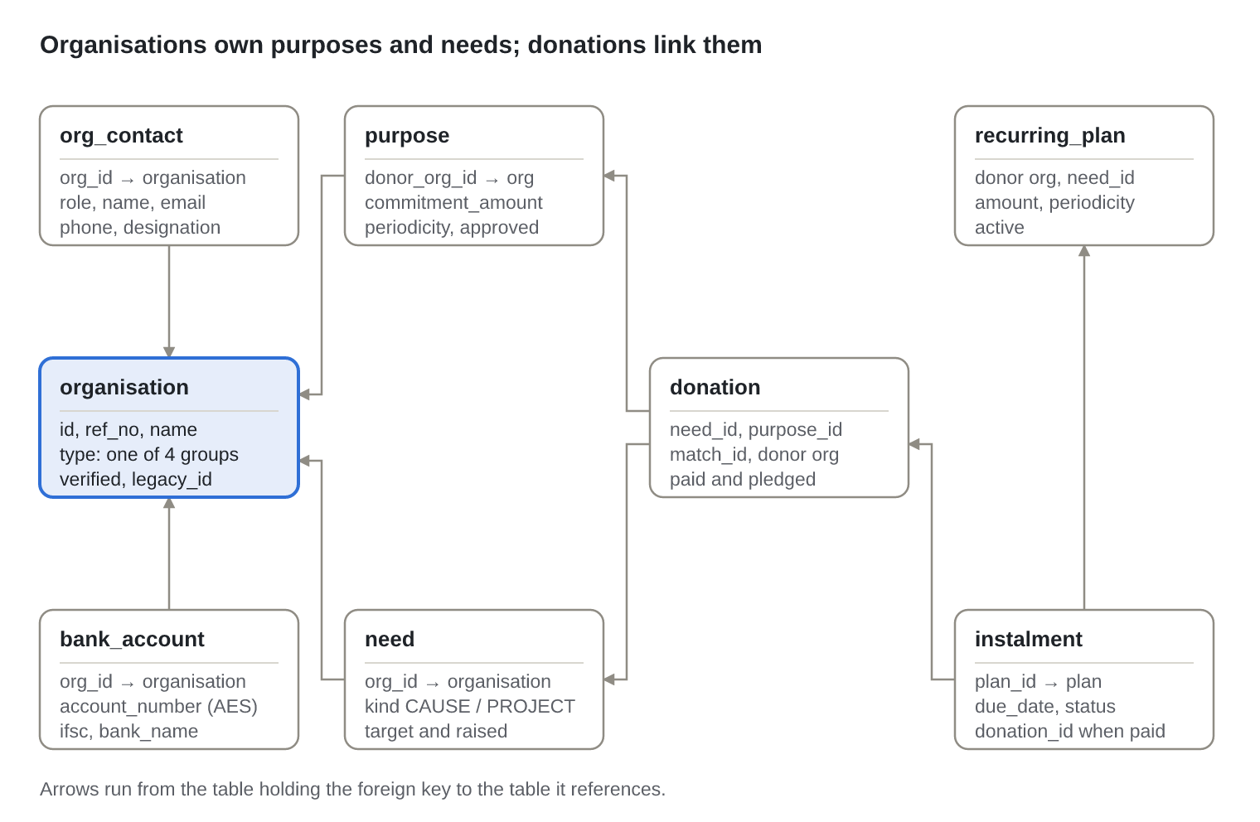
Figure: ER diagram 1 · organisations, purposes, needs and money
An organisation is any of the four groups, so a donor's purposes and a school's causes reference the same table. Money is recorded once, in donation, which points at the need it paid for and, when it came from a match, at the purpose and the match. Recurring giving is a plan with one instalment row per due date.
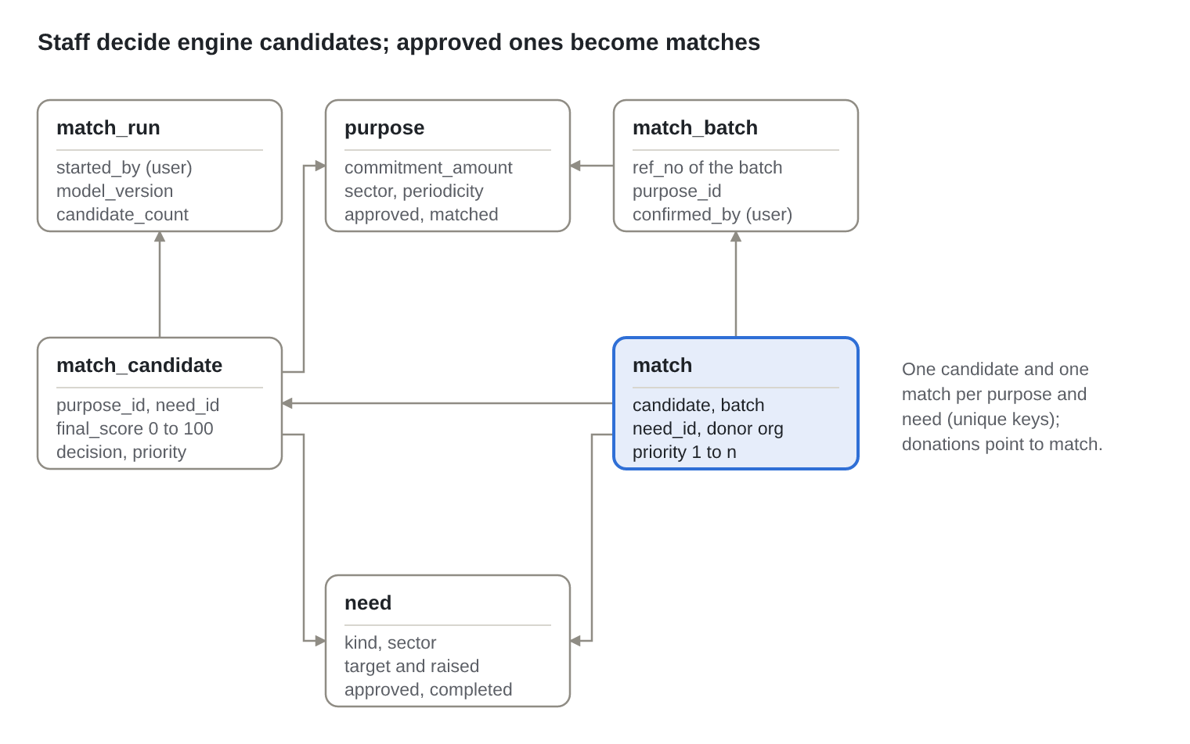
Figure: ER diagram 2 · matching
Each engine run stores candidates; staff decisions set decision and priority, and the approved ones are copied into match under one match_batch per confirmation.
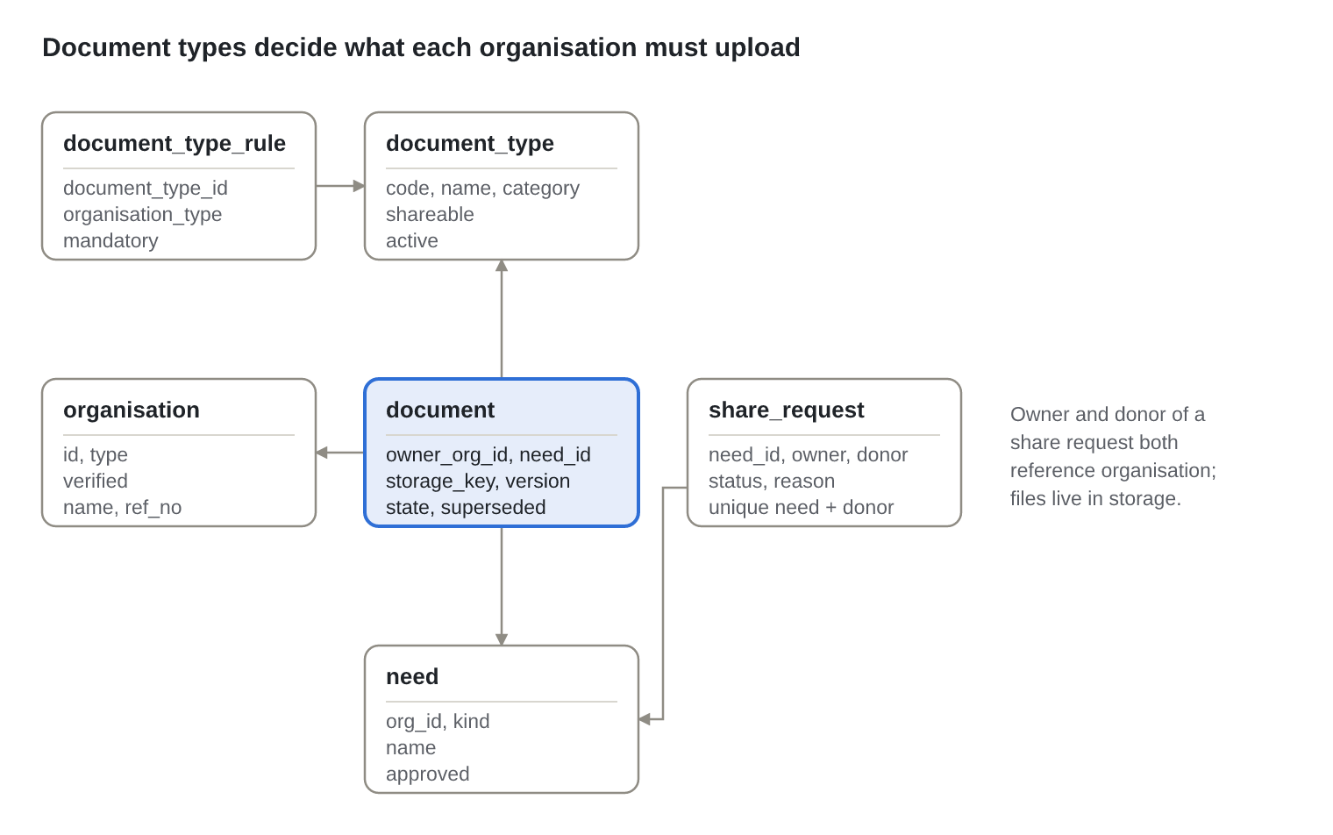
Figure: ER diagram 3 · documents and sharing
A document_type_rule says whether a type is mandatory for one organisation type; an organisation is verified when its newest document of every mandatory type is REVIEWED. File bytes live in object storage under storage_key, never in the database.
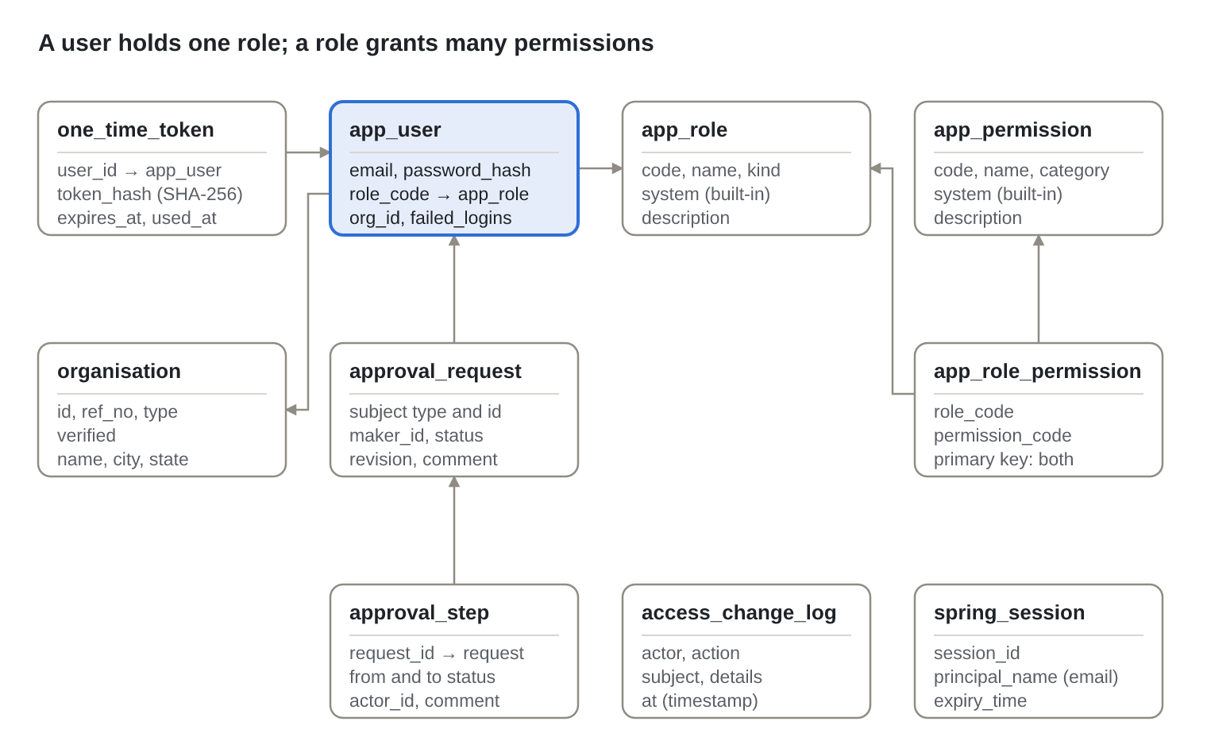
Figure: ER diagram 4 · identity, roles and approvals
app_user.role keeps the account type (staff, donor, school, NGO), which decides data scope; role_code is the assigned role, whose permissions decide what the person can do. approval_request is polymorphic: subject_type plus subject_id point at a user, organisation, purpose or need, so it carries no foreign key on the subject. access_change_log and spring_session stand alone and are joined by email.

11. Database design: Table dictionary
Every table, its owner module and its important columns and constraints; the audit columns and version common to entity tables are not repeated; the audit trail's audit_event table is described in section 18.6. Amounts are numeric(14,2) in rupees; timestamps are timestamptz in UTC.
Table | Module | Holds | Key columns and constraints
app_user | identity | People who sign in | email unique; password_hash (null until set); role account type; role_code FK app_role; org_id; status PENDING, ACTIVE, DISABLED, REJECTED; failed_logins, locked_until; theme
one_time_token | identity | Invitation and reset links | user_id FK; purpose INVITATION or PASSWORD_RESET; token_hash unique SHA-256; expires_at; used_at
app_role | identity | Assignable roles | PK code; name unique; kind account type; system
app_permission | identity | Permissions | PK code (e.g. record.approve); name, category, description; system
app_role_permission | identity | Grants | PK (role_code, permission_code), both FK with cascade delete
access_change_log | identity | Who changed roles and permissions | at, actor, action, subject, details
organisation | registry | Donors, schools and NGOs | ref_no unique; name; type DONOR_INDIVIDUAL, DONOR_CORPORATE, SCHOOL, NGO; city, state; pan_masked; verified; legacy_id
org_contact | registry | Contacts | org_id FK; role; name; designation; email; phone
bank_account | registry | Bank accounts | org_id FK; account_name; account_number AES-GCM ciphertext; ifsc (11 characters); bank_name; branch
approval_request | workflow | One maker-checker request per record | unique (subject_type, subject_id); maker_id; status DRAFT, SUBMITTED, APPROVED, REJECTED; revision; last_comment; subject_title
approval_step | workflow | Every transition | request_id FK; from_status, to_status; actor_id; comment
purpose | catalogue | What a donor wants to fund | ref_no unique; donor_org_id FK; name; description up to 8,000; sector; commitment_amount; periodicity; approved, matched, completed; commitment_date
need | catalogue | Causes and projects | ref_no unique; org_id FK; kind CAUSE or PROJECT; target_amount check > 0; raised_amount default 0; periodicity; approved, completed; approved_at
document_type | documents | Kinds of document | code unique; name; category; shareable; active
document_type_rule | documents | Mandatory per organisation type | unique (document_type_id, organisation_type); mandatory
document | documents | Uploaded files (metadata) | owner_org_id FK; document_type_id FK; need_id FK; donation_id; storage_key unique; original_name; content_type; size_bytes; doc_version; state PENDING, REVIEWED, REJECTED; rejection_reason; superseded; legacy_id and legacy_path (added by the legacy migration)
share_request | documents | Donor asks to see documents | unique (need_id, donor_org_id); owner_org_id, donor_org_id FK; status REQUESTED, APPROVED, REJECTED; reason
match_run | matching | One engine run | started_by; model_version; purpose_count; candidate_count
match_candidate | matching | Ranked suggestions | unique (purpose_id, need_id); run_id FK; retrieval_score, rerank_score; final_score check 0 to 100; engine_rank; model_version; explanation JSON; decision PENDING, APPROVED, REJECTED; remark; priority
match_batch | matching | One confirmation | ref_no unique; purpose_id FK; confirmed_by
match | matching | Confirmed pairings | unique (purpose_id, need_id); batch_id, candidate_id, purpose_id, need_id, donor_org_id FK; priority
donation | giving | Money paid | ref_no unique; donor_org_id, need_id FK; purpose_id, match_id FK (optional); pledged_amount; paid_amount check > 0; currency; payment_ref; paid_on; idempotency_key unique; confirmed
recurring_plan | giving | Repeat giving | unique (donor_org_id, need_id); purpose_id; periodicity; amount; active
instalment | giving | One due payment | unique (plan_id, due_date); amount; status DUE, PAID, SKIPPED; reminder_sent_at; donation_id FK
import_job | importer | One uploaded workbook | type; file_name; status COMPLETED or REJECTED; row_count, created_count, error_count
import_row_error | importer | Problems by row and column | job_id FK; row_number; column_name; message
sector | referencedata | Sectors | PK code; name; active
state_region | referencedata | Indian states and union territories | PK code; name

Supporting tables
Table | Created by | Holds
revinfo, *_aud (organisation, purpose, need, document, donation, app_user, match_candidate, …) | Flyway V1, V3, V5, V6 | Hibernate Envers revisions with the username of whoever made each change and the request id of the audited action that made it
spring_session, spring_session_attributes | Flyway V6 | Server-side sessions, indexed by email for sign-out on access changes
event_publication | Spring Modulith on start | Event outbox: each event until every listener has completed
shedlock | Flyway V1 | Lock so the daily reminder job runs on one instance
search.document | search service on start | entity_type, entity_id, kind, sector, card (JSON), body, text_hash, embedding vector(1024) with an HNSW cosine index and a full-text index
search.relevance_label | search service on start | purpose_id, need_id, label positive or negative, source, created_at

12. Database design: Indexes, migrations and data protection
The schema is owned entirely by Flyway migrations, validated by Hibernate at start-up (ddl-auto: validate), so the running code and the database cannot drift apart.
Migrations
Version | Contents
V1 | Core schema: identity, registry, workflow, catalogue, documents, matching, giving, reference tables, Envers audit tables, ShedLock
V2 | Reference data: sectors, states, document types, mandatory rules per organisation type
V3 | Theme preference, username on revisions, import tables
V4 | active flags on sectors and document types
V5 | need.approved_at and purpose.commitment_date, backfilled from approvals
V6 | Roles, permissions, grants, access change log, app_user.role_code, Spring Session tables
V7 | Audit trail: the append-only audit_event table with its triggers and indexes, revinfo.request_id, and the audit.view permission for Super admin and Manager
V100 (profile legacy-migration only) | One-time copy of the legacy system from the legacy schema, with a reconciliation view

Indexes beyond primary keys and unique constraints
Index | Serves
app_user(org_id), app_user(role_code) | People of an organisation; people holding a role (sign-out on change)
organisation(lower(name), type) | Name search in pickers and the Users screen
approval_request(status, subject_type, updated_at) | The approval queue, oldest first
need(org_id), need(org_id, approved_at) | A school's or NGO's needs; reports filtered by approval date
document(owner_org_id, superseded) | Current documents of an organisation
match(donor_org_id, need_id) | A donor's matches; scope checks
donation(donor_org_id, paid_on) | A donor's giving by period; dashboards
import_row_error(job_id, row_number) | Errors of an import in row order
access_change_log(at desc) | Latest access changes first
spring_session(session_id), (expiry_time), (principal_name) | Session lookup, expiry clean-up, sign-out by email
search.document HNSW (vector_cosine_ops) and GIN full text | Dense and keyword retrieval

Auditing. Entities marked @Audited keep every revision in their *_aud table; revinfo records when and who (the username from the security context). The history API shows readable field changes and never shows password_hash, totp_secret, failed_logins or locked_until. Approval steps and access changes have their own append-only tables.
Encryption at rest. Bank account numbers are encrypted in the column with AES-256-GCM using HUMSAADHAK_FIELD_KEY (32 random bytes), each value with its own random nonce; the screens only ever see the last four digits. Document files are encrypted by MinIO with STORAGE_KMS_KEY (S3 default encryption on AWS); database disks and backups are encrypted by the platform. Passwords are hashed (BCrypt), single-use tokens are stored as SHA-256 hashes, and PAN numbers are stored masked.
Integrity rules in the database, not only in code: positive targets and payments, scores between 0 and 100, one candidate and one match per purpose and need, one recurring plan per donor and need, one instalment per plan and date, one share request per need and donor, unique idempotency keys and reference numbers.
Legacy migration mapping (V100 reads the old tables from a legacy schema loaded from a dump)
Legacy table | New table
users, users_roles | app_user (real bcrypt password hashes are kept; people whose old password was an unhashed temporary one use "Forgot password")
benefactor, benefactors_type | organisation DONOR_INDIVIDUAL or DONOR_CORPORATE, detected from the type name
db_beneficiary, indirect_beneficiary | organisation SCHOOL, NGO
purpose | purpose, with an approval request
db_causes, ib_projects | need CAUSE, PROJECT, with approval requests and approved_at
cause_project_purpose_similarity | match_run, match_candidate (keyed by id, fixing the old position-based scores)
match | match_batch, match
donation | donation, with paid and pledged amounts kept apart
document, sector | document (files copied by LegacyFileCopier), document_type

Every copied row keeps its old id in legacy_id (and in legacy_map), and select * from legacy_migration_report compares counts and totals between old and new before go-live.

13. Functional flows: Accounts
Nobody gets in without a manager's approval and a password they chose themselves through a single-use link; there are no default or temporary passwords anywhere.

13.1 Sign-up and account approval
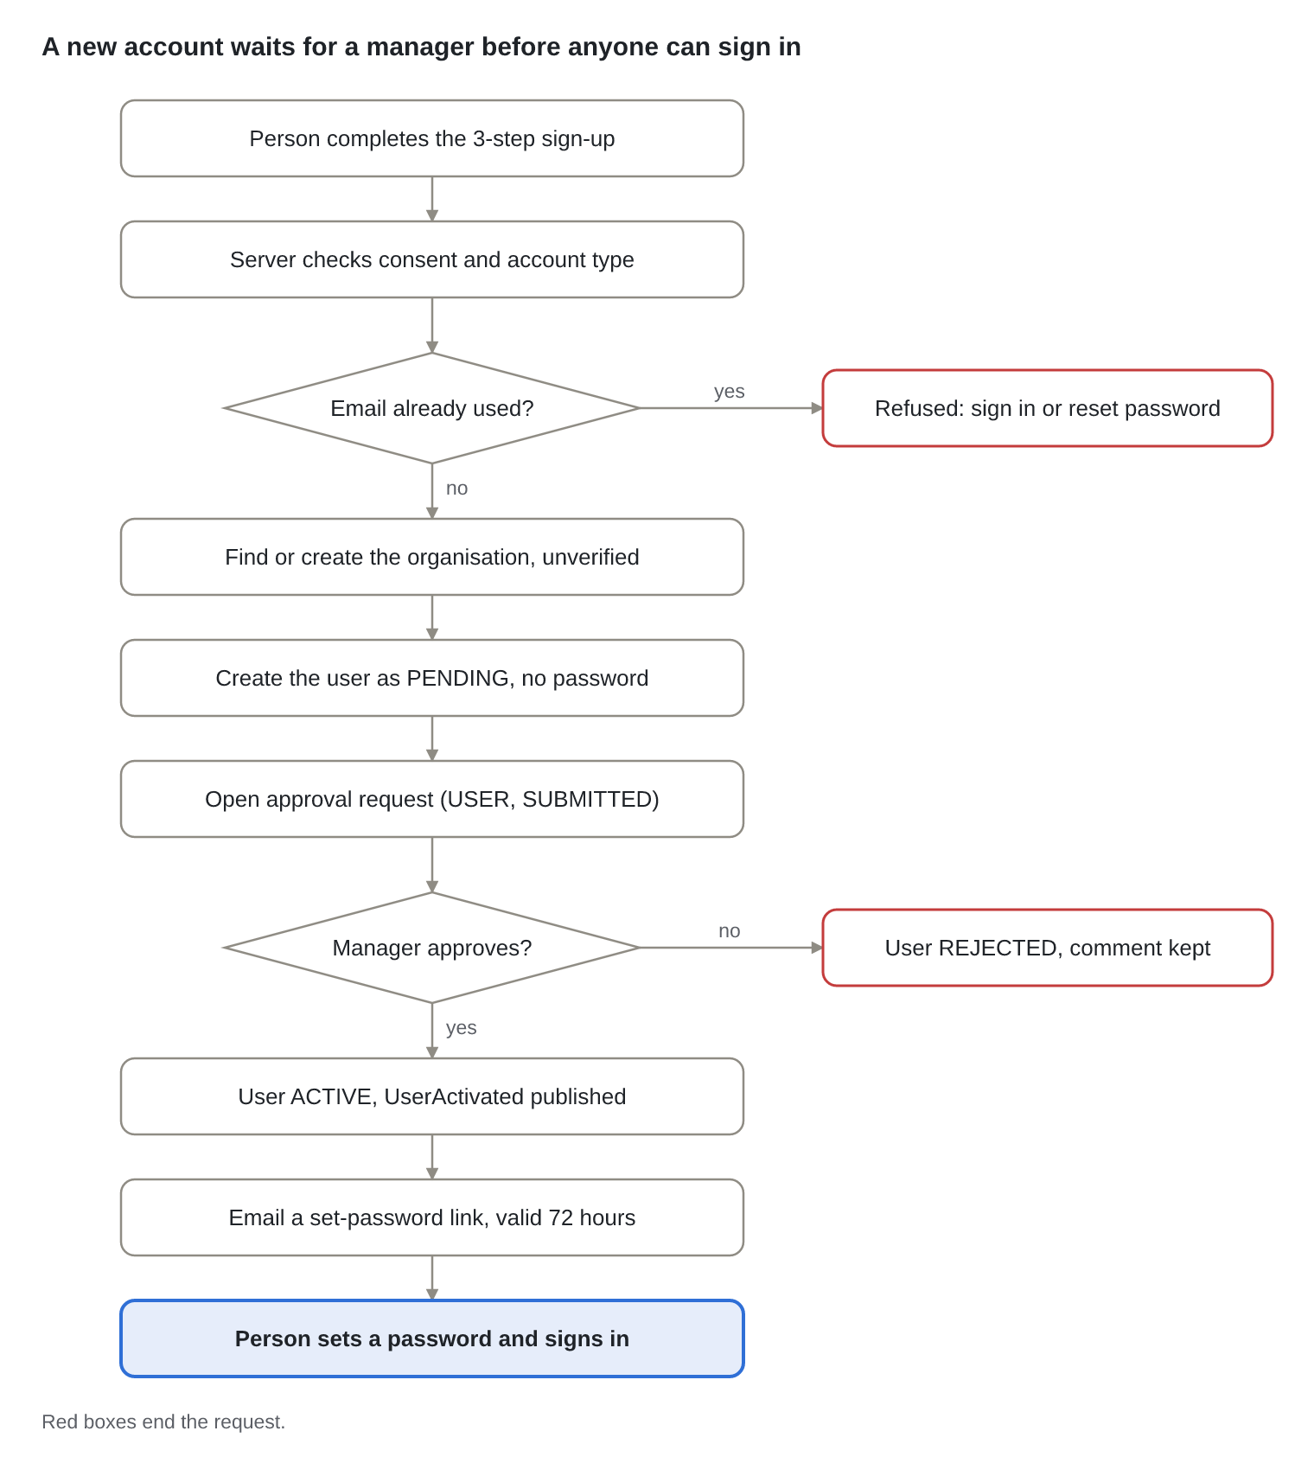
Figure: Flow 13.1 · sign-up and account approval
AuthController → AccountService.register → Organisations.findOrCreateForRegistration and Approvals.openAndSubmit. The manager's decision publishes ApprovalDecided; AccountService activates the user and NotificationListeners emails the invitation from AccountService.issueInvitationLink.

13.2 Sign-in and lockout
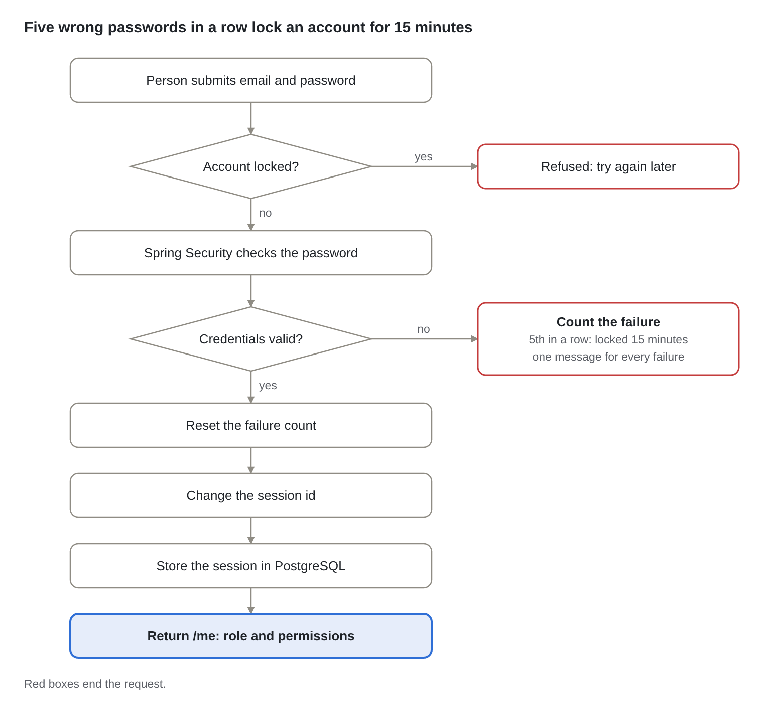
Figure: Flow 13.2 · sign-in and lockout
AuthController.login → AuthService.assertNotLocked → Spring Security with AppUserDetailsService (permissions read from the role tables) → AuthService.loginSucceeded or loginFailed. Disabled, pending and rejected accounts fail with the same message as a wrong password, so the answer never reveals whether an email is registered.

13.3 Set or reset a password
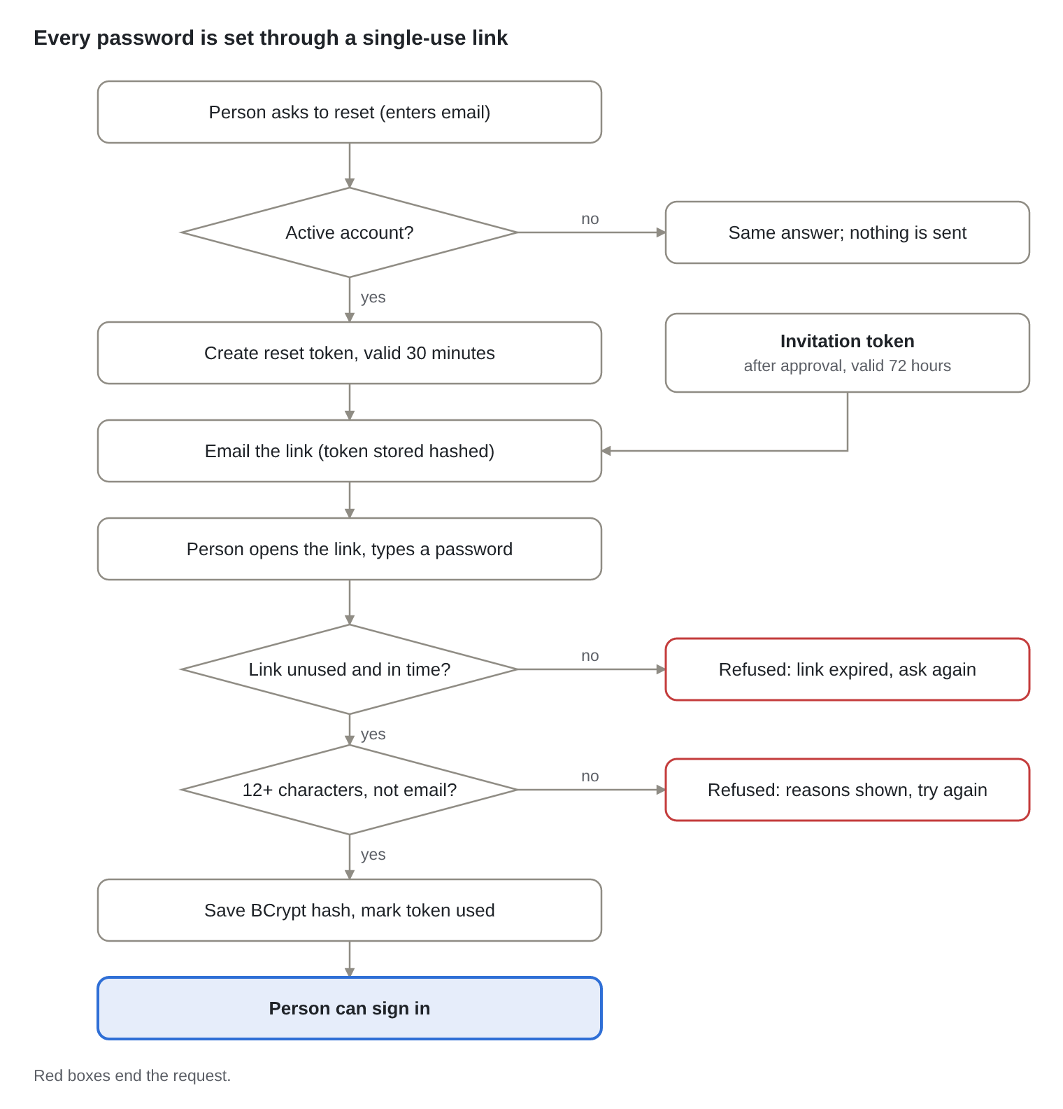
Figure: Flow 13.3 · set or reset a password
POST /auth/password-reset always answers the same; only an active account gets an email. POST /auth/set-password → AccountService.setPassword hashes the token, checks it is unused and in time, applies PasswordPolicy, stores the BCrypt hash and marks the token used.

14. Functional flows: Approvals, purposes and needs, verification
One approval engine governs users, purposes, causes and projects; a record reaches donors only when a second person has approved it, and loses that status the moment its substance changes.

14.1 Maker-checker approvals
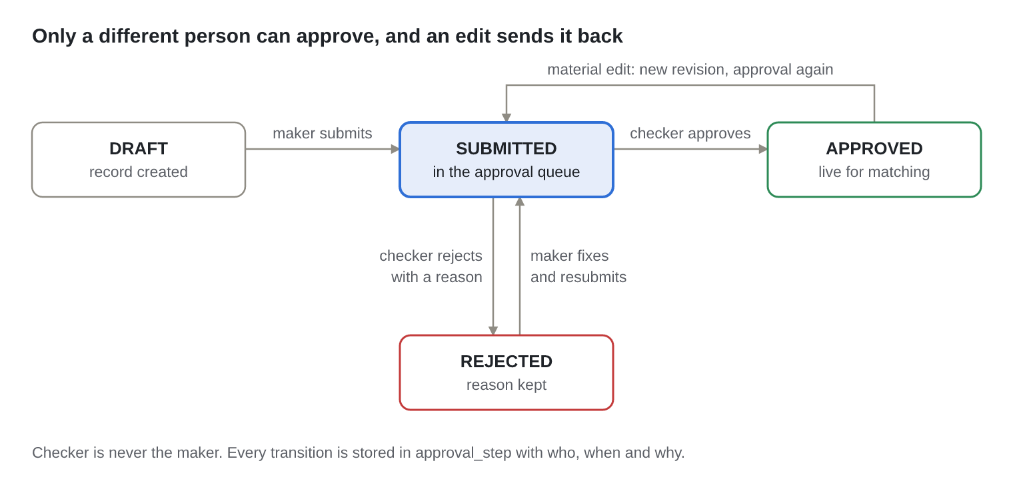
Figure: Flow 14.1 · approval states
ApprovalController → ApprovalService.decide → ApprovalPolicy (pure rules: submit only from DRAFT or REJECTED; decide only from SUBMITTED; checker ≠ maker; reject needs a reason; a material edit of an APPROVED record returns it to SUBMITTED as a new revision). Each decision publishes ApprovalDecided, which the owning module (identity or catalogue) applies.

14.2 Purposes, causes and projects
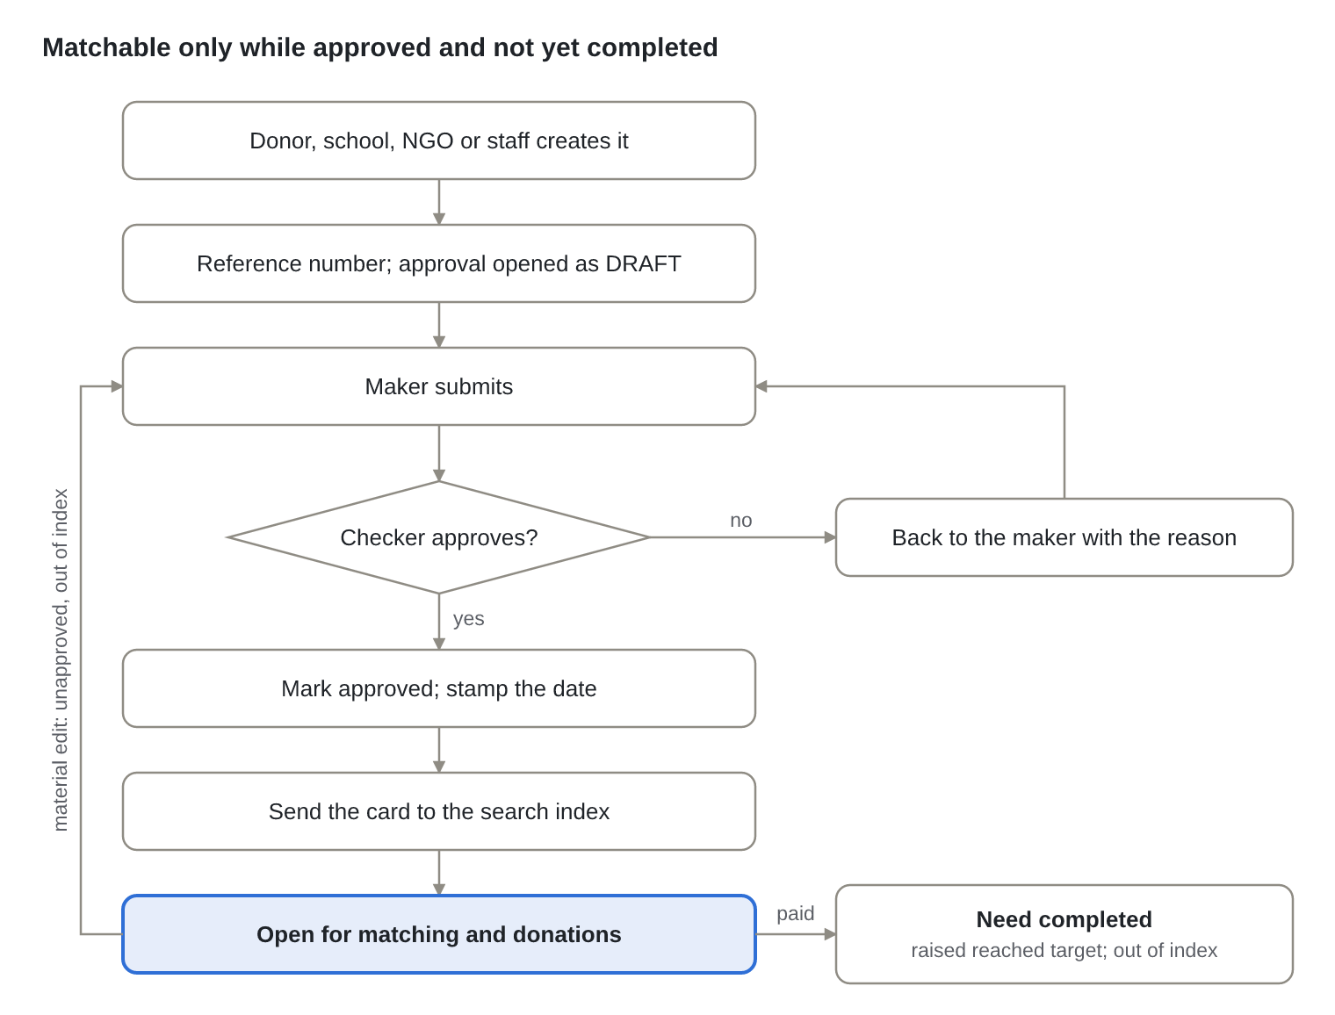
Figure: Flow 14.2 · purpose and need lifecycle
CatalogueController → CatalogueService. Approval stamps need.approved_at (or the purpose's commitment_date, kept on later re-approvals) and publishes PurposeIndexable or NeedIndexable, which MatchingService sends to POST /v1/index/upsert. A material edit (name, description, sector, amount or periodicity) unapproves the record, removes it from the index and reopens its approval. recordPayment adds each donation to raised_amount; when it reaches the target the need is completed and leaves the index.

14.3 Organisation verification
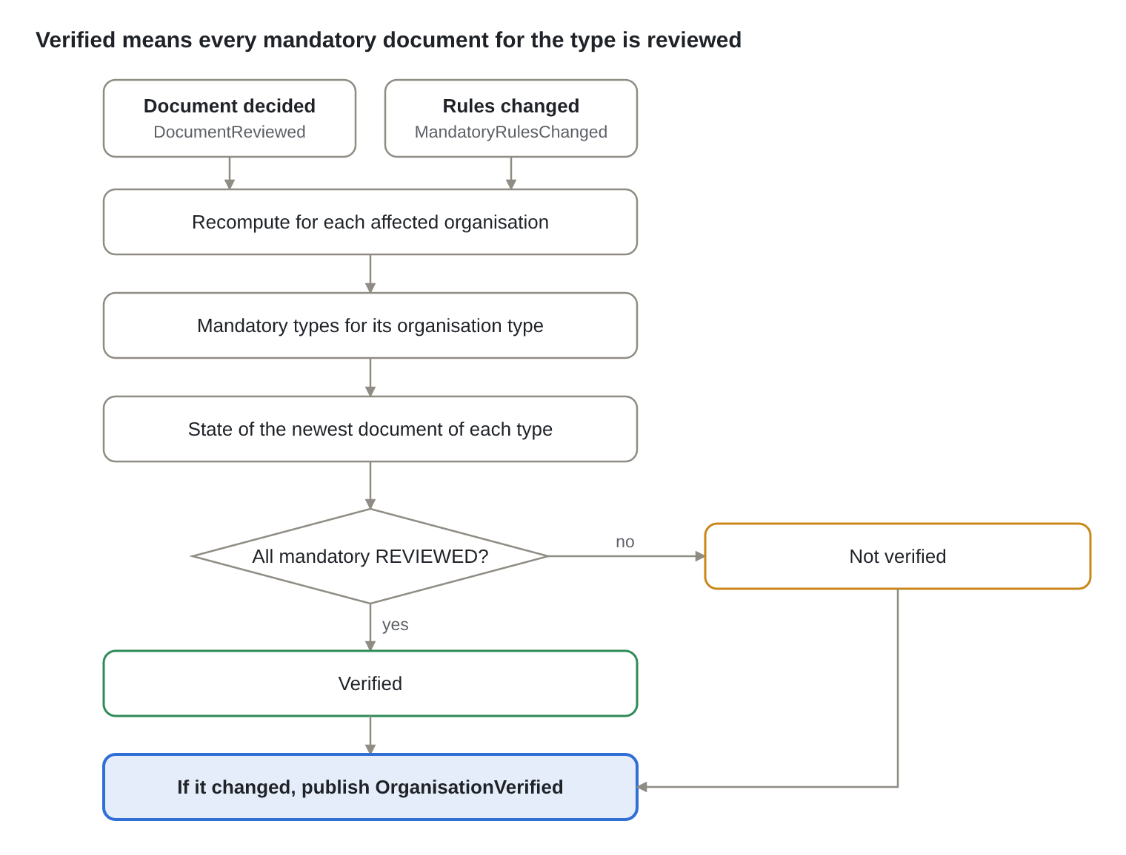
Figure: Flow 14.3 · organisation verification
OrganisationService.recomputeVerification uses MandatoryDocumentPolicy: verified only if the organisation type has at least one mandatory document type and the newest document of every one of them is REVIEWED. A rejection or a new pending version of a mandatory document takes verification away again, and a super admin changing the mandatory list re-checks every organisation of the affected types.

15. Functional flows: Documents and matching
Documents are versioned and reviewed before they count, and shared with donors only on the owner's say-so; matches are proposed by the engine but every one is decided by a person.

15.1 Upload and review
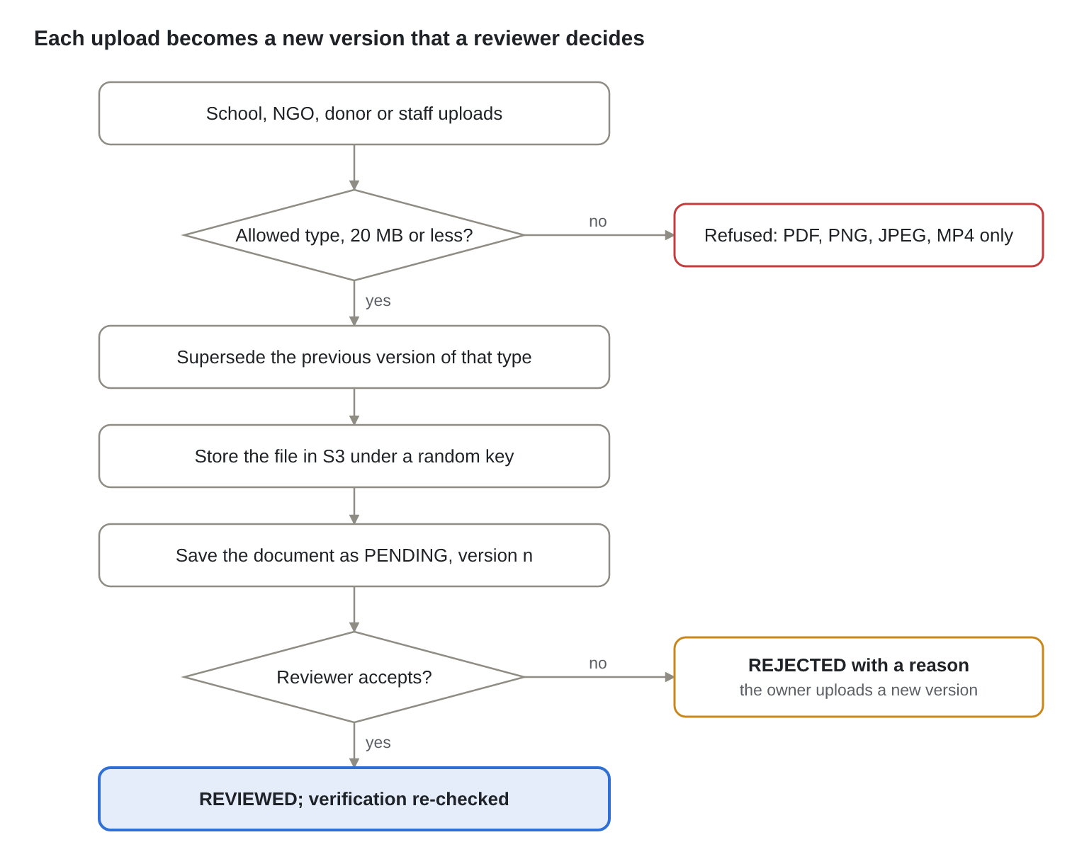
Figure: Flow 15.1 · document upload and review
DocumentController → DocumentService.upload: UploadPolicy checks the extension against the file's first bytes (PDF, PNG, JPEG, MP4) and the size (20 MB); the previous non-superseded document of the same type is marked superseded and the new one gets the next version number. The key is org-<id>/<year>/<month>/<uuid>, so file names never reach storage paths. Review and reject need document.review and publish DocumentReviewed.

15.2 Sharing and downloads
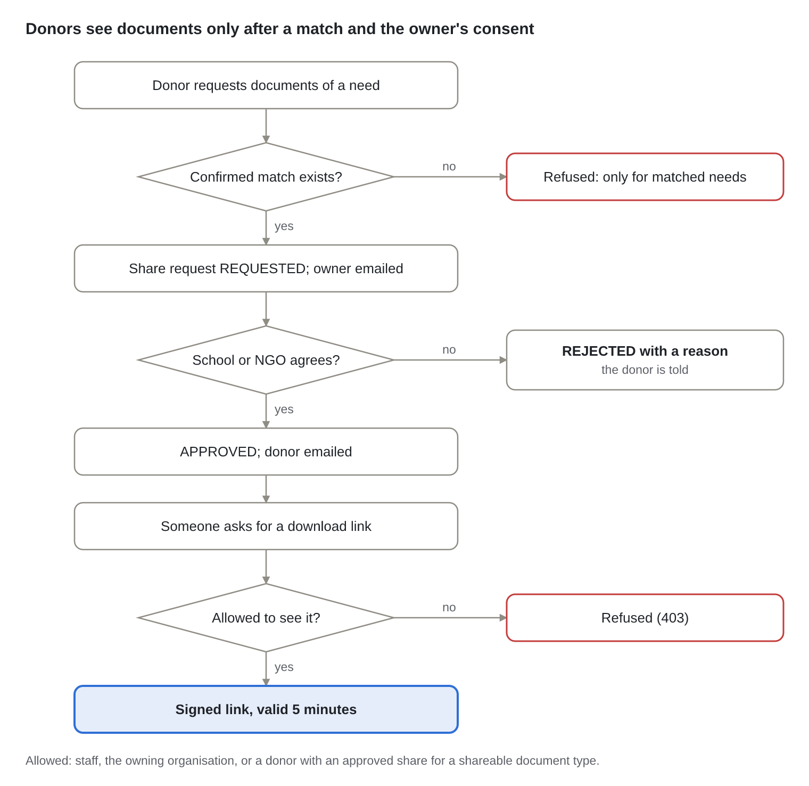
Figure: Flow 15.2 · sharing documents with donors
A donor can ask only for needs they have a confirmed match with (Matches.donorHasConfirmedMatch); a repeat request reuses the existing one. DocumentAccessPolicy.canView decides every download; the link is a pre-signed S3 URL on FILES_DOMAIN that expires after 5 minutes.

15.3 Matching run, review and confirmation
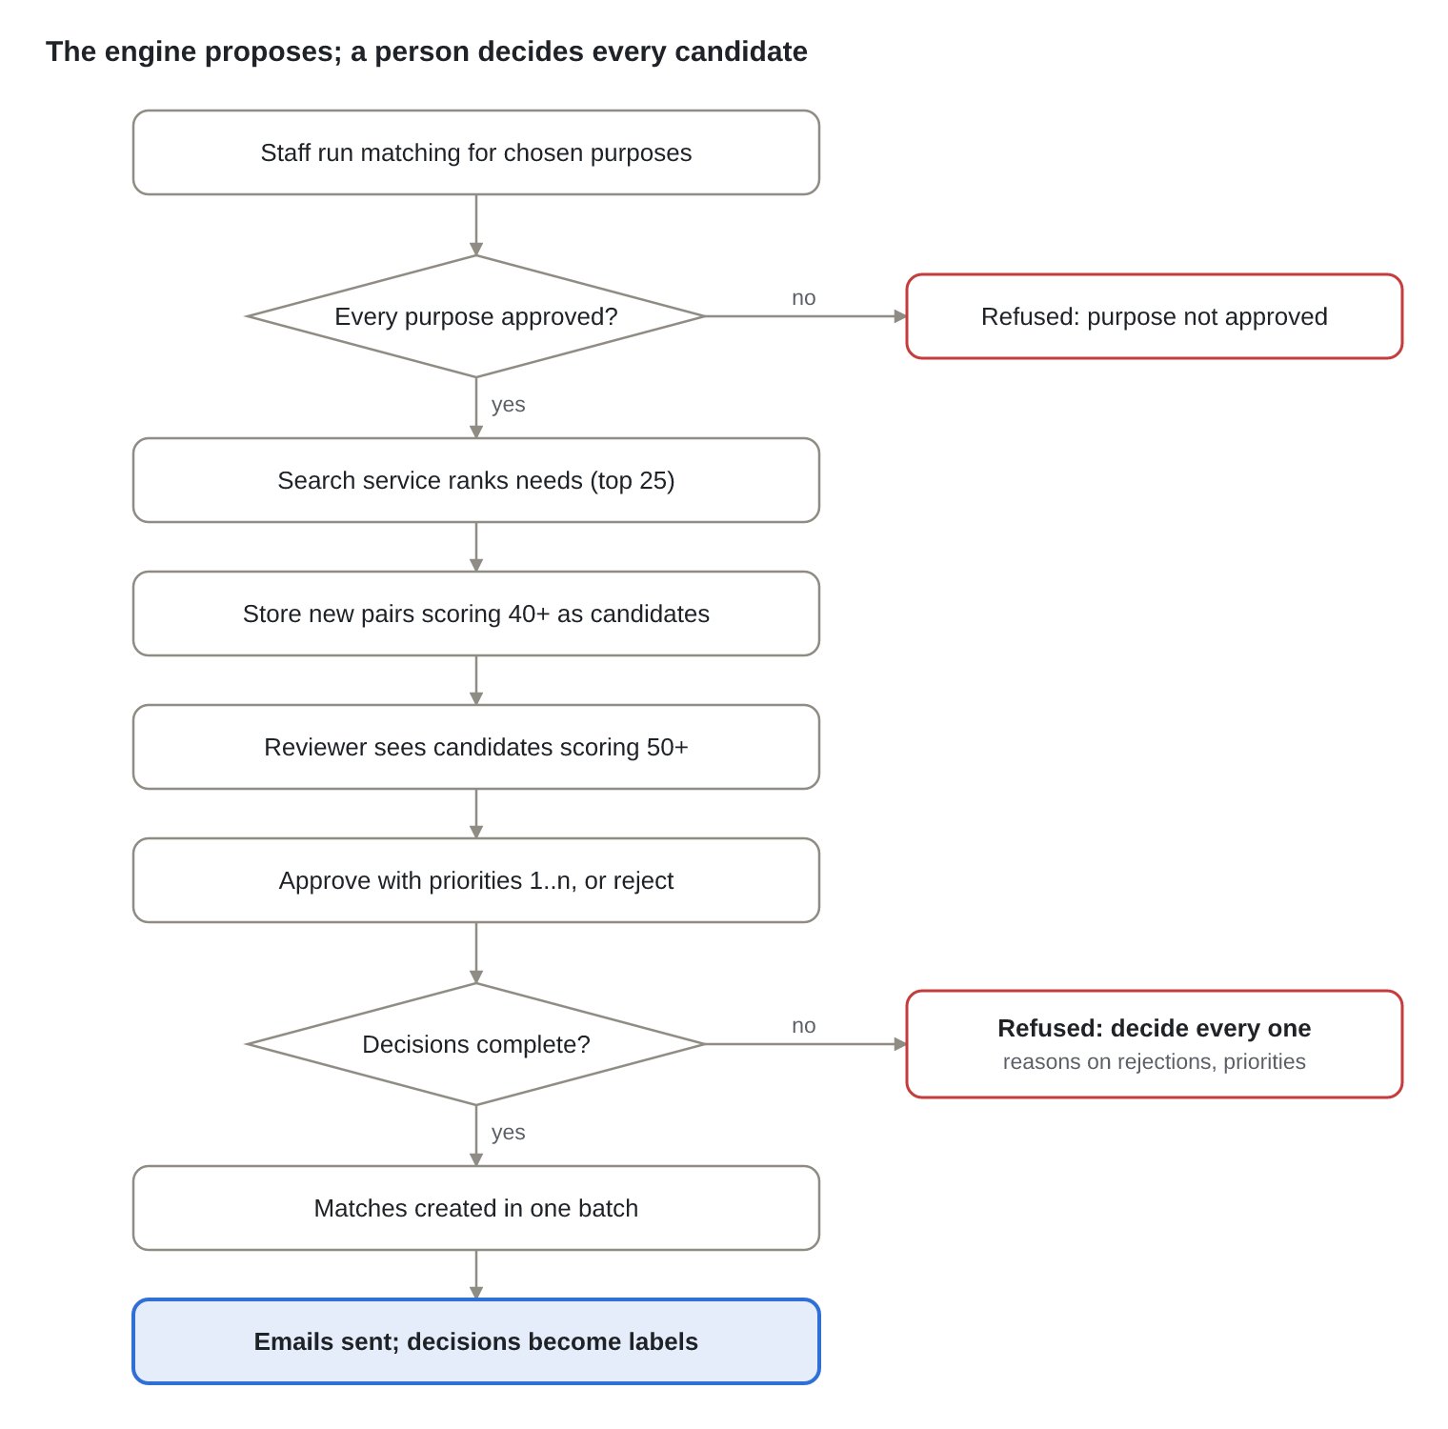
Figure: Flow 15.3 · matching run, review and confirmation
MatchingController → MatchingService.run calls SearchClient.purposeToNeeds for each purpose and stores new pairs at or above the store threshold (40) under one match_run. confirm validates the decisions with CandidateDecisionValidator (every shown candidate decided once, a reason on every rejection, at least one approval, every approval with a priority, priorities 1..n without gaps), creates the match_batch and its matches, then publishes MatchesConfirmed (emails) and LabelsCaptured (training labels for the search service).

16. Functional flows: Donations and recurring giving
A payment is recorded once even if the request is retried, never for more than the cause or project still needs, and a recurring commitment schedules its own next instalment and reminder.

16.1 Recording a donation
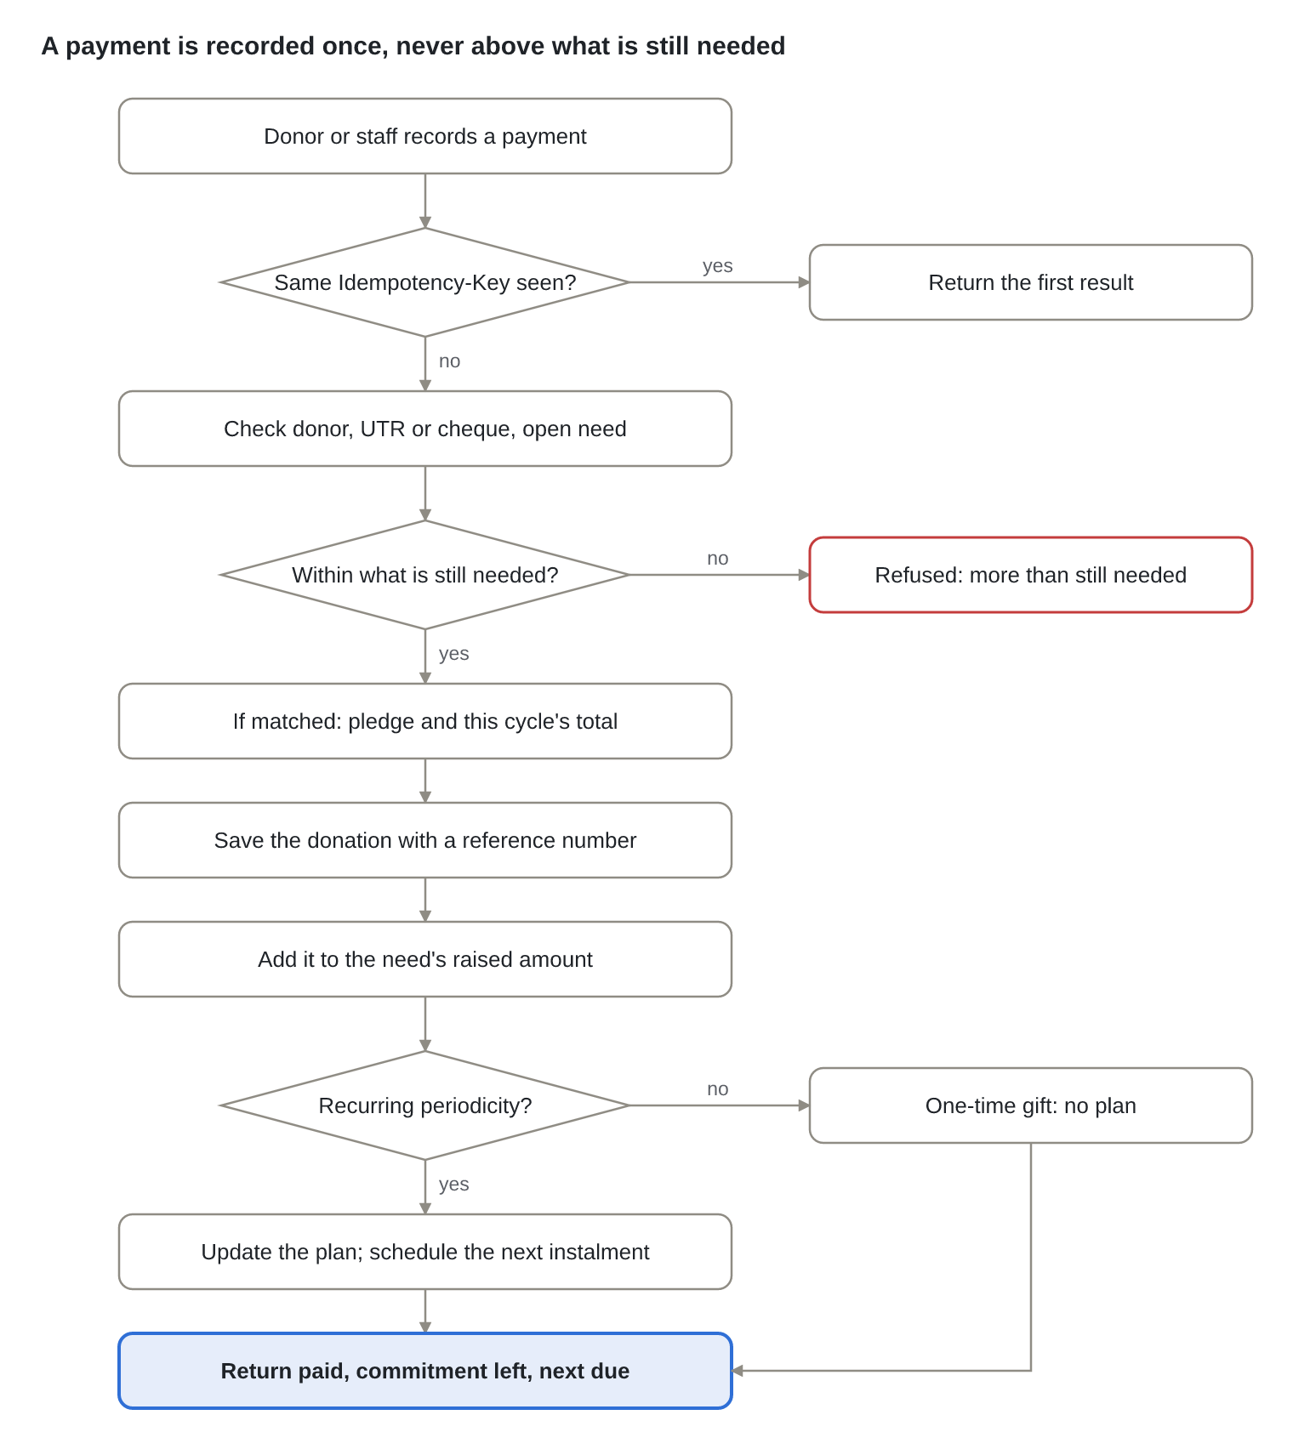
Figure: Flow 16.1 · recording a donation
GivingController → DonationService.record. Staff must name the donor; donors record for themselves. With a match, the purpose's pledge and the amount already given this cycle (DonationCalculator.cycleStart) are recorded beside the payment, so paid and pledged never mix. CatalogueService.recordPayment raises the need's total and completes it at the target. Donations paid against a match get a donation reference number, direct gifts a direct-donation one.

16.2 Instalment reminders
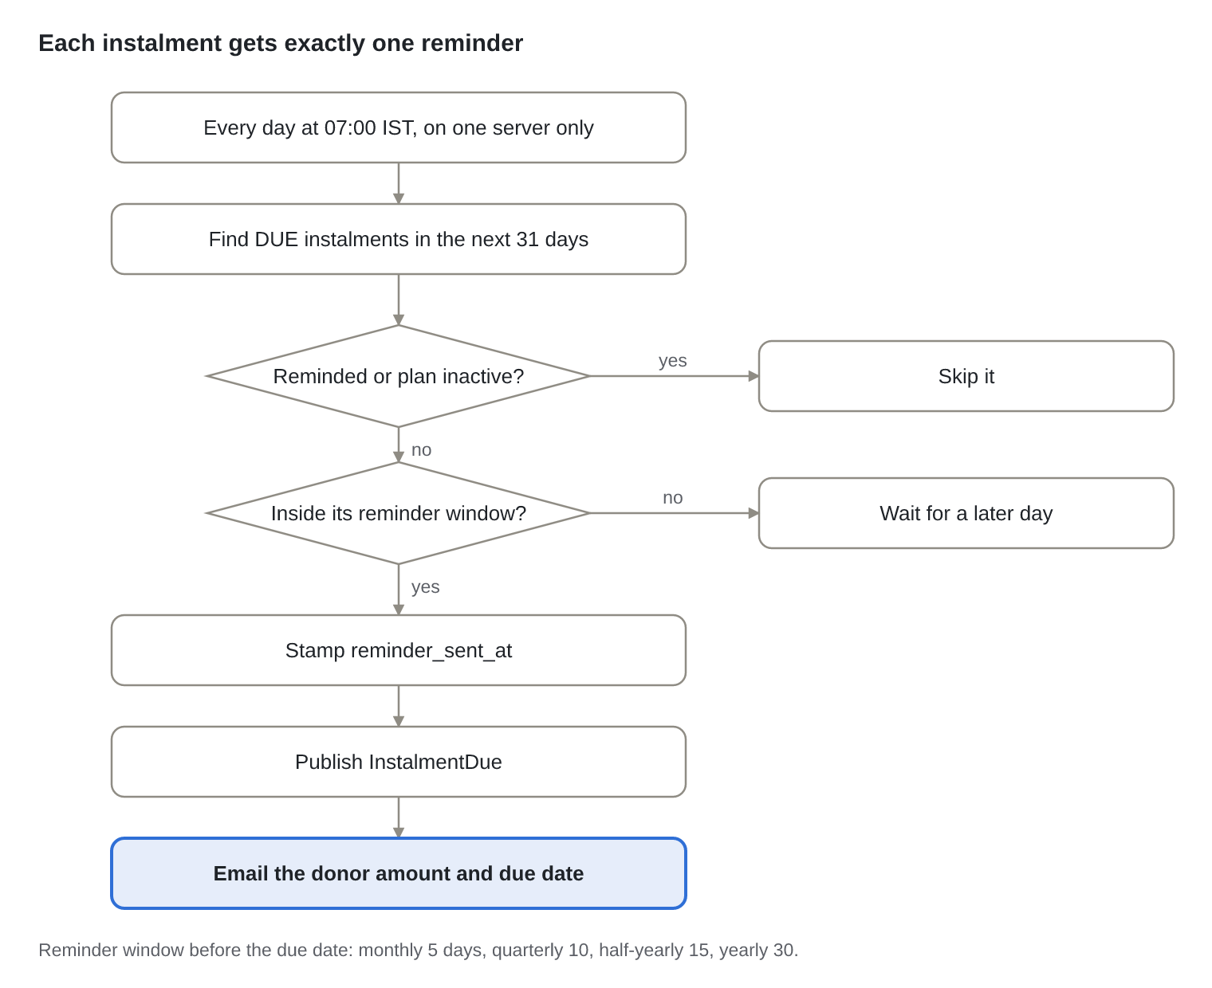
Figure: Flow 16.2 · instalment reminders
InstalmentScheduler.sendReminders runs on the cron humsaadhak.giving.reminder-cron (default 0 0 7 * * *, Asia/Kolkata) under a ShedLock lock (instalment-reminders, at most 30 minutes), so several app instances never send duplicates. Paying the instalment marks it PAID with the donation's id and schedules the next one.

17. Functional flows: Dashboards, reports and exports
Every number on a dashboard can be opened to the records behind it, every report from the original project is available with Excel and PDF export, and none of it ever builds SQL from what a person typed.

17.1 Dashboards and chart drill-down
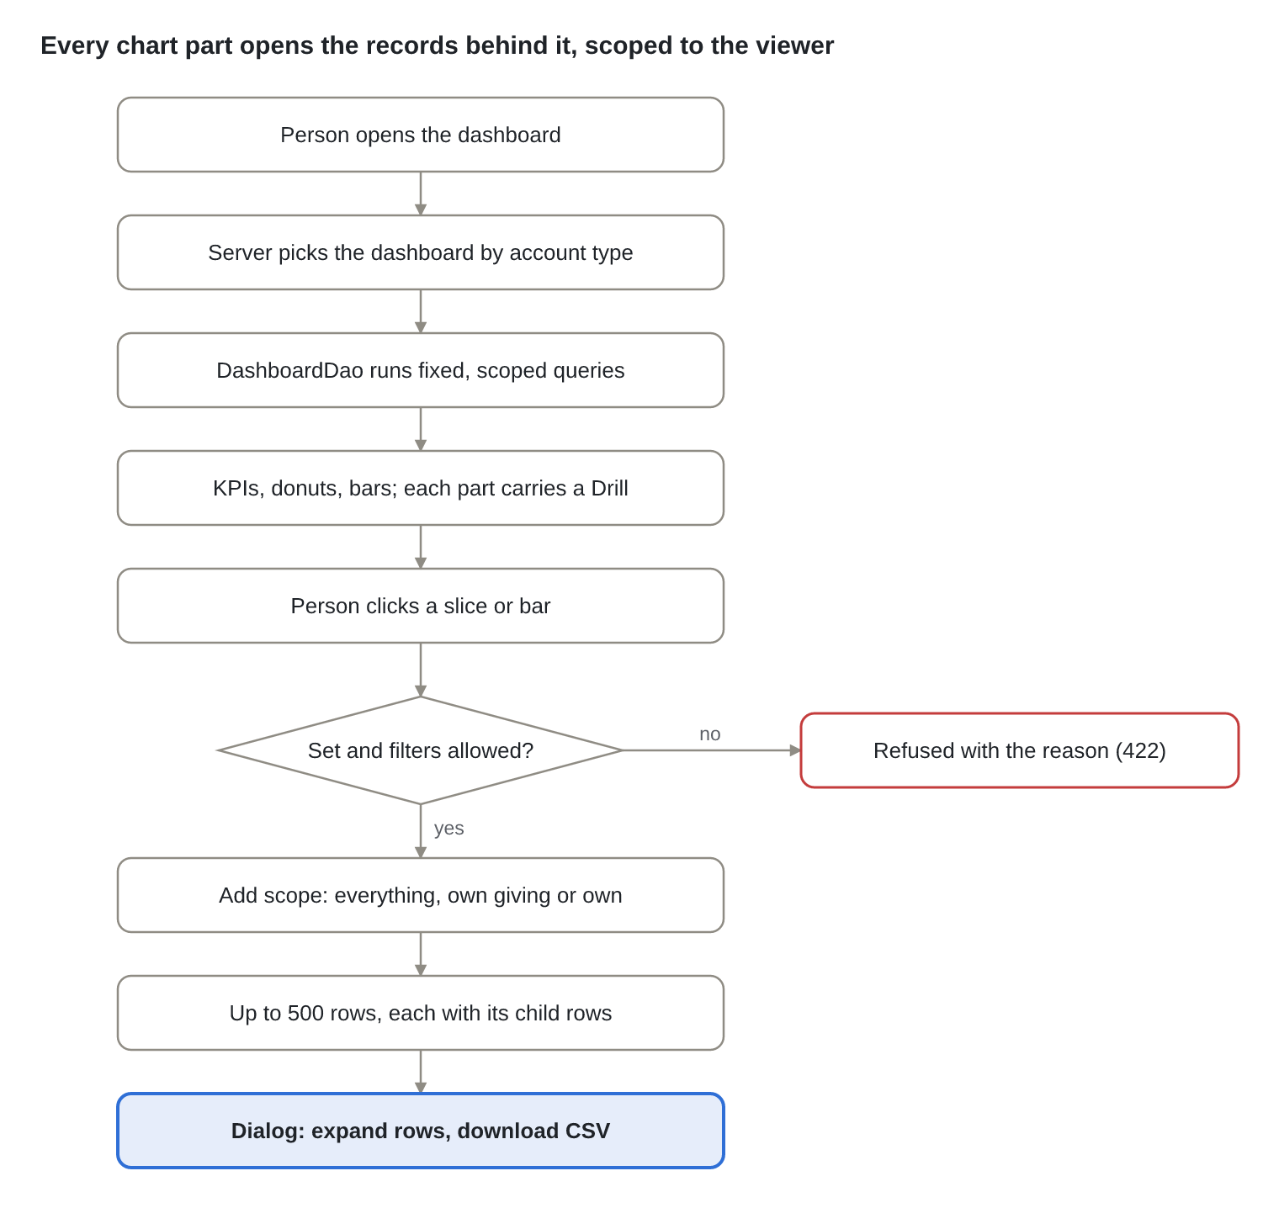
Figure: Flow 17.1 · dashboards and chart drill-down
DashboardController → DashboardService.forUser chooses the manager, associate, donor or school/NGO dashboard and assembles it from DashboardDao. Each slice and bar carries a Drill with a set (ORGANISATIONS, NEEDS, DONATIONS, PURPOSES) and filters. DetailController → DetailService → DetailQuery accepts only known filter names and values, adds the viewer's scope in SQL, caps the result at 500 rows (telling the dialog when there are more), and DetailDao loads child rows (a donor's donations, a need's donations, a purpose's matches).

17.2 Beneficiary reports (donation, match, project or cause, customize)
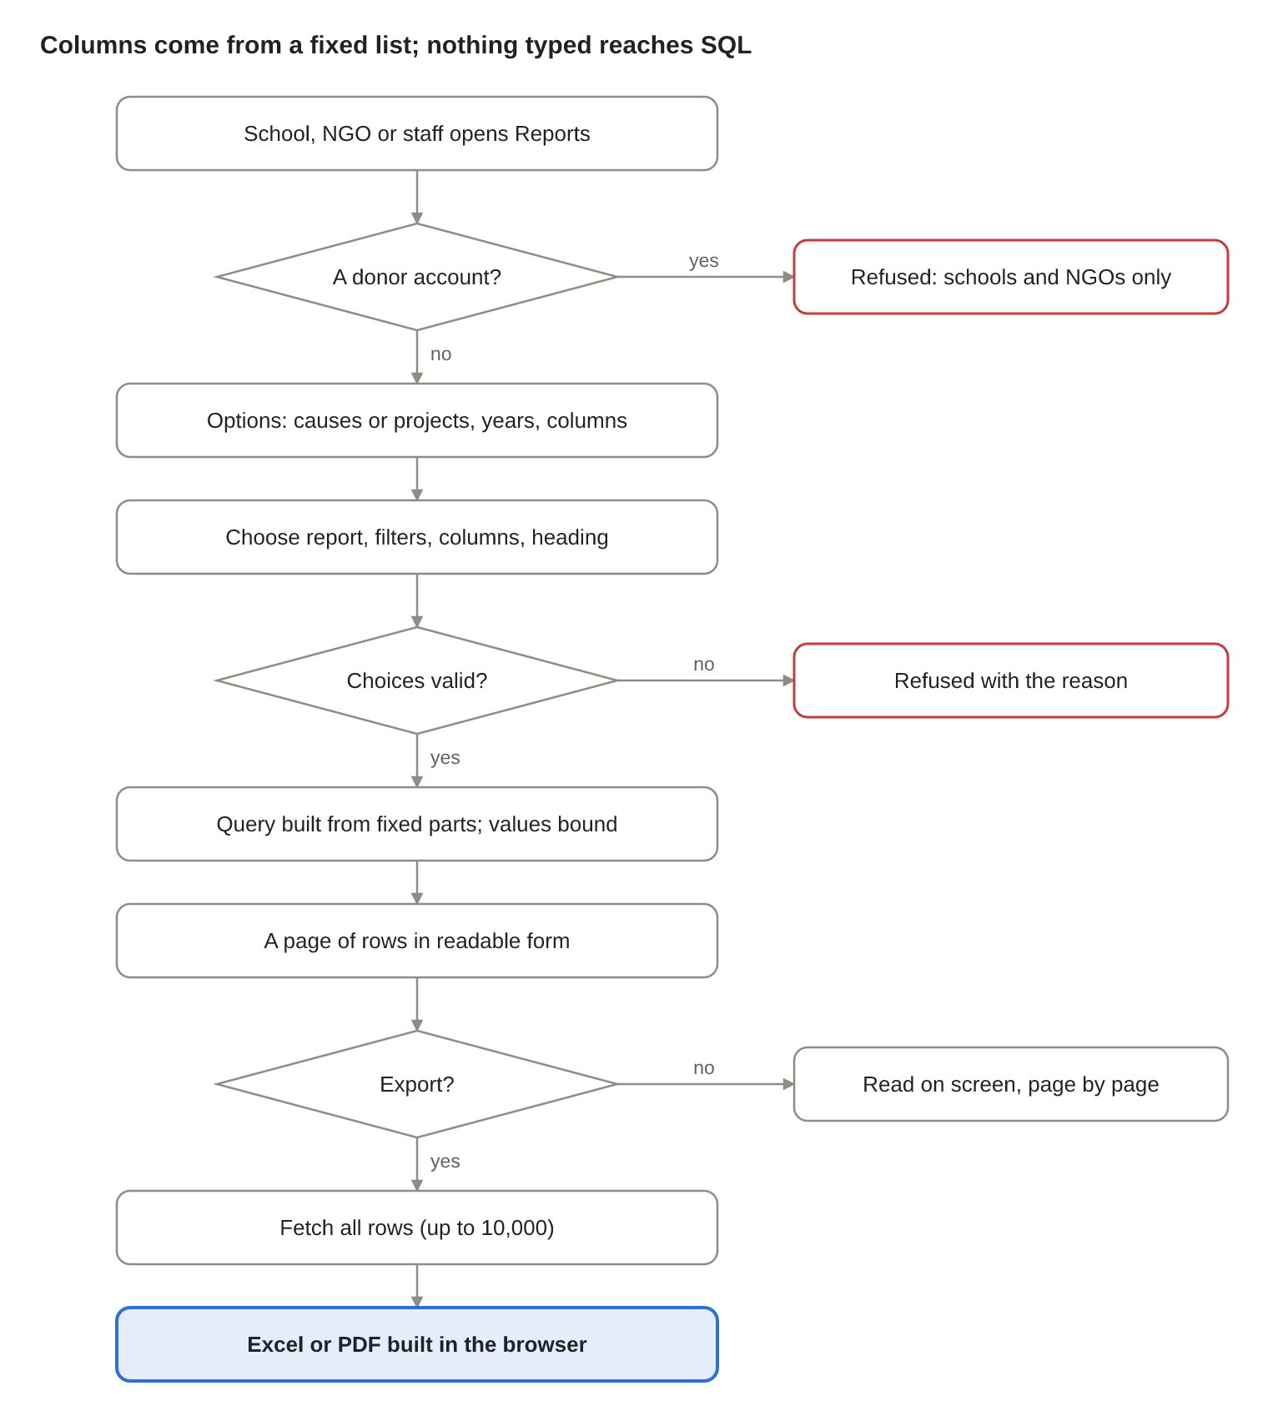
Figure: Flow 17.2 · beneficiary reports and export
BeneficiaryReportController → BeneficiaryReportService → BeneficiaryReportQuery. Valid choices: a financial year or an approved-date range, not both, with the end not before the start; for the customize report exactly one of "Project" or "Project (yet to be approved)" and only columns from the 16 allowed. Each column brings its own fixed SQL fragment and joins; project and cause totals use separate sub-queries so they never double-count. Screens page 10 to 100 rows; exports fetch up to 10,000 and build the file with ExcelJS or jsPDF in the browser, with the logo, title, entity line and filter line of the original reports.

17.3 Staff CSV exports
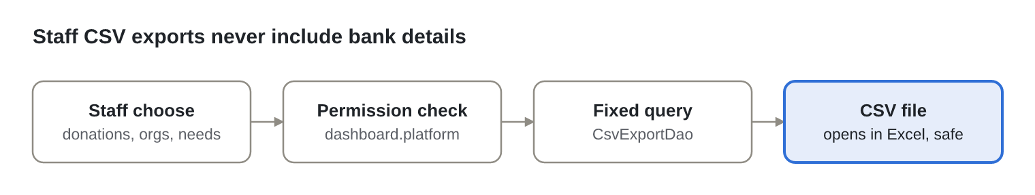
Figure: Flow 17.3 · staff CSV exports
ReportController → CsvExportService → CsvExportDao with three fixed queries (donations in a date range, organisations, causes and projects). Csv writes a byte-order mark so Excel reads Indian names correctly and prefixes cells starting with =, +, - or @ so they cannot run as formulas.

18. Functional flows: Import, access, notifications and history
Administration is all-or-nothing and immediate: an import never half-succeeds, and a change to anyone's rights takes effect at once because the affected sessions are ended.

18.1 Bulk import
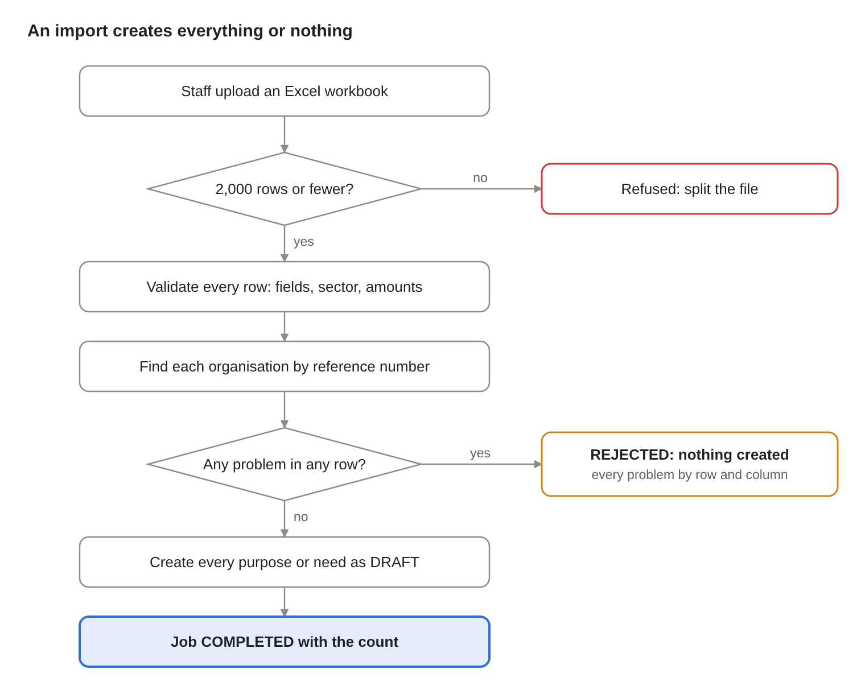
Figure: Flow 18.1 · bulk Excel import
ImportController → ImportService.upload (one transaction) → WorkbookIO.read (Apache POI, at most 2,000 rows) → RowValidator for each row (required fields, sector names, Indian-formatted amounts, periodicity) → organisations resolved by reference number. Created records still go through approval as DRAFT. Templates come from GET /imports/templates/{type}.

18.2 Changing a role's permissions
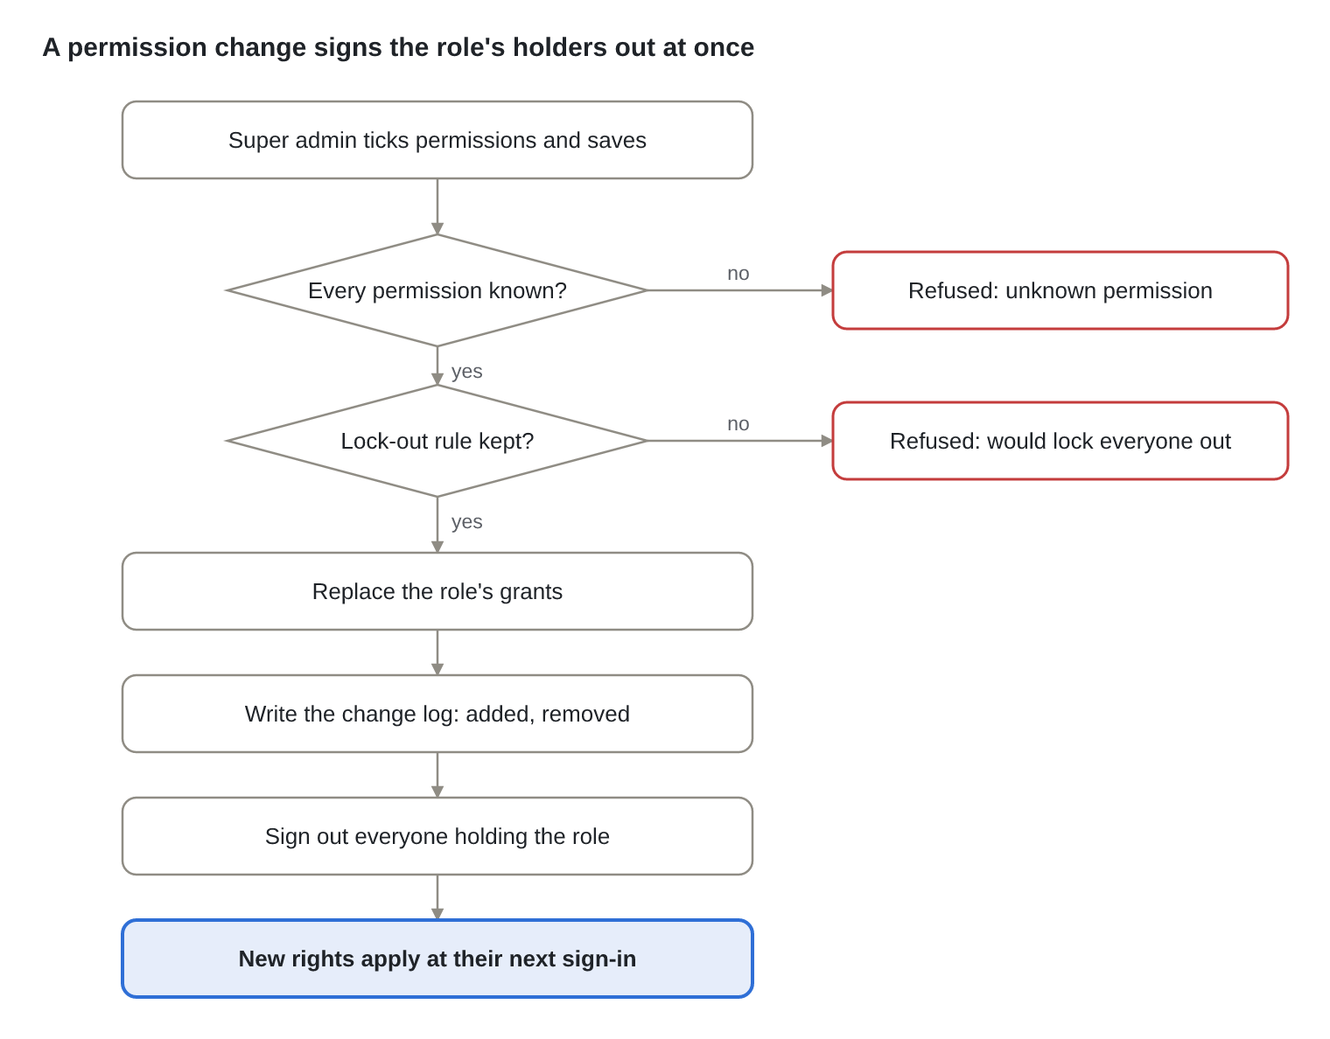
Figure: Flow 18.2 · changing a role's permissions
AccessController → AccessService.updateRole → RolePolicy.checkPermissions (known codes only; the Super admin role always keeps admin.users and admin.roles) → AccessDao.replaceGrants and log → SessionRevoker deletes the holders' rows in spring_session. Creating roles and custom permissions, and deleting unused custom ones, follow the same pattern and land in the same change log.

18.3 Changing a person's role
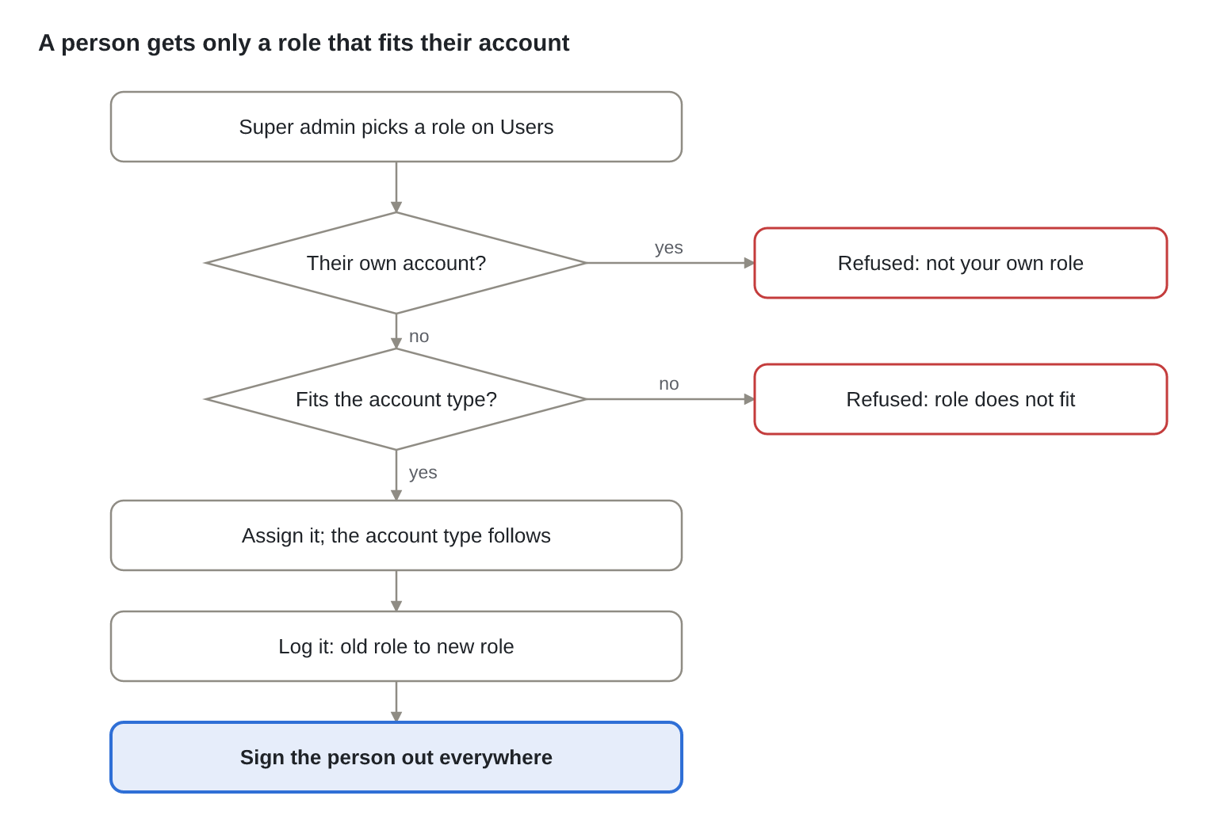
Figure: Flow 18.3 · changing a person's role
AdminUserController → UserAdminService.changeRole → RolePolicy.fits: staff roles only for people without an organisation, otherwise a role of the organisation's own type. Disabling an account also signs the person out everywhere; enabling, resending an invitation and adding a staff member follow the same screen. Staff never sign up themselves: POST /admin/users creates them active without a password, with a staff role only, and emails a single-use set-password link.

18.4 Notifications
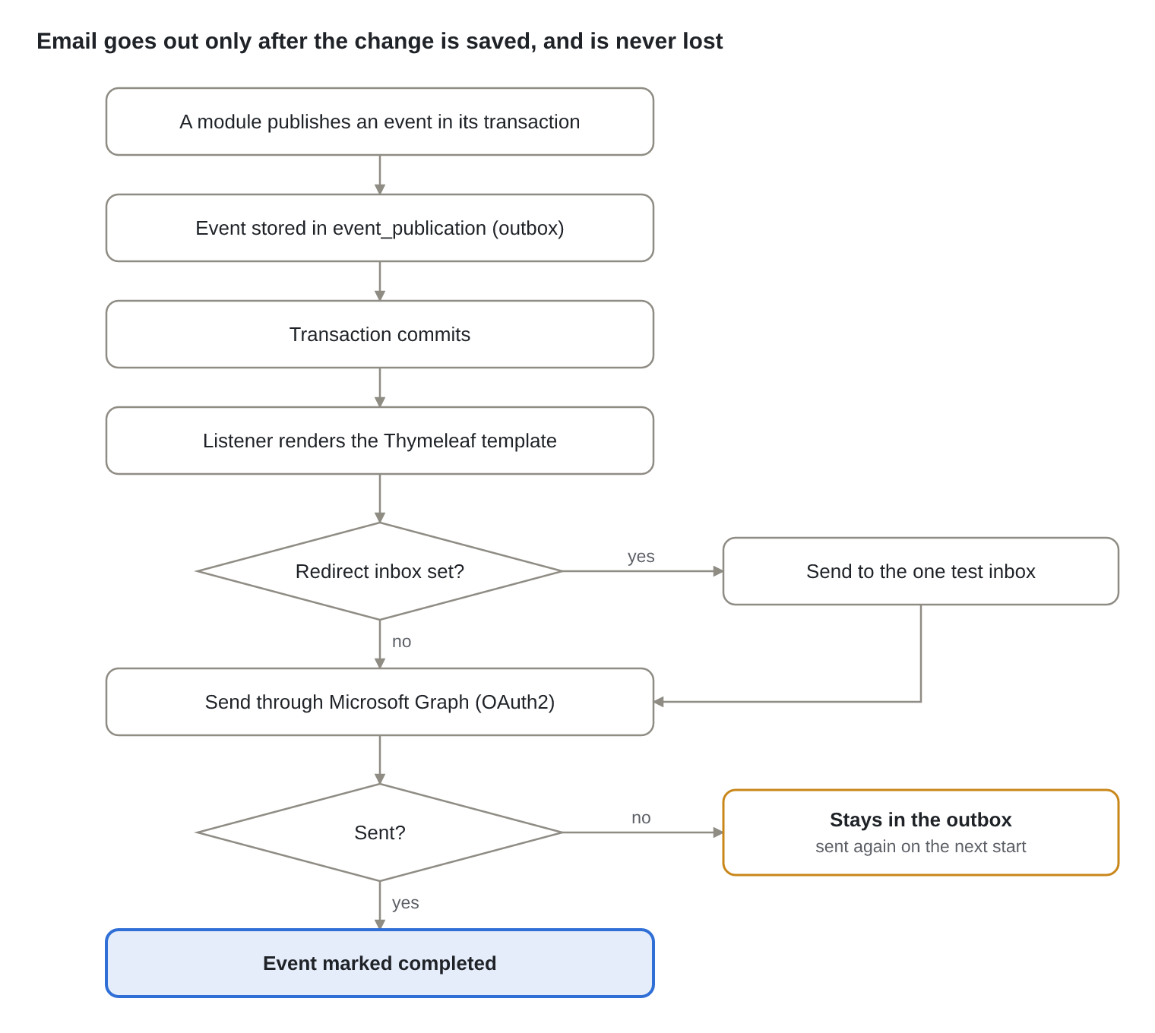
Figure: Flow 18.4 · email notifications
NotificationListeners handles UserActivated, PasswordResetRequested, MatchesConfirmed, ShareRequested, ShareDecided and InstalmentDue. GraphMailGateway gets an app-only token (client credentials, cached until it expires) and calls sendMail as MAIL_FROM; in development LoggingMailGateway writes the email to the log instead. MAIL_REDIRECT_TO sends every email to one inbox outside production so real donors never get test mail.

18.5 Change history
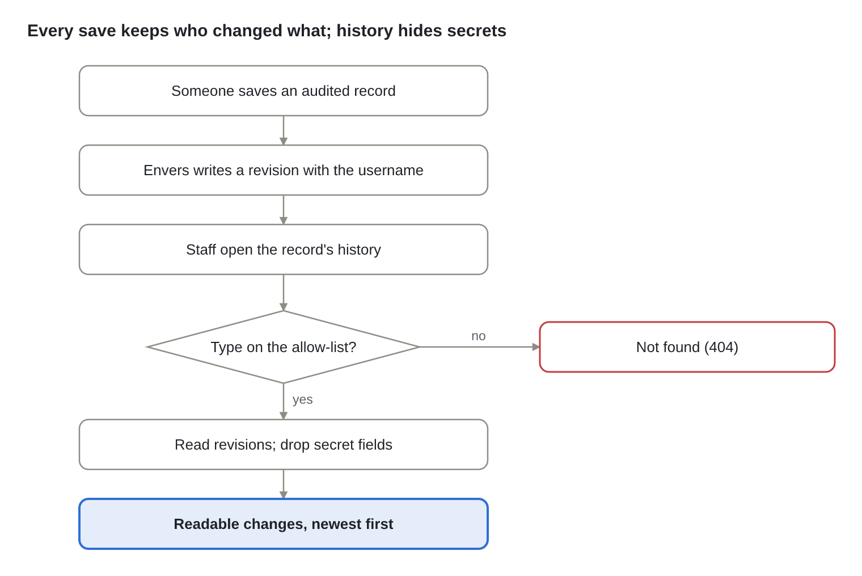
Figure: Flow 18.5 · change history
HistoryController → HistoryService → AuditedType (organisation, purpose, need, document, donation, user, match candidate) → HistoryDao reads <table>_aud joined to revinfo → HistoryDiff turns consecutive revisions into field-by-field changes. Each revision carries the id of the request that made it, so these field changes appear inside each record's audit trail (18.6), under the action that made them.

18.6 Audit trail of every action
Every action a person takes is recorded: who did it, what they did, to which record, when, from which address and browser, and whether it was done, refused or failed; and the trail is shown on the same page where the change is made.
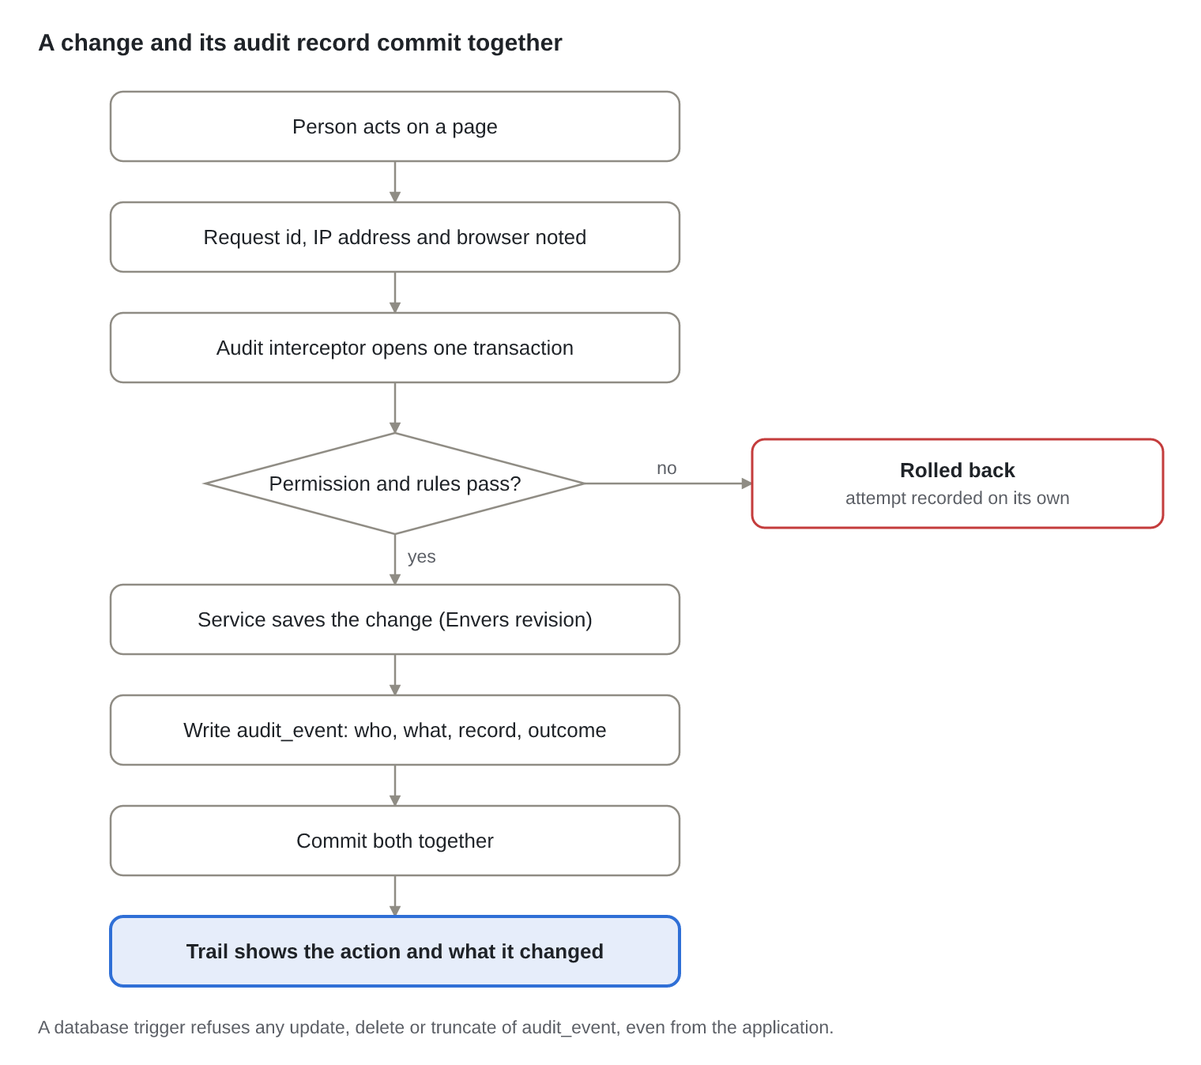
Figure: Flow 18.6 · recording an action in the audit trail
AuditRequestInterceptor starts each audited request (request id, client address, browser; the id is also returned as X-Request-Id). AuditMethodInterceptor, an advisor ordered outside method security, runs the controller method and writes the audit_event row in one transaction, so a change is never committed without its record. When the action is refused (@PreAuthorize, scope) or fails (a business rule, invalid input, a conflict), the transaction rolls back and the attempt is recorded on its own. UsernameRevisionListener stamps each Envers revision with the same request id, so AuditTrailService can show the fields each action changed.
What is recorded (48 audited endpoints, each a category.verb code with a readable name)
Area | Actions
Sign-in and settings | Sign in (including failures and lockouts), sign out, register, ask for a reset link, set a password, change theme
People and access | Change a user's role, disable, enable, resend invitation; create, change and delete roles and permissions (with the permissions added and removed)
Records | Create, edit and submit purposes, causes and projects; approve and reject (with the comment); update profile, contacts and bank accounts
Documents | Upload, open a download link, accept, reject (with the reason); ask for, agree to and decline document sharing
Matching and money | Run matching; confirm matches (how many approved and rejected); record a donation (amount)
Administration and reports | Bulk import, template download, sectors and document types, report runs, CSV exports, audit log exports

Passwords, tokens and file contents are never recorded. Every endpoint that changes data, and every download and export, must carry @AuditAction: LayeredArchitectureTest.everyStateChangingEndpointIsAudited fails the build otherwise.
Who sees what
Person | Record trails ("Audit trail" button) | Page activity panel | Refused or failed attempts, IP and browser | Full audit log and CSV
Staff with audit.view (Super admin, Manager) | Every record | Everything in that area | Yes | Yes (/admin/audit)
Other staff | Every record | Everything in that area | No | No
Donors, schools, NGOs | Records their organisation owns or shares (a donation or share request belongs to both sides) | What concerns their organisation | No | No
Anyone, in Settings | Their own sign-ins and settings changes ("My activity") | — | — | —

Ownership comes from each module's AuditOwnership implementation (catalogue, registry, documents, giving, identity), so the audit module depends on none of them.
The audit_event table (migration V7; not an entity, written with JdbcClient)
Column | Holds
id, at, request_id | Identity, time (UTC), and the request id shared with revinfo.request_id
actor_id, actor_email, actor_name, actor_role, actor_org_id | Who acted, as they were at the time (empty for anonymous requests such as a failed sign-in)
action, category | e.g. purpose.update, purpose
target_type, target_id | The record (text, because roles, permissions and sectors use codes)
org_ids (bigint[]) | Organisations whose people may see the record's trail
outcome, error_code, detail | SUCCESS, DENIED or FAILED; the error code; a short note such as a reason or amount
ip, user_agent | Client address (from the proxy's forwarded header) and browser

Indexes on (target_type, target_id, at), (category, at), (actor_id, at), (actor_org_id, at), at, request_id, and a GIN index on org_ids. Triggers audit_event_no_change and audit_event_no_truncate raise an error on any update, delete or truncate. The endpoints are listed in section 9.

19. Functional flows: Legacy migration and secure start-up
The old system's data is copied once with every old id kept for tracing, and a production deployment checks its own encryption before it accepts a single request.

19.1 Legacy data migration
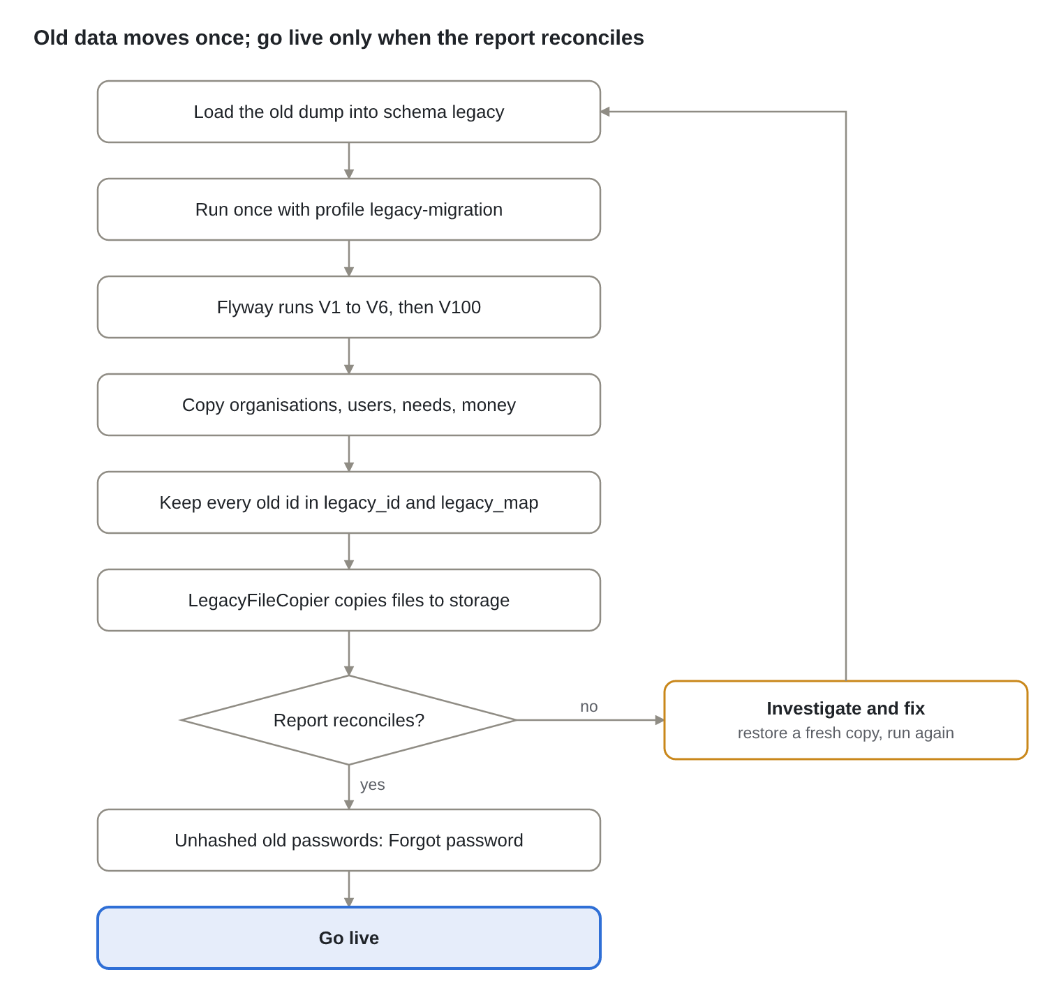
Figure: Flow 19.1 · legacy data migration
Run it on a copy of the real database first. V100 copies the 14 old tables listed in section 12 into the new schema, detects individual and corporate donors from the old type names, opens approval requests for migrated purposes and needs, and creates legacy_migration_report. Real bcrypt password hashes are kept, so most people sign in as before; those whose old password was an unhashed temporary one use "Forgot password". deploy/deploy.sh migrate-legacy <dump> <uploads> runs all of this, after a backup. LegacyFileCopier reads the old /uploads folder (LEGACY_UPLOAD_DIR), copies each file to object storage and logs the ones it cannot find.

19.2 Secure production start-up
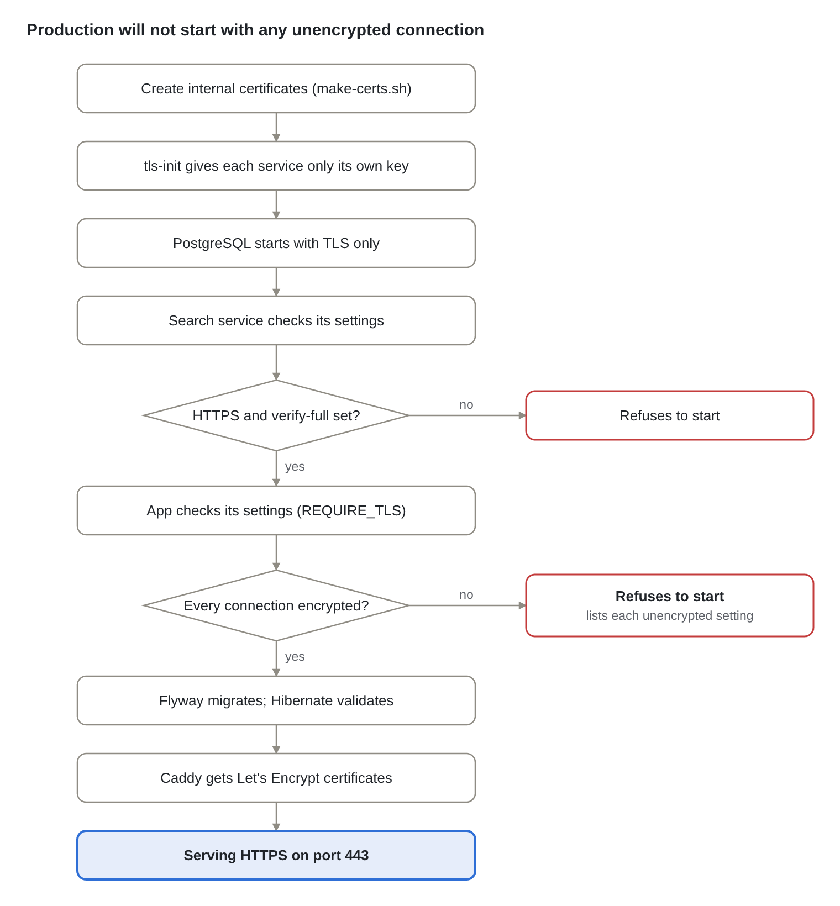
Figure: Flow 19.2 · secure production start-up
Order in deploy/compose.yaml: tls-init → db (healthy) → search → storage → app → proxy. The search service's Settings.from_env and the app's TransportSecurityCheck both refuse to start with plain HTTP, a missing certificate or a database URL without sslmode=verify-full; the app's error lists every problem at once. Flyway then applies any new migrations and Hibernate validates the schema, so a mismatch also stops the start.

20. Non-functional requirements and operations
Security is designed against the OWASP Top 10 and enforced by tests; capacity is bounded by explicit limits in the code; and the system is built to run on several app instances with all state in PostgreSQL and object storage.
Security controls (OWASP Top 10, 2021)
Risk | How it is met | Checked by
A01 Broken access control | Permission on every endpoint; data scope applied in services and SQL; checker never the maker | Spring integration tests (scope), ApprovalPolicyTest, DocumentPoliciesTest
A02 Cryptographic failures | TLS 1.3/1.2 everywhere with verification; AES-256-GCM bank numbers; BCrypt passwords; SHA-256 token hashes | TlsSupportTest, test_tls.py, FieldEncryptorTest
A03 Injection | Parameterised SQL only; report columns, chart filters and audit tables from allow-lists; CSV formula protection | BeneficiaryReportQueryTest, DetailQueryTest, CsvAndCodesTest
A04 Insecure design | Maker-checker, idempotent donations, all-or-nothing imports, lock-out rule for roles | DonationCalculatorTest, RowValidatorTest, RolePolicyTest
A05 Security misconfiguration | Production refuses unencrypted settings; CSP, HSTS, frame-ancestors none; secrets only in environment | TransportSecurityCheckTest, TransportSecurityPolicyTest
A06 Vulnerable components | Exact pinned versions; npm audit reports 0 known vulnerabilities; jsPDF upgraded to 4.2.1 and Vitest to 5.0.3 (critical tinypool advisories) | npm audit in the build
A07 Authentication failures | Lockout after 5 failures, new session id at sign-in, single-use expiring links, 12+ character passwords | PasswordPolicyTest, identity integration tests
A08 Integrity failures | Flyway-owned schema validated at start; event outbox; signed, expiring download links | Schema validation at every start (ddl-auto: validate)
A09 Logging failures | Every action in the append-only audit_event, refused and failed attempts included, with IP and browser; Envers changes linked by request id; approval steps; access change log; Actuator metrics | AuditTrailIntegrationTests, AuditTrailMergeTest, rule everyStateChangingEndpointIsAudited
A10 Server-side request forgery | Outbound calls only to configured hosts (Graph, search service, storage); no user-supplied URLs | Code review rule

Limits and timeouts built into the code
Item | Limit
Session idle timeout | 30 minutes
Invitation link, reset link, download link | 72 hours, 30 minutes, 5 minutes
Upload size | 20 MB per file (21 MB per request)
Bulk import | 2,000 rows per file
Screen pages | up to 100 rows; chart drill-down up to 500 rows
Report export | up to 10,000 rows
Matching | top 25 per purpose; retrieve 100 dense and 100 keyword, rerank 50
Search service calls from the app | 2-second connect timeout, 30-second read timeout
Reminder job | daily at 07:00 IST, lock held at most 30 minutes

Availability and operations
- Scaling: app instances are stateless (sessions, events and locks in PostgreSQL), so more can run behind the proxy or load balancer; the search service scales up (memory, GPU) before out.
- Health and metrics: /actuator/health/liveness and /readiness for orchestration; Prometheus metrics at /actuator/prometheus; search service at /v1/health.
- Backups: deploy/deploy.sh backup nightly from cron (database, files, configuration and certificates, with checksums, copied off the server with BACKUP_UPLOAD_CMD); on AWS, RDS point-in-time recovery and S3 versioning; and an offline copy of HUMSAADHAK_FIELD_KEY and the internal CA key; losing the field key makes stored bank numbers unreadable.
- Certificates: Let's Encrypt renews public certificates automatically; re-run deploy/tls/make-certs.sh before the 397-day internal certificates expire.
- Releases: one image per service; deploy/deploy.sh update takes a backup, keeps the running images as :previous, builds and starts the new release, and rolls back by itself if it is not healthy; Flyway applies new migrations on start (out of order is allowed, so releases after the legacy V100 still apply theirs).
Testing strategy
Level | What | Count
Pure unit tests (no Spring) | Business rules, query builders, policies, TLS handshakes, layering rules | 108 backend, compiled and run on Java 17
Spring and database tests | HTTP security, scope, dashboards, reports, roles; PostgreSQL in Docker (Testcontainers) | 40 (37 need Docker), including the real sign-in path from a client without a session
Architecture tests | Layers, SQL only in DAOs, module boundaries (LayeredArchitectureTest, ModularityTests) | 6 plus Modulith
Frontend | Type-checked; end-to-end on the demo backend, Excel and PDF generation, theme contrast, audit trail, responsive menu, card layout and full-width pages | 89
Search service | Ranking, calibration, API contract, layering, TLS | 21
Contract checks | Every frontend call has a backend endpoint; 47 response types match their Java records | Scripted

21. Open decisions and next steps
Nine decisions need the HumSaadhak team before go-live; three of them came out of the code review for this document.
# | Decision | Options | Recommendation
1 | Production email sender address | support@humsaadhak.com (current default in MAIL_FROM) or another mailbox | Confirm the mailbox exists in Microsoft 365 and grant the app Mail.Send for it only
2 | Mandatory documents per organisation type | Keep the starting list in V2 or change it | Review the list; super admins can change it later without a release
3 | Organisation types with no mandatory documents | Today they can never become verified (MandatoryDocumentPolicy needs at least one) | Give every type at least one mandatory document, or treat "none" as verified
4 | Sign-up with an existing email | Today it says the account exists | Answer the same either way and email the owner, as sign-in and password reset already do
5 | Staff alert for new sign-ups | UserRegistered is published but nothing listens | Email managers when a registration waits for approval, or rely on the approvals counter
6 | Retrying failed emails | Today on the next start only | Add a scheduled resubmission of incomplete events, for example every 15 minutes
7 | Data retention | Completed events, used or expired tokens, expired sessions and the legacy schema are kept | Purge events and tokens older than 90 days; drop legacy after go-live sign-off
8 | Hosting | Single VM with deploy/compose.yaml, or AWS (ECS, RDS, S3, ALB) | AWS for production (managed backups and encryption); the VM for trials
9 | How long to keep the audit log | Keep every row forever, or keep a fixed period and archive older years | Keep at least as long as financial records (8 years is common; confirm with the auditor), and move years older than two to cheaper storage by partitioning the table by year

Next steps
- Run mvn -B verify on a machine with internet access and Docker (the 32 Spring tests, including Spring Modulith's boundary check)
- Run deploy/deploy.sh up on a test machine (or a laptop with DOMAIN=localhost) and walk through every flow in sections 13 to 19
- Run the legacy migration on a copy of the real database and sign off legacy_migration_report
- Load-test matching runs and report exports at expected volumes
- Commission an external penetration test against the staging deployment
- Record the nine decisions above in this document

