A Specification-Driven Governance Framework for AI-Assisted Software Engineering
Nitin Garg
Independent Researcher
Email: Nitingar@gmail.com

Abstract
AI coding assistants now write a large share of production software, and they write it fast, which creates a new problem. The work of software engineering shifts from writing code to verifying it, and most teams lack a structured way to govern that shift. As a result, AI-generated code introduces security defects, functional bugs, and gradual drift from intended behavior. This paper proposes a specification-driven governance framework that treats the specification as the primary governance artifact across the development lifecycle. The framework adds a specification review gate that mirrors the high-level and low-level design reviews already trusted in mature engineering. Teams review the specification before generation rather than auditing generated code after the fact, which moves control to the cheapest and most useful point in the workflow. We then review generated code against the approved specification and design documents, flag any drift, and bring a human into the loop to reconcile the code with the design. We map specification artifacts to concrete lifecycle control points, and we connect known AI-code failure modes to the governance gaps they exploit. We validate the framework through a case study that walks the workflow end to end, and through three controlled studies, using held-out criteria and validated executable checkers across several models and task scales. The studies find that the delivery mode of a specification matters more than its mere presence: on a complex task, a specification that governs a separate generation step roughly doubled a weak model’s pass rate, whereas the same specification inlined in a prompt added nothing over direct generation. They further find that specification discipline reaches the same outcome with roughly half the developer effort of iterative prompting, and that the large apparent gains of “specify-first” prompting are largely a reasoning effect that must be controlled for. These results are preliminary and directional: sample sizes are small, the delivery-mode and effort studies each use a single task, and most effects are trends rather than statistically significant. The framework is designed to reduce production risk while preserving the velocity gains that make AI assistance valuable.
Index Terms—AI-assisted software engineering, code generation, software governance, specification-driven development, large language models, software quality, production risk

I. INTRODUCTION

A. Problem Motivation
AI coding assistants have moved from novelty to infrastructure. Tools built on large language models now generate code across the full software development lifecycle, and surveys report broad adoption across the industry [1], [2]. These tools speed up routine coding work, and they take on tasks that once took hours of developer time. The productivity story is real, and it explains why adoption has been so fast.
The reliability story is harder. Controlled studies report large productivity gains on well-scoped tasks. Yet the same work also documents slowdowns and quality concerns under real conditions [3]. The tools often generate correct code. But they also generate code that compiles and runs while it hides defects [4], [5]. This gap between speed and trust is the central problem of AI-assisted engineering, and it is the problem this paper addresses.

B. Problem Statement
The core problem is a governance gap. AI assistants increase the volume of code, but they do not increase our confidence that the code is correct, secure, or aligned with intent. The bottleneck moves from writing to verification, and verification is slow. Empirical studies of real projects show the results. Security weaknesses appear in AI-generated code committed to production repositories [6]. Bugs cluster in familiar patterns, including hallucinated objects and misused interfaces [7], [8]. Over many iterations, generated code drifts away from the behavior the team intended.
Existing work treats this problem mainly at the point of output. Teams review what the model produces, and they add checks after generation. This approach is needed, but it is costly, and it scales poorly as code volume grows. No widely adopted framework treats the specification itself as the enforceable control layer across the lifecycle. That gap is what we set out to close.

C. Research Question
This paper asks a focused question:
How can a specification-driven governance framework reduce production risk and code drift in AI-assisted software engineering while preserving developer velocity?
The question joins two goals that often compete. We want stronger control, and we want to keep the speed that makes AI assistance worthwhile. A useful framework must serve both.

D. Our Contribution
We make four contributions.
First, we propose a specification-driven governance framework that maps specification artifacts to concrete lifecycle control points. The centerpiece is a specification review gate. Mature teams already run formal high-level design (HLD) and low-level design (LLD) reviews before they build. Our framework applies the same discipline to the specification before any code is generated. We review the specification closely, in the same way teams review an HLD and an LLD. The premise is simple. Large language models produce strong code when they get clear, reviewed instructions, much as a capable intern does well when given a precise brief and a playbook to follow. We therefore review the input rather than only checking the output.
Second, we close the loop between documents and code at build time. Once the specification, HLD, and LLD are reviewed and approved, the framework treats all three documents as the reference baseline for the generated code. We review the LLM output against this baseline and flag any drift from the agreed design. Each flagged drift then triggers a human-in-the-loop decision. The human makes the final call on what is correct. The team then either corrects the code or updates the documents, so the code and the design stay aligned.
Third, we present a risk taxonomy that connects AI-code failure modes to the governance gaps they exploit. The taxonomy links hallucination, security defects, and behavioral drift to specific points in the lifecycle where a specification control would have caught them.
Fourth, we validate the framework two ways. A case study walks the workflow from specification to deployment. Three controlled studies then test the framework’s premise under held-out criteria across several models and task scales, and report honestly what the evidence supports: that the way a specification is delivered to the model matters more than its presence, that specification discipline is more effort-efficient than iterative prompting, and that the large apparent gains of “specify-first” prompting are largely a deliberation effect.

E. Paper Organization
The rest of this paper proceeds as follows. Section II reviews specification-driven development, evidence on AI-code quality, and existing governance approaches. It also positions our work against the closest prior frameworks. Section III presents the governance framework and the specification review gate. Section IV validates the framework through a case study and three controlled studies. Section V discusses implications and boundaries, Section VI states threats to validity, and Section VII concludes.

II. RELATED WORK
We organize related work into four parts. We first review specification-driven development, which gives us the idea of the specification as a primary artifact. We then survey empirical evidence on the quality and reliability of AI-generated code, which defines the problem our framework targets. We next examine existing governance approaches for AI-assisted development, and we close by positioning our framework against the closest prior work.

A. Specification-Driven Development
Specification-driven development inverts the traditional workflow. It treats the specification as the source of truth and treats code as a generated or verified secondary artifact. Piskala surveys this approach for the era of AI coding assistants and defines three levels of specification rigor, from spec-first to spec-anchored to spec-as-source [9]. This work frames the specification as the control point for AI generation. It also motivates our use of the specification as a governance artifact.
Marri extends the idea into the security domain [10]. The work embeds non-negotiable security principles into the specification layer through a versioned, machine-readable constitution. It derives those principles from the CWE and MITRE Top 25 vulnerabilities. Marri’s own banking case study reports a 73% reduction in security defects compared to unconstrained AI generation [10]; we treat this as a motivating data point from a single self-reported study rather than as established fact. It still supports a key premise of our framework, that a reviewed, explicit specification tends to produce safer code than free-form generation. Our framework generalizes this premise beyond security to cover functional correctness and behavioral drift.

B. Quality and Reliability of AI-Generated Code
A growing body of empirical work measures how well AI assistants actually generate code, and the results justify a governance response. Li et al. evaluate five mainstream code generation tools across five programming languages and 65,325 code suggestions [4]. They report limited functional correctness and pervasive code smells. They also find that even the best tool reaches only moderate success rates. Kharma et al. study generated code across four languages and five model families using static and dynamic analysis [5]. They find recurring memory safety issues, hard-coded secrets, and cryptographic misuse. They also note that many models fail to use modern secure-coding features.
Other studies confirm the pattern. Molison et al. compare the internal quality of AI-generated and human-written code and find meaningful gaps in maintainability and reliability [11]. Sun et al. apply the ISO/IEC 25010 quality model and report that gains in one quality dimension often come at the cost of another [12]. Wadhwa et al. propose CORE, a pair of language models that revise code to resolve static-analysis findings. They show that automated revision still needs a ranking step to avoid unintended functional changes [13]. Together these studies show that AI-generated code passes tests far more often than it passes with quality. That gap is what a governance framework must address.
Failure-mode studies sharpen this picture. Tambon et al. conduct an empirical study of bugs in LLM-generated code and identify recurring patterns, including hallucinated objects [7]. Zhang et al. study hallucinations in practical code generation and trace their phenomena, mechanisms, and mitigations [8]. Fu et al. analyze Copilot-generated code in real GitHub projects and document concrete security weaknesses that reach production repositories [6]. These works supply the failure categories that our risk taxonomy organizes in Section III.

C. Governance Approaches for AI-Assisted Development
Several recent frameworks respond to these risks. Navneet and Chandra propose the SAFE-AI framework, which emphasizes safety, auditability, feedback, and explainability. It also introduces a taxonomy of suggestive, generative, autonomous, and destructive AI behaviors [14]. Lyashkevych et al. update the traditional risk taxonomy with an LLM-specific taxonomy that maps risks across eight stages of the software development lifecycle [15]. We draw on this taxonomy when we connect failure modes to lifecycle stages.
Taldenko addresses the governance gap between code production speed and code quality assurance [16]. The work proposes a five-phase Engineering Control and Verification Model. The model assigns responsibility to both automated toolchains and human engineers at each lifecycle stage. Alenezi argues that software engineering should reorganize around orchestration, verification, and human-AI collaboration. That work proposes a conceptual framework with governance models for an agentic future [17]. Sonkin and Tudose move from concept to mechanism with a workflow-centric framework. It adds context discovery, self-healing, rollback, and coding-standard enforcement to end-to-end generation [18]. These approaches confirm that the community sees governance as the missing layer, and they inform our design.

D. Positioning and Research Gap
Our framework shares a goal with this prior work, but it differs in where it places control. The closest work is Farrag, who defines the Productivity-Reliability Paradox and proposes a Specification Governance Model grounded in Transaction Cost Economics [3]. Farrag classifies six methodologies under three AI integration tiers. He argues that specification discipline, not model capability, is the binding constraint on AI-assisted dependability. We agree with that central claim, and we build on it. Our framework differs in three concrete ways.
First, we ground governance in established engineering practice rather than in economic theory. We model the specification review gate on the HLD and LLD design reviews that mature teams already run. This gives the framework an adoption path that practitioners recognize. Second, we make the specification an operational control point, not a classification axis. We specify how the specification, HLD, and LLD act as a reference baseline, how we detect drift against that baseline, and how a human reconciles each flagged drift. Third, we treat drift detection as a first-class mechanism. We compare generated code against the approved documents and route every disagreement to a human decision. This directly targets the drift that empirical studies repeatedly observe [6], [7], [8].
The other governance frameworks differ from ours in scope. Marri constrains the specification for security alone [10], while we govern functional correctness and drift as well. Taldenko centers control on human verification checkpoints [16]. We instead center control on the reviewed specification and treat human review as the reconciliation step for flagged drift. Alenezi describes the competencies an agentic future will need [17], while we provide a concrete, reviewable workflow. To our knowledge, no prior framework combines a closely reviewed specification, a document-versus-code drift check, and human-in-the-loop reconciliation into a single governance loop. That combination is the gap we close.

III. THE GOVERNANCE FRAMEWORK
This section presents our framework. We first give an overview and state the design principles, and we then describe the five lifecycle control points. We detail the specification review gate, the document-versus-code drift loop, and the human-in-the-loop reconciliation step. We close with the risk taxonomy that links failure modes to control points.

A. Overview and Design Principles
The framework rests on one idea. The specification is the governance artifact, and every control point in the lifecycle derives its authority from it. We treat AI code generation as a capable but unchecked activity, and we surround it with controls that mirror the reviews teams already trust.
Three principles guide the design. First, govern the input before the output. A reviewed specification is cheaper to fix than generated code, so we move the heaviest review to that stage. Second, make the baseline explicit. The approved specification, HLD, and LLD form a single reference baseline, and every later check compares against it. Third, keep a human in the loop for judgment, not for volume. Automation flags drift, but a human decides what is correct, which keeps human effort focused on the decisions that matter.
These principles answer the competing goals from Section I. We gain control by reviewing the specification and by checking code against it. We keep speed by letting the model generate freely once the specification is approved.

B. Lifecycle Control Points
The framework defines five control points. Figure 1 shows them as a connected flow, where each point produces an artifact that the next point consumes.
The first control point is specification authoring, where the team writes the specification, the HLD, and the LLD before any code is generated. The second control point is the specification review gate, where the reviewers check these documents and approve them as the baseline. The third control point is the guided generation, wherein the model generates code from the approved documents. The fourth control point is drift detection, where we compare the generated code against the baseline and flag any divergence. The fifth control point is reconciliation, where a human resolves each flagged drift and the team updates either the code or the documents.

Figure 1 illustrates the reference flow.
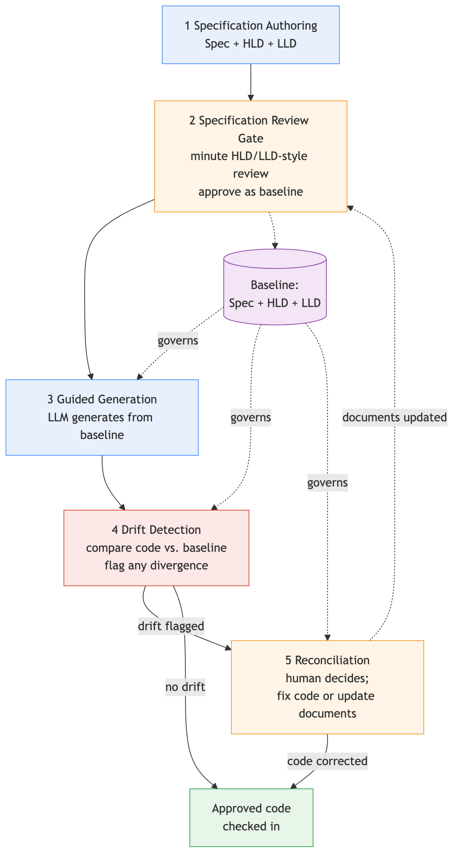
Fig. 1. Reference flow of the specification-driven governance framework. The approved specification, HLD, and LLD form the baseline (purple) that governs generation, drift detection, and reconciliation. A flagged drift routes to a human, who either corrects the code or updates the documents and re-approves the baseline.

C. The Specification Review Gate
The specification review gate is the centerpiece of the framework. It is where we move governance to the point where it helps most. Mature teams already run formal HLD and LLD reviews before they build, and these reviews catch design defects while they are still cheap to fix. We apply the same discipline to the specification that drives AI generation.
The gate works as follows. The team prepares the specification together with the HLD and the LLD. Reviewers then examine the documents closely, in the same way they review an HLD and an LLD today. They check the documents for completeness, for clear interfaces, for explicit constraints, and for testable behavior. They resolve ambiguity before generation, because ambiguity in the specification becomes a defect in the code. The gate approves the documents only when they are clear enough to act as a baseline.
This step shows a simple observation: large language models produce strong code when they get clear, reviewed instructions, much as a capable intern does well when given a precise brief and a playbook to follow. Prior work on constrained specifications reports lower defect rates relative to unconstrained generation [10], and our controlled studies in Section 4.5 find that the benefit depends on how the specification is supplied: a reviewed specification that governs a separate generation step helps, whereas a specification merely placed inside the prompt does not. This is why our review gate treats the specification as an approved, governing artifact rather than as prompt text, and why we review the full specification, not only its security constraints, so that the baseline governs functional behavior as well.

D. The Document-Versus-Code Drift Loop
A reviewed specification improves generation, but it does not guarantee that the generated code matches the baseline. Models still hallucinate objects, misuse interfaces, and introduce subtle logic errors [7], [8]. The framework therefore adds a drift loop that compares the code against the documents after generation.
The loop has three steps. First, we treat the approved specification, HLD, and LLD as the single reference baseline. Second, we review the generated code against this baseline and flag any drift. Drift is any divergence between the code and the agreed design. It includes a missing interface, an added behavior, a changed data contract, or a security control that the specification required but the code omitted. Third, we route each flagged drift to reconciliation.
This loop targets the failure that empirical studies repeatedly observe. Generated code often passes its tests while it diverges from intent [12], and security weaknesses reach production repositories when no baseline catches them [6]. By comparing code against an explicit baseline, the loop surfaces these divergences before the code ships.
Figure 2 shows the interaction between the participants in the loop.
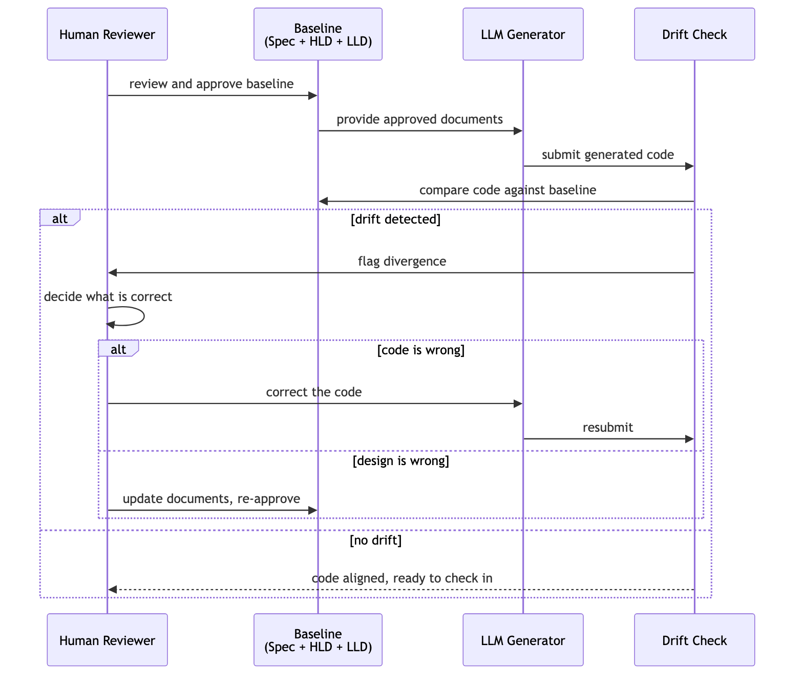
Fig. 2. Drift loop interaction. The approved baseline governs generation, the drift check compares code against the baseline, and the human reconciles each flagged drift by either correcting the code or updating the documents.

E. Human-in-the-Loop Reconciliation
Drift detection flags divergence, but it does not decide what is correct, so the framework reserves that judgment for a human. For each flagged drift, a reviewer makes the final call. Both the specification and the code can be wrong, and only a human can weigh the trade-off.
Reconciliation has two outcomes. When the specification is correct and the code diverges, the team corrects the code to match the baseline. When the code reveals a better design or a missing requirement, the team updates the documents and re-approves the baseline. Either way, the code and the design return to alignment, and the baseline stays the final word. This step keeps human effort focused on judgment rather than on volume, which keeps up speed while it protects correctness.

F. Risk Taxonomy
The framework targets specific failures, and we organize them in a risk taxonomy. Table I maps each failure mode to the governance gap it exploits and to the control point that addresses it. We derive the failure modes from the empirical studies in Section II [6], [7], [8]. We map them to lifecycle stages in the manner of Lyashkevych et al. [15].
TABLE I
RISK TAXONOMY MAPPING AI-CODE FAILURE MODES TO GOVERNANCE GAPS AND FRAMEWORK CONTROL POINTS.
Failure mode | Governance gap exploited | Framework control point
Specification ambiguity | No review of the input before generation | Specification review gate (3.3)
Hallucinated object or API [7], [8] | No baseline to compare generated code against | Drift detection (3.4)
Missing or weak security control [6] | Security intent absent from the reviewed baseline | Specification review gate (3.3) + drift detection (3.4)
Changed data contract or interface | No check that code matches the agreed design | Drift detection (3.4)
Behavioral drift across iterations [12] | No authoritative source of truth for intent | Reconciliation (3.5)
Unintended functional change during revision [13] | Automated fixes applied without human judgment | Human-in-the-loop reconciliation (3.5)
The taxonomy shows how the control points work together. The review gate removes ambiguity and encodes intent, drift detection catches divergence from that intent, and reconciliation resolves the divergence and keeps the baseline the final word. Each failure mode meets a control point designed to catch it. That is how the framework reduces production risk without slowing generation.

IV. EVALUATION
We validate the framework two ways. First, a case study walks the full workflow on a single scenario. It shows how each control point catches a real failure. The scenario is anonymized and illustrative, so for it we report observed behavior rather than statistical results. Second, three controlled studies (Section 4.5) probe the framework’s premise under held-out criteria across several models and task scales: whether the spec-first gain is specification or deliberation, whether the delivery mode of the specification matters, and what specification discipline costs in developer effort. The case study explains the mechanism; the controlled studies test where, and in what form, specification discipline actually helps.

A. Scenario and Method
The scenario is a premium-payment microservice for an insurance platform. The service accepts a premium payment, validates the policy, applies the payment to the policy balance, and emits a payment-confirmed event. We chose this scenario for two reasons. It reflects a regulated, high-stakes domain where correctness and auditability matter, and it follows a common microservices pattern that holds beyond insurance.
We apply the framework as a structured walkthrough. We author the specification, HLD, and LLD, we run them through the review gate, and we generate the service with a large language model. We then detect drift against the baseline and reconcile each flagged drift. We also generate the same service without the framework and compare the two outcomes. We measure the comparison by the defects that reach the candidate code and by the stage at which each defect is caught.

B. Applying the Framework
Specification authoring. The team writes three documents. The specification states the functional behavior, the payment states, and the audit requirements. The HLD defines the service boundaries, the upstream policy service, and the downstream event bus. The LLD defines the payment state machine, the data contracts, and the idempotency rule for repeated payment requests.
Specification review gate. Reviewers examine the documents closely, and they find two problems before any code exists. First, the specification leaves the behavior for a duplicate payment request ambiguous, because it does not state whether a repeated request applies the payment twice. Second, the LLD omits the audit field that the platform requires for every financial transaction. The reviewers resolve both problems. They add an explicit idempotency rule, and they add the audit field to the data contract. The gate then approves the documents as the baseline.
Figure 3 shows the approved payment state machine that the LLD defines.
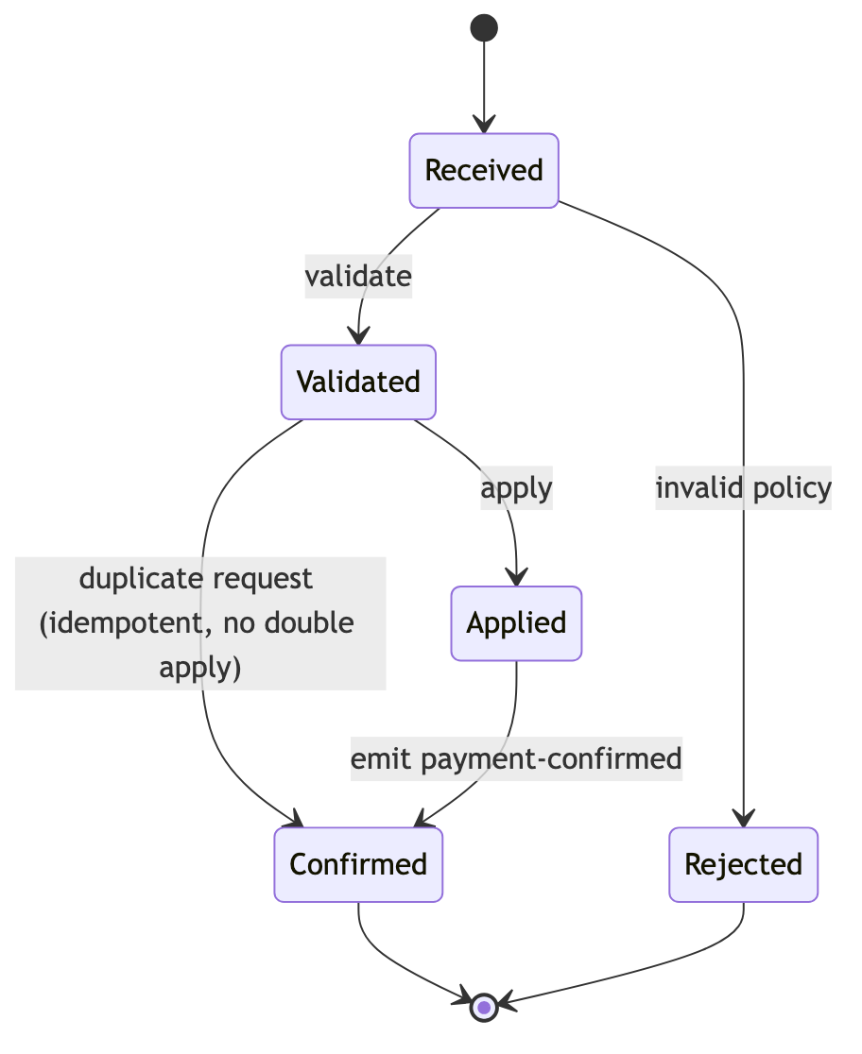
Fig. 3. Approved payment state machine from the LLD. The duplicate-request path (Validated to Confirmed) was added during the review gate to enforce idempotency and prevent a double apply.
Guided generation. The model generates the service from the approved documents. The clear specification gives the model a precise brief. The generated code follows the state machine and the data contracts for most of the behavior.
Drift detection. We compare the generated code against the baseline and flag two drifts. First, the code implements the happy path correctly but ignores the idempotency rule, so a repeated payment request applies the payment twice. This is a behavioral drift from the LLD. Second, the code writes the audit record but omits one required field from the data contract, which is a changed-contract drift. Both drifts pass the unit tests the model generated. The tests do not cover the duplicate-request case or the full audit contract. This matches the pattern that prior studies report, where generated code passes its tests while it diverges from intent [8], [12].
Reconciliation. A reviewer resolves each flagged drift. The specification is correct, and the code is wrong for the idempotency drift. The team corrects the code to satisfy the idempotency rule. The contract is correct, and the code is not complete for the audit-field drift. The reviewer confirms that the team then corrects the code to write the full audit record. The code and the baseline return to alignment, and the service is checked in.

C. Comparison Against Unconstrained Generation
We then generate the same service without the framework. We give the model a short, informal prompt that describes the service in two sentences, which reflects common practice. The unconstrained run produces working code quickly, but it carries the same two defects into the candidate code, and it adds a third. It applies duplicate payments, it omits the audit field, and it validates the policy with a weaker check that a reviewed specification would have caught. No baseline exists to compare against, so the defects survive until a human reads the code in detail.
Table II summarizes the comparison. The framework catches the ambiguity and the missing audit field at the review gate, before generation. It then catches the idempotency and audit drifts at drift detection, before check-in. The unconstrained run catches nothing until late code review. It relies on a reviewer noticing defects in code that already passes its tests.
TABLE II
DEFECT HANDLING WITH AND WITHOUT THE FRAMEWORK.
Defect | Without framework | With framework | Caught at
Duplicate-payment ambiguity | Reaches code as a double-apply bug | Resolved in the specification | Review gate (pre-generation)
Missing audit field | Reaches code, passes tests | Added to the contract, enforced | Review gate + drift detection
Idempotency not implemented | Survives to late review | Flagged and corrected | Drift detection (pre-check-in)
Weak policy validation | Survives to late review | Prevented by reviewed specification | Review gate (pre-generation)

D. Observations
The case study supports three observations. First, the review gate moves defect discovery earlier, where defects are cheaper to fix. The framework catches the ambiguity and the missing field before any code exists. Second, the drift loop catches divergence that tests miss, because it compares code against intent rather than against itself. The idempotency and audit drifts pass the generated tests, yet the baseline comparison surfaces them. Third, the framework keeps up speed, because generation runs freely once the documents are approved, and the human spends effort only on the flagged drifts.
Figure 4 makes the first observation concrete. It shows where each defect is caught along the lifecycle, with and without the framework. The framework shifts every defect left, away from late code review and toward the specification stage.
Fig. 4. Defect-catch comparison. Without the framework, all defects survive to late code review. With the framework, the review gate and drift detection catch every defect before check-in, which shifts discovery left. The audit-field defect appears in both framework stages because the review gate adds it to the contract and drift detection confirms its presence in the code.
These observations align with the framework’s design goals, and they show the governance loop working end to end. We treat them as illustrative rather than conclusive, and we discuss the limits of this evidence in Section VI.

E. Controlled Studies: What Specification Discipline Actually Buys
The case study shows where defects are caught in one scenario. We now ask sharper, falsifiable questions across many generations, and we report what the evidence supports rather than the strongest story we could tell. Three questions structure the studies. First, when a specification-first prompt improves generated code, is the gain due to specification or merely to deliberation? Second, does the way a specification is delivered to the model matter? Third, what does specification discipline cost or save in developer effort? We treat all results as preliminary: the effects below are consistent and directional, but most are not statistically significant at our sample sizes, and they depend on the model and the task. We publish every harness, generation, per-case log, and analysis script so the results can be reproduced and re-scored.
All studies use a held-out design that avoids circularity: the specific quality criteria we score appear in no prompt, so a spec-driven or reasoning prompt cannot copy the answer. A deterministic or executable checker then scores each generation, and we validate every checker against a known-correct reference (full score) and a known-naive reference (partial score) before running any model. We isolate each generation in its own workspace and account for the package layout the model chooses, so we measure behavior rather than incidental structure.
Study A — specification versus deliberation. A spec-first prompt differs from a plain prompt in two ways at once: it asks for a specification and it induces more reasoning before code. To separate these, we add a third arm. The direct arm (A0) asks only for code. The chain-of-thought arm (A2) asks the model to reason about edge cases first, but to write no specification. The spec-first arm (A1) asks for a short specification, then an implementation. We run ten generic task families with five samples per arm, on two strong assistants (Claude Opus 4.8 and GPT-5.4, 50 generations per arm per model), and score two held-out robustness criteria per family. We analyze at the task-family level (n = 10) with paired tests to avoid treating clustered samples as independent. The result is consistent across both models: chain-of-thought captures almost all of the gain, and writing a specification adds little beyond it. On Claude Opus the arms moved from 59% (direct) to 95% (chain-of-thought) to 92% (spec-first); on GPT-5.4 from 47% to 99% to 100%. The spec-versus-chain-of-thought difference was not significant on either model (paired Wilcoxon over ten families, p ≈ 0.28 and p ≈ 0.32). The lesson is cautionary and important: a large apparent benefit of “specifying first” is largely a deliberation effect. Claims that specification prompting dramatically improves code quality should control for reasoning, or they overstate the role of the specification.
Study B — specification delivery mode. If a spec-as-prompt is not the active ingredient, perhaps the form of the specification is. Our framework does not inline a specification into a single generation; it treats the specification as a separate, reviewed artifact that governs a distinct generation step. We tested this on one larger task with headroom for the contrast: an in-memory banking service with twenty interacting invariants (overdraft protection, transfer atomicity, idempotency, audit completeness, type-checked interest, daily limits, statement integrity, and lifecycle rules), scored by a hidden executable suite, on two models (DeepSeek-V4-flash and North-Mini-code) with four samples per arm. Three arms shared the same task: direct generation; a one-shot arm that asked for “a specification, then code” in a single prompt; and a staged arm that first authored a specification document and then, in a fresh generation, implemented strictly from that document. On the stronger model all three arms reached near-complete correctness, so the task had no headroom to separate them, though the staged arm produced markedly richer and better-decomposed code. On the weaker model with headroom the contrast was sharp: the one-shot spec arm was indistinguishable from direct generation (both 23.8%), while the staged arm nearly doubled the pass rate, to 45.0%, and halved the rate of builds that failed to assemble. The one-shot result is the key control: asking for a specification inside the prompt added nothing; treating the specification as a separate governing artifact that a distinct step executes is what helped. This pattern is the framework’s mechanism in miniature. Two honest caveats bound the claim. First, the effect is a strong trend rather than a significant result at this sample size (paired Wilcoxon, p ≈ 0.18) on a single task, so it is case-level evidence, not a general estimate. Second, the staged arm runs the model twice while the one-shot arm runs it once, so part of the gain may come from a second pass rather than from the specification’s governing role; isolating these with a two-pass control that carries no specification is necessary follow-up work. The effect is largest where it should be: when the model is weak enough to need the scaffolding.
Study C — effort and reliability under growing complexity. Finally we asked what specification discipline costs in practice. We built one large, edge-case-heavy feature (an employee payroll pipeline with twenty-six validation and calculation invariants spanning null, empty, non-numeric, negative, boundary, and partial-failure cases) two ways on two free-tier models (Mimo-v2.5 and North-Mini-code, three samples per arm): by iterative “vibe coding” across five prompts with no specification, and by authoring a specification and implementing from it. We instrumented developer effort directly — the number of turns and the wall-clock time — and the error rate against the hidden suite. One result is consistent: the specification approach reached the same outcome in far less effort, two turns versus five and roughly half the wall-clock time on both models. The reliability picture, however, is honest and unflattering to both approaches. On these free-tier models neither approach was usable: both were unstable, each producing occasional catastrophic builds, and average error rates were similar and high (roughly 37–53% of invariants unmet). We therefore do not claim that specification discipline improves reliability here; the “same outcome” the two approaches share is “comparably unreliable,” and on free-tier models the dominant source of failure is the model itself, which swamps any approach effect. The defensible reading of Study C is narrow and about effort alone: when two approaches reach the same (here, poor) result, the specification path reached it in fewer turns and less time. Establishing a reliability difference would require stronger models, where the floor is not model flakiness, and more than one task.
What the studies establish, and what they do not. Taken together the evidence supports three claims and refutes a fourth. It supports that the delivery mode of a specification matters more than its mere presence (Study B); that specification discipline reaches the same outcome with less developer effort than iterative prompting (Study C); and that naive “specify first” gains are largely a deliberation effect that must be controlled for (Study A). It does not support a claim that specification prompting dramatically raises code quality on its own, nor that it improves reliability on weak models — in Study C both approaches were comparably unreliable. The delivery-mode and effort findings come from a single task each and are case-level evidence. We regard the framework’s premise — that a reviewed specification governing generation improves AI-assisted engineering — as supported in a specific and bounded form, and we are explicit about the boundaries. Section VI states the matching threats to validity.
TABLE III
SUMMARY OF THE THREE CONTROLLED STUDIES. EACH USES HELD-OUT CRITERIA SCORED BY A VALIDATED CHECKER. EFFECTS ARE DIRECTIONAL; EXCEPT WHERE NOTED THEY ARE NOT STATISTICALLY SIGNIFICANT AT THE STATED SAMPLE SIZES. STUDIES B AND C USE A SINGLE TASK EACH AND ARE CASE-LEVEL EVIDENCE.
Study | Scope (models × tasks × samples) | Arms | Key result | Reading
A. Deliberation vs. specification | 2 models × 10 task families × 5 samples | direct / chain-of-thought / spec-first | Chain-of-thought captured almost all of the gain; spec-first ≈ chain-of-thought (paired Wilcoxon over 10 families, p ≈ 0.28, 0.32) | Naive “specify-first” gains are largely a deliberation effect
B. Delivery mode | 2 models × 1 task × 4 samples | direct / spec one-shot / spec staged | One-shot ≈ direct (both 23.8%); staged 45.0% on the weak model (p ≈ 0.18); confounded by a second pass | The specification governing a separate step helps more than spec-as-prompt, on this task
C. Effort & reliability | 2 models × 1 task × 3 samples | iterative vibe coding / spec-driven | Spec reached the same (poor) outcome in ~2 vs 5 turns and ~half the time; both approaches unreliable | Spec discipline is more effort-efficient at equal outcomes; no reliability claim
When the benefit is largest: an interaction, not a single trend. Reading the studies together on two axes — task complexity and model strength — shows that specification discipline does not help uniformly; its payoff concentrates where two conditions hold at once. The first is headroom: a model must be far enough from perfect that structure can move the outcome. On the complex banking task (Study B), the same specification discipline that gave the weaker model a large lift (direct 23.8% to staged 45.0%, +21 points) gave the stronger model almost nothing (98% to 100%, +2 points), because the stronger model already solved the task and left no room to improve. The second is complexity that rewards structure: on toy single-function tasks (Study A) even a large apparent lift is mostly a deliberation effect, because there is little cross-cutting structure for a specification to organize. The benefit that is genuinely attributable to specification appears in the intersection — a task complex enough that many interacting constraints must be held consistent, generated by a model weak enough to need the scaffolding. Table IV lays this out. The practical implication is not “always specify” but a targeting rule: specification discipline pays most for hard, multi-constraint work built by capable-but-imperfect models, and least for either trivial work or models that already saturate the task.
TABLE IV
SPECIFICATION ADVANTAGE (SPEC ARM MINUS DIRECT ARM, IN POINTS OF HELD-OUT CRITERIA MET) ACROSS TASK COMPLEXITY AND MODEL STRENGTH. THE ADVANTAGE IS LARGEST AT THE INTERSECTION OF HIGH COMPLEXITY AND A MODEL WITH HEADROOM; STRONG MODELS SATURATE AND SHOW LITTLE ADVANTAGE, AND ON TOY TASKS THE APPARENT ADVANTAGE IS LARGELY DELIBERATION RATHER THAN SPECIFICATION.
 | Strong model (saturates) | Weaker model (has headroom)
Toy task (1 function, 2 criteria) | +33 to +53 pts, but mostly a deliberation effect (Study A) | not measured
Complex task (20–26 interacting invariants, multi-file) | +2 pts — no headroom (Study B) | +21 pts — the specification-attributable benefit (Study B)

V. DISCUSSION
This section explains the framework’s value, states where it applies, and lays out future work. We address both the research community and practitioners, because the framework speaks to both.

A. Implications
The framework reframes where governance belongs in AI-assisted development. Most current practice reviews the model output, and that practice grows costly as code volume rises [6], [16]. We move the heavy review to the specification, where one review shapes all the code that follows. This shift turns governance from a per-output cost into a per-specification cost. That cost scales far better as teams generate more code.
The framework also reframes the role of the human. We do not ask the human to read every line the model writes. We ask the human to review the specification once and then to judge only the drifts that the document-versus-code comparison flags. This division of labor matches the strengths of each party. The model generates at scale, the comparison against the baseline surfaces divergence, and the human supplies judgment. In this paper that comparison is performed by human review against the baseline rather than by an automated tool; automating it is future work (Section 5.3). The result keeps people focused on decisions rather than on volume.
For researchers, the framework offers a concrete, testable governance loop. Prior work argues that specification discipline is the binding constraint on AI-assisted dependability [3]. Our framework puts that argument into practice with a review gate, a drift check, and a reconciliation step. Researchers can measure each control point, and they can compare it against alternatives. For practitioners, the framework offers an adoption path that fits existing process. Teams that already run HLD and LLD reviews can extend those reviews to the specification with little new overhead, which lowers the barrier to adoption.

B. When the Framework Applies
The framework is not free, and it does not fit every project. The review gate adds upfront effort, and that effort pays off only when correctness matters enough to justify it. The framework suits regulated, high-stakes, or long-lived systems, where defects are costly and intent must stay clear over time. Our insurance scenario is a natural fit, and similar domains such as finance and healthcare share the same need.
The framework fits less well for exploratory or throwaway work. A prototype that no one will maintain does not justify a full specification review, and a small script gains little from a drift loop. This aligns with our empirical targeting rule (Table IV): the specification-attributable benefit was largest for complex, multi-constraint work generated by a capable-but-imperfect model, and smallest for trivial tasks or for models that already saturate the task. Teams whose assistant reliably one-shots the work in question will see little quality lift, though they may still gain the effort savings of Study C; the quality case for the framework is strongest exactly where the work is hard enough that many constraints must stay consistent. We also assume that the team can write a clear specification, HLD, and LLD. Teams that lack this practice must build it first, which is a real cost. The framework therefore complements, rather than replaces, the workflow-centric tooling that targets faster, lighter generation [18]. Teams should match the level of governance to the stakes and the complexity of the work.

C. Future Work
Two directions follow from this work. The first direction extends the specification beyond build time. In this paper the specification governs the code up to check-in, and the baseline returns the code and the design to alignment. A natural next step makes the specification the durable source of truth after check-in as well. Under this model, every later change starts from the specification. The framework then keeps intent and implementation aligned during migration, deprecation, and other maintenance tasks across the software development lifecycle. This direction needs evidence that a single paper cannot supply. It requires observing a system as it evolves over time. We leave it to future work and to a follow-on study, and we expect it to strengthen the case for specifications as long-lived governance artifacts.
The second direction concerns automation and measurement. Our drift detection relies on human review against the baseline. Future work can automate parts of that comparison, for example by checking generated code against the data contracts and the state machine in the LLD. Our controlled studies measure a handful of held-out criteria per task on free and frontier models, where strong models saturate and weak models are unstable. Future work can broaden them to richer defect sets, paid mid-strength models with many samples per condition to reach statistical significance, multiple task families, and metrics such as review effort and delivery time across many projects. Such studies would move the strongest of our effects from directional trends to established results and would test the framework against the alternatives we surveyed in Section II.

VI. THREATS TO VALIDITY
We report the threats to validity that affect our results, and we group them as construct, internal, and external threats.

A. Construct Validity
Construct validity concerns whether our studies measure what we claim. For the case study, we measure governance value by the defects that reach the candidate code and by the stage at which each defect is caught. For the controlled studies, we measure adherence with held-out criteria scored either by pattern matching (Study A) or by executable acceptance tests (Studies B and C); the executable tests are a stronger construct, and we validated every checker against a known-correct reference (full score) and a known-naive reference (partial score) before running any model. We also corrected a scoring defect during development — an import-isolation bug that under-counted generated packages using lazy submodule imports — and re-scored the affected studies, which left the headline results unchanged. Pattern matching remains a conservative proxy that can miss a correct implementation written in an unusual form, and none of our checkers capture every dimension of code quality, such as long-term maintainability, which a fuller construct would include in the manner of the ISO/IEC 25010 model [12]. For Study C we measure developer effort directly as turns and wall-clock time, which addresses the velocity question more concretely than the case study alone, though it does so on a single feature.

B. Internal Validity
Internal validity concerns whether the framework, rather than some other factor, produced the observed outcome. The case study is a structured walkthrough that we conducted, so author bias is a real threat. We may have framed the specification or the prompt in ways that favored the framework. The controlled studies reduce this threat, because the scored criteria appear in no prompt and the scoring is automated, so we could not tune a prompt toward the checks we score. Study A is designed precisely to remove a confound that would otherwise inflate the framework’s case: by adding a chain-of-thought arm we show that most of the naive spec-first gain is a reasoning effect rather than a specification effect, and we report that finding even though it weakens a simple pro-specification narrative. Study B’s one-shot arm is a similar internal control: it isolates the delivery mode of the specification from its mere presence. For the case study, however, we did not remove the bias threat, because a single self-conducted walkthrough cannot rule out bias on its own.

C. External Validity
External validity concerns whether our results generalize. Our evidence has several parts with different reach. The case study examines one scenario in one domain, so we do not claim that its qualitative narrative transfers to all projects. The controlled studies span single-function tasks, a twenty-invariant service, and a twenty-six-invariant edge-case-heavy feature, across both frontier and free-tier models, which broadens the evidence beyond a single task and a single model. The studies still share important limits. Sample sizes are small, so most effects are directional trends rather than statistically significant results; the clearest exception is the consistency of the deliberation effect across two models in Study A. Model strength is the dominant confound: strong models saturate our tasks and leave no headroom, while free-tier models are unstable, so the band in which an approach effect is cleanly measurable is narrow. This same confound bounds the complexity-by-strength reading in Table IV: that interaction is inferred by comparing across studies that differ in both task and model at once, not from a single controlled sweep that varies complexity and strength independently. We present it as an organizing hypothesis consistent with our data, not as an established law; a dedicated experiment that holds the model fixed and scales task complexity, and vice versa, is needed to confirm it. The studies also test lightweight and staged forms of specification discipline rather than the full review gate with human reviewers that the framework describes. We therefore treat the combined evidence as support for the framework’s premise in a specific and bounded form — that a specification governing a separate generation step helps, and that it does so most where the model needs scaffolding — rather than as proof of a fixed effect size. Only broader studies, with more domains, paid mid-strength models, many samples, and a faithful implementation of the full review gate, can establish general claims.

VII. CONCLUSION
AI coding assistants have made code abundant, and they have made verification the new bottleneck. This shift creates a governance gap, and that gap lets security defects, functional bugs, and behavioral drift reach production. We proposed a specification-driven governance framework that closes the gap by treating the specification as the governance artifact. The framework adds a specification review gate that mirrors the HLD and LLD reviews teams already trust, and it reviews the input before it audits the output. It then compares generated code against the approved specification, HLD, and LLD, flags any drift, and routes each drift to a human who reconciles the code with the design.
We organized the framework around five control points. We also connected known AI-code failure modes to the gaps they exploit through a risk taxonomy. A case study on an insurance premium-payment service showed the governance loop working end to end. The review gate caught ambiguity and a missing audit field before any code existed, the drift loop caught divergence that the generated tests missed, and the framework focused human effort on the flagged drifts. Three controlled studies then tested the framework’s premise under held-out criteria. They show, as case-level evidence on a single complex task, that the way a specification is delivered matters more than its presence: a specification that governs a separate generation step roughly doubled a weak model’s pass rate, while the same specification placed inside a prompt added nothing over direct generation. They show that specification discipline reaches the same outcome with about half the developer effort of iterative prompting. And they show, as an honest control, that the large apparent gains of “specify-first” prompting are largely a reasoning effect rather than a specification effect. We report these results as preliminary and directional — small samples, single tasks for two of the three studies, and trends rather than significant effects — and we are clear about where they hold and where they do not. We look forward to extending this evidence with paid mid-strength models, larger samples, multiple tasks, and a faithful implementation of the full review gate.
The broader message is simple. Specification discipline, not model capability, governs the dependability of AI-assisted software. When we review clear specifications and hold code accountable to them, we gain control without giving up speed. Future work will extend the specification into a long-lived source of truth and will automate the drift checks. We expect both steps to deepen the value of governing AI-assisted engineering at the specification.

REFERENCES
[1] M. Alenezi and M. Akour, “AI-Driven Innovations in Software Engineering: A Review of Current Practices and Future Directions,” Applied Sciences, vol. 15, no. 3, p. 1344, 2025.
[2] V. D. Kirova, C. S. Ku, J. R. Laracy, and T. J. Marlowe, “Software Engineering Education Must Adapt and Evolve for an LLM Environment,” in Proc. 55th ACM Tech. Symp. Computer Science Education (SIGCSE), 2024, doi: 10.1145/3626252.3630927.
[3] S. E. Farrag, “The Productivity-Reliability Paradox: Specification-Driven Governance for AI-Augmented Software Development,” arXiv preprint arXiv:2605.01160, 2026.
[4] R. Li, R. Mo, Y. Zeng, Z. Liu, Z. Li, and Y. Ma, “A Multi-Dimensional Quality Evaluation of Code Generated by LLM-Based Tools Across Multiple Programming Languages,” ACM Trans. Software Engineering and Methodology, 2026, doi: 10.1145/3800582.
[5] M. F. Kharma, S. Choi, M. Alkhanafseh, and D. Mohaisen, “Security and Quality in LLM-Generated Code: A Multi-Language, Multi-Model Analysis,” IEEE Trans. Dependable and Secure Computing, 2026.
[6] Y. Fu, P. Liang, A. Tahir, Z. Li, M. Shahin, and J. Yu, “Security Weaknesses of Copilot-Generated Code in GitHub Projects: An Empirical Study,” ACM Trans. Software Engineering and Methodology, 2025, doi: 10.1145/3716848.
[7] F. Tambon, A. Moradi-Dakhel, A. Nikanjam, F. Khomh, M. C. Desmarais, and G. Antoniol, “Bugs in Large Language Models Generated Code: An Empirical Study,” Empirical Software Engineering, vol. 30, 2025, doi: 10.1007/s10664-025-10614-4.
[8] Z. Zhang, C. Wang, Y. Wang, E. Shi, and Y. Ma, “LLM Hallucinations in Practical Code Generation: Phenomena, Mechanism, and Mitigation,” Proc. ACM on Software Engineering, 2025, doi: 10.1145/3728894.
[9] D. B. Piskala, “Spec-Driven Development: From Code to Contract in the Age of AI Coding Assistants,” arXiv preprint arXiv:2602.00180, 2026.
[10] S. R. Marri, “Constitutional Spec-Driven Development: Enforcing Security by Construction in AI-Assisted Code Generation,” arXiv preprint arXiv:2602.02584, 2026.
[11] A. Santa Molison, M. Moraes, G. Melo, and F. Santos, “Is LLM-Generated Code More Maintainable and Reliable Than Human-Written Code?,” in Proc. ACM/IEEE Int. Symp. Empirical Software Engineering and Measurement (ESEM), 2025.
[12] X. Sun, D. Ståhl, K. Sandahl, and C. Kessler, “Quality Assurance of LLM-Generated Code: Addressing Non-Functional Quality Characteristics,” arXiv preprint arXiv:2511.10271, 2025.
[13] N. Wadhwa, J. Pradhan, A. Sonwane, S. P. Sahu, N. Natarajan, A. Kanade, and S. Parthasarathy, “CORE: Resolving Code Quality Issues Using LLMs,” Proc. ACM on Software Engineering, vol. 1, no. FSE, 2024, doi: 10.1145/3643762.
[14] S. K. Navneet and J. Chandra, “Rethinking Autonomy: Preventing Failures in AI-Driven Software Engineering,” arXiv preprint arXiv:2508.11824, 2025.
[15] M. Y. Lyashkevych, V. Y. Lyashkevych, and R. Y. Shuvar, “Security and Other Risks Related to LLM-Based Software Development,” Ukrainian Journal of Information Technology, vol. 7, no. 1, 2025.
[16] I. Taldenko, “Human-in-the-Loop Governance for LLM-Generated Code: An Engineering Control, Accountability, and Verification Model in AI-Augmented Software Development,” EJSMT, 2026.
[17] M. Alenezi, “Rethinking Software Engineering for Agentic AI Systems,” arXiv preprint arXiv:2604.10599, 2026.
[18] V. Sonkin and C. Tudose, “Beyond Snippet Assistance: A Workflow-Centric Framework for End-to-End AI-Driven Code Generation,” Computers, vol. 14, no. 3, p. 94, 2025.

