Project Report on

Title of the Project

Database Management Systems (UEC716)

Submitted by:

(102315071) Ananya
(102315253) Archit Aggarwal
(102315254) Ashmit Cajla
(102315239) Ayush Singh
(102315259) Nitin Garg

Submitted to:

Dr. Shashikant



Department of Electronics and Communication Engineering TIET, Patiala
July - Dec 2025

Page 1 of 45

INDEX

S. No. |  | Content |  | Page. No.
01. | Introduction |  | 3 | - 4
02. | ER-Diagram |  | 5 | - 10
03. | ER to Table |  | 11-13
04. | Normalization |  | 14-16
05. | SQL & PL/SQL |  | 17-44
06. | Conclusion |  | 45

Page 2 of 45

1. Introduction

With the growing popularity of shared mobility services and the increasing demand for sustainable urban transportation solutions, the development of an efficient, user-friendly, and secure Bike Rental System has become more essential than ever. The rapid urbanisation in cities across the globe has led to congestion, pollution, and transportation inefficiencies, prompting the need for alternative mobility options. This project aims to address these challenges by offering a robust digital solution that enables users to conveniently locate, reserve, and rent bikes through an integrated online platform.

The Bike Rental System is designed to streamline the process of renting bikes for a wide range of users, including urban commuters seeking eco-friendly alternatives to traditional vehicles, tourists exploring cities at their own pace, and delivery riders in need of reliable short-term transport. Through a responsive and intuitive interface, users can register an account, browse available bikes based on location, check real-time availability, select rental durations, and complete secure payments using various methods such as credit/debit cards, digital wallets, or UPI.

In addition to the user-facing features, the system provides a comprehensive administrative panel that empowers system managers to monitor and control operations efficiently. Admins have access to functionalities such as inventory management, booking oversight, user management, system analytics, and maintenance scheduling. This dual-layered approach ensures a balanced experience for both users and system operators.

Technically, the system’s backend is structured around a relational database model, utilizing a detailed Entity-Relationship (ER) diagram to represent and manage core entities such as Users, Bikes, Bookings, Locations, Payments, and Admins. This architecture ensures scalability, consistency, and ease of maintenance, making it suitable for deployment in both small-scale communities and large urban environments. Furthermore, the modular design facilitates future enhancements, such as integration with GPS tracking, mobile app support, or dynamic pricing models.

Ultimately, the Bike Rental System not only enhances urban mobility but also contributes to broader goals such as reducing traffic congestion, minimising carbon footprints, and promoting healthier, more active lifestyles. By digitising and

Page 3 of 45

automating the rental process, this system paves the way for a smarter and more sustainable future in urban transportation.

Project Resource Requirements:

A database is an application that stores the organised collection of records. It can be accessed and manage by the user very easily. Today, many databases available like MySQL, Sybase , Oracle, MongoDB, PostgreSQL, SQL Server, etc. We used MySQL server for managing data.

MySQL is a relational database management system based on the Structured Query Language, which is the popular language for accessing and managing the records in the database. MySQL is open-source and free software under the GNU license. It is supported by Oracle Company. MySQL is a widely used relational database management system (RDBMS). It is free and open-source. MySQL is ideal for both small and large applications.

MySQL follows the working of Client-Server Architecture. This model is designed for the end-users called clients to access the resources from a central computer known as a server using network services. Here, the clients make requests through a graphical user interface (GUI), and the server will give the desired output as soon as the instructions are matched. The process of MySQL environment is the same as the client-server model.

MySQL is a very powerful program that can handle a large set of functionality of the most expensive and powerful database packages. It supports large databases, up to 50 million rows or more in a table. The default file size limit for a table is 4GB, but you can increase this (if your operating system can handle it) to a theoretical limit of 8 million terabytes (TB).

Page 4 of 45

2. ER-DIAGRAM
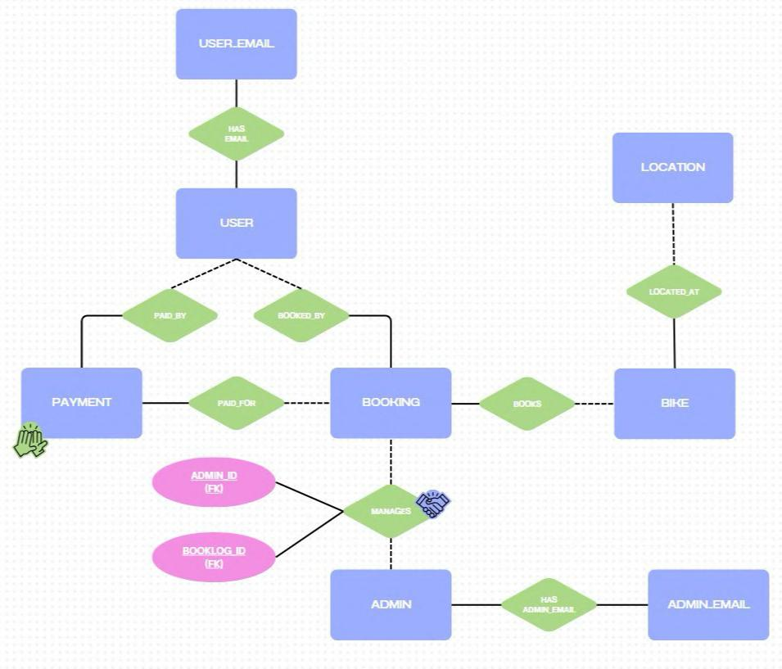

Page 5 of 45

1. USER

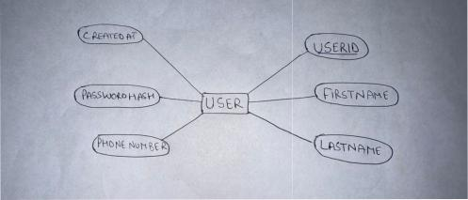

2. USER_EMAIL

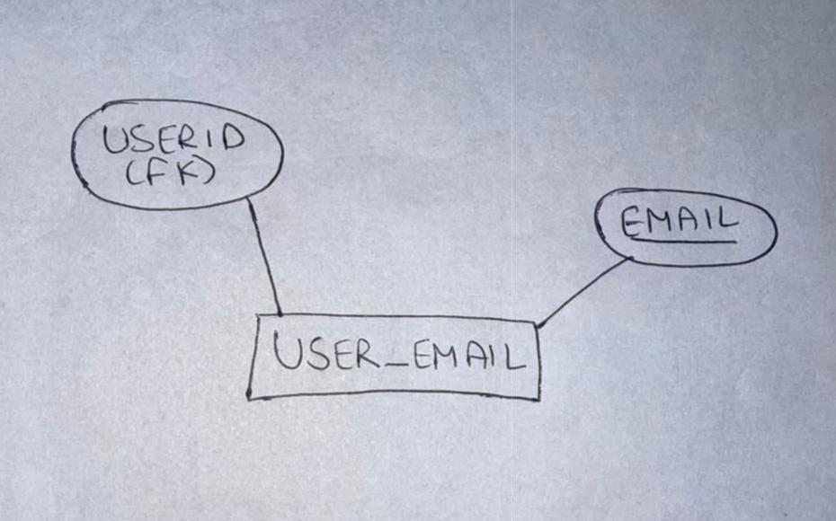

Page 6 of 45

3. BIKE

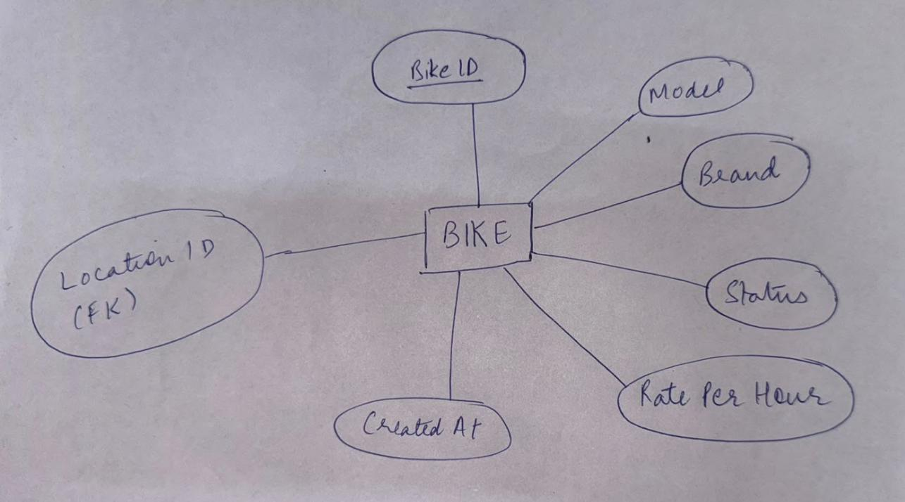

4. LOCATION

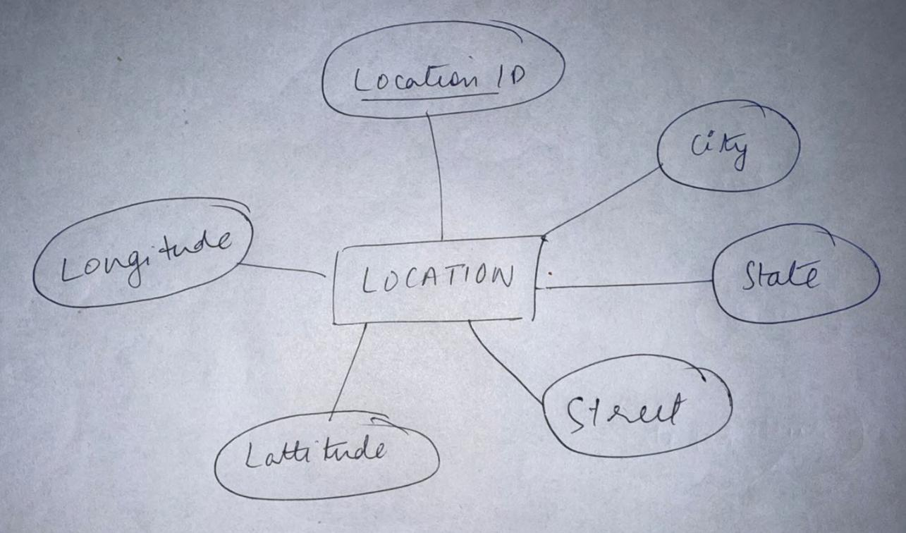

Page 7 of 45

5. BOOKING

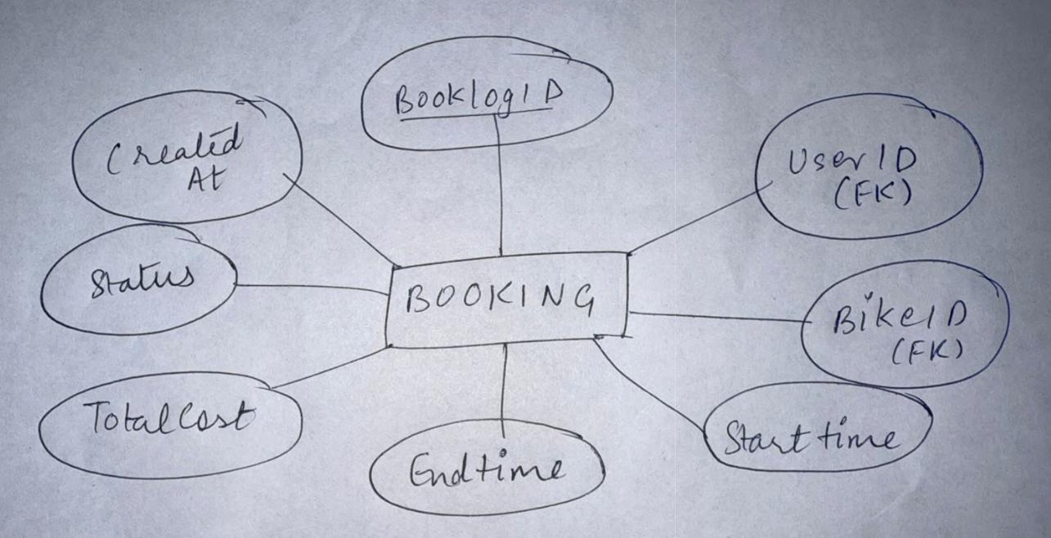

6. PAYMENT

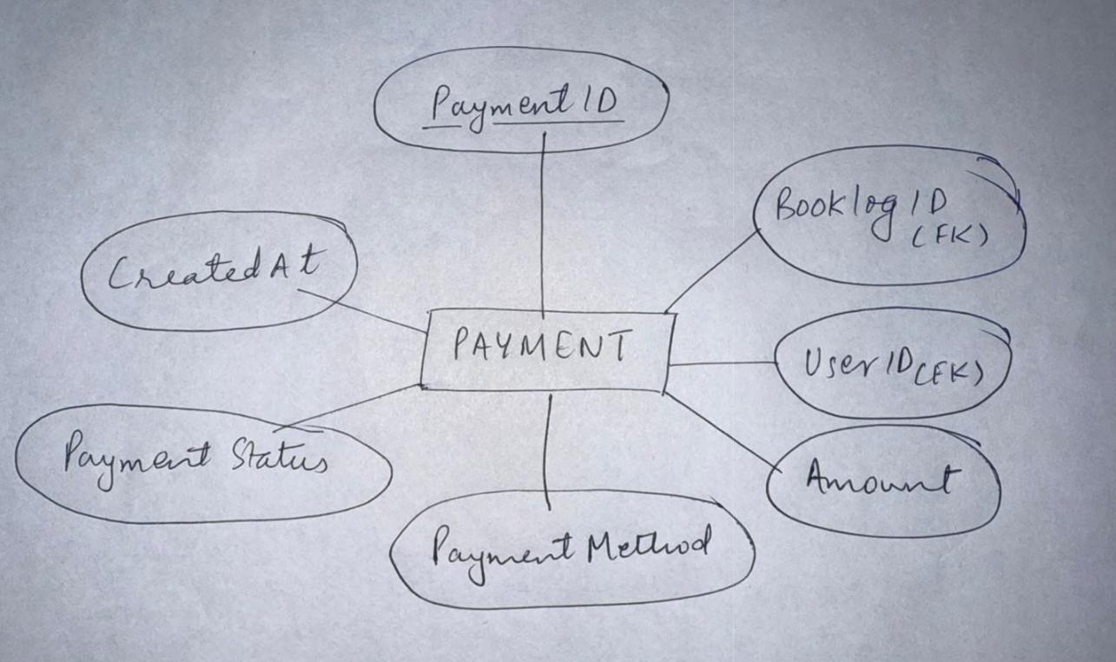

Page 8 of 45

7. ADMIN

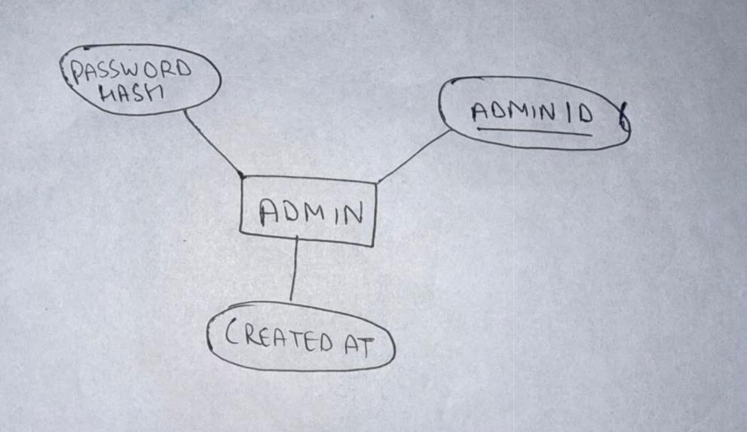

8. ADMIN_EMAIL

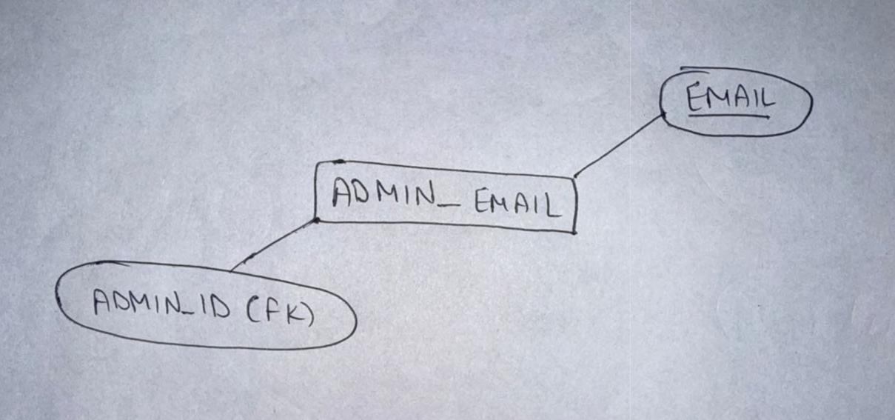

Page 9 of 45

9. MANAGES (Junction Table)

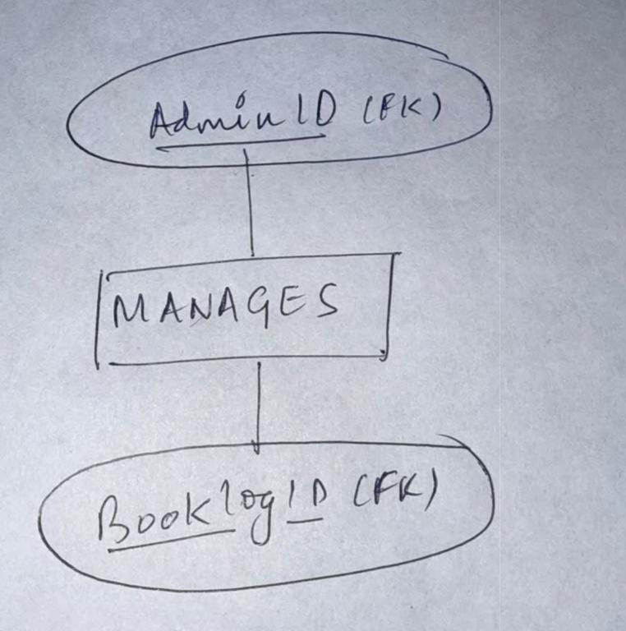

Page 10 of 45

ER ANALYSIS

Identifying Entity Sets and Relationship Sets:

Entity Sets:

1. ADMIN:

AdminID (PK, INT, Auto-Increment)
Email (VARCHAR, UNIQUE)
PasswordHash (VARCHAR, 255)
CreatedAt (DATETIME)

2. USER

UserID (PK, INT, Auto-Increment)
FirstName (VARCHAR, 50)
LastName (VARCHAR, 50)
Email (VARCHAR, UNIQUE)
PhoneNumber (VARCHAR, 20)
PasswordHash (VARCHAR, 255)
CreatedAt (DATETIME)

3. BIKE

BikeID (PK, INT, Auto-Increment)
Model (VARCHAR, 50)
Brand (VARCHAR, 50)
Status (ENUM: "Available", "Rented", “Maintenance")
LocationID (FK to LOCATION)
RatePerHour (DECIMAL, 5.2)
CreatedAt (DATETIME)

4. LOCATION

LocationID (PK, INT, Auto-Increment)
City (VARCHAR, 50)
State (VARCHAR, 50)
Street (VARCHAR, 100)
Latitude (DECIMAL, 10, 8)
Longitude (DECIMAL, 10, 8)

Page 11 of 45

5. BOOKING
BooklogID (PK, INT, Auto-Increment)
UserID (FK to USER)
BikeID (FK to BIKE)
StartTime (DATETIME)
EndTime (DATETIME)
TotalCost (DECIMAL, 6.2)
Status (VARCHAR, e.g., "Confirmed", “Cancelled")
CreatedAt (DATETIME)

6. PAYMENT
PaymentID (PK, INT, Auto-Increment)
BooklogID (FK to BOOKING)
UserID (FK to USER)
Amount (DECIMAL, 6.2)
PaymentMethod (ENUM: "Cash", "Wallet", “Card")

PaymentStatus (ENUM: "Pending", "Processing", "Failed", “Completed")

CreatedAt (DATETIME)

Relationship Sets

- 1. MANAGES

  - Admin (0,1) ↔ Booking (1,N)

  - An admin can manage multiple bookings, but a booking is managed by at most one admin (optional).

- 2. BOOKS

  - User (1,N) ↔ Booking (1,1)

  - A user can create multiple bookings, but each booking is made by exactly one user.
- 3 . ASSIGNED_TO (between BIKE and BOOKING)

  - Bike (1,1) ↔ Booking (0,N)

  - A bike can be booked multiple times (or not at all), but each booking is for exactly one bike.
- 4. LOCATED_AT

  - Bike (0,N) ↔ Location (1,1)

  - A bike is assigned to exactly one location, and a location can have multiple bikes (or none).
- 5. PAYS_FOR

  - Booking (1,1) ↔ Payment (1,N)

  - A booking can have multiple payments (e.g., installments), but each payment is tied to one booking.
- 6. MAKES_PAYMENT

  - User (1,1) ↔ Payment (0,N)

  - A user can make multiple payments, but each payment is made by one user.

Page 12 of 45

7. Conversion of ER to Tables

1.1. USER

1.UserID → {FirstName, LastName, Email, PhoneNumber,
_{2.}PasswordHash, CreatedAt}
2.2. BIKE

1.BikeID → {Model, Brand, Status, LocationID, RatePerHour,
_{2.}CreatedAt}
3.3. LOCATION
◦ LocationID → {City, State, Street, Latitude, Longitude}
4.4. BOOKI◦NG

- BooklogID → {UserID, BikeID, StartTime, EndTime, TotalCost, Status,

- CreatedAt}

5.5. PAYMENT

- PaymentID → {BooklogID, UserID, Amount, PaymentMethod,

- PaymentStatus, CreatedAt}

6.6. ADMIN
◦ AdminID → {Email, PasswordHash, CreatedAt}
7.
7. MANAGES (Admin-Booking Relationship)

- AdminID → BooklogID

Page 13 of 45

NORMALISATION

Introduction

The database for the Bike Rental Management System is designed to handle users, bikes, bookings, payments, locations, and admin activities efficiently. Normalization ensures minimal redundancy, data integrity, and optimized performance. This report documents the normalization process from UNF → 1NF → 2NF → 3NF → BCNF.

First Normal Form (1NF)

Transformation Actions

- Ensure atomic attributes (no repeating groups).

- Assign primary keys for uniqueness.

Normalized Tables

- USER (UserID, FirstName, LastName, Email, PhoneNumber, PasswordHash, CreatedAt)

- BIKE (BikeID, Model, Brand, Status, LocationID, RatePerHour, CreatedAt)

- LOCATION (LocationID, City, State, Street, Latitude, Longitude)

- BOOKING (BooklogID, UserID, BikeID, StartTime, EndTime, TotalCost, Status, CreatedAt)

- PAYMENT (PaymentID, BooklogID, UserID, Amount, PaymentMethod, PaymentStatus, CreatedAt)

- ADMIN (AdminID, Email, PasswordHash, CreatedAt)

- MANAGES (AdminID, BooklogID) (Composite key for Admin-Booking relationship)

Page 14 of 45

Second Normal Form (2NF)

Transformation Actions

- Remove partial dependencies (non-key attributes must depend on the entire PK).

- Split composite-key dependencies.

Changes

- BOOKING already satisfies 2NF (all non-key attributes depend on BooklogID).

- PAYMENT has a dependency on BooklogID (not just PaymentID), but since PaymentID is the PK, no changes needed.

Third Normal Form (3NF)

Transformation Actions

1. Remove transitive dependencies (non-key attributes must depend only on the PK).

Changes

- USER has Email which is unique and could be a candidate key → Extract to a separate table.

- ADMIN has Email which is unique → Extract to a separate table.

Updated Tables

- USER (UserID, FirstName, LastName, PhoneNumber, PasswordHash, CreatedAt)

- USER_EMAIL (Email, UserID) (Ensures uniqueness and removes transitive dependency)

- ADMIN (AdminID, PasswordHash, CreatedAt)

- ADMIN_EMAIL (Email, AdminID) (Ensures uniqueness and removes transitive dependency)

Boyce-Codd Normal Form (BCNF)

Transformation Actions

1. Ensure every determinant is a candidate key.
•
Changes

- BOOKING depends on UserID and BikeID (both are candidate keys).

- PAYMENT depends on BooklogID (candidate key).

Page 15 of 45

Final Tables (BCNF-Compliant)

- USER (UserID, FirstName, LastName, PhoneNumber, PasswordHash, CreatedAt)

- USER_EMAIL (Email, UserID)

- BIKE (BikeID, Model, Brand, Status, LocationID, RatePerHour, CreatedAt)

- LOCATION (LocationID, City, State, Street, Latitude, Longitude)

- BOOKING (BooklogID, UserID, BikeID, StartTime, EndTime, TotalCost, Status, CreatedAt)

- PAYMENT (PaymentID, BooklogID, UserID, Amount, PaymentMethod, PaymentStatus, CreatedAt)

- ADMIN (AdminID, PasswordHash, CreatedAt)

- ADMIN_EMAIL (Email, AdminID)

- MANAGES (AdminID, BooklogID)

Functional Dependencies After Normalisation

- USER

  - UserID → {FirstName, LastName, PhoneNumber, PasswordHash, CreatedAt}

- USER_EMAIL

  - Email → UserID

  - UserID → Email (1:1 relationship, since each user has one email and vice versa)

- BIKE

  - BikeID → {Model, Brand, Status, LocationID, RatePerHour, CreatedAt}

  - LocationID → {City, State, Street, Latitude, Longitude} (via LOCATION table)

- LOCATION

  - LocationID → {City, State, Street, Latitude, Longitude}

- BOOKING

  - BooklogID → {UserID, BikeID, StartTime, EndTime, TotalCost, Status, CreatedAt}

  - {UserID, BikeID, StartTime} → BooklogID (Candidate key for uniqueness)

- PAYMENT

  - PaymentID → {BooklogID, UserID, Amount, PaymentMethod, PaymentStatus, CreatedAt}

  - BooklogID → {UserID, BikeID, ...} (Partial dependency resolved via foreign key)

- ADMIN

  - AdminID → {PasswordHash, CreatedAt}

- ADMIN_EMAIL

  - Email → AdminID

  - AdminID → Email (1:1 relationship)

- MANAGES (Admin-Booking Relationship)

  - {AdminID, BooklogID} → {} (Pure junction table with no additional attributes)

Page 16 of 45

SQL & PL/SQL

(Stored Procedure and Functions, Cursors, Triggers) Snapshots with output.

1. Create DBMS Database

- CREATE DATABASE BikeRentalSystem;
- USE BikeRentalSystem;
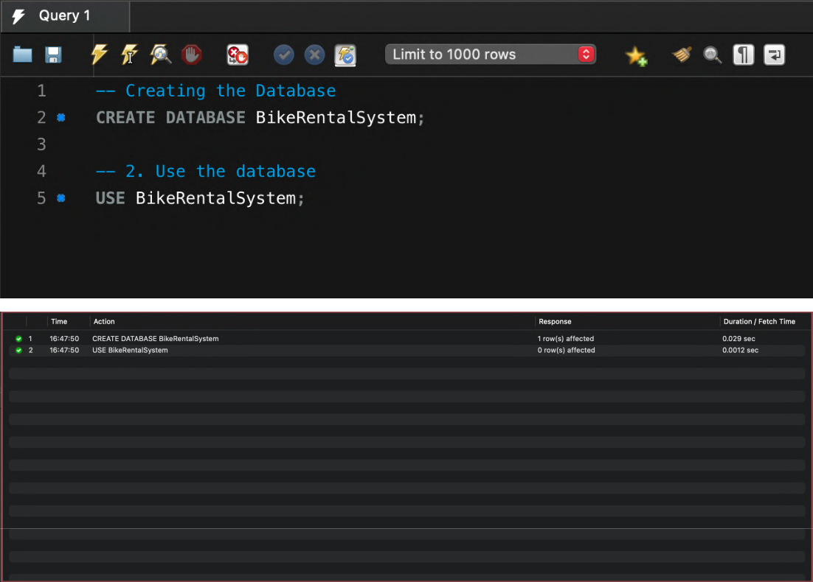

2. Create Location Table

CREATE TABLE Location (
0 |  | LocationID INT AUTO_INCREMENT PRIMARY KEY,
0 | City VARCHAR(50),
0 | State VARCHAR(50),
 | Street VARCHAR(100),
0 | Latitude DECIMAL(10, 8),
Longitude DECIMAL(10, 8);
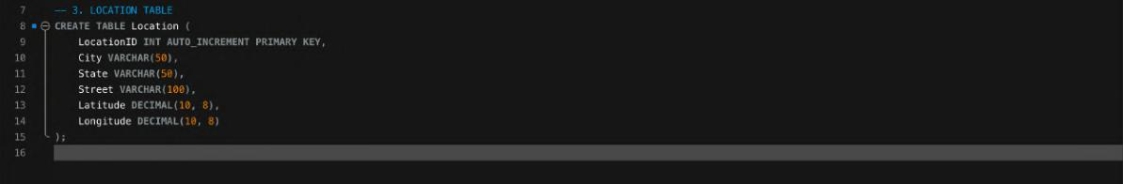

Page 17 of 45

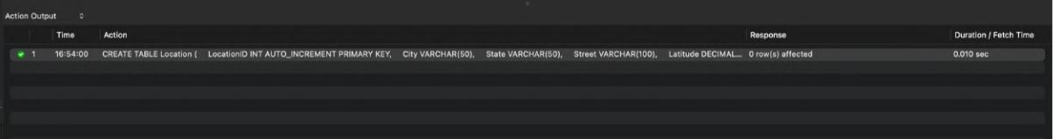

- Creating User and User_Email Table

CREATE TABLE User (
UserID INT AUTO_INCREMENT PRIMARY KEY,
FirstName VARCHAR(50),
LastName VARCHAR(50),
PhoneNumber VARCHAR(20),
PasswordHash VARCHAR(255),
CreatedAt DATETIME DEFAULT CURRENT_TIMESTAMP
);
CREATE TABLE User_Email (
Email VARCHAR(100) UNIQUE,
UserID INT UNIQUE,
FOREIGN KEY (UserID) REFERENCES User(UserID) ON DELETE 0
CASCADE
);
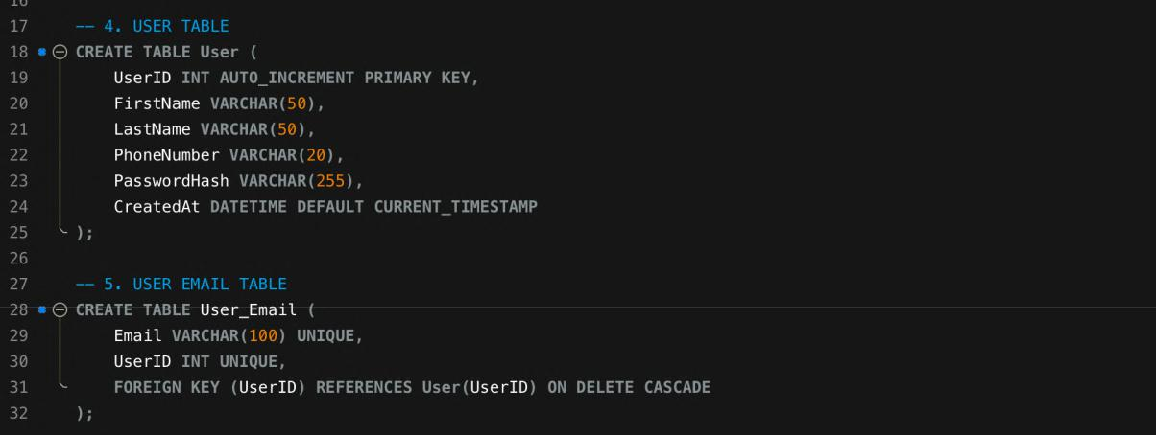
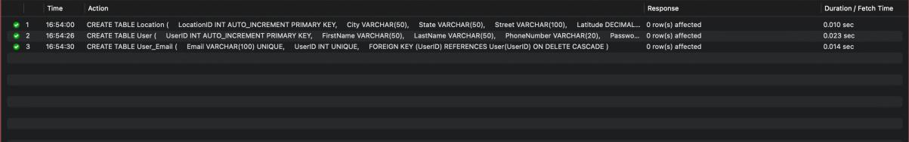

Page 18 of 45

4. Creating Admin and Admin_Email Tables

CREATE TABLE Admin (

AdminID INT AUTO_INCREMENT PRIMARY KEY, PasswordHash VARCHAR(255),
CreatedAt DATETIME DEFAULT CURRENT_TIMESTAMP
);

CREATE TABLE Admin_Email (
Email VARCHAR(100) UNIQUE,
AdminID INT UNIQUE,

FOREIGN KEY (AdminID) REFERENCES Admin(AdminID) ON DELETE
CASCADE
);
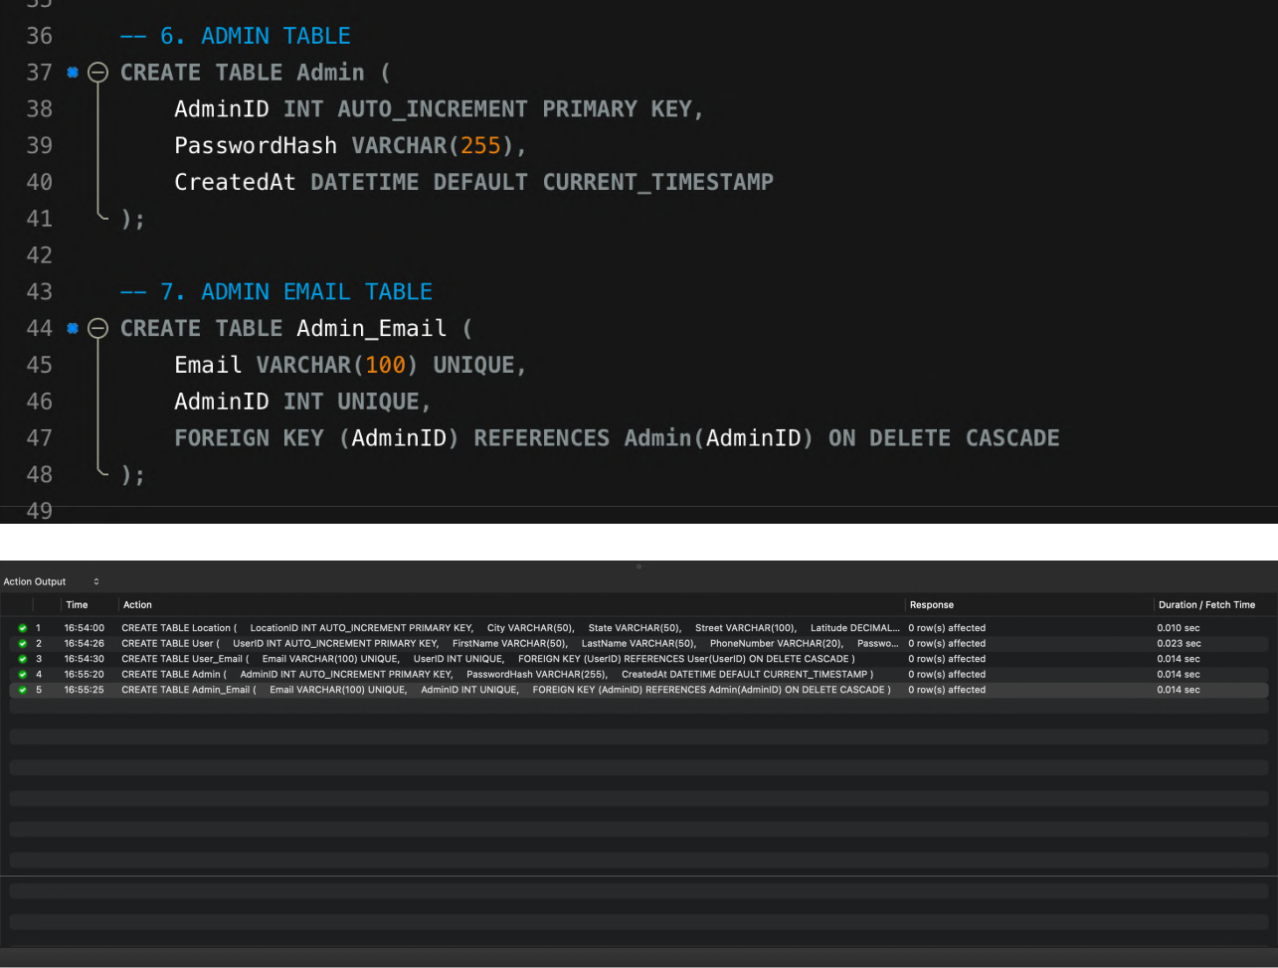

Page 19 of 45

5. Creating the Bike Table

CREATE TABLE Bike (
BikeID INT AUTO_INCREMENT PRIMARY KEY,
Model VARCHAR(50),
Brand VARCHAR(50),
Status ENUM('Available', 'Rented', 'Maintenance'),
LocationID INT,
RatePerHour DECIMAL(5,2),

CreatedAt DATETIME DEFAULT CURRENT_TIMESTAMP, FOREIGN KEY (LocationID) REFERENCES Location(LocationID)
);
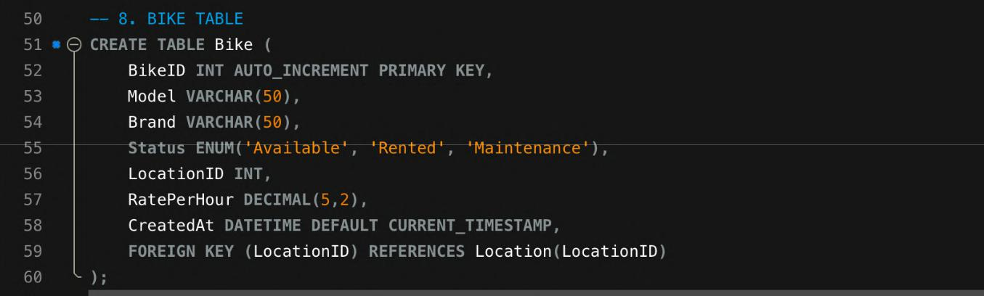
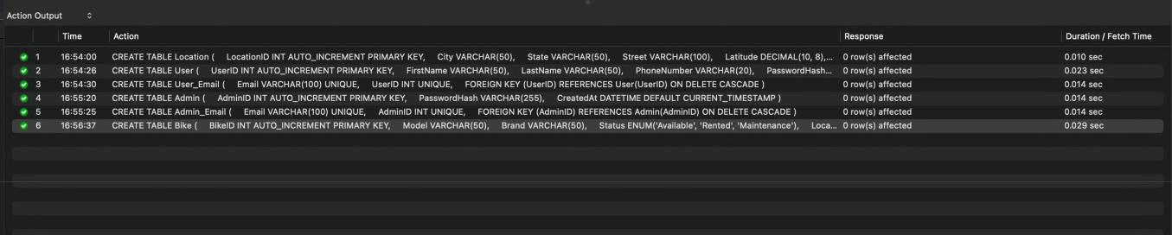

Page 20 of 45

6. Creating the Booking , Manages and Payments Table

CREATE TABLE Booking (

BooklogID INT AUTO_INCREMENT PRIMARY KEY,

UserID INT,

BikeID INT,

StartTime DATETIME,

EndTime DATETIME,

TotalCost DECIMAL(6,2),

Status VARCHAR(20),

CreatedAt DATETIME DEFAULT CURRENT_TIMESTAMP,

FOREIGN KEY (UserID) REFERENCES User(UserID),

FOREIGN KEY (BikeID) REFERENCES Bike(BikeID)

);

CREATE TABLE Manages (

AdminID INT,

BooklogID INT,

PRIMARY KEY (AdminID, BooklogID),

FOREIGN KEY (AdminID) REFERENCES Admin(AdminID), FOREIGN KEY (BooklogID) REFERENCES Booking(BooklogID)
);

CREATE TABLE Payment (

PaymentID INT AUTO_INCREMENT PRIMARY KEY, BooklogID INT,

UserID INT,

Amount DECIMAL(6,2),

PaymentMethod ENUM('Cash', 'Wallet', 'Card'),

PaymentStatus ENUM('Pending', 'Processing', 'Failed', 'Completed'), CreatedAt DATETIME DEFAULT CURRENT_TIMESTAMP, FOREIGN KEY (BooklogID) REFERENCES Booking(BooklogID), FOREIGN KEY (UserID) REFERENCES User(UserID)
);

Page 21 of 45

Code Snippet:
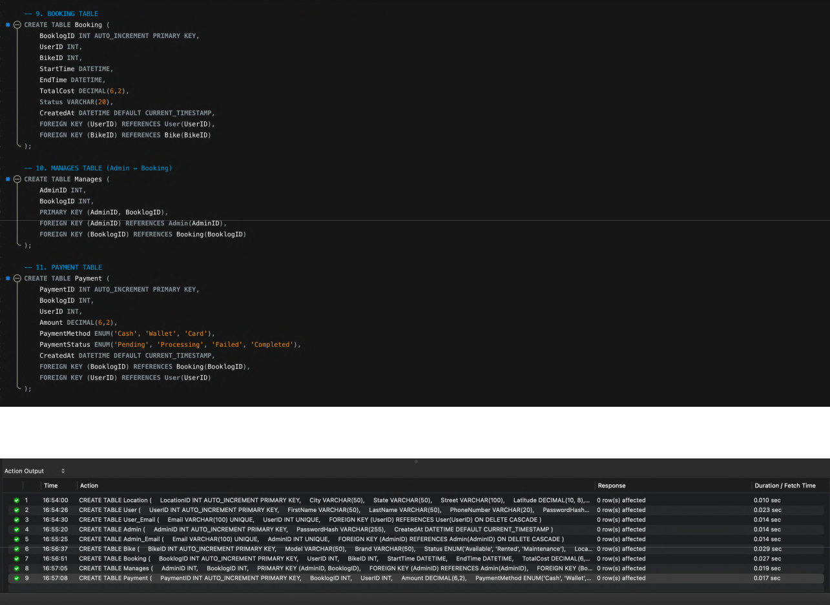

Page 22 of 45

7. Creating a Trigger to Calculate the total cost of booking

DELIMITER //

CREATE TRIGGER calculate_total_cost

BEFORE INSERT ON Booking

FOR EACH ROW

BEGIN

DECLARE rate DECIMAL(5,2);

DECLARE duration DECIMAL(10,2);

SELECT RatePerHour INTO rate FROM Bike WHERE BikeID = NEW.BikeID; SET duration = TIMESTAMPDIFF(MINUTE, NEW.StartTime, NEW.EndTime) /
60.0;

SET NEW.TotalCost = ROUND(duration * rate, 2); END;

//

This trigger calculate_total_cost automatically calculates the total cost of a bike booking before it's inserted into the Booking table.
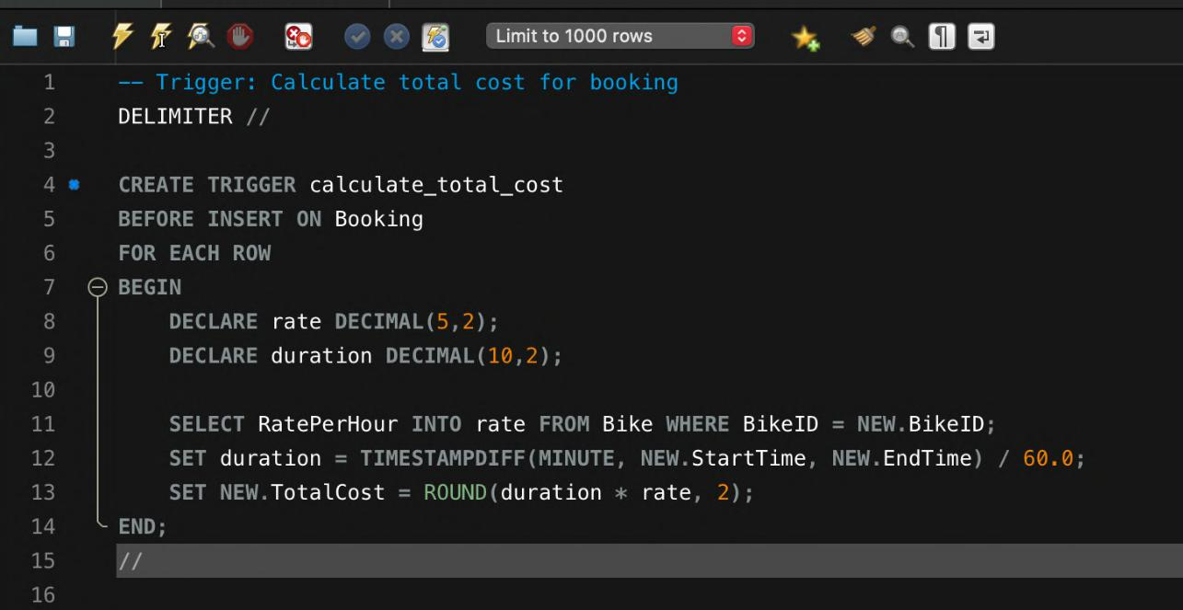

Page 23 of 45

- Create a Trigger that prevents double-booking of a bike CREATE TRIGGER prevent_double_booking

BEFORE INSERT ON Booking

FOR EACH ROW BEGIN

DECLARE count_bookings INT;

SELECT COUNT(*) INTO count_bookings FROM Booking

WHERE BikeID = NEW.BikeID AND NEW.StartTime < EndTime AND NEW.EndTime > StartTime;

IF count_bookings > 0 THEN

SIGNAL SQLSTATE '45000'

SET MESSAGE_TEXT = 'Bike already booked during this time';

END IF;

END;

//
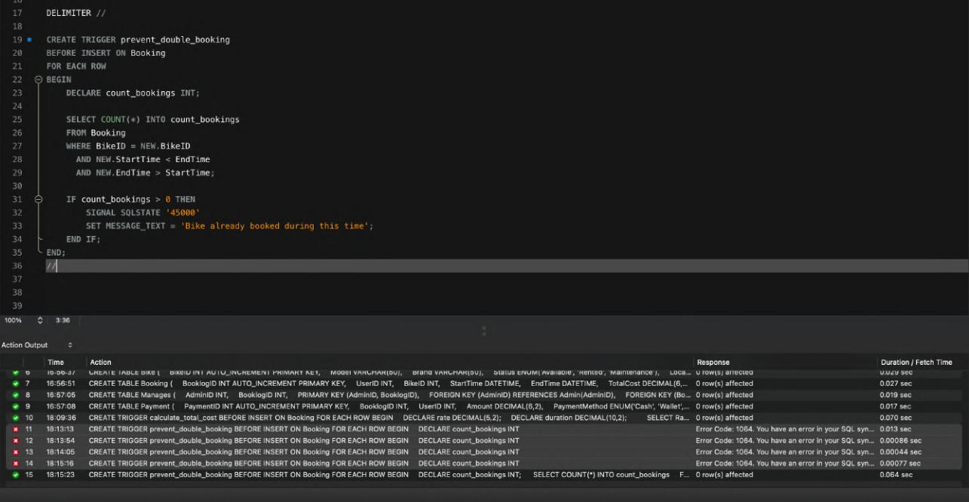

Page 24 of 45

9. Creating a Trigger to allow person to book one bike at a time interval
DROP TRIGGER IF EXISTS prevent_user_double_booking;
DELIMITER //
CREATE TRIGGER prevent_user_double_booking
BEFORE INSERT ON Booking
FOR EACH ROW
BEGIN
IF (SELECT COUNT(*)
FROM Booking
WHERE UserID = NEW.UserID
AND Status <> 'Cancelled'
AND NEW.StartTime < EndTime
AND NEW.EndTime > StartTime) > 0
THEN
SIGNAL SQLSTATE '45000'
SET MESSAGE_TEXT = 'User already has a booking during this time.';
END IF;
END //
DELIMITER ;

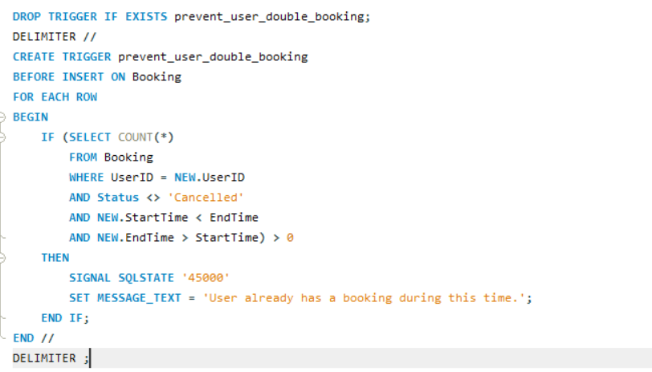

Page 25 of 45

10.Creating a procedure to add a bike in the bike table

DELIMITER //

CREATE PROCEDURE AddBike (

IN p_Model VARCHAR(50),

IN p_Brand VARCHAR(50),

IN p_Status VARCHAR(20),

IN p_LocationID INT,

IN p_RatePerHour DECIMAL(5,2)

)

BEGIN

-- Validate ENUM value

IF p_Status NOT IN ('Available', 'Rented', 'Maintenance') THEN SIGNAL SQLSTATE '45000'

SET MESSAGE_TEXT = 'Invalid Status. Must be Available, Rented, or Maintenance.';

ELSE

INSERT INTO Bike (Model, Brand, Status, LocationID, RatePerHour) VALUES (p_Model, p_Brand, p_Status, p_LocationID, p_RatePerHour);
END IF;

END //
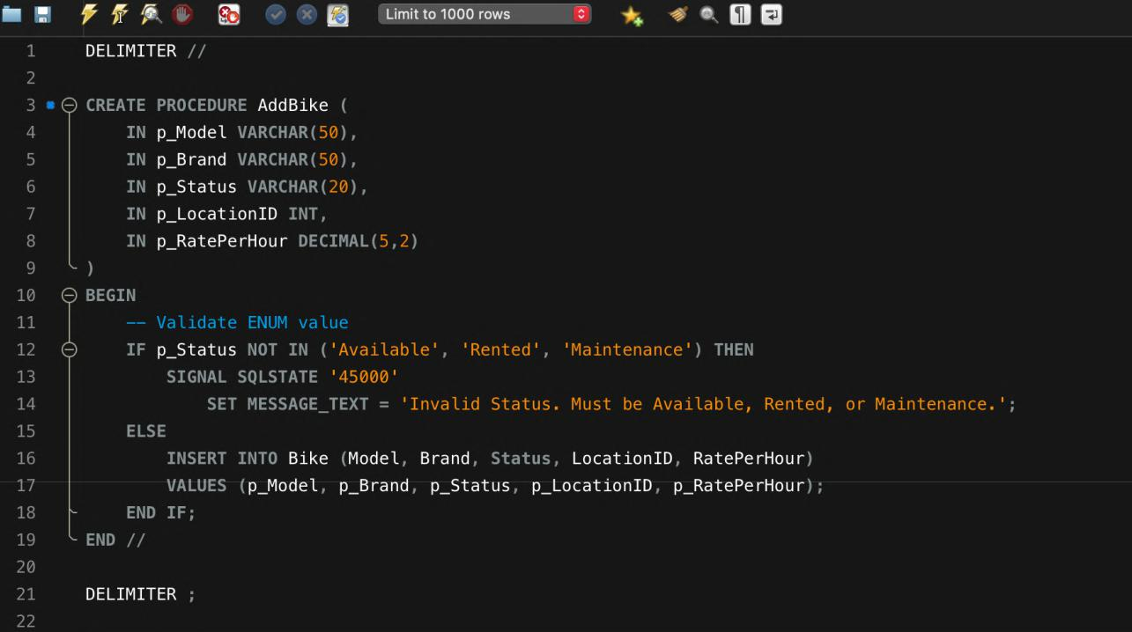

Page 26 of 45

11. Creating a Procedure to Return a Bike
DELIMITER //
CREATE PROCEDURE ReturnBike(IN p_BooklogID INT)
BEGIN
DECLARE v_BikeID INT;
DECLARE v_Status VARCHAR(50);

IF NOT EXISTS(SELECT 1 FROM Booking WHERE BooklogID=p_BooklogID) THEN
SIGNAL SQLSTATE '45000' SET MESSAGE_TEXT='Booking does not exist';
END IF;

SELECT BikeID,Status INTO v_BikeID,v_Status
FROM Booking WHERE BooklogID=p_BooklogID;

IF v_Status='Cancelled' THEN
SIGNAL SQLSTATE '45000' SET MESSAGE_TEXT='Cannot return a cancelled booking';
END IF;

IF v_Status='Completed' THEN
SIGNAL SQLSTATE '45000' SET MESSAGE_TEXT='Bike already returned';
END IF;

UPDATE Booking SET Status='Completed' WHERE BooklogID=p_BooklogID;
UPDATE Bike SET Status='Available' WHERE BikeID=v_BikeID;
UPDATE Payment SET PaymentStatus='Completed' WHERE BooklogID=p_BooklogID;
END //
DELIMITER ;

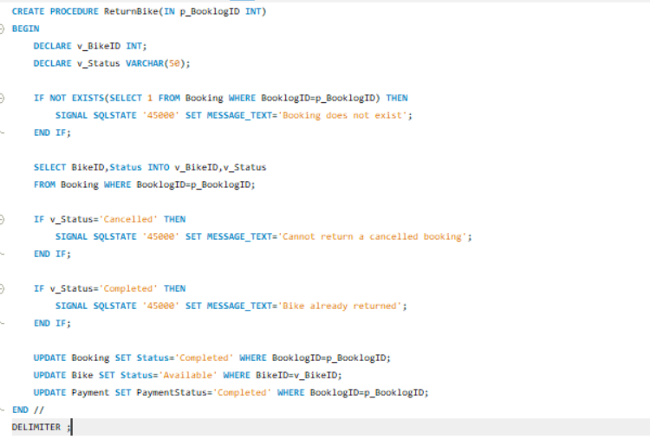
Page 27 of 45

12. Creating a Trigger to Update Bike status after booking

DELIMITER //

CREATE TRIGGER update_bike_status_after_booking AFTER INSERT ON Booking
FOR EACH ROW

BEGIN

IF NEW.Status = 'Confirmed' THEN

UPDATE Bike

SET Status = 'Rented'

WHERE BikeID = NEW.BikeID;

ELSEIF NEW.Status = 'Cancelled' THEN

UPDATE Bike

SET Status = 'Available'

WHERE BikeID = NEW.BikeID;

END IF;

END //
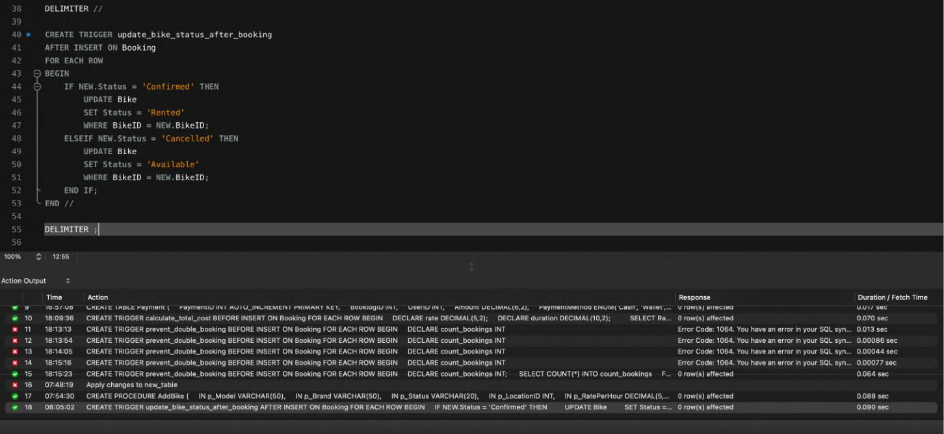

Page 28 of 45

13. Creating a Stored Procedure for Canceling Booking

DELIMITER //

CREATE PROCEDURE CancelBooking(

IN p_BooklogID INT

)

BEGIN

DECLARE v_BikeID INT;

DECLARE v_Status VARCHAR(20);

- Get the Bike ID and Status from Booking SELECT BikeID, Status INTO v_BikeID, v_Status FROM Booking

WHERE BooklogID = p_BooklogID;

- Check if the booking is Confirmed or Completed IF v_Status IN ('Confirmed', 'Completed') THEN
  - Update Bike Status

UPDATE Bike

SET Status = 'Available'

WHERE BikeID = v_BikeID;

- Update Booking Status UPDATE Booking

SET Status = 'Cancelled'

WHERE BooklogID = p_BooklogID;

- Update Payment Status

UPDATE Payment

SET PaymentStatus = 'Refunded'

WHERE BooklogID = p_BooklogID;

ELSE

-- Signal error

SIGNAL SQLSTATE '45000'

SET MESSAGE_TEXT = 'Only confirmed or completed bookings can be cancelled.';

END IF;

END //

Page 29 of 45

This procedure allows users or admins to cancel a booking, making sure the status of the bike is updated, and it refunds the payment if needed.
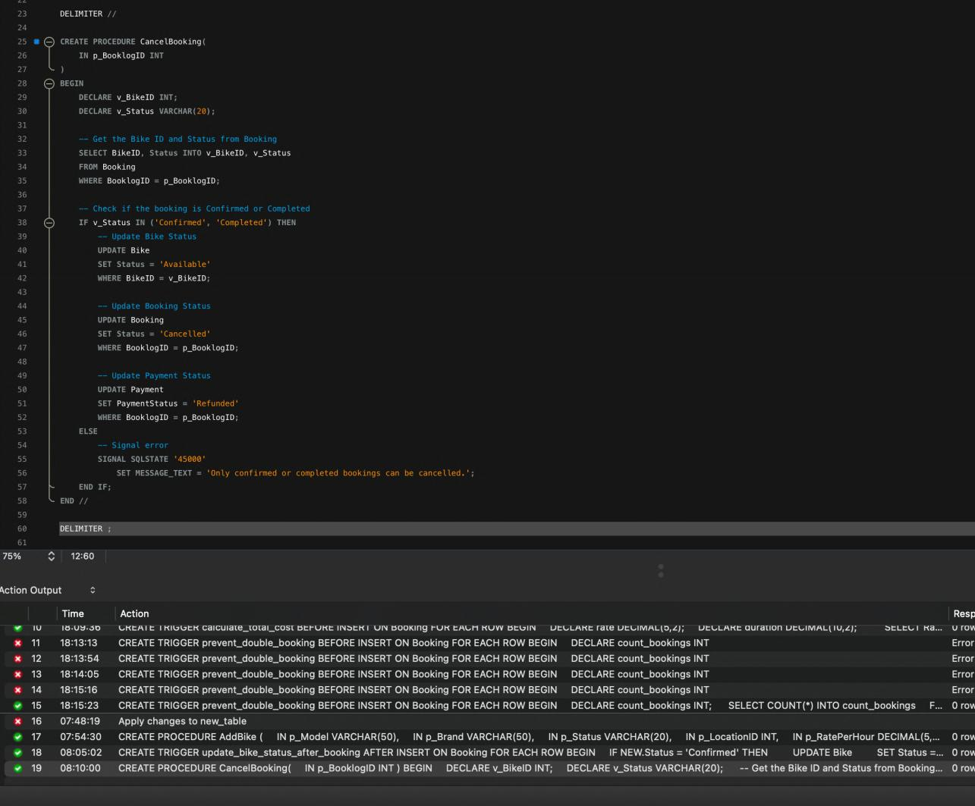

Page 30 of 45

14.Creating a Procedure to get available bikes on the basis of location

DELIMITER //

CREATE PROCEDURE GetAvailableBikesByLocation ( IN p_LocationID INT
)
BEGIN

SELECT BikeID, Model, Brand, RatePerHour FROM Bike

WHERE LocationID = p_LocationID AND Status = 'Available'; END //

DELIMITER ;
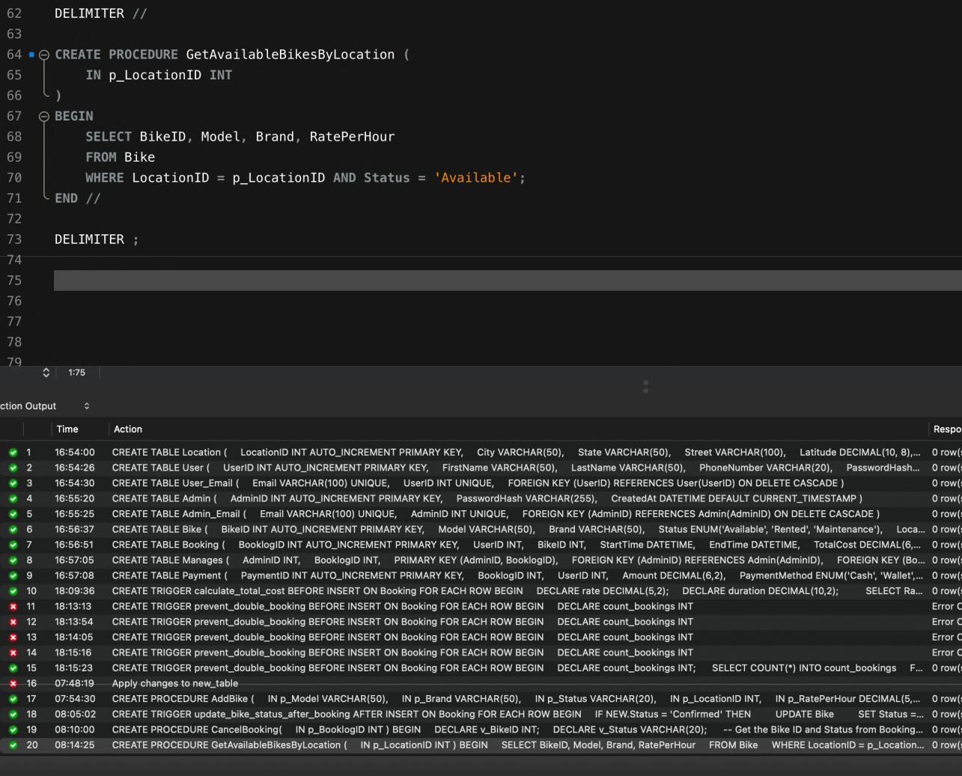

Page 31 of 45
15.Create a Procedure to Get User Booking History
DELIMITER //

CREATE PROCEDURE GetUserBookingHistory ( IN p_UserID INT
)
BEGIN

SELECT B.BooklogID, B.StartTime, B.EndTime, B.TotalCost, B.Status FROM Booking B
WHERE B.UserID = p_UserID
ORDER BY B.StartTime DESC;
END //

DELIMITER ;
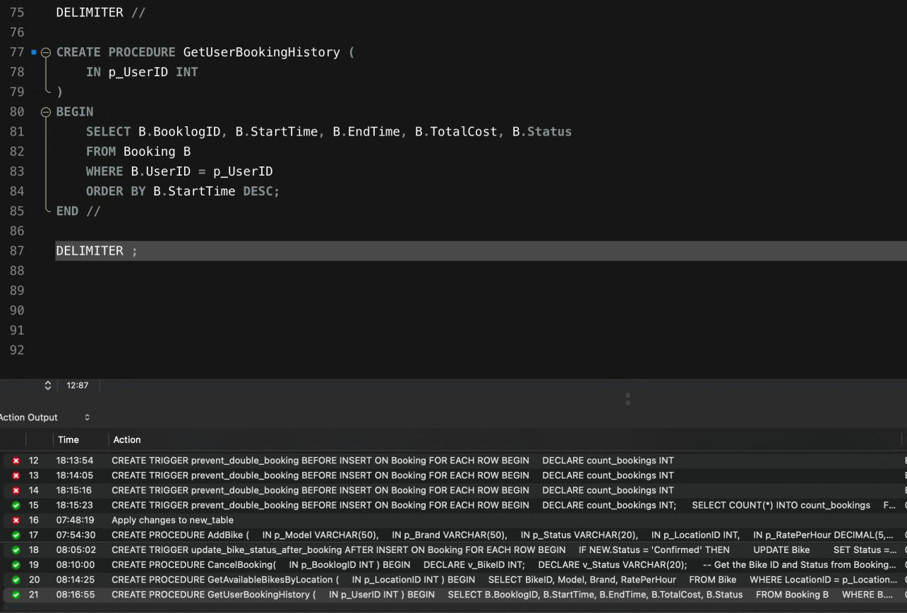

Page 32 of 45

16.Entering information

1. Location Table
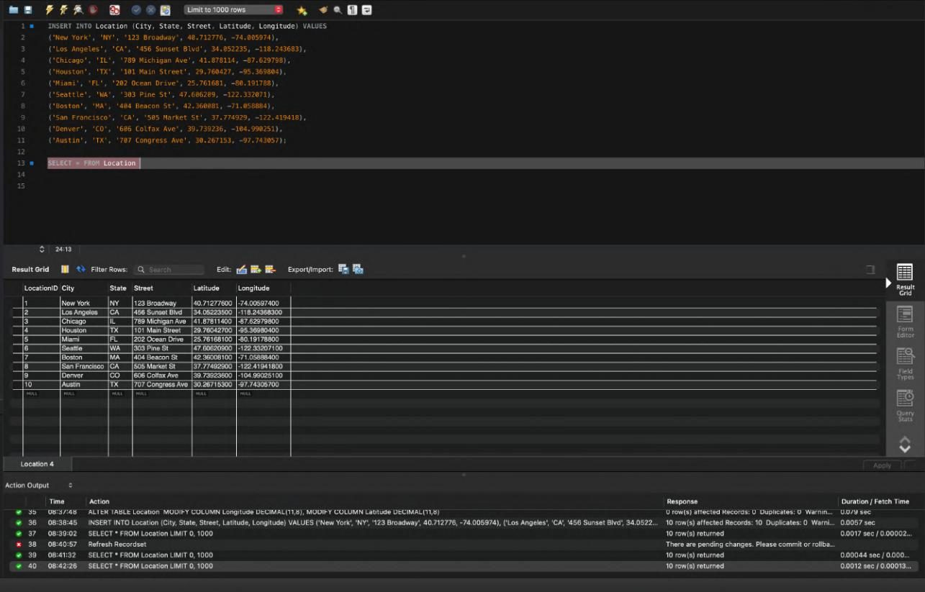

2. User Table

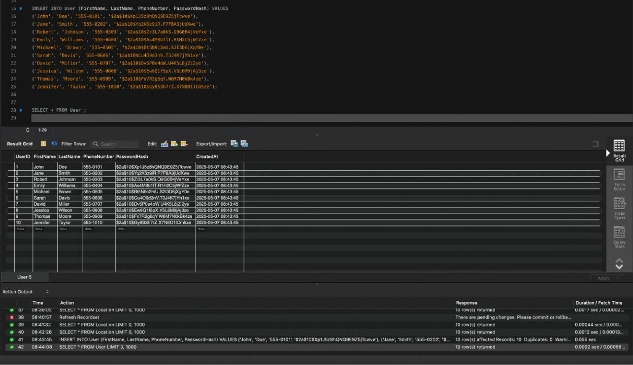

Page 33 of 45

3. User_Email Table
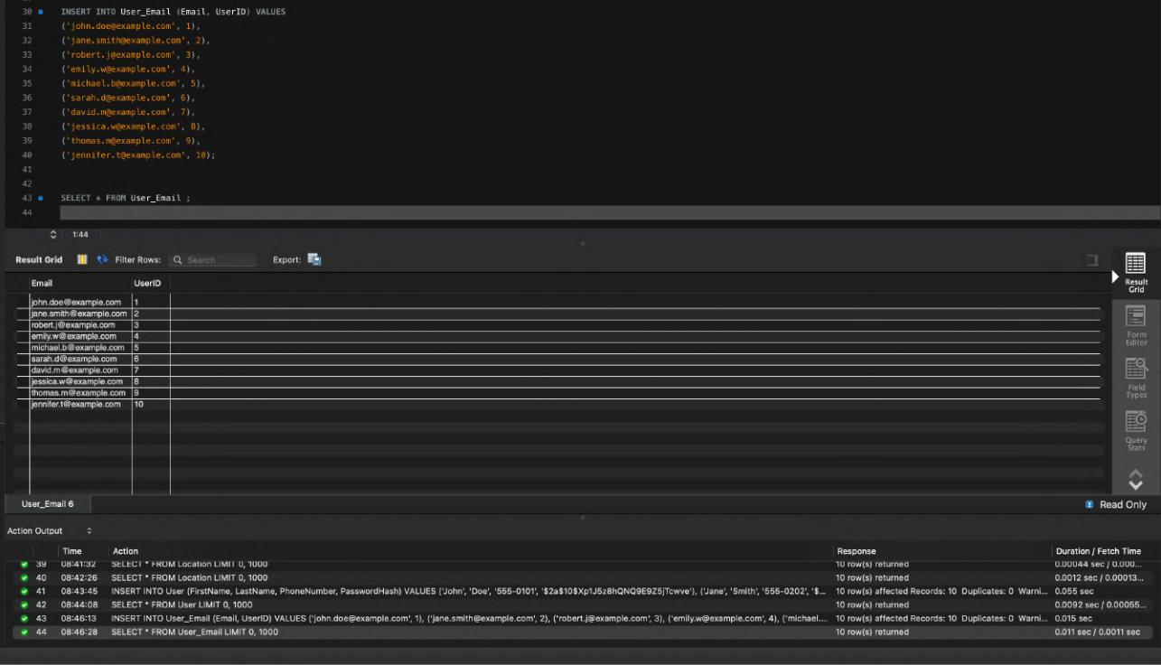

4. Admin Table
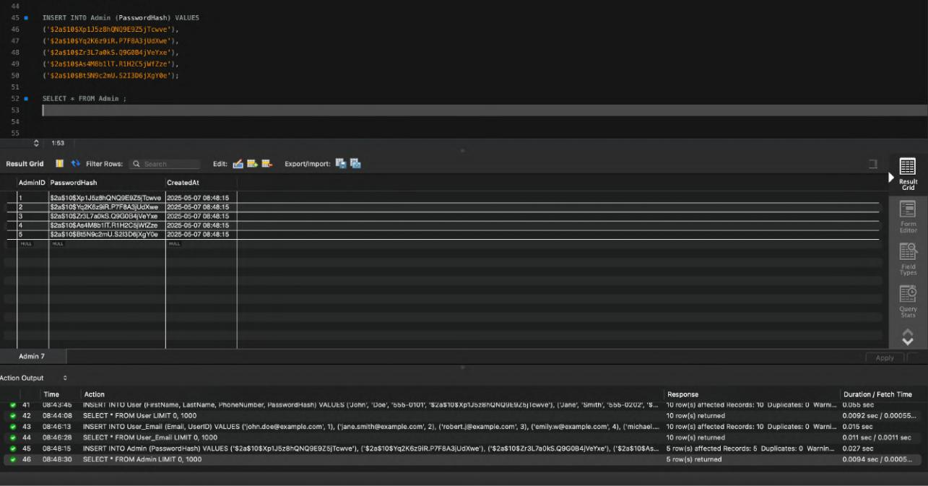

Page 34 of 45

5. Admin_Email Table

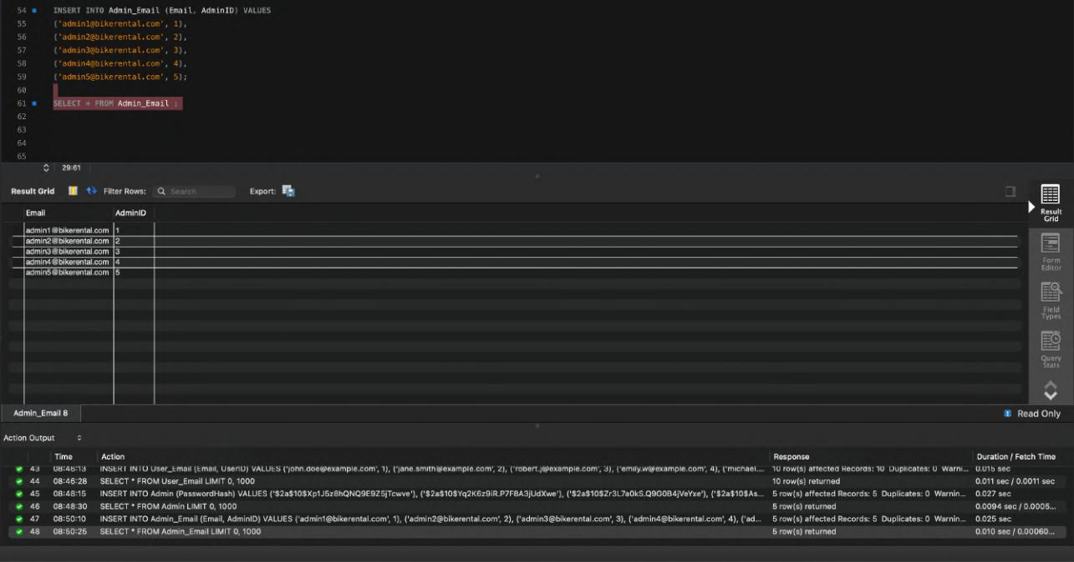

6. Bike Table
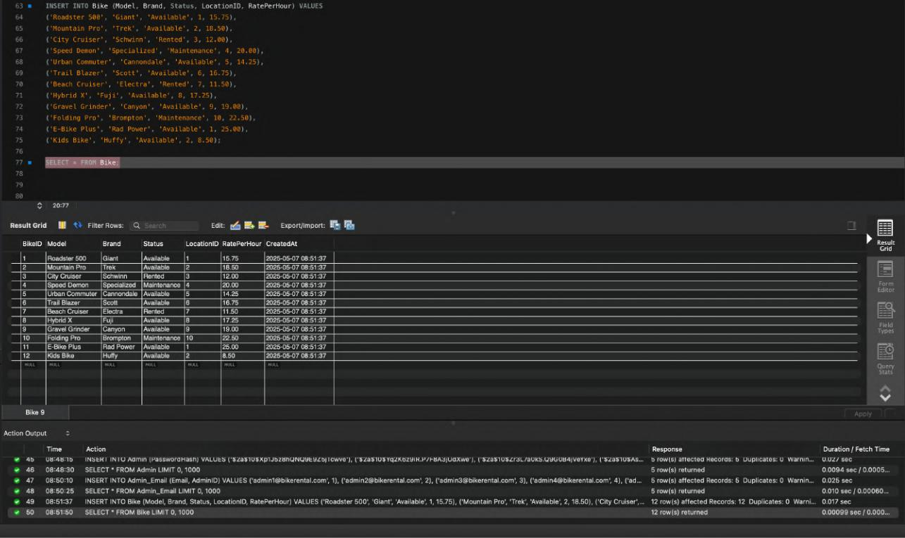

Page 35 of 45

7.Booking Table
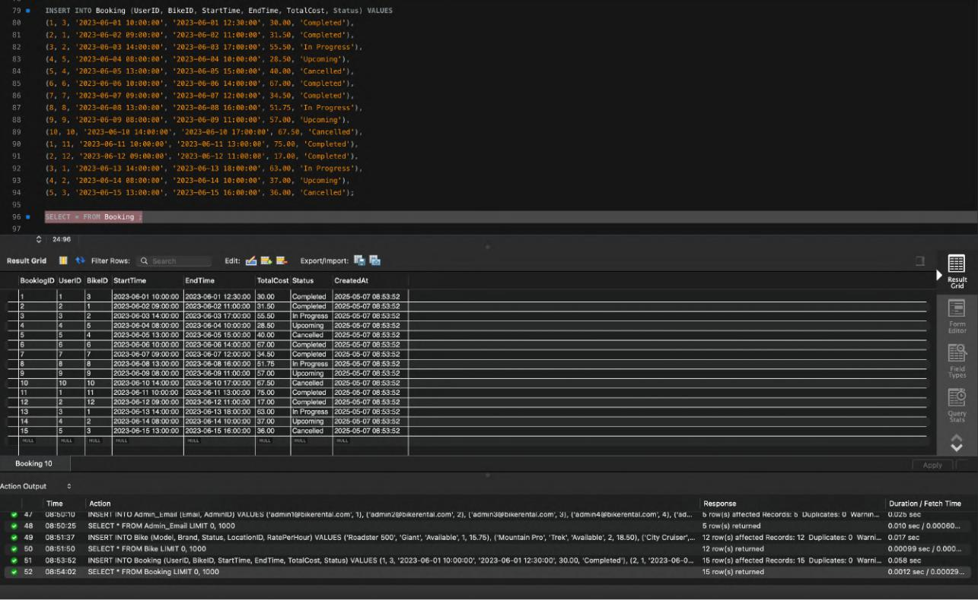

8. Manages Table
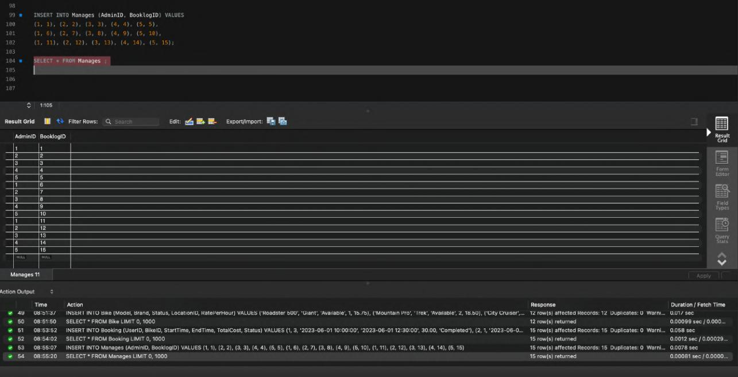

Page 36 of 45

9.Payment Table
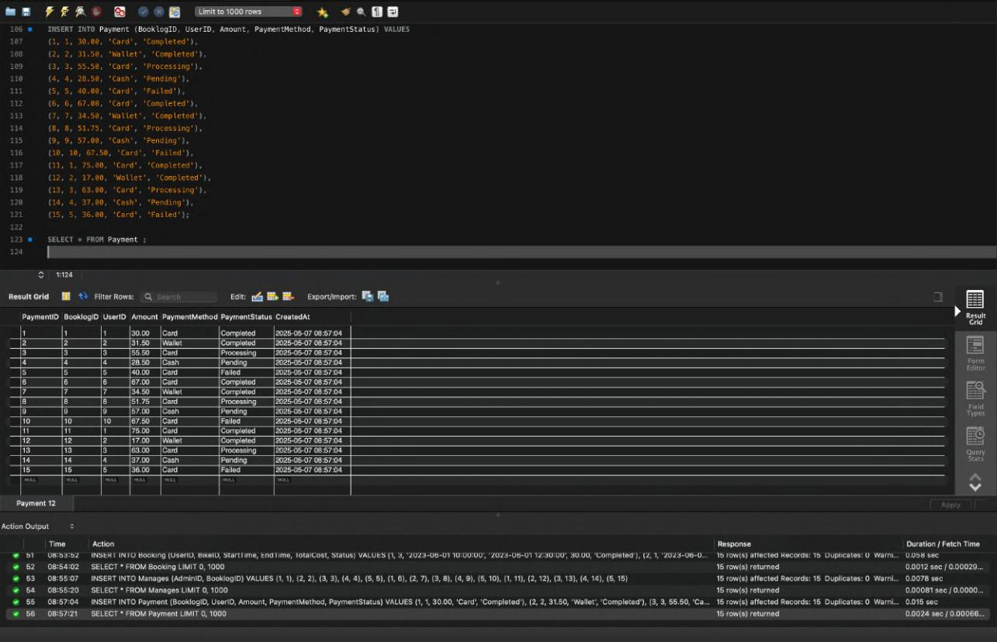

Working of Stored Procedures in the database
- Add Bike Procedure
Command to call the Procedure :
- CALL AddBike('Mountain Pro', 'Trek', 'Available', 3, 18.50);

Verifying the procedure worked
- SELECT * FROM Bike WHERE Model = 'Mountain Pro' AND Brand = 'Trek';
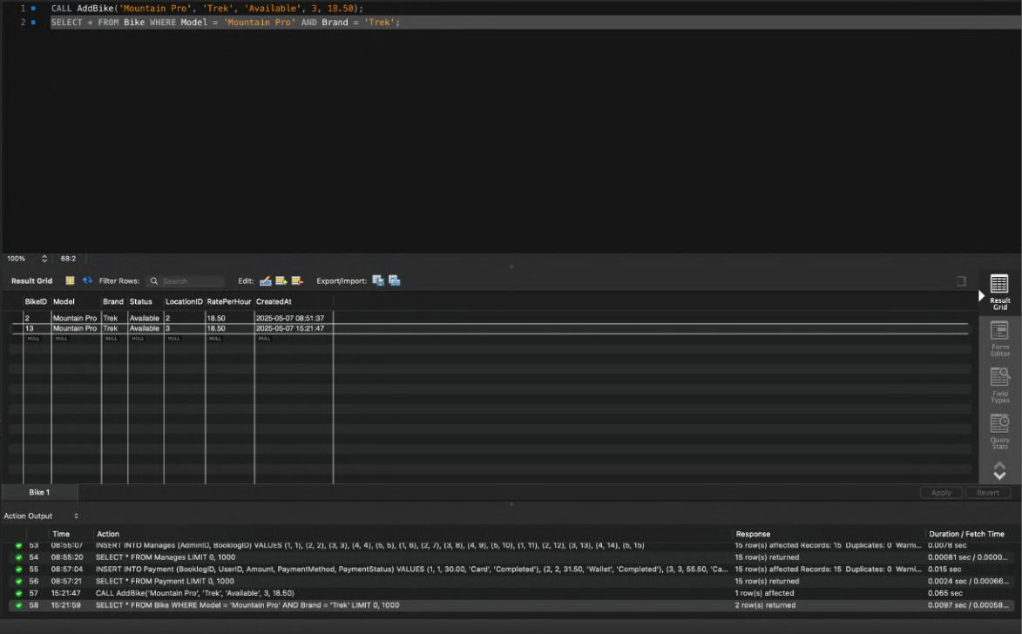

Page 37 of 45

Testing Error Cases :
- CALL AddBike('Test Bike', 'Brand', 'InvalidStatus', 1, 15.00);

Returns:
- Error Code: 1644. Invalid Status. Must be Available, Rented, or Maintenance.
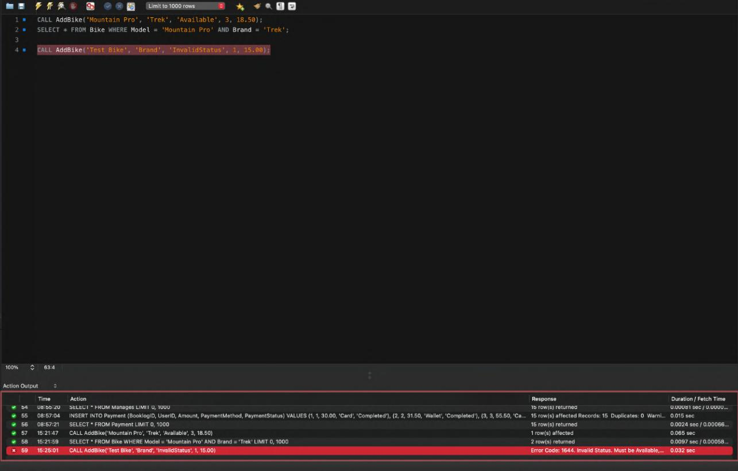

0

0 0

2. Cancel booking Procedure

From Booking table we cancel BookLogID = 2:

- SELECT * FROM Booking WHERE BookLogID = 2;

Call the cancel Procedure:

- CALL CancelBooking(2);

Verify the Updates:

- SELECT BooklogID, Status FROM Booking WHERE BooklogID = 2;

- SELECT BikeID, Status FROM Bike WHERE BikeID = 1;

- SELECT BooklogID, PaymentStatus FROM Payment WHERE BooklogID = 2;

Page 38 of 45

Before Calling the procedure:
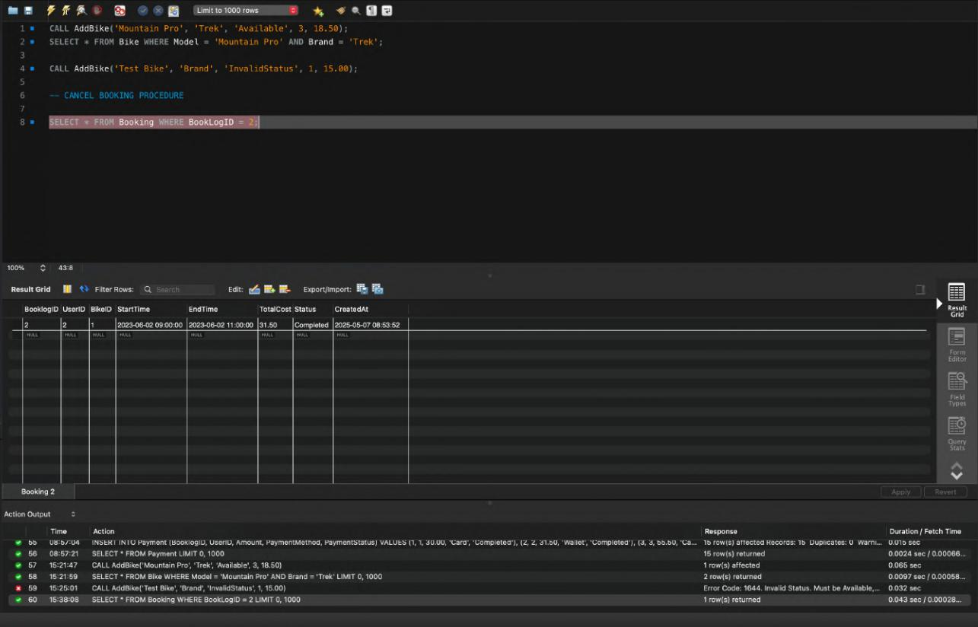

After Calling the Procedure :
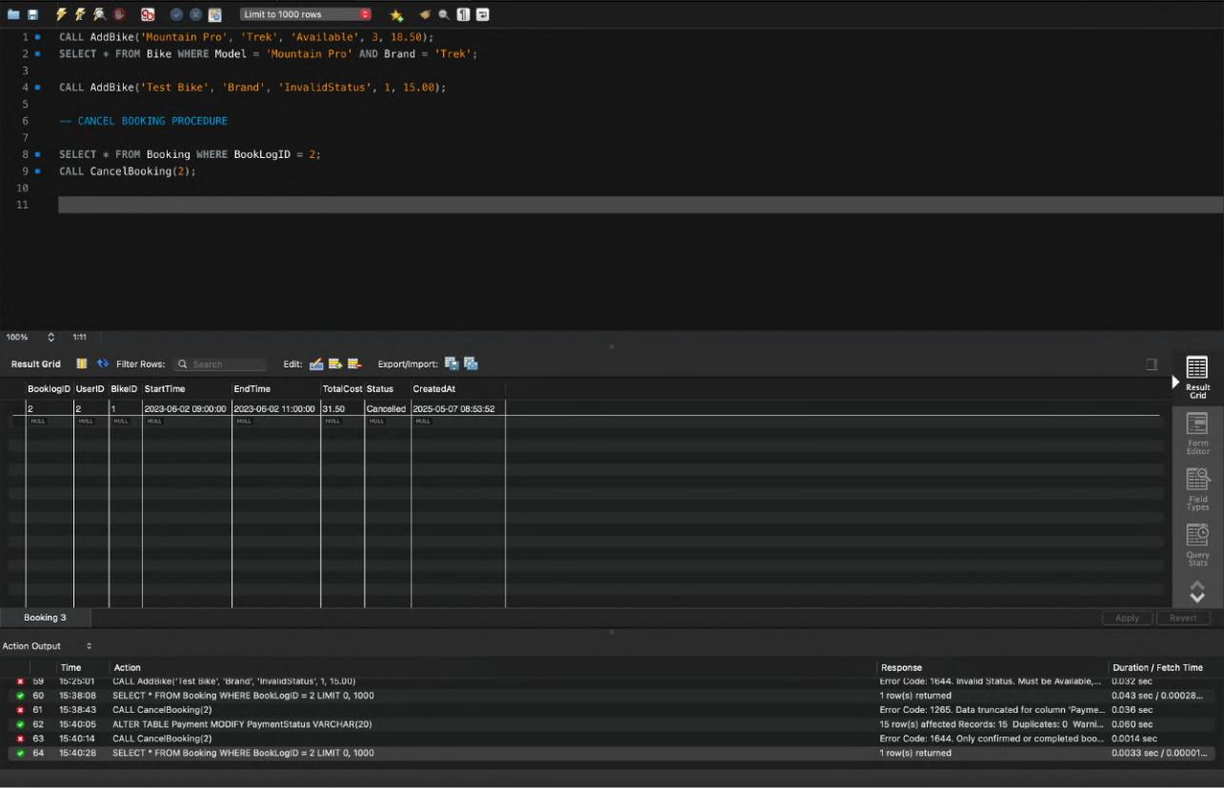

Page 39 of 45

3. Get Available Bikes at a location Procedure

Calling the Procedure :
- CALL GetAvailableBikesByLocation(1);

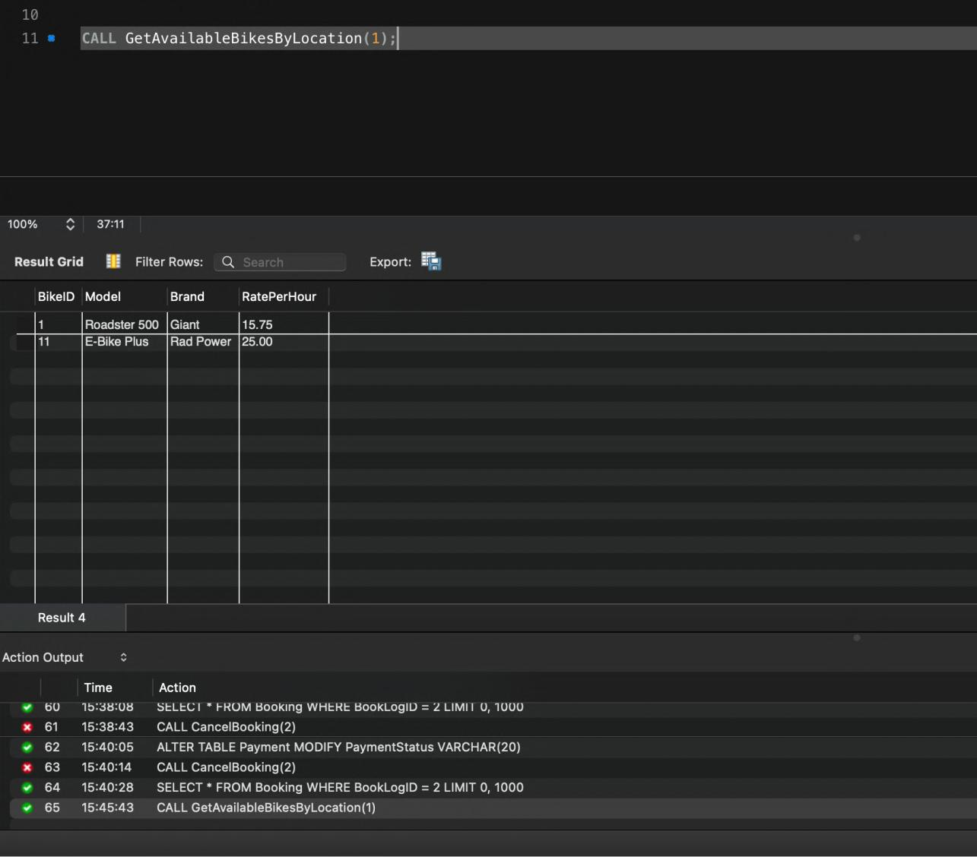

Page 40 of 45

4. Get User Booking History

Check the available users :
- SELECT UserID, FirstName, LastName FROM User;

Calling the Procedure:
- CALL GetUserBookingHistory(1);

Available users:
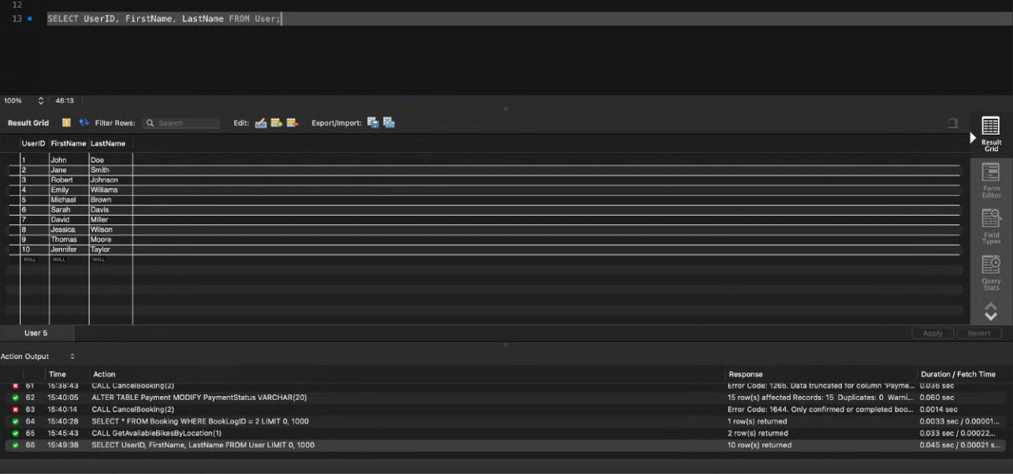

User Booking History of UserID = 1 :
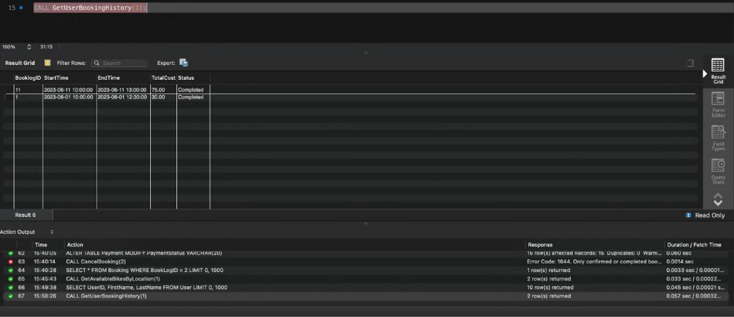

Page 41 of 45

5. Book a bike and then booking another bike by the same user at a same time interval

Check for available bikes :
- SELECT * FROM Bike;
SELECT * FROM Booking;
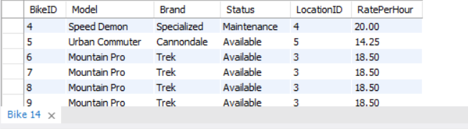

- These are the bikes available
- Now I’ll book a bike from these

Run a command to book a bike :
- CALL BookBike(9,5,'2025-11-04 12:00:00','2025-11-04 15:00:00');
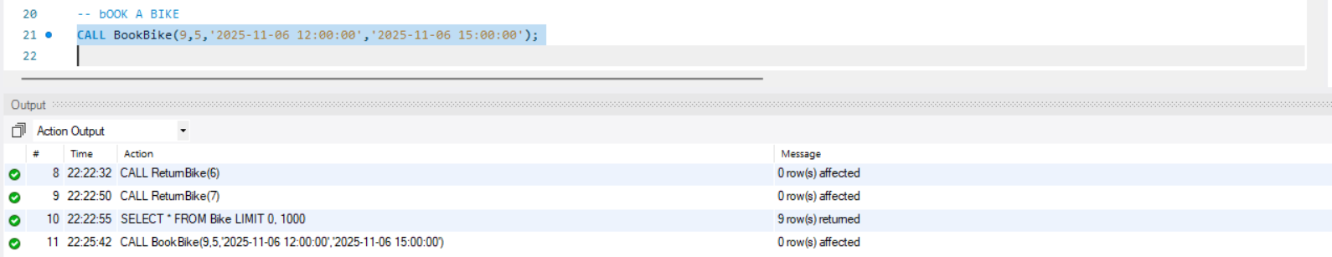

- Bike is booked

Book another bike for same user in a same time period
- CALL BookBike(8,5,'2025-11-06 13:00:00','2025-11-06 16:00:00');

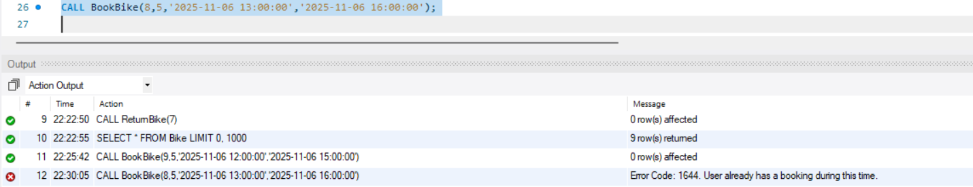

Check for booklogId:
- SELECT * FROM Booking;

Page 42 of 45

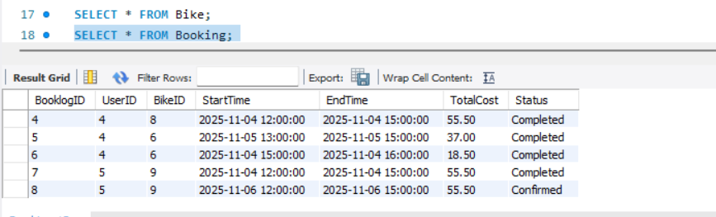

Return a bike :
- CALL ReturnBike(8);
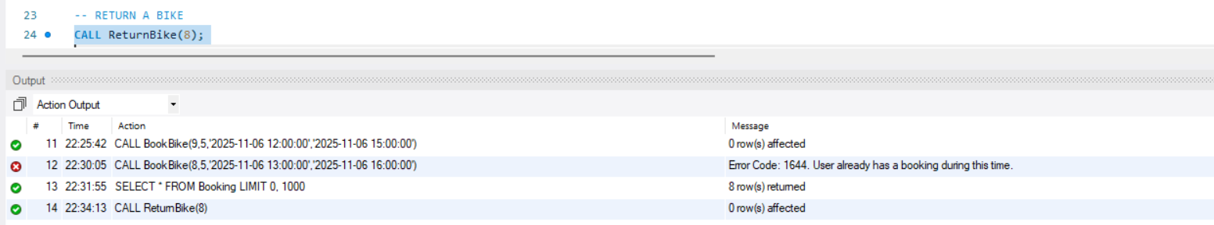

Book a bike and cancel the booking:
- CALL CancelBooking(9);

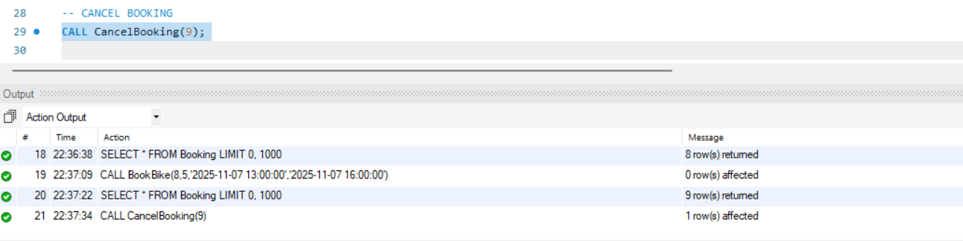

Check booking and payment status :
- SELECT * FROM Booking WHERE BooklogID = 9;
- SELECT * FROM Payment WHERE BooklogID = 9;

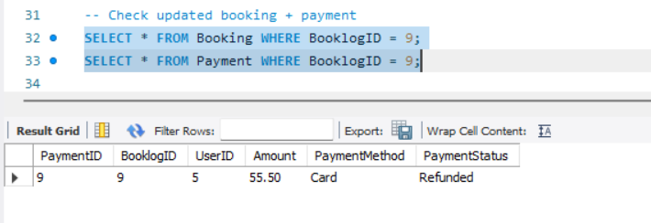

- Payment shows refunded as we cancelled the booking

Page 43 of 45

User booking history
- CALL GetUserBookingHistory(5);

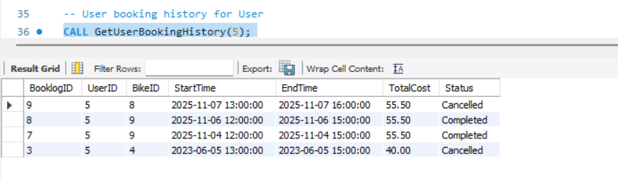

Page 44 of 45

CONCLUSION

The Bike Rental System project has been designed to offer a seamless and efficient experience for both users and administrators in managing the entire lifecycle of bike rentals. Through an organised and normalised database structure, along with the use of stored procedures for tasks like booking cancellations, checking bike availability, and viewing user booking history, the system ensures accuracy, speed, and reliability. Users can conveniently browse available bikes at specific locations, make or cancel bookings, and complete their payments through multiple methods. At the same time, administrators can manage bookings and payments effectively without the need for manual tracking, reducing errors and workload.

One of the most significant benefits of this system is its contribution to environmental sustainability. By making bike rentals more accessible and efficient, it encourages more individuals to opt for bicycles over traditional motor vehicles. This shift not only helps in reducing fuel consumption and harmful greenhouse gas emissions but also promotes a healthier and cleaner urban lifestyle. As cities worldwide look for smarter, greener mobility solutions, systems like this play a crucial role in building eco-friendly transportation networks.

In summary, this Bike Rental System not only simplifies and modernises the process of renting and managing bikes but also supports a broader vision of sustainable development by promoting environmentally responsible travel choices.

Page 45 of 45

