1. Open the application at <https://vast-cliffs-8955.herokuapp.com/>

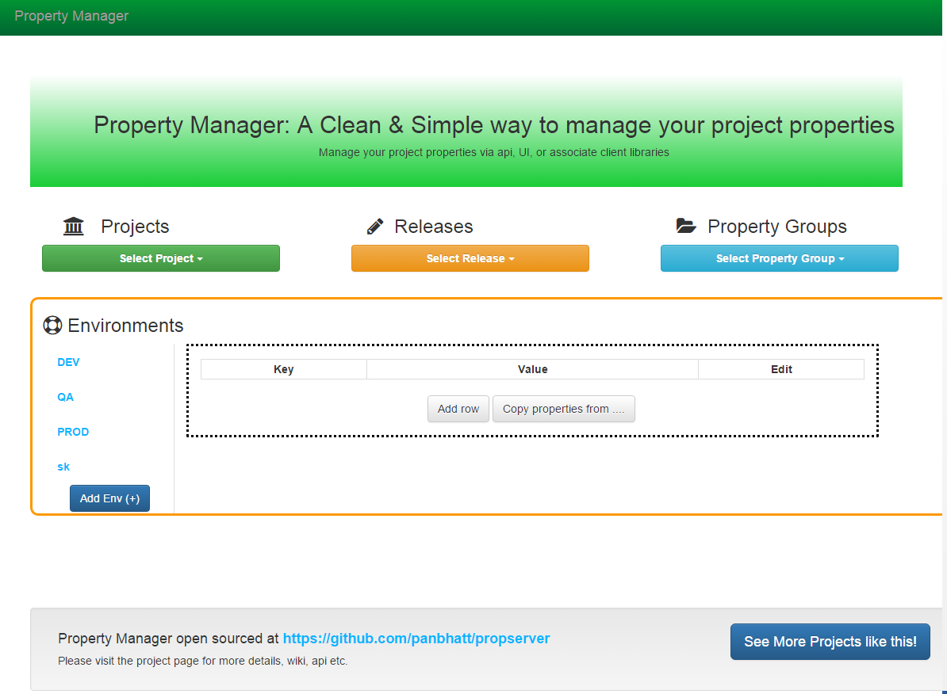

1. Click on “Select Project” and a list box will appear that will show the list of available projects with an option of Adding a new PROJECT in the console.

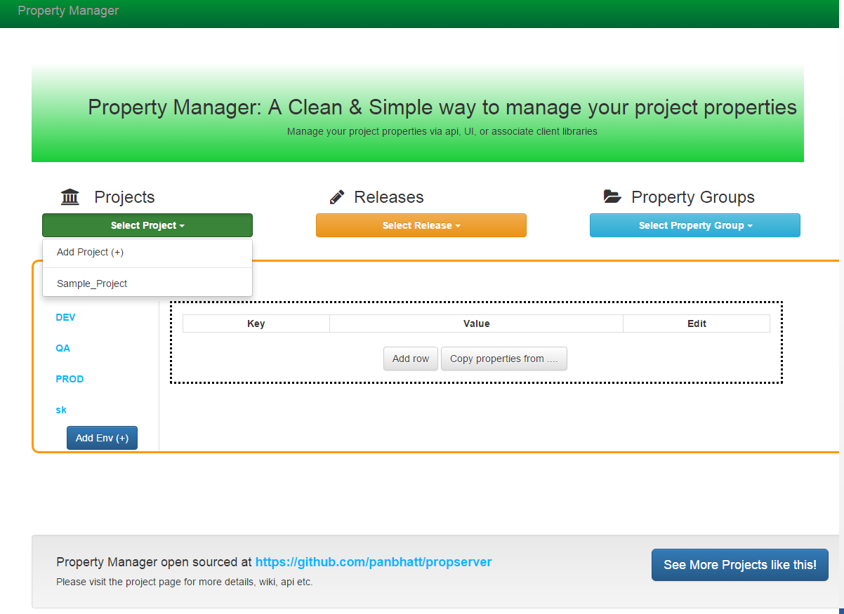

1. Click on “Add Project (+)” to add a new project. A Popup will come up that will ask for Project Name and description. Fill the detail and click on “OK”.

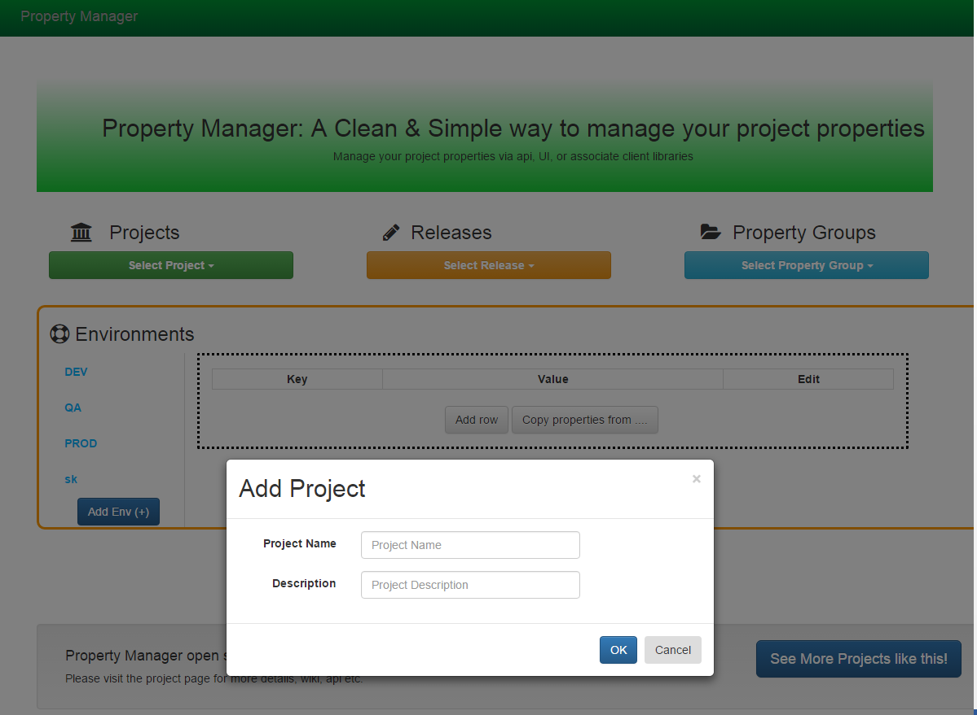

1. If “First_Project” has been entered as the project name, it is being added in the system with a message box and it will appear in the list of available projects.

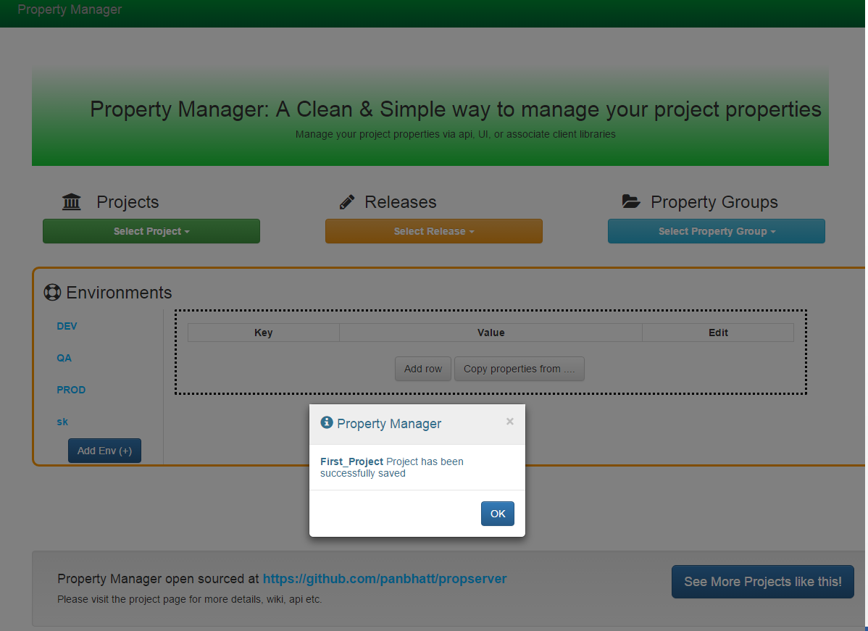

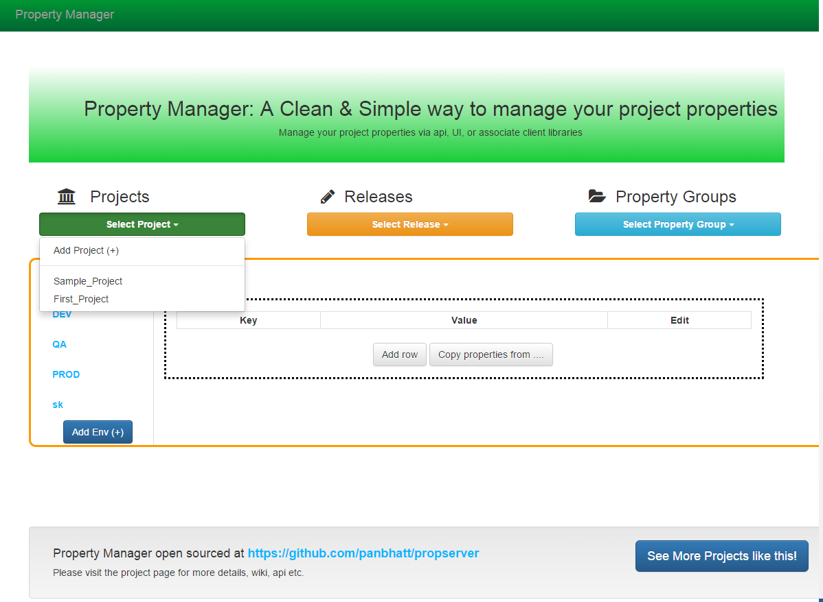

1. Similarly we need to click on “Select Release” to either select a specific release in the project or add a new release in the selected project. A project must be selected before adding a release.

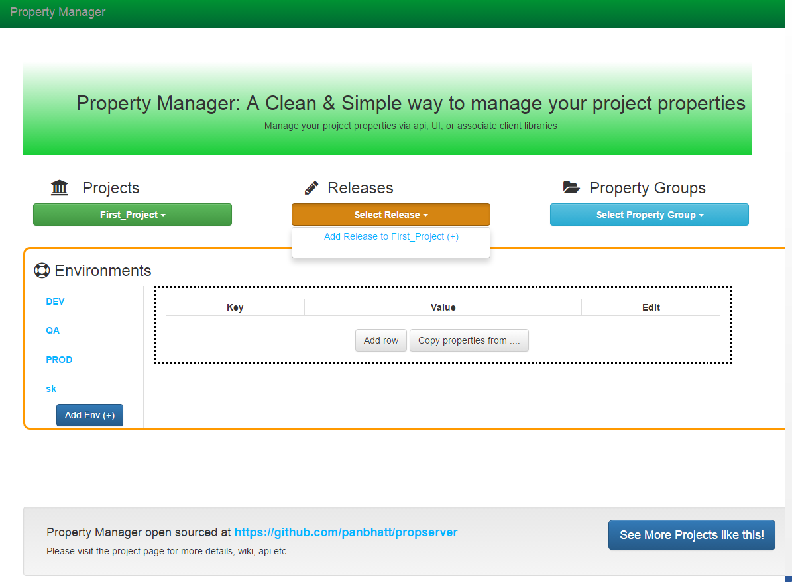

1. A Popup will appear asking for the RELEASE version and the description. Fill in the required details e.g. Release as “**v1.0.0**”and click on OK.

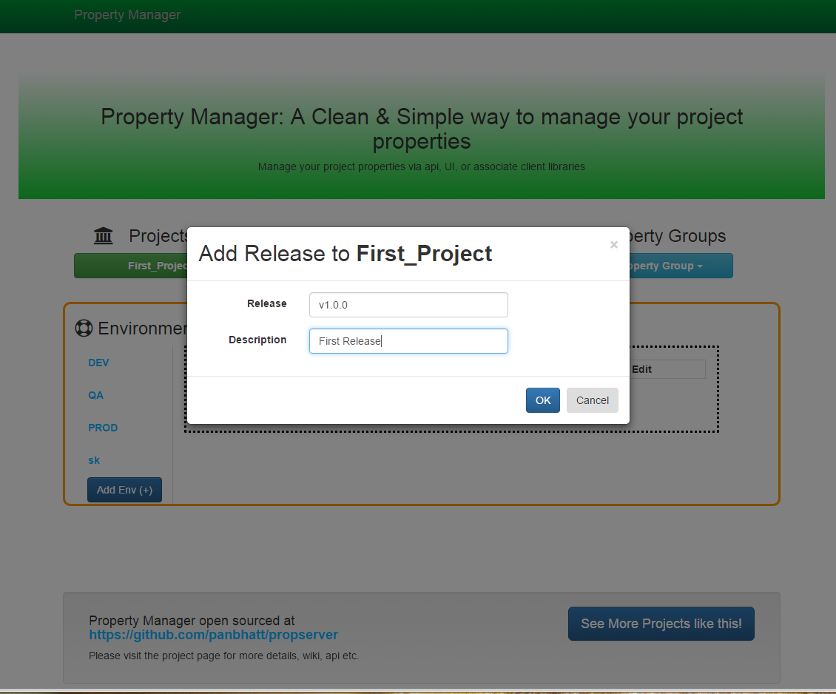

1. A Popup box will appear indicating that the release has been added successfully for this project. It will be automatically added to the List of releases too.   
   Select the release from the list to make it the current one under we are going to made the changes.

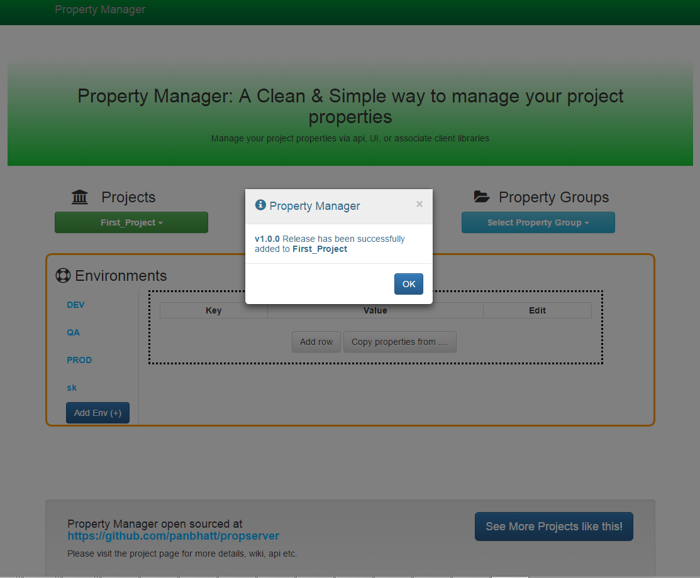

1. Similarly, select the available list of PROPERTY GROUPS or add a new property groups for the selected project. Multiple property groups are associated with a project. A selected group of properties available for a PROJECT/ENVIRONMENT/RELEASE/PROPGROUP.   
   However the client API like NODEJS, JAVA doesn’t take the PROPGROUP as input, as it searches for the properties across the combination of PROJECT/ENVIRONMENT/RELEASE.

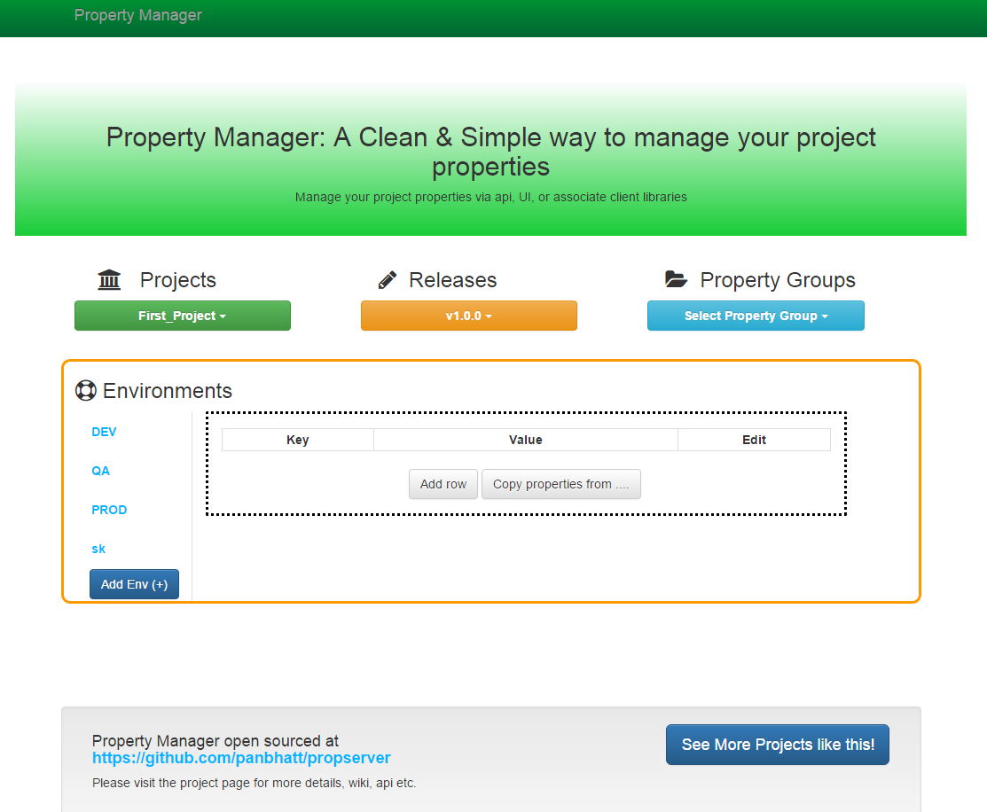

1. Click on “Add Group to YOUR_PROJECT_NAME”. A Popup will appear asking for the information for the property group that is to be added. For E.g. Add the name as “DB_Properties” and any available description. Click on OK.

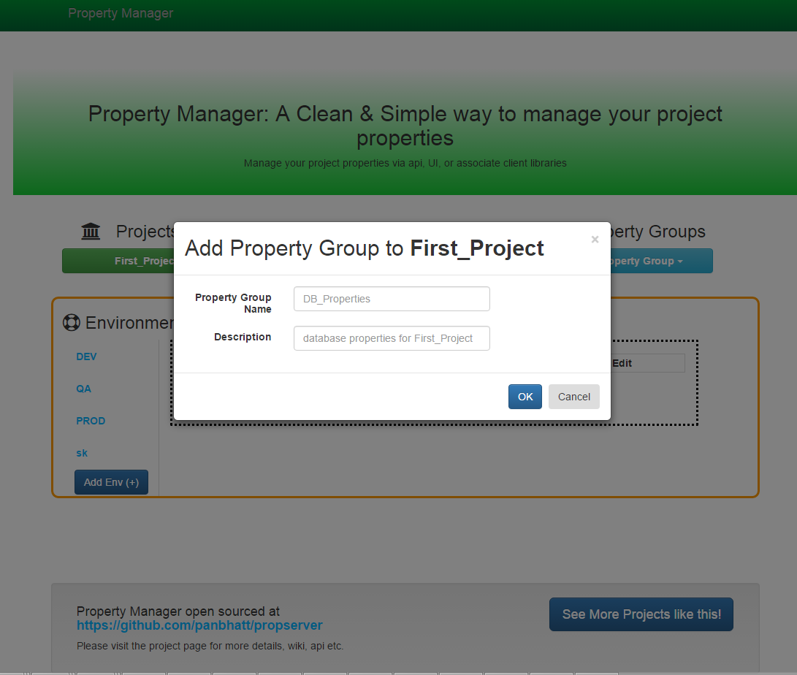

1. A Popup will appear signifying that the property group has been added for the selected project & it will also be displayed in the list of currently available property groups.

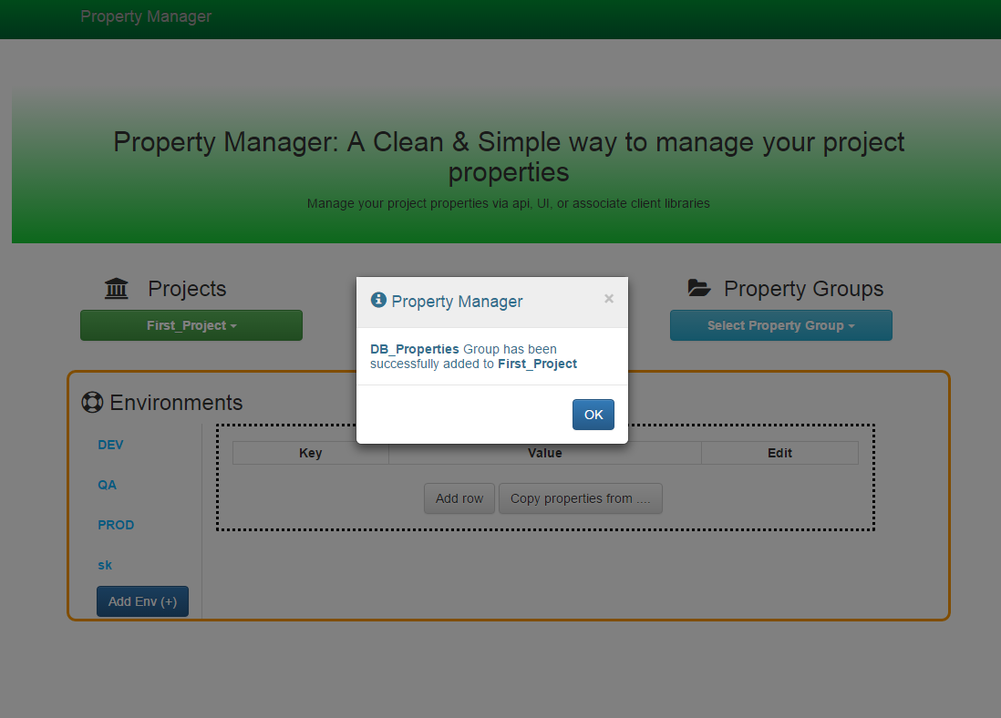

1. Select a property group available, for which we wanted to manage the properties as shown below.

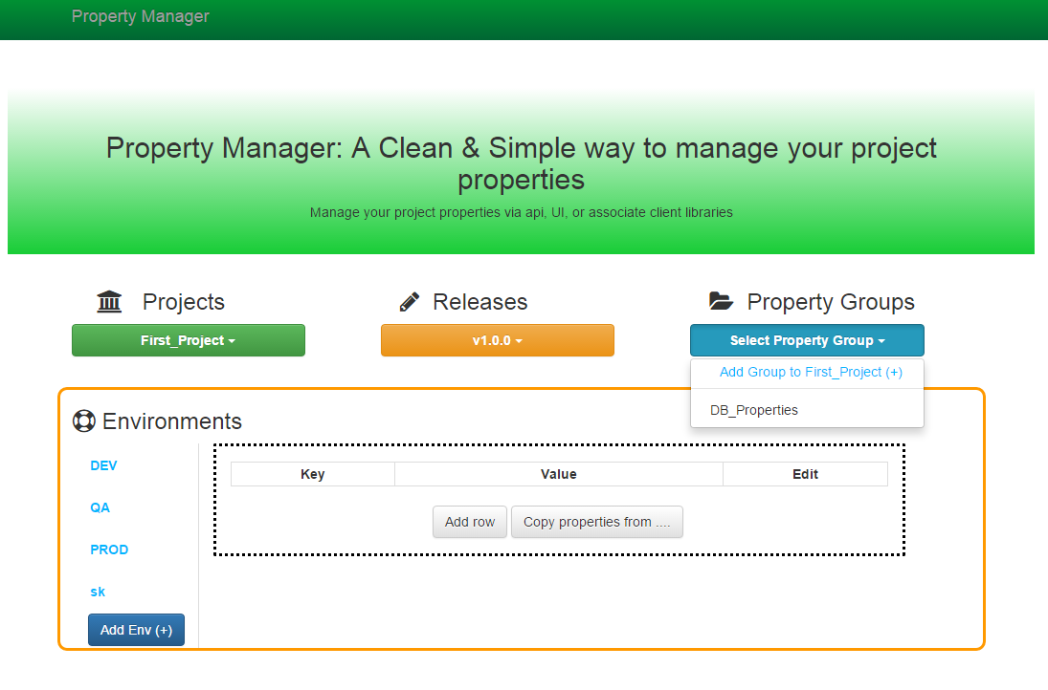

1. Select an Environment also available on the left side of the Window where the effect would take place.

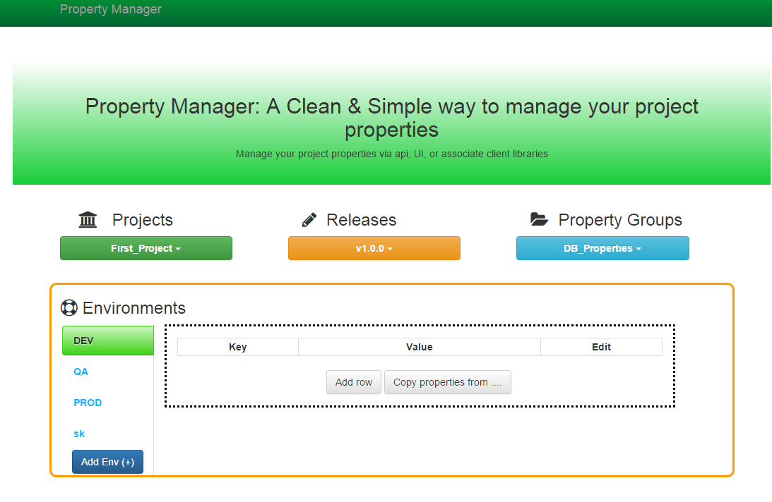

1. A Empty list of properties will be displayed. Click on “Add Row” to add a property key and its value for the selected combination of PROJECT/ENVIRONMENT/RELEASE/PROPERTY GROUP.   
   Click on “EDIT” to edit the name and value & once done click on “SAVE” to save the key/value in the database for the combination. A Popup will appear signifying that the property key has been added.

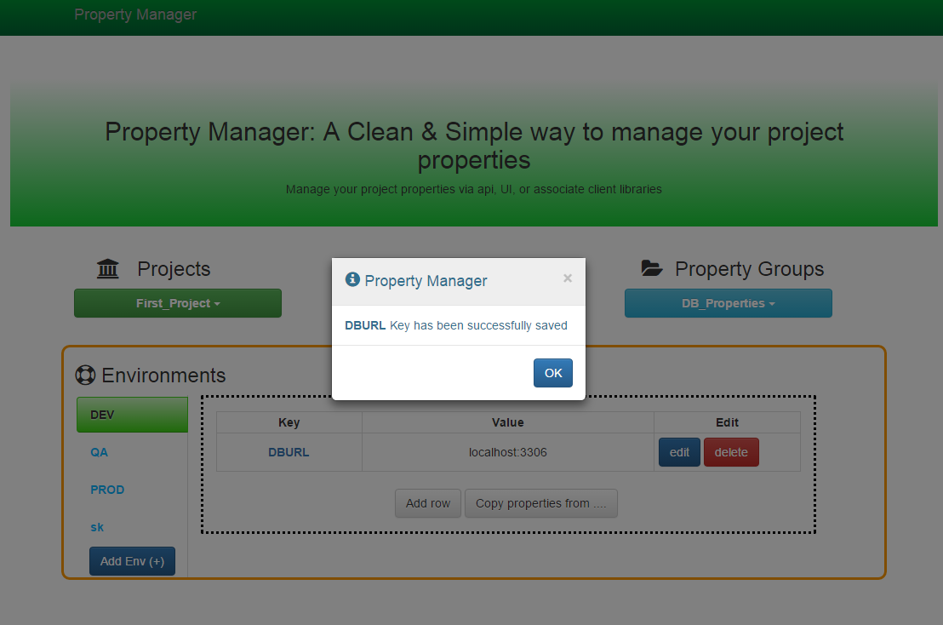

1. Once multiple properties are entered, it can be saved and then we can go and add multiple property groups and save as many properties as we want.
2. Once we did so, we can use them in our project via using the Java API/NodeJS client api (the links are available on the project page). We do not need to specify the property group while getting the properties as it is just a logical separation of properties. However we have to make sure that the property names are not same across multiple property groups, otherwise the first property will always be returned back despite having second present in the property manager.
3. It provides a functionality through which we can copy the properties under a PROPERTY Group to another release or environment/release. To achieve this, select the release/propertyGroup/Environment (this would be our target), since it will not contain any properties (or if it contain all the properties would be overridden). Click on “Copy properties from…” . It will present us with a popup that allows us to select the SOURCE from where we wanted the properties to be inherited.

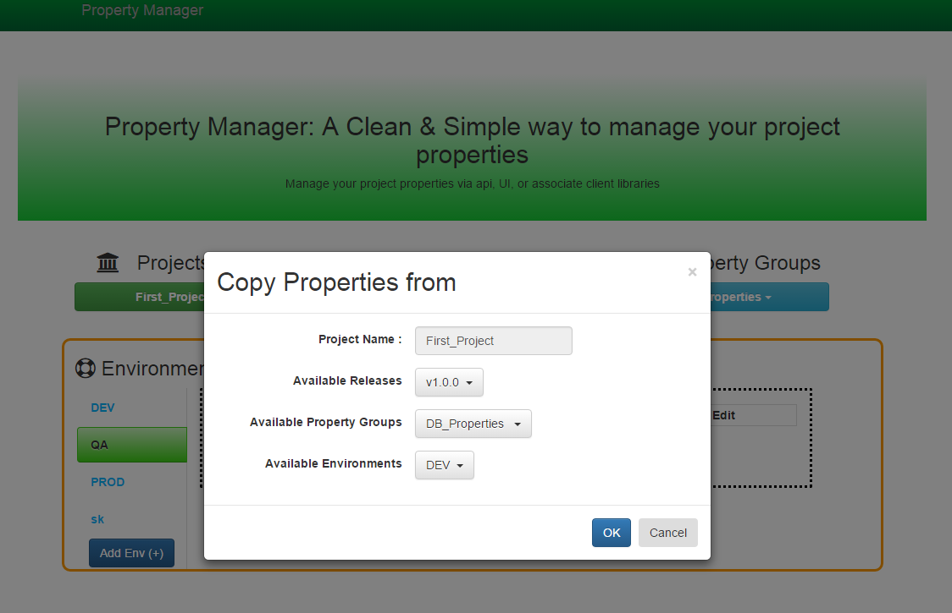

1. Clicking on OK will copy the properties in the current selected environment and automatically saved them in property manager.

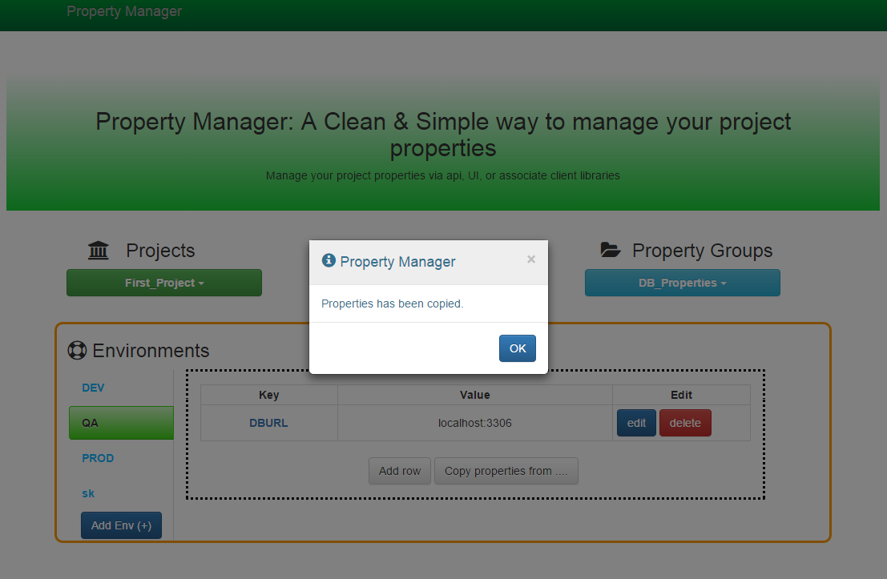

1. If we need more environment to work with we can always click on the “ADD Env(+)” link at the bottom left corner to add a new environment to the Property manager. It will be added globally and will be available to every project. We need to fill the new environment information and lcick on OK. The added environment will be added in prop manager and the UI will be refreshed to show the new environment.

