Assignment(Nitin Jain)

1. Write a program(WAP) to print INEURON using pattern programming logic

Prog:

//INEURON

public class FirstProg {

public static void main(String[] args) {

int n = 5;

for (int i = 0; i < n; i++) {

//FOR PRINTING I

for (int j = 0; j < n; j++) {

if (i == 0 || i == n - 1 || j == n / 2)

System.out.print("*");

else

System.out.print(" ");

}

System.out.print(" ");

//FOR PRINTING N

for (int j = 0; j < n; j++) {

if (j == 0 || j == n - 1 || i == j)

System.out.print("*");

else

System.out.print(" ");

}

System.out.print(" ");

//for E

for (int j = 0; j < n; j++) {

if (i == 0 || i == n - 1 || i == n / 2 || j == 0)

System.out.print("*");

else

System.out.print(" ");

}

System.out.print(" ");

//for U

for (int j = 0; j < n; j++) {

if ((j == 0 && i != n - 1) || (i == n - 1 && j != 0 && j != 3 && j != 4) || (j == 3 && i != n - 1))

System.out.print("*");

else

System.out.print(" ");

}

System.out.print(" ");

//for R

for (int j = 0; j < n; j++) {

if ((i == 0 && j != 3 && j != 4) || (j == 0) || (i == 1 && j == 3) || (i == 2 && j != 3 && j != n - 1) || (i == 3 && j == 2) || (i == n - 1 && j == n - 1))

System.out.print("*");

else

System.out.print(" ");

}

System.out.print(" ");

//for O

for (int j = 0; j < n; j++) {

if ((i == 0 && j != 0 && j != n - 1) || (j == 1 && i != 0) || (j == n - 2) || (i == n - 1 && j != 0 && j != n - 1))

System.out.print("*");

else

System.out.print(" ");

}

System.out.print(" ");

//FOR PRINTING N

for (int j = 0; j < n; j++) {

if (j == 0 || j == n - 1 || i == j)

System.out.print("*");

else

System.out.print(" ");

}

System.out.println();

}

}

}

**O/P-:**

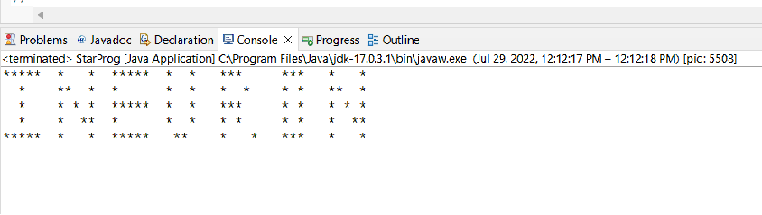

2. Write a program to print

1 1 1 1

2 2 2 2

3 3 3 3

4 4 4 4

Prog: -

public class SecondProg {

public static void main(String args[]) {

for (int i = 1; i < 5; i++) {

for (int j = 1; j < 5; j++) {

System.out.print(i);

}

System.out.println();

}

}

}

**O/P-:**

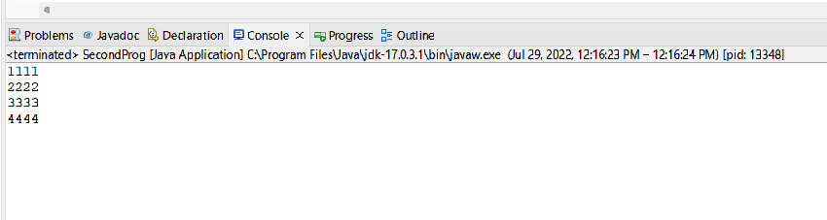

3) Star Pattern Prog1

public class ThirdProg {

public static void main(String args[]) {

int n = 14;

for (int i = 0; i < n; i++) {

for (int j = 0; j < n; j++) {

if (i == 0 || i == n - 1 || j == 0 || j == n - 1 || (i + j) <= (n - 1) / 2 || (i < 7 && j >= 7 && i + j >= (n / 2) + i * 2))

System.out.print("*");

else

System.out.print(" ");

}

System.out.println();

}

}

}

**O/P:-**

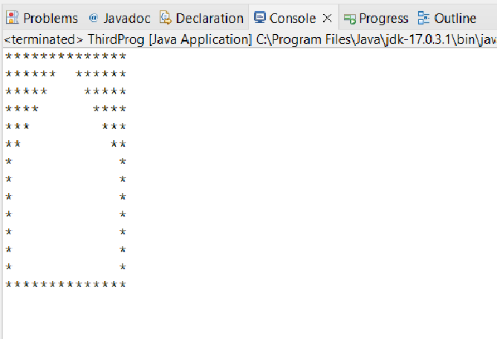

4) Print star pattern 2

package Assignment1;

public class FourthProg {

public static void main(String args[]) {

int n = 14;

for (int i = 0; i < n; i++) {

for (int j = 0; j < n; j++) {

if (i == n - 1 || i == n - 2 || (i >= 6 && j < 6 && (i + j) >= (n - 1) / 2 + (j * 2)) || i >= 6 && j > 6 && i + j >= (n + (n - 1) / 2 - 1))

System.out.print("*");

else

System.out.print(" ");

}

System.out.println();

}

}

}

**O / P: -**

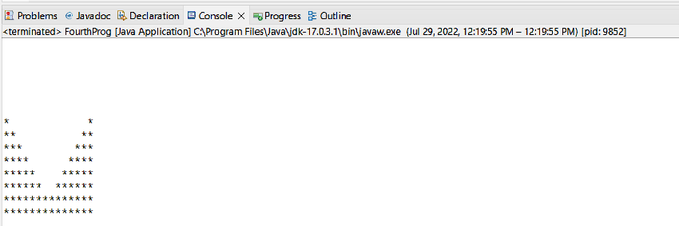

5) Star pattern 3

package Assignment1;

public class FifthProg {

public static void main(String args[]) {

int n = 14;

for (int i = 0; i < n; i++) {

for (int j = 0; j < n; j++) {

if (i == 0 || i == n - 1 || (i <= 6 && j <= 5 && (i + j) <= (n - 1) / 2) || i >= 7 && j <= 6 && (i + j) >= ((n - 1) / 2) + (j * 2))

System.out.print("*");

else

System.out.print(" ");

}

System.out.println();

}

}

}

**O/P:-**

