Docker file sample for Python Flask App
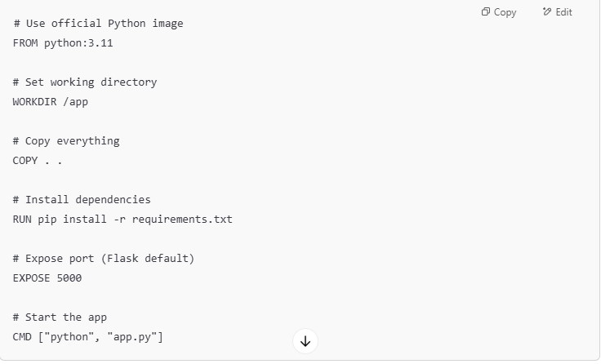
Node.js App Sample Docker file
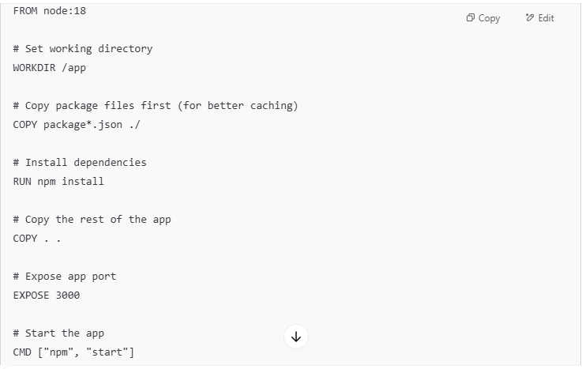
Java Spring Boot App (with JAR)
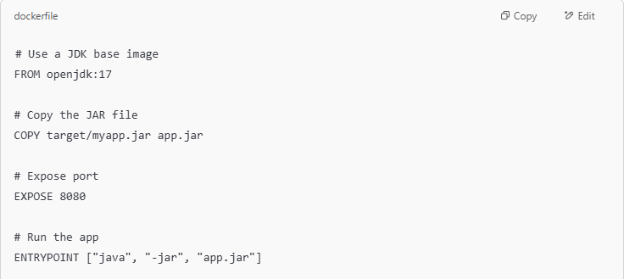

Multi-Stage Dockerfile Example (Python Web App)

# -------- Stage 1: Build stage --------
FROM python:3.11-slim AS builder # AS build is alise name whih will use in next stage of docker file

# Set working directory
WORKDIR /build

# Install build tools
RUN apt-get update && apt-get install -y gcc

# Copy and install dependencies
COPY requirements.txt .
RUN pip install --upgrade pip && \
pip install --user -r requirements.txt

# Copy app code
COPY . .

# -------- Stage 2: Production image --------
FROM python:3.11-slim

# Set working directory
WORKDIR /app

# Copy installed packages from builder
# Below we have used alise name if base image and copied slime package from first image
COPY --from=builder /root/.local /root/.local
ENV PATH=/root/.local/bin:$PATH

# Copy source code
COPY --from=builder /build /app

# Expose app port (adjust if needed)
EXPOSE 5000

# Command to run the app
CMD ["python", "app.py"]

