Que. What is Docker?
- Docker is an open-source platform that package application and dependencies into containers
- Docker containers are created from docker file which has instructions to form container. From the docker file we create a docker image and this image created every stage in layer form.
- Docker containers are lightweighted, standalone, and executable software packages that include everything need to run container
IMP: - Docker container uses host OS kernel, there is no custom or additional kernel inside running container
Que. VM vs Docker?
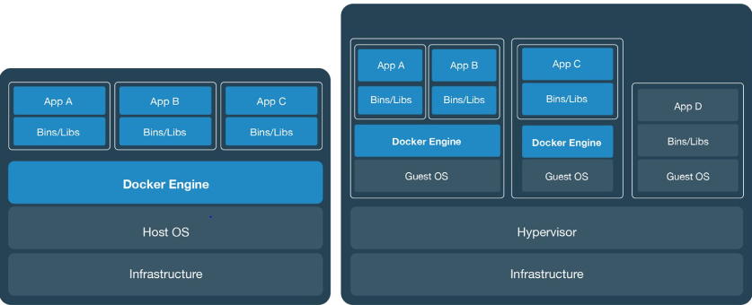
Features | Virtual Machine (VMs) | Docker (Container)
Isolation level | Full OS virtualization required | Process level isolation via Container runtime
Boot Time | In Minutes (need to boot OS) | In Seconds (just start App)
Size | Heavy (GBs, full OS image) | Lightweighted (Only in MBs, only what is required for app)
Resources (CPU/RAM) | Use more CPU, RAM | Very efficient with system resources
Used Cases | Legacy app, which requires full OS  UI apps or OS level testing | Used of lightweighted microservices

Que. What Docker Images?
- Docker images are created in form of layers with help of Docker file
- While creating Docker images it follows instruction define in docker file which has command to set application configuration and dependencies
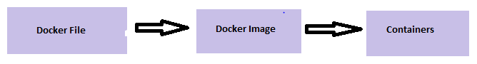
Que. Why Docker Containers are lightweighted?
- Docker Containers are lightweighted because they do not have complete OS and they use base OS images
- Eg. If your container is running on EC2 instance, it uses base OS of EC2 instance
- Containers are very easy to shift to move from one platform to another in form of docker images, where we just need to run images to create containers.

Que. How to delete containers and images?
- Docker rm <container id> à delete containers
- Docker rmi <image id> à delete image
Que. Docker file Instructions?
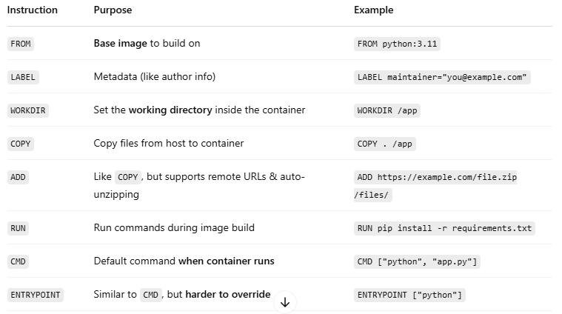

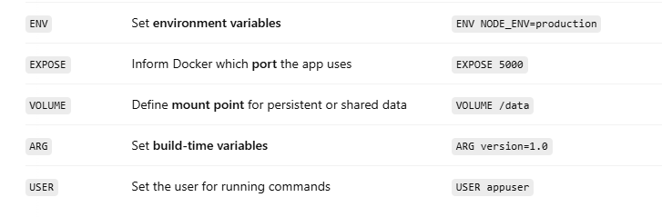
Que. Docker Arcthicture?
- Docker Engine – It help to run container
- Docker Demon – Help to create and manage container, in backend dockerd and containerd is running to create container
- Docker CLI - User pass command command and it goes to Docker demon

Que. RUN & CMD diffrence? (Both are Docker file command)
- RUN: it execute command inside docker image. (eg: if you want to install package or create Directory inside of your Dockerimage then RUN will be used)
- CMD: we can run/execute command/script duing container creation not the image creation.

Que. ENTRYPOINT & CMD diffrence? (Both are docker file instructions)
- CMD: when you define CMD command in docker file (eg: CMD "java") and while creating/run Container & if you pass "ping google.com" then it will overwrite CMD command mention in Docker file & image and it will execute next command "ping google.com"
- ENTRYPOINT: When you define ENTRYPOINT in dockerfile & create image, same command which you have passed in docker file will executed while creating container. You cannot run other entrypoint while creating contaier.
ENTRYPOINT is used to define command in fix format which will not change while creating container. But in CMD you can change command while running conatiner

Q. Where docker volume is stored?
--> /var/lib/docker/volume
--> command to map volume (docker -v /home/mount/data:/var/lib/mysql/data)
- Docker volume is used to prevet data from container, in case if we restart, stop container there is chance to loss of data, so docker volume is used
- This volumes are stores in part of host filesystem
- name pipes volume(mount): it is used communicate between docker host and containers

Que. Why Docker Compose? (yaml - yet another markup language)
- If we need to setup complex application by running multiple services on multiple COntainer, it is better way to use Docker Compose
- With Docker Compose we can crete configuration file in yml or yaml format (docker-compose.yml)

Imp Point (Ref below docker file for multi build docker image)
Que. MultiStage build Docker file?
Que. How you will reduce size of Docker image?
- Using Multistage docker file we can redure size of docker image.
- Multistage build allow to use multiple FROM statemet in docker file, where each FROM will start new file and carry required compressed dependences from previous FROM statement, to achive this we use alise name to carry first FROM base image to next FROM statement
- You can define alise in 1st FROM stagement and use this alise name in second FROM statement, which will compress 1st FROM statement base image and carry to second image
- This help to reduce docker file size

Multi Stage Build – Sample Docker file
# -------- Stage 1: Build stage --------
FROM python:3.11-slim AS builder #AS build is alise name which use next FROM stage

# Set working directory
WORKDIR /build

# Install build tools
RUN apt-get update && apt-get install -y gcc

# Copy and install dependencies
COPY requirements.txt .
RUN pip install --upgrade pip && \
pip install --user -r requirements.txt

# Copy app code
COPY . .

# -------- Stage 2: Production image --------------------------
FROM python:3.11-slim

# Set working directory
WORKDIR /app

# Copy installed packages from builder Here we have used Alise name of first Image
COPY --from=builder /root/.local /root/.local
ENV PATH=/root/.local/bin:$PATH

# Copy source code
COPY --from=builder /build /app

# Expose app port (adjust if needed)
EXPOSE 5000

# Command to run the app
CMD ["python", "app.py"]

Que. How many Docker components are there ?
- Docker Engine – it has Docker demon and Docker CLI
- Docker Images
- Docker containers
- Docker File
- Docker compose
- Docker Volumes
- DOckerket Network
- Docker Registory

Que. Docker Networking:
(When you install docker, by default it will create 3 networks)
- NOTE: Below network are also know as Network drivers
- Bridge Network: This network will paly main role for whole docker system, which help container to communicate with each other
- Host Network: this network help to host to container communication or container to host communication
- Null : No sence of creating container in null network

- docker network ls --------------------------------------------> will display docker network info
- docker network create <network_name> -d brigde -----> create your own bridge network (Network name - any u can give) (here -d is know as network drive)

Que. Docker container lifecycle?
- Create docker inage
- Create docker container
- Starte Docker container
- Check container status via docker ps -a
- Container stop/start/restart

Que. How you will ensure container 1 is running before container 2 in docker compose?
Ans. Define Health check in yaml file
