Name: Nitin Kandikatla

**Section 0**

1.Create a directory 'project dir' & cd to 'project dir'.

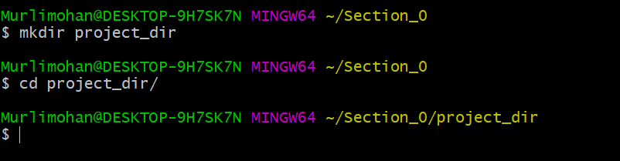

2.Initialize git version database. (git init)

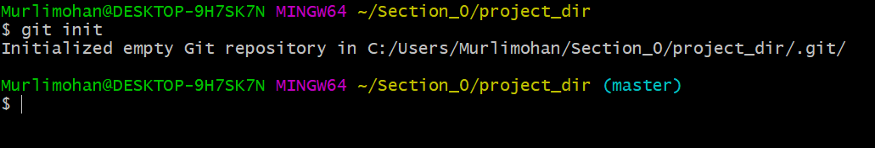

3.Create a new file index.html.

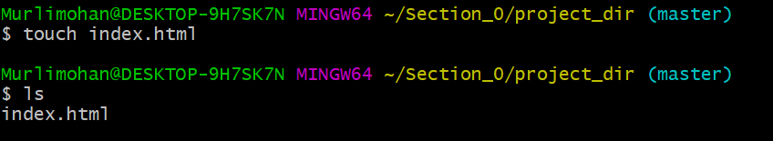

4. Check the git status. You should find index.htmlas untracked file.

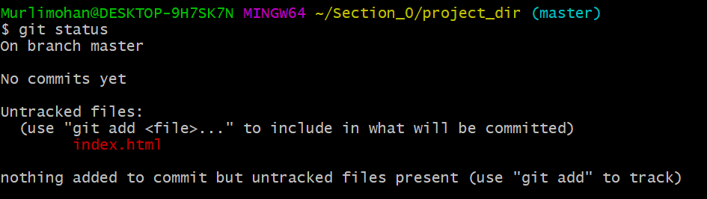

5. Stage the index.html file.

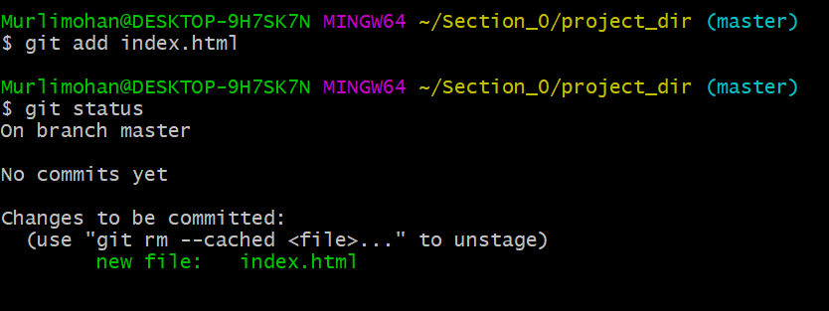

6. Commit index.html

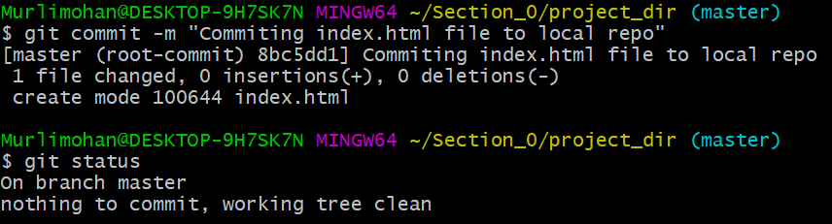

7. Make few changes in index.html & create a new file info.txt file.

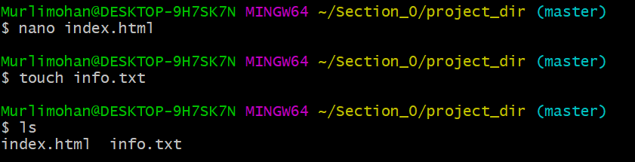

8. Check git status. You should find index.html& info.txt as untracked files.

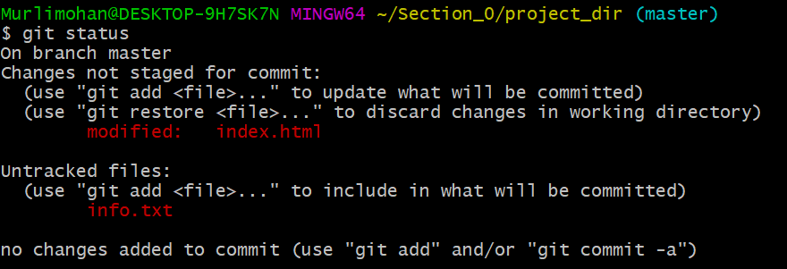

9. Configure GIT to ignore all txt files.

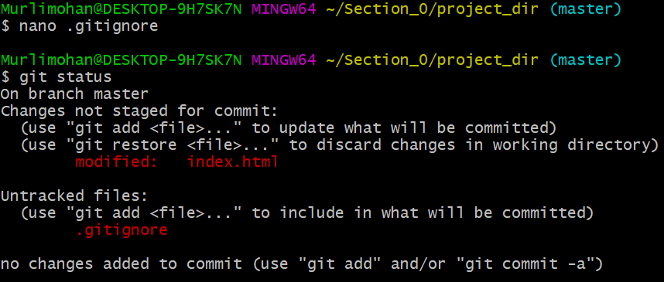

10. Again check the git status. You should find only index.htmlas untracked file.

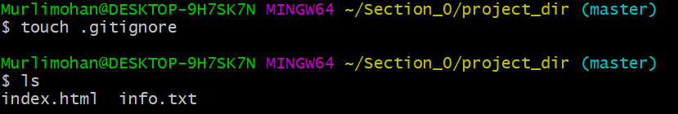

11. State & commit index.html

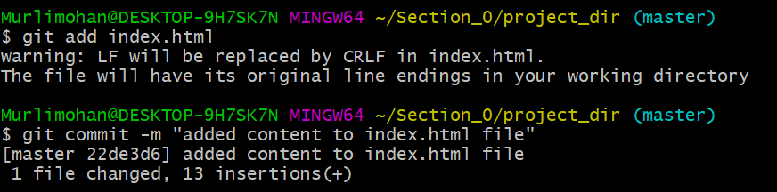

12. Log all your comments so far.

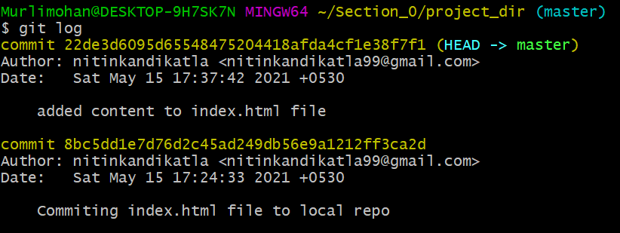

13. Make some changes in index.html.

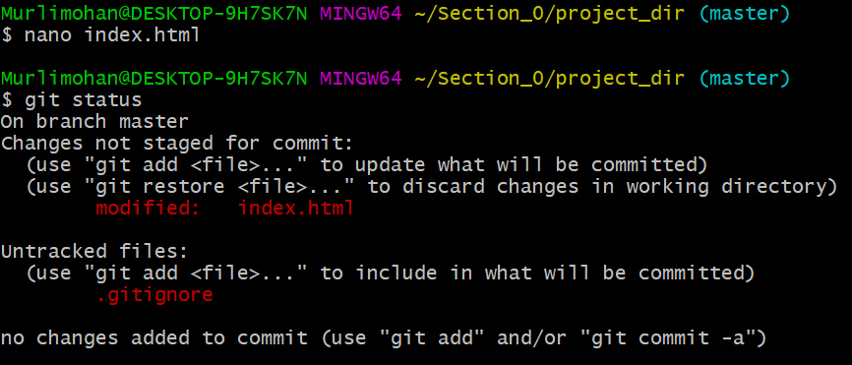

14. Revert the change made in the previous step using git command.

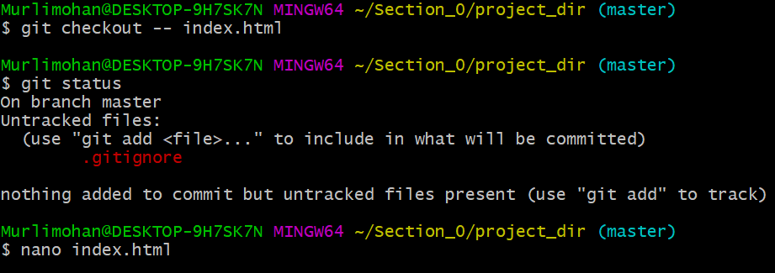

15. Again change index.html.

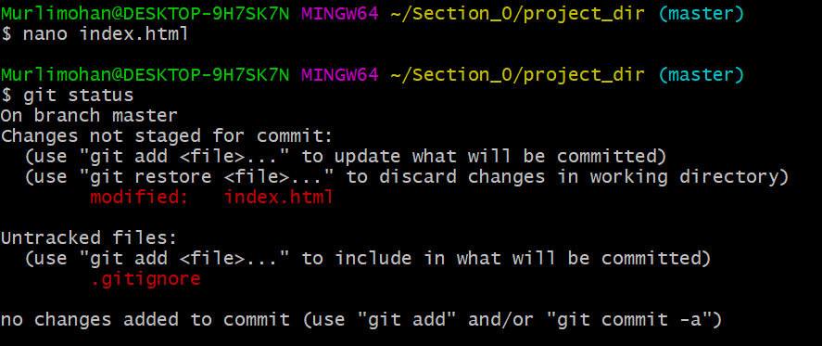

16. Stage index.html

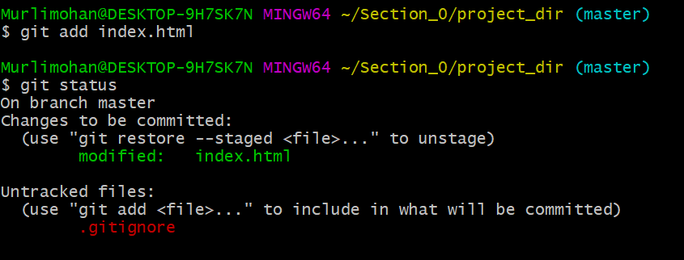

17. Revert back the last stage.

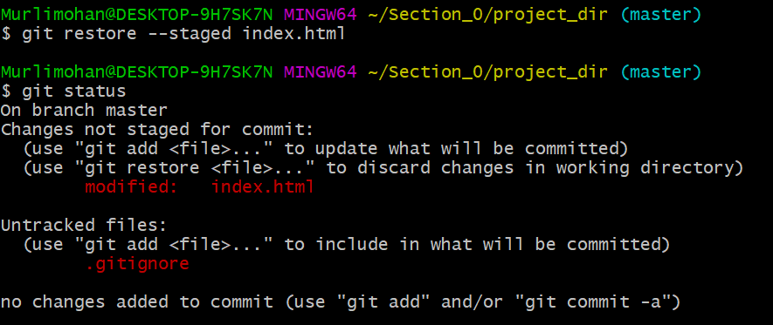

18. Rename add command to 'my-add.



19. Using my add command Stage index.htmlagain & commit the changes.

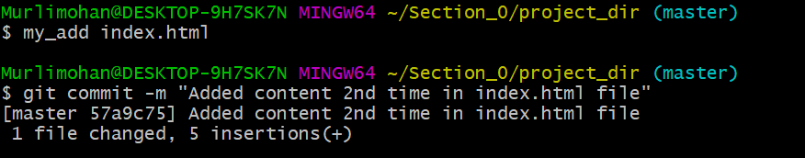

20. Revert the last commit.

