Project monitoring system
Draft scope for discussion with CEL
Version 2.0 · Prepared for review meeting

1. Purpose
This draft sets out what the project monitoring software will do, based on the activity track template shared by CEL and the alert requirements described in the covering note. It is a starting point for the review meeting, not a final specification.
Section 10 lists the points that still need a decision. These are the items we would like to settle in the meeting, along with the remaining alarms and escalation rules that CEL has offered to provide.

2. How this replaces the current workbook
The existing workbook holds one sheet per project — P101 to P104 and P201 for purchase-order related work, R101 and R102 for R&D activity. Each sheet records a project manager and a table of milestones with start and end dates, target and actual, status, the person assigned, and columns for reason for delay, corrective action and support from HOD.
The software keeps this structure. The same people record the same information, entered directly into the system rather than into a sheet. What changes is that the system then acts on those dates: it watches every milestone and raises an alert on its own, instead of relying on someone noticing.
Values are entered in the system by the project manager and the person assigned to each milestone. There is no spreadsheet upload; the workbook is replaced rather than imported.

3. Overall workflow
The system is used in a fixed order. An administrator sets up the people, a project manager sets up the work, and from that point the system watches the dates on its own.
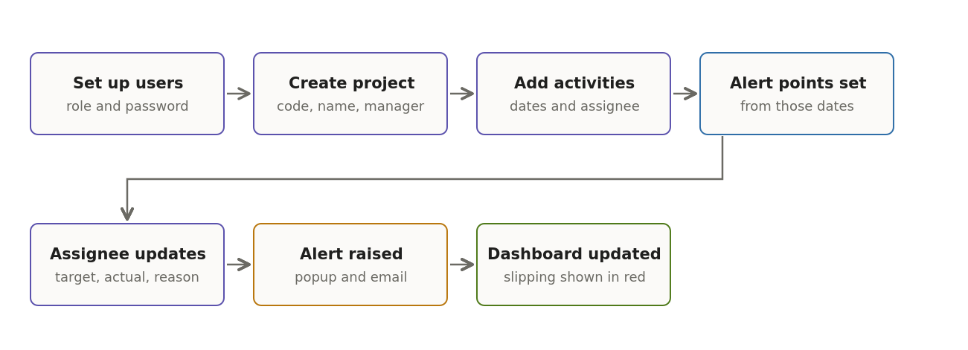
The first four steps are set-up, done once per project. The last three repeat for the life of the project.

3.1 Setting up users
An administrator opens the users screen and creates each person directly: full name, login name, password and role. There is no email authentication and no self sign-up — the administrator sets the password and hands it over.
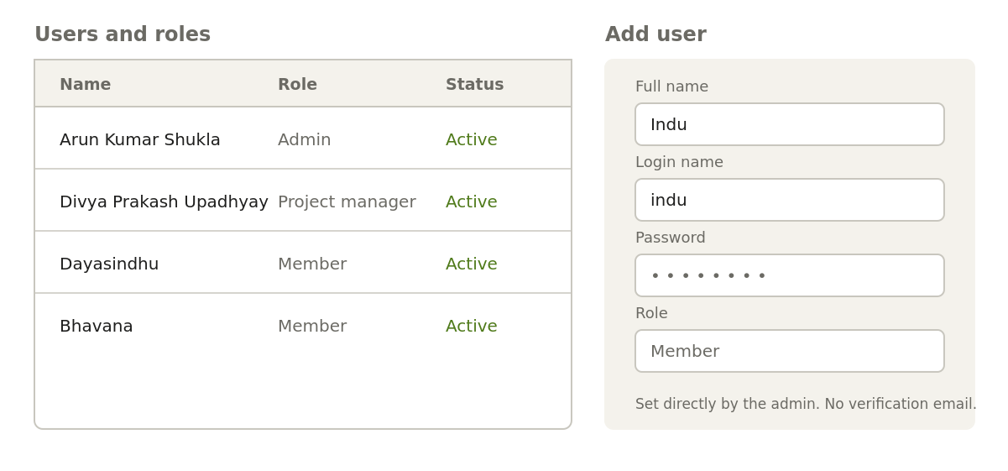
Users are created by the administrator. No verification email is sent.
One consequence of having no email authentication: a forgotten password has to be reset by an administrator from this screen, since the system cannot send a reset link. The administrator sets a new password and informs the user.
Role | What they can do
Administrator | Create users, create projects, see and edit everything
Project manager | Create and edit their own projects and activities, update status
Member | See projects, update status on activities assigned to them

3.2 Setting up a project and its activities
A project is created with a code, a name, a type and a project manager. Activities are then added to that project, each with a start date, an end date and the person assigned to it. Nothing else is required.
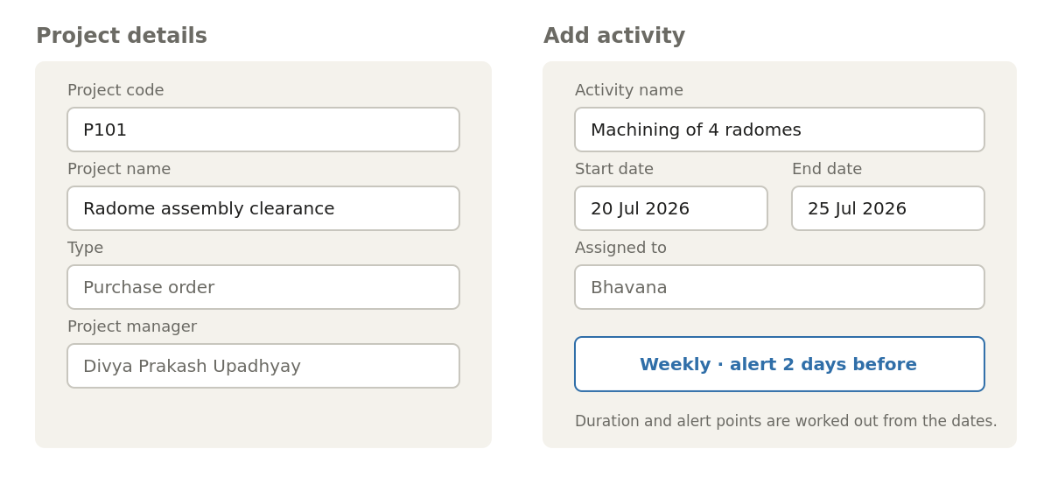
As soon as the dates are entered the system classifies the activity and shows which alerts it will raise, so the user can see the effect before saving.
The duration classification and the alert points are worked out by the system from the dates entered. The user does not set them.

3.3 Day-to-day use
- The dashboard is the first screen after login and lists every project with its status. Projects that are slipping are shown in red.
- Clicking a project line opens that project, showing its activities with dates, assignees and status.
- The person assigned to an activity updates its status, actual date, and where relevant the reason for delay and corrective action.
- When an activity reaches an alert point, the beacon popup is raised and the email is sent.
- Any change to status flows straight to the dashboard, so the project colour is always current.

4. Scope
Included | Not included at this stage
Projects with a project manager | Purchase order and sales value tracking
Milestones with start and end dates | Percentage resource allocation
Target, actual and status per milestone | Gantt chart with dependencies
Person assigned to each milestone | Mobile application
Reason for delay and corrective action | Integration with other CEL systems
Support from HOD and HOD remark | Automatic changing of any date
Beacon popup alerts with history
Email alerts on the same rules
Status dashboard across all projects
Users and roles

Purchase order and sales columns appear in the current workbook but are not included above. Whether the software should also hold them is question 1 in section 10.

5. Alerts
This is the core requirement and is described here in full.

5.1 Rules
Every milestone is classified by its own duration, and alerts are calculated from its start and end dates. Nothing is hard-coded; the thresholds can be changed by an administrator without a software change.
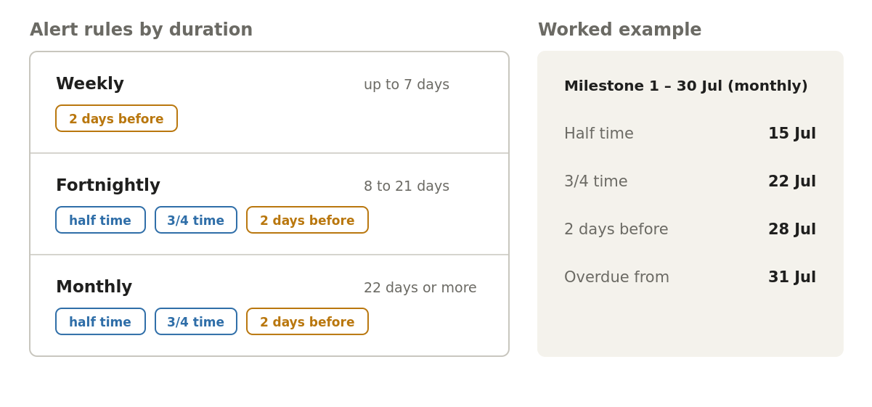
Alert points are proportional for longer milestones and fixed for weekly ones, as described in the covering note.
Duration | Alerts raised
Weekly | 2 days before the end date
Fortnightly | At half time, at three-quarter time, and 2 days before the end date
Monthly | At half time, at three-quarter time, and 2 days before the end date

5.2 Beacon popup
When an alert point is reached, the system raises a popup window inside the application. At this stage the popup is shown to all users, so that nothing is missed while the reporting lines are being agreed.
Closing the popup does not delete it. Every alert is kept, and any user can reopen the full history at any time from an icon in the header. This means an alert dismissed in a hurry can still be found later.
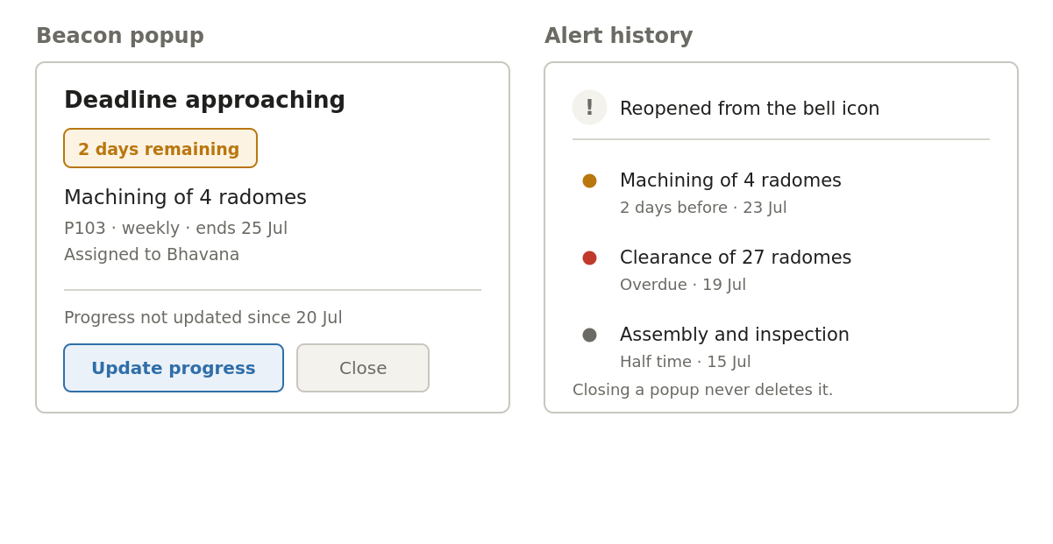
Left, the popup raised at an alert point. Right, the same alerts reopened from the header icon after being closed.

5.3 Email
The same alert points also send an email, so that a person who is not logged in is still informed. Email content matches the popup.
Each alert is recorded once. A restart or a retry cannot cause the same alert to be raised or emailed twice.

6. Screens
The following wireframes show layout and content. Colours and wording will be refined during build.

6.1 Project status dashboard
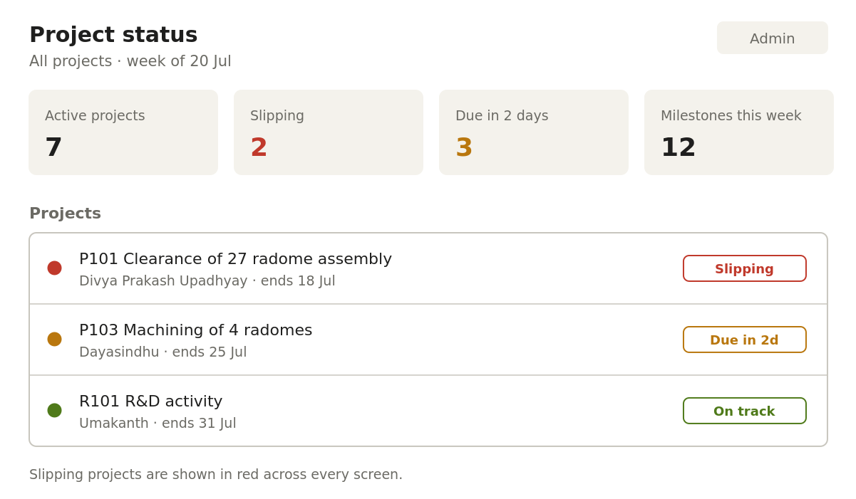
Projects that are slipping are shown in red. The same red is used consistently on every screen so that a problem project is recognisable at a glance.

6.2 Project and milestones
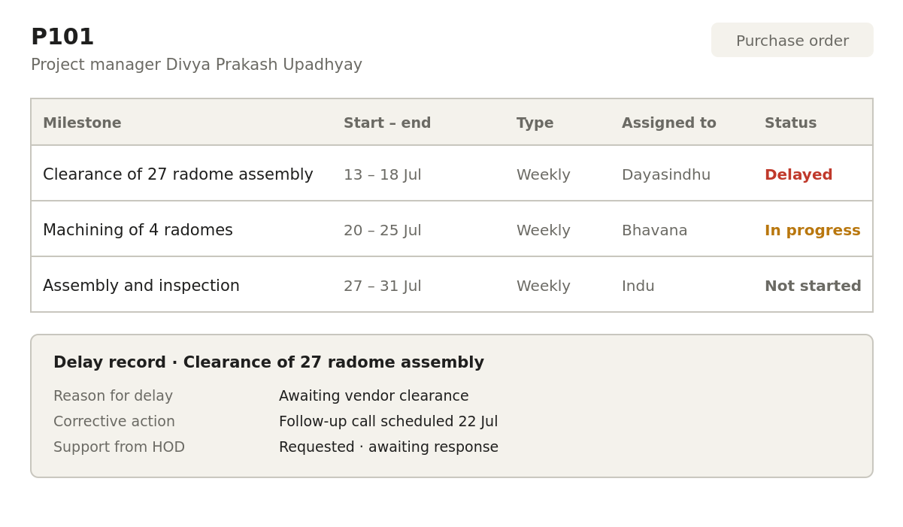
The milestone table follows the columns of the existing workbook. Reason for delay, corrective action and support from HOD are recorded against the milestone that is late.

7. Technical approach
The architecture is deliberately small. Everything runs on one server inside CEL’s own network. There is no cloud service, no external dependency other than CEL’s mail server, and no component that requires specialist support to keep running.
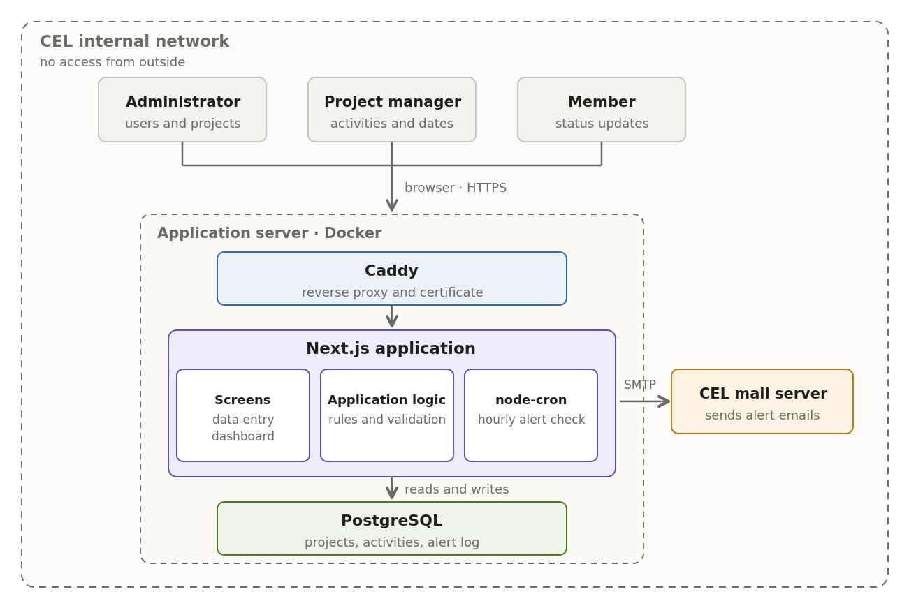
Everything inside the outer boundary sits on CEL premises. The inner boundary is the single server on which the system is installed.

7.1 What each part does
Part | What it does
Caddy | Receives every browser request, applies the HTTPS certificate, and passes the request to the application. Nothing else is exposed.
Screens | Everything the user sees: login, user setup, project and activity entry, the dashboard, and the beacon popup.
Application logic | Applies the rules. Works out whether an activity is weekly, fortnightly or monthly, calculates its alert points from the dates, decides which projects are slipping, and checks what each role is allowed to do.
node-cron | Wakes up every hour, asks the database which activities have reached an alert point, and raises the popup and the email for those that have.
PostgreSQL | Holds everything: users, projects, activities, dates, status, delay records, and a log of every alert raised.
CEL mail server | Delivers the alert emails. The system does not run a mail server of its own.

7.2 How a screen is served
A user opens the system in a browser on the CEL network. Caddy receives the request and applies the certificate. The application checks that the user is logged in and what role they hold, reads what it needs from PostgreSQL, and returns the screen. Nothing is fetched from outside CEL at any point.

7.3 How an alert is raised
This is the path that matters most, so it is described step by step.
- Every hour, node-cron runs a check inside the application.
- The check asks PostgreSQL for activities whose half time, three-quarter time, or two-days-before point has been reached and for which that alert has not already been raised.
- For each one found, a record is written to the alert log. This record is what makes the alert appear as a beacon popup, and what keeps it available in the alert history after it is closed.
- The same alert is passed to CEL’s mail server for delivery by email.
- Because the alert log is written first and checked before raising anything, the same alert cannot be raised twice, even if the server is restarted partway through the hour.
No date is ever changed by this process. The system reads the dates that users have entered and acts on them; it does not move them.

7.4 Why this shape
- One server, started by one command. There is no cluster to manage and no queueing service to keep running.
- The alert check runs inside the application. Nothing has to be added to the server’s own scheduler, so there is one less thing to configure and one less thing that can be switched off by mistake.
- All data stays in PostgreSQL on CEL premises. There is no external storage and no data leaves the network.
- Every component is open source with no licence cost, and each is widely used, so the system can be maintained by any competent developer after handover.

7.5 Components
Layer | Technology
Application | Next.js — screens and server logic in one codebase
Database | PostgreSQL
Authentication | Auth.js — user name and password
Email | Nodemailer over CEL’s SMTP server
Scheduling | node-cron, running inside the application
Web server | Caddy — reverse proxy and certificate handling
Packaging | Docker, started with a single command

8. Deployment
The system is installed on a server provided by CEL and runs as containers started by a single command.

8.1 Web address and access
The system is reachable only from inside the CEL network. It is not published to the internet, and no port is opened on the external firewall. This removes a large part of the security burden and means project data never leaves CEL premises.
It can still use a name under the existing CEL domain, for example projects followed by the existing domain name, resolved by CEL’s internal DNS. No change is made to the existing public website.
One consequence follows from internal-only access. The link inside an alert email opens the system, and that link will only work when the recipient is on the CEL network. Someone reading the alert on a phone away from the office will see the alert text and the details of the activity, but cannot open the system until they are back on the network. The email is therefore written to carry the full details rather than relying on the link.
Because the system is not reachable from the internet, an HTTPS certificate cannot be issued automatically. If CEL has an internal certificate authority, a certificate issued by it is preferred, since staff machines will already trust it. If not, the alternatives are a self-signed certificate installed on staff machines, or plain HTTP within the internal network if CEL’s security policy permits it. This is question 11.

8.2 Required from CEL
- A Linux server with Docker installed and able to retrieve container images.
- SMTP server details and credentials, with outbound access confirmed through the firewall. Without this the email alerts cannot be sent.
- An internal host name and DNS record pointing at the server.
- A named person to act as the first administrator.

8.3 Provided at handover
- Installation runbook and deployment configuration
- Nightly database backup and documented restore procedure
- Administrator guide covering users and alert settings
- Source code and database schema

9. Indicative plan
Expressed in weeks from start. Dates will be added once the start is agreed and section 9 is settled.
Phase | Content | Outcome
Weeks 1–2 | Environment, database, login, users and roles | Users can log in
Weeks 3–5 | Projects, milestones, data entry screens | Workbook content can be entered
Weeks 6–9 | Alert engine, beacon popup, alert history, email | Alerts are raised and emailed
Weeks 10–11 | Status dashboard, delay and corrective action records | Full status view is live
Weeks 12–13 | Installation on CEL server, testing, handover, training | System in use

The alert engine is scheduled early rather than at the end. It is the requirement CEL values most and the one that depends on CEL’s mail server, so it is proved while there is time to resolve any access issues.

10. Points to settle in this meeting
These items change either the scope or the alert behaviour, and cannot be decided by us.

10.1 Scope
- Should the software hold the purchase order and sales columns — PO number, PO value, order quantity, quantity supplied, sales achieved, pending sales orders — or only milestones and dates?
- The P-series and R-series sheets carry different fields. Should the system have two project types with different forms, or one common form?
- Is "support from HOD" a request that is raised and then answered in the system, or simply a note?
- Is a risk register with likelihood and impact wanted, or are reason for delay and corrective action sufficient?

10.2 Alerts
- An alert at half time is most useful when it compares time elapsed against work completed. Who updates progress against a milestone, and how often are they expected to do so?
- Is half time measured across the milestone’s own start and end dates, or across the whole project?
- Is weekly, fortnightly or monthly set by the user on each project, or worked out from the dates entered?
- Should the popup continue to be shown to all users, or be limited to the assigned person, the project manager and the HOD once reporting lines are agreed?
- Should acknowledging a popup be recorded against the user, or is closing it enough?
- Please confirm the remaining alarms and the escalation matrix in writing: who is escalated to, after how long, and for which project types.

10.3 Environment
- Does CEL have an internal certificate authority that can issue a certificate for the system? If not, is a self-signed certificate or plain HTTP acceptable on the internal network?
- What internal host name should the system use, and who maintains the internal DNS record?
- How many people will use the system, and do they all have CEL email accounts?
- Which server will it be installed on, and can it send mail through CEL’s mail server?

11. Approval
This draft is issued for discussion. Once section 10 is settled it will be reissued as a final scope document for signature.

Name | Signature | Date

