Project 1 Report

Experimental Analysis of Sorting Algorithms

CS 5120

Design and Analysis of Algorithms

Nitin Chaurasia

Academic Supervisor:

Dr. Robert Dyer

Fall 2014

Department of Computer Science

Bowling Green State University, Ohio

Project 1

Nitin Chaurasia

Supervisor: Dr. Robert Dyer

Dept. of Computer Science

Bowling Green State University, Ohio

Reporting date: Oct/20/2014

### Introduction

The Programs are implemented to compare the theoretical runtime with that of the experimental. Presented below is the Theoretical Performance of Sorting Algorithms for each of the 4 cases.

1. **Random Data**

1.1 Insertion Sort: Θ(n2): The first for loop will iterate n times and then for each iteration, there is another nested for loop that iterates n times. So n*n or Θ(n2).

1.2 Quick Sort: Θ(n log2 n): Algorithm always chooses best pivot and keeps splitting sub-arrays in half at each recursion;

T(0) = T(1) = O(1) and

T(n) = 2T(n/2) + O(n)

T(n) = O(n log n)(By using 2nd case of master theorem)

1.3 Heap Sort: Θ(n log2 n): It takes O(n*log2n) time to build a heap. Heapification is applied roughly n/2 times (to each of the internal nodes). And it takes O(n*log2n) time to extract each of the maximum elements, since we need to extract roughly n elements and each extraction involves a constant amount of work and one heapify. Therefore the total running time of heap sort is Θ(n log2 n).

1.4 Merge Sort:Θ(n log2 n): Every iteration splits the problem into two halves until the halving comes down to one. Thus there are log2 n steps involved. We need log2(n) iterations, and each iteration takes exactly O(n) (each iteration is on all sub lists, total size is still n), so total Θ(n log2 n)

1.5 3 Way merge Sort: Θ(n log3 n): At each iteration the array is split into three sub lists, and recursively calls the method. At best case the split it exactly in the factors of 3, and thus the reduction of the original problem(in each recursive call) . We need log3(n) iterations, and each iteration takes exactly O(n) (each iteration is on all sub lists, total size is still n), so at total Θ(n log3 n).

1. **Sorted Data and Identical Data**

2.1 Insertion Sort: Θ(n): Same as above. The complexity is of order of theta(n).

2.2 Quick Sort: Θ(n2) : Because the pivot is always the last element and also quick sort would produce one region with n-1 elements and one with only 1 element at every recursion step. The recurrence for this running time would be (partitioning costs O(n) time):  
T(n) = T(n-1) + O(n) => Θ(n2)(by using mathematical induction).

2.3 Heap Sort: Θ(n log2 n): The total running time of heap sort is Θ(n log2 n).

2.4 Merge Sort:Θ(n log2 n): Every iteration splits the problem into two halves until the halving comes down to one. Thus there are log2 n steps involved. We need log2(n) iterations, and each iteration takes exactly O(n) (each iteration is on all sub lists, total size is still n), so total Θ(n log2 n)

2.5 3 Way merge Sort: Θ(n log3 n): At each iteration the array is split into three sub lists, and recursively calls the method. At best case the split it exactly in the factors of 3, and thus the reduction of the original problem(in each recursive call) . We need log3(n) iterations, and each iteration takes exactly O(n) (each iteration is on all sub lists, total size is still n), so at total Θ(n log3 n).

1. **Reverse Sorted Data**

3.1 Insertion Sort: Θ(n2): because the first for loop will iterate n times and then for each iteration, there is another nested for loop that iterated n times. So essentially n*n or Θ(n2).

3.2 Quick Sort: Θ(n2): Because the pivot is always the last element and also quick sort would produce one region with n-1 elements and one with only 1 element at every recursion step. The recurrence for this running time would be (partitioning costs O(n) time):  
T(n) = T(n-1) + O(n) => Θ(n2)(by using mathematical induction).

3.3 Heap Sort: Θ(n log2 n): because (1) that it takes O(n*log2n) time to build a heap, because we need to apply heapify roughly n/2 times (to each of the internal nodes), and (2) that it takes O(n*log2n) time to extract each of the maximum elements, since we need to extract roughly n elements and each extraction involves a constant amount of work and one heapify. Therefore the total running time of heap sort is Θ(n log2 n).

3.4 Merge Sort:Θ(n log2 n): Every iteration splits the problem into two halves until the halving comes down to one. Thus there are log2 n steps involved. We need log2(n) iterations, and each iteration takes exactly O(n) (each iteration is on all sub lists, total size is still n), so total Θ(n log2 n)

3.5 Merge3 Sort: 3 Way merge Sort: Θ(n log3 n): At each iteration the array is split into three sub lists, and recursively calls the method. At best case the split it exactly in the factors of 3, and thus the reduction of the original problem(in each recursive call) . We need log3(n) iterations, and each iteration takes exactly O(n) (each iteration is on all sub lists, total size is still n), so at total Θ(n log3 n).

**Practical Performances(Θ) of Sorting Algorithms for each case(Time(in micro seconds)):**

Execution Time with Random data

|  |  |  |  |  |  |
| --- | --- | --- | --- | --- | --- |
| **Random - Execution Times** |  |  |  |  |  |
| **Length of Input** | **Insertion Sort** | **Merge Sort** | **Quick Sort** | **Heap Sort** | **3 Way Merge** |
| **1000** | **15714** | **386** | **1693** | **4651** | **3413** |
| **2000** | **6775** | **812** | **4176** | **7384** | **4406** |
| **4000** | **9515** | **133** | **4935** | **8622** | **8593** |
| **8000** | **23187** | **200** | **6021** | **8326** | **27238** |

Graph based on the above table

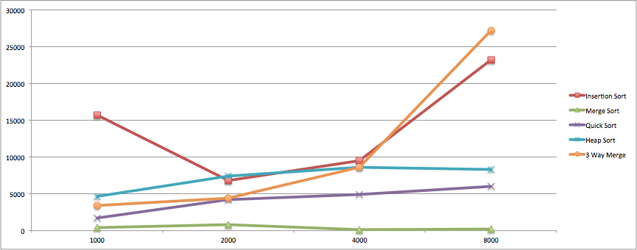

Execution Time with Identical data

|  |  |  |  |  |  |
| --- | --- | --- | --- | --- | --- |
| **Identical - Execution Times** |  |  |  |  |  |
| **Length of Input** | **Insertion Sort** | **Merge Sort** | **Quick Sort** | **Heap Sort** | **3 Way Merge** |
| **1000** | **148** | **205** | **8703** | **701** | **1981** |
| **2000** | **163** | **421** | **7889** | **1693** | **3544** |
| **4000** | **445** | **543** | **20061** | **2759** | **6377** |
| **8000** | **794** | **94** | **69825** | **4700** | **20558** |

Graph based on the above table

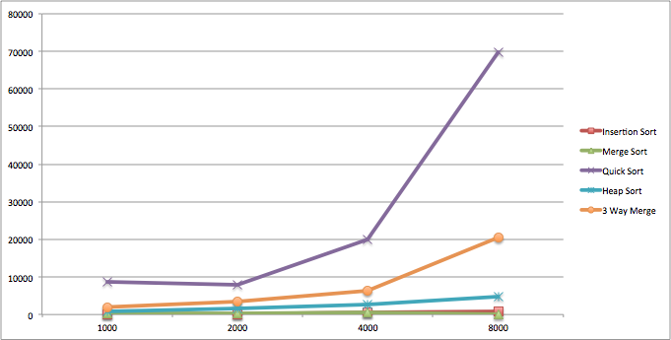

Execution Time with Sorted data

|  |  |  |  |  |  |
| --- | --- | --- | --- | --- | --- |
| **Sorted - Execution Times** |  |  |  |  |  |
| **Length of Input** | **Insertion Sort** | **Merge Sort** | **Quick Sort** | **Heap Sort** | **3 Way Merge** |
| **1000** | **91** | **309** | **8970** | **10398** | **1972** |
| **2000** | **292** | **552** | **9755** | **10454** | **3881** |
| **4000** | **384** | **867** | **17930** | **8164** | **8747** |
| **8000** | **719** | **65** | **62681** | **8412** | **22939** |

Graph based on the above table

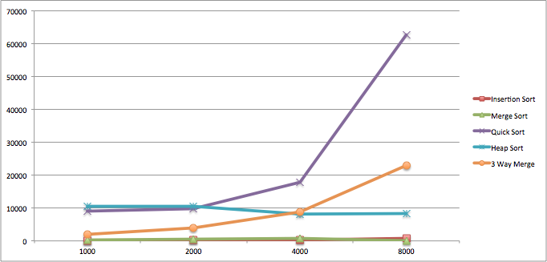

Execution Time with Reversed Sorted data

|  |  |  |  |  |  |
| --- | --- | --- | --- | --- | --- |
| **Reversed Sorted - Execution Times** |  |  |  |  |  |
| **Length of Input** | **Insertion Sort** | **Merge Sort** | **Quick Sort** | **Heap Sort** | **3 Way Merge** |
| **1000** | **9380** | **291** | **7356** | **4615** | **2087** |
| **2000** | **8162** | **597** | **8850** | **9857** | **3718** |
| **4000** | **12898** | **54** | **24122** | **7468** | **9131** |
| **8000** | **35884** | **93** | **53378** | **8913** | **23337** |

Graph based on the above table

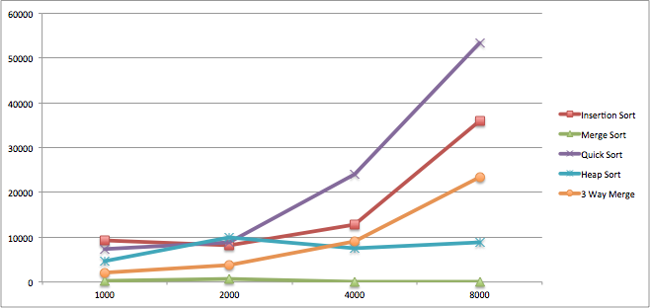

**Table of Sorting Algorithms for each case(Number of Comparisons):**

Presented below is the table giving the total number of comparisons

1. Total number of comparisons with Random Data

|  |  |  |  |  |  |
| --- | --- | --- | --- | --- | --- |
| **Random - Comparisions** |  |  |  |  |  |
| **Length of Input** | **Insertion Sort** | **Merge Sort** | **Quick Sort** | **Heap Sort** | **3 Way Merge** |
| **1000** | **248667** | **31442** | **10770** | **18822** | **17321** |
| **2000** | **971960** | **68710** | **23545** | **41701** | **38519** |
| **4000** | **4008554** | **149642** | **50531** | **91474** | **85699** |
| **8000** | **16153993** | **323128** | **119035** | **198744** | **187835** |

1. Total number of comparisons with Identical Data

|  |  |  |  |  |  |
| --- | --- | --- | --- | --- | --- |
| **Identical - Comparisions** |  |  |  |  |  |
| **Length of Input** | **Insertion Sort** | **Merge Sort** | **Quick Sort** | **Heap Sort** | **3 Way Merge** |
| **1000** | **999** | **24060** | **499500** | **2997** | **6345** |
| **2000** | **1999** | **52124** | **1999000** | **5997** | **13486** |
| **4000** | **3999** | **112252** | **7998000** | **11997** | **29619** |
| **8000** | **7999** | **240508** | **31996000** | **23997** | **65521** |

1. Total number of comparisons with Sorted Data

|  |  |  |  |  |  |
| --- | --- | --- | --- | --- | --- |
| **Sorted - Comparisions** |  |  |  |  |  |
| **Length of Input** | **Insertion Sort** | **Merge Sort** | **Quick Sort** | **Heap Sort** | **3 Way Merge** |
| **1000** | **999** | **24060** | **499500** | **19636** | **6345** |
| **2000** | **1999** | **52124** | **1999000** | **43276** | **13486** |
| **4000** | **3999** | **112252** | **7998000** | **94706** | **29619** |
| **8000** | **7999** | **240508** | **31996000** | **205453** | **65521** |

1. Total number of comparisons with Reversed Sorted Data

|  |  |  |  |  |  |
| --- | --- | --- | --- | --- | --- |
| **Reversed Sorted - Comparisions** |  |  |  |  |  |
| **Length of Input** | **Insertion Sort** | **Merge Sort** | **Quick Sort** | **Heap Sort** | **3 Way Merge** |
| **1000** | **499500** | **23836** | **499500** | **17953** | **12084** |
| **2000** | **1999000** | **51678** | **1999000** | **39924** | **26513** |
| **4000** | **7998000** | **111362** | **7983406** | **87993** | **59858** |
| **8000** | **31996000** | **238760** | **31852038** | **192368** | **126042** |

**Discussion of Results:**

Practical Performance and Theoretical Performance results are consistent.

**Insertion Sort:**

1.) For Random Data: It's theoretical performance(Worst Case) is Θ(n2) and in the practical performance also we are getting a n^2 graph. This was the expectation also. At the time of testing, the run time for the random data file with 1000 entries took more time than that of 2000 for the reasons unknown.

2.) For Sorted Data and Identical data: As It's theoretical performance (Best Case) is Θ(n) and in the practical performance also we have a straight line graph.

3.) For Reverse Sorted Data: It's theoretical performance(worst case) is Θ(n2) and in the practical performance also we are getting a n^2 graph.

**Quick Sort/Merge Sort:**

1.) For Random Data: It's theoretical performance(Best Case) is Θ(n log2 n) and in the practical performance also we are getting a n log2 n graph. As in graph, it is showing a constant line but in reality quick sort graph comes in this way in the best case. This was the expectation.

2.) For Sorted Data: It's theoretical performance(Worst Case) is Θ(n2) and in the practical performance also we are getting a n^2 graph.

3.) For Reverse Sorted Data: It's theoretical performance(Worst Case) is Θ(n2) and in the practical performance also we are getting a n^2 graph. This was the expectation.

Heap Sort and 3 Way Merge Sort:

1.) For Random Data: It's theoretical performance is Θ(n log2 n) and in the practical performance also we are getting a n log2 n graph..

2.) For Sorted Data: It's theoretical performance is Θ(n log2 n) and in the practical performance also we are getting a n log2 n graph. This was the expectation also.

3.) For Reverse Sorted Data: It's theoretical performance is Θ(n log2 n) and in the practical performance also we are getting a n log2 n graph..

As we know that, The merge and heap sort complexity remains same for the best case and worst case means we can give any type of input whether random data, sorted data or reverse sorted data there will be no effect in complexity and same in case of drawing the graph(i.e. practical performance). In case of merge sort, the best or worst case time complexity remains same even if we are dividing the array into three sub-arrays or if we are dividing into k-sub arrays.

**Analysis of Practical results:**

* Insertion Sort is suitable for small files, but again it is an O(n2) algorithm, but with a small constant. Also note that it works best when the data is already almost sorted as can be seen from graph. This algorithm is very good when the file/numbers are already sorted in increasing order.
* Quick Sort results in surprising results. It is an O(n*log2(n)) algorithm on an average and best case and an O(n2) algorithm in the worst case. (Quick sort’s worst case occurs when the numbers are already sorted!!) The graph speaks it all. This algorithm is very good when the data are not sorted in any order(i.e. random data).
* Heap Sort takes O(n log n) in average and worst case, no extra space. On random data somewhat slower than Quick Sort and Merge Sort. If you only need the first few items in a sorted list, it can be better since the initial "heapify" can be done in time O(n) as can be seen from graph. This sorting algorithm is very good for implementing priority queues. This algorithm is very good when the data are already sorted in any order.
* 3 way merge sort and Merge Sort takes O(n log n) in average and worst case, O(n) extra space. On random data they are slower than Quick Sort (graph). Theoretically performs well on external files where all data size is huge. This algorithm performs better when already sorted (in any order).

**Output Results:** Partial Screen shot is presented here

***Snapshot of the executing program***

