**Automotive Suspension**

This problem shows how to model a simplified half-car model that includes an independent front and rear vertical suspension. The model also includes body pitch and bounce degrees of freedom. The example provides a description of the model to show how simulation can be used to investigate ride characteristics. You can use this model in conjunction with a powertrain simulation to investigate longitudinal shuffle resulting from changes in throttle setting.

**Equation:**

**Ff=2Kf(Lf*Theta-(Z+h))+2Cf(Lf*Thetadot - Zdot)**

Where:

Ff,Fr=upward force on body from front/rear suspension

Kf,Kr=front and rear suspension spring constant

Cf,Cr=front and rear suspension damping rate

Lf,Lr=horizontal distance from gravity center to front/rear suspension

Theta,Thetadot=pitch angle and its rate of change

Z,Zdot=bounce distance and its rate of change

h=road height

**Configurations:**

* Callback is used in the model
* Data inspector used to inspect the enable signals
* Matlab function block used in the model
* Signal builder is used to generate test signals for road height
* 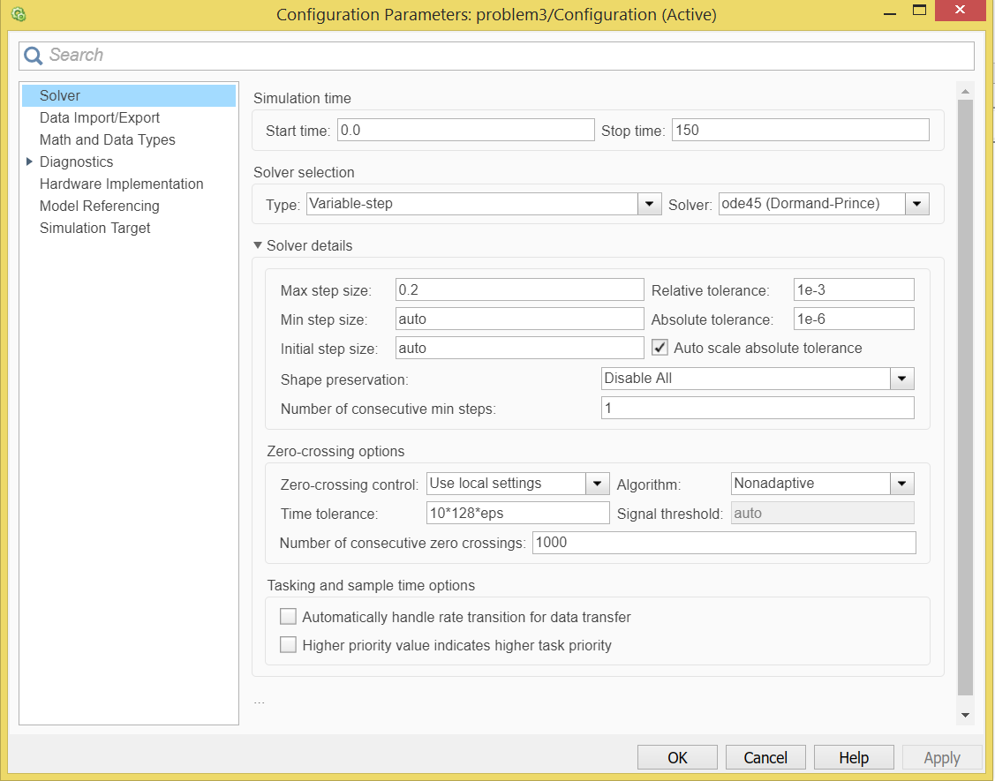Solver Configuration (ode45) selected as the best fit solver.

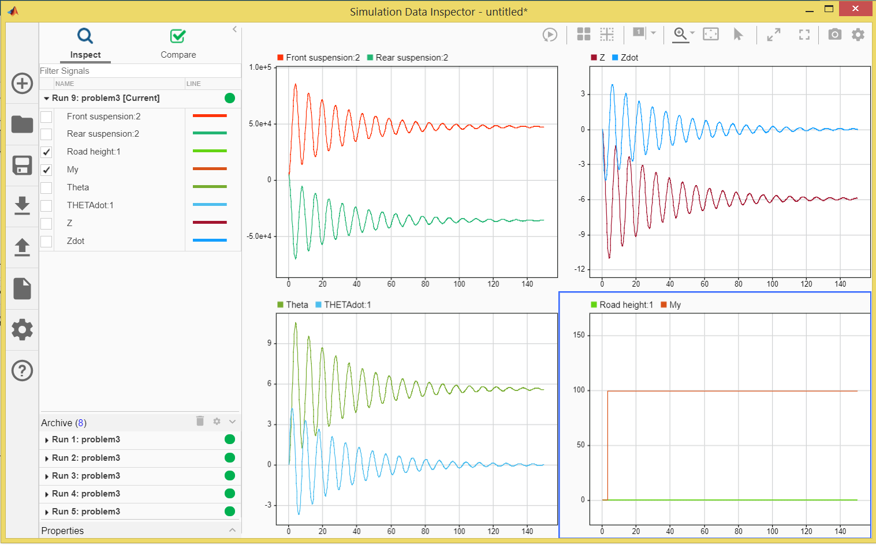**Data Inspector:**