CipherStream-128X
[UDYAM '26 (I-CHIP PS-2)]
Design Report

Submitted by: - Team Ronit
Team Member 1:- Rohanraj Mallick, ECE, 24095094
Team Member 2:- Nitin Kumar Rai, ECE, 24095072

The CipherStream-128X is a fully unrolled, 10-stage pipelined AES-128 hardware accelerator designed for high-throughput, deterministic encryption in hostile environments. The core is integrated with a custom AXI4-Lite memory-mapped interface, ensuring seamless SoC compatibility and strict protocol adherence.

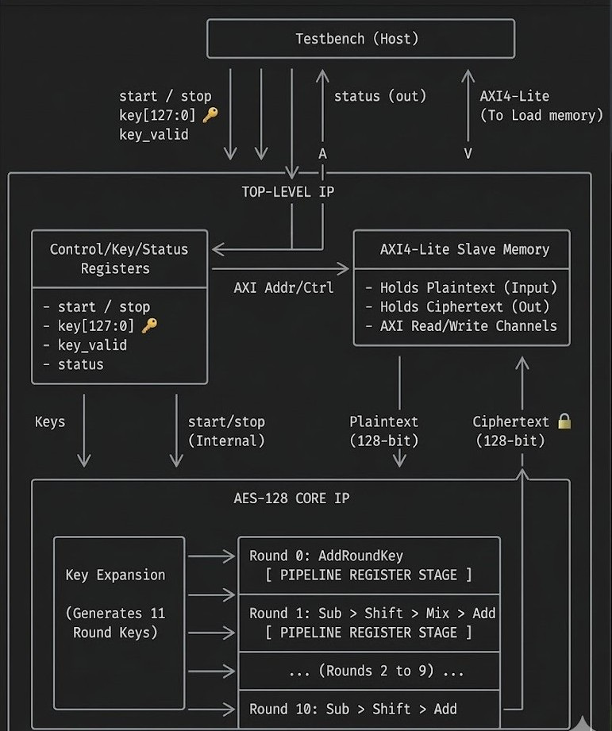

1. Pipelined Architecture of the AES Datapath
The core encryption engine of the CipherStream-128X is designed as a fully unrolled, 10-stage synchronous pipeline. This architectural approach is specifically chosen to maximize throughput for continuous streaming applications, ensuring that once the pipeline is full, a new 128-bit ciphertext block can be generated every valid clock cycle.
Structural Breakdown
The datapath maps the standard AES-128 FIPS-197 algorithm into discrete physical hardware stages, separated by 128-bit flip-flop registers.
- Stage 0 (Initial AddRoundKey): The raw 128-bit plaintext input is immediately XORed with the Round 0 key (the initial_key). This combinational result is latched into the stage[0] register.
- Stages 1 through 9 (Standard Rounds): These stages execute the core cryptographic transformations. Each stage consists of a purely combinational aes_standard_round module that sequentially performs:
  - SubBytes: Non-linear byte substitution using 16 parallel 8-bit S-Boxes.
  - ShiftRows: Cyclic byte shifting across the state matrix.
  - MixColumns: Linear mixing operating on columns over Galois Field GF(2^8).
  - AddRoundKey: Bitwise XOR with the respective 128-bit round key.
The output of each combinational block is captured by the stage[1] through stage[9] pipeline registers on the positive clock edge.
- Stage 10 (Final Round): The final stage utilizes an aes_final_round module, which performs SubBytes, ShiftRows, and AddRoundKey, deliberately omitting the MixColumns step as per the AES specification. The result is latched into the final ciphertext output register.
Pipeline Control and Stall Logic (Backpressure Handling)
In a real-world SoC environment, memory interfaces (like AXI4-Lite) cannot always feed or read data at the exact speed of the accelerator. To prevent data corruption, a global stall mechanism was integrated directly into the datapath pipeline.
- The enable Signal: Every pipeline register (stage[0] to stage[10]) is gated by an enable control wire.
- Zero-Data-Loss Freezing: When the AXI slave memory asserts backpressure (e.g., the downstream processor is busy and cannot read the previous ciphertext), the enable signal is pulled low. This instantly freezes the clock enable (CE) pins on all 1,408 flip-flops in the datapath, holding all in-flight blocks perfectly in place until the system is ready to resume.
In-Flight Data Tracking
Because the AES core is decoupled from the AXI 32-bit unpacking logic, the pipeline does not receive valid data on every single clock cycle (it takes 4 cycles to assemble a 128-bit block).
- To manage these "bubbles" (empty clock cycles) flowing through the datapath, an 11-bit shift register (valid_pipeline) runs in parallel with the data registers.
- When a valid block is pushed into Stage 0, a logic 1 is pushed into the shift register.
- As the data advances through the 10 stages, the valid bit advances with it.
- This elegantly solves two problems:
  - It asserts ciphertext_valid exactly when a real block exits Stage 10.
  - It calculates pipeline_empty (when all 11 bits are 0), which allows the external control logic to safely execute dynamic key updates without corrupting data in the middle of the pipeline.

2. SubBytes Transformation & S-Box Implementation Strategy
The SubBytes transformation is a non-linear byte substitution step where each byte of the AES state matrix is replaced independently using an 8-bit substitution box (S-box). For the CipherStream-128X architecture, the S-box was implemented purely using Distributed Combinational Logic (LUTs) rather than synchronous Block RAM (BRAM).
This architectural choice was made specifically to satisfy the strict deterministic, high-throughput streaming constraints of the system.

To support the stall-free, 10-stage unrolled pipeline, the sub_bytes module utilizes Verilog generate blocks to instantiate 16 identical, parallel 8-bit S-boxes per round.
This allows the entire 128-bit state matrix to undergo non-linear substitution simultaneously.
Because the S-box is combinational, the pipeline can successfully cascade the SubBytes, ShiftRows, MixColumns, and AddRoundKey transformations into a single, seamless clock cycle per round.
3. Key Schedule Strategy & Dynamic Updates
The AES-128 algorithm requires 11 distinct 128-bit round keys (one for the initial AddRoundKey, and 10 for the subsequent rounds). Furthermore, the system must support dynamic key updates initiated by the AXI Master without interrupting streaming operations or corrupting data currently propagating through the pipeline. To satisfy these stringent constraints, a combined architecture of On-the-Fly Key Expansion and a Shadow Key Register was implemented.
The Challenge of Dynamic Key Updates
In a fully unrolled 10-stage pipeline, multiple blocks of plaintext are processed simultaneously at different stages of encryption. If a new key is written directly to the key expansion module while data is in flight, the round keys will instantly change. This would cause a block at Stage 5 to be encrypted with the first half of "Key A" and the second half of "Key B," completely corrupting the ciphertext.
The Shadow Register Architecture
To guarantee zero data corruption, the core isolates the AXI interface from the active cryptographic datapath using a Shadow Register mechanism:
- Separation of State: The design utilizes two primary registers for key management: the shadow_key and the active_key.
- Asynchronous Writes: When the processor writes a new 128-bit key to the AXI wrapper, it is exclusively stored in the shadow_key register, and a key_update_pending flag is asserted. The active_key (which drives the AES rounds) remains unchanged, allowing the current data in the pipeline to finish encrypting safely.
- Safe-Swap Mechanism: An 11-bit shift register tracks valid data flowing through the pipeline. When the final block of data exits Stage 10, the pipeline_empty signal asserts. On the very next clock cycle, the hardware safely copies the shadow_key into the active_key. This guarantees an atomic, zero-latency key swap exactly between the end of the old data stream and the start of the new data stream.
On-the-Fly Key Generation
Instead of utilizing a Precomputed Key Schedule stored in memory (which would consume valuable BRAM resources and require multi-cycle read operations), the design implements On-the-Fly Key Expansion.
- The active_key is fed into 10 parallel key_expansion_round modules, which apply the standard AES RotWord, SubWord (using S-boxes), and Rcon XOR operations.
- This logic generates the entire 1408-bit expanded key bus dynamically.

4. AXI4-Lite Interface and Buffering Design
To ensure the CipherStream-128X can be deployed as a standard IP block within an SoC environment, the core is wrapped in a custom AXI4-Lite memory-mapped slave interface. A fundamental architectural challenge in this integration is the data width mismatch: the AXI4-Lite protocol utilizes a 32-bit data bus (S_AXI_WDATA), whereas the AES-128 engine requires 128-bit blocks of plaintext and key data to initiate an encryption cycle.
To resolve this without stalling the internal pipeline, a specialized buffering and packing state machine was developed.
32-to-128-Bit Data Packing (Write Buffering)
The AXI slave interface acts as an accumulation buffer for incoming data.
- Plaintext and Key data are mapped across four distinct 32-bit register addresses each (e.g., 0x20, 0x24, 0x28, 0x2C for plaintext).
- As the AXI Master writes sequential 32-bit words, the wrapper FSM latches them into holding registers.
- Single-Cycle Triggering: The logic is designed to monitor the final word address. When the Master writes to the 4th word (0x2C), the hardware instantly concatenates the four words into a 128-bit bus and generates a data_valid_in pulse for exactly one clock cycle. This precise trigger pushes the assembled block into Stage 0 of the AES pipeline, preventing the core from ingesting partial or duplicated data.
128-to-32-Bit Data Unpacking (Read Buffering)
A corresponding buffering strategy is used for the output.
- When the AES core finishes an encryption cycle, the 1-cycle ciphertext_valid pulse is caught by the wrapper, which latches the 128-bit ciphertext into an output buffer and asserts a Done bit in the Status Register (0x04).
- The AXI Master can then perform four subsequent 32-bit read operations to extract the ciphertext.
- Auto-Clearing Status: To minimize software overhead, the hardware automatically clears the Done bit the moment the Master reads the final 32-bit ciphertext word, resetting the interface for the next block.
AXI Handshake Compliance and Backpressure Management
The wrapper strictly adheres to the AXI4 VALID/READY handshake protocol, ensuring deterministic operation under variable-rate memory conditions.
- Global Pipeline Stall: If the AXI Master streams plaintext faster than it can read the resulting ciphertext, there is a severe risk of overwriting unread data at the end of the pipeline.
- To prevent this, the AXI wrapper utilizes an internal enable control signal mapped to the clock-enables of all 1,408 flip-flops in the AES datapath. If the interface detects backpressure or an unread ciphertext collision, it pulls enable low. This instantly freezes the entire 10-stage pipeline, holding all in-flight blocks perfectly in place until the Master relieves the backpressure, guaranteeing zero data loss.

5. Performance Analysis
The performance of the CipherStream-128X is dictated by the maximum operating frequency achieved post-synthesis and the inherent bandwidth of the 32-bit AXI4-Lite interface. Based on the Vivado Timing Summary, the critical path (located in the pipelined key expansion) operates with a Worst Negative Slack of +5.368 ns against a 10.0 ns target, yielding an actual critical path delay of 4.632 ns.
- Maximum Operating Frequency (F_{max}): 215.89 MHz
Throughput
During steady-state streaming operations, the internal 10-stage AES pipeline processes one 128-bit block per clock cycle. However, the system throughput is bounded by the 32-bit AXI4-Lite write interface, which requires 4 clock cycles to inject a full 128-bit block into the accelerator.
- Calculation: $(128 / 4 ) * 215.89 MHz
- Effective System Throughput: 6,908.48 Mbps (~6.9 Gbps)
This massive throughput easily satisfies the requirement to sustain continuous high-speed data streams like sensor feeds and telemetry.
Latency
System latency is measured from the moment the processor writes the final (4th) word of the plaintext to the interface, to the moment the 4th word of the ciphertext is successfully read back.
- Write Phase: 4 clock cycles to pack the plaintext.
- Encryption Phase: 11 clock cycles to propagate through the 10-stage unrolled pipeline.
- Read Phase: 4 clock cycles to unpack the ciphertext.
- Total Latency (Cycles): 19 clock cycles.
- Total Latency (Absolute): 19 * 4.632 = 88.0 nanoseconds.
Architectural Quality
The structural integrity of the CipherStream-128X heavily prioritizes deterministic behaviour, zero-data-loss backpressure handling, and secure dynamic key disruptions.
- Zero Data Corruption: The implementation of the Shadow Key Register paired with an 11-bit pipeline emptiness tracker ensures that real-time key updates issued by the AXI Master never corrupt in-flight telemetry. The update is held safely in isolation and executed as a zero-latency swap only when a data stream concludes.
- Stall-Free Internal Datapath: By fully unrolling the 10 rounds and utilizing distributed combinational LUTs for the 16 parallel S-boxes per round, the core never stalls internally waiting for synchronous memory reads.
- Robust System Integration: The custom AXI-wrapper correctly packs/unpacks data and routes an enable control signal to every flip-flop in the system. If the SoC asserts backpressure, the entire core freezes atomically, preserving all pipeline states safely until standard streaming resumes.
Resource Utilization
The design was synthesized for the target Xilinx Zynq-7000 series architecture (xc7z020clg484-1). The utilization reflects the calculated trade off of utilizing distributed logic for the S-Boxes and pipelining the key expansion to achieve the 215+ MHz clock speed.
Resource Type | Utilized Count | Available | Utilization %
Slice LUTs | 9,686 | 53,200 | 18.21%
Slice Registers (FFs) | 3,381 | 106,400 | 3.18%
Block RAM (BRAM) | 0 | 140 | 0.00%

Note: BRAM utilization is intentionally kept at zero. By synthesizing the SubBytes transformations strictly into LUTs, the architecture guarantees single-cycle combinational evaluation, preventing the synchronous read latencies that would otherwise bottleneck the streaming throughput.

6. Architectural Tradeoff Analysis
Hardware design inherently requires balancing competing constraints: Area (Resource Utilization), Speed (Maximum Frequency / Throughput), and Latency. For the CipherStream-128X, the primary design directives were maintaining continuous high-throughput streaming and ensuring zero data corruption during dynamic updates. To satisfy these, several critical architectural trade-offs were made.
Key Expansion: Area Efficiency vs. Maximum Frequency ($F_{max}$)
The most significant trade off occurred within the On-the-Fly key expansion module.
- Initial Approach: The initial architecture utilized a purely combinational key expansion, cascading 10 rounds of RotWord, SubWord, and XOR operations into a single clock cycle. This approach was highly area-efficient, requiring minimal Flip-Flops. However, timing analysis revealed a severe critical path delay (resulting in a negative slack of ~-23ns against a 250 MHz target), limiting the $F_{max}$ to approximately 35 MHz.
- The Tradeoff: To meet the high-throughput requirements of modern communication subsystems, the key expansion was pipelined. Flip-flops were inserted between each key expansion round.
- Result: This decision intentionally sacrificed Area (increasing Slice Register utilization to 3,381 FFs) in exchange for Speed. The critical path was reduced to 4.632 ns, skyrocketing the operating frequency to 215.89 MHz and enabling the core to achieve nearly 6.9 Gbps of throughput.
S-Box Implementation: Distributed Logic (LUTs) vs. Block RAM (BRAM)
The AES SubBytes transformation requires substituting bytes via a pre-defined table.
- The BRAM Option: Storing the S-box in FPGA Block RAM is the standard method for saving Slice logic area. However, BRAMs are inherently sequential (requiring 1-2 cycles of read latency) and possess limited read ports. Evaluating a 128-bit state matrix requires 16 independent S-box lookups simultaneously per stage. Using BRAM would have necessitated massive data serialization, fundamentally breaking the stall-free nature of the 10-stage pipeline.
- The Tradeoff: The design deliberately avoided BRAM entirely (0 BRAMs utilized) and synthesized the 160 S-boxes directly into Distributed Combinational Logic (Slice LUTs).
- Result: This traded away Area efficiency (driving Slice LUT utilization to 9,686) to guarantee absolute zero-stall operation and single-cycle evaluation across the entire 128-bit datapath.
Dynamic Key Updates: Pipeline Complexity vs. Shadow Registers
To support dynamic key updates without corrupting in-flight data, there were two viable approaches:
- Approach A (Pipelined Keys): Pass the active 128-bit key down the 10-stage pipeline alongside the data. This allows the key to change instantly for block $N+1$ without pausing block $N$. However, this requires registering 128 bits across 10 stages (costing over 1,280 extra Flip-Flops just for key routing).
- Approach B (The Tradeoff): The chosen Shadow Register architecture holds the new key in isolation. The system momentarily halts incoming data, allows the pipeline to drain (tracked by the 11-bit shift register), and performs an atomic key swap when the pipeline is empty.
- Result: This approach traded away a microscopic amount of operational uptime (a brief ~11-cycle pause during a key update) to save massive amounts of routing complexity and Flip-Flop resources, all while strictly guaranteeing the zero-data-corruption constraint.

