Aim :- Solution of 1-1Assignment Problem.

Algorithm :-

This Problem can be efficiently by Graph flow Algorithm (Ford Fulkerson Algorithm).

We can construct a graph having one source node ,one destination node , noUsers number of nodes each represent one user and noIntervals number of nodes representing each interval.

We can construct unidirectional edges having weight 1 from source node to every node representing a user, from every node representing interval to destination node and from every node representing a user to nodes representing its favourable intervals.

Note :-Weight 1 refers that atmost 1 intervaL can be assigned to any user.

Now we can Use Ford Fulkerson Algorithm to find maximum assignment.

Description of Ford Fulkerson Algorithm :-

Construct a residual list as same as of adjacency list.

Try to find a path from source vertex to destination vertex having non zero flow(minimum weight in the path).

If we find non zero flow then from all the forward edges in path substract the flow and to all the backward edges in path add flow value.

This process is called Augmentation and new forward weights are Residual capacity.

Backward edges represent how much flow we can undo .

Repeat the same untill zero flow is obtained.

Implimetation :-

Edmond Karp Algorithm:-

This implimenation uses a breath first search to find the path from source to destination and parent of each node is stored in a array in the discovered path.

Whenever we find non zero path augment it.

The Total flow (assignments) can be obtained as sum of flows in every iteration.

Constructing Solution ?

All those edges having forward weight 1 initially and now weight 0 are assignments.

Thus We got one optimal Solution.

How to more Solutions ?

We can change the graph in following way

1)By reversing the order of Users.

2)By reversing the order of Intervals.

3)By reversing the order of Users and Intervals both.

We will 4 solutions but there may repitition.

Remove Duplicate solutions if any .

If number of solution are less than 4 now

We can now create another destination

Weight from initial destination to final destination should be initialised with a very high value.

After every solution we should change the weight to noAssignments-1 as we are interested in finding the solution having assignments less than previous by 1.

As soon we have 4 solutions we can terminate the algorithm.

Tracing the Algorithm :-

Consider the example

U1-I1,I2

U2-I2

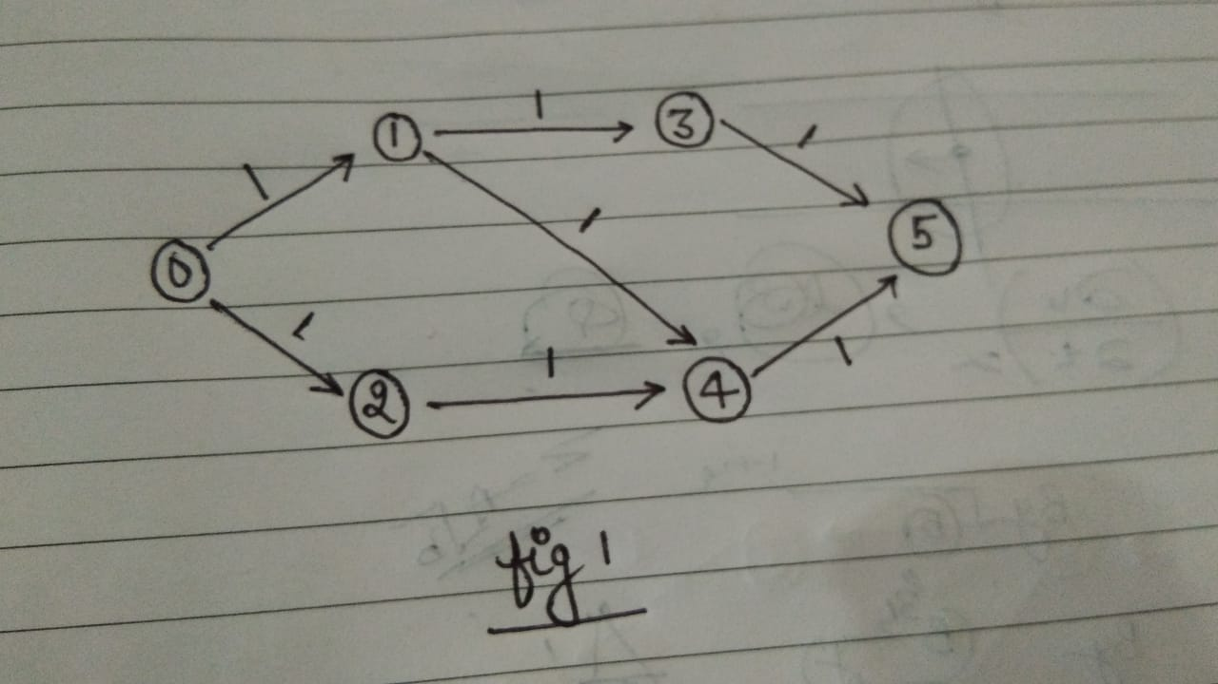

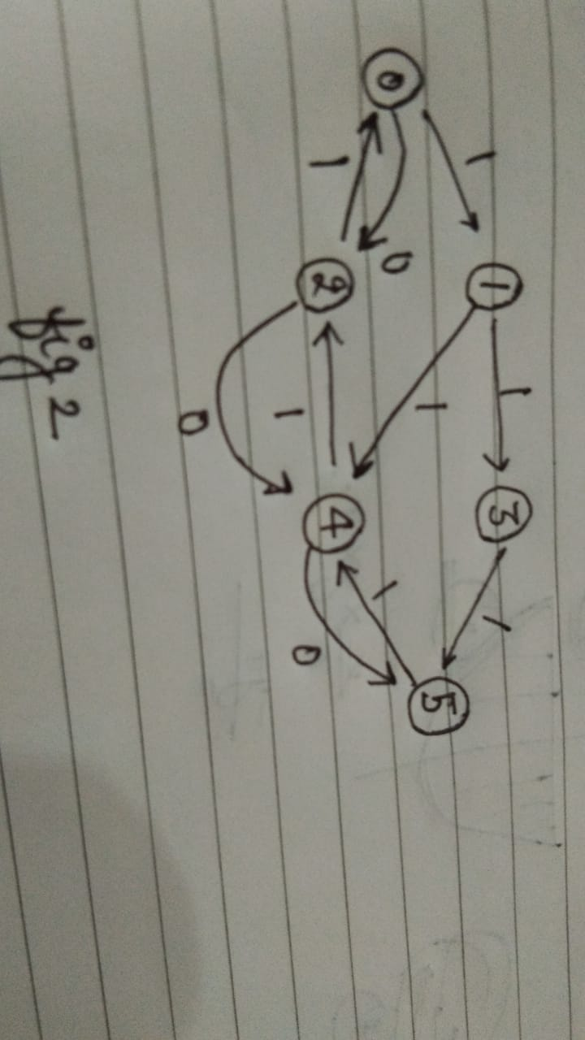

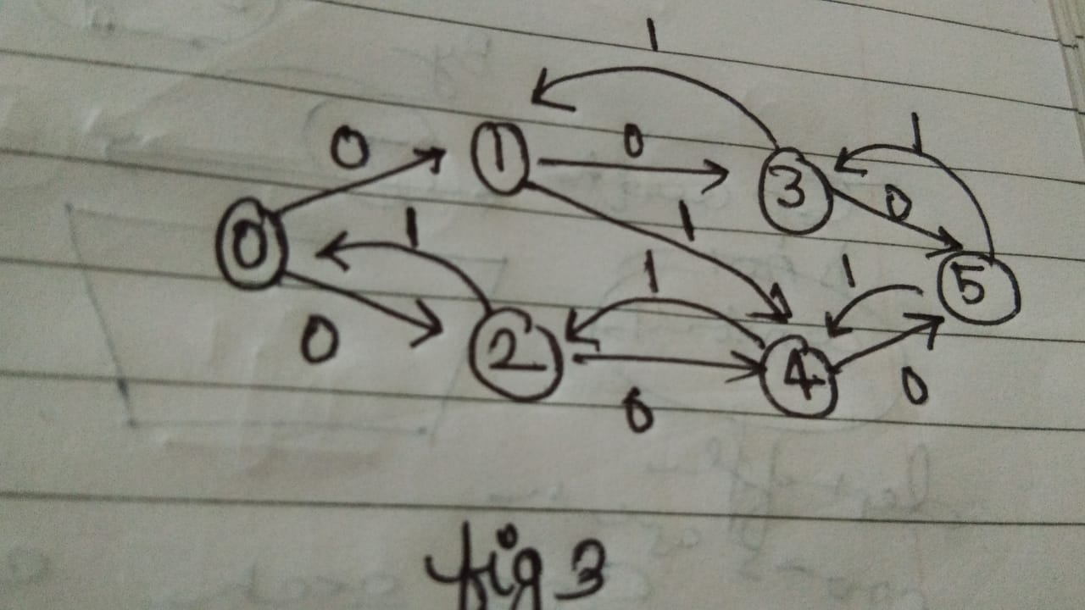

Graph can be changed by

1)User order reversing:-

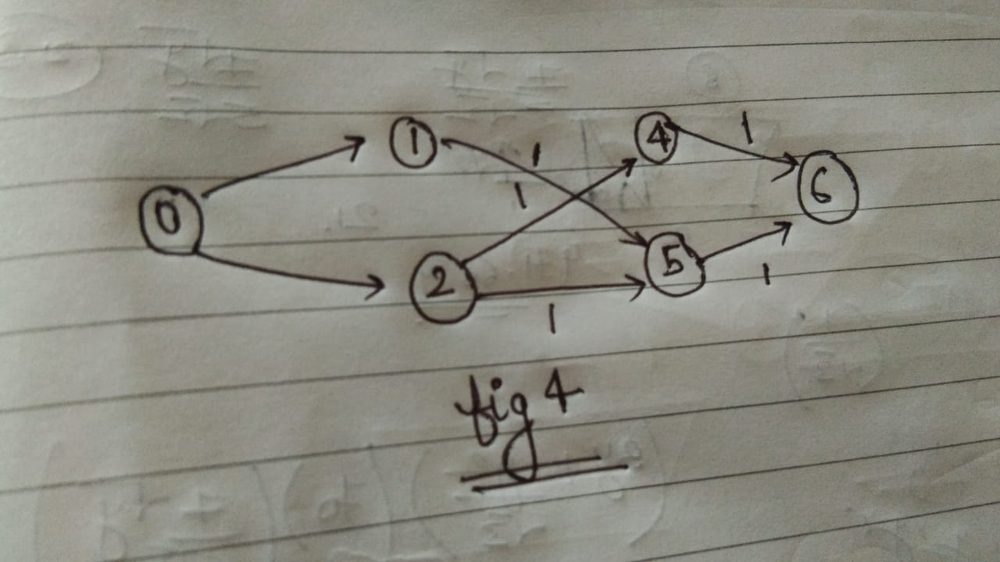

2)Reversing interval

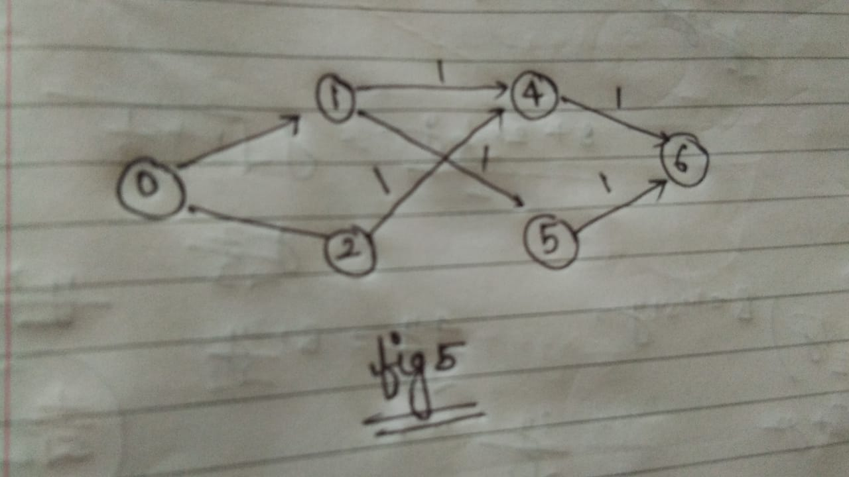

3)By reversing both users and intervals

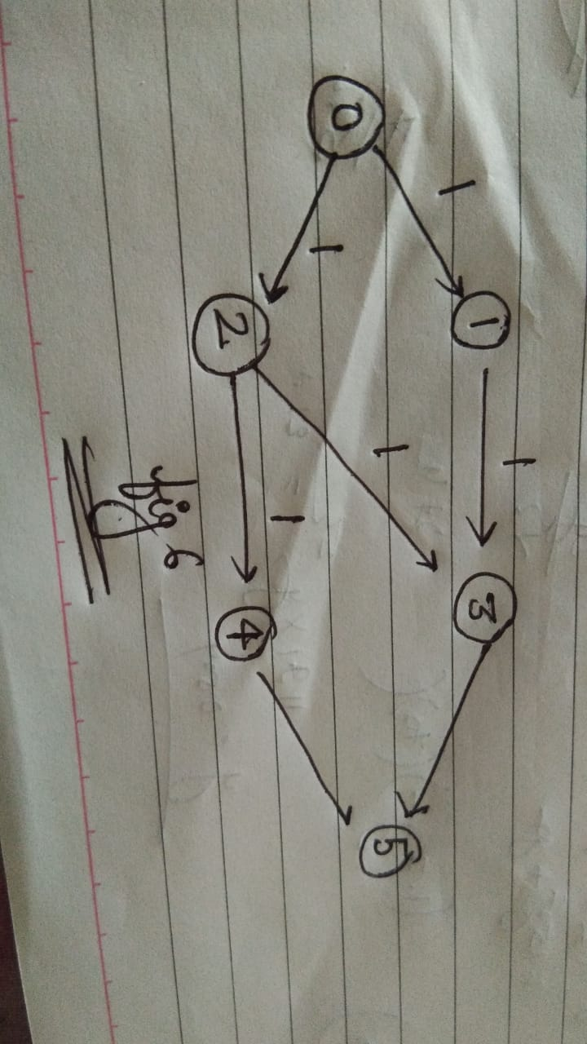

Code in cpp:-

|  |
| --- |
| #include <bits/stdc++.h>  using namespace std;  const int N=1e2+5;  vector<int> parent(N);  vector<int> visited(N);  vector<vector<pair<int,int> > > adjacencyList(N);  vector<vector<pair<int,int> > > residualAdjacencyList(N);  vector<vector<int> > input(N);  vector<vector<pair<int,int> > > solution;  int totalAssignment=10000;  int finalEdge=10000;    bool comparTor(vector<vector<pair<int,int> >> ::iterator iteraTor1, vector<vector<pair<int,int>> > ::iterator iteraTor2)  {      vector<pair<int,int> > vector1=*iteraTor1;  vector<pair<int,int> >vector2=*iteraTor2;  if(vector1.size()!=vector2.size())  return false;    for(int onesolutionVariable =0; onesolutionVariable<vector1.size(); onesolutionVariable++)  {  if(vector1[onesolutionVariable].first==vector2[onesolutionVariable].first and vector1[onesolutionVariable].second == vector2[onesolutionVariable].second)  continue;  return false;  }    return true;    }  void removeDuplicates()  {  for(vector<vector<pair<int,int >>> :: iterator iteraTor =solution.begin();iteraTor != solution.end(); iteraTor++)  {  for(vector<vector<pair<int,int> >> :: iterator itr=solution.begin();itr!=iteraTor;itr++ )  {  if(comparTor(iteraTor,itr))  {  solution.erase(iteraTor);  iteraTor--;  break;  }  }  }  }    void reverseSort()  {  for (int iteraingVariable = solution.size() - 2; iteraingVariable >= 0; --iteraingVariable)  {  vector<pair<int,int> > oneSolution=solution[iteraingVariable];  int iteratingVariable2=iteraingVariable;  while (iteratingVariable2 < solution.size() - 1 && oneSolution.size() > solution[iteratingVariable2].size())  {  solution[iteratingVariable2]=solution[iteratingVariable2+1];  iteratingVariable2++;  }  solution[iteratingVariable2]=oneSolution;    }    }    void printSolution()  {    reverseSort();  for(int iteratingVariable=0;iteratingVariable<min(100,(int)solution.size());iteratingVariable++)  {  vector<pair<int,int > > oneSolution = solution[iteratingVariable];  for(pair<int,int> onePair : oneSolution)  {  cout<<onePair.first<<"th user is assigned "<<onePair.second<<"th interval"<<endl;  }  cout<<endl;  }  }    int bfsForFindingParent(int sourceVertex, int destinationVertex)  { //clearing the visited array    for(int node=0;node<N;node++)  visited[node]=0;    visited[sourceVertex]=1;  parent[sourceVertex]=-1;  queue<int> pendingNodes;  pendingNodes.push(sourceVertex);    while(!pendingNodes.empty())  {  int currentVertex=pendingNodes.front();  pendingNodes.pop();    for(pair<int,int> adjacentEdge : residualAdjacencyList[currentVertex])  {  int adjacentVertex=adjacentEdge.first;  int weightOfEdge=adjacentEdge.second;  if(visited[adjacentVertex]==0 and weightOfEdge>0)  {  pendingNodes.push(adjacentVertex);  visited[adjacentVertex]=1;  parent[adjacentVertex]=currentVertex;  }  }  }  return visited[destinationVertex];  }    void findingMaximumMapping(int noUser, int noInterval)  {  totalAssignment=0;  while( bfsForFindingParent(0,noUser+noInterval+2))  {    int possibleAssignment=INT_MAX;  for(int node=noUser+noInterval+2;parent[node]!=-1;node=parent[node])  {  for(auto edge : residualAdjacencyList[parent[node]])  {  if(edge.first==node)  {  possibleAssignment=min(possibleAssignment,edge.second);  }  }  }  for(int node=noUser+noInterval+2;parent[node]!=-1 ;node=parent[node])  {      for(pair<int,int>& edge : residualAdjacencyList[parent[node]])  {  if(edge.first==node)  {  edge.second-=possibleAssignment;    }  }    for(pair<int,int>& edge : residualAdjacencyList[node])  {  if(edge.first==parent[node])  edge.second+=possibleAssignment;  }  }  totalAssignment+=possibleAssignment;    }  }  void initialisingAdjacencyList(int noUser ,int noInterval)  {  for(int node=0;node<=noUser+noInterval+2;node++)  {  residualAdjacencyList[node].clear();  adjacencyList[node].clear();  }    for(int user=1;user<=noUser;user++)  {  adjacencyList[0].push_back(make_pair(user,1));  residualAdjacencyList[0].push_back(make_pair(user,1));  //reverse edge with zero weight  adjacencyList[user].push_back(make_pair(0,0));  residualAdjacencyList[user].push_back(make_pair(0,0));  }    for(int interval =noUser+1;interval<=noUser+noInterval;interval++)  {  adjacencyList[interval].push_back(make_pair(noUser+noInterval+1,1));  residualAdjacencyList[interval].push_back(make_pair(noUser+noInterval+1,1));  adjacencyList[noUser+noInterval+1].push_back(make_pair(interval,0));  residualAdjacencyList[noUser+noInterval+1].push_back(make_pair(interval,0));  }    residualAdjacencyList[noUser+noInterval+1].push_back(make_pair(noUser+noInterval+2,finalEdge));  residualAdjacencyList[noUser+noInterval+2].push_back(make_pair(noUser+noInterval+1,0));  adjacencyList[noUser+noInterval+1].push_back(make_pair(noUser+noInterval+2,finalEdge));  adjacencyList[noUser+noInterval+2].push_back(make_pair(noUser+noInterval+1,0));      }  void userIntervalMapping(int noUser, int noInterval)  {    initialisingAdjacencyList(noUser,noInterval);      for(int user=1;user<=noUser;user++)  {  for(int interval : input[user])  {  adjacencyList[user].push_back(make_pair(interval+noUser,1));  residualAdjacencyList[user].push_back(make_pair(interval+noUser,1));  // //adding reverse edge  adjacencyList[interval+noUser].push_back(make_pair(user,0));  residualAdjacencyList[interval+noUser].push_back(make_pair(user,0));  }    }      findingMaximumMapping(noUser,noInterval);    vector<pair<int,int> > oneSolution;    for(int user=1;user<=noUser;user++)  {  int * freqWeight= new int[105]{};    for(pair<int,int> edge : adjacencyList[user]) freqWeight[edge.first]+=edge.second;    for(pair<int,int> edge : residualAdjacencyList[user]) freqWeight[edge.first]-=edge.second;    for(int frequency =noUser+1;frequency<=noUser+noInterval;frequency++)  {  if(freqWeight[frequency]==1)  {  oneSolution.push_back(make_pair(user,frequency-noUser));  }  }  }    sort(oneSolution.begin(),oneSolution.end());  solution.push_back(oneSolution);  removeDuplicates();    }  void userReverseIntervalMapping(int noUser, int noInterval)  {  initialisingAdjacencyList(noUser,noInterval);    for(int user=1;user<=noUser;user++)  {  for(int interval : input[user])  {  adjacencyList[noUser+1-user].push_back(make_pair(interval+noUser,1));  residualAdjacencyList[noUser+1-user].push_back(make_pair(interval+noUser,1));  // //adding reverse edge  adjacencyList[interval+noUser].push_back(make_pair(noUser-user+1,0));  residualAdjacencyList[interval+noUser].push_back(make_pair(noUser-user+1,0));  }    }    findingMaximumMapping(noUser,noInterval);  vector<pair<int,int> > oneSolution;    for(int user=1;user<=noUser;user++)  {  int * freqWeight= new int[105]{};    for(pair<int,int> edge : adjacencyList[user]) freqWeight[edge.first]+=edge.second;    for(pair<int,int> edge : residualAdjacencyList[user]) freqWeight[edge.first]-=edge.second;    for(int frequency =noUser+1;frequency<=noUser+noInterval;frequency++)  {  if(freqWeight[frequency]==1)  {  oneSolution.push_back(make_pair(noUser-user+1,frequency-noUser));  }  }      }    sort(oneSolution.begin(),oneSolution.end());  solution.push_back(oneSolution);  removeDuplicates();          }  void userIntervalReverseMapping(int noUser, int noInterval)  {  initialisingAdjacencyList(noUser,noInterval);  for(int user=1;user<=noUser;user++)  {  for(int interval : input[user])  {  adjacencyList[user].push_back(make_pair(noInterval-interval+noUser+1,1));  residualAdjacencyList[user].push_back(make_pair(noInterval-interval+noUser+1,1));  // //adding reverse edge  adjacencyList[noInterval-interval+noUser+1].push_back(make_pair(user,0));  residualAdjacencyList[noInterval-interval+noUser+1].push_back(make_pair(user,0));  }    }        findingMaximumMapping(noUser,noInterval);  vector<pair<int,int> > oneSolution;    for(int user=1;user<=noUser;user++)  {  int * freqWeight= new int[105]{};    for(pair<int,int> edge : adjacencyList[user]) freqWeight[edge.first]+=edge.second;    for(pair<int,int> edge : residualAdjacencyList[user]) freqWeight[edge.first]-=edge.second;    for(int frequency =noUser+1;frequency<=noUser+noInterval;frequency++)  {  if(freqWeight[frequency]==1)  {  oneSolution.push_back(make_pair(user,noInterval+1-(frequency-noUser)));    }  }  }      sort(oneSolution.begin(),oneSolution.end());  solution.push_back(oneSolution);    removeDuplicates();  }  void userReverseIntervalReverseMapping(int noUser, int noInterval)  {  initialisingAdjacencyList(noUser,noInterval);    for(int user=1;user<=noUser;user++)  {  for(int interval : input[user])  {  adjacencyList[noUser-user+1].push_back(make_pair(noInterval+1-interval+noUser,1));  residualAdjacencyList[noUser-user+1].push_back(make_pair(noInterval+1-interval+noUser,1));  // //adding reverse edge  adjacencyList[noInterval+1-interval+noUser].push_back(make_pair(noUser-user+1,0));  residualAdjacencyList[noInterval-interval+noUser+1].push_back(make_pair(noUser-user+1,0));  }    }    findingMaximumMapping(noUser,noInterval);    vector<pair<int,int> > oneSolution;      for(int user=1;user<=noUser;user++)  {  int * freqWeight= new int[105]{};    for(pair<int,int> edge : adjacencyList[user]) freqWeight[edge.first]+=edge.second;    for(pair<int,int> edge : residualAdjacencyList[user]) freqWeight[edge.first]-=edge.second;    for(int frequency =noUser+1;frequency<=noUser+noInterval;frequency++)  {  if(freqWeight[frequency]==1)  {  oneSolution.push_back(make_pair(noUser+1-user,noInterval+1-(frequency-noUser)));    }  }  }  sort(oneSolution.begin(),oneSolution.end());  solution.push_back(oneSolution);  removeDuplicates();    }  void userToIntervalMapping(int noUser ,int noInterval)  { userIntervalMapping(noUser,noInterval);  userReverseIntervalMapping(noUser,noInterval);  userIntervalReverseMapping(noUser,noInterval);  userReverseIntervalReverseMapping(noUser,noInterval);  finalEdge=totalAssignment-1;    }    int main()  {  #ifndef ONLINE_JUDGE    freopen("input.txt", "r", stdin);    freopen("output.txt", "w", stdout);    #endif  time_t start, end;  time(&start);  // enter the number of users  int noUser;  cin >> noUser;  //enter the number of intervals    int noInterval;  cin >> noInterval;  //taking input      for(int user=1;user<=noUser;user++)  { //enter number of intervals for ith user  int noOfIntervals;  cin >> noOfIntervals;  while(noOfIntervals--)  {  int favourableInterval;  cin >> favourableInterval;  input[user].push_back(favourableInterval);    }    }  while(solution.size()<4 and totalAssignment>0)  userToIntervalMapping(noUser,noInterval);    printSolution();    time(&end);  double time_taken = double(end - start);    cout<<"calculation of total time taken by program " << fixed << time_taken << setprecision(5);  cout << " sec " << endl;      return 0;  } |

Efficiency of Algorithm :-

Let the noUsers=n1 noInterval=n2

Time Complexity:-

Adjacency Matrix Implimentation O(n1*n2^3).

Adjacency List Implimentation O(n1*n2^2).

Space Complexity:-

Adjacency Matrix implimentation O((n1+n2)^2).

Adjacency List implimentation O(n1*n2).

Pros of Algorithm :-

1)Solution is very efficient for user <=500 solution can be obtanied within 1sec.

2)Space is optimised using Adjacency list implimentation.

Cons of Algorithm:-

1)For finding more than 1 solution we have to change the Graph.

2)Doesn’t cover all possiblity only 4 are covered which may produce duplicate solutions.