1. Sign Up:  
   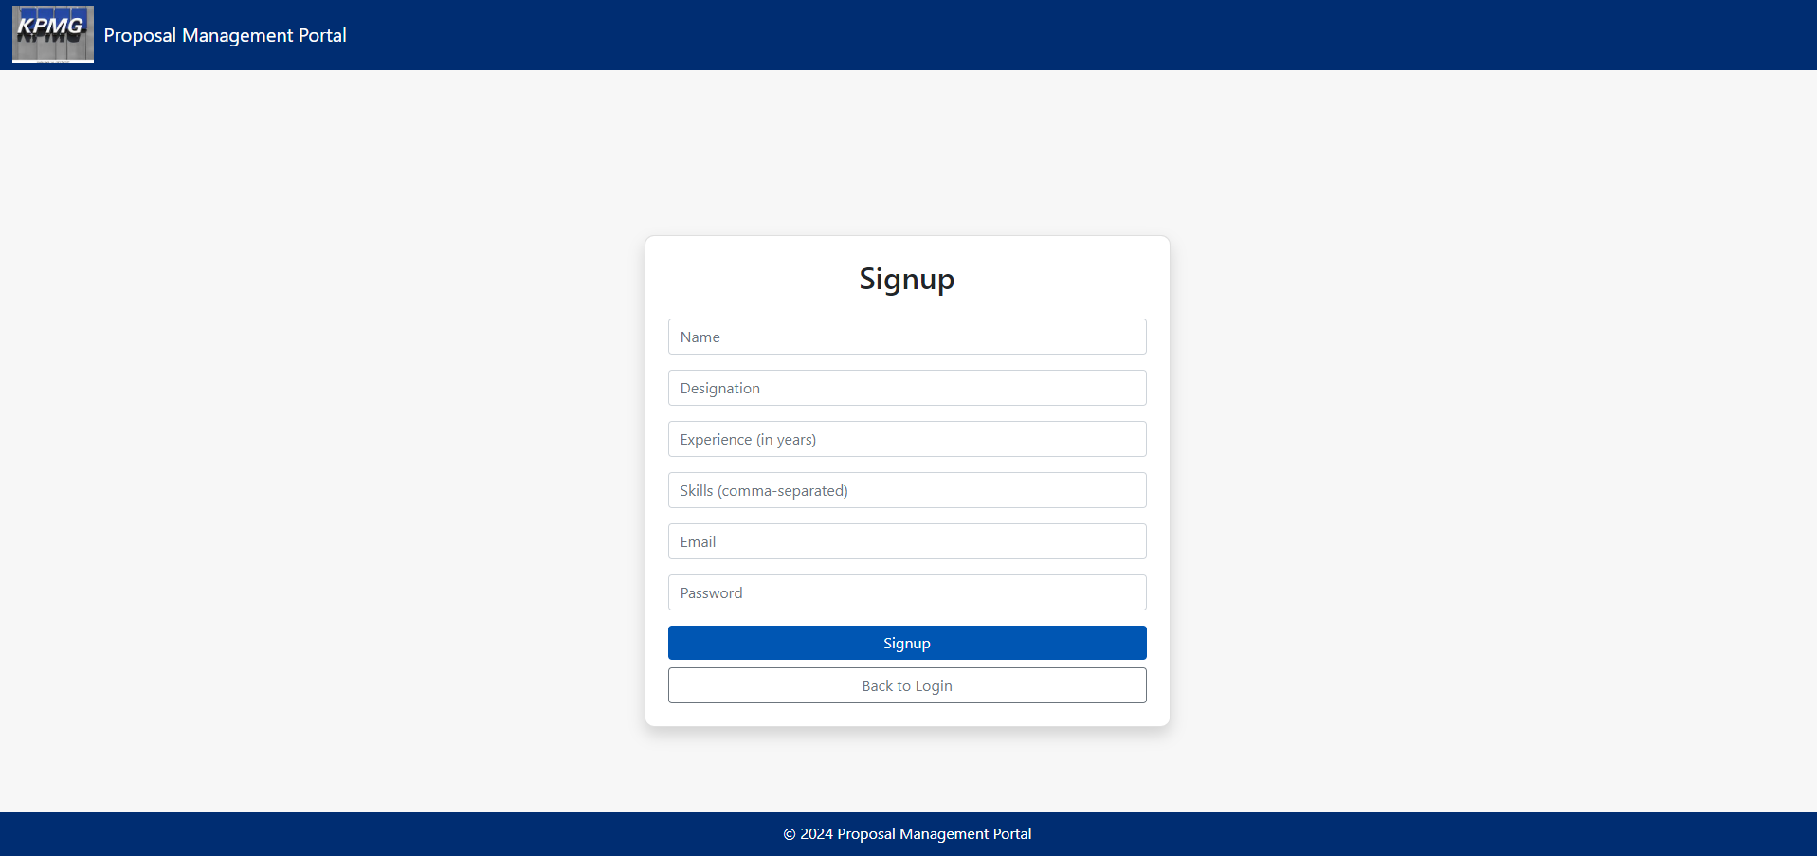
2. Login Page:  
   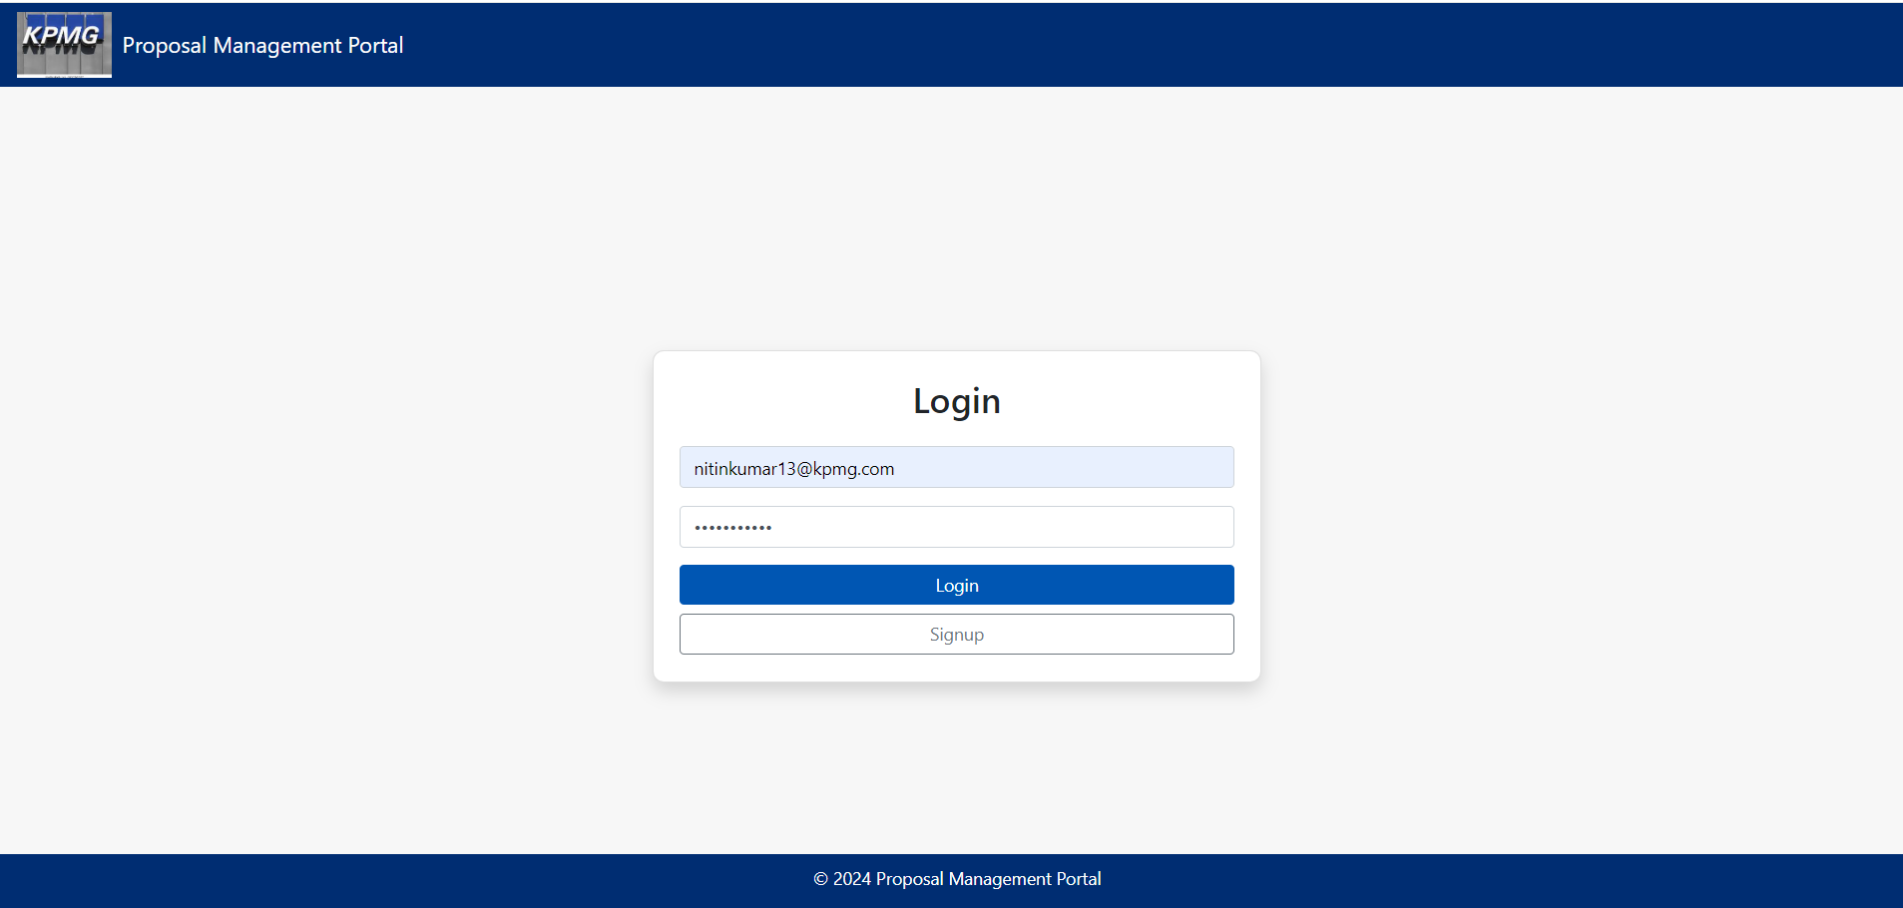

On Invalid Credentials:  
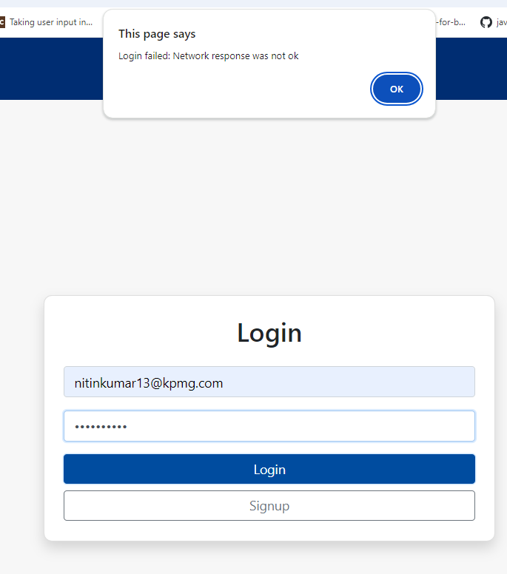

1. Home Page (Post login displaying all proposals):  
   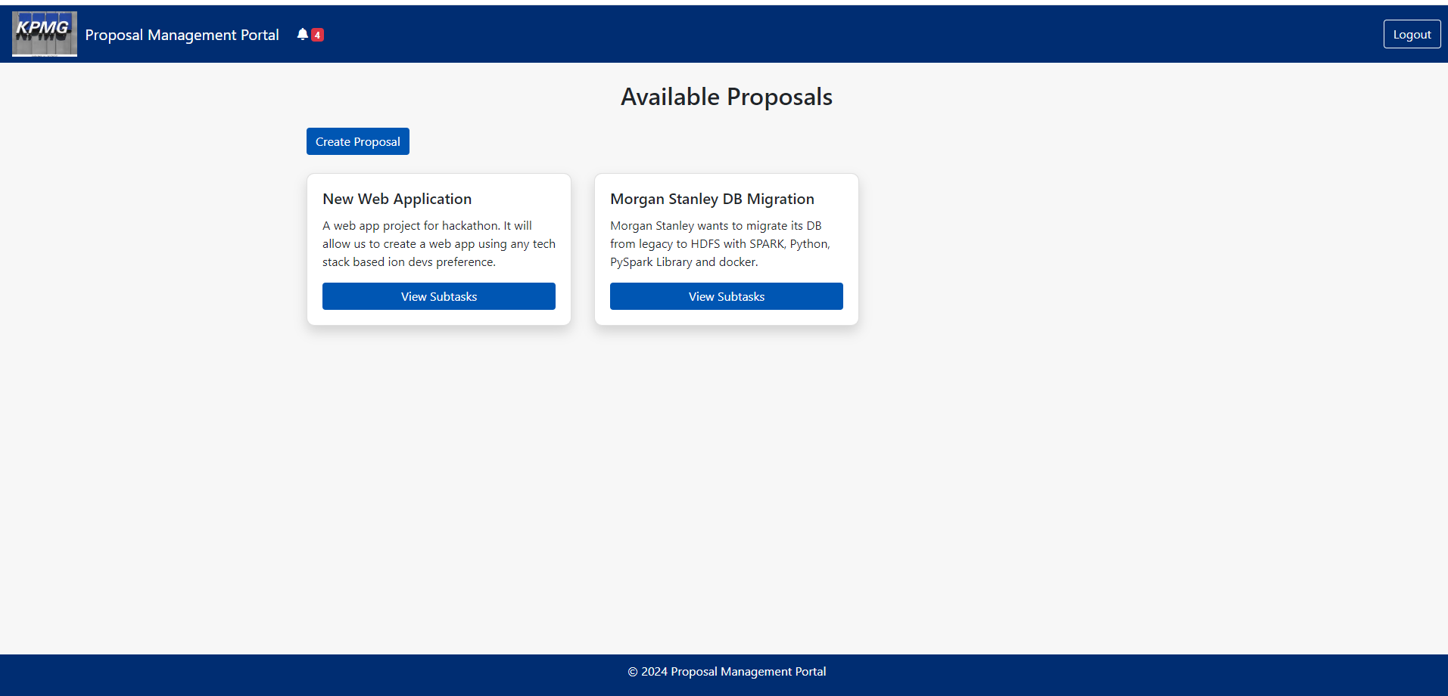
2. Create Proposal:  
   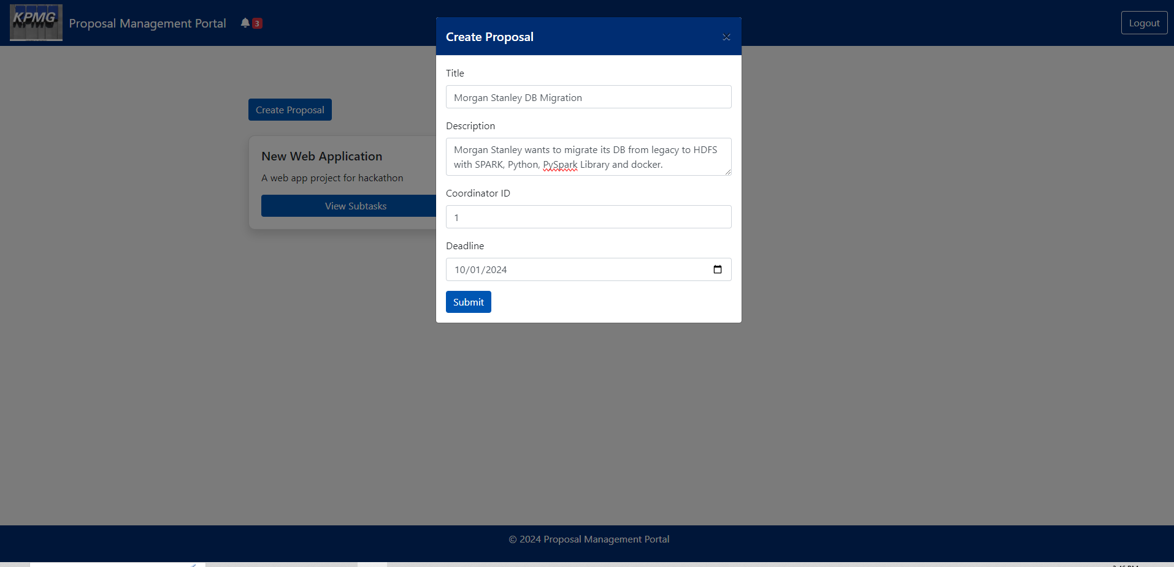
3. Notification:  
   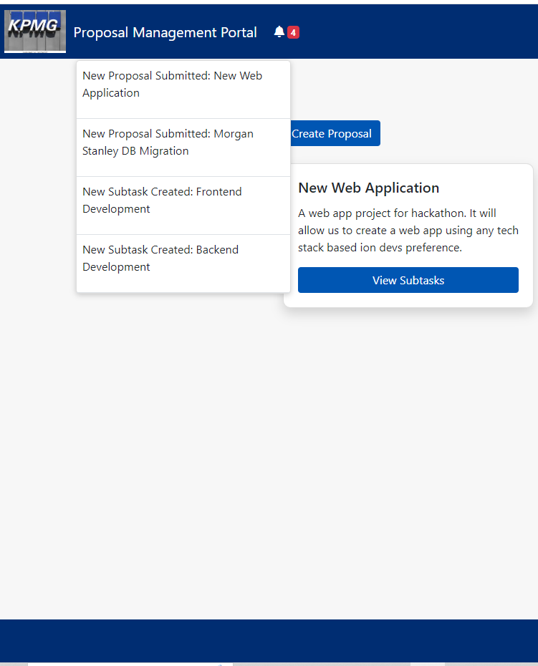

1. Create Subtask for the proposal:

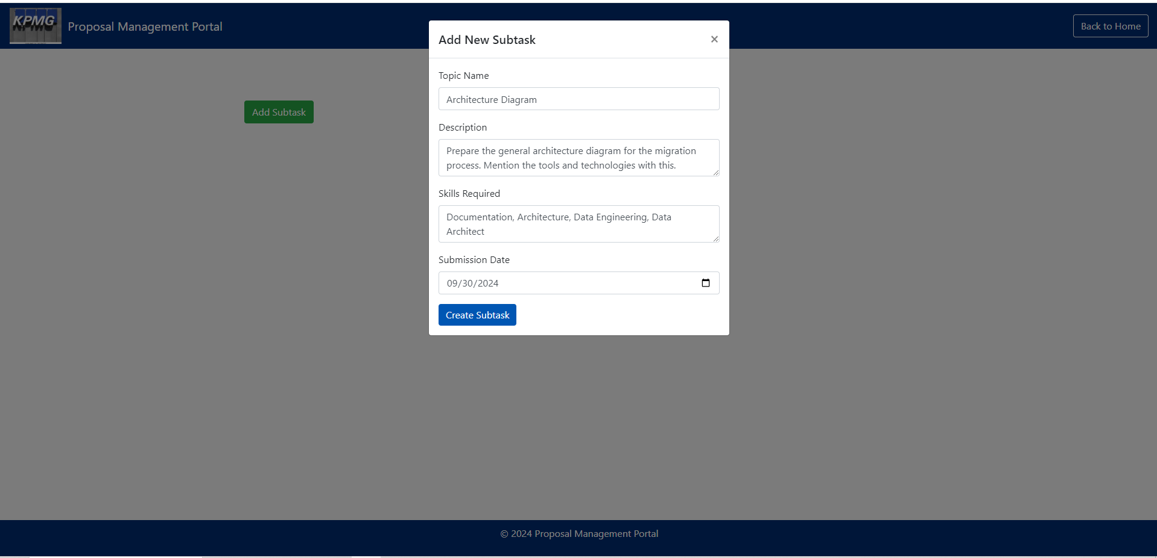

1. Select Proposal to view subtasks for selected proposal:  
   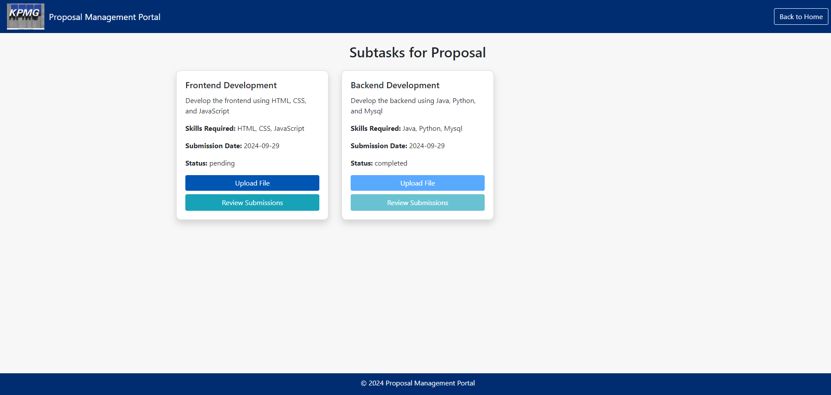
2. Upload subtask File – Solution File PPT or any file:  
   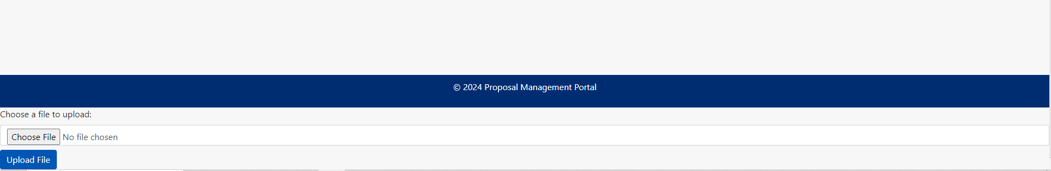
3. Review the Submissions:  
   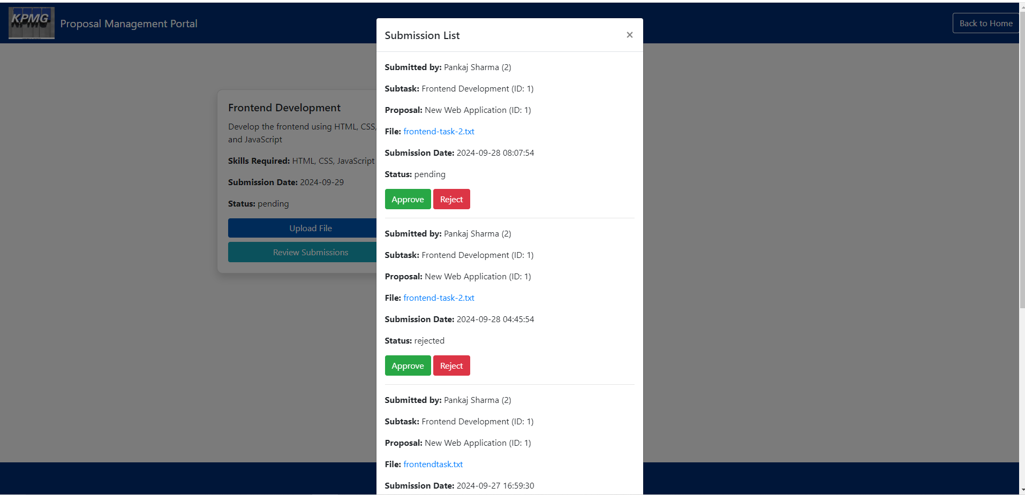

Approve click -> Submission will be approved and subtask will be completed

Reject Click -> Submission will be rejected and subtask will be still open

File Click -> File will be downloaded to review the content

1. Post Approval:

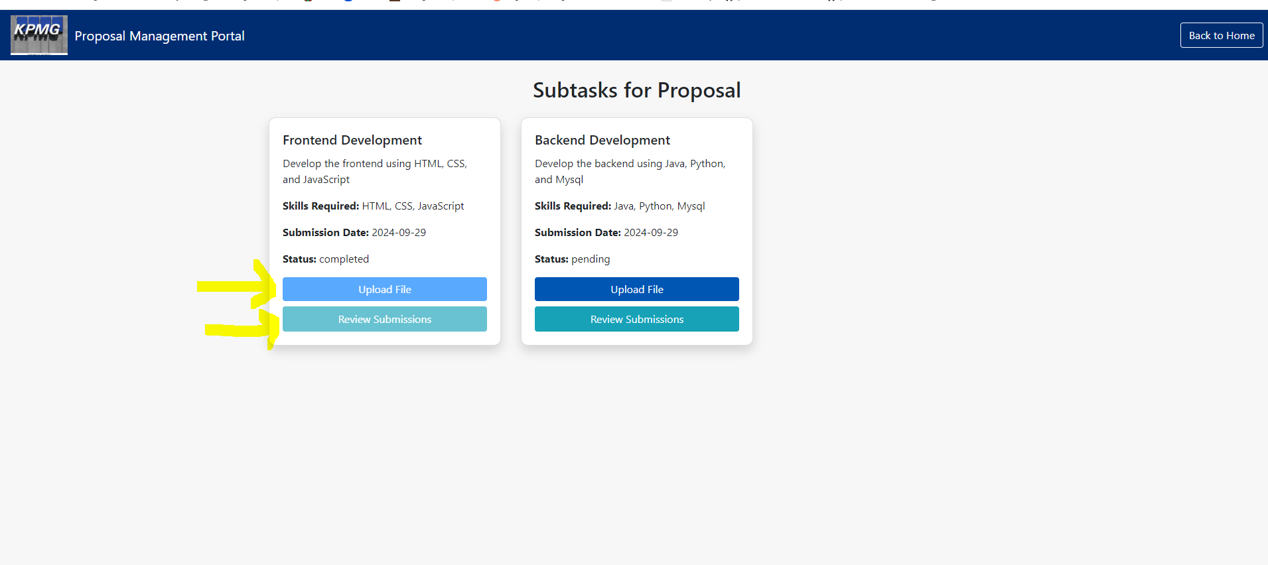

Upload and Review button will be disabled for no more submissions. Also subtask status is completed.