  - YuvaIntern Junior ReactJS Developer Internship

TaskFlow Week 3 State Management and Hooks
  - Implementation and verification report
Week 3 of the six week ReactJS internship
Prepared on 19 October 2026

Project outcome
TaskFlow now provides a functional local task manager with creation, editing, completion, reopening, confirmation-based deletion, search and filtering. Dashboard statistics derive from the same collection. React Hooks, a pure reducer and Context API organize application state, while versioned browser storage preserves valid tasks across refreshes.
The implementation extends the existing project in place and reuses the Week 2 interface library. Week 1 and Week 2 commits, reports and evidence are preserved. The full automated suite passed 44 tests with zero failures. Genuine browser screenshots and command logs support this report.
Repository: github.com/nitinmehra1017/taskflow-reactjs-internship
Submission branch: week-3-state-management
The 35 hour breakdown is a planned allocation, not a statement of measured attendance. Dependency advisories and production size warnings remain documented follow-up items.

Introduction objectives and proposed solution

Existing project and problem statement
Week 1 established React, JavaScript and JSX, custom Webpack 5 builds, Babel, linting, formatting and routing. Week 2 added Button, Input, Modal, Card, Badge, Select and Alert, shared Sass tokens, an interactive showcase and 33 regression tests. The Tasks page was still a placeholder and the dashboard displayed structural project metrics rather than task progress.
Week 3 needed a single reliable source of task data. Duplicating task arrays in individual pages would create inconsistent counts and lost changes. Persisting initial defaults too early could overwrite valid saved data, while unguarded storage access could break the application in restricted browsers.

Objectives and scope
• Implement the full local task lifecycle with validated controlled forms and stable identities.
• Share task records and actions between Tasks and Dashboard through Context and a pure reducer.
• Separate storage, filtering, statistics and validation into meaningful reusable modules.
• Preserve the existing forest green, lime and neutral interface and accessible keyboard interactions.
• Verify real behavior through Jest, React Testing Library and browser checks across three widths.

Proposed and implemented solution
TaskProvider wraps the route tree and owns useReducer state. Pages consume useTasks; TaskForm owns only a draft. Actions validate and normalize values, assign IDs and timestamps, then dispatch pure transitions. Statistics and filters are derived values. A post-commit effect synchronizes changed task records to validated versioned localStorage. Dialogs provide focused editing and deletion confirmation.
Technology | Reason for use
React 19 and JavaScript JSX | Existing component model, Hooks and Context; no additional state library
React Router | Preserved shared layout and Overview, Tasks, Components and Settings routes
Webpack 5 and Babel | Existing custom compilation, asset handling and production build
CSS and SCSS tokens | Reuse established surfaces, focus styles and responsive design
Jest and React Testing Library | Pure logic tests and user-oriented component integration tests
ESLint and Prettier | Hooks rules, zero-warning lint and consistent formatting

State architecture and directory structure
There is one authoritative task collection. TaskProvider sends records and stable actions through Context. TasksPage composes filters, list and a single dialog mode. DashboardPage consumes the same memoized statistics. Reducer transitions cause React to render current data before the storage effect runs.
src/
context/TaskContext.jsx
reducers/taskReducer.js
hooks/useTasks.js
hooks/useLocalStorage.js
hooks/useTaskFilters.js
services/taskStorage.js
utils/taskValidation.js
utils/taskStatistics.js
components/tasks/
TaskForm.jsx
TaskCard.jsx
TaskList.jsx
TaskFilters.jsx
pages/TasksPage.jsx
pages/DashboardPage.jsx
styles/tasks.css
tests/tasks.test.jsx
evidence/week3/
docs/Week3_State_Management_and_Hooks.md

Component hierarchy
App > TaskProvider > Routes > AppLayout
DashboardPage > StatCard x 6
TasksPage
TaskFilters > Input + Select + Button
TaskList > memo TaskCard > Card + Badge + Button
Modal > TaskForm > Input + Select + Button + Alert
Modal > deletion confirmation
ComponentsPage + SettingsPage + NotFoundPage

TaskCard receives task and onEdit, onDelete and onToggle callbacks by ID. TaskList renders keyed cards or an appropriate empty state. TaskFilters receives controlled filters, a setter and reset action. TaskForm receives an optional existing task, onSave(values) and onCancel. Shared UI primitives remain independent of task business rules.
Naming follows the existing project: PascalCase for components and context, use-prefixed camelCase hooks and camelCase utility functions. Pure modules avoid browser dependencies except the explicit storage service. Historical reports and placeholder directory READMEs remain available.

React Hooks and Context implementation

Local state with useState
TaskForm initializes a controlled draft from the selected task. Errors are local to that form. TasksPage owns dialog mode and feedback. The filter hook owns temporary search, status and priority state. None of these temporary values are persisted.
const [values, setValues] = useState(() => ({ ...task }));
const [errors, setErrors] = useState({});
const [dialog, setDialog] = useState(null);

Reducer ownership and controlled effects
The provider receives initialTasks from a lazy storage read before initializing useReducer. Storage synchronization is the only task-persistence side effect; no reducer or render function writes to storage.
const { initialTasks, error, save } = useLocalStorage();
const [tasks, dispatch] = useReducer(taskReducer, initialTasks);
useEffect(() => {
save(tasks);
}, [tasks, save]);

Context and reusable actions
useTasks reads TaskContext using the React 19 use API and rejects use outside the provider with a clear developer error. Its contract exposes tasks, stats, storageError, addTask, updateTask, deleteTask and toggleTaskStatus. All task actions use stable useCallback identities. Their clocks and crypto.randomUUID calls run outside the reducer.
const stats = useMemo(() => taskStatistics(tasks), [tasks]);
const toggleTaskStatus = useCallback(
(id) => dispatch({ type: 'toggle', id,
timestamp: new Date().toISOString() }), []);
const context = use(TaskContext);

Memoization tradeoffs
Statistics and filters each scan the collection and are memoized against relevant dependencies. TaskCard is memoized; stable action callbacks and unchanged record references help it skip unrelated modal or filter renders. Small form handlers and filter setters remain simple functions. All Context consumers still rerender on shared changes; selector-based subscriptions would be a future scaling option.

Reducer task lifecycle and custom hooks
The reducer accepts complete action payloads and returns new arrays or changed record objects. It never mutates an input task, generates an ID, reads a clock or touches browser storage. Unknown actions return the original state. Adding a duplicate ID is ignored.
Action | Transition
add | Prepend a new task if its stable ID does not already exist
update | Replace one record; preserve id and createdAt, set updatedAt
toggle | Completed becomes pending; pending or in progress becomes completed
delete | Filter the matching ID out of the collection

case 'toggle':
return tasks.map((t) =>
t.id === action.id
? { ...t,
status: t.status === 'completed'
? 'pending' : 'completed',
updatedAt: action.timestamp }
: t);

Custom hook responsibilities
Hook | Purpose and contract
useTasks | Guarded access to shared task state, actions and statistics; pages do not implement their own task stores
useLocalStorage | Lazy validated hydration; stable save callback; readable storage warnings; protects original corrupt data
useTaskFilters | Temporary filters plus memoized case-insensitive search across title and description; combined priority/status checks and reset

User task lifecycle
New task opens an empty draft with medium priority and pending status. Save validates a trimmed nonempty title, supported enums, description length and a real calendar date. A valid action assigns a UUID and ISO creation/update timestamps. Edit opens populated fields and updates that ID without appending a duplicate. Complete and Reopen update status and statistics immediately. Delete asks for confirmation; cancelling leaves the collection untouched.
Search, priority and status filters combine on the current collection without mutation. No matching results is distinct from an entirely empty collection. Dashboard shows total, completed, pending, in-progress, high-priority and completion percentage; an empty collection yields zero percent.

Persistence validation and accessibility

Storage strategy and initialization safety
The versioned key taskflow.tasks.v1 stores an object containing version 1 and the task array. The service validates schema, unique nonempty IDs, enum membership, required title and bounds, optional valid dates and parseable timestamps. JSON parsing and storage access are protected by try/catch.
const [initial] = useState(() => readTasks(key));
const save = useCallback((tasks) => {
if (tasks === initial.tasks || initial.error) return;
setError(writeTasks(tasks, key));
}, [initial, key]);

Skipping the initial array avoids any startup write, including StrictMode effect replay. Corrupt or unreadable initial storage is preserved and automatic writes are disabled for that session. The UI explicitly warns that changes remain in memory. If a later write fails, the application keeps working and retries on another task change when initialization succeeded. Export, recovery controls, migrations and multi-tab synchronization remain future work.

Accessible form and dialog behavior
All fields have visible labels; errors are linked through aria-describedby and aria-invalid. Invalid submission announces an error summary and focuses the first invalid field. The optional description uses Input multiline mode to reuse field semantics. Native input events also synchronize the date field, following a browser-discovered issue with change-only handling.
Buttons include task titles in their accessible names. Badges state priority and status in text. Polite status regions communicate action feedback and result counts. Delete initially focuses Keep task, Escape cancels, and the existing modal contains keyboard focus while making background content inert. Closing restores a connected opener; deletion moves focus to New task because its opener was removed.
The task grid uses two columns on wider layouts and one below 600px. Filters use four, two or one columns across breakpoints. Controls wrap, descriptions preserve line breaks and long titles wrap. Existing reduced-motion behavior is preserved. Browser checks are representative; no full WCAG or assistive-technology certification is claimed.

Task workflows in the running application
The following figures are genuine captures from the in-app browser. Demonstration tasks were entered through the interface. These are running application screenshots, not design mockups.
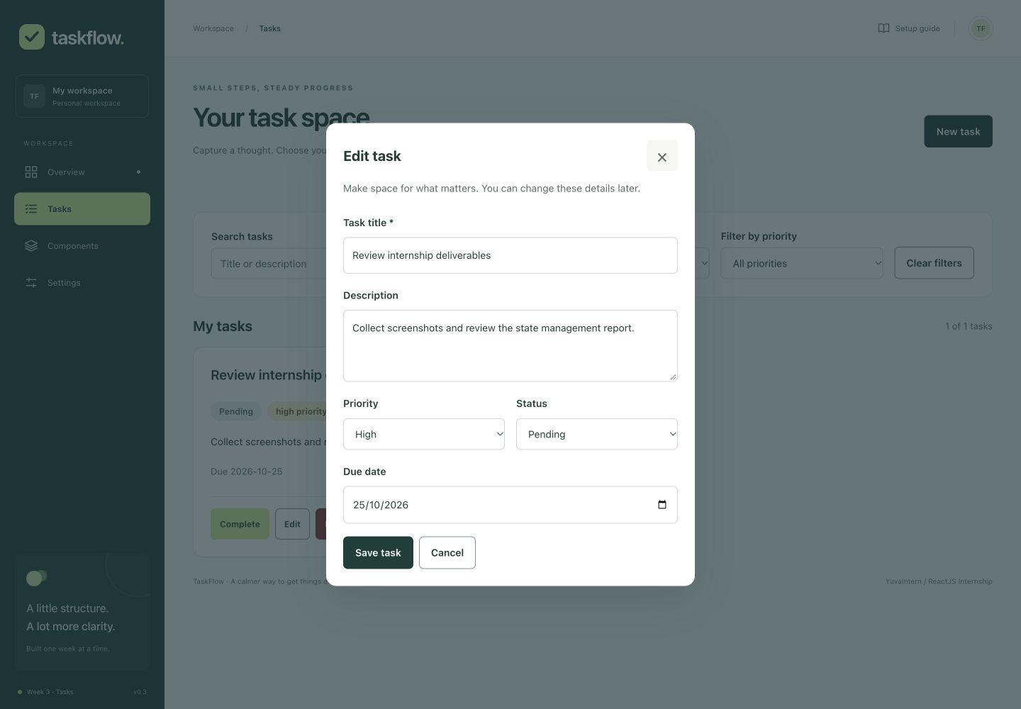
Figure 1 Populated editing form at 1440 pixels with the saved due date

Task list and saved task details
The saved record retains its edited title, description, high priority and optional due date. Completion and reopening update its badge immediately; reopening intentionally returns the task to pending. The browser also verified that refreshing retains this record.
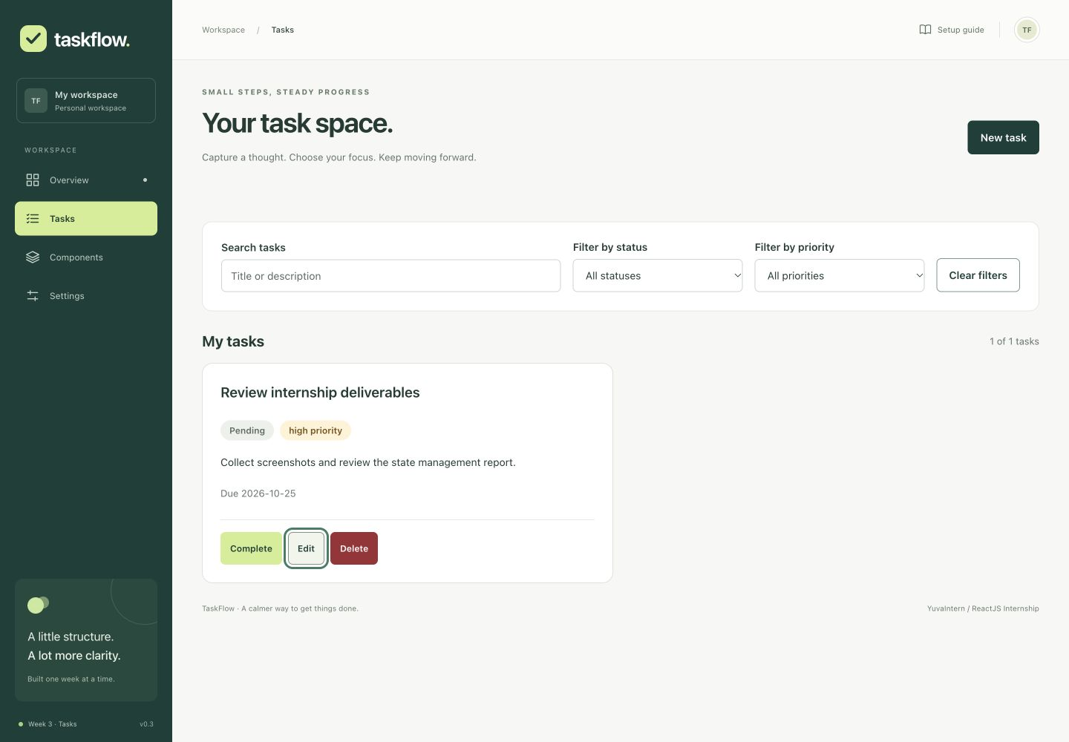
Figure 2 Desktop list after editing and reopening a task

Responsive browser verification
At 1440px the browser verified required-title feedback, creation, populated editing, due date, status changes, completion/reopening, combined filters, empty results, reset, refresh persistence and dashboard counts. At 768px it verified layout, delete cancellation, Escape and focus restoration. At 390px it verified keyboard creation, confirmed deletion and preserved Components and Settings routes. Horizontal document width matched the 1440px, 768px and 390px viewports on Tasks. These are representative checks rather than every workflow repeated at every width.
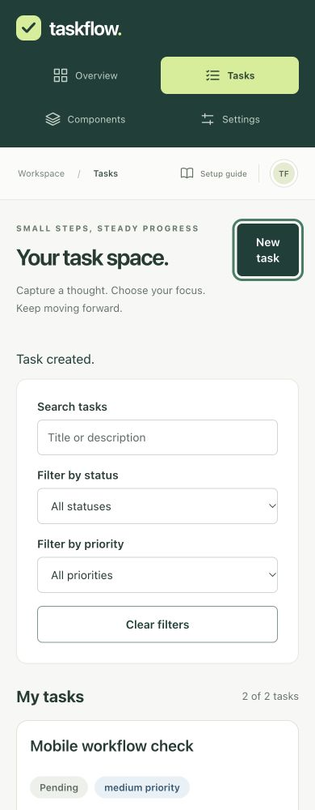
Figure 3 Mobile layout after keyboard task creation
A subsequent refresh retained the edited desktop task and due date. Captured browser error logs were empty. Desktop, tablet, mobile, filters, delete confirmation, creation, dashboard and persistence images are saved separately in evidence/week3. A browser presentation of verbatim command logs is also included; it is explicitly not a native Terminal capture.

Testing verification challenges and future scope
Actual command | Observed result
npm ci | Exit 0; 890 installed packages; audit and deprecation notices
npm test -- --watch=false | 44 passed, 0 failed, 3 suites; includes all 33 Week 2 tests
npm run lint | Exit 0, no warnings
npm run format:check | Exit 0; all matched files use Prettier style
npm run build | Exit 0; three performance warnings
npm start | Application served at localhost:3000; actual browser used
npm audit --json | Exit 1; 21 moderate and 5 high advisories; zero critical

New tests cover the integrated task lifecycle, required title and due-date input, modal confirmation and cancellation, dashboard sharing, combined filters, immutable reducer actions, Context actions, StrictMode initialization safety, remount persistence, malformed/schema-invalid storage, restriction/quota failures, filter-hook reset, statistics and invalid dates. A first test assertion matched both a badge and select option; scoping the query to the task list resolved it.

Challenges and solutions
Initialization safety required a lazy read before reducer creation and an explicit initial-array guard. Corrupt data recovery required preserving original bytes while warning about session-only changes. Browser testing exposed date input synchronization; handling native input events fixed the saved due date and a regression assertion now verifies it. Removed delete triggers required an explicit New task focus fallback.
Three production warnings remain for asset/entry size and code-splitting recommendations. The existing dependency graph reports 26 advisories, including five high development-server-chain findings. Proposed remediation includes a major webpack-dev-server upgrade; no force update was applied. Deprecated transitive packages and optional native-script notices are retained in the installation evidence. Dependency migration and bundle optimization remain follow-up work.

Planned work and conclusion
The following allocation describes approximately one internship week of planned effort. It is not a record of measured attendance. The total is 35 hours.

Planned work breakdown
Work item | Hours
Review Week 2 and state contracts | 3
Reducer, validation and statistics | 4
Context, custom hooks and persistence | 6
Task forms, cards and CRUD dialogs | 7
Filters and dashboard integration | 4
Automated and browser verification | 6
Documentation, report and evidence | 5
Total planned hours | 35

Week 3 delivers the local task workflow on the preserved foundation. Weeks 4 to 6 can refine organization and preferences, broaden accessibility/browser testing, address dependencies and bundle size, and prepare final delivery. No backend, authentication, collaboration, multi-tab synchronization, export or undo is included. The Markdown companion contains complete implementation excerpts and module responsibilities.

