  - YuvaIntern Junior ReactJS Developer Internship

TaskFlow Week 4 API Integration and Data Handling
  - Implementation and verification report
Week 4 of the six week ReactJS internship
Prepared on 19 October 2026

Project outcome
TaskFlow now includes a Remote Task Explorer that fetches actual JSONPlaceholder todos and users. It supports validated asynchronous requests, cancellation, loading and error feedback, retry, refresh, search, filters, pagination and independent local task imports. The existing task manager and all previous reports remain intact.
The full automated suite passed 66 tests with zero failures. Actual browser checks covered desktop, tablet and mobile layouts, live records, imports and persistence. Transient loading and failure captures use explicitly documented controlled conditions; successful records always come from the live service.
Repository: github.com/nitinmehra1017/taskflow-reactjs-internship
Submission branch: week-4-api-integration
The compatible audit fix updated one instrumentation package. The full graph still reports 26 development dependency advisories; production-only audit reports zero. Three bundle-size warnings remain. The 35 hour allocation is planned effort, not measured attendance.

Introduction objectives and existing application

Existing TaskFlow overview
Week 1 established the React and JavaScript application, custom Webpack 5 and Babel pipeline, linting, formatting, routing and scalable architecture. Week 2 introduced seven reusable UI primitives, SCSS design tokens, an interactive showcase and automated tests. Week 3 added local task CRUD, Context API, reducers, custom hooks, filtering, localStorage and six task-derived dashboard statistics.

Problem statement
A useful remote-data feature must handle uncertain response timing, failures, invalid records and abandoned requests. Fetching inside visual cards would duplicate network logic, and importing remote objects directly would bypass local validation. Remote data also needs clear separation from the user-owned task collection.

Objectives and delivered scope
• Fetch actual todos and associated users through dedicated native Fetch service modules.
• Validate HTTP status, JSON payloads, identifiers and todo-to-user relationships.
• Encapsulate request lifecycle, cancellation, retry, refresh and timeout in useRemoteTasks.
• Present remote cards with title search, completion/user filters, result counts and eight-item pages.
• Import independent local copies without duplicate source IDs or false persistence claims.
• Preserve existing routes, task workflows, visual language, keyboard support and regression tests.

API selection and justification
JSONPlaceholder is a free public demonstration REST API without API keys or paid services. Its todo and user collections are small and predictable enough for client-side filtering and pagination. The live browser returned 200 todos and ten users. It is a learning service, not a production task backend.
Endpoint | Purpose and fields
GET /todos | id, userId, title and completed supply remote task cards
GET /users | id, name and username supply owner labels and user filters

Base URL: https://jsonplaceholder.typicode.com. Only GET requests are made. Local edits and imported tasks are never posted back. Official API reference: https://jsonplaceholder.typicode.com/.

Architecture and data flow
App > TaskProvider > AppLayout > ExplorePage
useRemoteTasks
fetchRemoteTasks
getJson > native Fetch
validateRemoteData
RemoteTaskFilters > Input + Select + Button
RemoteTaskList > RemoteTaskCard > Card + Badge + Button
RemoteTaskSkeleton + Alert

Import > TaskProvider.importRemoteTask
> local validation + UUID + timestamps + sourceId
> taskReducer duplicate guard
> Tasks and Dashboard
> existing localStorage effect

Module | Responsibility
services/apiClient.js | Base URL, status checks, JSON decoding and error classification
services/remoteTaskService.js | Concurrent endpoint requests, joined validation and field projection
utils/remoteTaskValidation.js | Types, bounds, unique IDs, user references and remote source key
hooks/useRemoteTasks.js | Async state, lifecycle effect, timeout, abort, retry and stale-result protection
pages/ExplorePage.jsx | Filter/page state, derived results, import feedback and composition
components/remote/ | Card, filters, list and static skeleton presentation
styles/explore.css | Responsive layouts using the existing palette and primitives
tests/remote.test.jsx | Service, hook and integrated explorer/import behavior tests

The new route is added to Sidebar, Header and route focus/title mapping. The shared layout still hosts Dashboard, Tasks, Components, Settings and the not-found page. Local imported cards identify themselves as local copies. No external fetching or UI dependency was introduced.

Direction of state flow
The request hook owns remote snapshots and request feedback. ExplorePage owns only temporary controls and derives filtered/paged results. Local task state remains in TaskProvider. Import passes one validated remote todo into an explicit mapping action; user objects never enter the local task model.

Fetch async await and response validation

HTTP and decoding boundary
getJson awaits Fetch with a cancellation signal, Accept application/json and cache no-store. Network failures receive connection guidance; non-OK HTTP responses retain the status code. JSON decoding failures are distinguished from transport failures. Abort exceptions propagate so cancellation is not misreported as a network fault.
response = await fetch(`${API_BASE_URL}${path}`, {
signal,
cache: 'no-store',
headers: { Accept: 'application/json' },
});
if (!response.ok)
throw new ApiError(
`JSONPlaceholder returned HTTP ${response.status}. Please try again.`,
'http', response.status);
return await response.json();

Concurrent service requests
const [todos, users] = await Promise.all([
getJson('/todos', { signal }),
getJson('/users', { signal }),
]);
if (!validateRemoteData(todos, users))
throw new ApiError(
'JSONPlaceholder returned unexpected task or user data. Please try again.',
'validation');

Payload contract
Both values must be arrays with at most 1000 records. Todo IDs and user IDs are positive safe integers and unique. Titles are nonblank strings no longer than 120 characters, completion is boolean, and every userId resolves to a validated user. User names and usernames are bounded strings. Empty valid collections are supported.
Invalid snapshots are rejected as a whole to avoid misleading owner labels and invalid imports. The service projects only the fields used by the explorer; extra user details are discarded. This bounds parsed record counts, not streaming response bytes. The third-party service remains responsible for availability and payload delivery.

Custom hook lifecycle and asynchronous states
useRemoteTasks owns data, loading and error state plus a request revision. A stable refresh callback increments revision. One useEffect owns the complete lifecycle for that generation; search, filters, pagination and imports do not refetch.
const controller = new AbortController();
let active = true;
let timedOut = false;
const timer = setTimeout(() => {
timedOut = true;
controller.abort();
}, REQUEST_TIMEOUT_MS);

const data = await fetchRemoteTasks({ signal: controller.signal });
if (active && !controller.signal.aborted)
setState({ data, loading: false, error: null });

return () => {
active = false;
clearTimeout(timer);
controller.abort();
};

The excerpt shows lifecycle operations from the implemented effect; the await is inside its async load function. Cleanup stops obsolete work and prevents updates after unmount. The active flag also rejects late results from a transport that ignores abort. Finally clears the timer; a failed endpoint aborts its sibling. StrictMode replay follows the same cleanup path.
State | User-facing behavior
Initial loading | Polite loading status, static hidden-from-AT skeleton and disabled Loading button
Refresh | Refreshing button, busy results and retained previous successful snapshot
HTTP or network error | Meaningful message, Retry action and retained data when available
Validation failure | Unexpected-response feedback; invalid data never enters cards or imports
Timeout | 15-second deadline, aborted transport and explicit retryable timeout feedback
Cancellation | No false error announcement on route change or newer generation

There is no automatic retry loop or remote cache across route unmounts. These are deliberate limits for a compact learning application; requests occur on mount or explicit Refresh/Retry.

Filtering pagination imports and accessibility

Efficient derived presentation
useMemo derives a user lookup Map, imported source-ID Set and combined filtered todos. Search is case-insensitive and title-only; completion and user filters combine. Eight-item pagination slices those records. Page count, visible range and bounded current page are derived rather than duplicated state. Filter changes reset page one; smaller refreshed results clamp it without an effect. Stable remote IDs are list keys.

Remote to local mapping
importRemoteTask validates the selected todo, maps its title and completion into the existing local model, assigns medium priority and blank description/due date, and generates a local UUID and ISO timestamps. It adds sourceId in the form jsonplaceholder:todo:1. No remote user data is copied.
The reducer checks sourceId as well as local ID atomically, so rapid events cannot create duplicates. Existing records without sourceId remain valid. Local editing preserves source metadata; deletion permits reimport. The explorer disables already-imported actions and local cards display Imported local copy. Imports never mutate the remote API.
Feedback states that a local copy was added and saving is attempted. Existing storage errors remain visible; an unavailable storage device is labeled session only. A quota-like failure test verifies that no durable-save claim is made. Refresh/remount tests verify successful persistence.

Accessibility and responsive behavior
Existing Button, Input, Select, Card, Badge and Alert are reused. Native labeled controls, semantic headings, skip navigation, route focus/title updates and visible focus indicators remain. Status/source labels use text rather than color alone. A few polite live regions describe requests, imports, result counts and page changes; skeletons are aria-hidden and static.
After importing disables its trigger, focus moves to View local tasks. Pagination focuses the results heading; filters keep their own focus. Mobile controls and cards stack, while wider screens use two-column cards and multi-column filters. Existing reduced-motion behavior is preserved. No full WCAG or screen-reader certification is claimed.

Live Remote Task Explorer
The genuine desktop capture shows actual JSONPlaceholder records, remote ownership labels, completion badges and local-copy import actions. The running application fetched 200 todos and ten users. Remote tasks remain distinct from the user-owned collection.
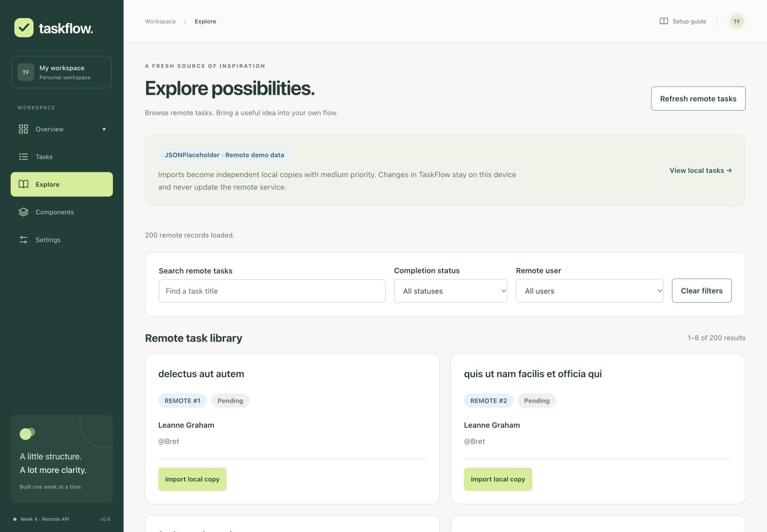
Figure 1 Live remote records in the existing TaskFlow shell at 1440 pixels
Desktop checks exercised combined title search, completion and user filters, the no-results state, page two of 25, pending-task import, dashboard updates and persistence after an actual reload. Tablet checks at 768 pixels verified completion filtering and wrapping layout. Horizontal document width matched viewport width at all three tested widths.

Controlled error and retry verification
This is an actual browser screenshot under an intentional test condition, not evidence of a JSONPlaceholder outage. A temporary entry wrapper rejected only the initial two calls; the visible banner identifies the simulation. Retry then fetched actual remote data. The wrapper is saved as evidence text and removed from final application source.
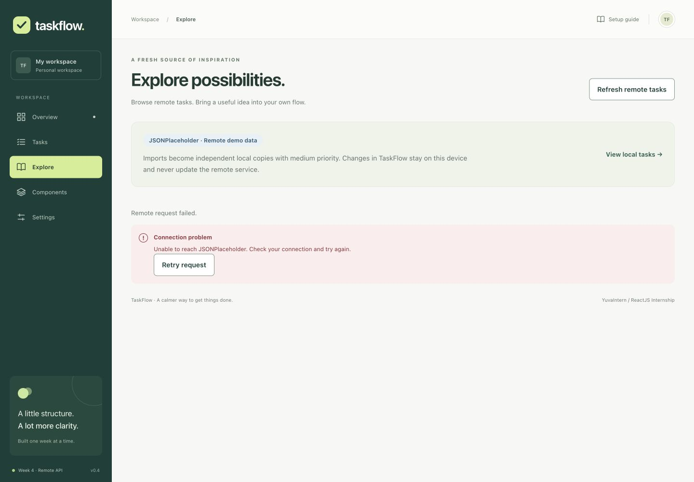
Figure 2 Controlled network failure with a working Retry request action
A separate temporary eight-second delay before real requests exposed initial skeletons and refreshing with retained live records. The delay was removed before final validation. No hardcoded successful API responses are used in these browser checks. HTTP, malformed data, timeout and late-response conditions are covered with mocked automated tests.

Mobile import and browser verification
At 390 pixels, a completed remote task was imported through keyboard Enter. Its local copy retained completion and updated the dashboard to one completed task out of three existing records. The preview also includes the earlier local task and a pending remote import; none of this demonstration data is bundled as defaults.
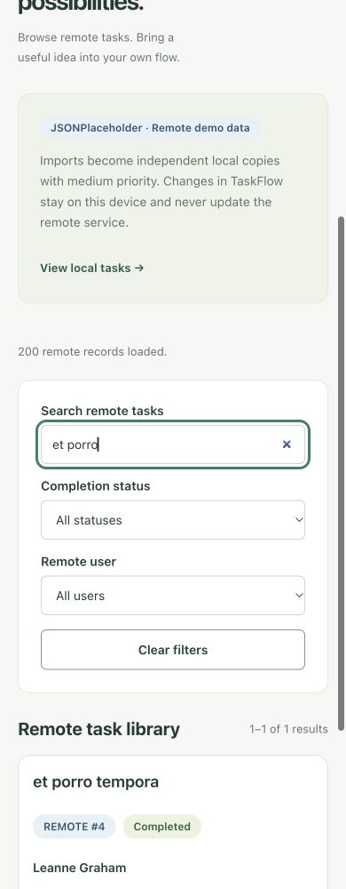
Figure 3 Mobile remote task search with responsive controls
Actual browser conditions were Codex in-app browser on macOS at 1440 by 1000, 768 by 1000 and 390 by 1000. Full-page screenshots can be taller than the viewport. Existing Dashboard, Tasks, Components and Settings routes rendered. Browser error output was checked after normal operation. These are representative checks, not a cross-browser or assistive-technology audit.

Automated testing and dependency review
Executed command | Observed result
npm ci | Exit 0; final lockfile installed successfully
npm test -- --watch=false | 66 passed, 0 failed across four suites
npm run lint | Exit 0, no warnings
npm run format:check | Exit 0
npm run build | Exit 0, three Webpack performance warnings
npm start | Application and /explore served at localhost:3000
npm audit fix | Compatible instrumentation patch; advisories remain
npm audit --json | 26 affected package entries: 21 moderate, five high
npm audit --omit=dev --json | Exit 0, zero production dependency advisories

Twenty-two new tests cover service success, HTTP/network/JSON/schema failures, validation bounds and user joins, loading, stable refresh, retry, retained snapshots, timeout, unmount cancellation and stale-generation safety. Integrated tests cover search, filters, pagination/reset, empty state, imports, duplicate events, status/source preservation, dashboard changes, remount persistence and quota-like storage failure. All 44 prior tests pass, including local CRUD and the Week 2 component suite.

Security review and mitigation
The compatible fix updated babel-plugin-istanbul from 8.0.0 to 8.0.2. Full audit counts remained 26 before and after; these are affected package entries, not 26 distinct underlying flaws. Production-only audit reports zero. No force fix was used.
High findings propagate through braces, micromatch, chokidar, http-proxy-middleware and webpack-dev-server. Moderate chains include sprintf-js through argparse/js-yaml and Jest instrumentation, plus uuid through SockJS. Suggested resolutions cross major versions, including webpack-dev-server 6.1.0 and a Jest/Babel-Jest 25 downgrade. Latest registry sprintf-js 1.1.3 is still within the reported affected range, so a blind override is not a fix.
The server remains bound to 127.0.0.1. Development tools should not be deployed publicly or run on untrusted inputs. Follow-up should review upstream patches or separately migrate affected tooling, then retest HMR, build and the full suite. Static production hosting should exclude development dependencies. A zero production audit is not a security guarantee.

Challenges planned work and conclusion

Challenges and solutions
Joining two endpoint snapshots required coherent validation before rendering. Cancellation needed both AbortController and an active-generation guard. Duplicate imports required a reducer-level check, and saving feedback needed to distinguish an in-memory copy from durable storage. Fast requests required transparent controlled conditions for transient-state screenshots. All temporary browser test code was removed before final verification.

Planned work breakdown
Work item | Hours
Review existing code and API contracts | 3
API service, validation and cancellation | 6
Custom hook and asynchronous states | 5
Explorer, filters and pagination | 6
Local imports and persistence integration | 4
Tests, browser checks and dependency review | 6
Documentation, report and evidence | 5
Total planned hours | 35

This is a planned allocation rather than measured attendance. It provides a reviewable 35 hour internship work breakdown.

Conclusion and future improvements
Week 4 connects a real public API to the existing TaskFlow application while preserving local ownership and earlier functionality. The delivered service boundaries, lifecycle hook, validation and reducer import guard support predictable behavior under failures and repeated interactions. Documentation and genuine evidence accompany a passing regression suite.
Remaining limits include third-party availability and CORS dependence, full small-collection fetching, no server pagination, no remote cache across routes, no remote writes, no backend/authentication and no multi-tab synchronization. Local storage can fail. Three bundle-size warnings and development dependency advisories remain. Weeks 5 and 6 can address performance and dependencies, broaden accessibility/browser verification and prepare final delivery.
The Markdown companion contains full implemented source excerpts, module responsibilities, verification details and evidence conditions. Weeks 1 to 3 reports and commits remain unchanged; the Week 4 branch is published without force-pushing or merging main.

