  - YuvaIntern Junior ReactJS Developer Internship

TaskFlow Week 6 Performance and Accessibility
  - Final week implementation and verification report
Week 6 of the six week ReactJS internship
Prepared 19 October 2026

Measured outcome
Initial JavaScript decreased from 306,434 to 279,437 bytes, a 8.81 percent reduction. Initial CSS decreased from 32,041 to 20,576 bytes. A controlled React Profiler fixture reduced remote card update commits from eight to one. The full suite passed 119 tests with zero failures.
This report explains the baseline methodology, actual Lighthouse comparisons, route splitting, rendering improvements, responsive corrections and accessibility findings for internship review. Timing regressions and outstanding manual checks are included alongside improvements.
Repository: github.com/nitinmehra1017/taskflow-reactjs-internship
Final branch: week-6-performance-accessibility
All previous reports and history are preserved. One entry-size build warning and 26 development dependency advisory entries remain. This report does not certify full WCAG compliance or hosted production readiness.

Introduction objectives and measurement method
TaskFlow combines a React dashboard, local task management and a Remote Task Explorer. Week 1 established custom Webpack, Babel, routing and architecture. Week 2 added seven reusable UI primitives and SCSS tokens. Week 3 added Context, reducers, custom hooks, CRUD, filters, statistics and localStorage recovery. Week 4 added validated public API requests and local imports. Week 5 added comprehensive tests, regression fixes and CI.
Week 4 and Week 5 implementation was verified in the repository before branching from Week 5 commit 7af5394961c7cec85fdb1df4d01ec2423dd0e694. Week 6 retains the design system and custom Webpack architecture. TaskProvider remains above the persistent layout so route loading does not discard task state.

Objectives
• Measure before changing performance source and repeat under the same lab method.
• Defer optional page code and avoid unnecessary remote card rendering.
• Fix actual contrast, naming, focus and reflow issues without removing features.
• Protect all previous workflows and provide traceable final documentation.

Lighthouse method
Twenty four baseline audits completed before performance source changes. The optimized phase repeats 24 audits: four routes, mobile and desktop presets, three runs each. Reports use Lighthouse 13.5.0, headless Chrome 155, default mobile simulated throttling and the desktop preset. Medians summarize three runs. Production assets are served at 127.0.0.1:4173 through the same gzip and cache-header preview server in both phases. Default Lighthouse storage/cache reset is retained.
Local tasks start empty. Explore calls the real public API, whose response timing is uncontrolled. Local tool/CPU activity introduces noise. These observations are lab measurements, not field Core Web Vitals or proof of statistically significant speed gains. Raw JSON records settings, environment, audit details, requests and timestamps; HTML reports are retained.

Webpack analysis and measured payload changes
Metric | Baseline | Optimized | Change
Initial JavaScript bytes | 306,434 | 279,437 | -8.81%
Initial CSS bytes | 32,041 | 20,576 | -35.78%
All emitted JavaScript bytes | 306,434 | 325,190 | Includes deferred code
Build warnings | 3 | 1 | Entry-size remains

These are uncompressed Webpack emitted bytes. Initial means the main entrypoint; a direct visit to a lazy route additionally downloads its page/shared chunks. Total emitted JavaScript can increase because code splitting needs runtime boundaries. Network transfer is measured separately in the Lighthouse tables.
Production mode, tree shaking, source maps, runtime separation and splitChunks existed already. Week 6 adds named page chunks and meaningful React DOM/router cache groups. The oversized single vendor file is divided. The original 244 KiB warning budget is unchanged: the individual asset and generic recommendation warnings are gone, but one combined entrypoint warning remains.
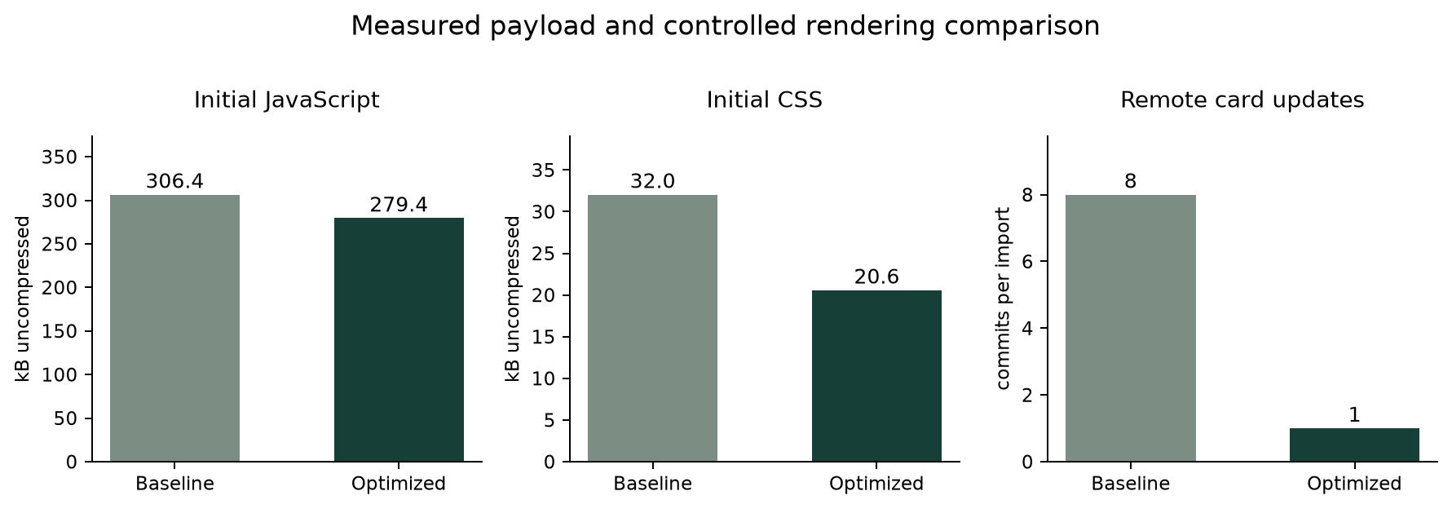
Measured entry payload and Profiler fixture counts. Commit-count reduction is not a production CPU timing claim.

Route loading rendering and API behavior
Tasks, Components, Explore and Settings use module-scope React.lazy with named dynamic imports. Dashboard stays eager. AppLayout keeps navigation outside Suspense; only Outlet is suspended. A static minimum-height fallback provides a heading and polite status. It reserves space without animation, but variable page content can still shift; actual CLS is reported.
const TasksPage = lazy(() =>
import(/* webpackChunkName: 'tasks' */ './pages/TasksPage')
);
<RouteErrorBoundary key={pathname} path={pathname}>
<Suspense fallback={<RouteLoading />}><Outlet /></Suspense>
</RouteErrorBoundary>

A rejected chunk reaches a route error boundary with a same-path full-document reload link. This supports stale-chunk recovery without automatic reload loops. The path key resets the boundary on navigation. Deferred/rejected module tests check fallback semantics, persistent navigation and recovery.

React Profiler evidence
Test-only instrumentation wraps the real Card in React Profiler, displays eight fixed remote records and imports record 1. Before the change all eight cards committed updates. After RemoteTaskCard memoization and a stable import callback, only record 1 committed: eight to one, an 87.5 percent reduction for this fixture. A regression test now requires that single update. Raw development/jsdom durations are retained without claiming production speedup.
Existing TaskCard memoization, stable task callbacks, memoized statistics, provider value and local filters were retained. No blanket memoization or unnecessary context rewrite was added.

API review
Existing parallel todos/users requests, response validation, eight-record pagination, AbortController cleanup, timeout, stale-response guards and retained results during refresh were retested. Search/filter/page changes do not refetch: the existing test checks two endpoint calls. Revisiting Explore intentionally fetches fresh data. Week 6 normalizes search once per calculation and skips unchanged remote-card renders. No cache changes freshness semantics.

Mobile Lighthouse median comparison
Three runs per route. Scores use a 0 to 100 scale. Timings are milliseconds; each cell shows baseline to optimized. Raw reports are in the matching baseline and optimized evidence folders.
Route | Perf | A11y | FCP ms | LCP ms | Speed Index
Dashboard | 100 to 99 | 95 to 100 | 756 to 1360 | 1802 to 1808 | 1088 to 1360
Tasks | 100 to 99 | 96 to 100 | 752 to 1202 | 1804 to 1802 | 752 to 1202
Components | 100 to 99 | 96 to 100 | 751 to 1505 | 1802 to 1802 | 751 to 1505
Explore | 99 to 99 | 97 to 100 | 1508 to 1505 | 1802 to 1803 | 1508 to 1505

Route | TBT ms | CLS | Transfer bytes | Requests
Dashboard | 0 to 0 | 0.0000 to 0.0000 | 105,878 to 98,081 | 7 to 8
Tasks | 0 to 0 | 0.0000 to 0.0000 | 105,878 to 104,757 | 7 to 10
Components | 0 to 0 | 0.0000 to 0.0000 | 105,878 to 106,058 | 7 to 10
Explore | 0 to 0 | 0.0160 to 0.0160 | 113,001 to 112,868 | 9 to 12

How to interpret these results
Scores and timings can improve, regress or remain unchanged. Lower payload does not prove lower LCP in every run. Network latency, CPU variation, browser scheduling and additional route requests affect measurements. Explore has uncontrolled public API timing. No feature was removed or audit disabled to improve the scores.
The full numeric comparison and percentage changes are in evidence/week6/comparison.json and docs/Week6_Performance_and_Accessibility.md. A zero baseline has no percent-change value; it is not reported as an infinite improvement. Request counts include the resources Lighthouse observed during initial load.

Desktop Lighthouse median comparison
Three runs per route. Scores use a 0 to 100 scale. Timings are milliseconds; each cell shows baseline to optimized. Raw reports are in the matching baseline and optimized evidence folders.
Route | Perf | A11y | FCP ms | LCP ms | Speed Index
Dashboard | 100 to 100 | 95 to 100 | 323 to 327 | 402 to 448 | 323 to 327
Tasks | 100 to 100 | 96 to 100 | 324 to 302 | 402 to 442 | 324 to 302
Components | 100 to 100 | 96 to 100 | 202 to 302 | 402 to 443 | 202 to 308
Explore | 100 to 100 | 97 to 100 | 202 to 302 | 403 to 442 | 202 to 302

Route | TBT ms | CLS | Transfer bytes | Requests
Dashboard | 0 to 0 | 0.0000 to 0.0000 | 105,878 to 98,081 | 7 to 8
Tasks | 0 to 0 | 0.0000 to 0.0107 | 105,878 to 104,757 | 7 to 10
Components | 0 to 0 | 0.0000 to 0.0599 | 105,878 to 106,058 | 7 to 10
Explore | 0 to 0 | 0.0003 to 0.0103 | 112,996 to 112,867 | 9 to 12

How to interpret these results
Scores and timings can improve, regress or remain unchanged. Lower payload does not prove lower LCP in every run. Network latency, CPU variation, browser scheduling and additional route requests affect measurements. Explore has uncontrolled public API timing. No feature was removed or audit disabled to improve the scores.
The full numeric comparison and percentage changes are in evidence/week6/comparison.json and docs/Week6_Performance_and_Accessibility.md. A zero baseline has no percent-change value; it is not reported as an infinite improvement. Request counts include the resources Lighthouse observed during initial load.

Accessibility findings and WCAG evaluation
Real-browser Lighthouse axe checks supplement Jest/jsdom semantics and manual keyboard observations. No full WCAG 2.2 AA compliance claim is made. Four genuine issue groups were corrected; findings and verification are retained.
Issue and criterion | Finding and change | Verification
Text contrast 1.4.3 | Muted breadcrumb, eyebrow, footer, welcome, roadmap and remote intro text failed contrast. Darkened within the existing palette. | Baseline selector findings, calculated ratios and final browser audits
Reflow 1.4.10 | Settings width 365 at viewport 320. Grid minimum and nonwrapping badge fixed; command text wraps. | Final width 320; 35 route/width checks
Label in Name 2.5.3 | Import local copy text was missing from its accessible name. Visible text now matches Import remote task plus ID. | Dedicated regression and browser label audit
Focus 1.4.11 and 2.4.7 | Green outline had 2.41 to 1 contrast on forest. Contextual lime ring now 9.11 to 1. | Computed 3px lime outline and keyboard check

Additional criteria evaluated
Semantic structure, landmarks and control names (1.3.1, 4.1.2); written non-color task statuses (1.4.1); actual text zoom (1.4.4); keyboard operation and traps (2.1.1, 2.1.2); skip link (2.4.1); focus order and visibility (2.4.3, 2.4.7); dialog bounds and obscuration (2.4.11); target sizes (2.5.8); form identification/labels (3.3.1, 3.3.2); and status messages (4.1.3) were reviewed through the documented automated and browser checks.
Screen-reader/speech-recognition software, independent engines, exhaustive interaction-state contrast and reduced-motion preference emulation remain unverified. Existing reduced-motion CSS and static fallback were inspected. Native select arrow selection did not change value through automation; it is recorded as a manual verification gap, while automated filter selection tests pass.

Responsive layouts and keyboard verification
All five major routes were checked at 320, 375, 390, 768, 1024, 1440 and 1920 CSS pixels: 35 final measurements without horizontal overflow. Every route heading was awaited. The 320px Settings overflow was fixed after an intermediate 339px result exposed a remaining nonwrapping badge.
Native Chrome confirmed 200 percent zoom; all five routes fit the 735 CSS pixel effective viewport. Zoom was restored to 100 percent. Below 400px the dashboard now uses two statistic columns; the sidebar can scroll in short desktop viewports. A 320 by 700 dialog measured left/top 12 and right/bottom 308/688 with internal content scrolling.
Keyboard checks created a task, triggered invalid form feedback, edited its title, used Space to complete and Enter to reopen, searched and cleared, then confirmed deletion with Tab and Return. Only the newly created QA task was deleted. Shift Tab wrapped Close to Cancel. Escape restored dialog triggers. Explorer search, clear and pagination focused the results heading. The detailed log records the native select limitation.
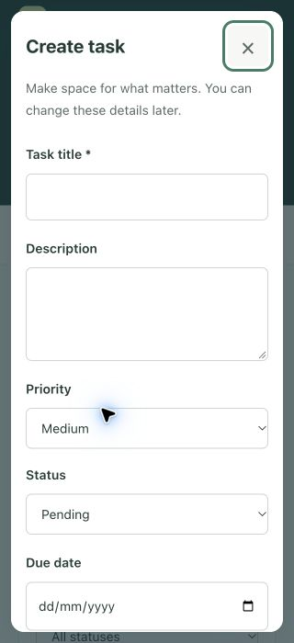
Actual 320px task dialog. Its boundaries remain inside the viewport; fields and actions can be reached by internal scrolling.

Genuine application and audit captures
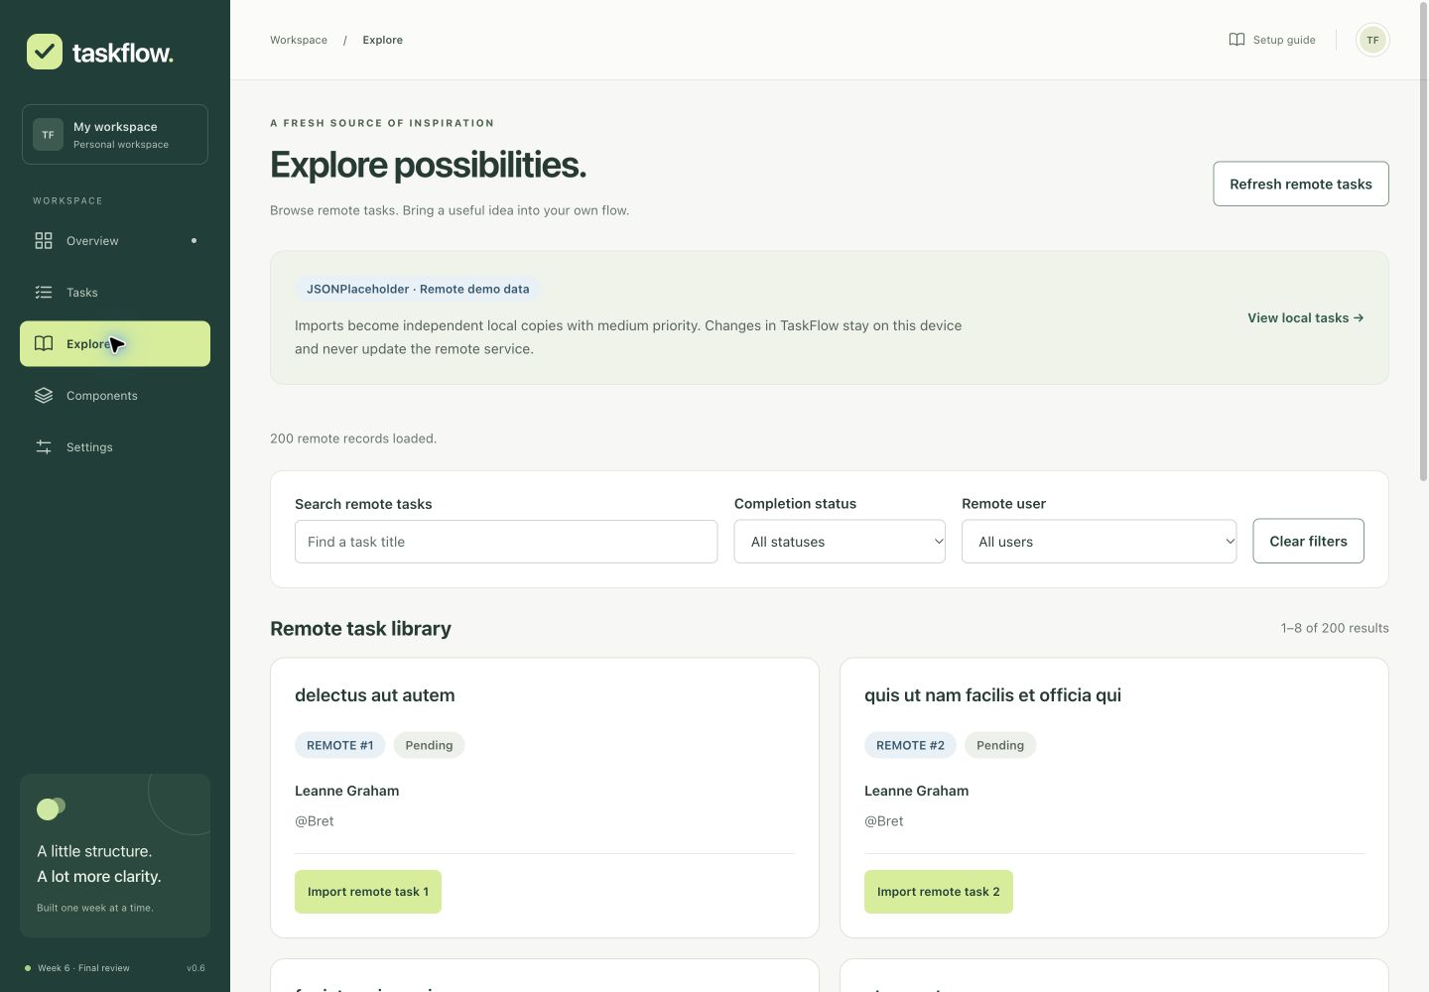
Final production Explorer showing live records and the corrected visible import labels.
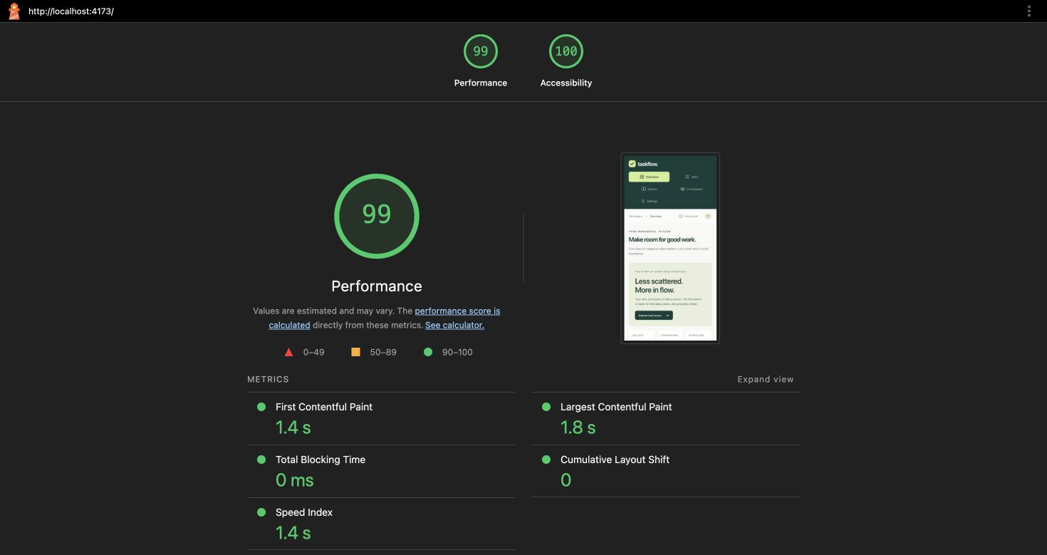
One genuine Lighthouse run. The report tables summarize three-run medians rather than treating this single capture as the median.

Regression quality security and challenges
The final coverage execution passed 119 tests across 13 suites with zero failures. All 111 previous assertions remain. New tests cover lazy resolution, pending/error semantics, recovery links, split-route navigation and retained state, import label naming and the Profiler update count.
Coverage metric | Actual | Threshold
Statements | 97.86% | 80%
Branches | 96.27% | 80%
Functions | 98.46% | 80%
Lines | 98.68% | 80%

Existing tests now await actual lazy modules through asynchronous act; production route modules are not mocked away. A deferred API response preserves the original loading-state assertion. CSS layout claims come from browser measurements rather than jsdom. npm ci, Jest, ESLint, formatting and production build passed. The production build retains one combined entry-size warning. GitHub Actions runs installation, lint, formatting, coverage and build on week branches.

Dependency review
Before and after a compatible npm audit fix, the full graph reports 26 development affected-package entries: 21 moderate and five high, zero critical. Production-only audit reports zero vulnerabilities. No compatible update cleared the remaining Webpack development server and Jest transitive chains. No force fix was used. The lockfile change records project version 0.6.0. These findings remain maintenance work before deployment tooling approval.

Challenges and solutions
Route splitting required asynchronous test setup without weakening behavior assertions. Browser audits found contrast and label-in-name issues missed by jsdom. A first reflow fix did not address the Settings badge, so actual widths were rechecked and corrected. Final audit runs were restarted after source fixes. Timing noise and public API latency require cautious comparison; regressions are retained.
Independent browser engines, assistive-technology checks, reduced-motion emulation, native-select arrow verification, one build warning and development advisories remain. The loopback preview is a verification server, not a hosted deployment.

Planned effort final readiness and conclusion
The following allocation totals 35 planned hours. It is a work breakdown, not a measured attendance record.
Activity | Planned hours
Verify previous work and prepare branch | 2
Baseline and repeated performance measurement | 4
Webpack route splitting and loading recovery | 5
Profiler analysis and rendering optimization | 4
Responsive layout and zoom verification | 5
Accessibility evaluation and genuine fixes | 5
Automated regression testing | 3
Security review and CI validation | 2
Documentation evidence and final reports | 5
Total | 35

Final internship readiness
All six weeks of source work and Word reports are present in this branch. Week 1 setup, Week 2 component library, Week 3 task manager, Week 4 remote integration and Week 5 QA are retained. Week 6 adds measured payload reduction, targeted rendering work, responsive and accessibility fixes and the final summary. docs/Final_Internship_Project_Summary.md links the six weeks and explains architecture, commands and limitations.
The project is ready for internship review with the documented gaps. Main has not been merged and no deployment is claimed. Future work should address independent engines, assistive technologies, field monitoring, bundle budgets and compatible dependency migrations.

Install run and submit
Use Node 24 and npm 10 or later. Run npm ci, then npm start for localhost:3000. For production verification run npm run build and npm run preview, then open localhost:4173. Submit this Word report, the week-6-performance-accessibility branch URL and submission-week6-description.txt.

