**Express JS and Express Generator Module**

### What is Express JS

Express JS is a Light-weight Web Framework to develop Web Applications very easily and quickly in Node JS Platform. Latest Express JS Framework version is : 4.x.

### Express JS Features

Express JS Framework provides the following features

* Light-weight Web Application Framework
* It Supports Routings
* It supports Template Engines
* It supports File Uploading
* Develop SPA(Singe Page WebApplications)
* Develop Real-time Applications

**Node JS:** HTTP Module is basic module to develop HTTP based Networking applications.

**Node JS: Connect** Module is developed on top of HTTP module to provide some extract features like Cookies, Middleware,CSRF etc.

**Node JS: Express** module is developed on top of “Connect” module to provide some more additional features on top of HTTP and Connect Modules.

**HTTP>>Connect>>Express**

**To DO ……..**

**Step 1: To install Express JS globally**

**npm install -g express**

**To verify installation**

C:\Users\[Windows_USerName]\AppData\Roaming\npm\node_modules\express

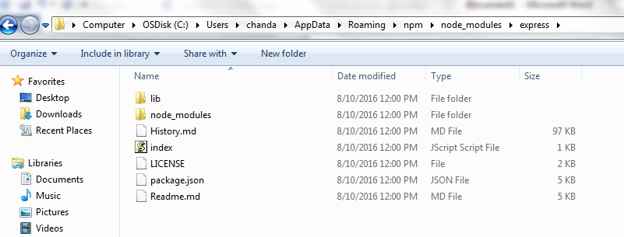

### What is Express Generator

Like Express JS, Express Generator is also a Node JS Module. It is used to quick start and develop Express JS applications very easily

**Step 2 : To install Express JS globally**

**npm install -g express-generator**

### Step 3: **Express JS Simple WebApplication**

**express SampleWebApp**

**If you get bad command set “C:\Users\chanda\AppData\Roaming\npm;” to PATH variable**

**Step 4 :** Install Dependencies

**cd SampleWebApp && run npm install**

**Step 5 :** Run

**npm start**