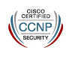

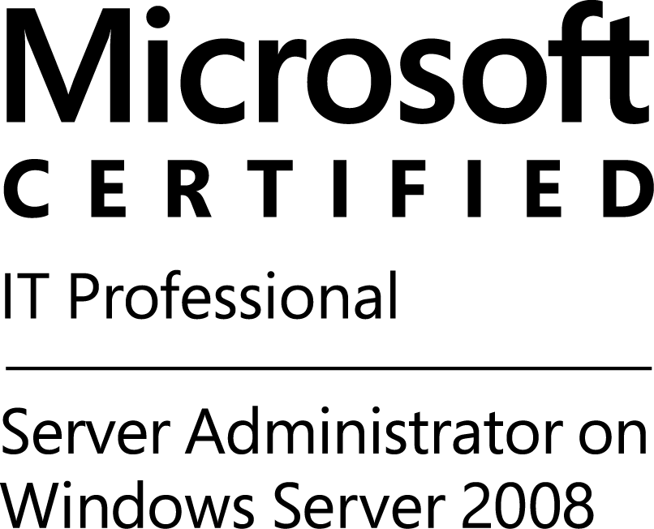
Jay Schnell
Bachelor of Science in IT with Emphasis in Security
CISSP, GCIH, CCNP Security, MCITP
also Security+, Network+, GSEC (expired)
9522701439
jay_schnell@yahoo.com
_____________________________________________________________________
Goal: I'm seeking a position as a Cybersecurity Vulnerability Management Engineer. I have a broad-based network and security architecture background that includes vulnerability management, patch deployment, customer engagement, and threat landscape risk assessment leading to prioritized and focused remediation of issues, resulting in protection of company data as well as service availability.
Significant Accomplishments:
- I helped stand up a SOC for Immigration and Customs Enforcement in Chantilly, Virginia in 2010. I was a shift lead, with six personnel under me. We used Bigfix, Tenable, Fidelis DLP, ISS, Bluecoat, and other tools. I became familiar with Encase, Regshot, and used wireshark on our VM off-net lab systems when building countermeasures from indicators. One of our functions was to provide the CISO with “Daily Top 5 Threats”.
- I lead operational support for network security at the Joint Network Communication Center (JNCC), Camp Victory, Iraq, in 2009, where I operated Cisco firewalls, Bluecoat web proxies, Cisco IDS, and Snort for over 10,000 seats at Camp Victory. This was a 24/7 Security Operation Center (SOC) that supported the entire Iraq area of operation (AOR). I also performed the same role in the Green Zone, Baghdad, Iraq, from 2005 to 2007.
- At Kinetic Concepts Inc., I managed Cisco ASA firewalls, F5 Load Balancers, Cisco WAAS (wan acceleration), and an MPLS mesh with VPN backup for a company with 6 datacenters and about 4000 employees. I also assisted with a WebSense Upgrade, and evaluation and implementation of FireEye and Bluecoat Packet Shaper.
- I've performed evaluation, testing, and implementation of FireEye, Imperva WAF, Bluecoat Packet Shaper, Symantec DLP (Vontu), and used products like Tanium or Bigfix as well as others for forensics or cyber hunting.
Important Capabilities:
- I can perform end-to-end troubleshooting of network connectivity issues as well as identify opportunities for improvement in configurations, primarily from a network perspective. My network and firewall skills are current.
- I've built Active Directory and Exchange environments from the ground up, managed patching using SCCM for large enterprises, and implemented common security tools such as antivirus software.
- I'm familiar with Splunk, Looker, ArcSight, NetCool, and monitoring tools such as SolarWinds. I've managed both McAfee EPO and Symantec Endpoint Protection, and am familiar with application whitelisting tools.
Technologies I've worked on specific to the job description:
- I have over 10+ years experience in Network Security roles.
- I've used Tenable, Retina, and other vulnerability assessment tools.
- I'm also familiar with Bigfix and Tanium for in-depth analysis and Cyber Hunting.
- I've deployed patches using VBScripts, as well as enterprise tools like SCCM.
- I've operated Snort, RealSecure/ISS, and Cisco IDS systems for Raytheon, SRC, and KCI Medical.
- I currently review and approve security connectivity patterns within datacenter and cloud for a Fortune 50.
Employment History:
The Home Depot (THD) – Principal Security Engineer (2015-Present)
- I managed a team of associates, contractors, and resident engineers to overhaul the firewall infrastructure from NetScreen to a mix of JunOS and PaloAlto, in the two THD datacenters.
- I built a firewall orchestration and compliance program from the ground up using Tufin software integrated with ServiceNow, which is now self-sustaining.
- I lead the project to analyze over 300 VPN site-to-site tunnels between THD and other businesses. In each case, the business justification was analyzed, and then an alternative solution was arrived at to replace the tunnel.
- I provide Subject Matter Expert (SME) support and guidance to the Architecture Security Assessment (ASA) program. This program assesses and certifies all major Information technology systems at THD.
- Technology utilized: Tufin firewall orchestration, SolarWinds monitoring, Tanium and Splunk for analysis. Some hands-on with PaloAlto, Juniper, Cisco, Fortinet firewalls.

Visa, Inc., as a Network Security Assurance Analyst (2014)
- I assisted in the rollout and implementation of firewall orchestration and compliance using Skybox, integrated with Remedy. I then performed firewall, router, and network architecture audits in support of compliance.
- I met regularly with senior architects during design sessions of new technology solutions, and participated in several initiatives to improve the security posture of the existing network.
- I coordinated with the PCI team, key portfolio leaders, and business teams at Visa to ensure that Visa's policies pertaining to secure technical patterns were being followed. I helped generate artifacts for the internal audit teams pertaining to PCI controls, or internal auditors.
- Technology Utilized: Checkpoint Firewalls, Skybox firewall orchestration and network security compliance

Kinetic Concepts, Inc. (Now Acelity) as a Senior Perimeter Security Analyst (2013)
- I re-designed the perimeter security infrastructure, implemented Quality of Service (QOS), application inspection, bandwidth controls, and performed security improvements that greatly impacted the business.
- I implemented backup VPN tunnels, and implemented Wide Area Network (WAN) acceleration using Cisco WAAS. The effect was greater resiliency and increased performance that internal customers could see.
- I worked as the key liason during an IT Security Audit conducted by Sirius Computer Solutions, an effort that yielded a 250 page report to the CIO on the availability, redundancy, efficiency, and security of the network.
- I evaluated and piloted FireEye and BlueCoat Packet Shaper (formerly Packeteer) and then assisted with an upgrade to WebSense Triton.
- Technology Utilized: Cisco ASA, Cisco IDS, Cisco 6509-E dual core switches and a 10,000 sq ft datacenter with top-of-rack switches that were 3750 or newer. Cisco ACS 4.x. Some UCS chassis support. Cisco WAAS, routers, and AP. EIGRP and some BGP. Netflow analysis using StealthWatch. Remote VPN and site-to-site tunnels using Cisco ASA. MPLS mesh with multiple datacenters. Over 100 remote offices with site-to-site VPN and telephony support.

Headquarters Marine Corps as a Cybersecurity Analyst (2011-2012)
- I participated in the design of the reference architecture for the Joint Information Environment(JIE) which is a total re-design of the network infrastructure for all military services.
- I also was a member of working groups for the National Institute of Standards and Technology, the DoD CIO office, the Department of Homeland Security (DHS), US CYBER COMMAND, and the Committee for National Security Systems (CNSS), where we helped formulate information security policy for the nation.
- I lead the Cyber vulnerability assessment team for the Marine Corps, maintaining track of our compliance and leading the worldwide team of staff who regularly scanned the network and attached systems. I initiated the first Industrial Control System (ICS) and Supervisory Control and Data Acquisition (SCADA) assessments.
- Technology Utilized: Red Seal evaluation, Imperva WAF evaluation, Fidelis and Vontu DLP evaluation. This role was primarily a leadership position with limited hands-on technical work.

Immigration and Customs Enforcement Syracuse Research Corporation, as a Network Intrustion Analyst (2010)
- I helped build a new Security Operation Center from the ground up with almost nothing to start with as the previous contractors did not turn over any operations playbooks, or documentation. This was a high profile customer, Immigration and Customs Enforcement (ICE) with over 35,000 endpoints at that time.
- Conducted network intrusion analysis using ISS, McAfee ePO, and EnCase, as well as Bluecoat web proxy logs. This was performed manually as we did not have a Security Incident Event Monitoring (SIEM) solution.
- We conducted daily vulnerability assessments with Tenable and HP Web Inspect, and coordinated patching efforts using Bigfix. Bigfix (now replaced by Tanium) was used as a computer forensics resource as well.
- Technology Utilized: Bigfix, Tenable, ISS IDS (formerly Realsecure), McAfee ePO, HP Web Inspect, with some use of EnCase and other forensics tools since our team was separate from the CSIRT (Incident Reponse Team).

Gunter Air Force Station with CACI, Inc., as a Certification, Test, and Evaluation Engineer (2009 – 2010)
- Conducted vulnerability assessments of the Air Force's Network Operations Division. (NOD) while attached to 26th Network Operations Squadron (NOS).
- Conducted technical and non-technical assessments, entering results into the Air Force's tool for maintaining certification and accreditation status.
- Technology Utilized: Retina, DISA Gold Disk, for analysis of deployable and non-deployable patch requirements.

Camp Victory, Baghdad, working for Raytheon, as an Information Assurance Network Engineer (2008-2009)
- I managed all perimeter security infrastructure for Camp Victory, Baghdad, Iraq, including Cisco ASA firewalls, Bluecoat Proxy (with SSL Inspection), Cisco IDS, and in addition operated the Symantec System Center Console, and WSUS servers, for a base which averaged about 10,000 concurrent users on two 4 MB satellite connections.
- I implemented Quality of Service on the perimeter firewall, and bandwidth controls on the Bluecoat, to priorize business traffic while minimizing unecessary traffic such as YouTube.
- I performed executive communication support for general officers. This included custom VPN solutions, or other tasks such as printer or desktop support.
- Technology Utilized: Cisco ASA, Bluecoat SG8100, SolarWinds, Cisco ACS (AAA/RADIUS/TACACS) with some troubleshooting on LAN/WAN. Cisco IDS, Snort IDS.

Central Command, Tampa, FL, with Dataline, Inc., as an Information Assurance Network Engineer (2008)
- Working for Central Command, MacDill Air Force Base, Tampa, Florida, I was the working area manager of a 24/7 team of contractors that was responsible for tracking all Cyber threats to the military network, including successful intrusions.
- I coordinated or directed Network Defense Actions (NDAs) that affected the entire CENTCOM Area of Responsibility (AOR). This could include anything from blocking an IP, installing a patch, or making a configuration change in response to a current threat such as a zero-day attack.
- Technology Utilized: ArcSight

Target, Inc., Minneapolis, MN, as a Senior Systems Engineer (2007-2008)
- I took over responsibility for all server patching in the corporation, using System Center Configuration Manager (SCCM). This included about 17,000 servers at stores, and about another 2,500 servers in the datacenter. I was able to bring Target from about 40% compliance on deployable patches, to around 95%.
- I was given a maximum of 30 minutes of downtime per store, per month, to perform patch and maintenance. There were 3-tier environments with critical dependencies between applications and databases. I was able to constently meet the 30-minute deadline and bring servers back up using embedded scripts with SCCM.
- Using scripts I was able to help Target determine what computing systems they had that were not in the scope of management for anti-virus, greatly improving the security posture of the Target network.
- Technology Utilized: SCCM 2007, VBScripts

Green Zone, Baghdad, Iraq, as well as other locations, for Raytheon, as a Systems Administrator and Information Assurance Network Engineer from (2005-2007)
- I upgraded firewalls to Cisco ASA from PIX, and from Websense URL filtering to Bluecoat with SSL inspection. I implemented QoS, deny-by-default on firewalls, and helped set up a VPN mesh, as well as managed remote VPN solution.
- I maintained Active Directory, Exchange, File, and Print servers, as well as storage area networks.
- Technology Utilized: Cisco ASA, Bluecoat SG8100, Cisco IDS, Snort IDS, Cisco ACS (AAA/RADIUS/TACACS), Windows 2003 Active Directory, Exchange, File, Print, Dell EMC CX 600 SAN with Emulex/Qlogic fiberchannel. Symantec Antivirus.

Bagram, Afghanistan, as well as other locations, for ITT Systems, as a Sr. Network Engineer (2004 – 2005)
- I built a new Active Directory domain, Exchange, File, and Print servers, for a small 500-user network in Afghanistan with six distributed sites.
- I was the Senior Technical Lead for a new network where I was responsible for satellite, cryptographic, mux, and network infrastructure. Most of the gear I had never used before, but I did receive specialized training at Fort Huachuca.
- Technology Utilized: Cisco routers and switches, Windows 2000 Active Directory and Exchange. Satellite communications, military encryption systems. Harris STAT vulnerability assessments, GFI Languard, Symantec antivirus.

Previous positions available upon request.

