# Mission

**Byron Gravelle**

**San Francisco CA**

[**ByronGravelle@gmail.com**](mailto:ByronGravelle@gmail.com)

**408-221-5957**

My professional commitment is training and inspiring people to achieve their upmost potential, creating highly skilled leaders and teams that consistently exceed customer expectations.

**Skills** • Systematic approach to cultivating leaders and teams.

* Extensive operations cost control expertise.
* Recognized culinary excellence.

# Experience

**Culinary Operations Manager at S.C. Seaside Company** 2018 - Present

* Overseeing and evolving the culinary production for the Santa Cruz Beach Boardwalk,  Cocoanut Grove, and Deli Commissaries.
* Introducing exciting and memorable food experiences by training the staff in both classic and modern recipes and techniques.

**Co-Founder of Enhance Food** 2016 - Present

* Developed and launched Enhance, an organic all-purpose seasoning which has been used to prepare and serve over 2 million meals.

**Owner and Operator of Cafe Carbonero** 2012 - 2015

* Created an organic café and catering food service designed for local businesses.
* Designed the concept around local, organic, and heart healthy recipes.
* Hired, trained and mentored the service and chef teams to excellence.

## Consulting Food & Beverage Director of Pasatiempo Golf Club 2011

* Reorganized the two restaurants, bar, banquet, and snack bar businesses.
* Implemented a cross-operational team structure to support special events.
* Established operation wide weekly cost accountability procedures.

## Food Service Director at Mount Hermon Conference Center 2004 - 2010

* Reorganized the food and beverage operations providing 250,000 meals a year through 5 public dining areas and 2 food outlets.
* Standardized all kitchen and service processes, and implemented cooking from scratch for all recipes while decreasing cost by 28% in the first year.
* Created a team of high-achieving individuals and departments.
* Achieved and maintained a 97% excellence rating from guest evaluations.
* Established a one-to-one special dietary menu process.

**Executive Chef at Bella Mia Restaurant** 2001 - 2004

* Reorganized the kitchen staffing structure to a 15% weekly labor.

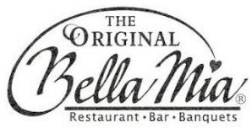 • Implemented efficient kitchen structure with documented recipes and line cook composition guides, elevating overall quality and consistency.

* Promoted the business through a Macy’s cooking demonstration with recipes published in the Weekend San Jose Mercury Newspaper.

## Executive Chef at Broadcom Café with Guckenheimer 2001

 • Developed and implemented a 5-week multicultural menu.

* Increased daily customers by 30%.

**Executive Chef at Sainte Claire Club** 1991 - 2001

 • Introduced French and Regional American Cuisine.

* Increased demand for special events from bi-yearly to bi-monthly.

**Executive Chef at The Inn at Pasatiempo** 1989 - 1991

* Designed restaurant menus with a seasonal focus.



* Increased weddings and events from 3-4 a month to 3-4 a week with a new banquet menu.

## Executive Sous Chef at the Bay Club, Decathlon Club 1986 - 1989

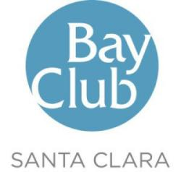

* Introduced Spa and Regional American Cuisine.
* Trained with top French and Swiss Chef’s.
* Developed and launched a new gourmet kiosk.

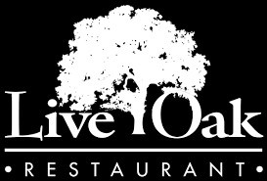

# Education

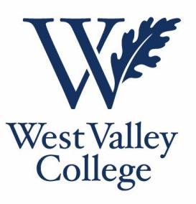

**Affiliations**

**General Manager at Live Oak Restaurant** 1984 - 1986

* Increased sales by 32% while decreasing costs, reinventing menus, recipes, sales- service strategy, methods of promotions and organization.
* Recovered operations from a loss position to 13% net revenue.

## Associates Education in Hotel, Restaurant & Institutional Food Service Management at West Valley College

* Mentored by the Founder of the Hospitality Program, Dr. Devins of Cornell University.
* Invited as guest chef to lead the graduates industry dinner over 5 consecutive years.

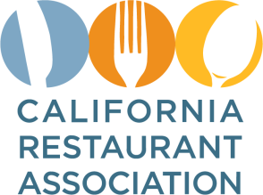 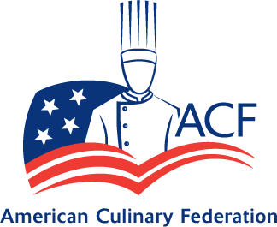   

# Technical Skills

* Proficient on Mac and Windows operating systems.
* Advanced Excel and Word abilities.
* Multi-platform POS experience.