***Chris Murphy***

[**Industrial Controls Technician**](https://youtu.be/BzHX_IqskRs) **&** [**Electrical Maintenance**](https://youtu.be/s6eb9Ujt8Jg)[**Trainer**](https://youtu.be/jgH2Hn73ONU)

***Analytical Approach with a Bias Toward Action***

***Military Multi-Craft Technician to Maintenance Supervisor***

***Customer Service to Skills Coach and Safety Champion***

**Recent Assignments**

*Automation Specialist*

[**Kennametal, Inc**](https://www.kennametal.com/en/home.html)

Jun 2018 – Ongoing Rogers, AR

* [Robot](https://youtu.be/dD1-iW0QYRg) [Integration](https://www.youtube.com/watch?v=1GkrKx11OME), [Machine](https://www.youtube.com/watch?v=46Bevf9c-DE) [Building](https://www.youtube.com/watch?v=dD1-iW0QYRg) - Commissioning & Operator Training

*Applications Trainer*

[**TEKsystems**](https://www.teksystems.com/en)

Jan – May 2018 Nationwide

* Delivered ERP Procedure Hands-On Instruction & Best Practice Coaching

*Technical Trainer*

[**ABB Marine Academy**](https://new.abb.com/marine/service/offerings/training)

Jun 2015 – Oct 2017 Houston, TX

* Developed Skill Assessments for the Offshore Electronic Technicians
* Delivered USCG Marine HV Safety (ArcFlash) Standards & Procedures
* Taught Liquid-Cooled ACS800 Drilling Drives Operations & Maintenance
* Improved PCTool Software Training by Creating Practical Skill Exercises
* Taught Troubleshooting Techniques, Fault Finding & Root Cause Analysis

*Training Specialist*

[**Cates Control Solutions**](http://www.cates.com/)

Sep 2013 – May 2015 Houston, TX

* Developed a Siemens S7-300 PLC Commissioning & Maintenance Course
* Improved the ACS800 VFD Maintenance Class by Including DriveWindows
* Created Student Guides Written Examinations & Instructor Presentations
* Created Electrical Safety, Lock Out/Tag Out, & Fall Protection Training
* Supported Service Performing Control Systems Trouble Calls

*Industrial Maintenance Instructor*

[**SynergyTech**](https://www.mfgday.com/events/2014/synergytech)

Oct 2008 – Sep 2013 Springdale, AR

* Assessed Maintenance Technicians Hands-On Skills & Written Knowledge
* Created a CAD Drawing Electrical Schematic Reading Course
* Taught VFD, PLC, HMI and CNC commissioning & programming.
* Delivered technical instruction & demonstrated advanced diagnostic techniques in all disciplines including AC/DC, 3-phase motor controls, mechanical drive systems, pneumatic & hydraulic fluid power systems.

*Maintenance Supervisor*

[**Advanced Environmental Recycling Technologies, Inc**](https://www.linkedin.com/company/aert-inc/)

Jan 2007 – Sep 2008 Lowell, AR

* Provided leadership for shift technicians by coordinating trouble-call repair efforts on all production equipment and mobile support pieces including forklifts, skid-steer loaders, man-lifts & skyjacks.

*Manufacturing Process Technician*

[**Sealed Air Corporation / Cryovac**](https://sealedair.com/)

Oct 2003 – Dec 2006 Rogers, AR

* Expertise in ten color flexographic printing in a LDPE conversion facility.
* Comprehensive experience in automatic viscosity control, color-matching, ink blending systems, flammable solvent safety & HazMat waste handling,
* Coordinated the pre-press tasks of order scheduling, resource management, customer-design technical issue resolution & job standard generation.

**Equipment Experience**

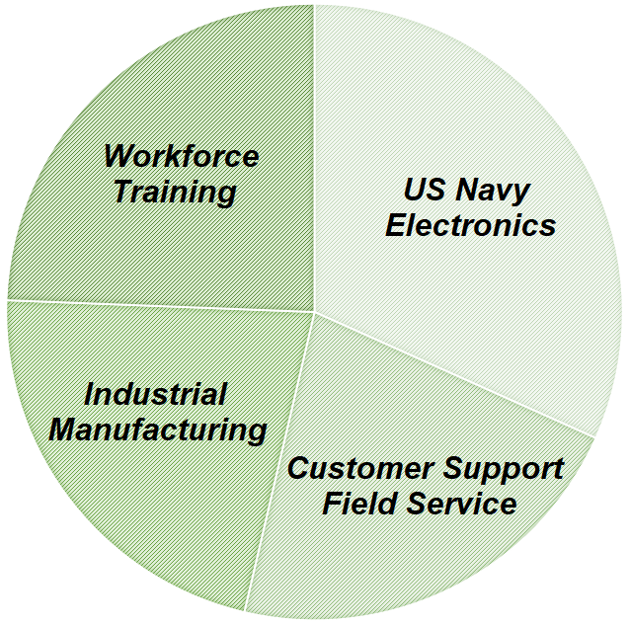

RF Receivers / Transmitters, Radars, Robots, MV Switchgear, Vacuum & SF6 Gas Breakers, Motor Control Centers, Product Labeling & Packaging Equipment, Compressed Air, Chilled Water, Boiler Steam Systems, Pumps, Load Cells, Augers, Blowers, Conveyors, Grinders, Extruders, Vacuum Systems, Fork Lifts, Skid-Steer Loaders, Transformers, Hydraulic / Pneumatic Fluid Power Systems

Low medium LV MV HV high voltage current resistance impedance Ohms Volts Amps transformer controls motor programmable logic controllers PLC PLCs VFDs CNC VFD variable frequency drives speed electrical electronics safety arc flash fault ohmmeter voltmeter ammeter megger megohmmeter troubleshooting reliability maintenance preventative corrective total productive manufacturing customer field representative service engineer support hands-on talent development industrial pneumatics hydraulics fluid power three-phase single 480 120 24 12.5KV VAC

Curriculum Development Quality Lean Six Sigma OSHA ANSI 5S DMAIC HazMat ASME ASTM NEA regulatory regulations TEAM conflict resolution NEMA ISO 9000 IEC NFPA 70E standards NEC LOTO lockout tagout asset plant performance compliance knowledgeable UL508A codes ISD SPC practices procedures TPM academic problem-solving BAS Bachelors Applied Science diploma certificate certification student continuous improvement leadership enthusiastic self-starter

Software hardware PC computer windows air-cooled liquid-cooled taught coached presented delivered instructed created developed improved exercises course curriculum RobotStudio DriveWindow ControlBuilder PanelBuilder automation integration robots CNCs machine Training Commissioning Installation Technical content developer applications ER STCW Yamaha Rockwell

MicroSoft MS Office Word Power Point Excel AutoCAD SAP Allen Bradley RSLogix ControlLogix RSView Studio Siemens STEP 7 S7 300 SIMATIC Bosch Rexroth Indraworks ABB ACS HMI AC DC alternating direct mechanical programming workforce train practical examinations written oral verbal advanced techniques fall protection repair coordination commission maintain complete comprehensive experience automatic inspection

**[](mailto:cmurphy747@gmail.com?subject=Resume%20Response)**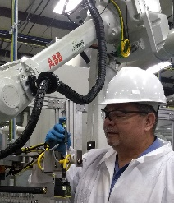

***Total Industrial Plant Asset Reliability***

***Regulatory Compliance, Talent Development and Performance Management***

Adept in OSHA 1910 Regs; ANSI, IEC, ISO, NEMA & NFPA 70E Standards;

5S, ISD, LEAN, SPC, TPM Practices; LOTO & HazMat Procedures; NEC & UL508A Codes

**Strengths**

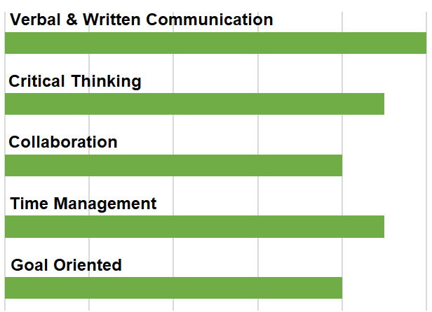

**Software Competence**

* *AutoCAD Electrical, MS Office and SAP*
* *Allen-Bradley’s PowerFlex, RSLogix, ControlLogix & RSView Studio*
* *Siemens STEP 7 SIMATIC Manager*
* *ABB’s RobotStudio, DriveWindow, ControlBuilder & PanelBuilder Applications*
* *Bosch Rexroth’s Indraworks Platform*

**Continuing Education**

**Yamaha Robotics Group**

*RCX 340 Maintenance*

**College of the Mainland; Gulf Coast Safety Institute**

*Safety Program Development, H2S Awareness, Fall Protection, Lock Out/Tag Out & Accident Investigation*

**Business & Industry Training Center**

*Rockwell’s Studio 5000 Logix Designer,*

*Hydraulic & Pneumatic Fluid Power Systems, Mechanical Drive Systems & CNC Machine Tooling*

**Corporate Sponsored**

*Quality Standards, ISO 9000 Certification,*

*Conflict Resolution, Interview Skills Training,*

*5S DMAIC, LEAN, and OSHA HazMat Training*

**US Coast Guard**

*Train the Trainer*

**Troy State University**

*BAS in Electronics Management (Earned 115 Qtr Hrs)*

**United States Navy**

*Academic Problem Solving and Student Motivation*

*Leadership, Management, Education & Training*

*Academic Instructor Training*

*Supervisor Skills Training*

**Green Text Contains Imbedded Links**