**Problem Statement:**

**Enhance the MapReduce program of Task 8 (refer session 19, assignment 3) to use multiple reducers for sorting. The driver should accept three additional values: the minimum units sold, the maximum units sold and number of reducers to use.**

**DRIVER CLASS:-**

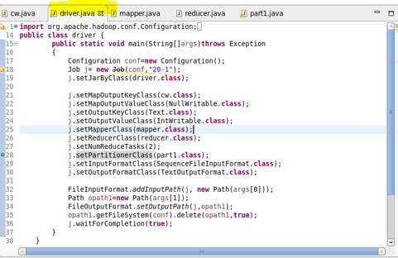

**MAPPER CLASS:-**

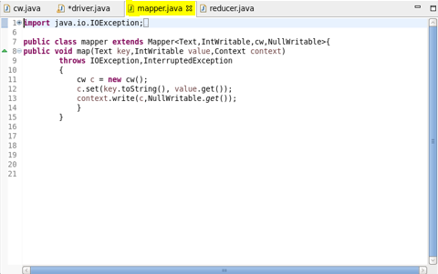

**REDUCER CLASS:-**

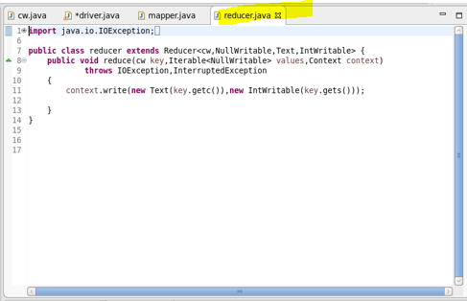

**CUSTOM_KEY CLASS:-**

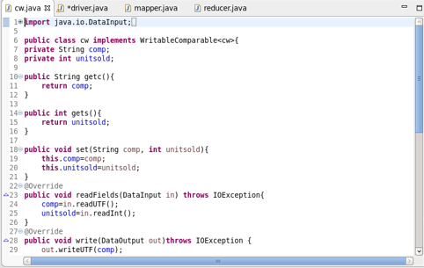

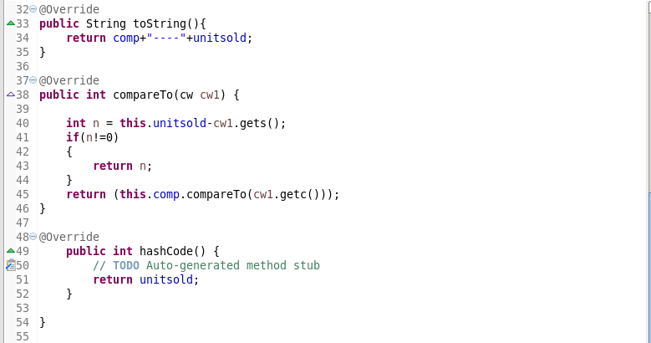

**PARTITIONER CLASS:-**

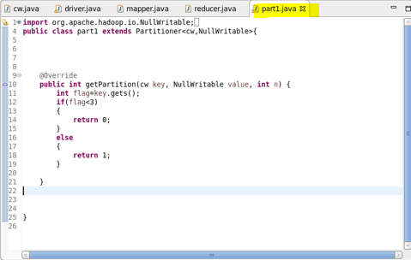

**EXECUTION COMMAND:-**

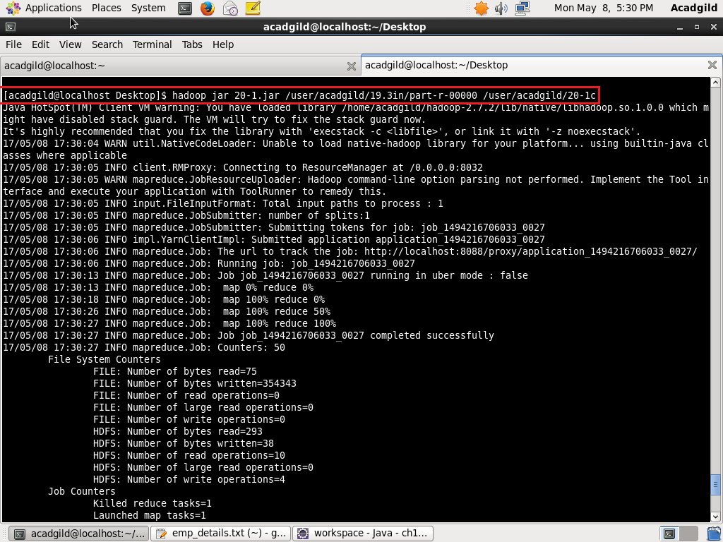

**OUTPUT:-**

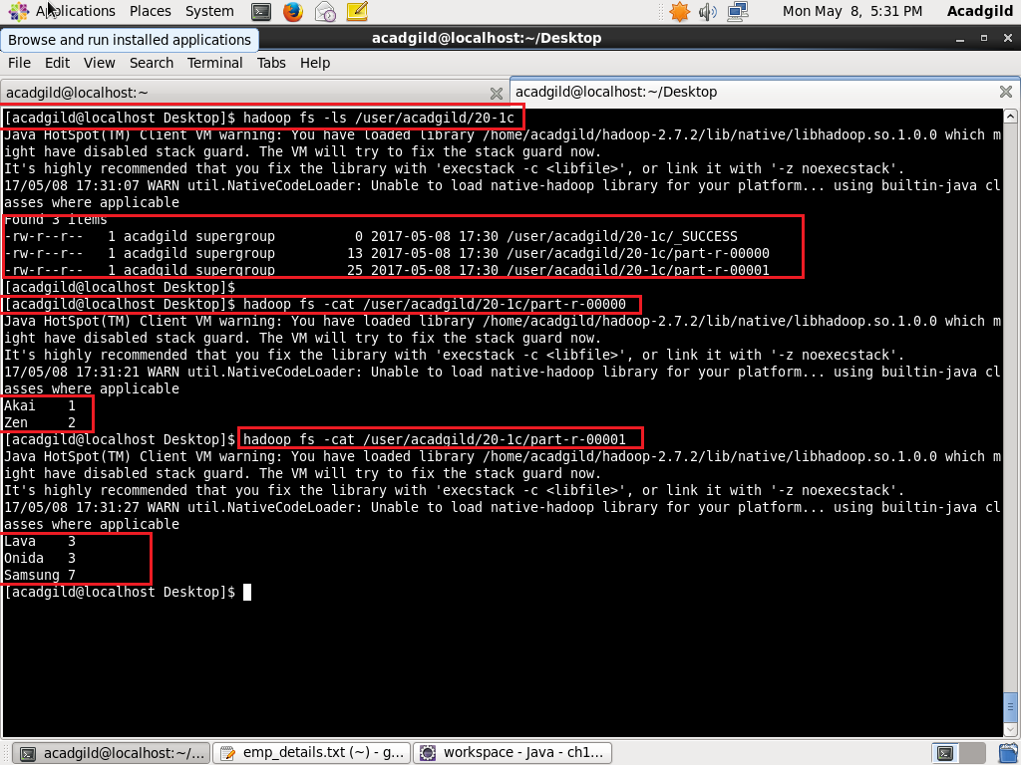

**DATASET:-**

