**PROBLEM:-**

**Write a pig script to find the count of each Hashtag in the dataset.**

**ANSWER:-**

**After doing unrar of our tweet.rar dataset we got following files :-**

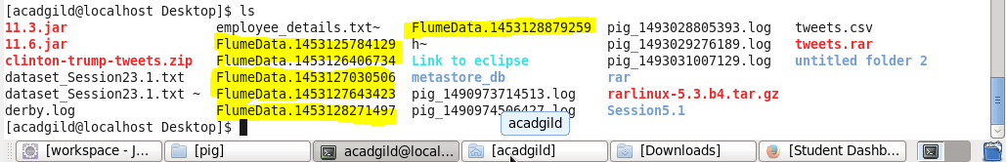

**Pig script:-**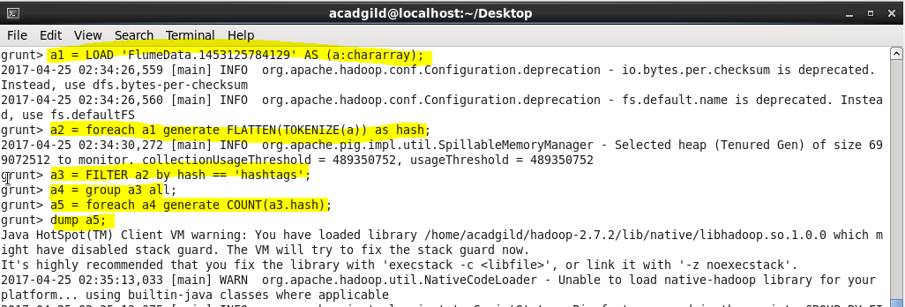

**Output:-**

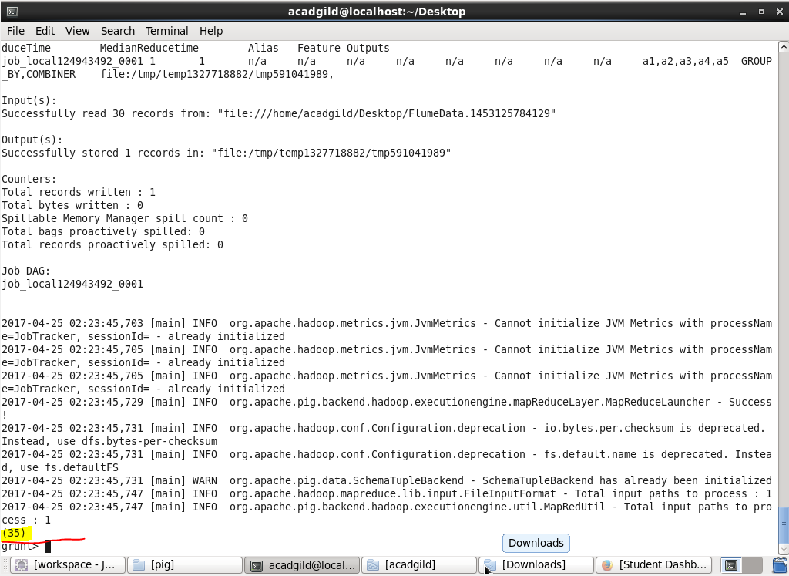

**So in total 35 hashtags in file 1:-**

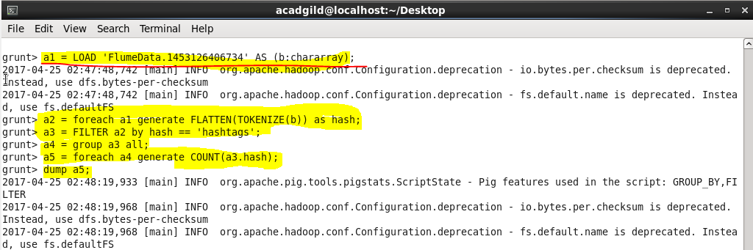

**Output:-**

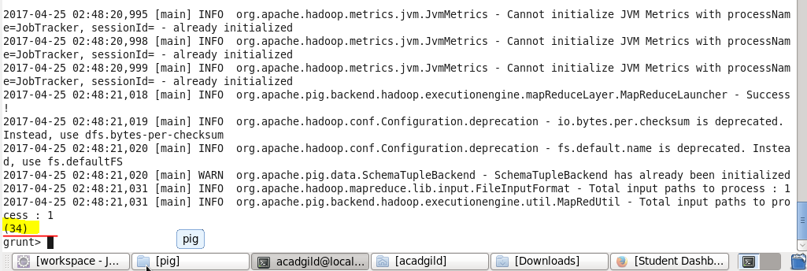

**So in total 34 hashtags in file 2:-**

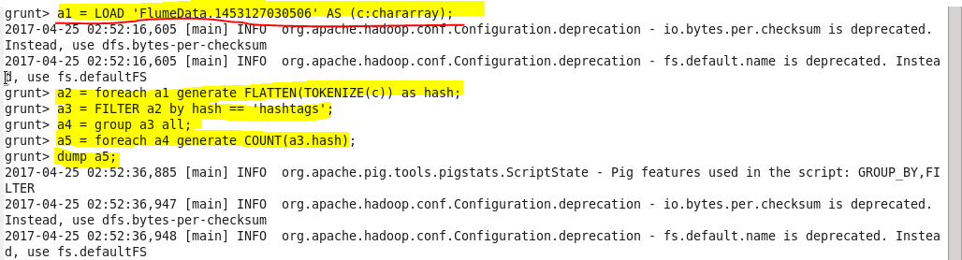

**Output :-**

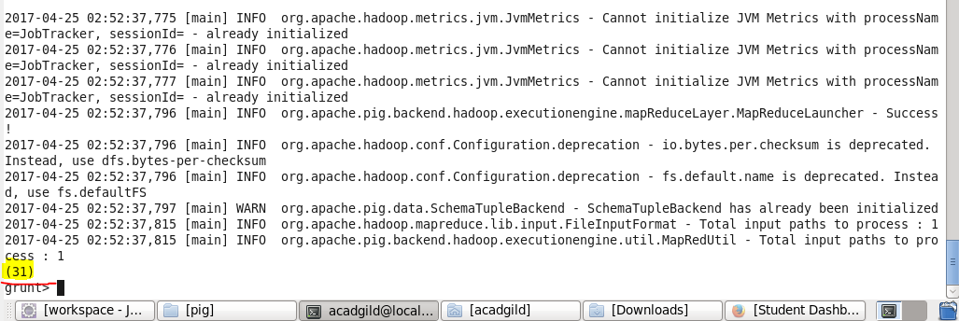

**So in total 31 hashtags in file 3:-**

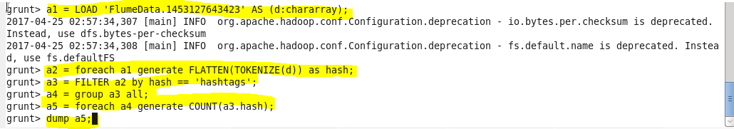

**Output:-**

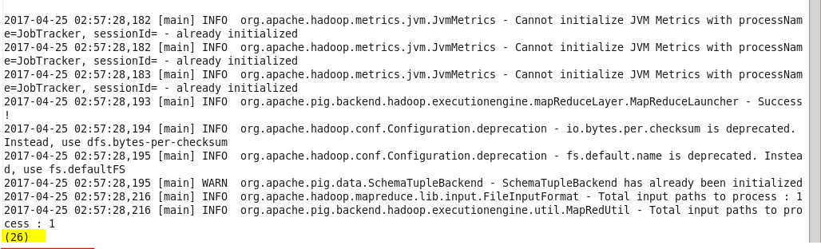

**So in total 26 hashtags in file 4:-**

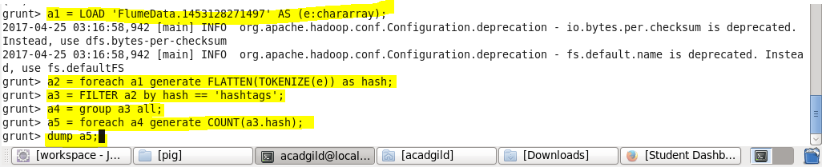

**Output:-**

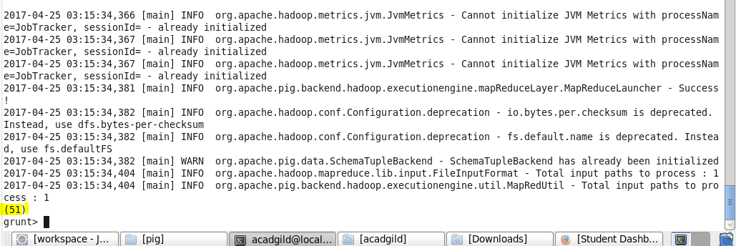

**So in total 51 hashtags in file 5:-**

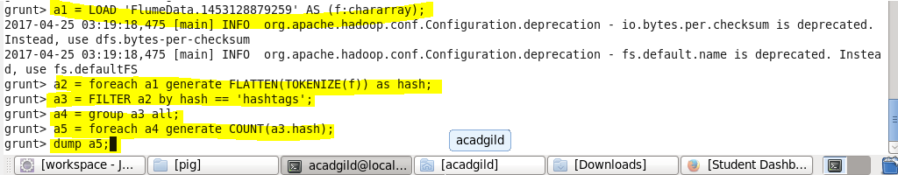

**Output:-**

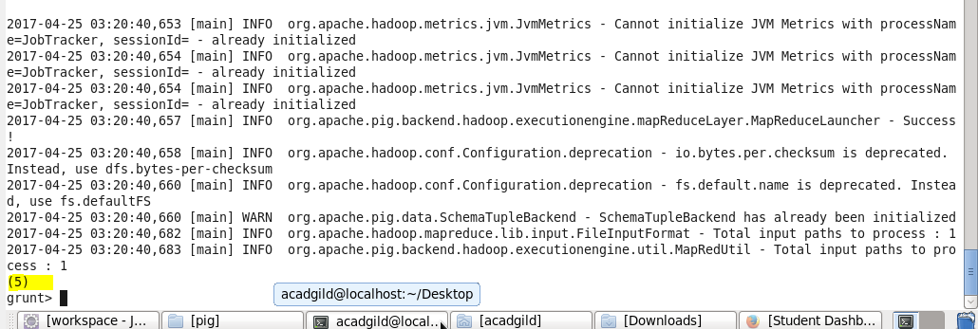

**So in total 5 hashtags in file 6**