**Write a MapReduce program that takes the output of Task 5 (refer session 7, assignment 1) as input, and produce output which is sorted on the total units sold. You may use a single reducer for the sorting. Use Sequence File formats as an output of Task 5 and as input for this task.**

**Driver :-**

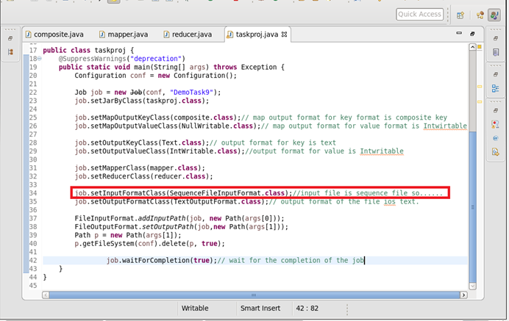

**Mapper :-**

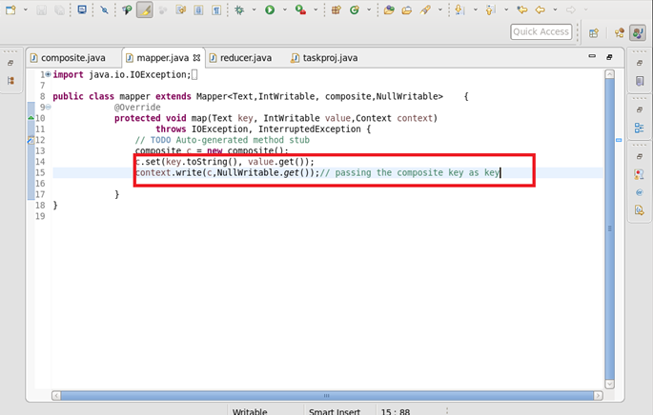

**Reducer :-**

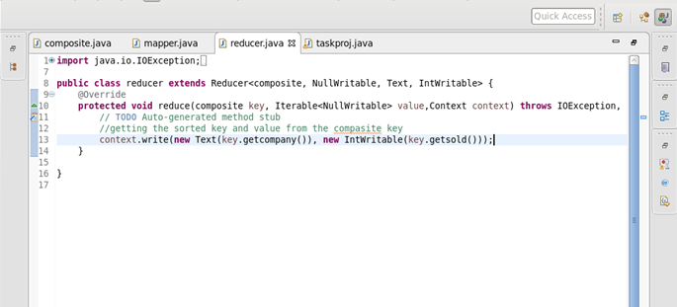

**Composite key :-**

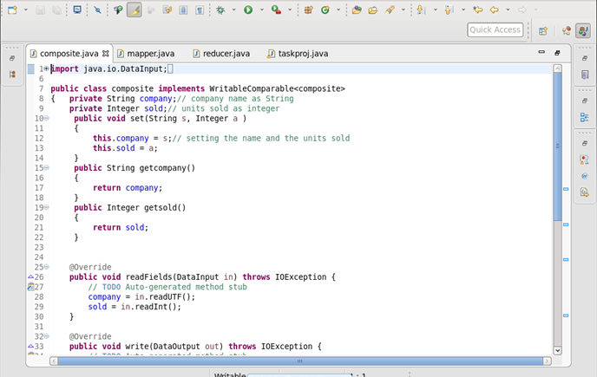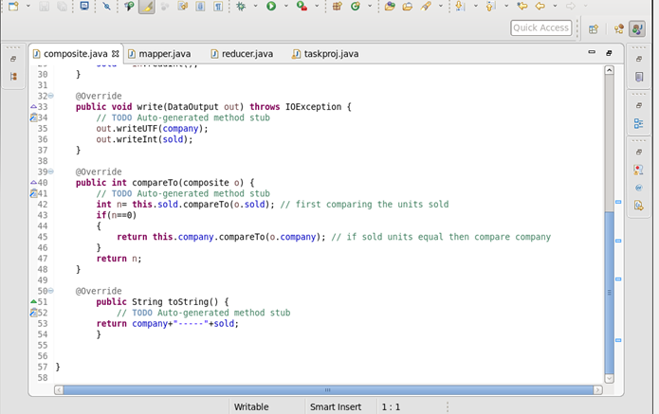

**Output :-**

