**Assignment 20.2**

**DATASET:**

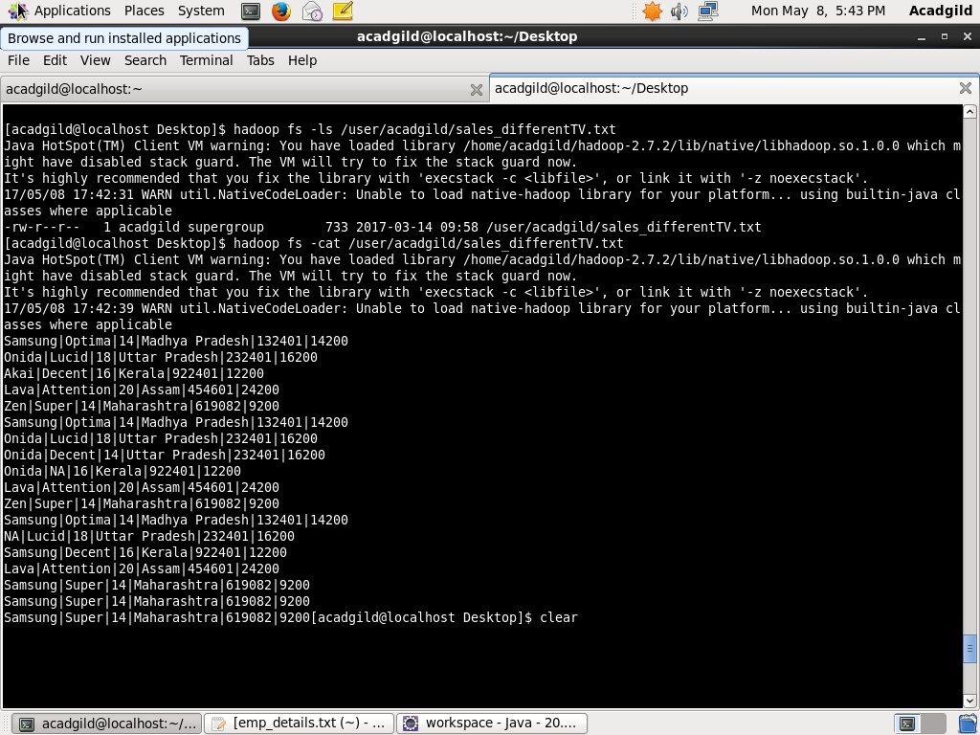

**We will use the above database for which we need to find out the top-3 state wise sales for each company.**

**PROGRAM:-**

**DRIVER CLASS:-**

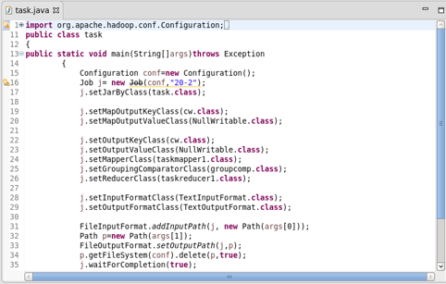

**MAPPER CLASS:-**

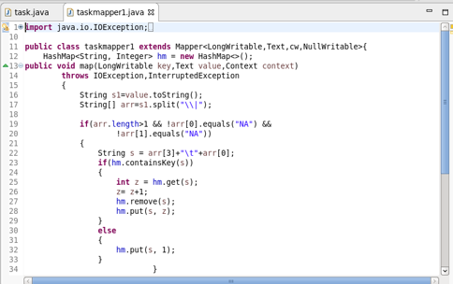

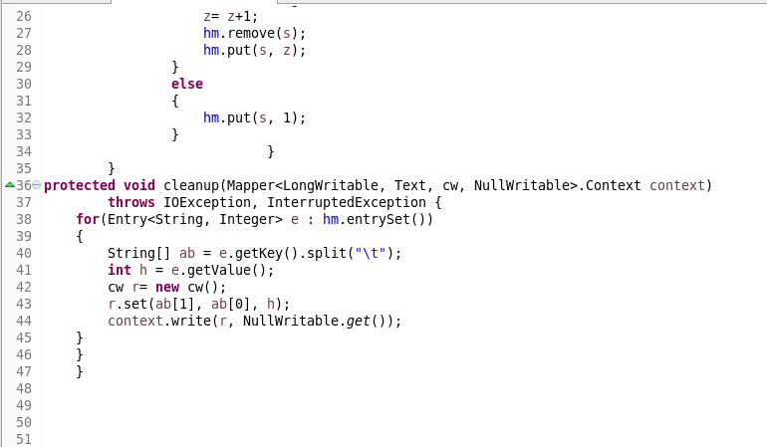

**CUSTOM_KEY CLASS:-**

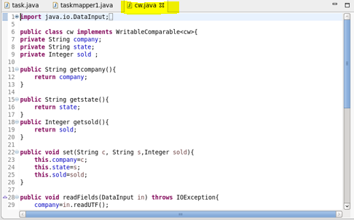

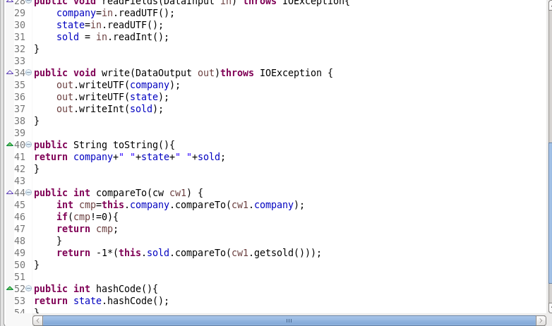

**GROUP COMPARATOR CLASS:-**

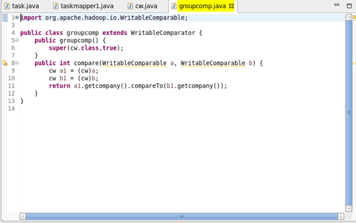

**PARTITIONER CLASS:-**

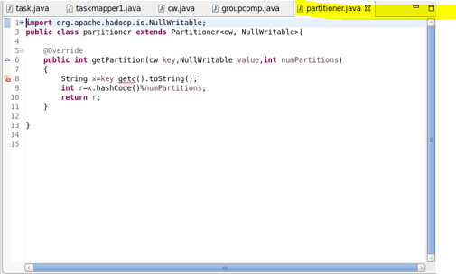

**REDUCER CLASS:-**

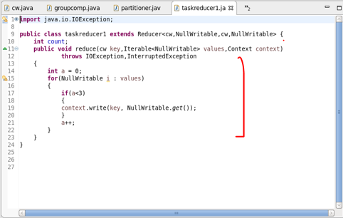

**OUTPUT:-**

