**This dataset consists of two columns i,e., first_name & last_name &city use custom input format to read the key as the combination of first_name and last_name and arrange the output of the program should be the key sorted by last_name.**

**Driver :-**

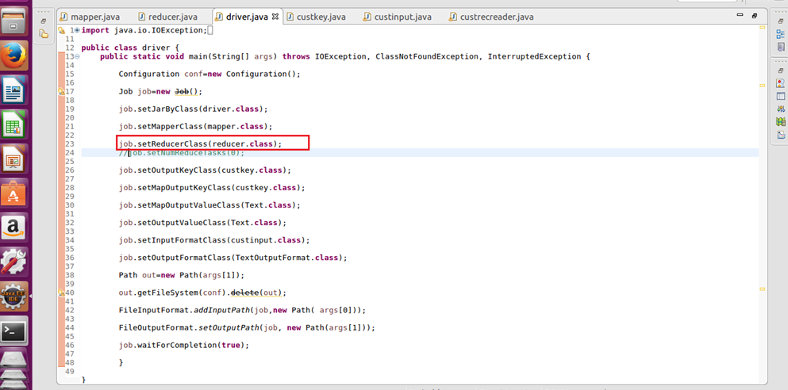

**Mapper:-**

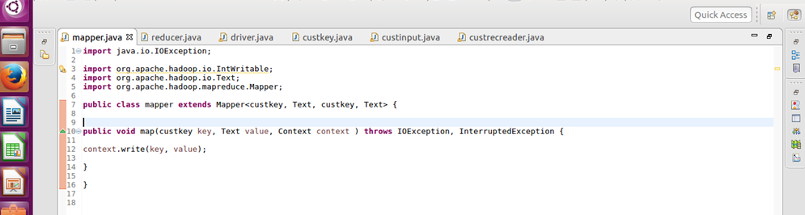

**Reducer:-**

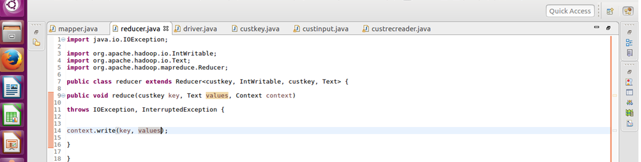

**Custom key :-**

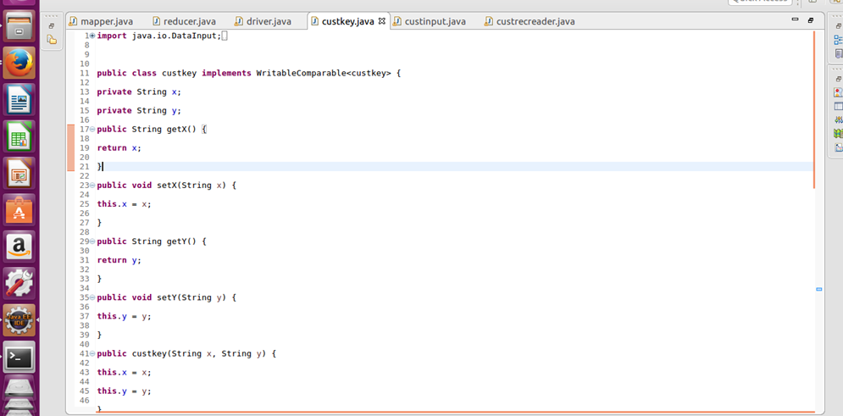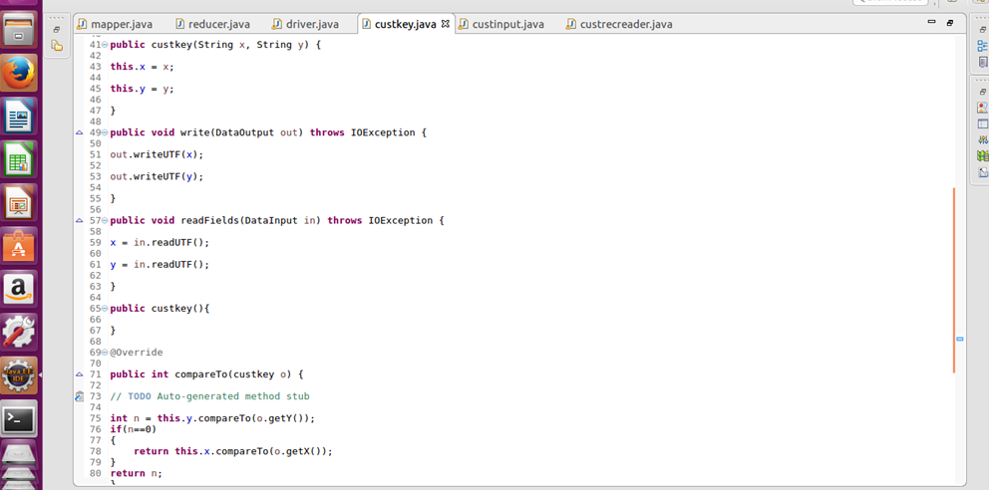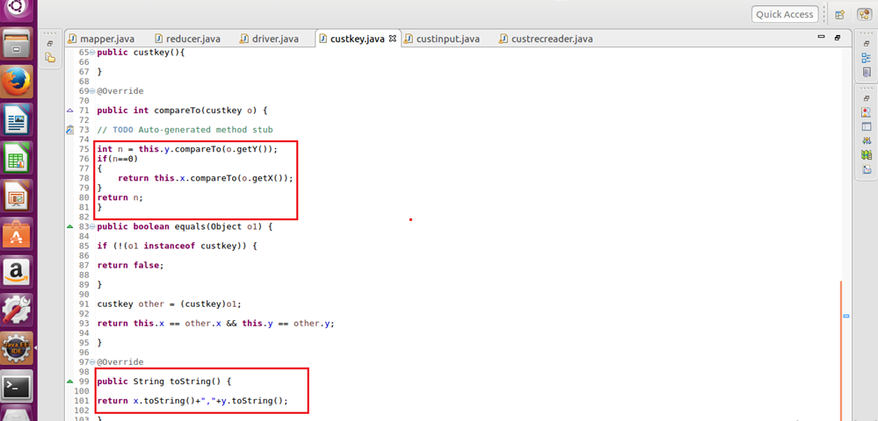

**Custom file format:-**

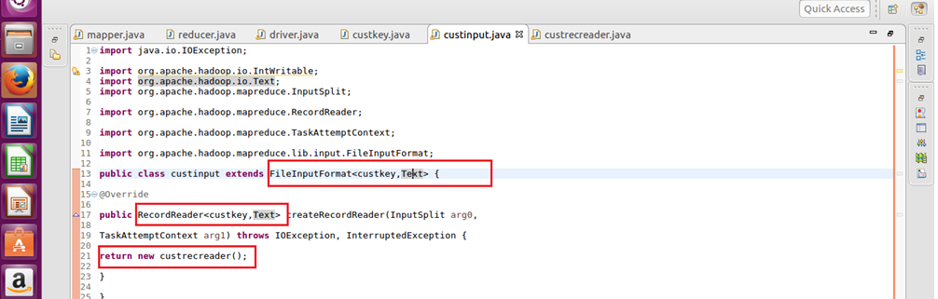

**Custom record reader :-**

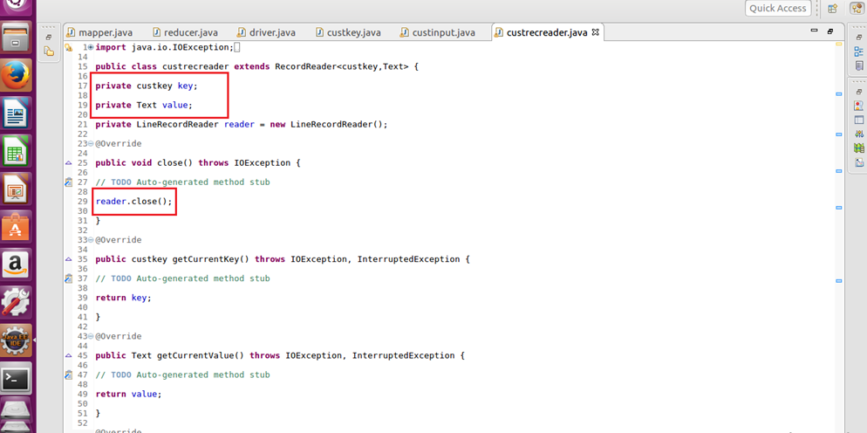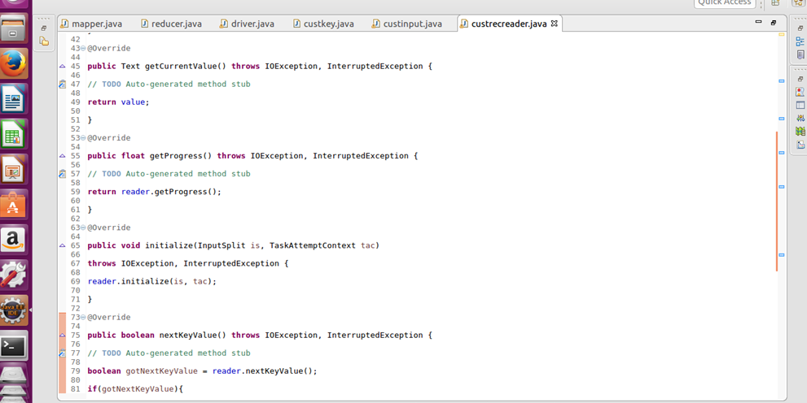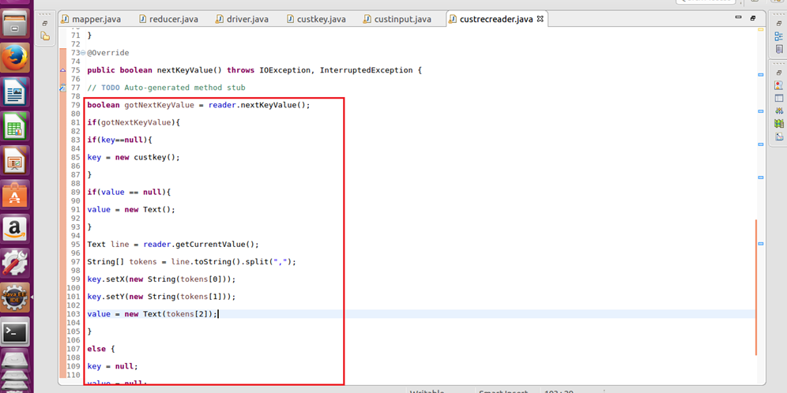

**Output :-**

