Find out what are the top 5 categories with maximum number of videos uploaded.

**Driver:-**

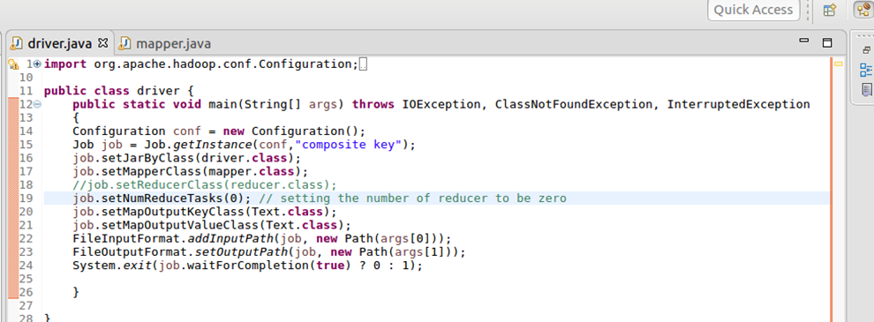

**Mapper:-**

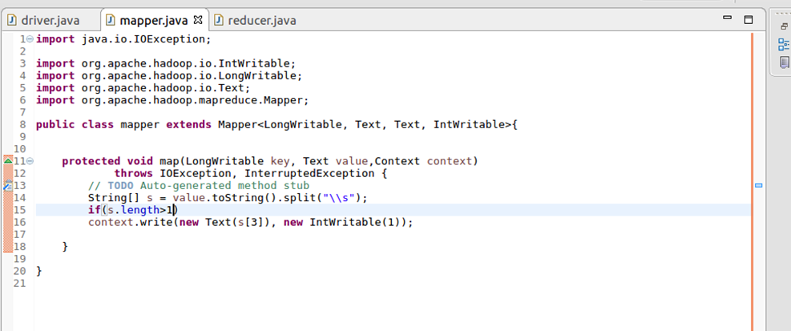

**Reducer:-**

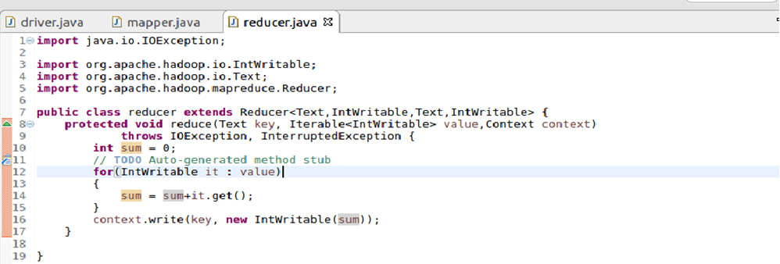

Output:-

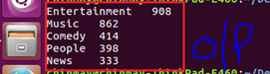

**Find the top 10 rated videos in youtube.**

**Driver:-**

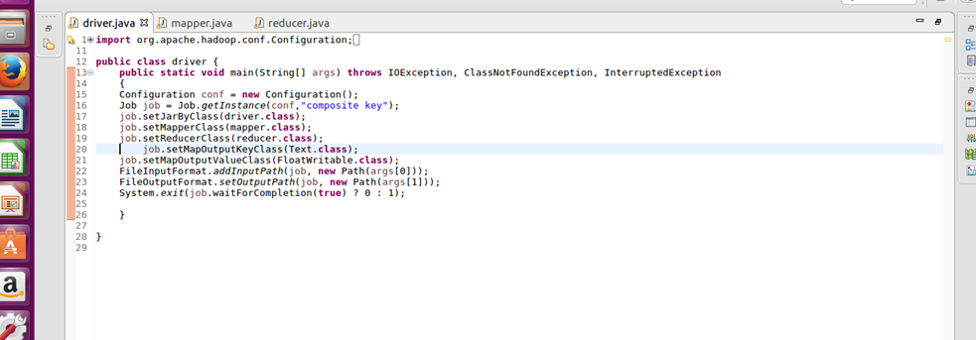

**Mapper:-**

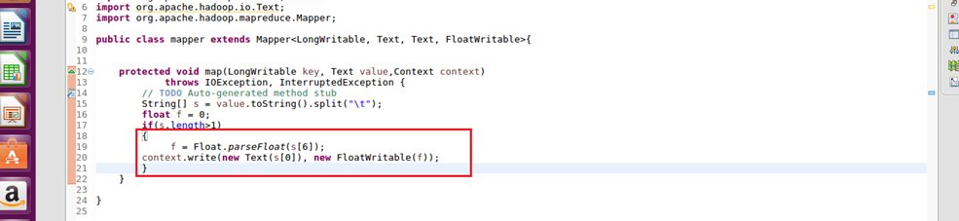

**Reducer:-**

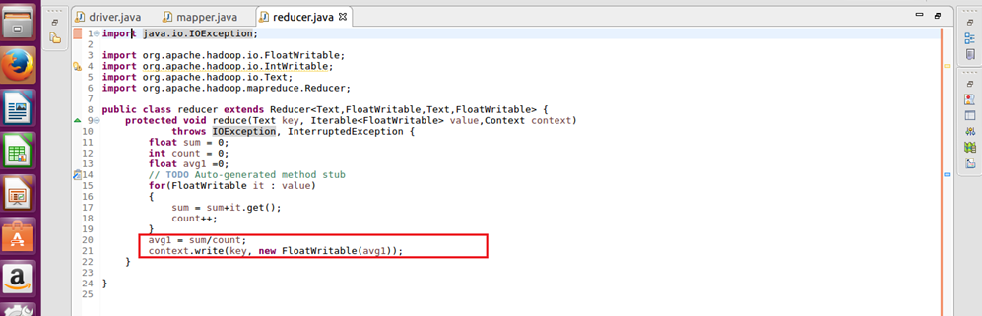

**Output :-**

