**1) Problem Statement: Write a Hive program to find the number of medals won by each country in swimming.**

**2) Problem Statement: Write a Hive program to find the number of medals that India won year wise.**

**ANSWER:-**

**CREATING A TABLE:-**

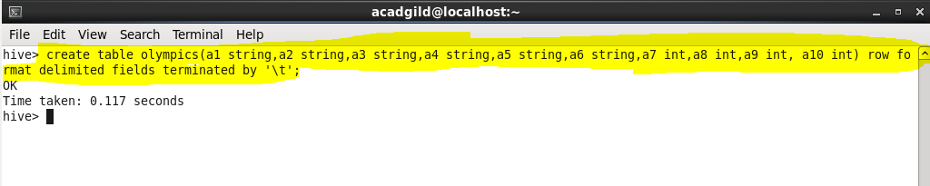

**LOADING A FILE IN THE TABLE:-**

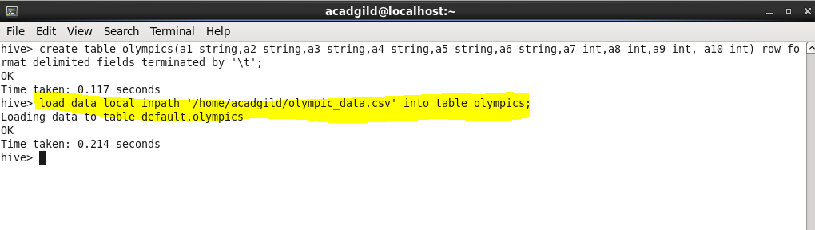

**INPUT DATA:-**

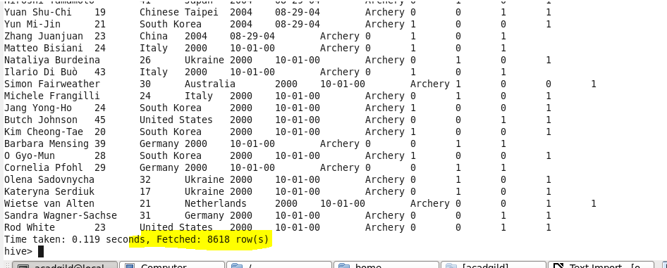

**ANSWER:-**

**1)**

**COMMAND:-**

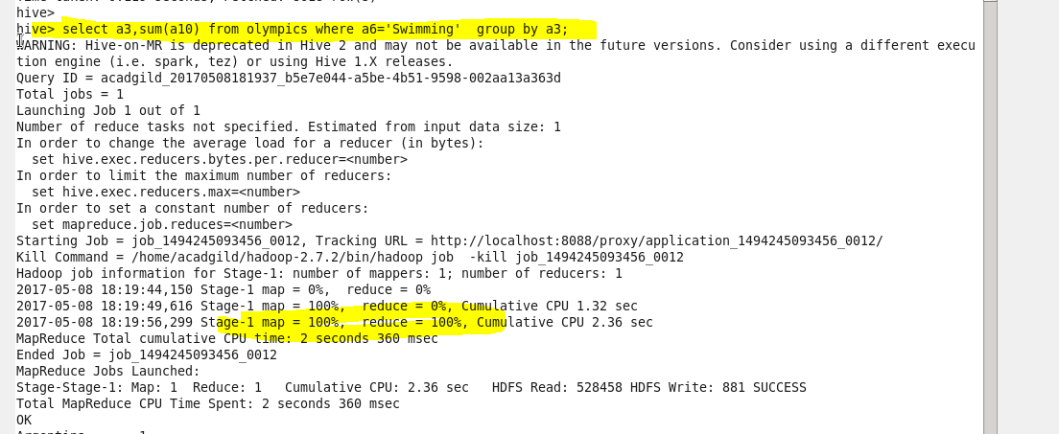

**OUTPUT:-**

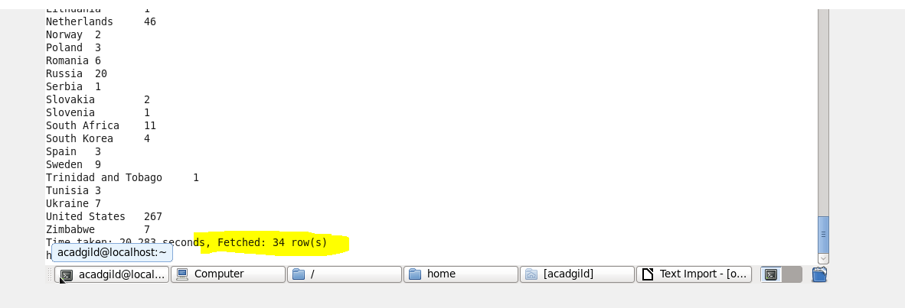

**ANSWER:-**

**2)**

**OUTPUT:-**

