**1) Problem Statement: Write a Hive Program to find the total number of medals each country won**

**2) Problem Statement: Write a Hive program to find the number of gold medals each country won**

**CREATING A TABLE:-**

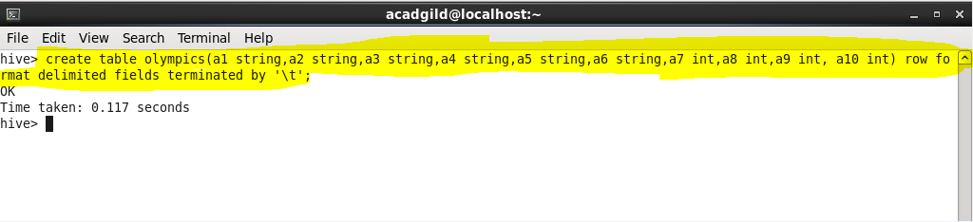

**LOADING A FILE IN THE TABLE:-**

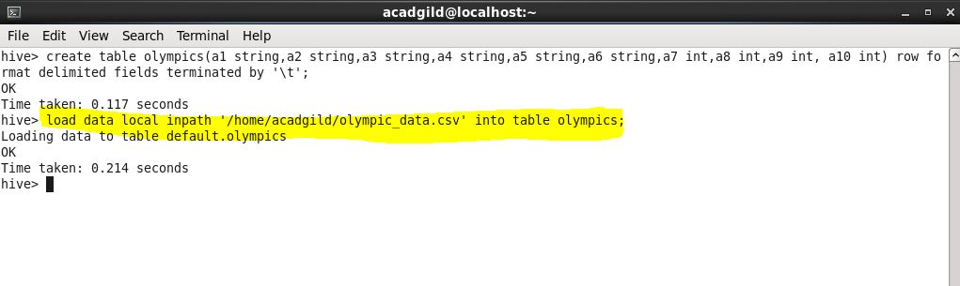

**INPUT DATA:-**

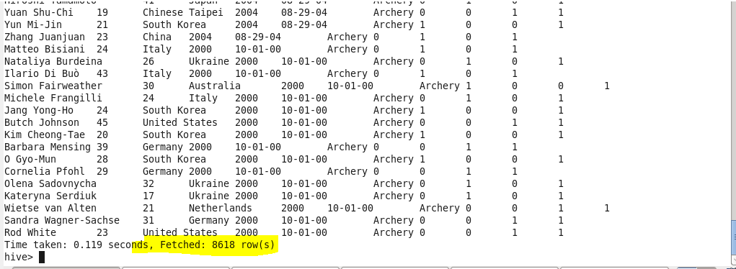

**ANSWER :**

**1 )-**

**COMMAND:-**

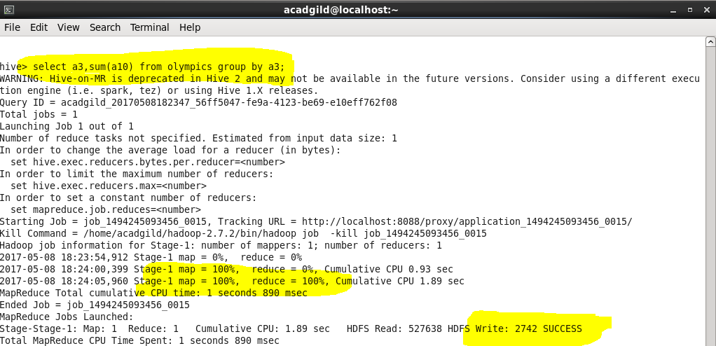

**OUTPUT:-**

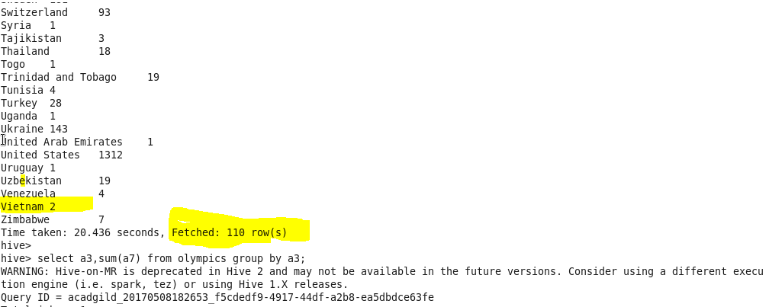

**ANSWER:**

**2)**

**COMMAND:-**

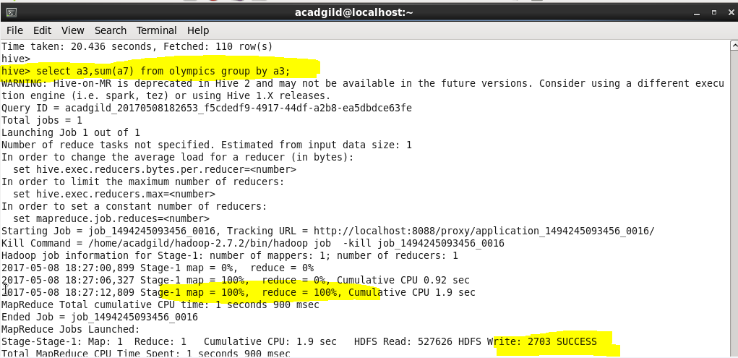

**OUTPUT:-**

