Implement view in hive by following the steps in the below blog

**Input file 1:-**

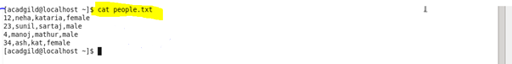

**Input file 2:-**

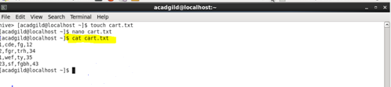

**Create table and load data :-**

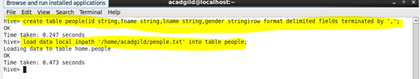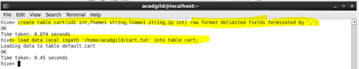

**Create view :-**

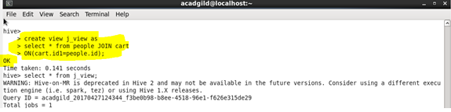

**Output :-**

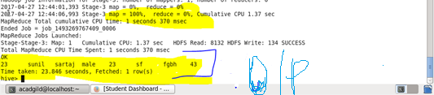

**Query :-**

