**Driver :-**

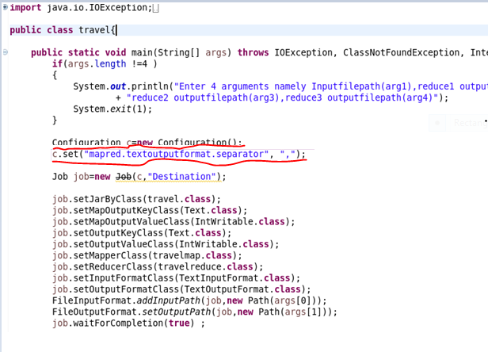

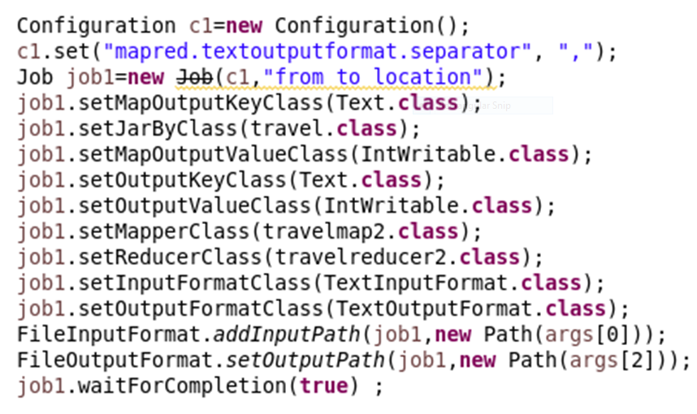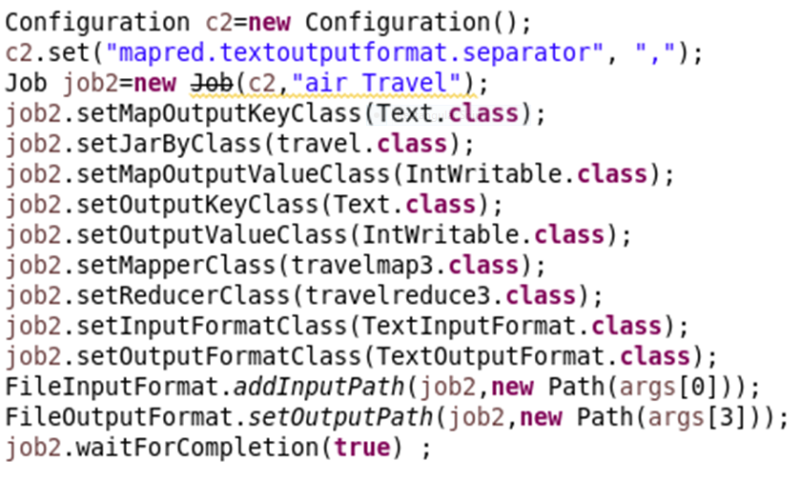

**Find out how many people has chosen their destination as MIA and MCO**

**Mapper:-**

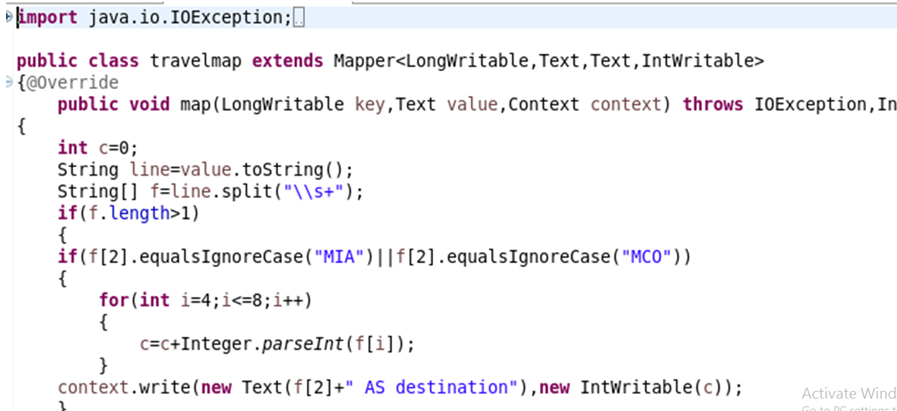

**Reducer:-**

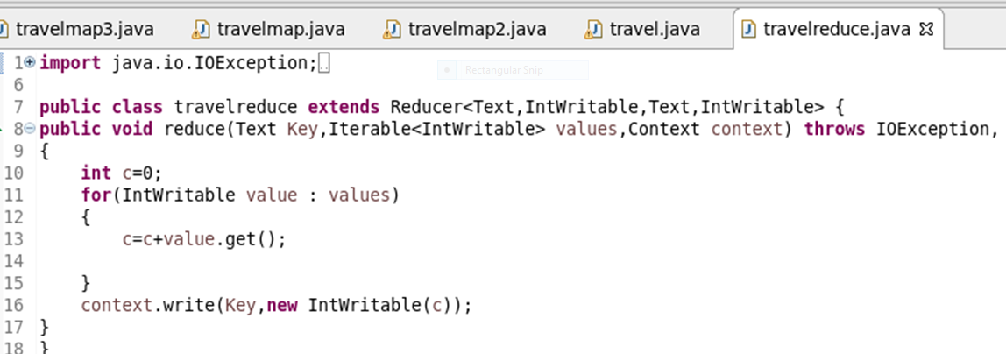

**Find out the number of people undertaken the trips from the places MIA and HOU**

**Mapper:-**

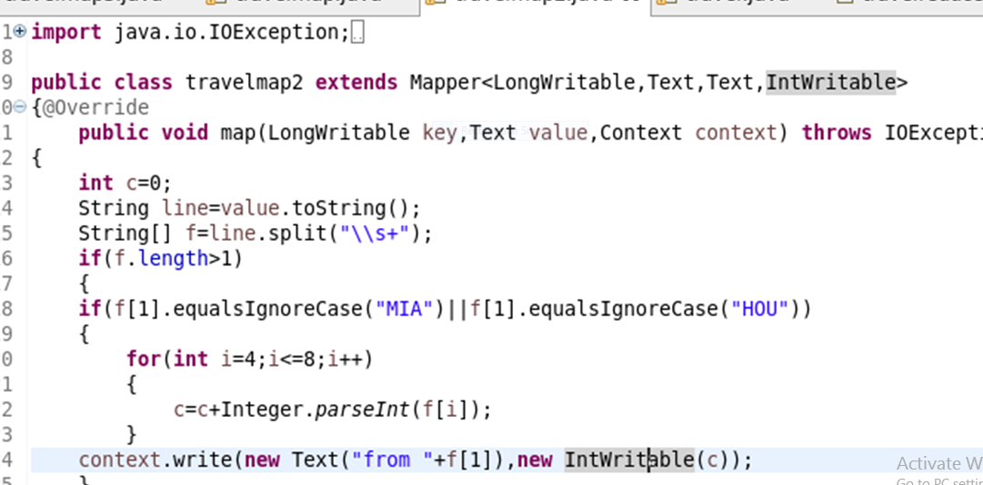

**Reducer:-**

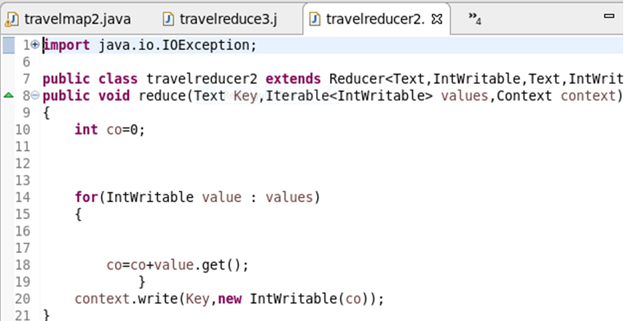

**Find out how many people has chosen airline mode of travel for the places LAS and LAX**

**Mapper:-**

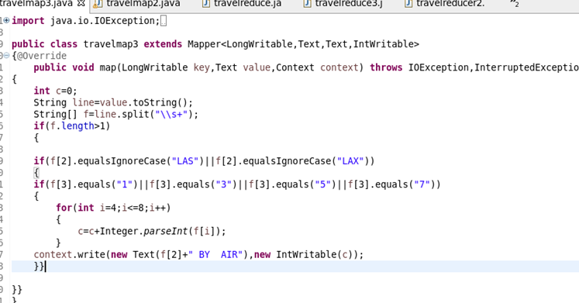

**Reducer:-**

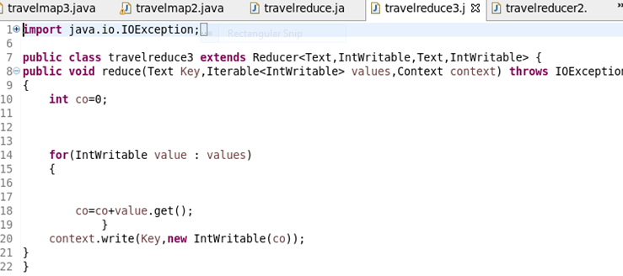

**Output:-**

