Problem Statement:

● Create a employee table in Mysql and columns as Emp_id, Emp_name, Dept_name(Hadoop Developer), Emp_sal.

● Import the employee table contents into the HDFS directory using Sqoop.

● Create a employee2 table in Mysql and Export Top 5 employee details Emp_name and Emp_sal from HDFS directory to Mysql table employee2 using Sqoop.

● Explain the procedures performed, Share the screenshots of commands and results for the same.

**Using use command**

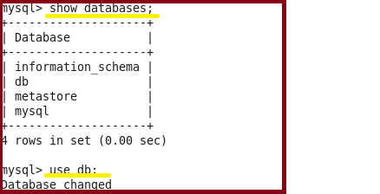

**Using insert command**

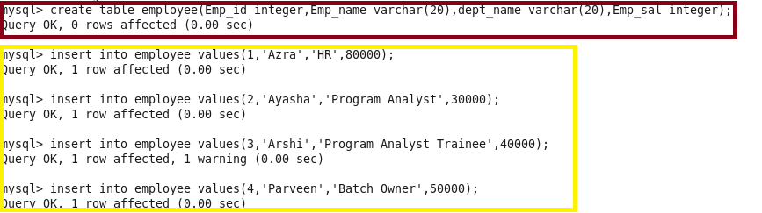

**Performing select operation to display contents of table**

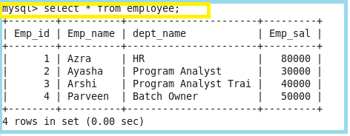

**Importing the data from mysql to hdfs**

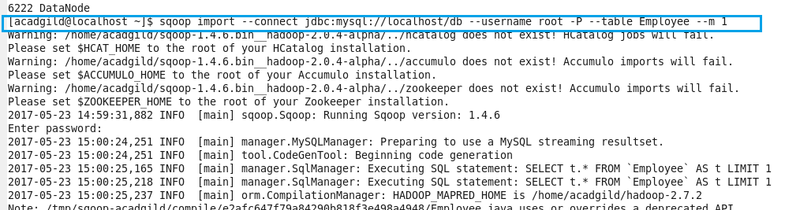

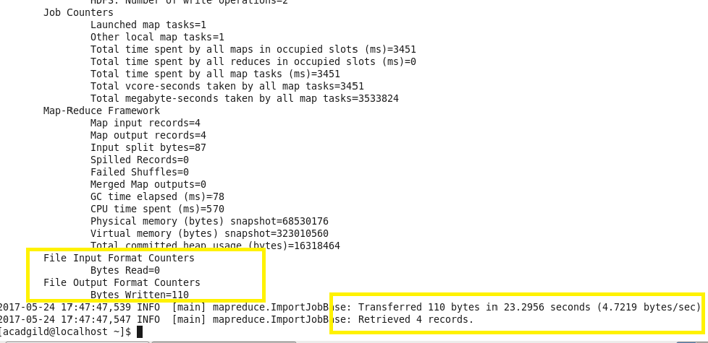

**Checking the files are imported and displaying the contents**

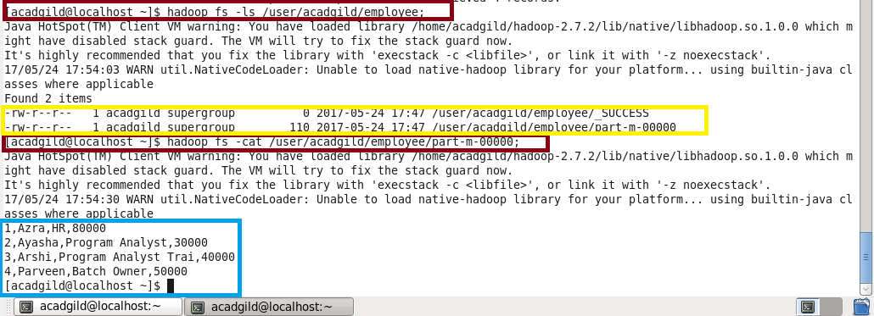

**Creating new table as Employee1 and no data is inserting into it so as to export it from hdfs to mysql**

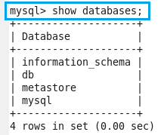

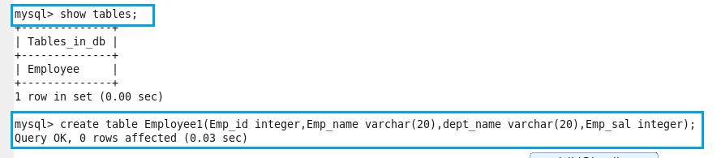

**Here we can see that there is no data present in table Employee1**

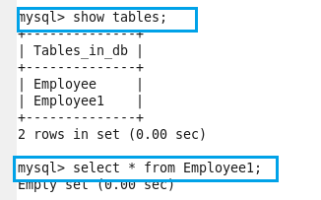

**Exporting table from hdfs to mysql**

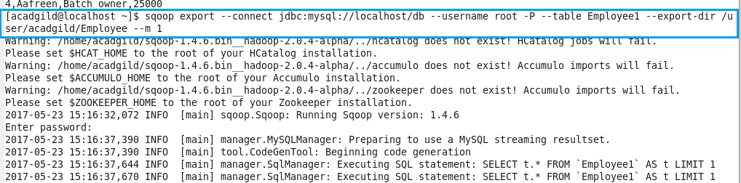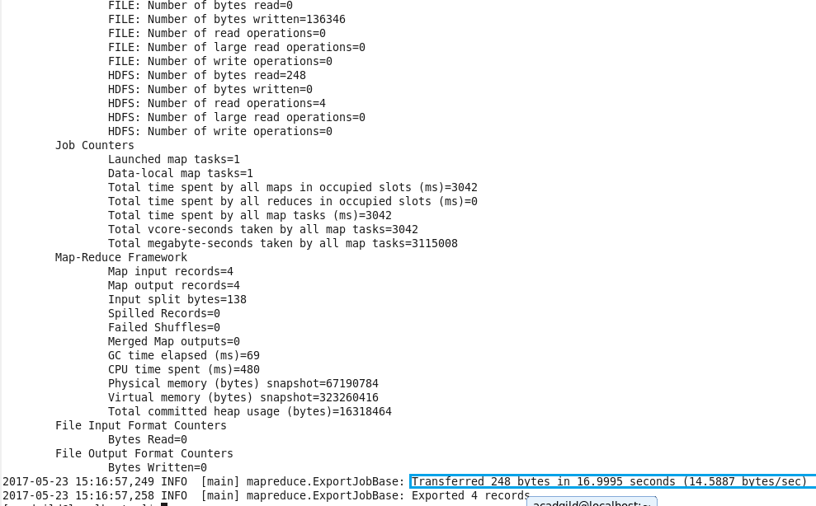

**Exported table**

