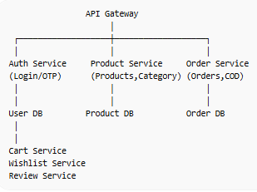

dotnet new webapi -n ProductService
dotnet new webapi -n CartService
dotnet new webapi -n OrderService
dotnet new webapi -n WishlistService
dotnet new webapi -n ReviewService

