***User Event:***

This data provides you with the demographics of the user who is doing the search for hotels on expedia. Based on this information we have to find out trends in the consumer/user behavior.

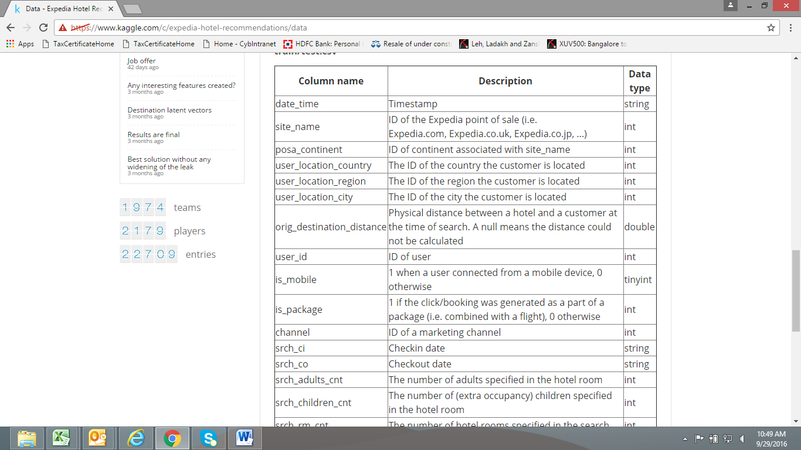

The above attributes belong to the user who will be performing the search for a specific destination. Some points to remember with regards to user search activity:

* A user id can do a search for multiple destinations from a user location.
* Site name is the POS from where the expedia site was accessed, like India – co.in, Japan – co.jp
* Time stamp identifies when the search was performed by the user.
* A user id can do search over multiple time stamps as see below for ID:44663:

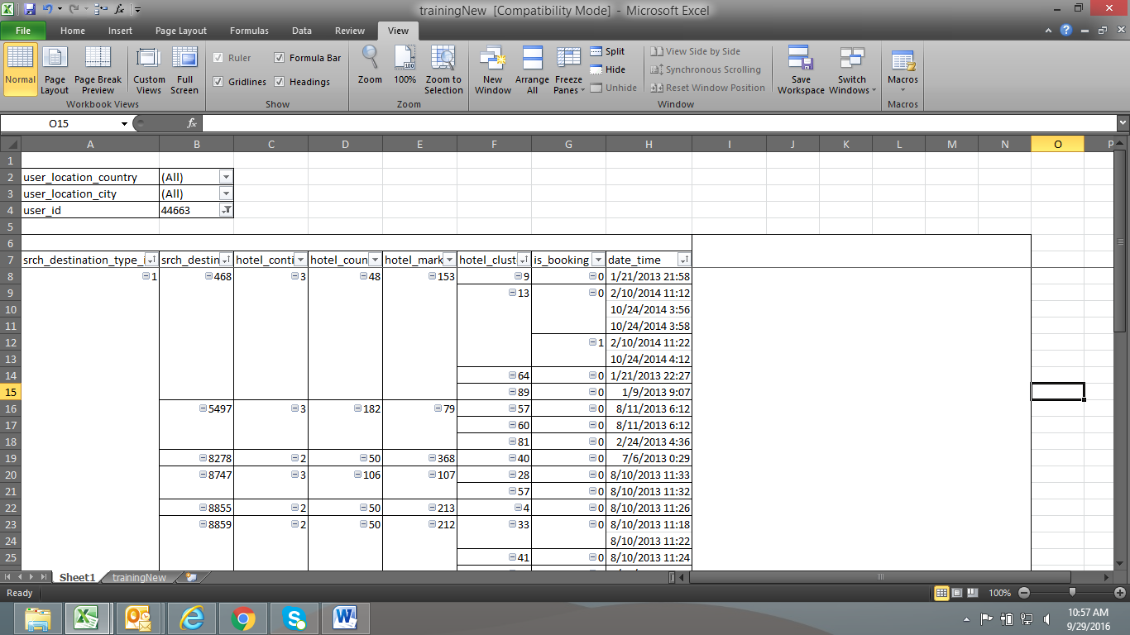

***Search and Result:***

The search will provide you logs of customer behavior. These include what customers searched for, how they interacted with search results (click/book), whether or not the search result was a travel package.  These include:

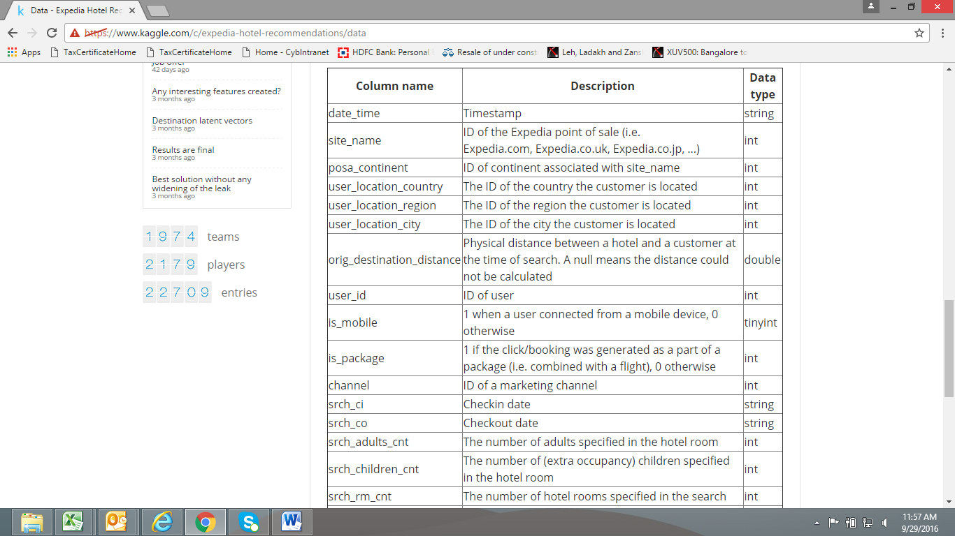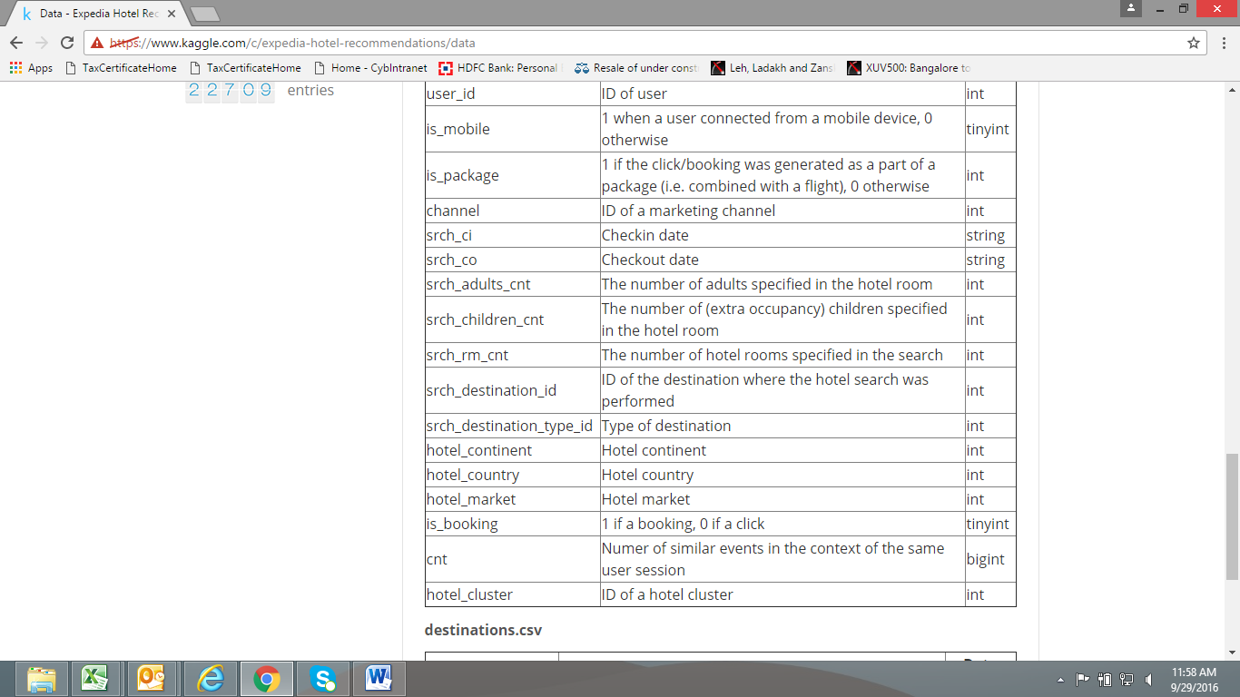

Points to Remember:

* Channel: this would be the id of the channel through which the click was initiated i.e. google or display ad, or through any affiliate website.
* Hotel_Continent/hotel_country/hotel_market: These are unique id’s and have a one to many relationship in the order they are mentioned. They are individual of the USER Events and the Search destinations. A hotel continent can be part of one or more destination type ids.
* Hotel_cluster: Hotel cluster though part of the above hierarchy of continent, is dynamically created based on the historic data for pricing and other parameters. This makes it unique and can be found in multiple markets. Please see below;

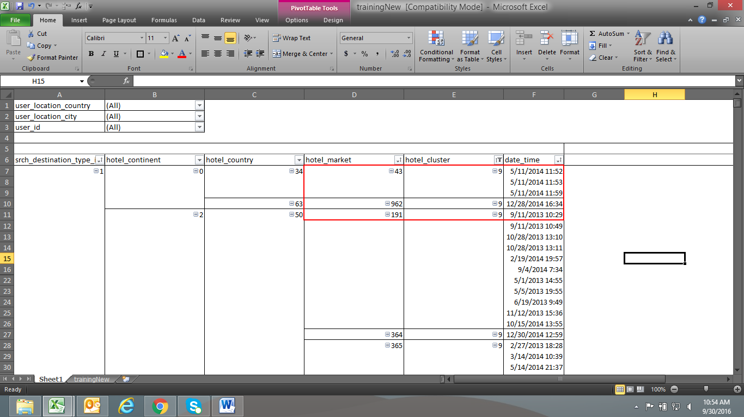

* Looking at :

*Is_booking:* When a booking activity happens on that particular click. When booking is complete it shows ‘1’ when no booking is done it shows ‘0’

Please see below the highlighted data in **Blue**

*Is_mobile:* When a user is connected from a mobile device, it will show ‘1’ if not then ‘0’.

Please see below data in **Purple.**

When a user connected through mobile device creates a booking it will show ‘1’ in the is_booking and ‘1’ in the is_mobile also.

Please see below the highlighted data in **Red**

*Is_package:* When a (click/booking) .i.e. event, was generated as a part of package i.e. combined with a flight it shows ‘1’ or else ‘0’.

Please see below data in **Green.**

But when a booking is created it will show ‘1’ in the is_booking and ‘1’ in the is_package also.

Please see below data in **Orange.**

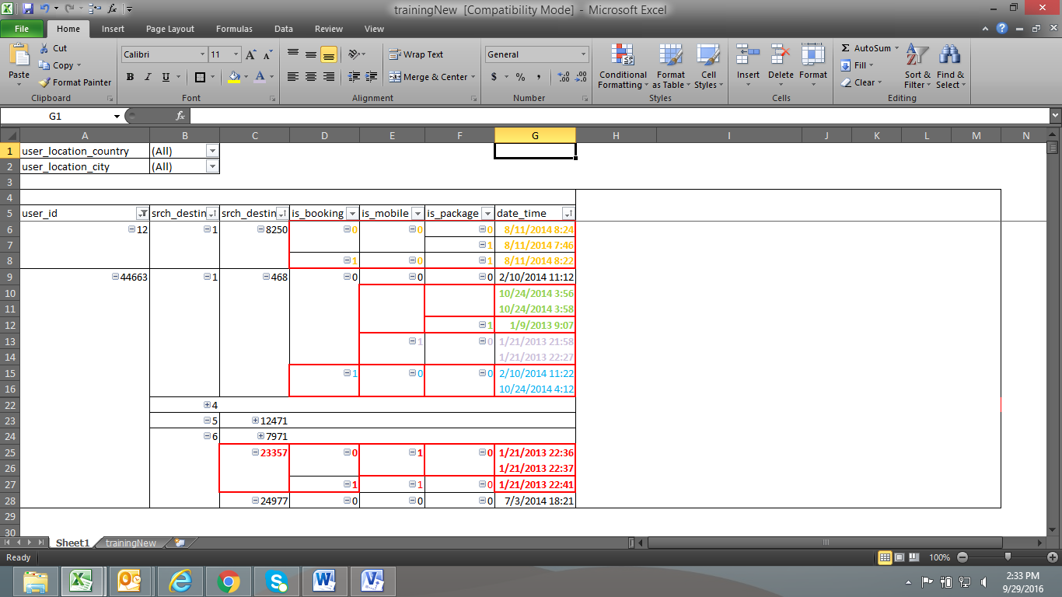

***Sample data results:***

* The below image displays the data is_booking data for search dest type 1, for different hotel clusters.
* By this we can drill down to the hotel cluster that was sold the most based on the conversion of clicks to bookings for destination type id:1

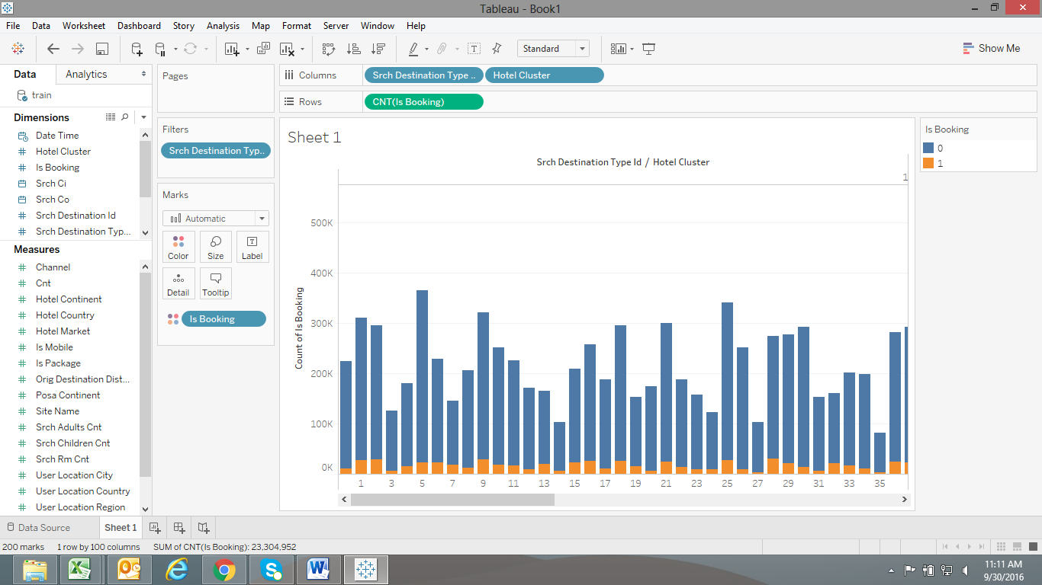

* The below image displays the booking data based on destination type id.
* We can add other parameters i.e. user events, hotel clusters to this and try to get the desired result.
* In the below image, though Type id 1 looks to be most searched carries a conversion of 7.54%, while type id 6 has a conversion of 10%. (This is FYI…)

