CUSTOMER CHURN
DATA PREPARATION PIPELINE
A technical walkthrough of missing-data treatment, outlier analysis, binning, encoding and scaling
An implementation-focused review of a notebook-driven customer analytics workflow

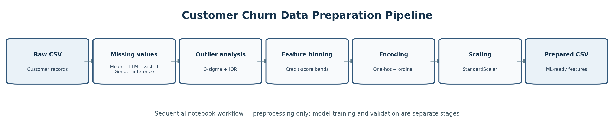
Figure 1. End-to-end preparation sequence represented by the repository notebooks.

Article scope
This article explains the pipeline implemented in the public repository, interprets its reported notebook outputs, and proposes engineering practices needed before using the resulting data in a production churn model. It intentionally omits author biography and personal author details.
Evidence boundary: this repository is primarily a data exploration and preprocessing project. The article does not attribute an accuracy score, a trained model, or a business uplift result to it because the reviewed artifacts do not establish those outcomes.

Contents
- Abstract and keywords
- 1. Introduction and business problem
- 2. Repository scope and technology stack
- 3. Dataset and target definition
- 4. Pipeline architecture
- 5. Notebook-by-notebook methodology
- 6. Findings reported by notebook outputs
- 7. Data-quality and implementation review
- 8. Reproducibility and execution guide
- 9. Recommended production design
- 10. Evaluation plan and metrics
- 11. Limitations, risks and responsible use
- 12. Conclusion
- References and repository links

Abstract
Customer churn prediction depends on more than selecting a classifier: source data must be inspected, missing values handled, extreme observations understood, categorical features represented correctly, and numeric features transformed consistently. This article reviews a notebook-based preprocessing pipeline for a bank-customer churn dataset. The repository separates five operations into Jupyter notebooks: missing-value treatment, outlier analysis, credit-score binning, categorical encoding and numeric scaling. Its first notebook reports 10,000 rows and missing values in Age (600), Gender (108), Firstname (7) and Lastname (6); it imputes Age using the observed mean and uses an LLM call to infer missing Gender values from names. The outlier notebook demonstrates both a three-sigma rule and an interquartile-range (IQR) rule. Subsequent notebooks transform credit scores into ordered bands, one-hot encode nominal variables, map ordinal categories to integers, and standardize selected columns. The article describes the approach, highlights important engineering risks—including potential target leakage from preprocessing before model splitting, demographic inference from names, ambiguous outlier handling, and fragile path/API configuration—and provides a safer roadmap for turning an educational workflow into a reproducible machine-learning pipeline. No trained-model performance is claimed.
Keywords: customer churn, data preprocessing, missing values, LLM-assisted imputation, outlier detection, feature engineering, one-hot encoding, standardization, reproducible machine learning.

1. Introduction and business problem
Customer churn occurs when a customer stops using a product or service. In banking, churn analysis can help teams understand retention patterns, prioritize service outreach and investigate whether product engagement, tenure, geography, age or account balance are associated with account exit. A churn dataset often contains a binary target such as Exited, where 1 indicates that the customer left and 0 indicates that the customer remained.
A practical predictive system must distinguish three tasks: (1) data preparation, which checks and transforms records; (2) model development, which learns a mapping from features to churn outcomes; and (3) operational decision-making, which translates validated predictions into retention actions. The repository primarily addresses the first task. It is a useful learning scaffold because each transformation is visible in its own notebook, but the processed CSV should not be interpreted as proof that a reliable predictive model has been built.

1.1 Why preprocessing matters
Data issue | Potential consequence | Typical control
Missing values | Rows may be dropped or models may fail; imputation can distort distributions. | Measure missingness, select a justified imputation policy, track imputed cells.
Outliers and unusual values | Errors can skew statistics, while genuine rare customers may be erased. | Use plots and domain checks; flag before deleting or capping.
Categorical variables | Raw text is not accepted by many estimators. | Use one-hot encoding for nominal categories and a documented order for ordinal categories.
Different numeric scales | Large-magnitude values can dominate scale-sensitive models. | Fit scaling parameters on training data and reuse them during inference.
Inconsistent workflow | Train/inference transformations can diverge. | Bundle transformations in a fitted pipeline and version the artifacts.

2. Repository scope and technology stack
The reviewed repository contains five numbered Jupyter notebooks, a raw CSV, several processed CSV checkpoints, a README, a dependency file and an example environment file. The README frames the project as an educational, step-by-step exploratory data analysis and preprocessing workflow.
Component | Observed role in the repository
Python + pandas + NumPy | Tabular loading, null checks, transformations and CSV export.
Matplotlib + Seaborn | Distribution plots, histograms, box plots and categorical visualizations.
scikit-learn | StandardScaler, MinMaxScaler examples and encoding utilities; model training is not demonstrated as the main pipeline outcome.
Groq client + Llama model | LLM-assisted prediction for missing Gender cells from first and last names.
OpenAI package | Listed/imported in the environment, but not the central call in the inspected imputation function.
Pydantic + Enum | Constrains the LLM response to the declared Male/Female enum in the notebook example.
CSV checkpoints | Preserve intermediate versions after selected preprocessing stages.

The requirements file pins NumPy, pandas and scikit-learn versions, while some other packages are unpinned. The environment example provides a GROQ_API_KEY placeholder. A reproducible setup should pin all direct dependencies, record Python version and install the correct python-dotenv package (the distribution name is python-dotenv, even though the import is dotenv).

2.1 Repository artifact map
Artifact | Purpose / observations
raw/Churn_modeling_ds_raw.csv | Source dataset. The notebook loads a bank churn modelling CSV with 10,000 records.
0_handle_missing_values.ipynb | Null checks, mean imputation for Age and name-based LLM inference for Gender.
1_handle_outliers.ipynb | Distribution analysis, box plots, three-sigma and IQR-based anomaly flags.
2_feature_binning.ipynb | Custom credit-score interval categories; notebook discusses potential binning of other variables.
3_feature_encoding.ipynb | One-hot encoding of Geography and Gender; ordered mapping of CreditScoreBins.
4_feature_scaling.ipynb | StandardScaler applied to selected numeric features; output exported as final CSV.
processed/*.csv | Stage snapshots for missing values, outliers, binning, encoding and final scaling; naming/path consistency requires cleanup.

3. Dataset and target definition
The notebook outputs identify a 10,000-row bank-customer dataset. Initial columns include identifiers and names (RowNumber, CustomerId, Firstname, Lastname), customer attributes (CreditScore, Geography, Gender, Age, Tenure), account attributes (Balance, NumOfProducts, HasCrCard, IsActiveMember, EstimatedSalary), and the target Exited. In later processing steps, identifier and name fields are dropped from the feature table, while Exited is retained.
Feature / field | Interpretation | Type / treatment note
Exited | Customer left vs stayed | Binary target; must never be used as an input feature for a churn prediction.
CreditScore | Credit score recorded in the source | Numeric initially; converted into ordered bands in the binning notebook.
Geography | Customer geography/country category | Nominal; one-hot encoded.
Gender | Recorded category | Nominal; repository fills missing values using name-based LLM inference, which has serious validity and fairness caveats.
Age | Age of customer | Numeric; mean-imputed in observed code, then standardized.
Tenure | Time with institution | Integer-like; remains numeric in the final representation.
Balance | Account balance | Numeric; standardized.
NumOfProducts | Number of products | Discrete count; semantic ordering exists, but treatment should be validated against model choice.
HasCrCard | Credit-card flag | Binary indicator.
IsActiveMember | Activity flag | Binary indicator.
EstimatedSalary | Estimated salary value | Numeric; standardized.
RowNumber, CustomerId, Firstname, Lastname | Row/customer identifiers and names | Usually excluded from model features unless a carefully justified use case exists.

The repository snapshot does not constitute a full data dictionary: units, collection windows, exact target horizon and business definition of churn are not formalized. A production study should document those definitions before training. A feature that is available only after a customer exits can leak the outcome into the model even if it looks like an ordinary column.

4. Pipeline architecture
Figure 2. Processing stages described in the repository README and notebook sequence.
The intended data flow is linear: raw records are checked for missingness; missing values are treated; numerical distributions are inspected for unusual observations; CreditScore is converted into interpretable categories; nominal categories are encoded; selected numeric columns are standardized; and a final CSV is written for downstream modelling. Intermediate CSVs make individual stages inspectable, but the current file naming and notebook path references are not fully consistent. An explicit orchestration layer should replace manual execution order before repeated use.

4.1 Data contract at each stage
Stage | Expected input | Expected output contract | Quality gate
Ingestion | Raw CSV | Known columns, 10,000 rows in reviewed snapshot | Schema, row count, duplicate key and type checks.
Missing-value stage | Raw records | Defined missingness policy; null audit attached | No unexplained nulls in required model inputs; imputation log retained.
Outlier stage | Imputed dataset | Flagged observations plus documented decisions | No silent deletion; domain review for unusual values.
Binning | Numerical credit score | Ordered CreditScoreBins category | All valid scores map to exactly one bucket.
Encoding | Categorical and binned data | Numeric matrix with stable feature columns | Unknown categories and column order handled.
Scaling | Encoded training features | Scaled numeric columns | Scaler fitted on training fold only.
Delivery | Transformed features + target | Versioned model-ready dataset or fitted Pipeline | Target excluded from X; checksummed output and schema logged.

5. Notebook-by-notebook methodology

5.1 Notebook 0 — Handling missing values
The notebook begins by reading the raw CSV and counting nulls by column. The observed output reports 600 missing Age entries and 108 missing Gender entries, plus seven missing first names and six missing last names. The notebook also demonstrates dropping columns with any missing values, but its main imputation flow creates a copy of the data, fills Age with the observed mean (38.91), and calls the Groq-hosted Llama model to infer a binary Gender value from first and last names. Pydantic and an Enum validate whether the returned text can be represented as Male or Female.
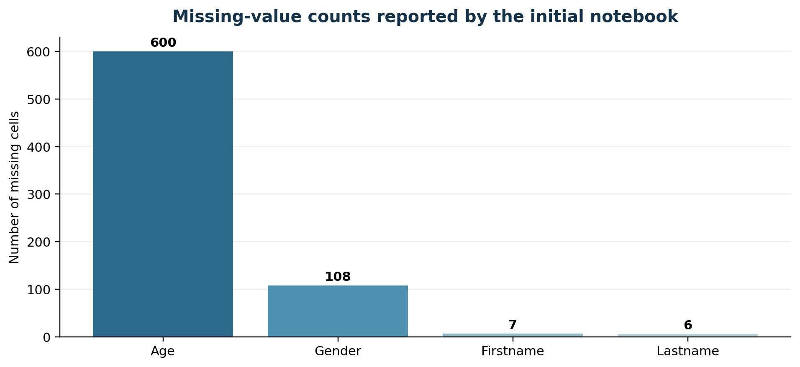
Figure 3. Missing-value counts as recorded in the notebook output; the chart counts missing cells, not missing rows.
The numerical imputation is straightforward. However, mean imputation can be sensitive to skew and may compress variability. The notebook calculates a median of 37 as well, but the code uses the rounded mean for filling. Median imputation or a model-based policy should be chosen through data understanding, not only convenience. Add a missingness indicator where missingness itself may contain useful signal, and fit imputation statistics only on the training partition.
The Gender strategy is a major methodological concern. Names do not reliably reveal a person’s gender, the inference may be culturally biased, and a demographic label should not be invented merely to remove nulls. The code sends names to an external LLM service, which introduces privacy, data-transfer, latency, cost and provider-availability considerations. The returned value is not an observed fact just because it satisfies an Enum. Better defaults are to preserve missingness as “Unknown”, use a transparent missing category, or exclude the field if it is not necessary. Any demographic inference should require a defensible legal and ethical basis and explicit validation.
# Illustrative safer default for a categorical field
# Avoid guessing sensitive/demographic attributes from names.
df['Gender'] = df['Gender'].fillna('Unknown')

# Fit numeric imputation only on the training split in a real workflow.
age_median = train_df['Age'].median()
train_df['Age'] = train_df['Age'].fillna(age_median)
valid_df['Age'] = valid_df['Age'].fillna(age_median)

Implementation note: the missing-value notebook exports `processed/ChurnModelling_Missing_values_handled.csv`, while the next notebook reads `processed/Missing_values_handled.csv`. This mismatch can break a clean run unless a corresponding file is created or the path is corrected. Also, first/last name nulls are present, so the LLM loop must handle missing names and API failures explicitly.

5.2 Notebook 1 — Outlier detection and treatment
This notebook uses distribution plots and box plots to inspect Age, Balance, EstimatedSalary, Tenure and CreditScore. It records qualitative observations: Age is right-skewed, Tenure is approximately uniform, CreditScore is close to a normal-shaped distribution, Balance shows two modes (including a group with zero balance), and EstimatedSalary appears relatively uniform. These observations motivate investigation, not automatic deletion.
Two flagging rules are demonstrated. The three-sigma rule marks values outside the mean plus or minus three standard deviations. The IQR rule uses the interval from Q1 − 1.5 × IQR to Q3 + 1.5 × IQR. Different counts are expected because the two rules have different assumptions and sensitivity. In a bounded or skewed feature, a statistical flag may be a plausible customer rather than an error.
# Three-sigma flag
lower_3s = series.mean() - 3 * series.std()
upper_3s = series.mean() + 3 * series.std()
flag_3s = (series < lower_3s) | (series > upper_3s)

# IQR flag
q1, q3 = series.quantile([0.25, 0.75])
iqr = q3 - q1
lower_iqr, upper_iqr = q1 - 1.5 * iqr, q3 + 1.5 * iqr
flag_iqr = (series < lower_iqr) | (series > upper_iqr)

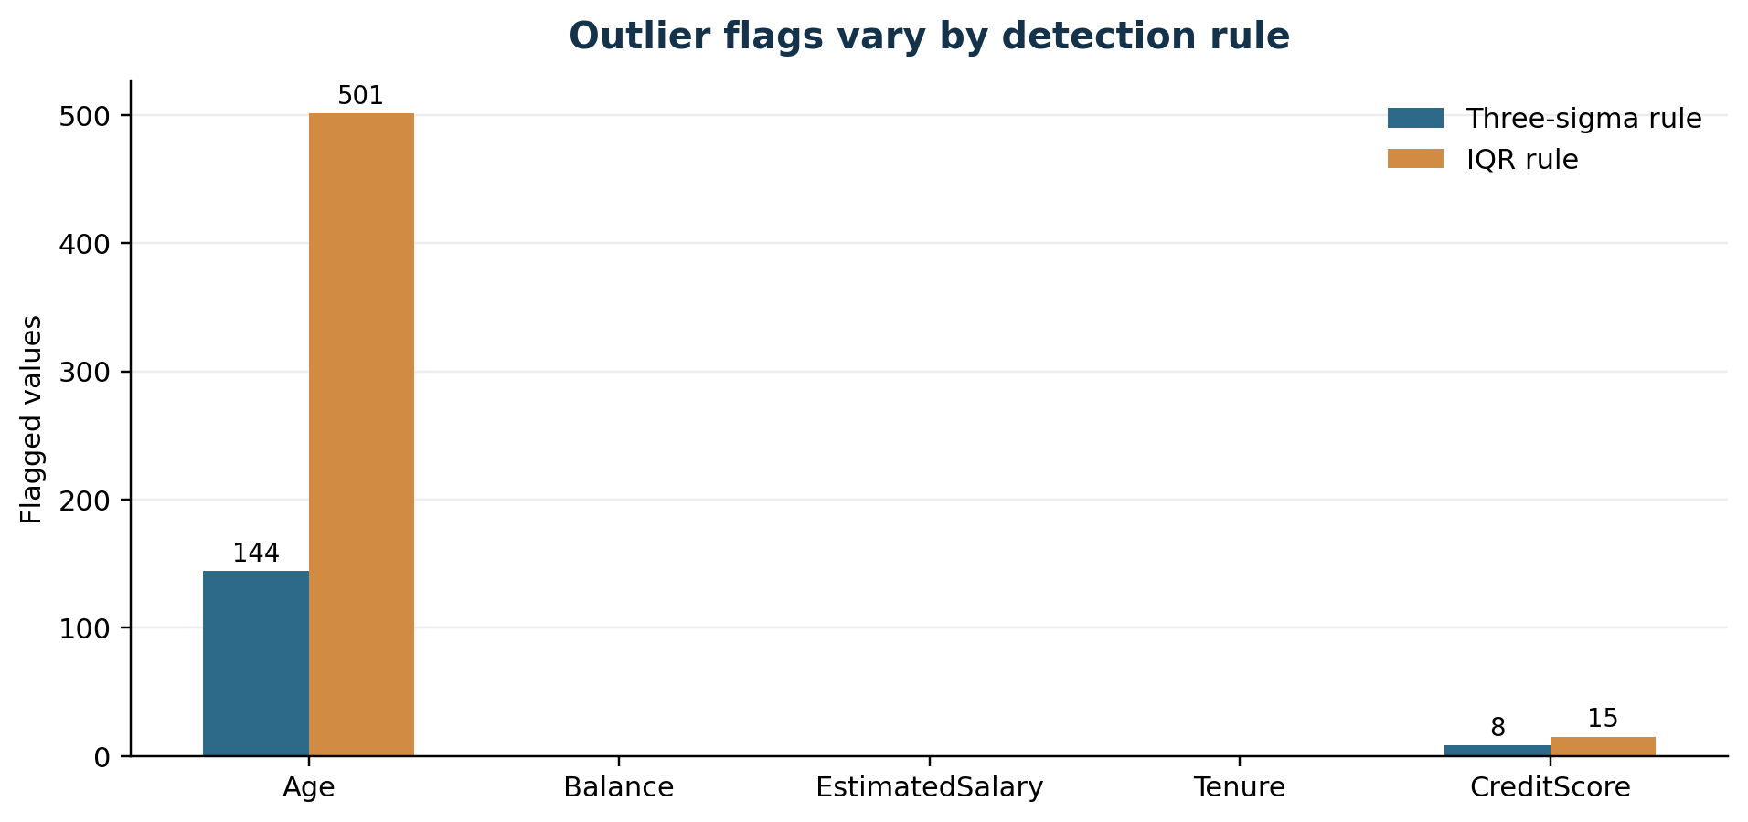
Figure 4. Observed counts flagged under two rules; the notebook exports the data without a clear documented row-removal/capping decision.
The output reports 144 Age and eight CreditScore flags under the three-sigma rule; IQR flags 501 Age and 15 CreditScore values. Balance, EstimatedSalary and Tenure have zero flags under both reported rules. The notebook explores a row-level mask, including a record flagged in both Age and CreditScore under IQR. Still, the export line writes `df` directly, so the displayed detection logic is not equivalent to an automated treatment step. This is a useful distinction: detecting an outlier, deciding it is erroneous, and transforming/removing it are separate actions.
The current code redefines a helper named `find_anomaly` for each method. That works in a sequential notebook but makes the active definition depend on the executed cell order. Prefer separate explicit functions such as `flag_three_sigma` and `flag_iqr`, and save flags in columns or a quality report rather than overwriting the only source copy.

5.3 Notebook 2 — Feature binning
Binning maps a continuous numeric variable to an interpretable category. The notebook examines feature ranges and applies custom bands to CreditScore, whose reported observed minimum and maximum are 350 and 850. The intended bands are Poor, Fair, Good, Very Good and Excellent. Age grouping is discussed as a possible design, but the inspected transformation actually applied in code is the credit-score binning.
Credit score band | Notebook rule | Ordinal code in next stage
Poor | score < 580 | 0
Fair | 580 ≤ score < 670 | 1
Good | 670 ≤ score < 740 | 2
Very Good | 740 ≤ score < 800 | 3
Excellent | 800 ≤ score ≤ 850 | 4

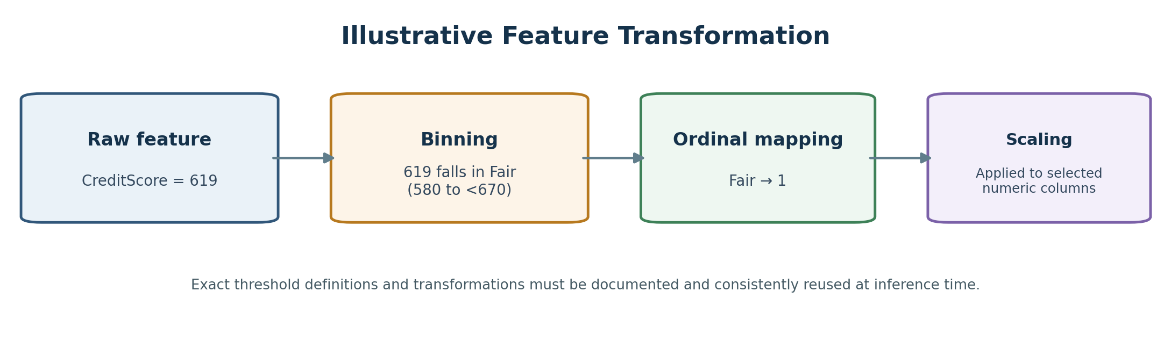
Figure 5. Example transformation from raw credit score to an ordinal band and then a numeric code.
Binning can improve interpretability and reduce sensitivity to small numeric variations, but it discards within-band information and may create arbitrary cut-off effects. The thresholds must be pre-declared or learned on training data if selected empirically. Boundaries should be tested directly: 579, 580, 669, 670, 739, 740, 799, 800 and 850. The function should also raise a clear exception for invalid scores, rather than relying on an assertion that is not correctly expressed in the current code.
def credit_score_band(score):
if pd.isna(score):
return 'Unknown'
if score < 580: return 'Poor'
if score < 670: return 'Fair'
if score < 740: return 'Good'
if score < 800: return 'Very Good'
if score <= 850: return 'Excellent'
raise ValueError(f'Credit score outside supported range: {score}')

5.4 Notebook 3 — Feature encoding
The encoding notebook treats Geography and Gender as nominal variables and uses one-hot encoding. Each category becomes a binary column—for example, Geography_France, Geography_Germany and Geography_Spain. CreditScoreBins is treated as ordinal and mapped to 0–4. The notebook also demonstrates scikit-learn encoder objects, though a production implementation should keep one fitted encoder and its output feature names instead of re-fitting independently in each run.
Method | Best fit | Example | Caution
One-hot encoding | Nominal categories with no inherent order | France → Geography_France=1, other geography flags=0 | Unseen categories and stable column ordering need explicit handling.
Ordinal mapping | Categories with meaningful, documented order | Poor=0 … Excellent=4 | Assumes order; integer gaps may be interpreted as numeric distance by some models.
Label encoding | Usually targets, or carefully justified ordered values | Class A=0, Class B=1 | Avoid arbitrary integer labels for nominal input features.

A further concern is the use of `NumOfProducts` as an integer count. It is discrete and has natural order, but whether it should be treated as numeric, ordinal, or categorical depends on the model and observed relationship with churn. The choice belongs in validation rather than being assumed universally correct.

5.5 Notebook 4 — Feature scaling
The final notebook compares Min-Max normalization and standardization, then uses scikit-learn StandardScaler on Age, Tenure, Balance and EstimatedSalary. Standardization transforms a value using (x − training mean) / training standard deviation, producing roughly centered, unit-scale features on the data used to fit it. The result is exported as `processed/ChurnModelling_Final.csv`. CreditScore has already been binned and encoded; binary flags and one-hot columns are left as indicators.
Crucial production rule: the scaler must be fitted on the training partition only. Fitting the scaler on all rows before a train/test split leaks information from the held-out data into the preprocessing parameters. At inference time, the same fitted scaler must be applied to new records without refitting. A scikit-learn Pipeline and ColumnTransformer can enforce this more safely.
from sklearn.compose import ColumnTransformer
from sklearn.pipeline import Pipeline
from sklearn.impute import SimpleImputer
from sklearn.preprocessing import OneHotEncoder, StandardScaler

numeric_pipe = Pipeline([
('imputer', SimpleImputer(strategy='median')),
('scaler', StandardScaler()),
])
preprocess = ColumnTransformer([
('numeric', numeric_pipe, numeric_columns),
('categorical', OneHotEncoder(handle_unknown='ignore'), categorical_columns),
])
# Fit preprocess only on X_train; call transform for validation/test/new data.

6. Findings reported by notebook outputs
Observation | Reported result | Interpretation
Input data | 10,000 rows | The notebook reports the full row count before outlier treatment.
Missing Age | 600 values; mean 38.91, median 37 | Code uses mean imputation; the median is computed for comparison.
Missing Gender | 108 values | Notebook invokes LLM inference from names; this should be reconsidered before real use.
Missing names | 7 Firstname and 6 Lastname cells | Needs an explicit null-name fallback for the LLM loop.
Three-sigma outlier flags | Age 144; CreditScore 8; all other inspected columns 0 | Detection results only; not proof the values are erroneous.
IQR outlier flags | Age 501; CreditScore 15; all other inspected columns 0 | More sensitive for the observed Age distribution.
CreditScore range | 350 to 850 | Notebook bins into five ordered bands.
Scaling step | Age, Tenure, Balance, EstimatedSalary | StandardScaler is applied and CSV is exported.
Model result | Not established in the reviewed artifacts | No accuracy, recall, AUC or business uplift should be inferred from preprocessing output.

These results summarize the notebook outputs examined in the repository; they are not an independent benchmark. Before publication or production use, rerun the repository from a clean environment and record exact dataset versions, code revision, transformed row/column counts and validation checks. The percentages printed in the outlier notebook are rounded coarsely, so the article emphasizes counts instead of presenting the printed percentage text as precise rates.

7. Data-quality and implementation review
Finding | Why it matters | Recommended correction
Inconsistent CSV paths | The next notebook reads a filename that differs from the previous notebook’s export name. | Centralize paths in configuration; validate that inputs exist before reading.
Possible target leakage | Preprocessing appears to operate on the full dataset before any model split in the notebooks. | Split first; fit imputers, binning decisions, encoders and scalers on training folds only.
Name-based demographic inference | Names are an unreliable proxy and may be sensitive personal data sent to an external service. | Prefer explicit Unknown/missing handling; avoid demographic inference unless there is a defensible, approved use.
API call fragility | Loop calls a remote LLM per missing row and lacks visible retry, timeout, caching and a safe unknown result. | Use batch calls only where justified, retries/backoff, request logging without PII and a non-LLM fallback.
Null first/last names | The LLM function expects text, but name fields themselves have missing values. | Check missing values before request; never format a null into a prompt.
Notebook execution-order dependence | A function is redefined for the second outlier method; manual cell order can change behavior. | Use distinct helper names, convert notebooks into tested Python modules.
Outlier treatment is ambiguous | Flags are computed but the export writes the original frame rather than an explicit filtered/capped frame. | Separate detection, review and treatment; document the final policy.
Hard-coded row count | Scaling reshapes using 10,000 rows. | Use `fit_transform(df[[col]])` with DataFrame columns and avoid hard-coded shape assumptions.
Inconsistent final feature schema | One-hot columns depend on encountered categories; notebook contains multiple encoding demonstrations. | Use a fitted encoder with `handle_unknown=ignore` and persist `get_feature_names_out()`.
Dependencies partly unpinned | The same commands may resolve different versions over time. | Pin all direct dependencies and use a lock file or tested environment export.
No end-to-end model validation | Preprocessed data is described as model-ready but prediction quality is not evaluated here. | Add train/validation/test protocol, baseline, metrics, calibration and drift monitoring.

7.1 Recommended data-quality gates
- Column contract: required feature names, types, allowed ranges and target definition are version-controlled.
- Missingness gate: missing counts and proportions are generated automatically before and after imputation.
- Duplicate check: validate the intended unique key, while keeping legitimate repeated customers if the data design permits them.
- Range and domain gate: age, tenure, credit score, product count and binary indicators are checked against documented rules.
- Output gate: output row count is reconciled, all feature columns are expected, and no target or identifiers leak into the model input matrix.
- Lineage gate: every artifact stores source hash, commit, timestamp, parameters, package versions and transformation configuration.

8. Reproducibility and execution guide

8.1 Baseline setup
git clone https://github.com/deaneeth/churn-prediction-data-pipeline.git
cd churn-prediction-data-pipeline
python -m venv .venv
# Windows PowerShell: .venv\Scripts\Activate.ps1
# macOS/Linux: source .venv/bin/activate
python -m pip install --upgrade pip
pip install -r requirements.txt
jupyter lab

For the LLM-based cell, configure the GROQ_API_KEY through the environment or a local .env file and never commit a real key. The example file is only a placeholder. The non-LLM stages should be runnable independently from a clean checkout if their input paths are aligned. Execute the notebooks in numeric order and verify each generated file before advancing.

8.2 Pre-run and post-run checks
from pathlib import Path
import pandas as pd

raw_path = Path('raw/Churn_modeling_ds_raw.csv')
assert raw_path.exists(), f'Missing source file: {raw_path}'
df = pd.read_csv(raw_path)
assert len(df) > 0
assert 'Exited' in df.columns
assert set(df['Exited'].dropna().unique()).issubset({0, 1})

# After each transformation, write checks such as:
# assert len(transformed) == len(df) # unless row removal is deliberate
# assert not transformed[required_feature_cols].isna().any().any()
# assert 'Exited' not in X.columns

The repository’s actual notebook code uses Windows-style backslash paths in several places and forward slashes in others. Python often accepts these on Windows, but consistent pathlib paths are clearer and more portable. Do not assume this baseline environment guide fixes every existing notebook issue; align filenames and variable contracts before treating the pipeline as fully reproducible.

9. Recommended production design
A robust implementation should treat preprocessing as a versioned component fitted alongside a model rather than a set of manually executed notebook cells. The following layout is a recommended design, not a claim that the repository already implements it.
src/
config.py # paths, schema, thresholds
data_validation.py # schema/range/null checks
preprocessing.py # ColumnTransformer + fitted Pipeline
train.py # split, baseline, evaluation, artifact save
predict.py # load bundle and apply same transform
monitoring.py # drift and quality metrics
tests/
test_schema.py
test_missing_values.py
test_credit_score_bins.py
test_train_inference_parity.py
artifacts/
preprocessing_pipeline.joblib
model.joblib
reports/
data_quality.json
model_evaluation.json

9.1 Proposed operating flow
Step | Action | Output / control
1. Ingest | Load a versioned source extract; validate schema and privacy permissions. | Raw snapshot checksum and ingestion log.
2. Split | Create stratified train, validation and test partitions before fitting transforms. | Fixed split seeds and saved row identifiers.
3. Fit preprocessing | Imputation, one-hot encoding, binning and scaling fit only on training data. | Single fitted preprocessing object.
4. Train baselines | Start with majority-class and logistic-regression baselines; compare tree-based models if justified. | Reproducible model candidates.
5. Evaluate | Measure recall/precision, PR-AUC, ROC-AUC, calibration and segment performance. | Held-out report and threshold analysis.
6. Release | Bundle model with its preprocessor and exact feature schema. | Versioned artifact and rollback path.
7. Monitor | Check input drift, null rates, score distribution and delayed outcome metrics. | Alerts, retraining criteria and audit trail.

10. Evaluation plan and metrics
Churn datasets are often imbalanced: a model can achieve a seemingly high accuracy by predicting that nearly everyone stays. Accuracy alone is therefore insufficient. The repository does not report trained-model results; the metrics below are the appropriate next-step evaluation plan, not measured outcomes.
Metric | Question answered | Churn-specific interpretation
Precision | Among customers flagged as likely to churn, how many actually churn? | Controls wasted retention contact and incentive cost.
Recall / sensitivity | Among customers who churn, how many were flagged? | Measures missed churners; often business-critical.
F1 score | What is the balance between precision and recall? | Useful summary at a fixed threshold, but hides cost trade-offs.
PR-AUC | How does precision-recall behave across thresholds? | Often useful when churn is the minority class.
ROC-AUC | How well are churners ranked above non-churners? | Threshold-independent discrimination; does not guarantee useful precision.
Calibration / Brier score | Do predicted probabilities match observed churn rates? | Supports risk bands and expected-value decisions.
Segment metrics | Does quality differ by geography, age band or other appropriate segments? | Surfaces uneven errors and helps assess responsible deployment.
Business utility | Does intervention value exceed outreach/incentive cost? | Connect predictions to retention experiments and incremental lift.

Use an untouched test set once during final assessment. If model or threshold selection is repeated, do it inside training/validation data or cross-validation. For a bank retention program, the ultimate question is not only whether a person is predicted to churn, but whether an intervention can change that outcome at a reasonable cost. A controlled experiment is needed to establish causal business uplift.

11. Limitations, risks and responsible use
- The repository’s principal deliverable is a set of preprocessed CSVs; the reviewed notebooks do not establish a production deployment or a validated churn classifier.
- LLM inference from names creates validity, fairness and privacy risks. Avoid treating generated demographic values as truth.
- Outlier flags depend on the chosen statistic and distribution. Retain legitimate high or low values unless data-quality evidence supports correction.
- Credit-score bands encode a policy choice. Validate business meaning, boundaries and predictive value, and keep the mapping stable across train and serving.
- Preprocessing must not learn from test data. Data splitting before fitting transformations is essential for unbiased evaluation.
- Customer analytics should follow applicable privacy, security, access-control and retention requirements; sensitive identifiers should be excluded from external LLM prompts.
- Churn predictions are decision-support signals, not explanations of why a customer leaves. Use interpretable diagnostics, feedback and carefully designed retention experiments.

12. Conclusion
The repository provides a clear educational sequence for learning core preprocessing techniques on a customer churn dataset. It makes missingness visible, introduces LLM-assisted imputation, explores two outlier rules, groups credit scores into interpretable bands, encodes nominal and ordinal features, and standardizes selected numeric columns. Its greatest value is the transparency of the individual steps.
The most important next improvement is not a more complex model but a more dependable data workflow: correct the file paths, remove unnecessary inference of demographic attributes, separate detection from outlier treatment, split data before fitting transformations, use a single fitted scikit-learn preprocessing pipeline, and add tests plus model-evaluation reports. Until a held-out model evaluation exists, claims about prediction accuracy or business benefit would be premature.

References and project links
- Primary repository: https://github.com/deaneeth/churn-prediction-data-pipeline
- Repository README: https://github.com/deaneeth/churn-prediction-data-pipeline/blob/main/README.md
- Missing-value notebook: https://github.com/deaneeth/churn-prediction-data-pipeline/blob/main/0_handle_missing_values.ipynb
- Outlier-analysis notebook: https://github.com/deaneeth/churn-prediction-data-pipeline/blob/main/1_handle_outliers.ipynb
- Feature-binning notebook: https://github.com/deaneeth/churn-prediction-data-pipeline/blob/main/2_feature_binning.ipynb
- Feature-encoding notebook: https://github.com/deaneeth/churn-prediction-data-pipeline/blob/main/3_feature_encoding.ipynb
- Feature-scaling notebook: https://github.com/deaneeth/churn-prediction-data-pipeline/blob/main/4_feature_scaling.ipynb
- scikit-learn preprocessing documentation: https://scikit-learn.org/stable/modules/preprocessing.html
- scikit-learn Pipeline documentation: https://scikit-learn.org/stable/modules/compose.html#pipeline
Reproducibility note. This article is based on the repository README, file structure, notebook source and visible notebook outputs reviewed for this draft. It is a technical explanation and critique; proposed production controls are recommendations, not features already demonstrated by the repository.

