* Some Remember – It’s good to know indicators & what they suggest but it should always be paired with other tools such as Support, Resistance, Volumes, and Candlestick patterns.
* Dependence on indicators is less compared to price action tools such as Support, Resistance, Volumes, and Candlestick patterns.
* The indicators act as a tool which the traders can use to confirm their trading decisions, and it is worthwhile to check what the indicators are conveying before placing a buy or a sell order.

**The Checklist**

In the previous chapters, we started building a checklist that acts as a guiding force behind the trader’s decision to buy or sell. It is time to revisit that checklist.

* The indicators act as a tool which the traders can use to confirm their trading decisions, and it is worthwhile to check what the indicators are conveying before placing a buy or a sell order. While the dependence on indicators is not as much S&R, volumes or candlestick patterns, it is always good to know what the basic indicators suggest. For this reason, I would recommend adding indicators in the checklist, but with a twist to it. I will explain the twist in a bit, but before that, let us reproduce the updated checklist.
* The stock should form a recognizable candlestick pattern
* S&R should confirm to the trade. The stop loss price should be around S&R
* For a long trade, the low of the pattern should be around the support
* For a short trade, the high of the pattern should be around the resistance
* Volumes should confirm
* Ensure above average volumes on both buy and sell day
* Low volumes are not encouraging, hence do feel free to hesitate while taking trade where the volumes are low
* Indicators should confirm
* Scale the size higher if the confirm
* If they don’t confirm, go ahead with the original plan
* The sub-bullet points under indicators are where the twist lies.
* Now, hypothetically imagine a situation where you are looking at an opportunity to buy shares of Karnataka Bank Limited. On a particular day, Karnataka Bank has formed a bullish hammer, assume everything ticks on the checklist:
* Bullish hammer is a recognizable candlestick pattern
* The low of the bullish hammer also coincides with the support
* The volumes are above average
* There is also a MACD crossover (signal line turns greater than the MACD line)
* With all four checklist points being ticked off I would be happy to buy Karnataka Bank. Hence I place an order to buy, let us say for 500 shares.
* However, imagine a situation where the first 3 checklist conditions are met, but the 4th condition (indicators should confirm) is not satisfied. What do you think I should do?
* I would still go ahead and buy, but instead of 500 shares, I’d probably buy 300 shares.
* This should hopefully convey to you how I tend to (and advocate) the use of indicators.
* When Indicators confirm, I increase my bet size, but when Indicators don’t confirm I still go ahead with my decision to buy, I scale down my bet size.
* However, I would not do this with the first three checklist points. For example, if the low of the bullish hammer does not coincide in and around the support, I’ll really reconsider my plan to buy the stock; in fact, I may skip the opportunity, and look for another opportunity.
* But I do not treat the indicators with the same conviction. It is always good to know what indicators convey, but I don’t base my decisions. If the indicators confirm, I increase the bet size; if they don’t, I still go ahead with my original game plan.

**VWAP – Volume Weighted Average Price**

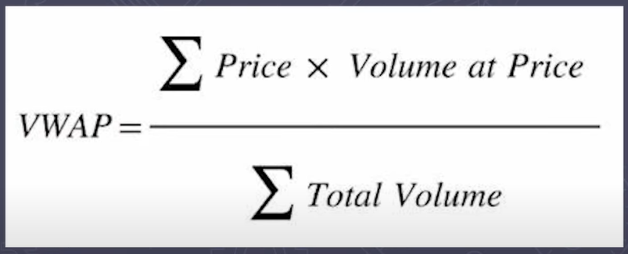

* It’s an volume weighted average price
* 95% of price movement would be around 2 standard deviations.
* If the gap between price & VWAP line increases then reversal movement is expected.
* Price above VWAP shows bullishness & price below VWAP indicates Bearishness
* VWAP on 1min, 2min, and 3min shows false signals. So never use them for these intervals
* Best intervals for VWAP are 5, 10 & 15 minutes. Find the entry at the 10 minutes time frame & trade on the 5 minutes candle.
* Do Analysis on multiple time frames
* In VWAP understanding volume is important
* We VWAP also act as a support or resistance. When price is around the VWAP many traders wait for the signal that will take the support at the VWAP or resistance at the VWAP.
* Look for the bearish (Bearish inverted Hammer or Bearish Engulfing) or the bullish candlestick patterns (Hanging man or Bullish Engulfing) at the VWAP that indicates that you will likely to see bearish or bullish trend.
* If price is above VWAP that means buyers strength is more compared to sellers.
* Similarly, if price is below VWAP that means we have more sellers compared to buyers.
* So we can use VWAP also to find out who are more active buyers or sellers.
* Try to take trade near VWAP line not when price is far from VWAP as it might break or reversal etc. If VWAP line & support or resistance are near to each other or coinciding that might be a very good signal for a put or a call trade. If you take the trade near to VWAP line your stop loss will be very small. So you can easily take the risk compared to when price & VWAP line are far & there your stop loss has to be very big. If it got triggered you might face big loss.
* Some more points to be added later.

**Bollinger Band**

* It’s the most used technical indicator.
* It is used to determine overbought & oversold levels, where a trader will try to sell when the price reaches the top of the band & will execute a buy when the prices reaches the bottom of the band.
* It has 3 components –
  + Middle Line – It’s the 20 day Simple Moving Average of the closing price
  + Upper Band – It’s a + 2 Standard Deviations of the middle line
  + Lower Band – it’s a - 2 Standard Deviations of the middle line
* Standard Deviation – Variance from its average. In finance standard deviation of the stock price represents volatility of the stock. For e.g. If standard deviation is12% , it is good as saying that the stocks volatility is 12%
* Ballinger Band works well in the sideways markets but fails in a trending market.

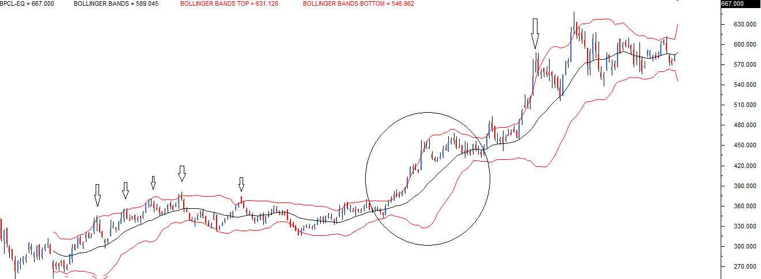

* The central black line is the 20 day SMA. The two red lines placed above and below the black like are the +2 SD and -2SD. The idea is to short the stock when the price touches the upper band, expecting it to revert to average. Likewise, one can go long when the price touches the lower band, expecting it to revert to the average.
* I have highlighted using a down arrow all the sell signals BB generated, while most of the signals worked quite well, there was a phase when the price stuck to the upper band. In fact, the price continued to drift higher, and therefore even the upper band expanded. This is called an envelope expansion.
* The BB’s upper and lower band together forms an envelope. The envelope expands, whenever the price drifts in a particular direction, indicating strong momentum. The BB signal fails when there is an envelope expansion. This leads us to an important conclusion; BB works well in sideways markets and fails in a trending market.
* Whenever I use BB, I expect the trade to start working in my favour almost immediately. If it does not, I start validating the possibility of an envelope expansion.

**ATR - Average True Range**

* It’s the Volatility indicator
* It measures volatility, taking into account any gaps in the price movement.
* ATR focuses on the total price movement & conveys how wildly the market is swinging as it moves. It takes into account the price movement in each period by considering the following ranges.
  + Difference between High & Low of each period
  + Difference between High & previous period’s Close
  + Difference between Low & previous period’s Close
* Traders use Bollinger Band & ATR in conjunction as they approach volatility differently & are complimentary.
* ATR calculation is based on 14 periods, which can be intraday, daily, weekly or monthly. You can change it to the value you wish.
* To measure recent volatility use shorter average such as 2 to 10 periods
* For longer volatility use 25 to 50 periods
* It is not upper or lower bound & hence can take any value
* ATR is stock specific, for one stock it can be 2 & for another it can be 150
* ATR can be used to identify stop loss as well
* ATR of a stock is 48 means that the stock is likely to move 48 points up or down on average. You can add this to the current day’s range to estimate the day’s range.
* If the ATR of a stock is 48, then it means that the stock is likely to move 48 points either ways up or down on average. You can add this to the current day’s range to estimate the day’s range. For example, the stock price is 1320; then the stock is likely to trade between 1320 – 48 = 1272 and 1320 + 48 = 1368
* If the ATR for the next day decreases to say 40, then it means that the volatility is decreasing, and so is the expected range for the day.
* It is best to use ATR to identify the volatility-based SL while trading. Assume you have initiated a long trade on the stock at 1325, then your SL should be at least 1272 or below since the ATR is 48
* Likewise, if you have initiated a short at 1320, then your stop loss should be at least 1368 or above.
* If these SL levels are outside your risk to reward appetite, then its best to avoid such trade.

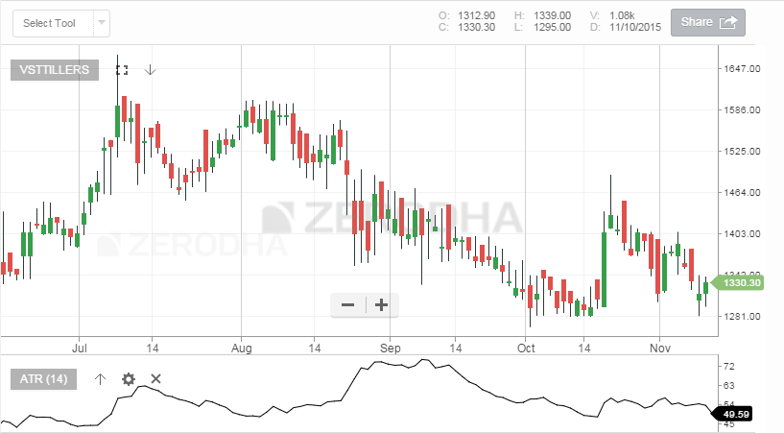

**Average True Range Band**

The ATR bands are an extension of the ATR concept. The idea is to plot an envelope around the stock price to evaluate if the stock prices are behaving “normally” or trending in a particular direction. To do this, the ATR band calculates the upper and lower band.

**What should you know?**

* The ATR band calculates and plots the upper and lower envelope around the stock price.
* To begin with, a moving average of the stock price is calculated.
* The ATR value is added to the moving average value, and this forms the upper envelope.
* The ATR value is subtracted to the moving average value, and this forms the lower envelope.
* If the stock price penetrates either the upper or lower envelop, the expectation is that the stock price will continue to move in the same direction. For example, if the stock price has penetrated above the upper envelop, the expectation is that the stock will continue to move higher.
* You can even use the ATR bands as an alternative to the Bollinger Bands trading system. You can read more about the [Bollinger Band (section 15.2)](http://zerodha.com/varsity/chapter/indicators-part-2/)

