Stocks Pointers

* Whenever the trend of the market is up short term or long term, medium term or intraday, market will continue to break the resistance. If trend is good then market doesn’t follow resistance but it follows support. So we use that resistance level for profit booking or square off my position or will hold & see how the price is moving. We should NEVER use that resistance level for selling/shorting opportunity. Is the market is holding at this level making this resistance as support & moving up again.
* In uptrend buyer is active, market will take resistance as lightly & support strongly & buyer will buy more.
* When the market trend is downwards, the market will feel resistance strongly & support lightly.
* If you are taking trade in the direction of trend keep the quantity high & when you are taking trade in the opposite of trend keep the quantity half or low.
* In Bank Nifty most of the Option sellers have OIs in the multiple of 500. Such as 43000, 435000, 44000, 44500 etc
* Average move of bank nifty in a day is around 250 points. If in upward rally market may take a pause & momentum goes down after a move of 250 - 300 points. For the range of 250 to 300 points. SL will be the low of consolidation.
* IF the range is small like 100 points then I will not wait for consolidation. After touching resistance 3rd times I will buy. If I see consolidation happening its good. SL of 60 points

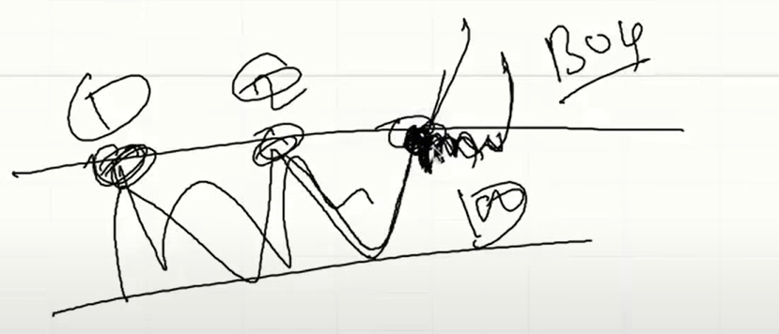

* In the below example market broke the resistance & came back for retest & now same level which was acting as a resistance now will act as a support & will take support & will go up.
* 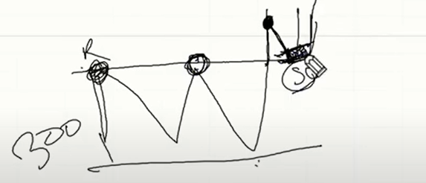
* In bank Nifty keep the stop loss of 70 to 90 points not above this. If market moves in your direction then keep trailing the stop loss.
* If market is within a range between support & resistance then if market consolidate at support then either it will breakdown or it will again go up to the resistance level. As show in below figure.
* 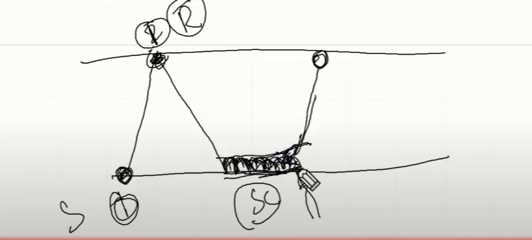
* If the range is above 100 around 150 or 200 or above & we see when it comes to support 2nd time & if there is hammer candle there then we can buy as hammer will be the confirmation that price will increase & goes up & will touch resistance & not down. Here the move will be small & slow. Keep the SL of below the support. If it hit the SL then we will go for shorting.
* Never ever take a trade within the support & resistance if there is no consolidation happening. Else you will get trapped.
* Check below is a hammer & price goes up.
* 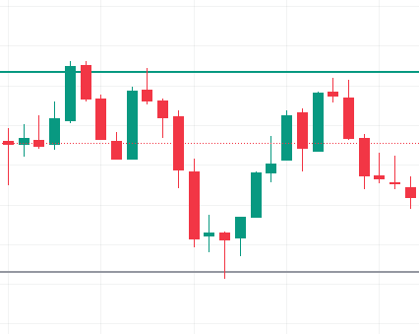
* Same for the downward move from resistance. Check above at resistance candle is a shooting star & price goes down.
* Whenever you are in range trade with small quantity. At breakout trade with large quantity.
* 