SymptoTrackAI: Hybrid RAG Chatbot for Symptom Monitoring

In propose work we are employing AI hybrid algorithm by combing RAG and ML algorithms to advice diseases to patients based on their input symptoms. In propose work we have trained Chatbot using RAG and FAISS similarity search algorithm and then trained Chatbot can accept symptoms as queries from users and then give best generated advice to user.

All symptoms and advices will be monitored and logged into database for future analysis. To trained Chatbot we have used below datasets which contains symptoms description along with possible diseases.

RAG is utilizing Sequence-NQ transformer algorithm to extract semantic meaning from database and queries which can help ML algorithm getting best accurate prediction for user query.

In below screen showing dataset details used to train Chatbot

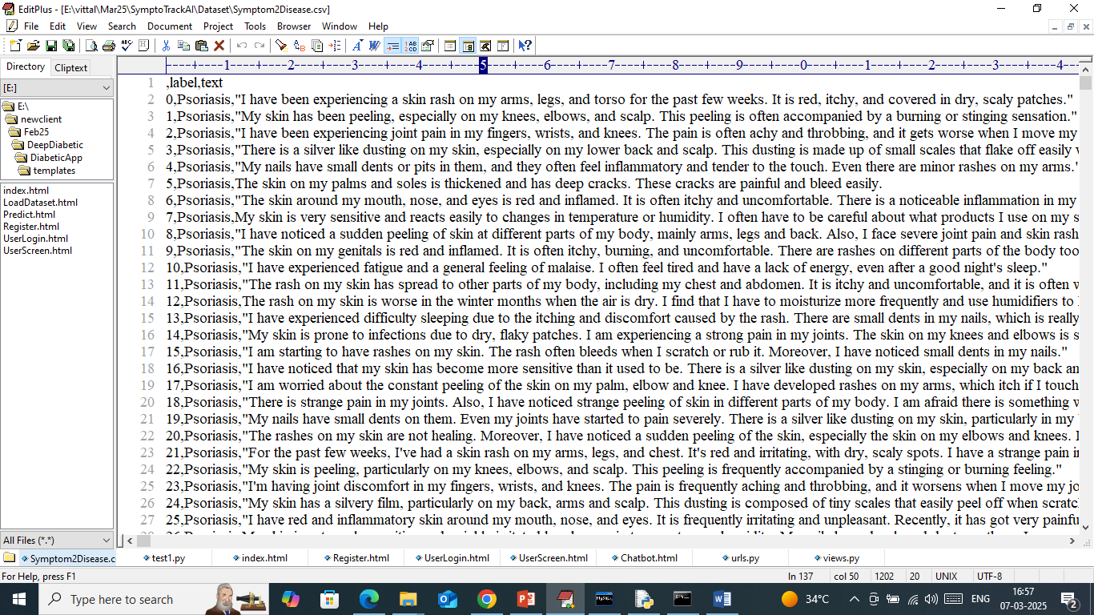

In above dataset screen we have symptoms along with possible disease which can be used as advice by the Chatbot.

To implement this project we have designed following modules

1. New User Signup: using this module user can sign up with the application
2. User Login: using this module user can login to system
3. Chatbot AI Based Symptoms Tracker: using this module user can send symptoms query to Chatbot and then Chatbot will employ RAG and FAISS algorithm to get best advice and then send response back to user
4. Access Previous Log: using this module user can view all previous log details to know about various symptoms and diseases he suffered over time.

To run project double click on ‘run.bat’ to start python server and then will get below page

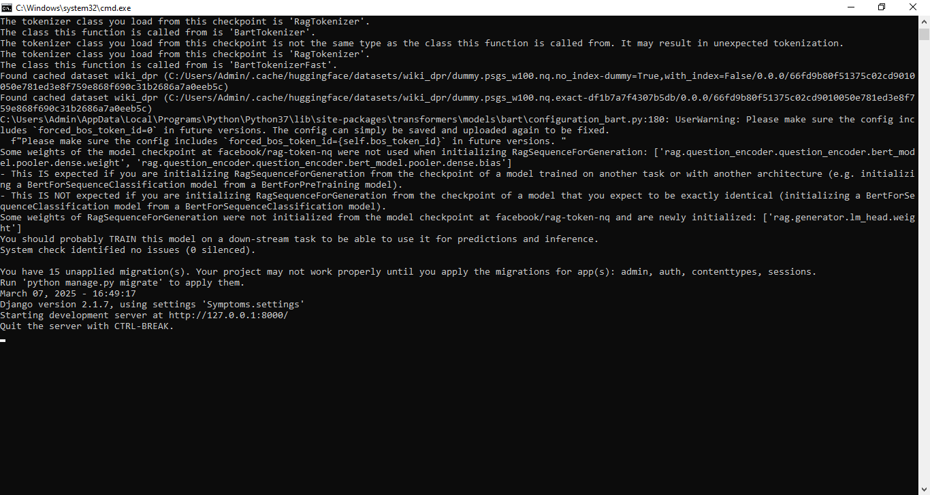

In above screen python server started and now open browser and enter URL as <http://127.0.0.1:8000/index.html> and then press enter key to get below page

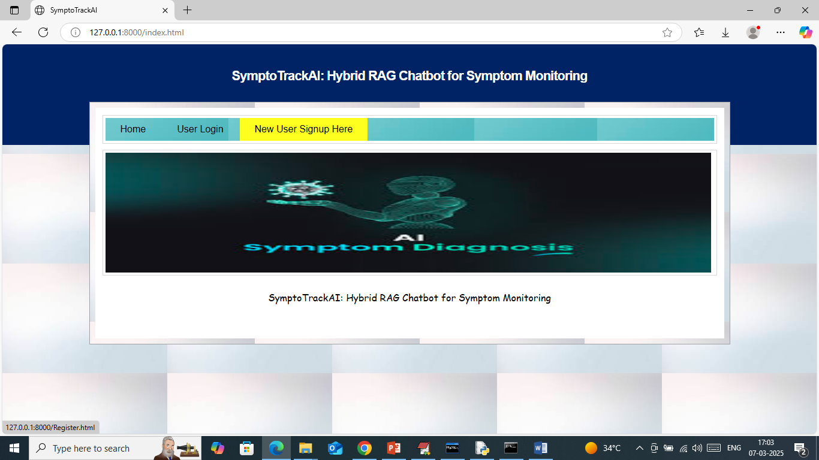

In above screen click on ‘New User Sign up’ link to get below page

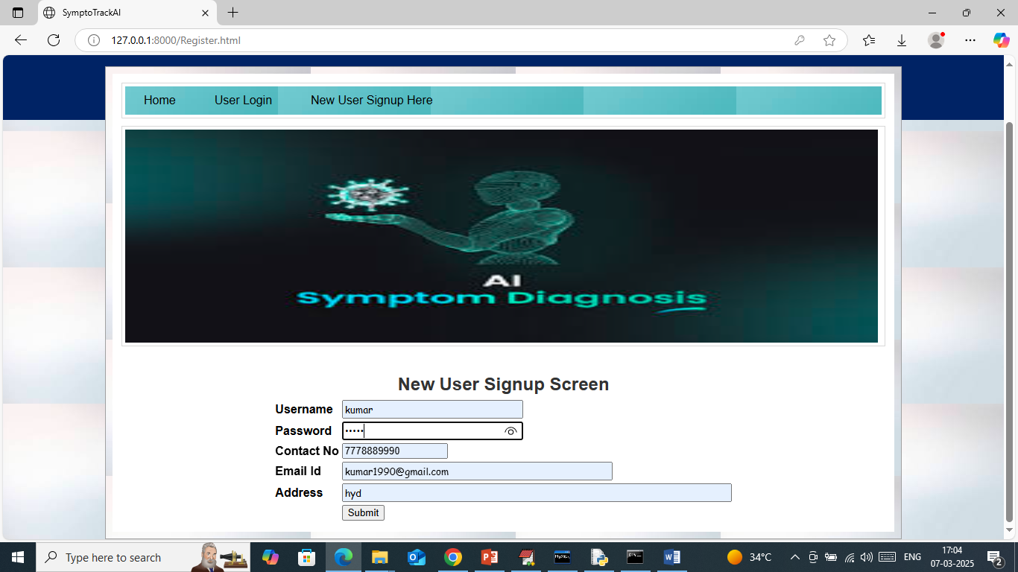

In above screen user is entering sign up details and then press button to get below page

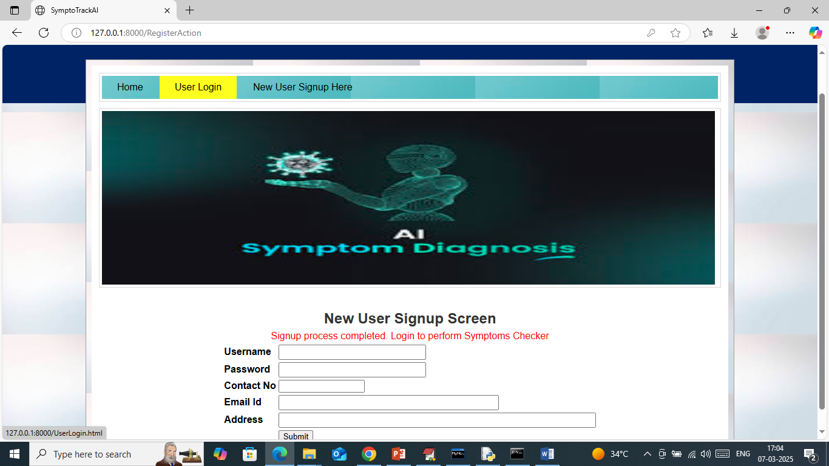

In above screen user sign up completed and now click on ‘User Login’ link to get below page

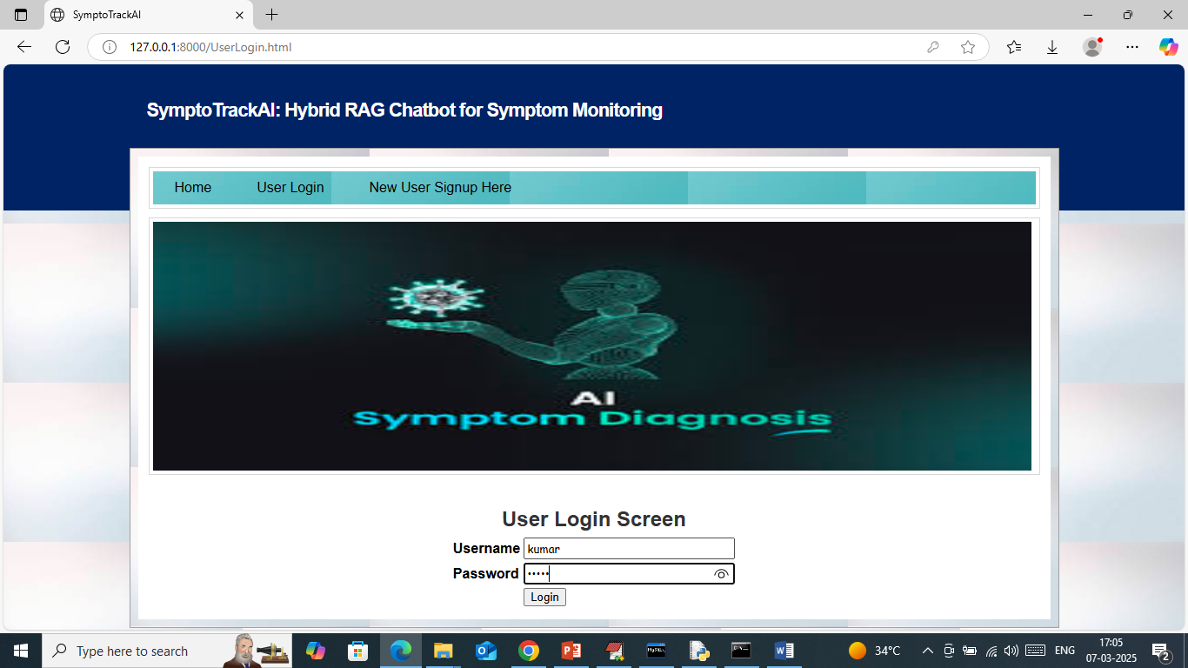

In above screen user is login and after login will get below page

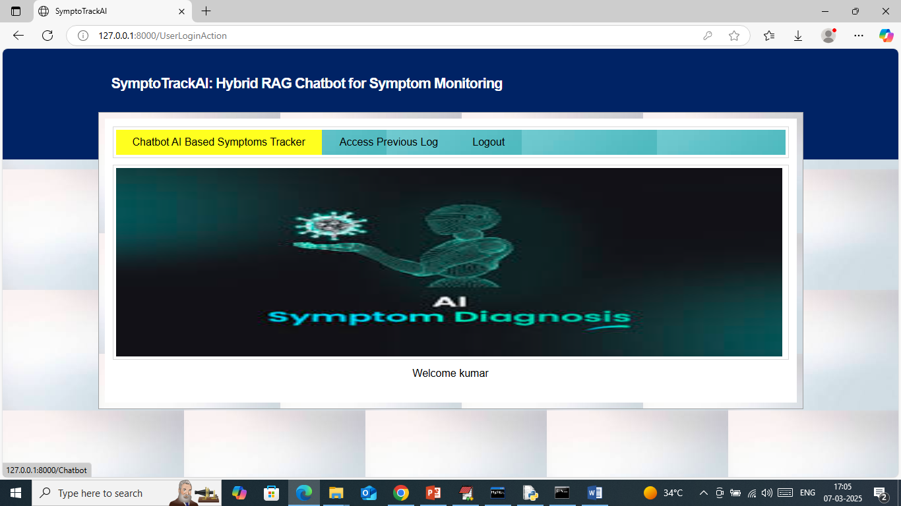

In above screen click on ‘Chatbot AI Based Symptoms Tracker’ link to get below page

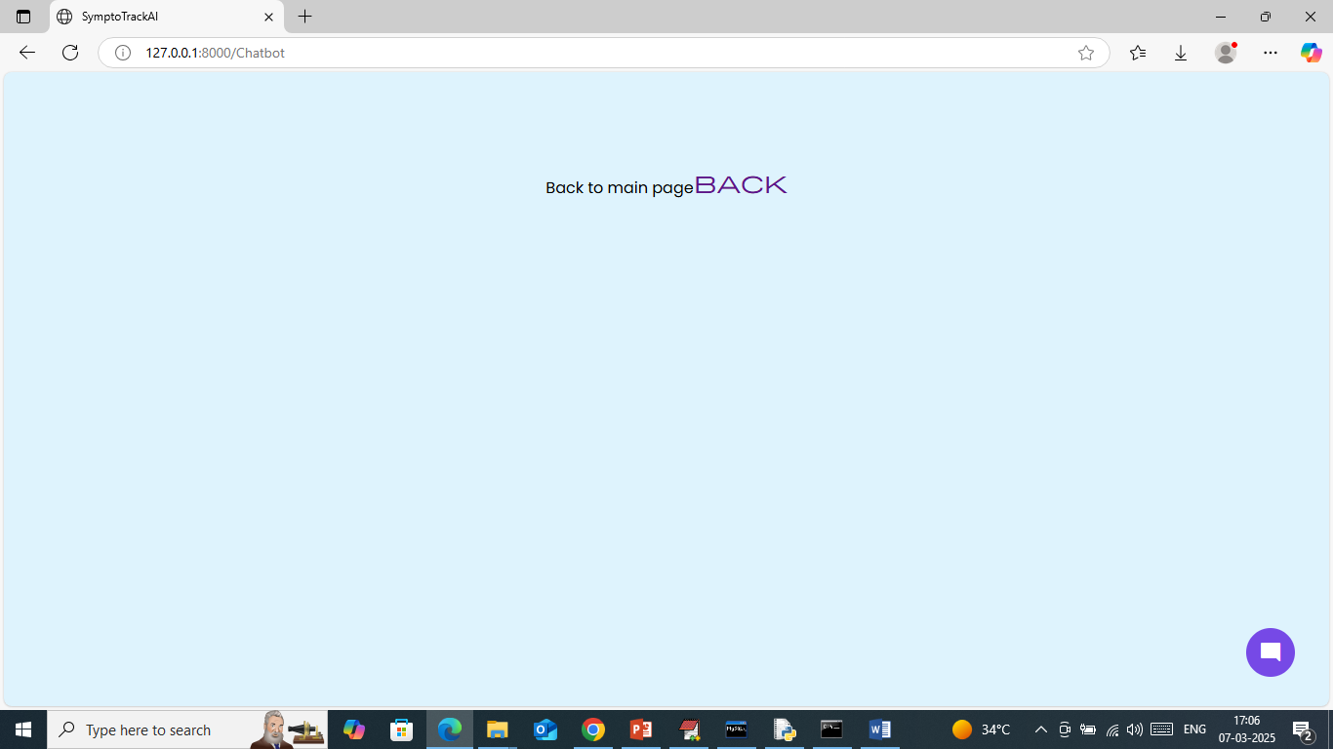

In above screen click on ‘Blue’ icon from bottom to activate Chatbot and then will get below page

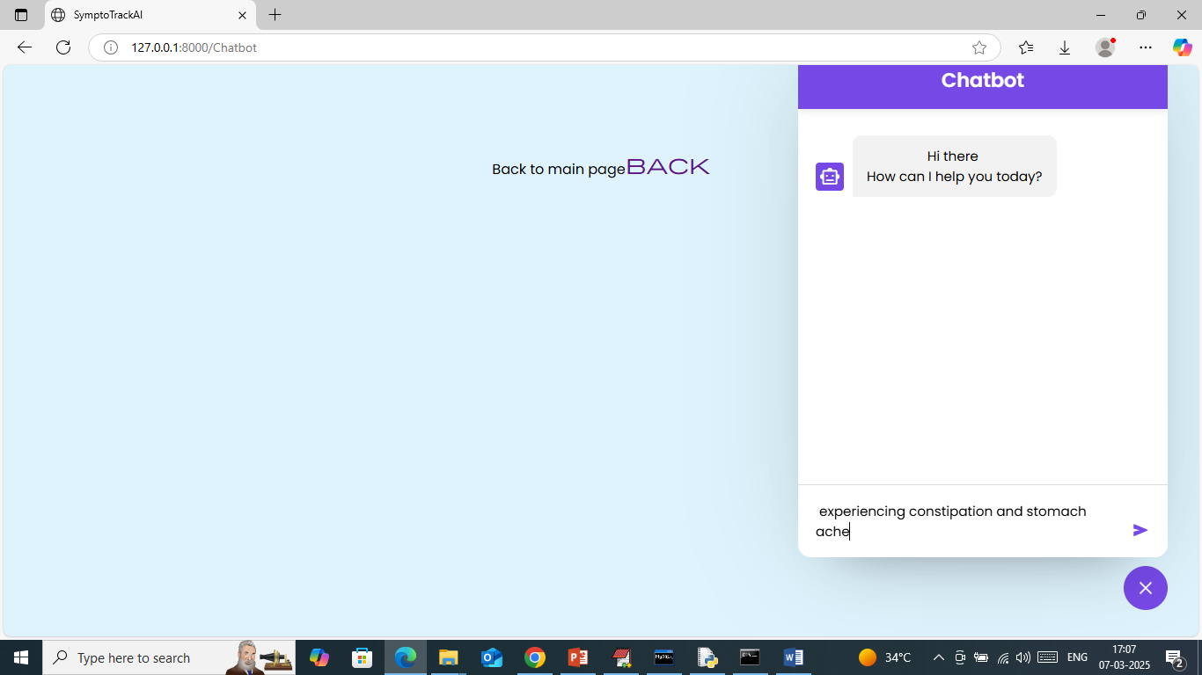

In above screen in bottom text field can enter input query and then press enter key to get below page

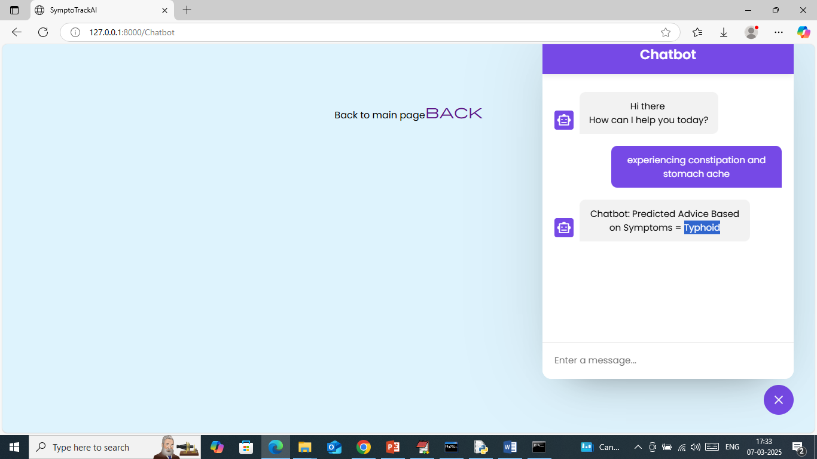

In above screen in blue text panel can see user query and then in white text panel Chatbot predicted disease of advice based on symptoms is ‘Typhoid’. Similarly you can enter query and get response and below are some other response

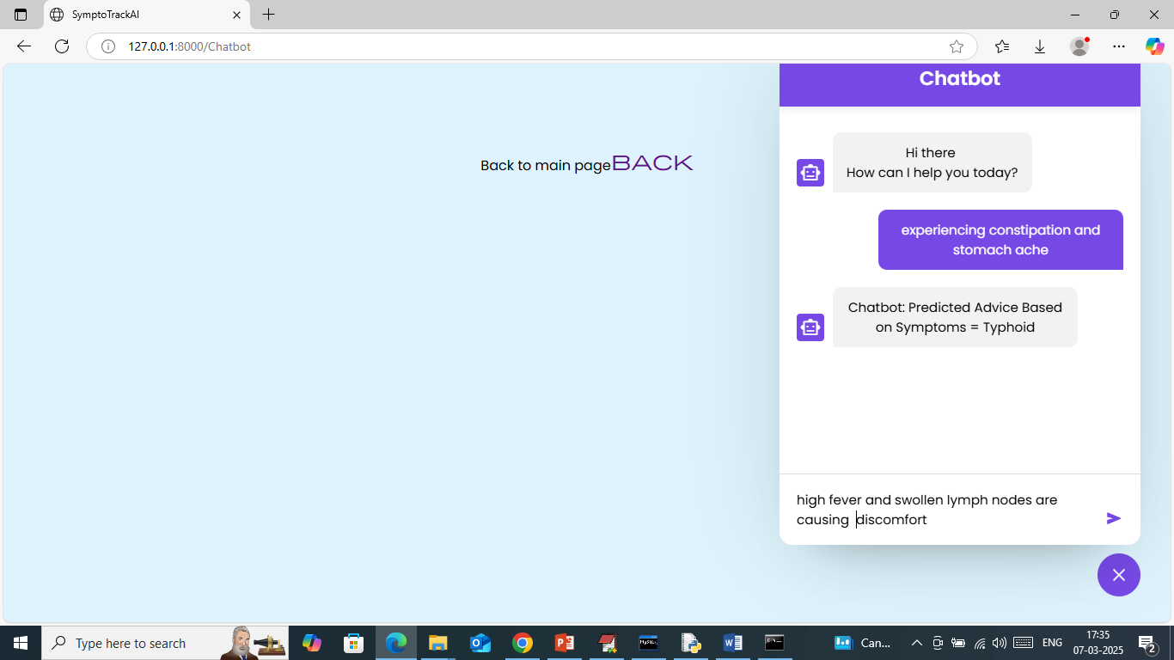

In above screen given another query and below is the response

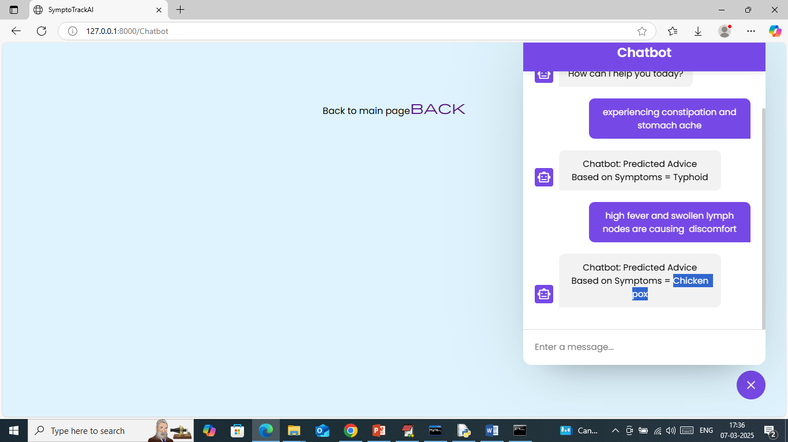

In above screen for given query Chatbot predicted Chickenpox and now click on ‘Back’ link to get below page

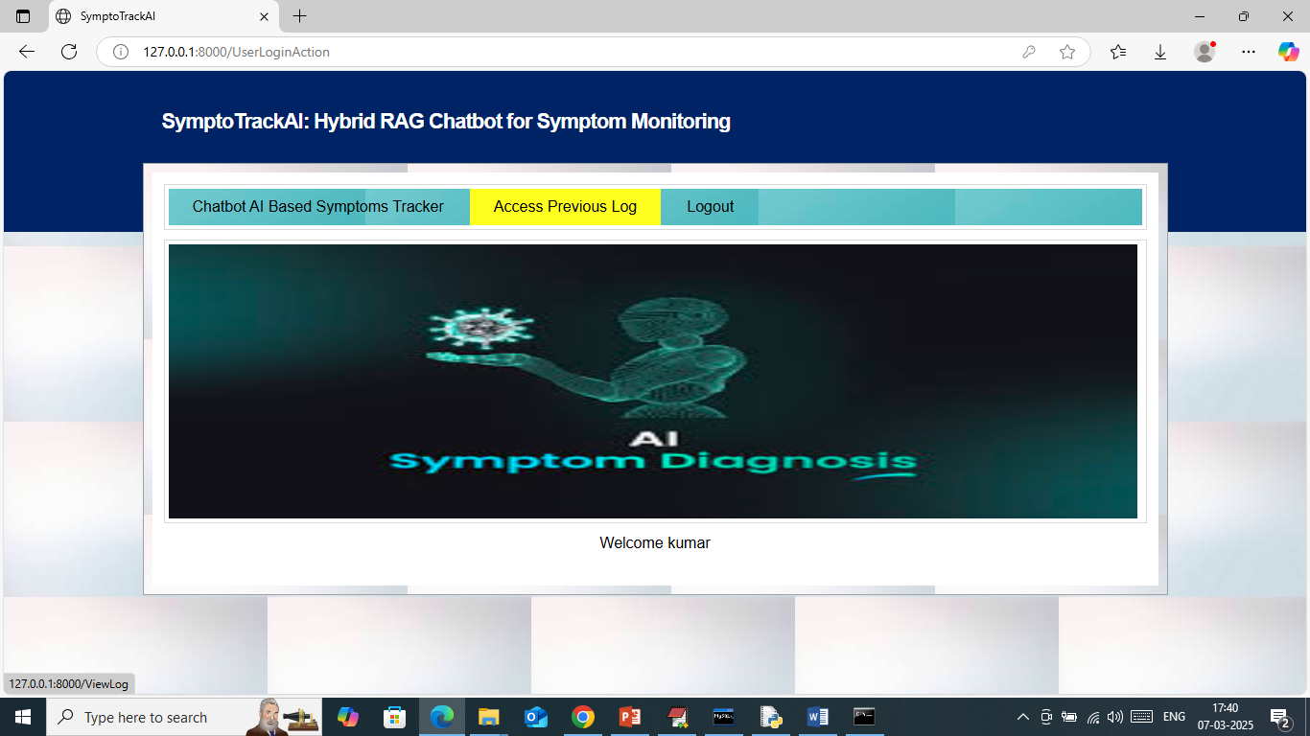

In above screen click on ‘Access Previous Log’ link to view all past symptoms and advices

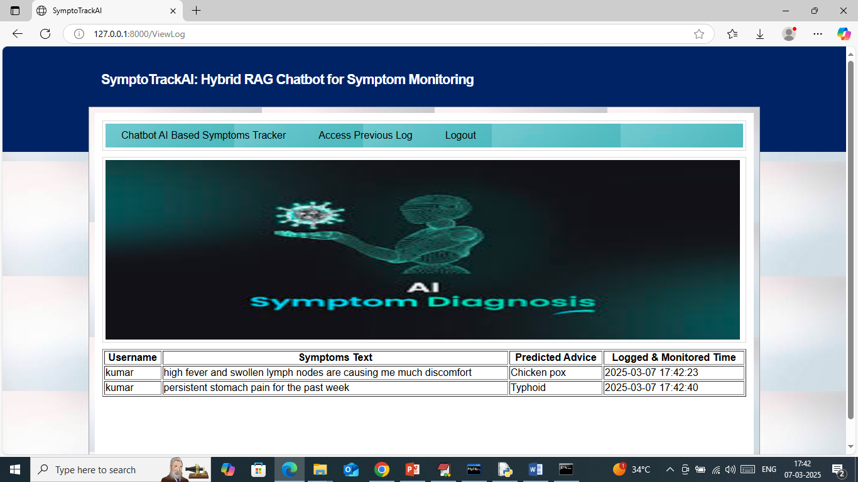

In above screen user can view all previous log which monitored over different times.

Similarly by following above screens you can ask symptoms to get advices and maintain proper health.