**Tutorial -5**

NITIN REDDY K – CS21B2028

VLAN

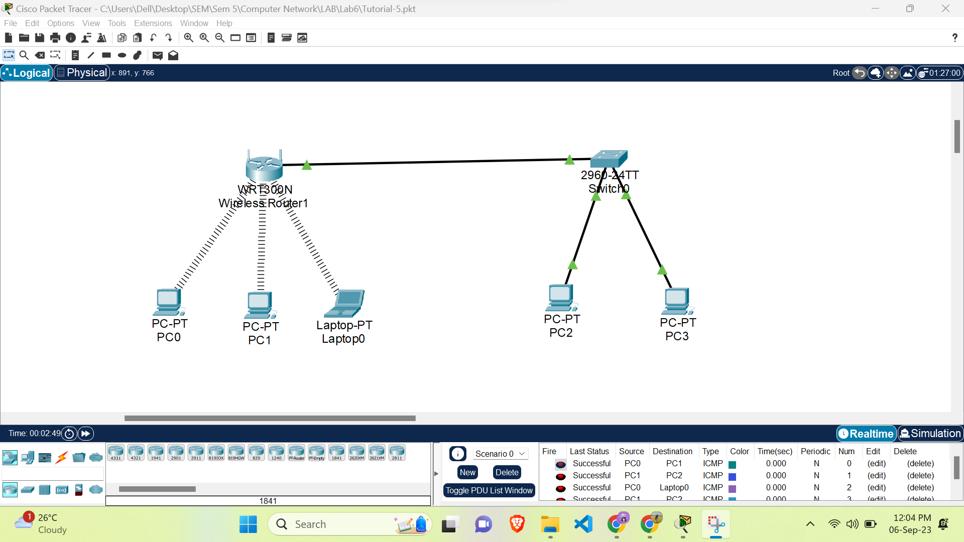

Create a Network Topology:

Start by creating a network topology. You can add routers, switches, and wireless access points to the workspace. For this example, let's use a router, a switch, and a wireless access point (WAP).

Connect Devices:

Connect the router, switch, and WAP using the appropriate cables. Ensure that the connections are secure.

Configure the Router:

Access the router's command line interface (CLI).

Configure basic settings such as the router's hostname, IP address, and subnet mask.

Configure the Wireless Access Point (WAP):

Access the WAP's configuration interface by double-clicking on it.

Set the SSID (network name) and security settings (e.g., WPA2/WPA3, password).

Assign the WAP to a specific VLAN if you have VLANs configured.

Save the configuration.

Connect Devices to the WLAN:

Add devices such as laptops or smartphones to the workspace.

Configure their wireless network settings to connect to the SSID of the WAP.

Verify that devices can obtain IP addresses and access the network.

Test Connectivity:

Ping devices within the WLAN to ensure they can communicate.

Test internet connectivity if the router is connected to the internet.