NITIN REDDY K

CS21B2028

1)

When you connect two end nodes (devices) with a straight Ethernet cable, it forms a direct link between the two devices. In this scenario, both end nodes should be on the same network, sharing the same local area network (LAN) or subnet.

This direct connection allows the two end nodes to communicate with each other directly without the need for any intermediary networking devices like switches or routers. It creates a simple point-to-point connection, often called a "peer-to-peer" connection.

Remember to use a straight Ethernet cable when connecting devices of different types (e.g., computer to switch). However, if you connected two similar devices (e.g., computer to computer or switch to switch), you would need a crossover Ethernet cable.

3)

If you connect two end nodes (devices) with a cross-coupled Ethernet cable, it would not establish a functional connection between them. Cross-coupled cables are used to connect similar devices, such as two computers or two switches, and they are not suitable for connecting end nodes to form a direct link.

For connecting two end nodes in the same network, you should use a straight Ethernet cable. A straight cable connects different types of devices, like a computer to a switch or a computer to a router. This allows the end nodes to communicate with each other effectively within the same network.

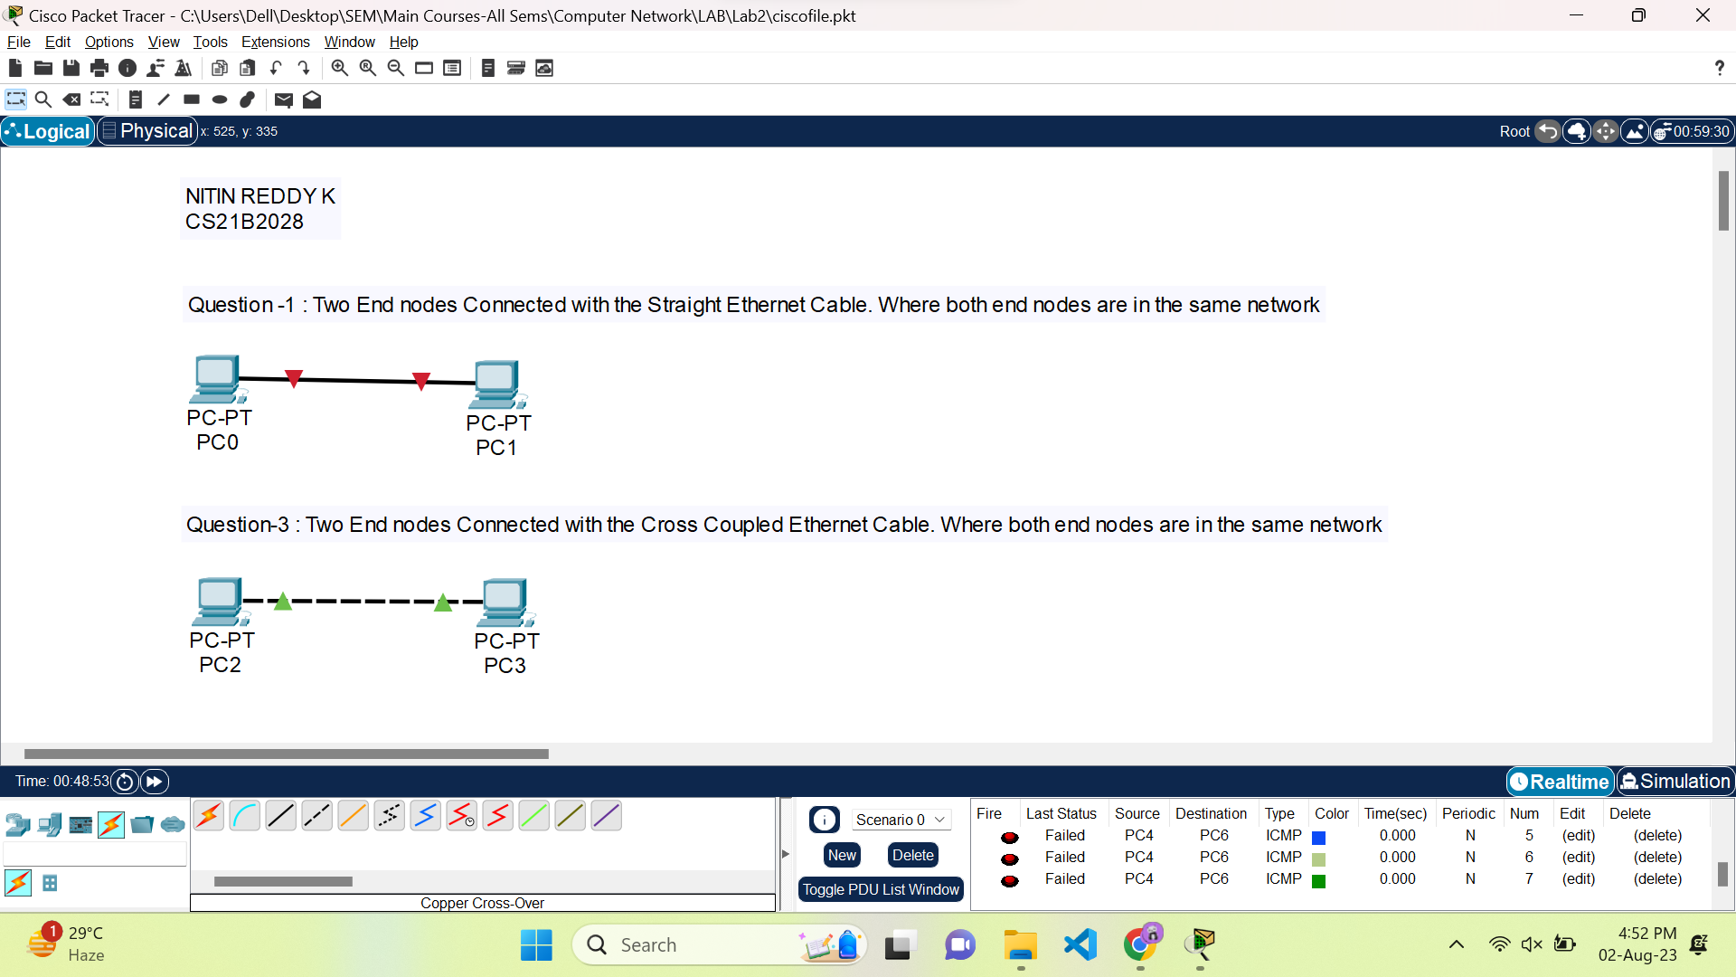

2)

When you connect two end nodes (devices) with a straight Ethernet cable, and both end nodes are in different networks, the connection will not work as expected. A straight Ethernet cable is designed to connect devices within the same local area network (LAN) or subnet.

For communication between devices in different networks, you would need to use a router or a layer 3 switch to route traffic between the networks. The router or layer 3 switch acts as an intermediary device, enabling communication between the two different networks.

To summarize, a straight Ethernet cable is suitable for connecting devices within the same network, but when connecting devices in different networks, a router or layer 3 switch is necessary to facilitate communication between them.

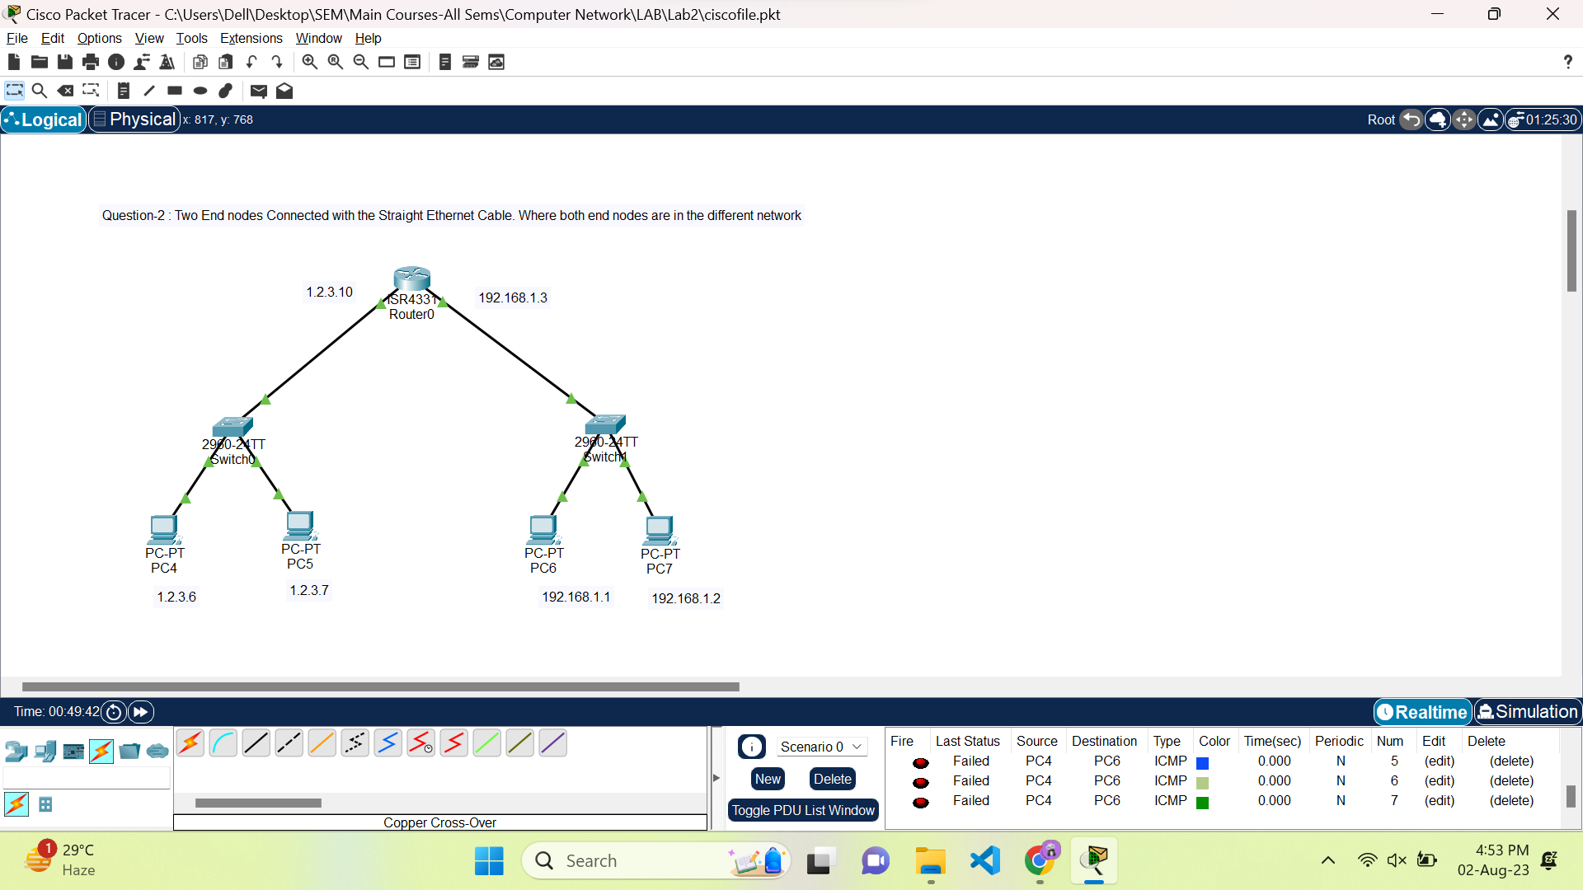

4)

If you connect two end nodes (devices) with a cross-coupled Ethernet cable, and both end nodes are in different networks, the connection will not function as expected. A cross-coupled Ethernet cable, also known as a crossover cable, is specifically used to connect similar devices directly, such as a computer to another computer or a switch to another switch.

To enable communication between end nodes in different networks, you must use a router or a layer 3 switch. These devices are designed to handle routing between different networks. By connecting the two end nodes to the router or layer 3 switch, they can exchange data and communicate across their respective networks.

In summary, for connecting end nodes in different networks, you need to use a router or a layer 3 switch. A cross-coupled Ethernet cable is not suitable for this purpose; it is intended for connecting similar devices within the same network.

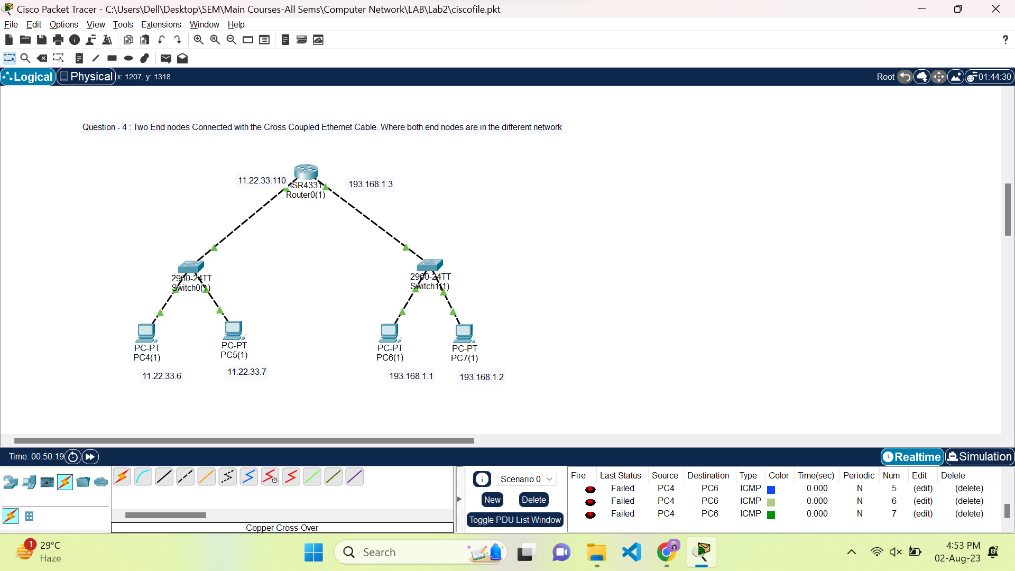

5)

What are ways (or technologies) two computers are directly connected and communicate with each other .

There are several ways (or technologies) through which two computers can be directly connected and communicate with each other:

1. Ethernet Cable: Two computers can be connected directly using an Ethernet cable. This is often done using a standard straight-through Ethernet cable, allowing them to communicate within the same local area network (LAN).
2. Crossover Ethernet Cable: Similar to the Ethernet cable, a crossover Ethernet cable can be used to connect two computers directly. This cable is specifically designed for connecting two similar devices, such as two computers, without the need for a switch or a router.
3. USB Cable: Some computers support direct communication via USB cables. You can connect two computers using a special USB cable designed for data transfer between devices.
4. Bluetooth: If both computers have Bluetooth capabilities, they can establish a direct wireless connection. Bluetooth allows for relatively short-range communication between devices.
5. Wi-Fi Direct: This technology enables two computers to connect directly to each other without the need for a wireless access point. It allows for peer-to-peer communication between devices.
6. Infrared (IR): Although not as common as other methods, some older devices might support direct communication via infrared. The computers need to have IR transmitters/receivers to establish a connection.
7. Ad-hoc Wireless Network: Two computers can create an ad-hoc wireless network, essentially forming a direct wireless connection without the need for a traditional Wi-Fi router.

Top of Form