**NITIN REDDY K**

**CS21B2028**

TUTORIAL-2: Report

**1)HUB**

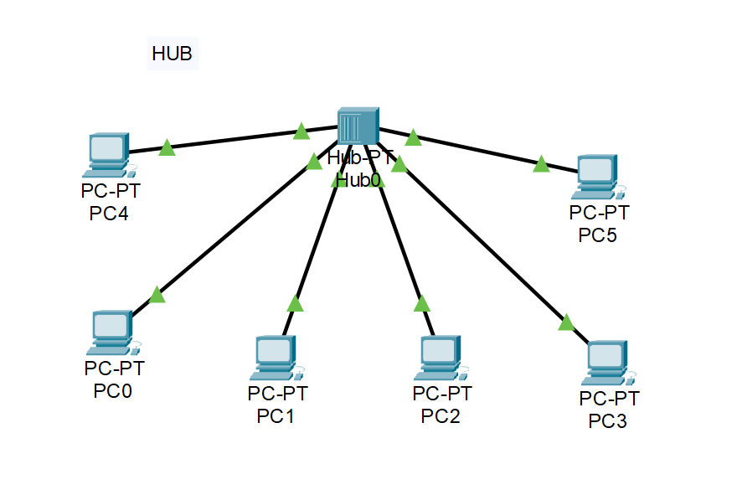

A hub is a network device that connects multiple devices. It operates at the physical layer of the OSI (Open Systems Interconnection) model. When the hub receives a payload, it broadcasts that to all the other devices in the network. This broadcasting method means that all devices connected to the hub can potentially receive and see all the data transmissions, regardless of whether the data is intended for them or not.

When the accepted device sends back the acknowledgment to the hub, the hub forwards this acknowledgment to all the devices connected to it. However, only the device with the corresponding MAC address, which matches the destination MAC address of the original transmission, will process and accept this acknowledgment. This process helps in minimizing unnecessary network traffic and optimizing data transmission within the network

**2)Layer 2 Switch**

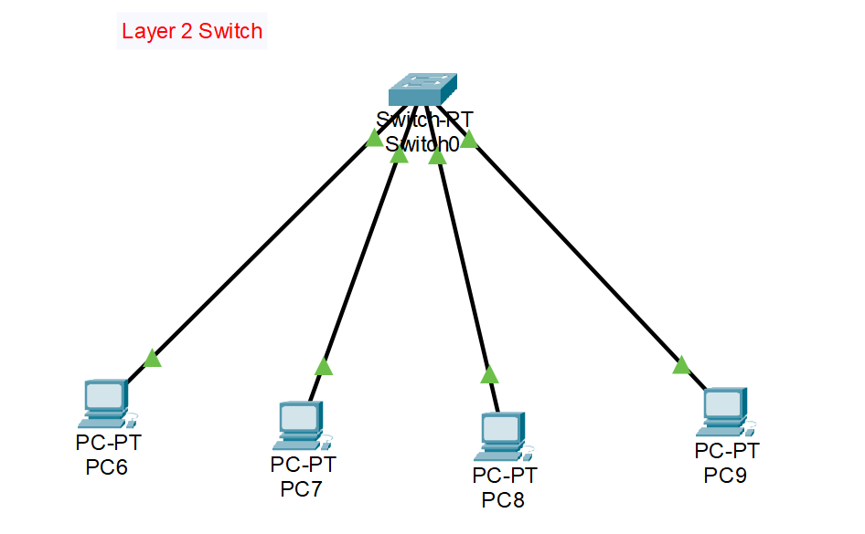

A layer 2 switch, also known as a data link layer switch, is a network device that operates at the second layer of the OSI (Open Systems Interconnection) model. It serves as a critical component in local area networks (LANs) to facilitate efficient data communication between multiple devices.

When a layer 2 switch receives a payload or data frame, it performs a process called "MAC address learning." This involves examining the source MAC address of the incoming data frame and recording it in its MAC address table, associating it with the port through which the frame arrived. This learning process allows the switch to build a database of MAC addresses and their corresponding physical ports.

**3)Layer 3 Switch**

A layer 3 switch, often referred to as a routing switch, is a sophisticated network device that operates at the third layer of the OSI (Open Systems Interconnection) model. While similar in concept to layer 2 switches, layer 3 switches introduce advanced routing capabilities, making them crucial components in larger and more intricate networks.

When a layer 3 switch receives a payload or data packet, it goes beyond the MAC address-based decision-making of layer 2 switches. Layer 3 switches are capable of understanding IP addresses, allowing them to make routing decisions based on the destination IP address of the data packet. This means that they can route traffic between different subnets and VLANs (Virtual Local Area Networks), making them particularly useful in complex network architectures.

**4)Router**

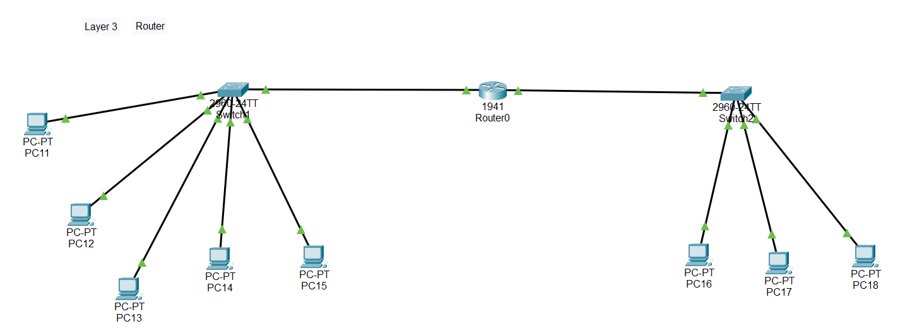

A router is a fundamental networking device designed to connect different networks or local area networks (LANs). It operates at the network layer (Layer 3) of the OSI (Open Systems Interconnection) model and plays a crucial role in directing data traffic between different networks.

**5)Bridge**

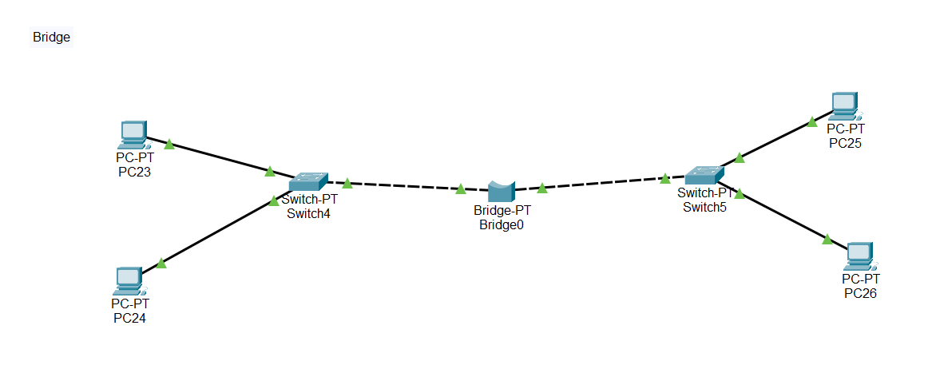

A bridge is a network device that serves the purpose of connecting and extending Local Area Networks (LANs) operating on the same network protocol. It operates at the data link layer (Layer 2) of the OSI (Open Systems Interconnection) model and plays a crucial role in segmenting and managing network traffic.

**6)Repeater**

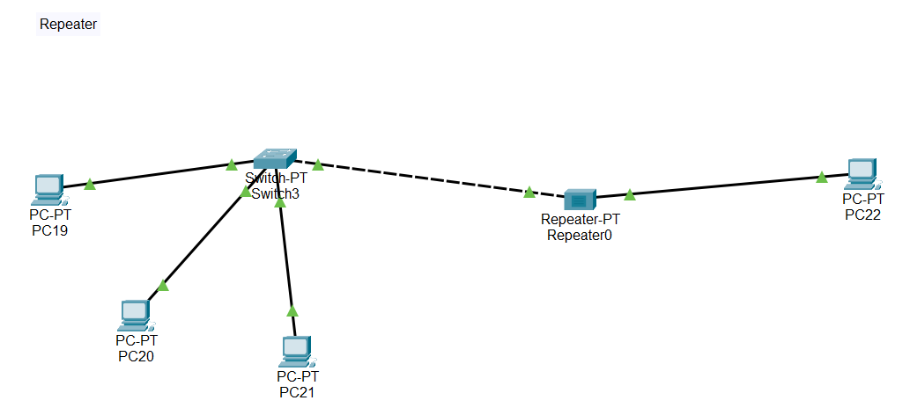

A repeater is a fundamental network device designed to extend the reach of network connections by amplifying and regenerating signals. It operates at the physical layer (Layer 1) of the OSI (Open Systems Interconnection) model and serves as a solution for overcoming limitations related to signal degradation and distance.