***CS21B2028***

***NITIN REDDY K***

1)Checking each topology with a different network ID:

**(a)BUS Topology:**

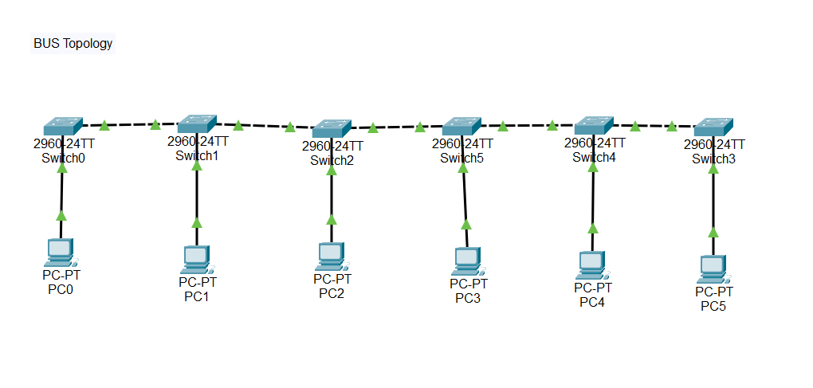

In a bus topology, all devices are connected to a single central cable (the bus). If one device wants to send data to another, it broadcasts the data on the bus, and the intended recipient catches it. However, this type of topology can have problems if the main cable fails, as the whole network could go down.

**(b) STAR Topology:**

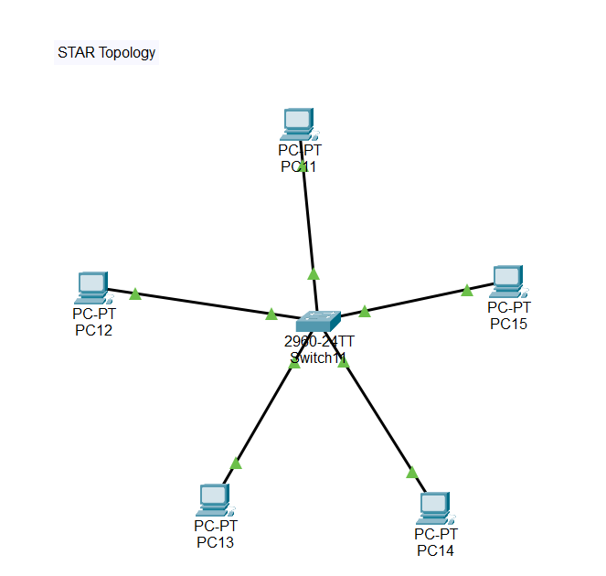

In a star topology, all devices are connected to a central hub or switch, like the spokes of a wheel. If one device wants to communicate with another, it sends data to the central hub, which then sends it to the intended recipient. This topology is more reliable than a bus because if one device or cable fails, it doesn't affect the whole network – only the device directly connected to the failed one

**(c) RING Topology:**

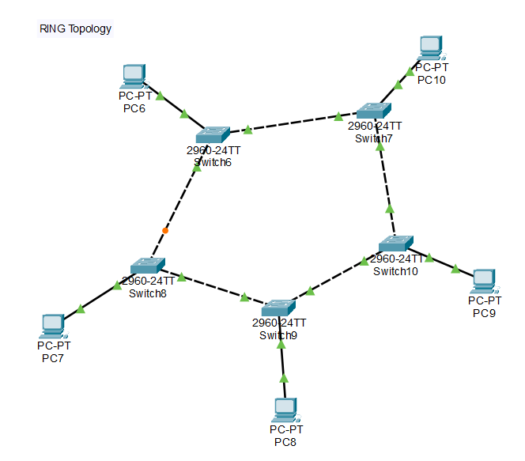

In a ring topology, data travels in a unidirectional path around the ring. If one device wants to communicate with another, data hops from one device to the next until it reaches its destination. While this topology can be efficient, it can also have issues if any device or cable in the ring breaks, as it could disrupt the entire network.

**(4) MESH Topology:**

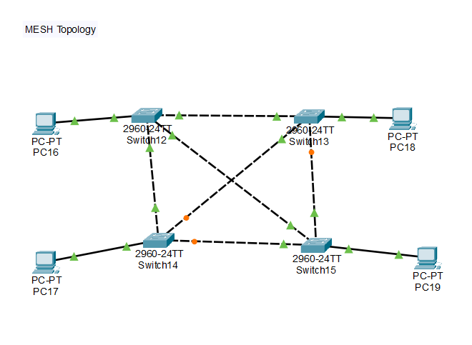

In mesh topology, every device is connected to every other device. Each device has a direct link to every other device in a full mesh topology. This ensures robustness and redundancy – if one link or device fails, there are still multiple paths for data to travel. However, this can become complex and expensive as the number of devices grows.

*NOTE: In each topology, the message is being transferred successfully.*

*In this question, all are different networks having IP series of 192.168.5.2 to 192.168.5.7, 192.168.6.2 to 192.168.6.6, 192.168.7.2 to 192.168.7.6, 192.168.8.2 to 192.168.8.5*

(2)  Checking All the topologies with the same network ID:

**Hybrid Topology:**

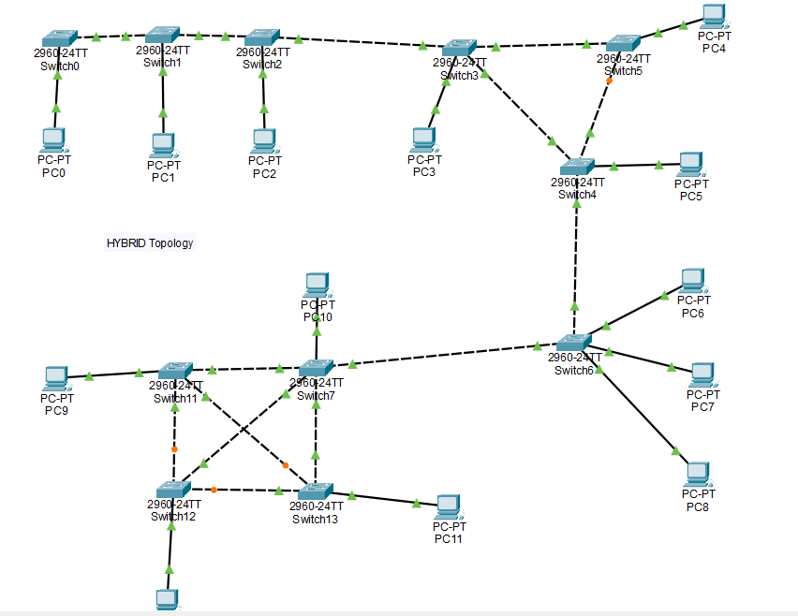

If all the PCs have similar IP addresses, the packet is getting transferred, which means they are connected to the same network.

If all the PCs have non-similar IP addresses, the packet will not get transferred, which means they are not connected to a network.

This approach is often used to take advantage of the strengths of different topologies while mitigating their weaknesses. This approach provides the reliability and redundancy of the ring topology along with the simplicity of managing smaller star networks.