**NITIN REDDY K**

**CS21B2028**

DNS Server Configuration

First, create two different lan connections using switches

# Step1:

1. Access your network equipment's web interface (usually through a web browser) or command line interface.
2. Create two separate VLANs or subnet configurations, such as:
   * LAN L1: Subnet 192.168.0.1/3..
   * LAN L2: Subnet 192.168.5.1/5..

# Step-2:

Name the Pc as cn1/.. and os1/.. in config option in a pc settings when we click on pc.

And give connections in between switch ,Pc’s and also too the router as shown in picture.

Now give IP address to the PC . For Lan L1

IP:192.168.0.1/3..

GateWay:192.168.0.2 DNS:192.168.5.200

For Lan L2:

IP:192.168.5.1/3..

GateWay:192.168.5.2 DNS:192.168.5.200

**Step 3: Use Server and Configure Server as DNS**

Configure the DNS server with the following steps:

* + Open the DNS Manager. Give a name to the server as dns.iiitdm.ac.in
  + Create DNS zones for each LAN.

On each computer in your LANs, set the DNS server IP address to point to the IP address of your DNS server.

Now go the services in server and select Dns on it. Now add all the pc using there name and their IP address. Add server using the name of the server given and instead of IP give DNS server Id to it.

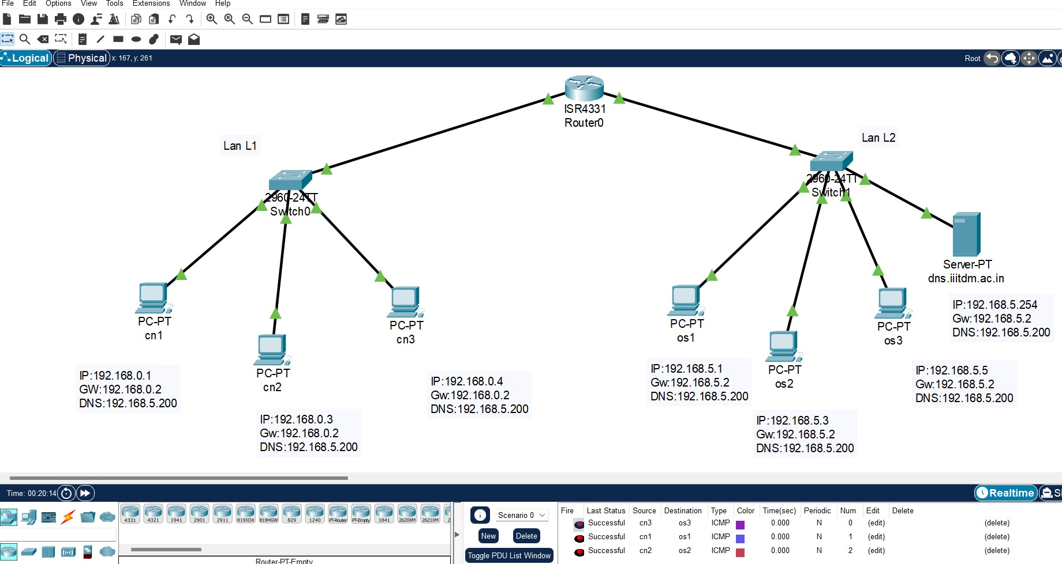

# Step-4:

Test the connection of server for that open any pc and go the terminal prompt type: ping dns.iiitdm.ac.in

Check for the connection by the ping command

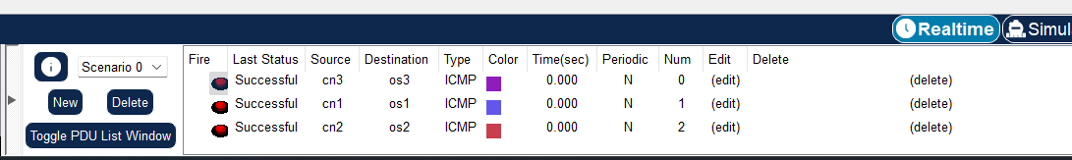Now send packets or messages to the each pc at first every message will fail or did not reach to the destinated pc. Again send them then it will work for this second time.