CN Tutorial 8

Name : NITIN REDDY K

Roll no.: CS21B2028

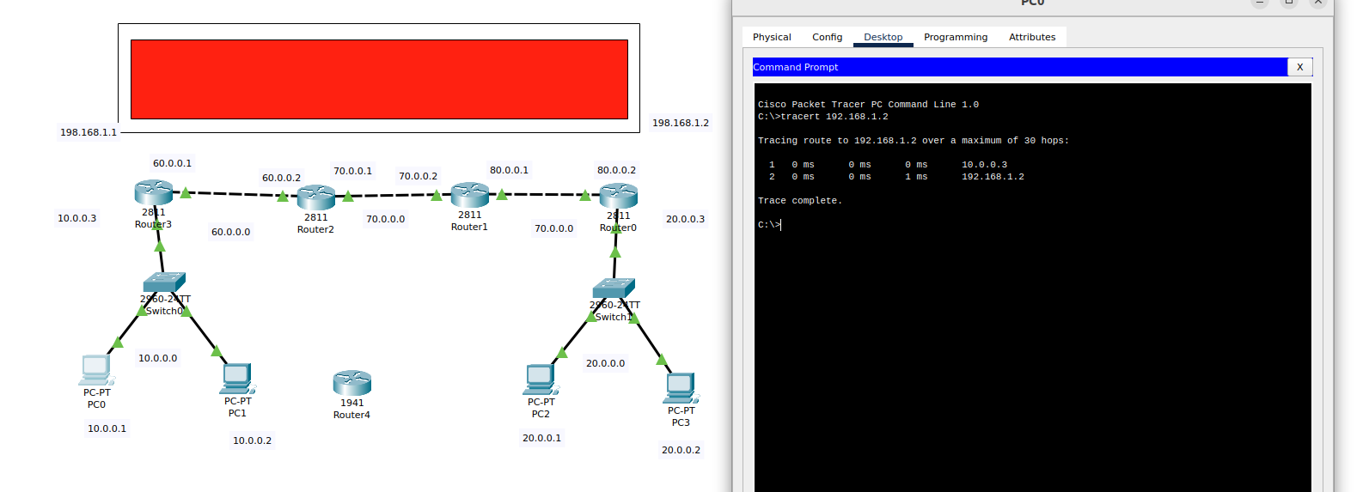 A Virtual Private Network (VPN) is a tool that enables you to establish a protected and confidential link to a different network through the Internet. It functions as a conduit between your device and the online realm, applying encryption to the information that traverses it.

**Privacy and Anonymity**: VPNs conceal your IP address and secure your online data, significantly increasing the difficulty for external entities to monitor your internet actions. This is particularly valuable when you seek to safeguard your privacy, especially when using public Wi-Fi networks.

**Security**: VPNs provide an extra layer of security, especially when using unsecured networks. This is important to protect against hackers and other potential threats.

**Bypassing Geographical Restrictions**: Many services and websites have geographical restrictions on content. A VPN can make it appear as though you're accessing the internet from a different location, allowing you to bypass these restrictions.

**Accessing Local Networks Remotely**: Businesses often use VPNs to allow employees to securely access company resources and files from anywhere in the world.