28/7/23

Nitin Reddy K, CS21B2028

**Lab -1: Various LINUX Commands(OS)**

1. **Listing contents in a directory -**

**ls**: This command lists all the files and directories in the current directory.

**ls -l** or **ls- ll:** This command also lists all the files and directories. Here you will get more details about the files and directories in the current directory. You will see the permission set, creation date, file/directory size, etc.

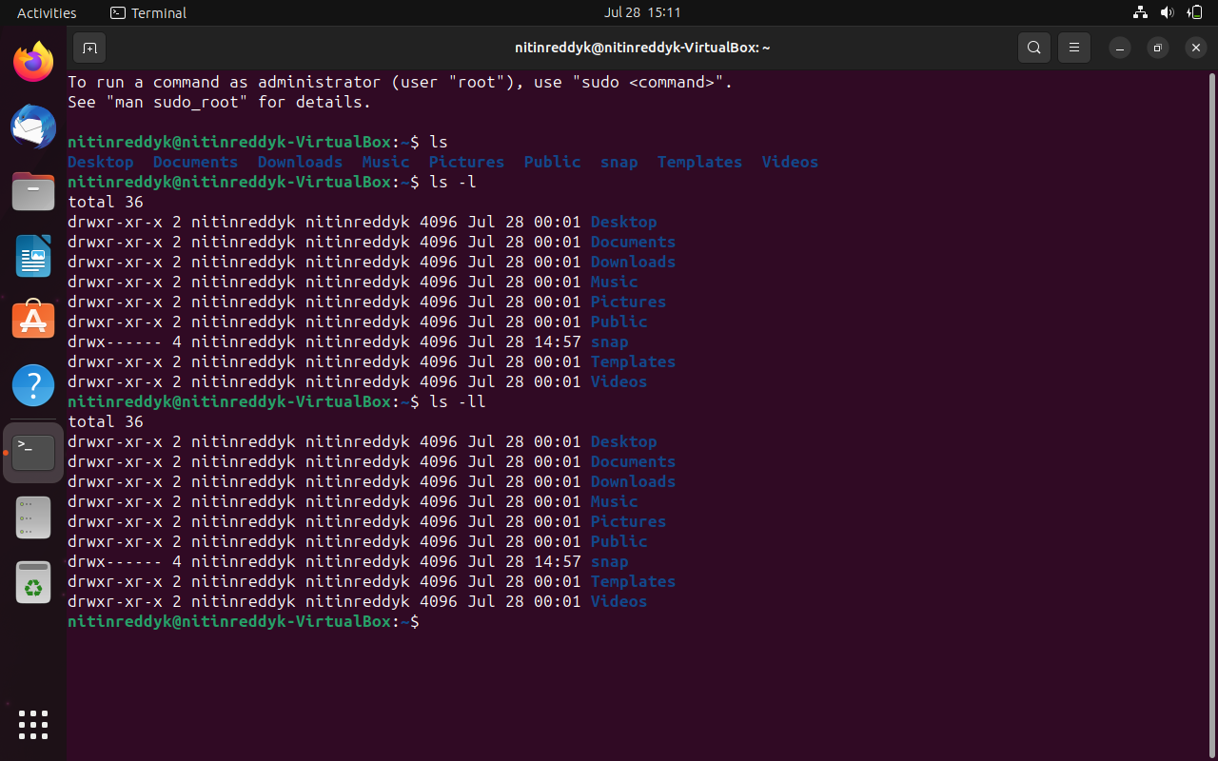

1. **Reading files in Linux -**

**cat**: used to display the contents of a file. You can also read the file contents

**more**: reads files and displays the text one screen at a time.

**less**: shows a file's contents one screen at a time.

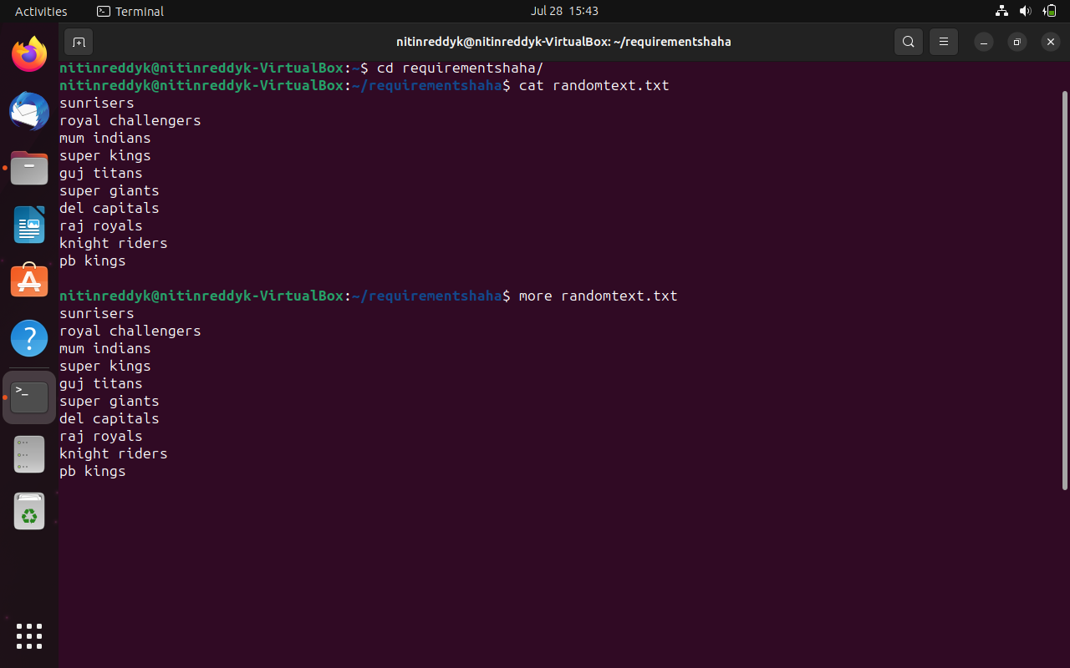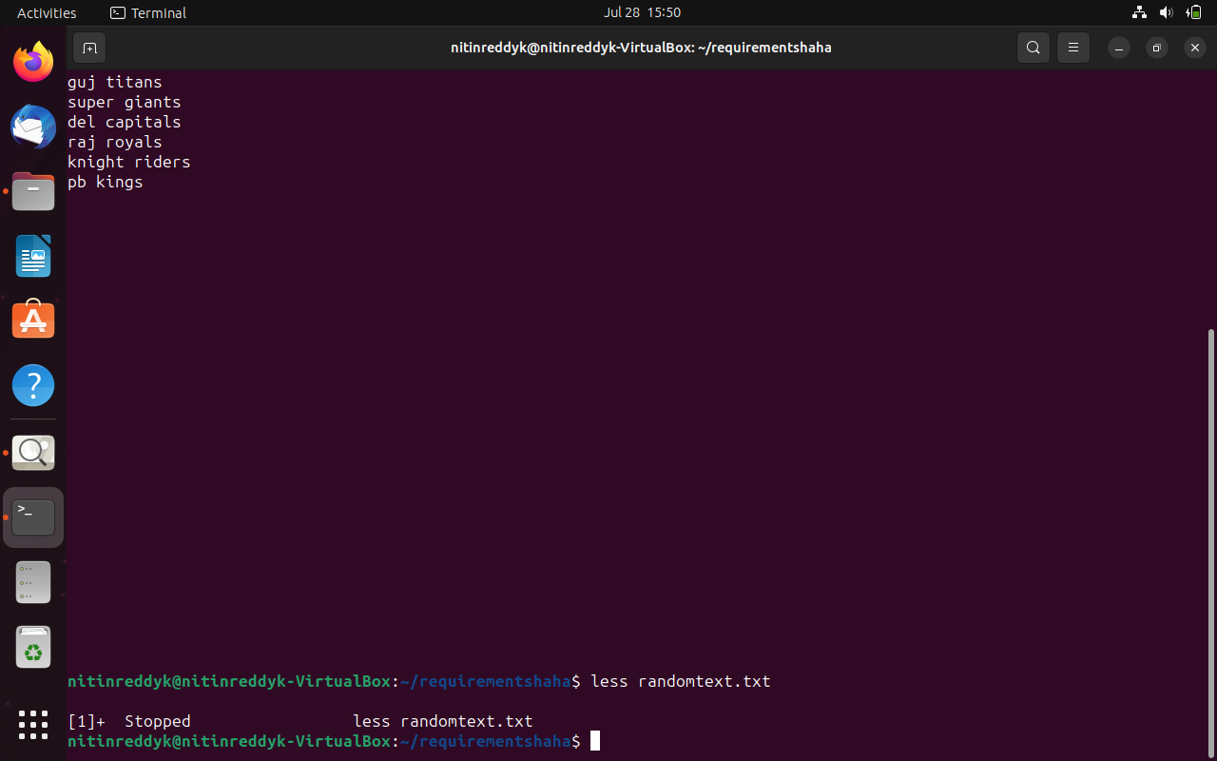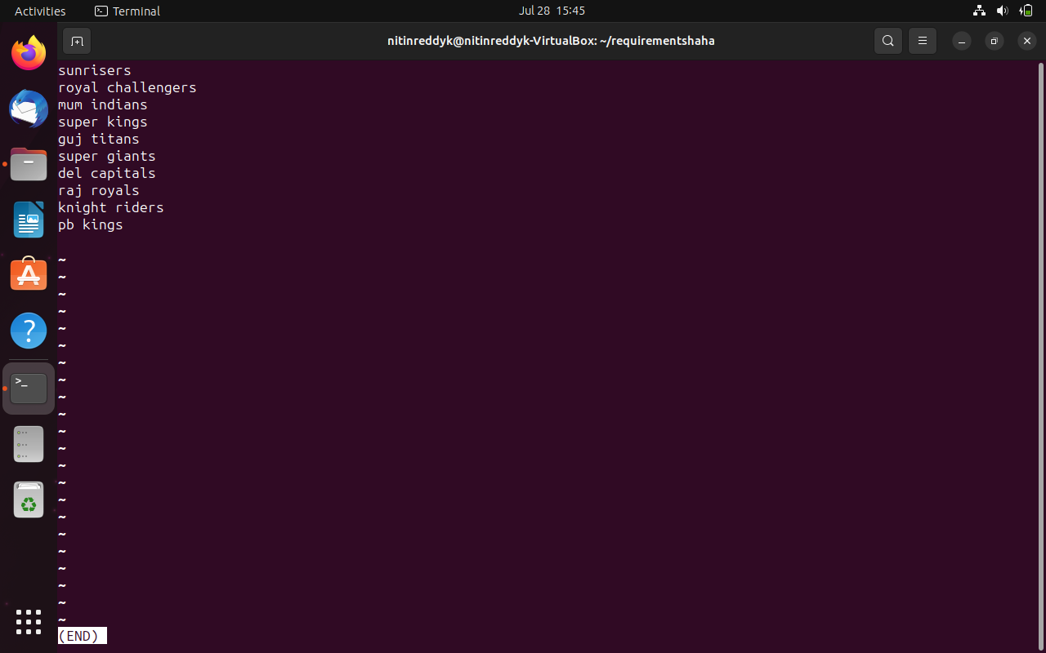

1. **Manipulating files –**

**cp**: This command is used to copy files.

**Single**: cp ./DirectoryA_1/README.txt ./DirectoryA_2

**Multiple**: cp ./DirectoryA_1/README.txt./DirectoryA_1/ANOTHER_FILE.txt ./DirectoryA_2

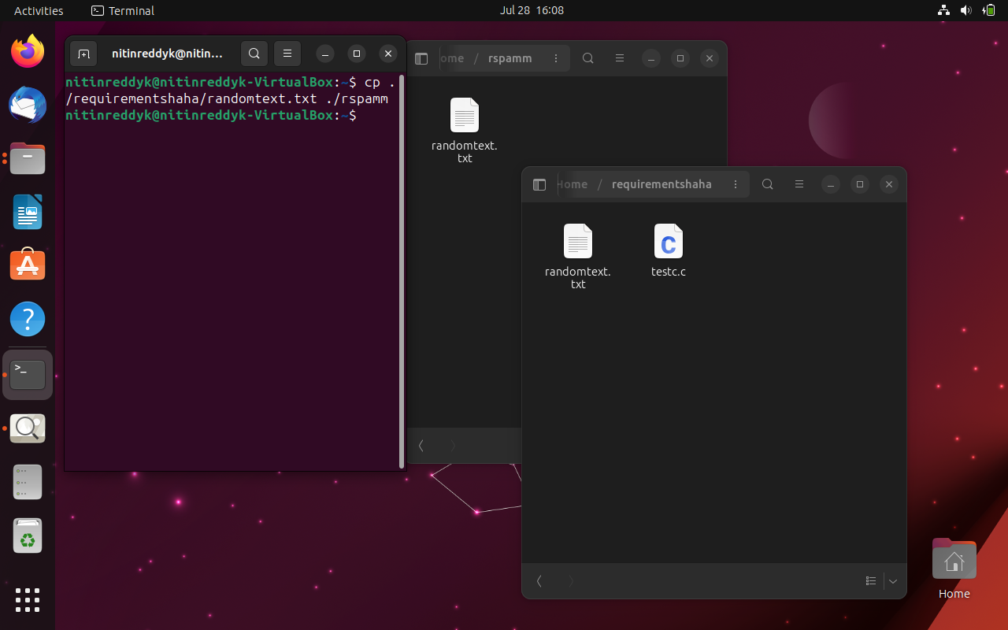

**cp –R**: This command is used to copy directories recursively (copy all the files and folders inside the directory).

cp -r ./DirectoryA_1/Folder/ ./DirectoryA_2

This command will recursively copy the **Folder** directory in **./DirectoryA_1/** as well as all files and directories in the **Folder** directory.

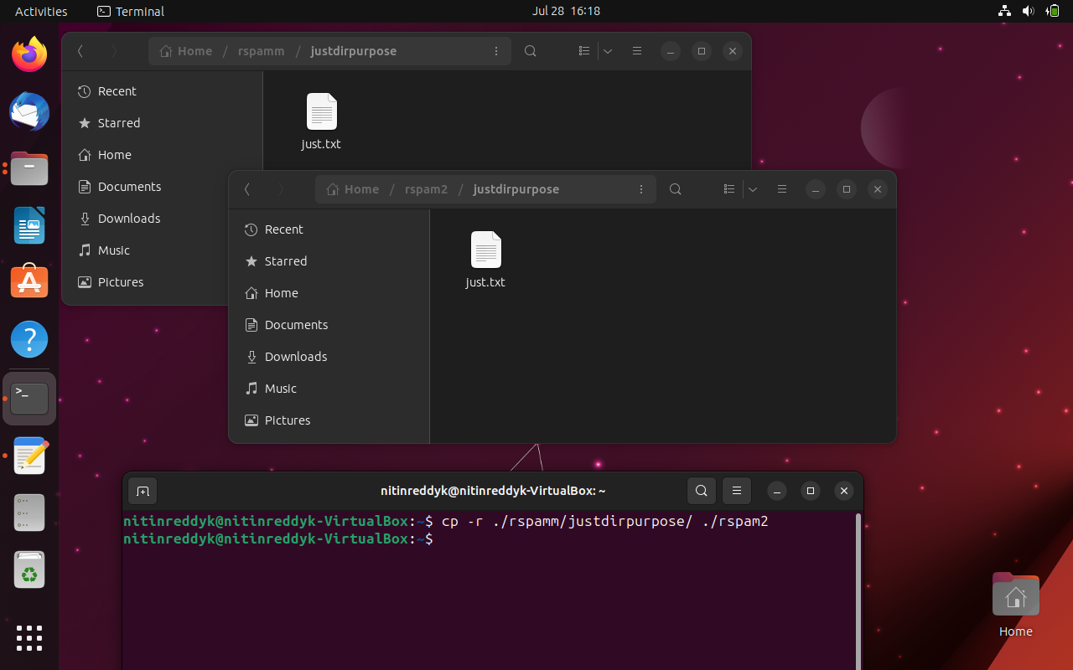

**mkdir**: This command is used to create a new directory This will create a new directory - directory3

**mv**: This command is used to move the file or directory

**rm**: This command is used to remove or delete files and directories.

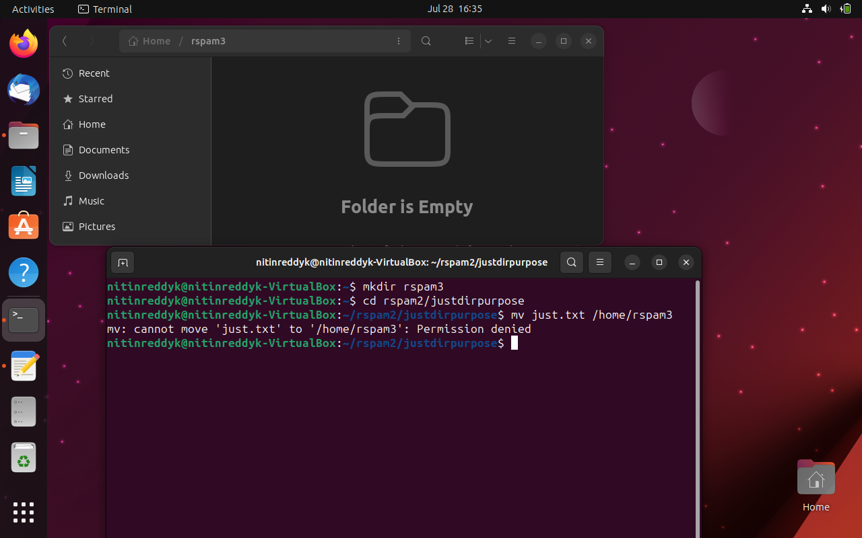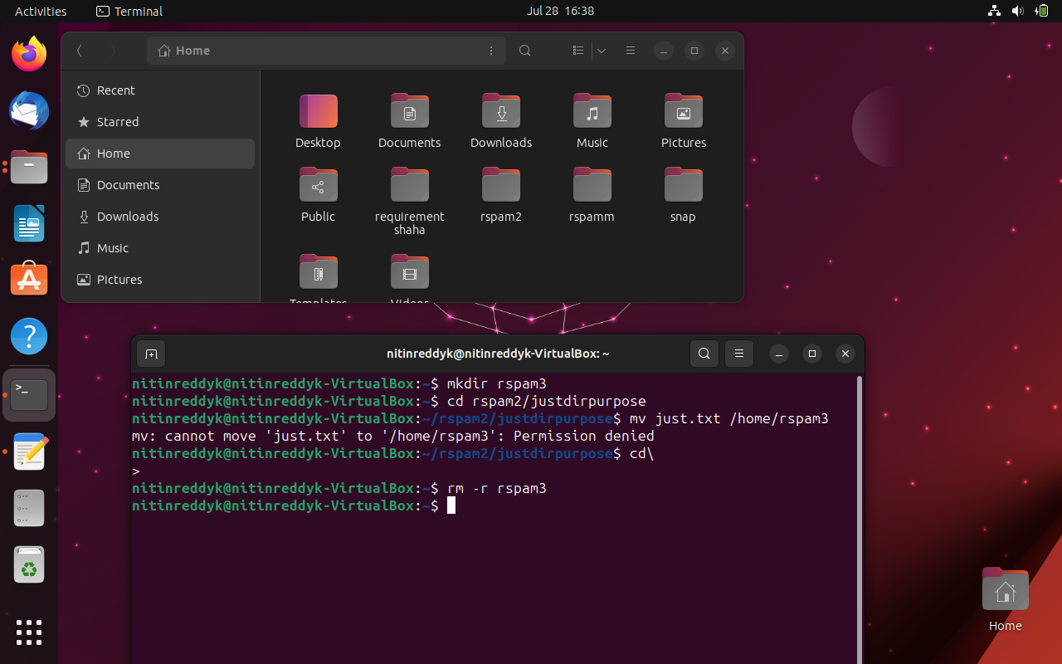

1. **Some other commands:**

(they all have SOO many functionalities. A couple of them will be run for each.)

**tar:** related to archiving files

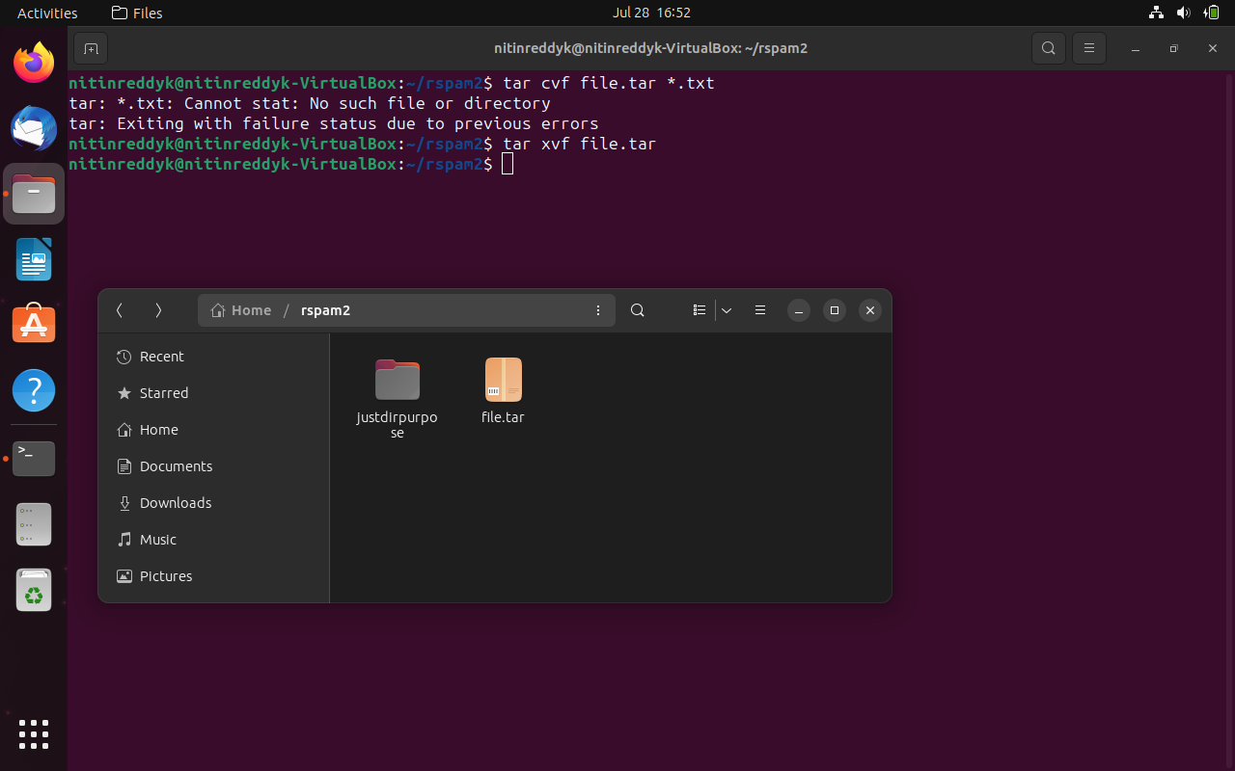

**grep:** related to searching in file

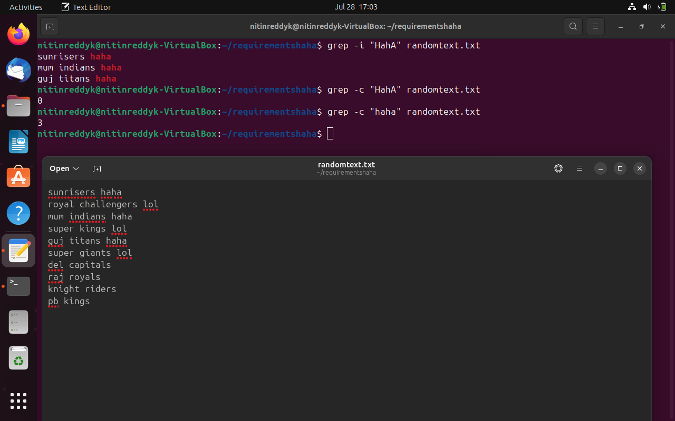

**find:** related to locating and showing directories

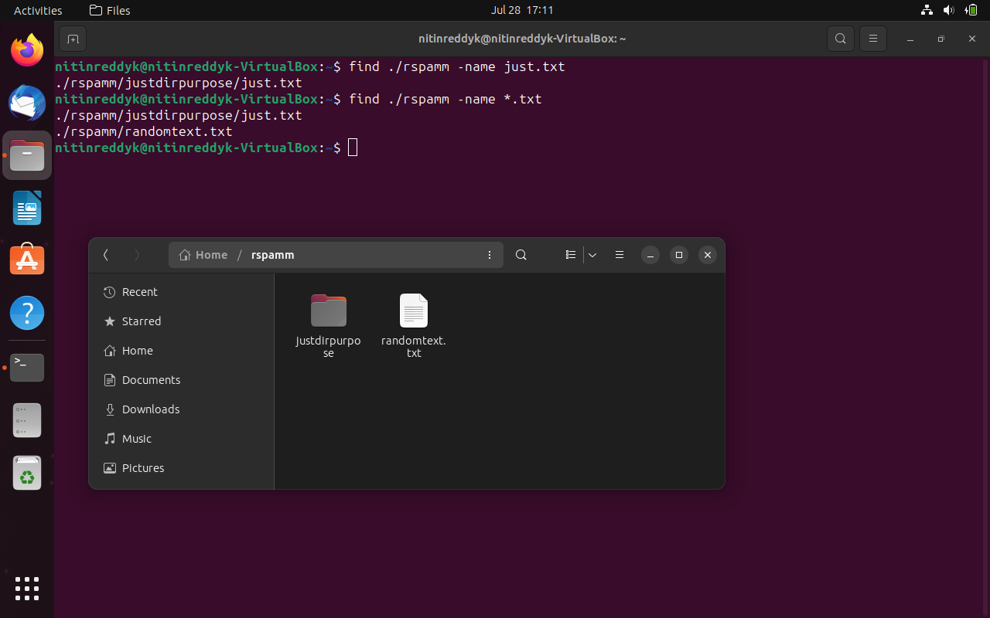

**ssh:** About permissions and network

**diff:** difference in files in different ways

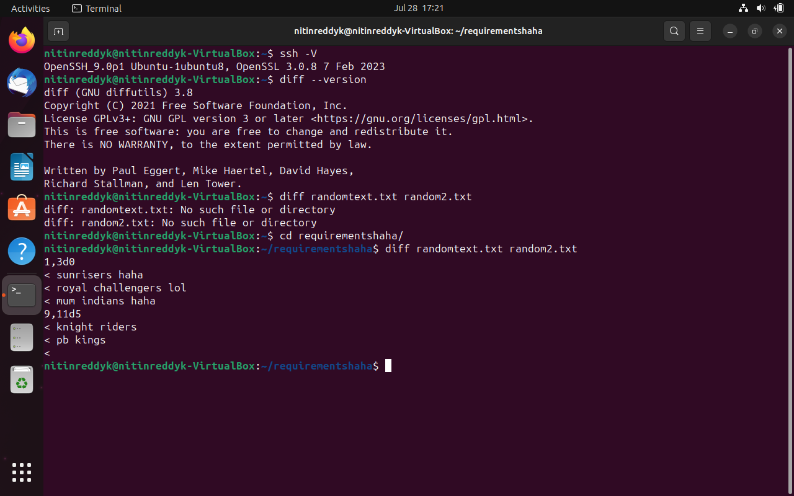

**sort:** sorting contents of the file in whichever way we need

**pwd:** shows the directory which we are currently working in

**gzip:** compresses the file

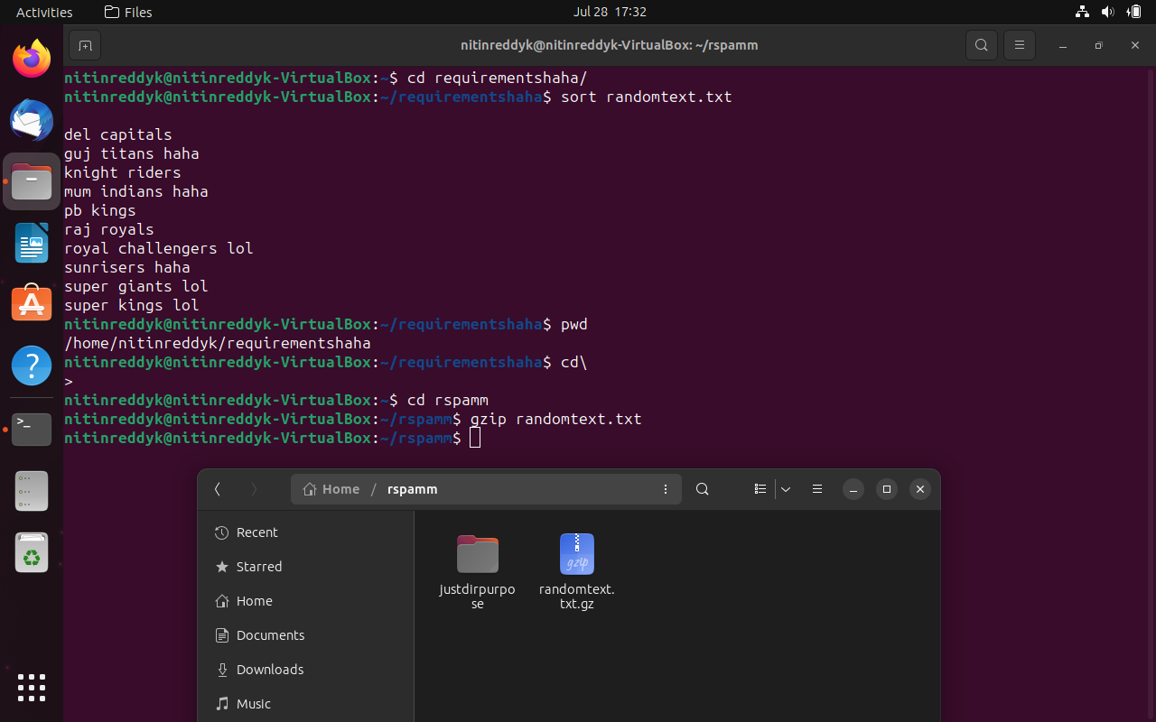

**ps :** writes the status of active processes and if the -m flag is given, displays the associated kernel threads to standard output

**free:** outputs a summary of RAM usage, including total, used, free, shared, and available memory and swap space

**kill:** to send a signal to a process

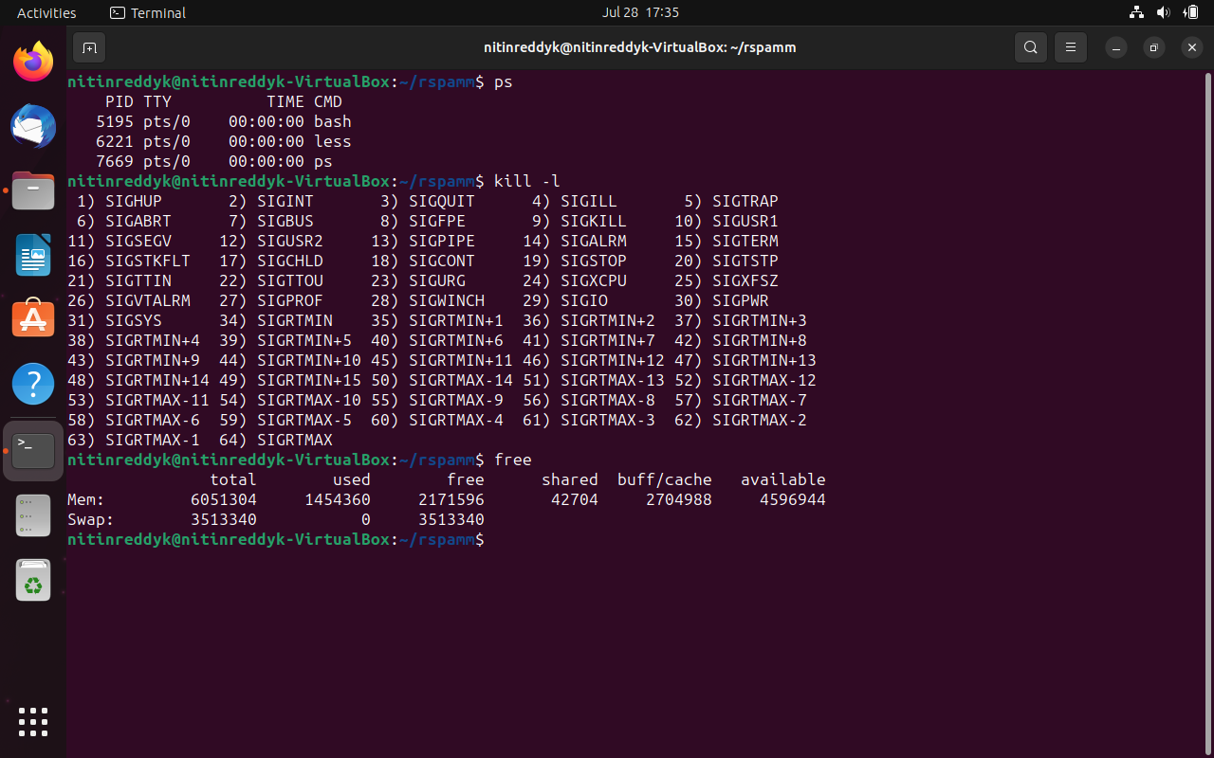

1. **chmod (Changing Permissions):**

**chmod o+r-wx mydata.c** ( add read permission, remove write & execute for others on file mydata.c)

**chmod go+wx file1.txt** (Add write, execute for group and other) chmod o-x file1.txt (remove execute permission for other)

**chmod u=rwx,g=rw,o=x file1.txt** (specific permissions for specified type of users)

**chmod 761 file1.txt** (rwx(4+2+1=7) for user , rw(4+2=6) for group and execute(1) for other)

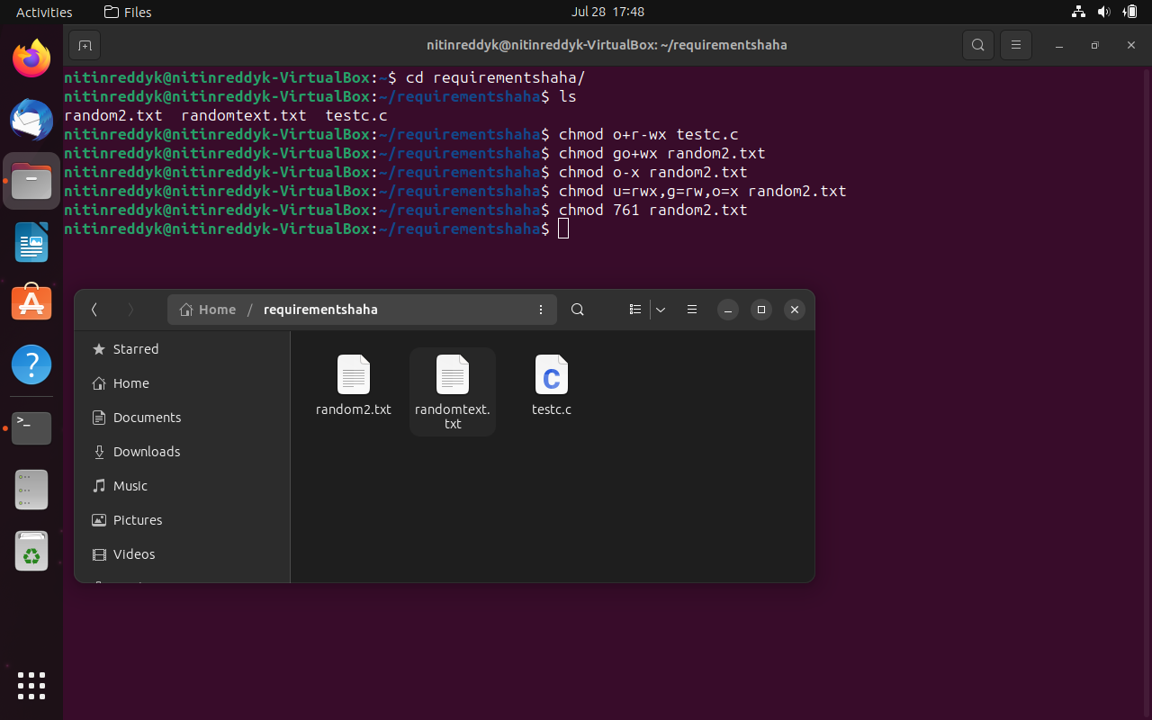

**(6) (b)**

**ps**: To check if a specific process related to this file is running, you can use the **ps** command with **grep**.

**top**: To monitor the system processes interactively and check if the file is causing any high resource usage, use the **top** command.

**glances**: Similar to **top**, **glances** is another system monitoring command that provides a comprehensive overview of system resources. Install it if you don't have it already:

**kill**: If you find a process related to the **random2.txt** file and need to terminate it, you can use the **kill** command. First, find the PID (Process ID) of the process and then use it in the **kill** command.

**(a)** 