**A**

**MINI PROJECT REPORT**

**ON**

**“Dictionary Website”**

**Submitted By**

Mr. Your Name Font Size 14[Roll No. XX]

Mr. Your Name Font Size 14 [Roll No. XX]

Mr. Your Name Font Size 14[Roll No. XX]

Mr. Your Name Font Size 14 [Roll No. XX]

In the partial fulfillment of the requirement of

Bachelor of Technology in Computer Science and Engineering

of

Dr. Babasaheb Ambedkar Technological University, Lonere

**Under The Guidance of**

## Prof.



Shri Pandurang Pratishthan Pandharpur’s

**Karmayogi Institute of Technology, Shelve, Pandharpur**

**Accredited by NAAC ‘B++’ Grade**

**2022-23**

Shri Pandurang Pratishthan Pandharpur’s

**Karmayogi Institute of Technology, Shelve, Pandharpur**

**Accredited by NAAC ‘B++’ Grade**



**Certificate**

This is to certify that,

**Mr. Your Name Font Size 14+Bold [Roll No. XX]**

**Mr. Your Name Font Size 14+Bold [Roll No. XX]**

**Mr. Your Name Font Size 14+Bold [Roll No. XX]**

**Mr. Your Name Font Size 14+Bold [Roll No. XX]**

of T**.**Y**. [**Computer Science and Engineering]have satisfactorily and successfully completed their mini project entitled as, **“Project Name”** and have submitted this mini project report in partial fulfillment of the requirements for the degree of “Bachelor of Technology [Computer Science and Engineering]” of the Dr. Babasaheb Ambedkar Technological University, Lonere during academic year 2022-23.

Date:

**Prof.**

**Project Guide External**

**Prof. D. V. Bhosale Dr. S. P. Patil**

**HoD[CSE] Principal**

**Content:**

1. **Introduction**
2. **What is API ?**
3. **Why we need Dictionary website**
4. **How Did We Build Dictionary website**
5. **Benefits of Dictionary website**
6. **Conclusion.**

**Preface :**

I have made this report file on the topic **“Dictionary Website”**, I have tried my best to explain all the relevant detail to the topic to be included in the report. While in the beginning I have tried to give a general view about this topic

.

My Team efforts and whole hearted co-corporation of each and everyone has ended on a successful note. I express my sincere gratitude “**Prof.V.J. Madane”** who assisting me throughout the preparation of this topic. I thank him for providing me the reinforcement, confidence and most importantly

The track for the topic whenever I needed it.

1. **Introduction :**
2. **What is API ?**

****Application Programming Interface (API)**** is a software interface that allows two applications to interact with each other without any user intervention. API is a collection of software functions and procedures. In simple terms, API means a software code that can be accessed or executed. API is defined as a code that helps two different software’s to communicate and exchange data with each other.



It offers products or services to communicate with other products and services without having to know how they’re implemented.

An application programming interface, or API, enables companies to open up their applications’ data and functionality to external third-party developers and business partners, or to departments within their companies. This allows services and products to communicate with each other and leverage each other’s data and functionality throug a documented interface. Programmers don't need to know how an API is implemented; they simply use the interface to communicate with other products and services. API use has surged over the past decade, to the degree that many of the most popular web applications today would not be possible without APIs.

1. **Why we need Dictionary Website :**
2. **How Did We Build Dictionary Website :**

* **Here's some screen shots of our codes And the screen shot of the browser where we can run our app**
* **Used HTML :**

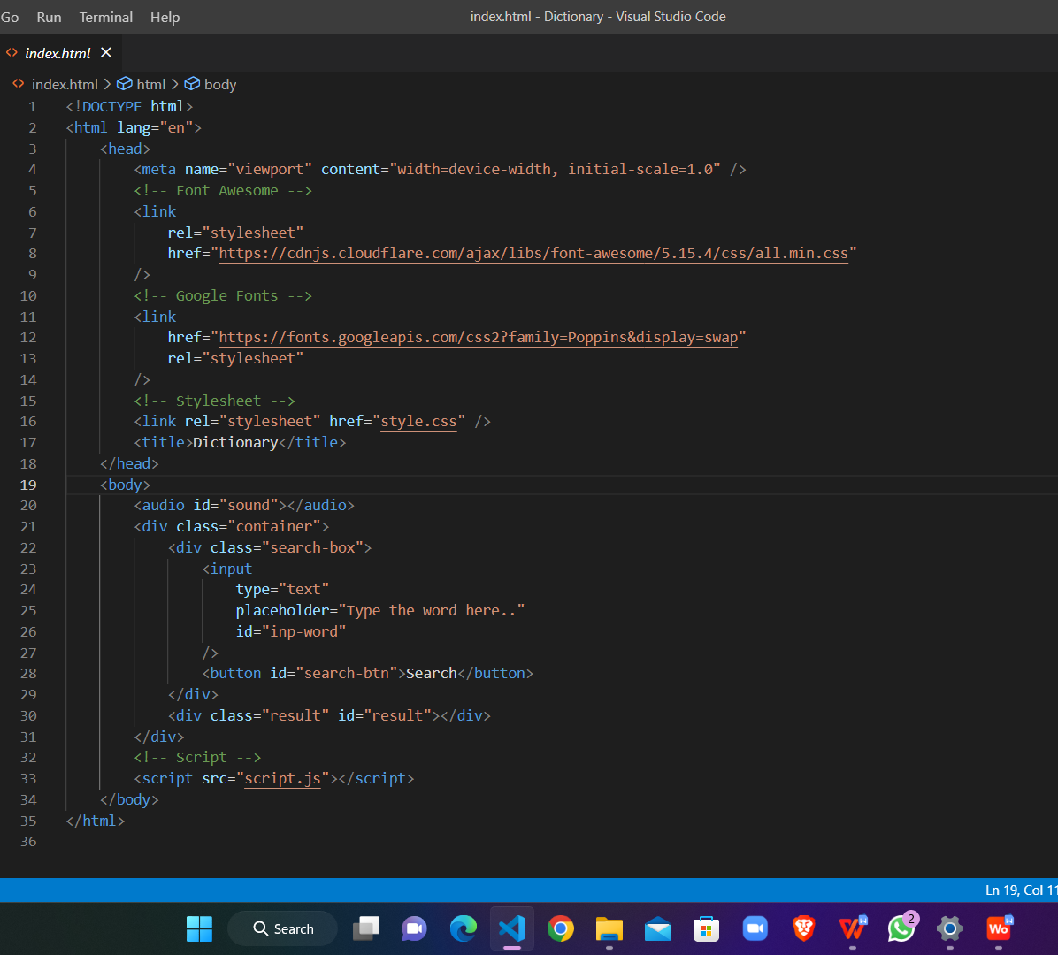

* **Used CSS :**

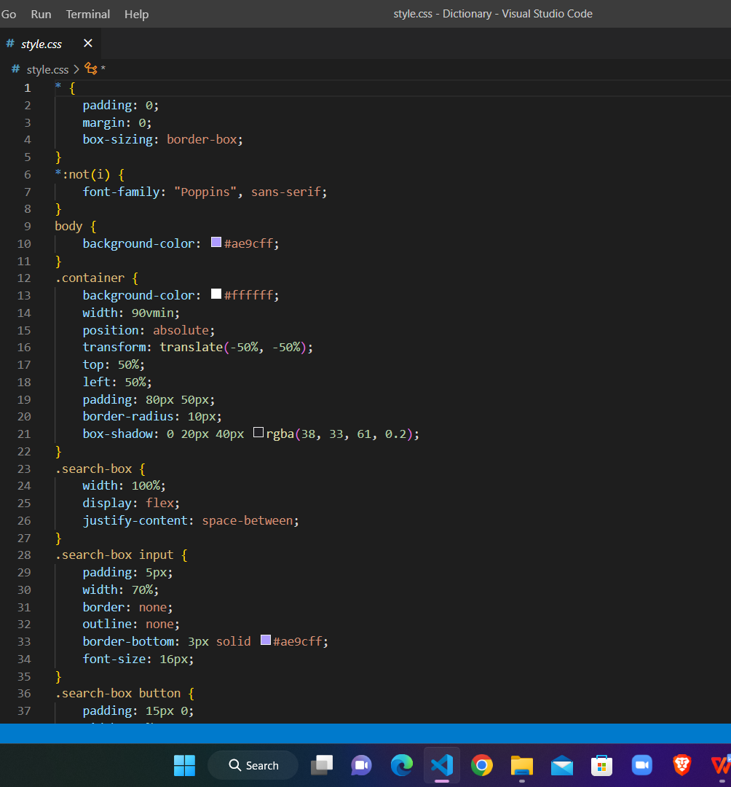

* **Used Javascript :**

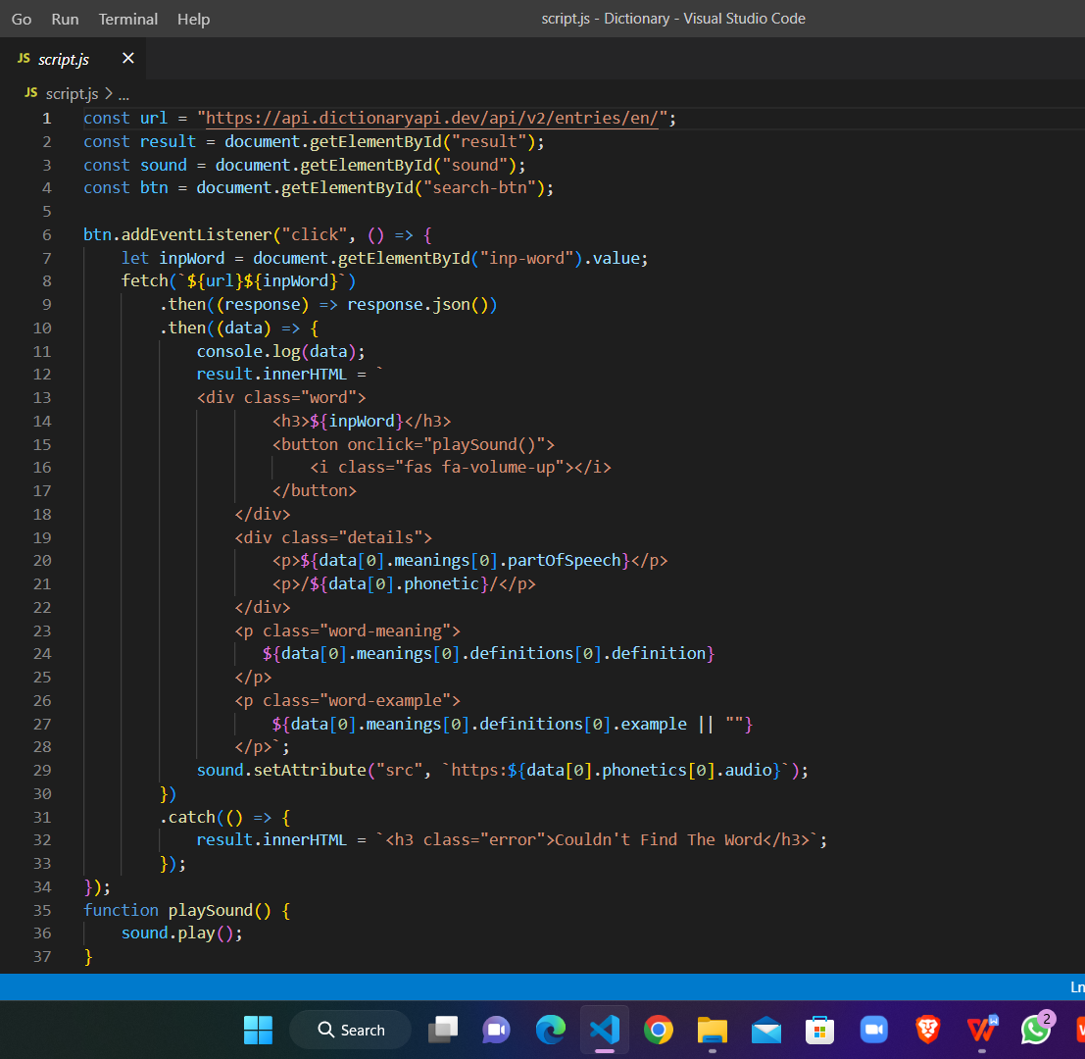

* **Output Of Code :**

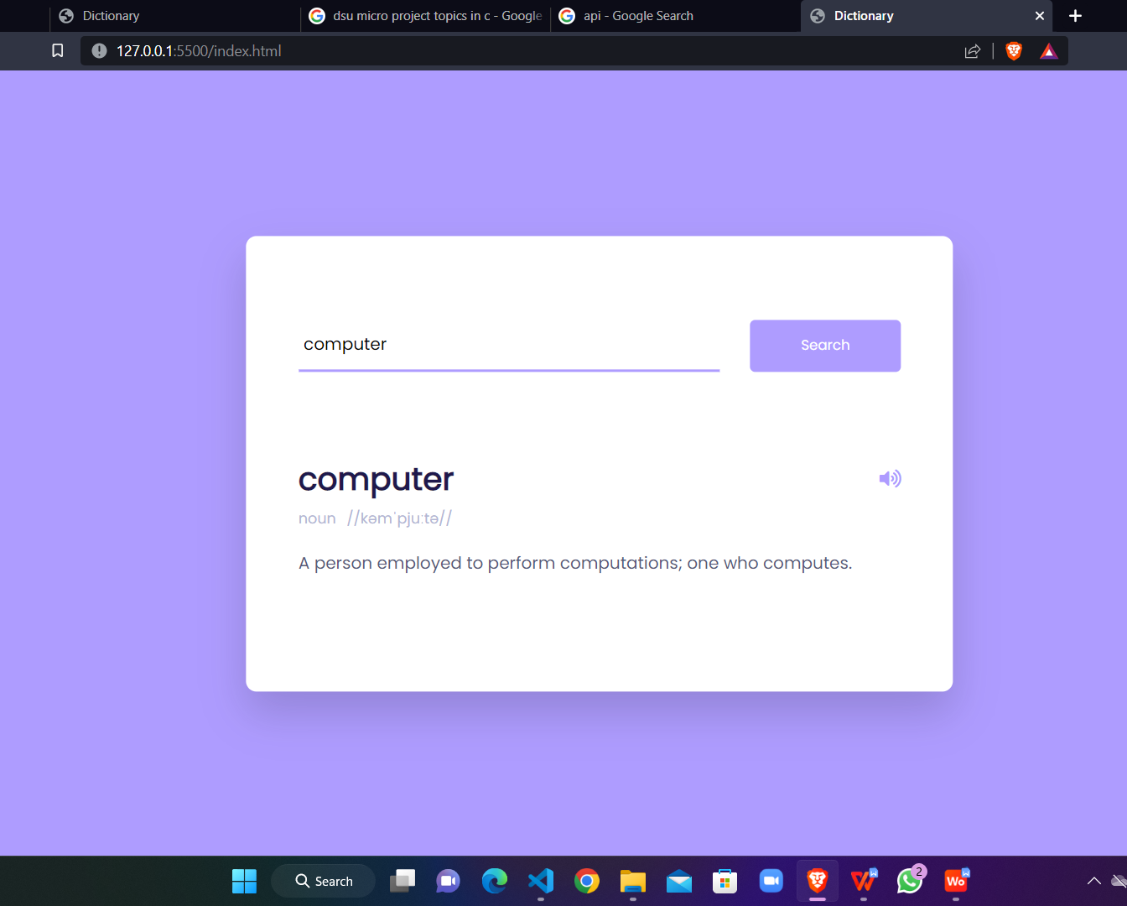

1. **Benefits of Dictionary Website :**
2. **Conclusion :**