**A**

**MINI PROJECT REPORT**

**ON**

**“Weather App”**

**Submitted By**

Mr. Sadekar Nitin Khandu [Roll No. 52]

Mr. Lode Narayan Ekanath [Roll No. 63]

Mr. Ganesh Govardhan Kamble [Roll No. 66]

In the partial fulfillment of the requirement of

Bachelor of Technology in Computer Science and Engineering

of

Dr. Babasaheb Ambedkar Technological University, Lonere

**Under The Guidance of**

## Prof. V.J.Madane



Shri Pandurang Pratishthan Pandharpur’s

**Karmayogi Institute of Technology, Shelve, Pandharpur**

**Accredited by NAAC ‘B++’ Grade**

**2022-23**

Shri Pandurang Pratishthan Pandharpur’s

**Karmayogi Institute of Technology, Shelve, Pandharpur**

**Accredited by NAAC ‘B++’ Grade**



**Certificate**

This is to certify that,

**Mr. Sadekar Nitin Khandu [Roll No. 52]**

**Mr. Lode Narayan Ekanath [Roll No. 63]**

**Mr. Ganesh Govardhan Kamble [Roll No. 66]**

of T**.**Y**. [**Computer Science and Engineering]have satisfactorily and successfully completed their mini project entitled as, **“Weather App”** and have submitted this mini project report in partial fulfillment of the requirements for the degree of “Bachelor of Technology [Computer Science and Engineering]” of the Dr. Babasaheb Ambedkar Technological University, Lonere during academic year 2022-23.

Date:24/12/2022

**Prof. V.J. Madane**

**Project Guide External**

**Prof. D. V. Bhosale Dr. S. P. Patil**

**HoD[CSE] Principal**

**Preface :**

I have made this report file on the topic **“Weather App”**, I have tried my best to explain all the relevant detail to the topic to be included in the report. While in the beginning I have tried to give a general view about this topic

.

My Team efforts and whole hearted co-corporation of each and everyone has ended on a successful note. I express my sincere gratitude “**Prof.V.J. Madane”** who assisting me throughout the preparation of this topic. I thank him for providing me the reinforcement, confidence and most importantly

The track for the topic whenever I needed it.

**Content:**

1. **Introduction**
2. **What is API ?**
3. **Why we need weather app**
4. **How Did We Build Weather App**
5. **Benefits of Weather app**
6. **Conclusion.**
7. **Introduction :**

* Weather apps are the most popular way to instantly access forecasts, warnings and other useful weather information on our mobile phones. They provide the public with unprecedented flexibility: users choose the information they want, how they get it and how it looks.
* Weather apps enable users to get instant alerts regarding weather conditions. Weather apps are the simplest method to know about the updates of the upcoming weather.
* Knowing what the day will bring is one good. way to making a perfect plan for each day. Sometimes this is usually a difficult one for all us because nobody really knows for certain what is likely to happen in the nearest minutes. Even in the area of the weather, this is paramount.
* In order to minimize the risk of distorted daily plans and arrangements, owing to changes in weather, there is need to take close looks daily weather condition - which means determining what the weather is likely to bring for the day. This goes to help us realize the need and importance of weather forecast and its instruments, including a weather app.

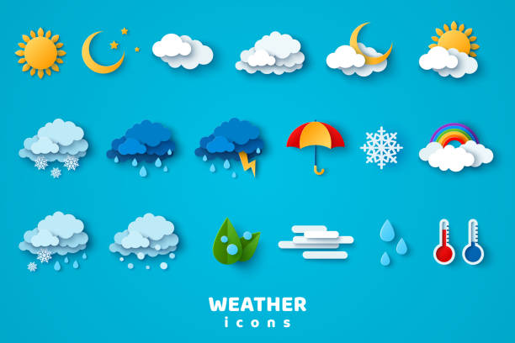

1. **What is API ?**

****Application Programming Interface (API)**** is a software interface that allows two applications to interact with each other without any user intervention. API is a collection of software functions and procedures. In simple terms, API means a software code that can be accessed or executed. API is defined as a code that helps two different software’s to communicate and exchange data with each other.

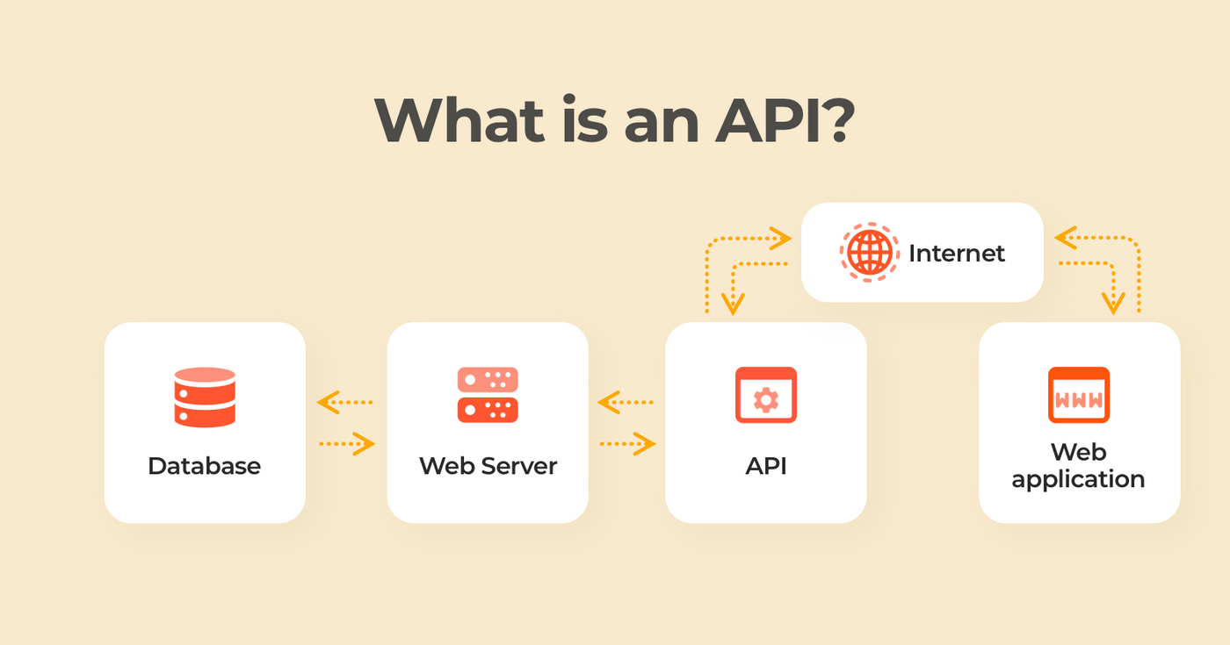

It offers products or services to communicate with other products and services without having to know how they’re implemented.

An application programming interface, or API, enables companies to open up their applications’ data and functionality to external third-party developers and business partners, or to departments within their companies. This allows services and products to communicate with each other and leverage each other’s data and functionality throug a documented interface. Programmers don't need to know how an API is implemented; they simply use the interface to communicate with other products and services. API use has surged over the past decade, to the degree that many of the most popular web applications today would not be possible without APIs.

## **Why would we need an API?**

Here, are some reason for using API:

* Application Programming Interface acronym API helps two different software’s to communicate and exchange data with each other.
* It helps you to embed content from any site or application more efficiently.
* APIs can access app components. The delivery of services and information is more flexible.
* Content generated can be published automatically.
* It allows the user or a company to customize the content and services which they use the most.
* Software needs to change over time, and APIs help to anticipate changes.

## **Features of API**

Here are some important features of API:

* It offers a valuable service (data, function, audience,.).
* It helps you to plan a business model.
* Simple, flexible, quickly adopted.
* Managed and measured.
* Offers great developer support.

1. **Why we need weather app :**

* To plan journeys ahead.
* To plan meeting/ commute timings.
* To decide what to wear.
* To know when rain comes or stops. To receive alerts / warnings during cyclones,sandstorms, typhoons etc.
* A person travelling in a bus / train/flight/ ,may need to check the weather in his destination city.
* Some travellers may need to know more details about the weather such as visibility, chances of rainfall, humidity etc.
* Farmers can known when to plant or harvest their crops

1. **How Did We Build Weather App :**

* **Here's some screen shots of our codes And the screen shot of the browser where we can run our app**
* **Used HTML :**

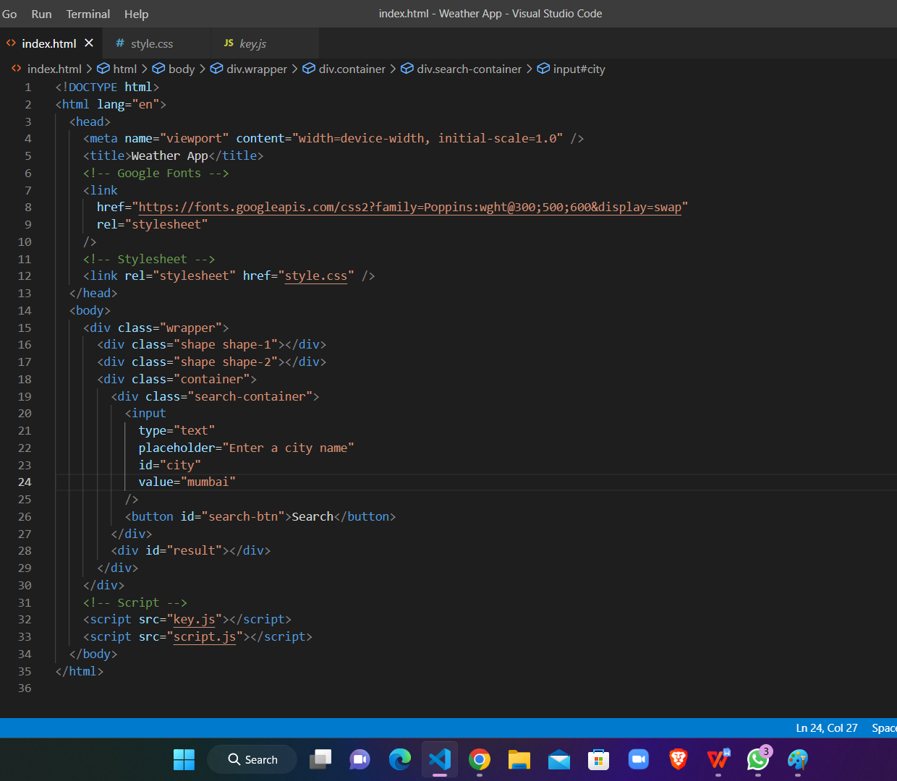

* **Used CSS :**

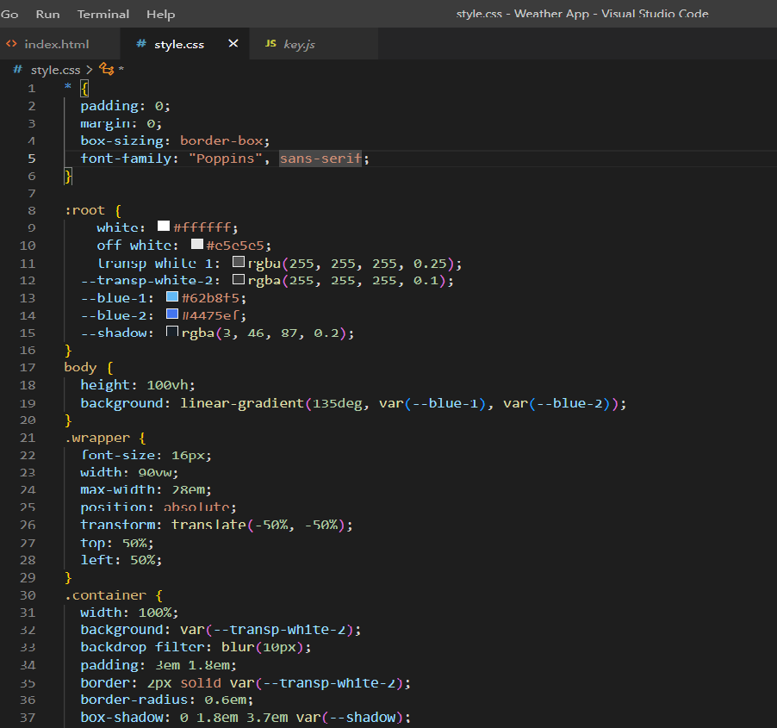

* **Used Javascript :**

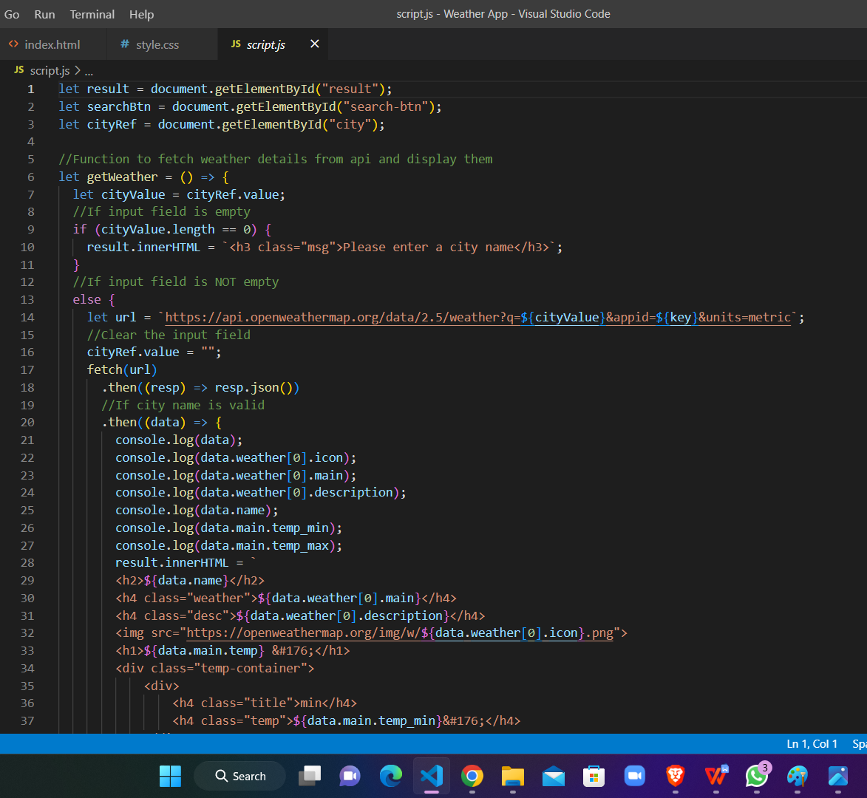

* **Output Of Code :**

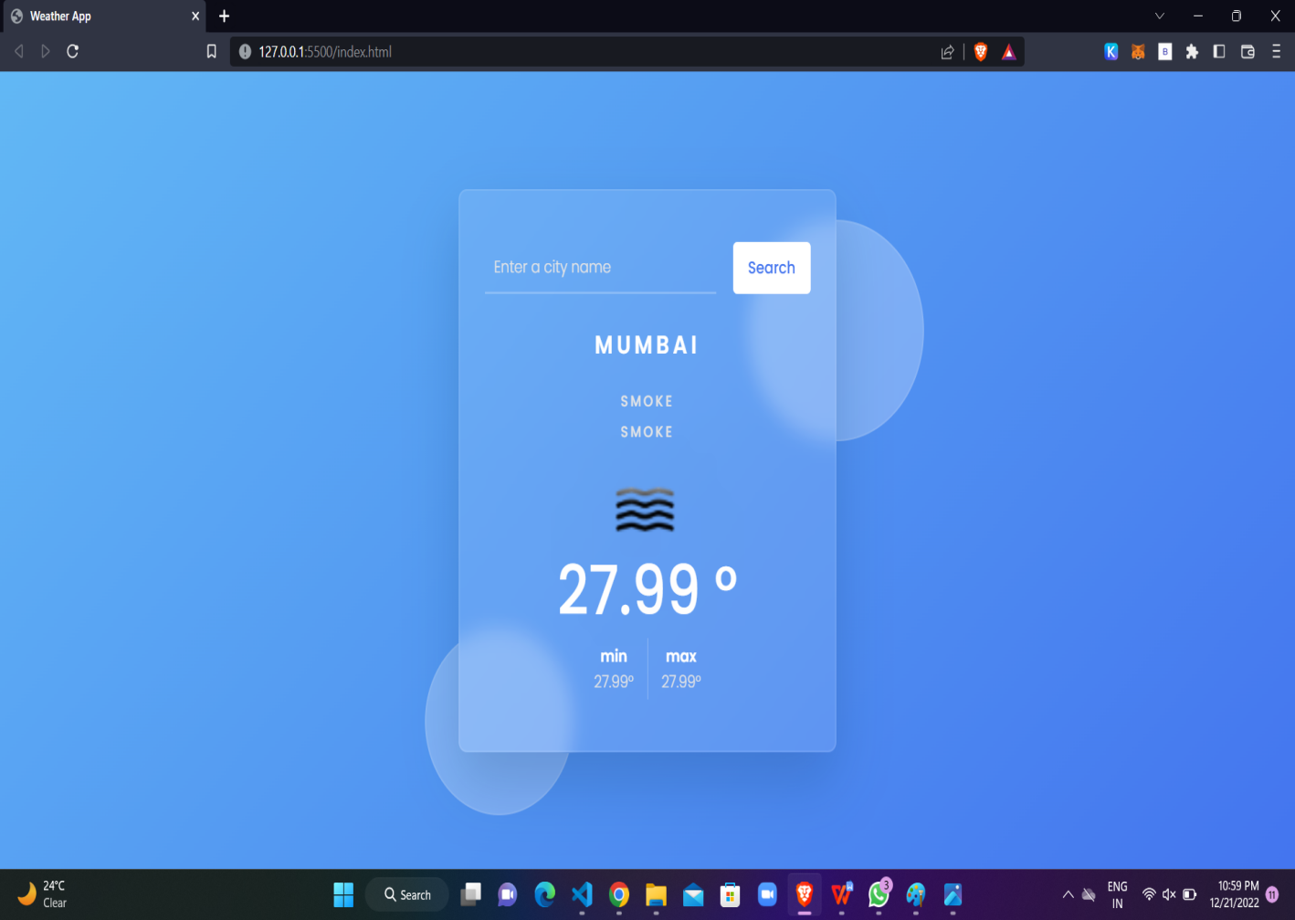

* **When we input a name of a city, we can easily see**

1. **Current Temperature**
2. **Min And Max Temperature**

**3) Air Condition**

1. **Benefits of Weather app :**

The weather app enables you make better preparation for the day in relation to giving accurate daily weather forecast. The app provides you with details of the weather elements - pressure, winds, precipitation. Browse interactive maps, satellite, radar, heat, show, all when you download and install the weather app in your smartphone.

Simply know what weather brings just from the comfort of you handy smart mobile device, PCs and tablets. The app also comes with animated sunrise, sunset, modules. Track details of you favorite cities and regions.. And even more.....all with the weather app!

1. **Conclusion :**

Here , I have come to the end of the project on the topic “Weather App”.

I would like to share my experience while doing this project.I learnt many new things about Weather app and it was wonderful learning experience for me while working on this project.

This project has developed my team members and my thinking skills and more interset in this subject.We learned HTMl,CSS,JAVASCRIPT.

I do hope that my project will be interesting and may be knowledgeable.

**Thank You!!**