DHCP

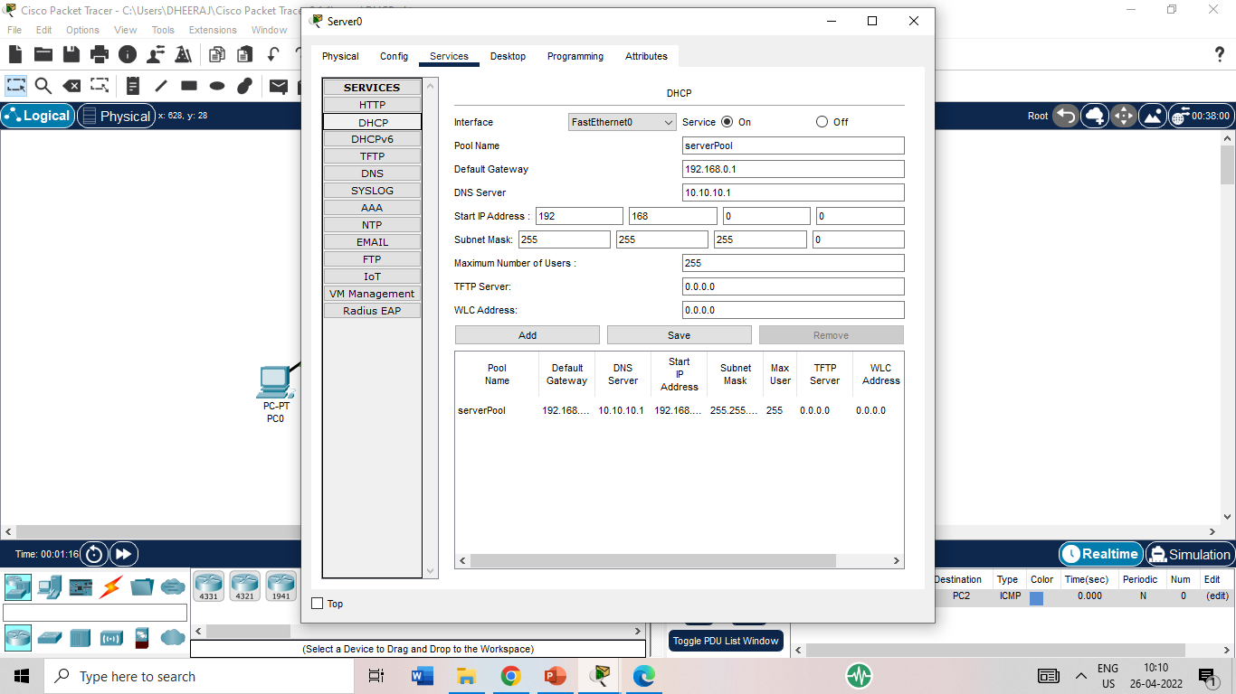

<https://www.youtube.com/watch?v=lmnptnqn-WI>