WOXSEN UNIVERSITY

A Project Report on
RepoPulse: Explainable Health and Risk Scoring for GitHub Repositories
Course: [Course name]
Submitted by
Team member | Roll no.
[Team member 1] | [Roll no.]
[Team member 2] | [Roll no.]
[Team member 3] | [Roll no.]
Faculty
[Faculty name]
Date: 2 November 2026

Index
Abstract 4
1. Introduction 5
1.1 Background 5
1.2 Problem statement 5
1.3 Objectives 5
1.4 Scope 5
2. Related work 6
2.1 OpenSSF Scorecard 6
2.2 Truck factor research 6
2.3 Vulnerability databases 6
2.4 The gap RepoPulse fills 6
3. Requirements and technology 7
3.1 Functional requirements 7
3.2 Non-functional requirements 7
3.3 Technology stack 7
4. System design 8
4.1 Architecture 8
4.2 Module responsibilities 8
4.3 Request flow 9
4.4 Data model 9
4.5 REST API 9
5. Scoring method 10
5.1 Ramp functions 10
5.2 Metric catalogue 10
5.3 Category scores and missing data 11
5.4 Weights and final score 11
5.5 Maturity adjustment 11
5.6 Risk rating and overrides 12
5.7 Concerns and strengths 12
5.8 Sensitivity analysis 12
6. Implementation 13
6.1 Data collection 13
6.2 Caching and concurrency 13
6.3 Dependency scanning 13
6.4 Reports and badge 14
6.5 CLI risk gate 14
6.6 Frontend 14
6.7 Containers and CI 14
7. Testing and results 15
7.1 Test strategy 15
7.2 Test results 15
7.3 Worked example: pallets/flask 16
7.4 Live results 16
7.5 Performance and API cost 17
7.6 Feature walkthrough 17
7.7 Sensitivity result 20
8. Limitations 21
8.1 Limits of the method 21
8.2 Issues confirmed during verification 21
9. Security considerations 23
10. Conclusion and future work 24
References 25
Appendix A. Running the project 26
Appendix B. Verification environment 26

Abstract
RepoPulse is a web application and command-line tool that turns public GitHub data into a health score from 0 to 100 and a Low, Medium or High risk rating for any public repository. It measures 25 metrics across five categories: Activity, Bus factor, Responsiveness, Documentation and Security. The score uses fixed, published formulas and no machine learning, so a reader can trace every result back to its raw measurement.
Users can change category weights and rescore from cached data without new API calls, compare two to four repositories with a 300-trial sensitivity analysis, and scan package.json or requirements.txt manifests for repository risk and known vulnerabilities from OSV.dev. Results are available as a web page, PDF, CSV, an embeddable SVG badge, and a CI gate that returns an exit code. The backend uses FastAPI and SQLite and the frontend uses React.
All 181 automated tests pass on the project's Linux CI, and backend line coverage is 94 percent. A live run on 1 November 2026 reproduced three of the four scores recorded in the project documentation exactly. The fourth differed by 0.2 points, which is expected because elapsed-time metrics change daily. A cached rescore took 2.5 ms against about 5 s for a first collection. Verification also found limitations, including double counting of vulnerabilities and a CI gate that passes when nothing was scored. Chapter 8 records them with evidence and fixes.
Keywords: repository health, software supply chain, bus factor, explainable scoring, dependency risk, sensitivity analysis.

1. Introduction

1.1 Background
Modern software depends on open source packages that their users did not write and cannot review line by line. Choosing a dependency is therefore a risk decision, but a repository page gives little help with it. Stars and forks show popularity. They do not show whether anyone still answers issues, whether one person holds most of the knowledge, or whether the project has a process for security reports.
Two incidents show the cost. In March 2016 the removal of the small left-pad package from npm broke builds across the JavaScript ecosystem [1]. In 2024 malicious code was found in the upstream release tarballs of xz Utils from version 5.6.0 onward, recorded as CVE-2024-3094 [2]. Research points the same way. Zimmermann et al. found that a very small number of maintainer accounts could be used to inject malicious code into the majority of npm packages [3]. Avelino et al. studied 133 popular GitHub systems and reported that 46 percent had a truck factor of 1 and 28 percent had a truck factor of 2 [4].

1.2 Problem statement
A developer choosing a dependency has to gather evidence by hand from commits, issues, pull requests, contributor graphs and advisory databases. The work is slow, and the result is an impression that is hard to repeat or defend. Automated scores exist, but a single number with no explanation does not help a reader decide, and it cannot be challenged.
RepoPulse addresses this question: can public data be turned into a repeatable health rating where a person can check every step of the calculation?

1.3 Objectives
1. Collect repository measurements from public APIs and keep unavailable data separate from a zero result.
2. Produce a deterministic score from published formulas, with a plain-language list of concerns and strengths.
3. Let users change category priorities without spending API quota.
4. Compare repositories and test whether the ranking survives different weights.
5. Screen dependency manifests for repository health and known vulnerabilities.
6. Deliver results through a web interface, PDF, CSV, a badge and a CI gate.
7. Keep the whole test suite runnable offline, with no token and no live network.

1.4 Scope
RepoPulse reads public metadata only. Machine learning is out of scope by design, because a trained model would make results harder to explain. The project does not analyse source code, read private repositories, or resolve a full dependency tree from a lockfile. Hosted deployment is optional, and running locally with Docker or Python and Node is sufficient.

2. Related work

2.1 OpenSSF Scorecard
OpenSSF Scorecard is an automated tool that evaluates a set of security heuristics, called checks, and gives each one a score from 0 to 10 [5]. Examples include Code-Review, Dependency-Update-Tool, Security-Policy and Vulnerabilities. Scorecard focuses on security practice. RepoPulse covers a wider set of concerns, including maintainer concentration and responsiveness. It reads the public Scorecard API and shows that value beside its own score as an independent cross-check. The Scorecard value never enters the RepoPulse calculation.

2.2 Truck factor research
The truck factor (or bus factor) is the number of people who would have to leave before a project stalls. Avelino et al. estimate it from commit history, with steps that include detecting developer aliases and defining file authorship [4]. RepoPulse uses a simpler proxy. It finds the smallest number of contributors who account for at least half of the commits returned by the GitHub contributors endpoint. This proxy is cheap to compute from one API call, but it measures commit share, not file knowledge.

2.3 Vulnerability databases
OSV.dev is an open vulnerability database that accepts a query by ecosystem, package name and version, and returns matching advisories [6]. RepoPulse queries it for the latest version of a repository's detected package, and for the declared version of each dependency in a scan.

2.4 The gap RepoPulse fills
Table 1. How RepoPulse differs from the sources a developer would otherwise use
Source | What it tells you | What it leaves out
Stars and forks | Popularity | Maintenance, responsiveness and security
OpenSSF Scorecard | Security practices, scored check by check | Maintainer concentration, issue handling and user-chosen priorities
OSV.dev | Known vulnerabilities for a package version | Whether the project is maintained at all
RepoPulse | A combined, traceable score across five areas, with adjustable weights and ranking stability | Code quality, private data and full dependency resolution

3. Requirements and technology

3.1 Functional requirements
Table 2. Functional requirements
ID | Requirement
FR1 | Analyse a repository from owner/repo or a GitHub URL and return a score, risk rating, every metric, and findings.
FR2 | Adjust five category weights and rescore without extra GitHub requests.
FR3 | Compare 2 to 4 repositories with a radar chart and a 300-trial ranking sensitivity analysis.
FR4 | Scan a package.json or requirements.txt, up to 50 packages by default, with live progress.
FR5 | Record score history on each fresh collection and show a trend.
FR6 | Export a PDF report, a metric CSV, a scan CSV and an embeddable SVG badge.
FR7 | Provide a CLI gate with --max-risk and --min-score that returns an exit code.
FR8 | Show whether a token is configured and how much GitHub quota remains, without exposing the token.

3.2 Non-functional requirements
Table 3. Non-functional requirements
Quality | How the design meets it
Explainability | Every metric shows its raw value, its 0 to 1 score and a sentence of explanation.
Determinism | Scoring has no I/O and takes an injected clock. Sensitivity uses a fixed seed of 7.
Resilience | A failed sub-request produces null for that metric and does not fail the whole analysis.
Security | The GitHub token stays on the backend. Input is validated and output is escaped.
Testability | HTTP clients accept a mock transport and storage accepts an in-memory database.
Accessibility | Tabs support arrow-key navigation, charts have text labels, and tables repeat chart values.
Portability | Docker Compose runs the full stack with no local Python or Node.

3.3 Technology stack
Table 4. Technology choices and reasons
Layer | Choice and version | Why
API | FastAPI 0.115.6, uvicorn 0.34.0, pydantic 2.10.4 | Async routes suit network-heavy work. Validation and OpenAPI documentation come built in.
HTTP client | httpx 0.28.1 | Async support, and MockTransport makes offline tests simple.
Storage | SQLite (Python standard library) | No server to run. Enough for one instance.
PDF | ReportLab 4.2.5 | Generates PDF in memory with no browser dependency.
Frontend | React 18.3.1, Vite 5.4.11, Recharts 2.15.0 | Component model, fast builds, ready-made radar and line charts.
Testing | pytest 8.3.4, pytest-asyncio 0.25.0, Vitest 2.1.8, Testing Library 16.1.0 | Same style of test on both sides, including async code.
Packaging | Docker with python:3.12-slim, node:20-alpine, nginx:1.27-alpine | Pinned runtimes and a single start command.

4. System design

4.1 Architecture
RepoPulse has three layers. Clients call a REST API. The API delegates to a Service object that owns caching, locking and background jobs. The service calls collectors, the scoring engine and report generators, and stores results in SQLite.
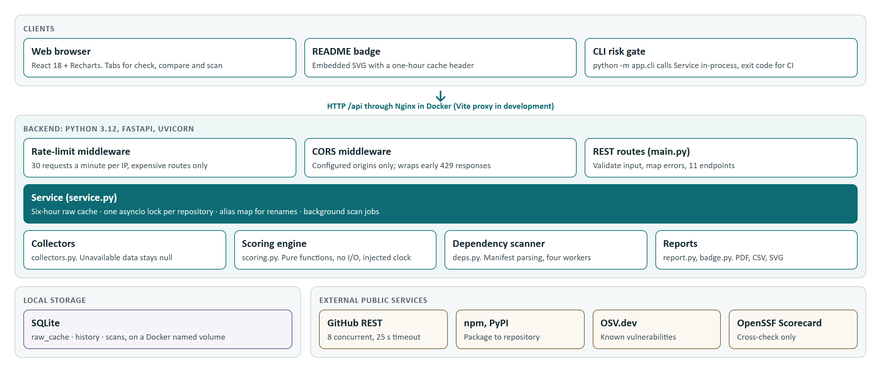
Figure 1. System architecture
The scoring engine sits in the middle with no I/O of its own. This is the central design decision. Because scoring.py is a set of pure functions, the team can test it with fixed inputs and a fixed clock, and it can run again on stored data at any time.

4.2 Module responsibilities
Table 5. Backend modules, in `backend/app`
File | Lines | Responsibility
scoring.py | 205 | Ramps, metrics, category scores, maturity, risk, findings, sensitivity. No I/O.
collectors.py | 261 | Gathers GitHub data and validates each response shape. Failures become null.
main.py | 169 | App factory, routes, validation, error mapping and lifespan handling.
deps.py | 120 | Parses manifests and runs the four-worker dependency scan.
service.py | 91 | Cache lookup, per-repository locks, rename aliases and scan jobs.
github_client.py | 75 | GitHub REST calls, concurrency limit and error mapping.
external.py | 70 | npm, PyPI, OSV.dev and Scorecard clients that fail softly.
cli.py | 64 | Dependency risk gate for terminals and CI.
report.py | 58 | PDF and CSV generation in memory.
db.py | 56 | SQLite access guarded by a threading lock.
utils.py | 45 | Parsing of repository references and URLs.
ratelimit.py | 37 | Per-IP sliding-window limiter, written as ASGI middleware.
badge.py | 23 | SVG badge.
config.py | 16 | Environment-based settings.

4.3 Request flow
Figure 2 shows one analysis request. The cache stores raw measurements, not scores. Scoring runs on every request, so a change of weights never needs new data. Elapsed-time metrics also stay current between collections.
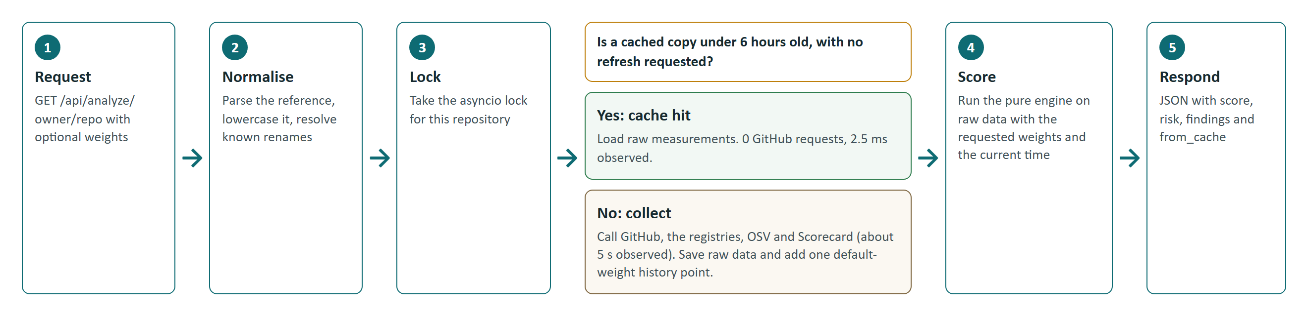
Figure 2. Handling of one analysis request

4.4 Data model
Table 6. SQLite tables
Table | Columns | Purpose
raw_cache | full_name (primary key), fetched_at, raw (JSON) | Latest raw measurements per repository, reused for 6 hours
history | id (primary key), full_name, ts, score, risk, categories (JSON), indexed on name and time | One default-weight score per fresh collection
scans | id (primary key), created, status, total, done, payload (JSON) | Persisted scan jobs, polled by the frontend

History always uses default weights, so moving a slider does not rewrite the baseline. Repository names are stored in lowercase because GitHub treats them as case-insensitive.

4.5 REST API
Table 7. API routes
Method | Route | Purpose
GET | /api/status | Health, token presence and rate-limit information
GET | /api/config | Categories, default weights and risk thresholds
GET | /api/analyze/{owner}/{repo} | Full score and findings; accepts weights and refresh=true
GET | /api/compare?repos=a/b,c/d | 2 to 4 repositories with sensitivity analysis
GET | /api/history/{owner}/{repo} | Score history ordered by time
GET | /api/badge/{owner}/{repo}.svg | SVG badge, public cache for one hour
GET | /api/report/{owner}/{repo}.pdf | PDF report; accepts weights
GET | /api/report/{owner}/{repo}.csv | One metric per CSV row; accepts weights
POST | /api/scan | Start a scan; returns job_id, total, truncated
GET | /api/scan/{id} | Job status and rows so far
GET | /api/scan/{id}/csv | Scan results as CSV

Invalid input returns 422, unknown scan jobs return 404, and GitHub errors keep their mapped status with a readable message. Interactive documentation is at /api/docs.

5. Scoring method
Figure 3 shows the six steps from raw measurement to risk rating. The sections below describe each step.
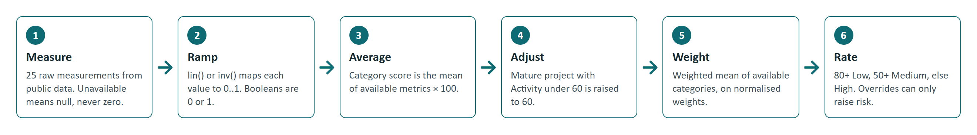
Figure 3. Scoring pipeline

5.1 Ramp functions
Raw measurements have different units, so each one is mapped to a value between 0 and 1. Two functions do this.
lin(x, lo, hi) = clamp((x - lo) / (hi - lo), 0, 1) # higher is better
inv(x, good, bad) = 1 - lin(x, good, bad) # lower is better

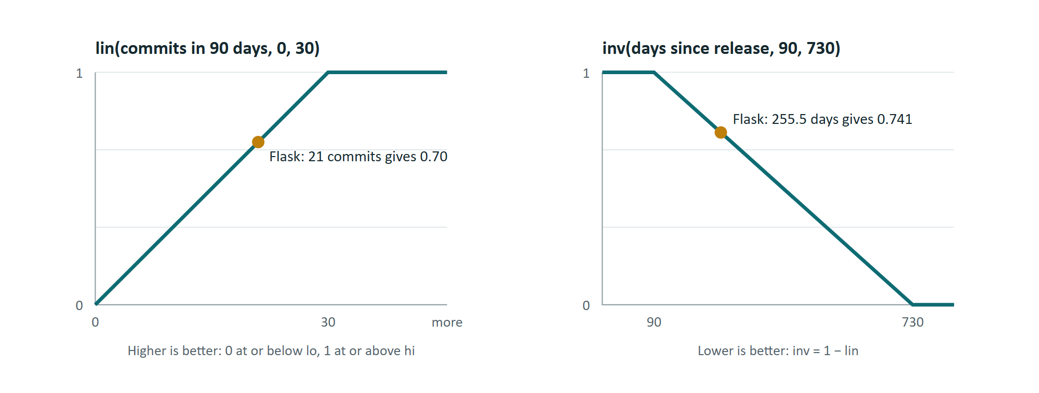
Figure 4. The two ramp functions, with real Flask values marked
A ramp is simple to explain and has no hidden behaviour. The thresholds are design choices taken from the project specification. They are not statistically fitted, and Chapter 8 discusses what that means for validity.

5.2 Metric catalogue
Table 8. The 25 metrics
Category (weight) | Metric | Rule | Null when
Activity (25%) | Commits in 90 days | lin(count, 0, 30) | Commit data unavailable
 | Days since last commit | inv(days, 30, 365) | No date; falls back to pushed_at
 | Releases in 365 days | lin(count, 0, 4) | No releases
 | Days since last release | inv(days, 90, 730) | No releases
 | Not archived | 1 or 0 | Field missing
Bus factor (20%) | Bus factor | lin(value, 1, 5) | No contributor data
 | Largest contributor share | inv(share, 0.5, 0.9) | No contributor data
 | Total contributors | lin(count, 1, 20) | No contributor data
 | Active authors in 90 days | lin(count, 1, 5) | No recent commits
Responsiveness (20%) | First response hours (median) | inv(hours, 24, 336) | No non-author, non-bot reply
 | Unanswered old issues ratio | inv(ratio, 0.1, 0.6) | Under 5 issues older than 14 days
 | Issue closing days (median) | inv(days, 7, 180) | No closed issues
 | Issue closing share | lin(share, 0.3, 0.9) | Under 5 sampled issues
 | PR merge days (median) | inv(days, 3, 60) | Under 3 merged PRs
Documentation (15%) | README size | lin(bytes, 300, 4000) | Response unavailable (a 404 scores 0)
 | License, contribution guide, code of conduct, templates, docs directory, examples | 1 or 0 each (6 metrics) | A required source is unavailable and nothing was found
Security (20%) | Security policy, CI, dependency updates | 1 or 0 each (3 metrics) | File listing unavailable
 | Known vulnerabilities | 0 gives 1; 1 gives 0.6; 2 gives 0.3; 3 or more gives 0 | No package detected

5.3 Category scores and missing data
A category score is the mean of its available metrics, multiplied by 100 and rounded to one decimal. A null metric is left out of the mean. If a whole category is null, its weight is shared across the remaining categories.
Treating null as zero would punish a project for GitHub's outage or for a metric that does not apply. The cost is that a category can rest on very little evidence. Django disables GitHub Issues, so four of its five Responsiveness metrics are null, and its Responsiveness score of 97.1 comes from pull request merge time alone.

5.4 Weights and final score
Default weights are Activity 25, Bus factor 20, Responsiveness 20, Documentation 15 and Security 20. User weights are clamped to zero or above and normalised to percentages. If all five are zero, the defaults apply. The final score is the weighted mean of available categories.
final = sum(weight[c] * score[c]) / sum(weight[c]) # over categories with a score

5.5 Maturity adjustment
A finished library may rightly change little. A low commit count should not punish it, so RepoPulse raises Activity to 60 for mature projects whose Activity falls below that value. The adjustment is recorded and shown to the user. A repository counts as mature only when all of these hold:
- It is not archived and is at least 1,095 days old.
- It has at least 200 stars and a commit within the last 365 days.
- It has no high or critical known package vulnerabilities.
- Its backlog is manageable: at most 30 open issues, or at least 60 percent of sampled issues closed.
Stars are not a metric. They affect only eligibility for this adjustment.

5.6 Risk rating and overrides
Table 9. Base risk from the score, and overrides that can only raise it
Rule | Result
Score 80 or more | Low
Score 50 to 79.9 | Medium
Score below 50, or no score at all | High
Repository archived | Forced to High
No commit for 730 days or more | Forced to High
Any high or critical known vulnerability | At least Medium
Bus factor 1 with top contributor at 90 percent or more | At least Medium

Overrides exist because an average can hide a deal-breaker. A well-documented archived project could otherwise score well, even though it will never receive a fix.

5.7 Concerns and strengths
Concerns are metrics below 0.4, ordered by weight multiplied by (1 minus the metric score). Archived status and known vulnerabilities get a tenfold priority. The list keeps at most two per category and six in total. Strengths are metrics at 0.85 or above, ordered by weight multiplied by the metric score, with at most one per category and three in total.

5.8 Sensitivity analysis
Weights are a judgement call, so a ranking should not be trusted if a small change of priorities reverses it. For a comparison, RepoPulse runs 300 trials. Each trial multiplies every default weight by a random factor between 0.5 and 1.5, then ranks the repositories. The random seed is fixed at 7, so the same inputs give the same output. A ranking is stable only if every repository has the same best and worst rank across all trials.

6. Implementation

6.1 Data collection
collect() first fetches the repository record, which also resolves redirects from renamed repositories. It then runs ten requests together with asyncio.gather, covering commits, contributors, releases, issues, pull requests, the community profile, the README, the root listing, the .github listing and Scorecard. Each request is wrapped so that a failure returns null. Only a rate-limit error passes through, because continuing would waste the remaining quota.
The collector separates cases that a simple design would merge. A missing README (HTTP 404) scores 0, while an unavailable README stays null. A 409 from an empty repository also becomes null. Every response then passes through a small validator, so a malformed record cannot crash the analysis.
Package detection reads the name from package.json or pyproject.toml, then tries the repository name. A registry entry counts only if its linked repository matches the one being analysed. This stops an unrelated package with the same name from affecting the score.

6.2 Caching and concurrency
- Raw cache. Measurements are reused for 6 hours by default, which protects the GitHub quota.
- One lock per repository. Two simultaneous requests for the same repository wait on one asyncio.Lock, so the second reads the cache and GitHub is called once.
- Global limit. A semaphore allows at most 8 GitHub requests at a time.
- Scan workers. Four workers share one index into the package list. No lock is needed because nothing awaits between reading and incrementing the index, and asyncio runs one coroutine at a time.
- SQLite. One connection is shared behind a threading.Lock.

6.3 Dependency scanning
POST /api/scan parses the manifest, creates a job and returns at once. A background task then looks up each package in npm or PyPI, finds its GitHub repository, analyses it through the same cached service, and queries OSV for the declared version. The job is saved after every package, so the frontend can poll once a second and show progress.
The scanner uses the base version of a range, so ^1.2.3 is checked as 1.2.3. If no version is declared, it uses the latest registry version. A high or critical vulnerability raises a Low row to Medium. If GitHub's rate limit is reached, remaining packages are marked skipped with the message, and packages already running may finish.

6.4 Reports and badge
report.py builds the PDF and CSV in memory, so no temporary files are created. The PDF escapes all text before ReportLab processes it. The SVG badge is colour-coded by risk and sends Cache-Control: public, max-age=3600. If GitHub fails, the badge shows unknown instead of an error image.

6.5 CLI risk gate
python -m app.cli reuses the same service directly, with no HTTP server. It prints a table and exits with 1 if any scored dependency exceeds --max-risk or falls below --min-score. The repository includes dependency-risk.yml.example, a workflow that other projects can copy to run this gate on every push.

6.6 Frontend
The interface uses plain React state and one CSS file, with no router or state library. Its three tabs stay mounted, so switching tabs keeps results and running scans.
- Slider changes wait 250 ms before sending a request, so dragging does not flood the API.
- Each request has an AbortController and a sequence number, so a slow old response cannot overwrite a newer result.
- Risk colours are reserved for risk. Chart series use a separate set of four colours.
- Null values appear as n/a and stay missing in charts.

6.7 Containers and CI
Docker Compose runs two services. The frontend image builds with Node and serves static files from Nginx, which also proxies /api/ to the backend with a 120-second read timeout. The backend is not published to the host. SQLite lives on a named volume that survives docker compose down. GitHub Actions runs backend tests, frontend tests and two frontend builds on every push and pull request, with read-only repository permissions.

7. Testing and results

7.1 Test strategy
Tests never touch the real network. Backend HTTP calls go through httpx.MockTransport, SQLite runs in memory, and an automatic fixture fails any test that tries a real connection. Scoring functions take an injected clock, so date-based results stay fixed. Frontend tests use a mocked fetch and jsdom.
Table 10. Automated tests by file
Test file | Tests | Focus
test_scoring.py | 46 | Ramps, each metric, missing data, maturity, overrides, sensitivity
test_api.py | 34 | Routes, validation, rate limiter, CORS, zero extra calls on rescoring
test_foundation.py | 27 | Reference parsing, GitHub client errors, database
test_deps_utils.py | 19 | Manifest parsing and version handling
test_collection.py | 12 | Collector behaviour with failed and malformed responses
test_reports.py | 10 | PDF text, CSV rows, badge content
test_cli.py | 8 | Exit codes and gates
test_service.py | 7 | Caching, locking, scans, rate-limit handling
Backend total | 163
App.test.jsx | 17 | Rendering, debounce timing, stale responses, scan polling
api.test.js | 1 | API helper
Frontend total | 18

7.2 Test results
Table 11. Test runs carried out for this report
Environment | Result
GitHub Actions on Ubuntu, Python 3.12, Node 20 (run 41331519538) | Backend 163 passed. Frontend 18 passed. All steps succeeded.
Windows 11, Python 3.12.14, unmodified repository | 1 failed, 88 passed, 149 errors. See item 1 in Table 17.
Windows 11, scratch copy with loopback allowed in the test guard | Backend 163 passed in 15.51 s.
Windows 11, Node 24.16, unmodified frontend | 18 passed. Production build succeeded.
Coverage on the same scratch copy | 94 percent of backend lines (982 of 1,040 statements).

Coverage is 100 percent for scoring.py, report.py, ratelimit.py and badge.py. The lowest figures are cli.py at 83 percent and main.py at 86 percent.

7.3 Worked example: pallets/flask
This section traces one real result from measurement to rating, using the live run of 1 November 2026. Flask had 21 commits in 90 days, so lin(21, 0, 30) = 0.70. Its last release was 255.54 days earlier, so inv(255.54, 90, 730) = 1 - (165.54 / 640) = 0.741.
Table 12. Activity for pallets/flask
Metric | Raw value | Calculation | Score
Commits in 90 days | 21 | lin(21, 0, 30) | 0.700
Days since last commit | 2.12 | inv(2.12, 30, 365) | 1.000
Releases in 365 days | 1 | lin(1, 0, 4) | 0.250
Days since last release | 255.54 | inv(255.54, 90, 730) | 0.741
Not archived | true | 1 | 1.000
Activity score |  | (3.691 / 5) × 100 | 73.8

Table 13. Final score for pallets/flask
Category | Score | Weight | Contribution
Activity | 73.8 | 25% | 18.450
Bus factor | 62.5 | 20% | 12.500
Responsiveness | 96.4 | 20% | 19.280
Documentation | 90.9 | 15% | 13.635
Security | 50.0 | 20% | 10.000
Final score |  |  | 73.865, rounded to 73.9

A score of 73.9 is between 50 and 79.9, so the base risk is Medium. Flask qualifies as mature, but its Activity is above 60, so no adjustment applies. No override applies either. The largest drag is Security at 50, because the check found no repository-level security policy or dependency-update configuration. The project notes that Flask has an inherited Pallets organisation policy, which this check cannot see, so the 50 understates Flask's real position.
Changing the Documentation weight to 50 returned 78.3 from the cache, with from_cache true and no GitHub request.

7.4 Live results
Table 14. Live results at default weights, 1 November 2026
Repository | Score | Value in README | Risk | Scorecard (0 to 10)
django/django | 91.2 | 91.2 | Low | 6.8
psf/requests | 83.0 | 83.2 | Low | 8.4
pallets/click | 82.2 | 82.2 | Low | 7.2
pallets/flask | 73.9 | 73.9 | Medium | 7.1
atom/atom (archived) | 41.2 | Not recorded | High | 2.5

Three of the four recorded scores matched exactly. The requests score moved by 0.2, which shows that results depend on the day they are measured. The archived atom/atom repository scored 0 for Activity and Security, fell below 50, and also triggered both High overrides.
RepoPulse and Scorecard do not always agree. Django ranks first of the four maintained projects on RepoPulse and last of the four on Scorecard. Scorecard measures a narrower set of security practices, so the difference has an explanation, but the cross-check needs interpretation and does not validate the score.

7.5 Performance and API cost
Table 15. Measured cost of an analysis
Operation | Time | GitHub requests
First collection, pallets/flask | 5.2 s | Not instrumented
First collection, pallets/click | 5.8 s | 23
First collection, atom/atom | 6.6 s | 24
Rescore with new weights from cache | 2.5 ms | 0

At about 23 requests per repository, the unauthenticated limit of 60 requests an hour [7] allows 2 or 3 fresh repositories. The authenticated limit of 5,000 allows about 217. This is why the project recommends a token and why the raw cache matters. The production JavaScript bundle is 579 kB, or 164 kB after gzip, and the build warns about its size because of Recharts.

7.6 Feature walkthrough
The screenshots below come from the running application, not from mock data.
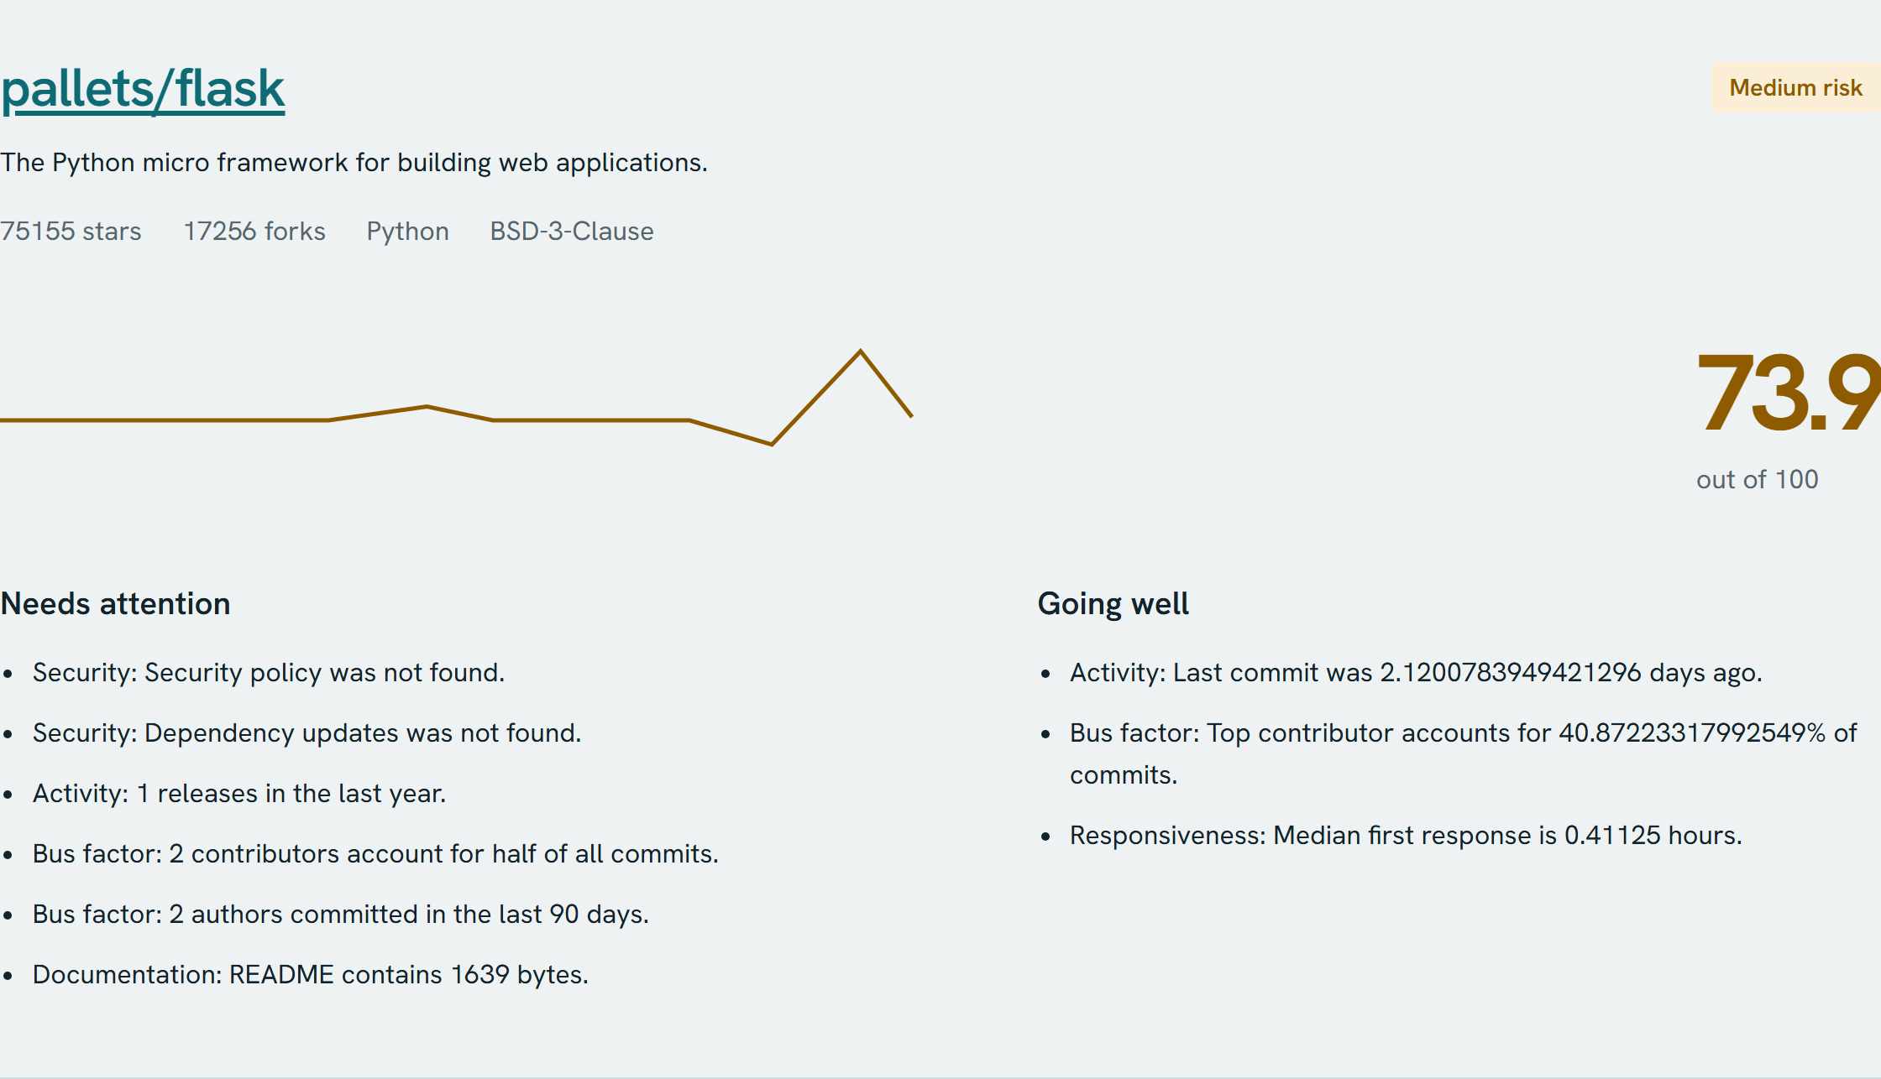
Figure 5. Analysis result for pallets/flask, with score, risk and findings
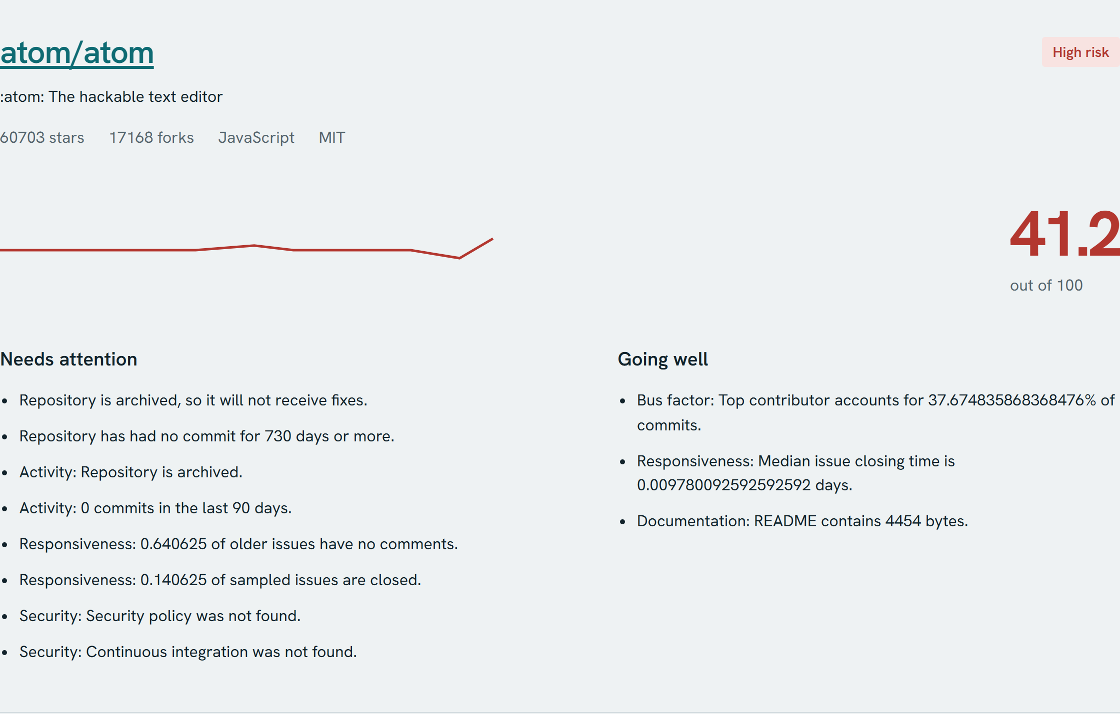
Figure 6. An archived repository triggers the High risk overrides
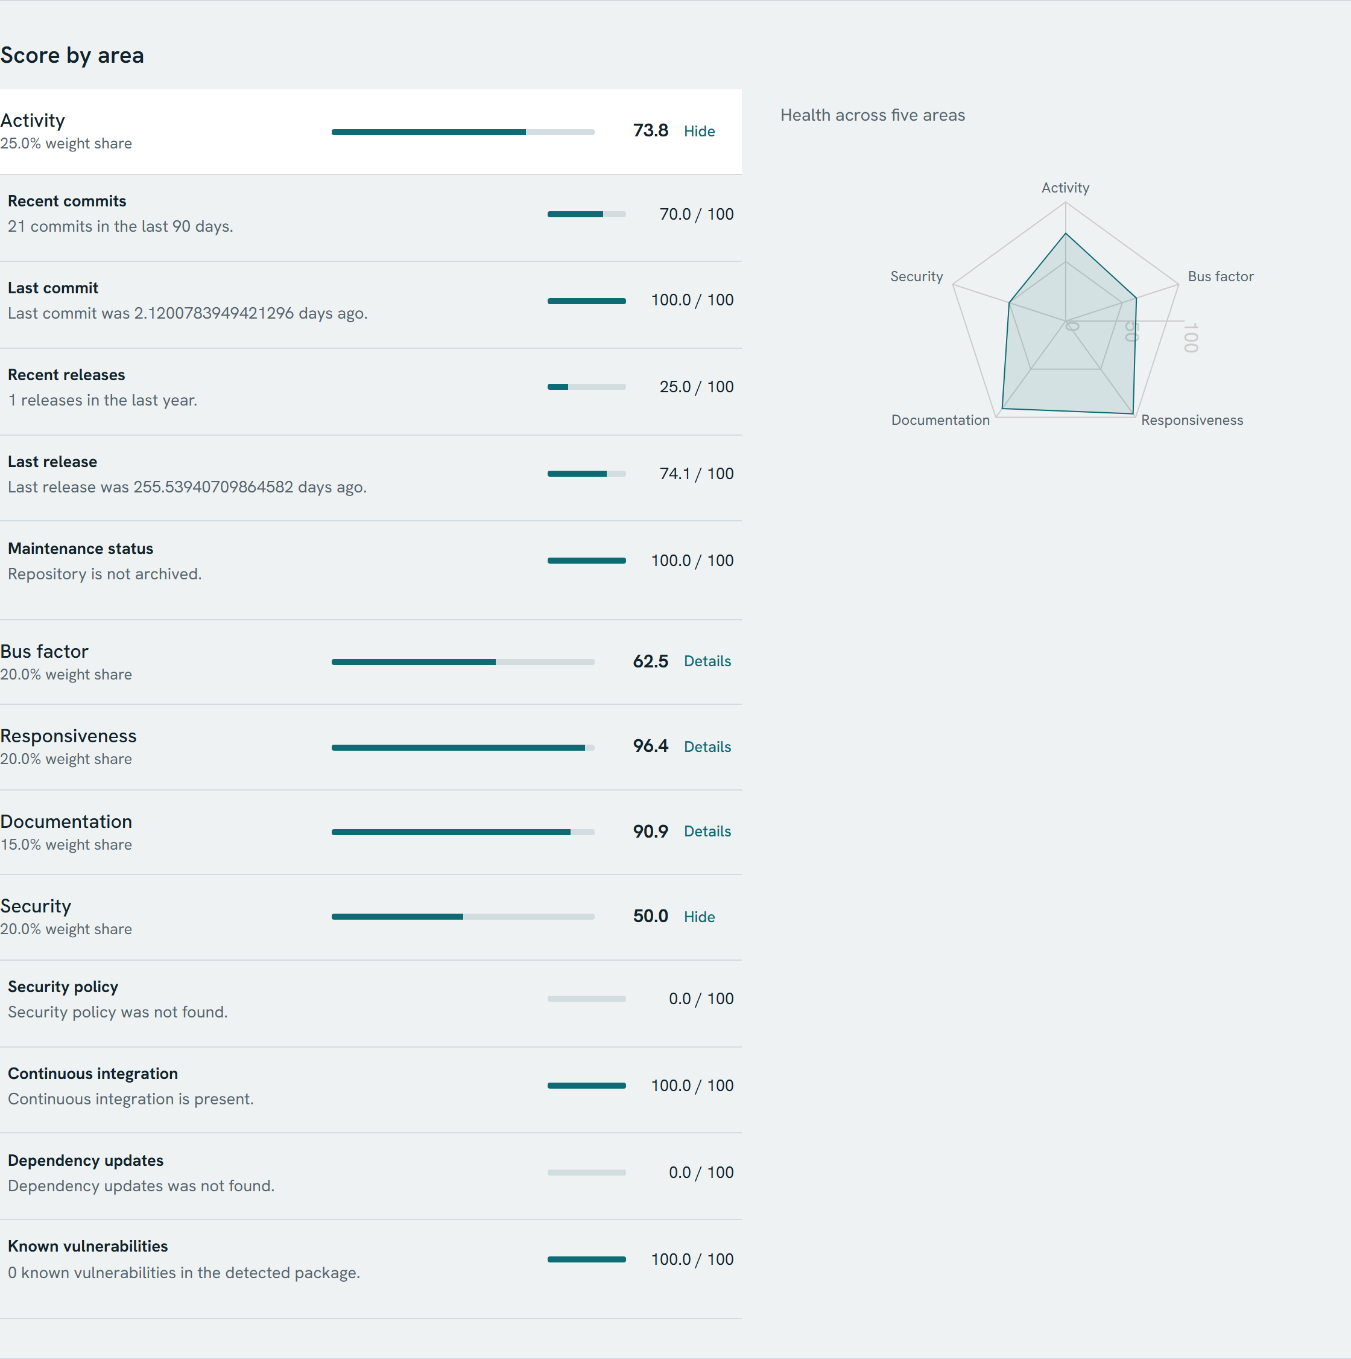
Figure 7. Score by area with Activity and Security expanded to show each metric
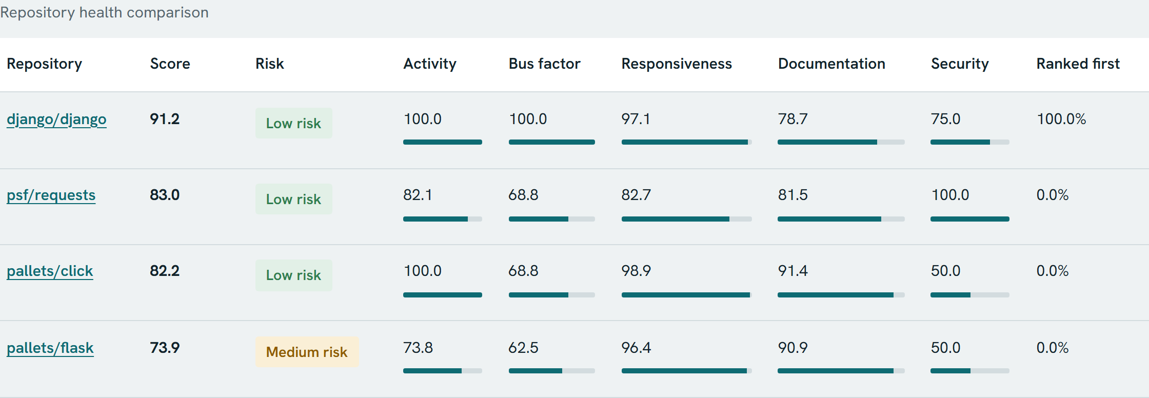
Figure 8. Comparison of four repositories
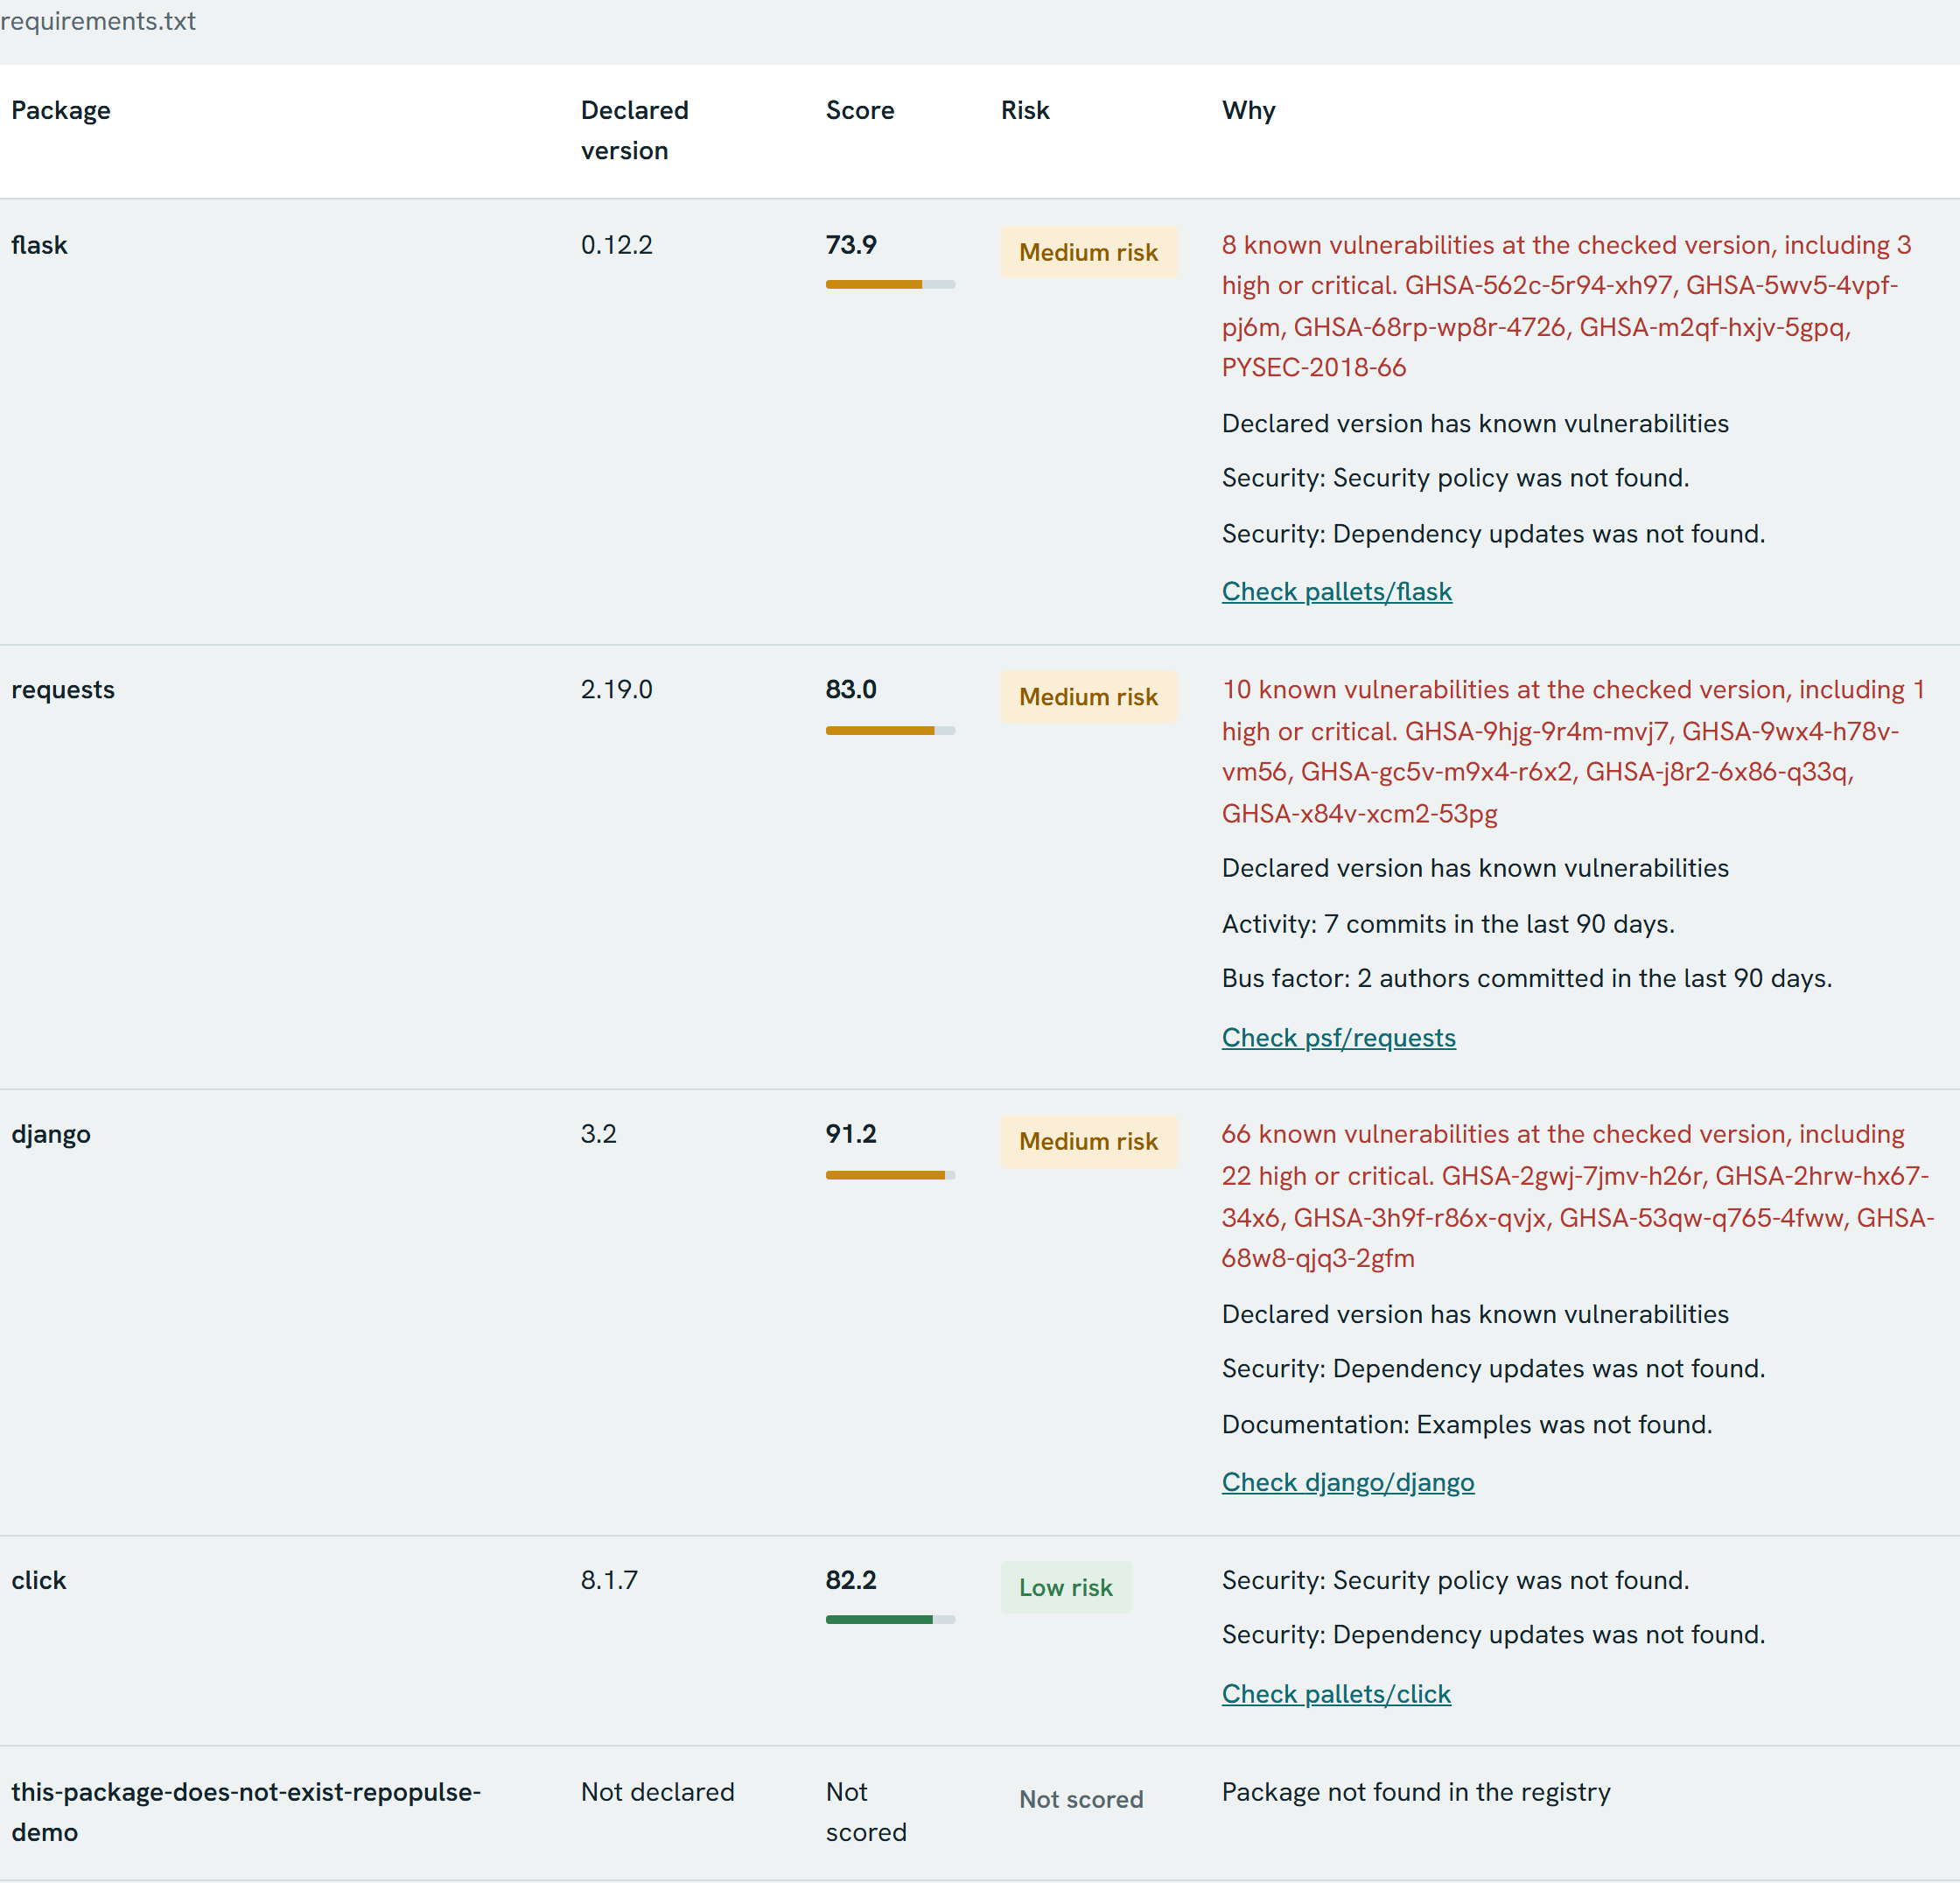
Figure 9. Dependency scan with old pinned versions and one package that does not exist

7.7 Sensitivity result
Table 16. Sensitivity over 300 trials for the four-repository comparison
Repository | Mean rank | Best | Worst | Ranked first
django/django | 1.00 | 1 | 1 | 100%
psf/requests | 2.42 | 2 | 3 | 0%
pallets/click | 2.58 | 2 | 3 | 0%
pallets/flask | 4.00 | 4 | 4 | 0%

Django was always first and Flask always last, so those two positions hold under any tested weighting. Requests and click swapped places: requests came second in 175 of the 300 trials (58.3 percent) and click in the other 125. RepoPulse therefore reports the ranking as unstable. This is the behaviour the analysis was built to show. The 0.8-point gap between them is too small to act on.

8. Limitations

8.1 Limits of the method
- Thresholds are not validated. The ramp limits and weights are reasoned choices. No study has linked them to real project failures, so a score is a structured opinion and not a prediction.
- There is no ground truth. Repository health has no agreed reference value, so accuracy cannot be measured. The project can show consistency and traceability only.
- Metrics are proxies. README size stands in for documentation quality, and commit share stands in for knowledge. A project could raise its score by adding files without improving.
- Data is sampled. The contributors call returns at most 100 people, so Flask shows 100 contributors. The 100 newest issues include pull requests, which are then removed. Flask kept only 26 real issues.
- A score describes a repository, not a version. Django 3.2 appears in a scan at 91.2 with 66 advisories reported, because the score belongs to the current project and the advisories belong to the old release.

8.2 Issues confirmed during verification
The items below were reproduced by running the code. The README mentions the underlying behaviour of some of them, such as items 3, 4, 6, 7 and 8. It does not mention items 1 and 5, and the evidence column shows the practical effect of each one.
Table 17. Confirmed issues with evidence and fixes
# | Issue | Evidence | Suggested fix
1 | The offline test guard breaks on Windows. It blocks socket.connect, which asyncio uses on Windows to build its internal socket pair. | 1 failed, 88 passed, 149 errors. All 163 pass once loopback is allowed. | Allow loopback addresses in conftest.py.
2 | One bad repository link fails an entire scan. Only RateLimited is caught for each package. | A 3-package scan with one dead link ended status: failed. | Catch GitHubError per package and mark that row.
3 | The CLI gate passes when nothing was scored. | All packages rate limited, with --max-risk low --min-score 99: exit code 0. | Fail, or add --fail-on-unscored.
4 | An OSV outage looks like a clean result. | HTTP 500 returned [], and the metric scored 1.0 with the text 0 known vulnerabilities. | Return null when the lookup fails.
5 | Vulnerabilities are double counted. OSV lists one flaw under both GHSA and PYSEC identifiers. | Flask 0.12.2 reported 8. The raw response has 4 distinct CVEs. | Group records by their aliases field.
6 | The version heuristic misreads some ranges. | v1.2.3 gives 2.3. <2,>=1.2 gives 2. 1.2.3.4 gives 1.2.3. | Use a real version parser.
7 | The badge route has no rate limit but can start a full collection. | 6 badge requests under a limit of 2 a minute all returned 200, with 6 analyses. | Serve cached data only, or limit on cache miss.
8 | The limiter trusts the first X-Forwarded-For value, which a client controls. Nginx appends to that header and keeps the client's value first. | 6 requests with different header values under a limit of 2 all returned 200. | Use X-Real-IP set by Nginx.
9 | Bots count as people. | dependabot[bot] appears in contributors and recent authors. | Filter by type or [bot] suffix.
10 | Closed issues with no comments count as unanswered. | A closed issue with 0 comments raised the unanswered count. | Count open issues only.
11 | Interface text shows raw values and rough grammar. | "Last commit was 2.1200783949421296 days ago." "1 releases in the last year." | Format numbers and pluralise.
12 | Some manifest lines are dropped with no warning. | requests @ https://... and -r other.txt were skipped. | Report skipped lines to the user.

Item 8 was reproduced against the backend directly. The Nginx part comes from reading nginx.conf, because the Docker stack was not running during verification.
Two further behaviours follow from the design. The sensitivity analysis always varies the default weights, so it ignores a user's custom sliders. GitHub's open_issues_count also includes open pull requests, so the backlog test can fail busy projects. Django is an example: it does not qualify as mature, because Issues are disabled and its open pull requests exceed the limit of 30.

9. Security considerations
- Token handling. The token is read from the backend environment and never sent to the browser. /api/status exposes only a true or false value. .env is ignored by Git and excluded from Docker build contexts. The project asks for a classic token with no scopes.
- Input validation. Repository references pass an allow-list pattern and a host check, which also rejects embedded credentials and . or .. path parts. Weights must be between 0 and 100 and finite.
- Output escaping. React escapes rendered text, and the PDF and SVG generators escape their content, so a hostile repository description cannot inject markup.
- Resource limits. Scans stop at 50 packages by default, GitHub calls are limited to 8 at a time, and expensive routes are rate limited, subject to items 7 and 8 in Table 17.
- Dependencies. Versions are pinned. npm audit reports 0 production vulnerabilities and 5 in development tooling (2 moderate, 1 high, 2 critical). These tools do not ship to users, but the versions should be reviewed before any deployment.
- CI permissions. The workflows request read-only repository access.

10. Conclusion and future work
RepoPulse met its objectives. It turns public data into a score that a person can check by hand, as the Flask example shows. Its strongest design decision is the separation of a pure scoring engine from data collection, combined with a cache of raw measurements. That choice makes results testable, and it brought a rescore from 5.2 s down to 2.5 ms with no API cost. The sensitivity analysis tells a user when a ranking depends on their priorities.
The work also shows that a high test count does not prove correctness in every environment or for every input. A 94 percent coverage figure did not reveal the double counting of vulnerabilities or the CI gate passing with nothing scored. Those appeared only when the system met real data and failure conditions.
Future work, in priority order:
1. Fix the items that can give false reassurance: the CLI gate (3), OSV failure handling (4) and scan failure handling (2).
2. Remove duplicate vulnerabilities (5) and use real version parsing (6).
3. Close the rate-limit gaps (7, 8) before any public hosting.
4. Improve measurement quality by excluding bots (9), fixing the unanswered ratio (10), and showing how many metrics support each category.
5. Calibrate thresholds against repositories with known outcomes, for example projects that were later abandoned.
6. Read organisation-level security policies, and add lockfile support for exact dependency versions.

References
1. "npm left-pad incident", Wikipedia. https://en.wikipedia.org/wiki/Npm_left-pad_incident
2. Debian Security Tracker, CVE-2024-3094. https://security-tracker.debian.org/tracker/CVE-2024-3094
3. M. Zimmermann, C.-A. Staicu, C. Tenny and M. Pradel, "Small World with High Risks: A Study of Security Threats in the npm Ecosystem", 28th USENIX Security Symposium, 2019, pp. 995-1010. https://www.usenix.org/conference/usenixsecurity19/presentation/zimmerman
4. G. Avelino, L. Passos, A. Hora and M. T. Valente, "A Novel Approach for Estimating Truck Factors", 24th International Conference on Program Comprehension (ICPC), 2016, pp. 1-10. doi:10.1109/ICPC.2016.7503718. https://arxiv.org/abs/1604.06766
5. OpenSSF Scorecard. https://github.com/ossf/scorecard
6. OSV.dev, Open Source Vulnerabilities. https://osv.dev
7. GitHub Docs, Rate limits for the REST API. https://docs.github.com/en/rest/using-the-rest-api/rate-limits-for-the-rest-api
8. RepoPulse source code, commit d647eec. https://github.com/nitinsaipatha-cell/repopulse

Appendix A. Running the project
With Docker, from the repository root:
cp .env.example .env # add GITHUB_TOKEN privately if wanted
docker compose up --build # then open http://localhost:8080
docker compose down # keeps the database volume

Without Docker, using Python 3.12 and Node 20:
cd backend
python3.12 -m venv .venv && . .venv/bin/activate
pip install -r requirements-dev.txt
uvicorn app.main:app --host 0.0.0.0 --port 8000

cd frontend # second terminal
npm ci && npm run dev # then open http://localhost:5173

Tests and the CLI gate:
cd backend && python -m pytest -q
cd frontend && npm test
cd backend && python -m app.cli ../frontend/package.json --max-risk medium

Appendix B. Verification environment
- Source: commit d647eec of the main branch, cloned on 1 November 2026.
- Machine: Windows 11 with Python 3.12.14 and Node 24.16. The project targets Node 20, which the CI run used.
- The backend and frontend ran directly, with no GitHub token, so requests were limited to 60 an hour.
- The Docker Compose stack was not run, because the Docker daemon was not available on the verification machine. Its Dockerfiles and Nginx configuration were reviewed by reading them.
- Confirmed issues in Table 17 were reproduced with stubbed network calls, except item 5, which used a live OSV response.

