

**TRIBHUVAN UNIVERSITY**

**FACULTY OF HUMANITIES AND SOCIAL SCIENCE**

**A Project Proposal**

**On**

**PC Management System**

**Submitted to**

**Department of Computer Application**

**National College of Computer Studies**

*In partial fulfillment of the requirements for Bachelor Degree in Computer Application*

**Submitted By:**

**Nitin Raja Shahi**

**March,2021**

**Under the Supervision of   
Dinesh Khadka**

**Tribhuvan University**

**Faculty of Humanities and Social Sciences**

**National College of Computer Studies**

# Supervisor’s Recommendation

This is to certify that the summer project entitled “**Pc Management System**” is an academic work done by “Mr. Nitin Raja Shahi” submitted in the partial fulfillment of the requirement for the degree of **Bachelor of Computer Application** at the faculty of Humanities and Social Science, Tribhuvan University under my guidance and supervision. To the best of my knowledge, the information presented by him in the project report has not been submitted earlier.

|  |
| --- |
| Dinesh Khadka  Date: 12 Baisakh 2078 |

**Tribhuvan University**

**Faculty of Humanities and Social Sciences**

**National College of Computer Studies**

# Letter of Approval

This is to certify that this project prepared by Bibek Neupane entitled “**PC Management System”** in partial fulfillment of the requirements for the degree of Bachelor in Computer Application has been evaluated. In our opinion it is satisfactory in the scope and quality as a project for the required degree.

|  |  |
| --- | --- |
| **SIGNATURE of Supervisor**  Dinesh Khadka  Faculty Member  Department of Computer Application  National College of Computer Studies Paknajol, Kathmandu | **SIGNATURE of HOD/Coordinator**  Rajan Poudel  Coordinator  Department of Computer Application  National College of Computer Studies Paknajol, Kathmandu |
| **SIGNATURE of Internal Examiner** | **SIGNATURE of External Examiner** |

# **Approval of Project Proposal**

The project entitled “**PC Management System**” proposed by Mr. Nitin Raja Shahi for the partial fulfillment of the requirement for Bachelor in Computer Application (BCA), fourth semester has been approved for further development.

**Proposal Evaluation Committee**

1. **_______________________**
2. **_______________________**
3. **_______________________**
4. **_______________________**

Mr. Santosh Maskey

Campus Chief (.)

# Abstract

Cyber cafe is a management system to replace the manual registration system using paper form that are currently use. This system can record all the user information for the Cyber Cafe computer usage such as user's name, date and time, and Pcs.

The software provides you with a means to control the workstations, manage customer database and generate detailed reports. This is a Cyber Cafe management software that helps with managing customers and controlling computers accounting and billing. It simplifies and automates running your Internet Cafe business.

# Acknowledgement

“It is not possible to prepare a project report without the assistance and encouragement of other people. This one is certainly no exception.”

On the very outset of this report, I would like to extend my sincere and heartfelt obligation towards all the personages who have helped me in this endeavor. Without their active guidance, help, cooperation and encouragement, I would not have made headway in the project.

I am ineffably indebted to Mr. Dinesh Khadka for conscientious guidance and encouragement to accomplish this assignment. I am extremely thankful and pay my gratitude for his valuable guidance and support on completion of this project in its presently.

I extend my gratitude to National College of Computer Studies for giving me this opportunity.

I also acknowledge with a deep sense of reverence, my gratitude towards my parents and member of my family, who has always supported me morally as well as economically.

At last, but not least gratitude goes to all my friends who directly or indirectly helped me to complete this project report.

Any omission in this brief acknowledgement does not mean lack of gratitude.

**Thanking You**

**Nitin Raja Shahi**

# Table of Contents

Supervisor’s Recommendation i

Letter of Approval ii

Approval of Project Proposal iii

Abstract iv

Acknowledgement v

Table of Contents vi

List of Tables viii

List of Figures ix

Chapter 1: Introduction 1

1.1 Introduction 1

1.2 Problem Statement 1

1.3 Objectives and Aims 2

1.4 Scope of product 2

Chapter 2: Background Study and Literature Review 3

2.1 Background Study 3

2.2 Literature Review 3

3 Chapter 3: System Analysis and Design 4

3.1 System Analysis 4

3.2 System Design 10

Chapter 4: Implementation and Testing 14

4.1 Implementation 14

4.2 Testing 15

Chapter 5: Conclusion and Future Recommendations 16

5.1 Lesson Learnt / Expected outcome 16

5.2 Conclusion 16

5.3 Future Recommendations 16

6 Appendices 17

7 References 23

# List of Tables

Table 1: tbl_admin 12

Table 2: tbl_computers 12

Table 3: tbl_computers 13

Table 4 : tbl_report 13

Table 5: Test cases for Unit Testing 15

Table 6: Test Cases for System Testing 15

# List of Figures

Figure 1 : Waterfall Model 4

Figure 2: ER diagram of PC Management System 9

Figure 3: System Flowchart for PC Management System 10

Figure 4: Use Case Diagram for PC Management System 11

Figure 5: Architectural Design 12

## Chapter 1: Introduction

## 1.1 Introduction

Cybercafe is a place that provides computers to access the Internet, play games, create documents, chat with friends using voice and video, and other computer-related tasks. At most Internet cafes the computer and Internet access is provided for an hourly or daily fee. [1]

The software is the solution for an Internet cafe. The software provides you with a means to control the workstations, manage customer database and generate detailed reports. This is a Cyber Cafe management software that helps with managing customers and controlling computers accounting and billing. It simplifies and automates running your Internet Cafe business. Unlike many other competitive programs, Cyber Cafe management system is robust, quick, secure and easy to use.

Cyber cafe management system is designed to be a complete solution for Internet cafes and to make life easier for Internet cafe owners.

The basic task of our software is to provide operators and customers with an accurate timing and billing information at any time.

Cyber cafe is a management system to replace the manual registration system using paper form that are currently use. This system can record all the user information for the Cyber Cafe computer usage such as user's name, date and time, and Pcs.

## 1.2 Problem Statement

In existing system, a lot of manual work has to be carried out. Large amount of paperwork is involved which may cause high degree of error. [2]

Registration of usernames, keeping records of user are done manually, which is time consuming process and there is possibility of making errors. Administrator must keep the track of time, which is tedious job. Once the user logs out, while preparing bill, he has referred to user details including name, login time and time allocated leading to possibility of causing errors in bill calculation. This may be unbeneficial to administrator. Hence also there is not accuracy in bill calculation.

Also, a lot of files, records are required to store these documents thus making it difficult to maintain.

Since all these reports are prepared manually, we require computer software for all these purposes

## 1.3 Objectives and Aims

* To produce a web-based system that allows a cybercafé to manage their pcs, customers and billing effectively
* To ease admins tasks and smooth operation in the cyber

## 1.4 Scope of product

As this is automated cyber management system it makes it very easy for administrator to search details. Also, its time allotment is done very efficiently, and it provides fast service in term of the bill calculation and time management which is very advantageous to both administrator and user.

# Chapter 2: Background Study and Literature Review

## 2.1 Background Study

It is the study of history of PC management system, how it emerged and when did it started gaining popularity. The existing systems has been studies as the background study for this project

## 2.2 Literature Review

For this project, some of the related websites and applications are researched and reviewed. Throughout the research, there are very few website or applications related to cybercafé management system. Similar to the Pc management system there are many other websites available in their own cybers which are used to run the work flow of the cyber smoothly.

phpgurukul, w3school, javatpoint, tutorials are some of the websites visited for documentation of this project.

# 3 Chapter 3: System Analysis and Design

## 3.1 System Analysis

The waterfall model was selected as the SDLC model since the requirements were very clear, fixed and short:

Requirement

Analysis

System Design

Implementation

Deployment

Maintenance

Testing

**Figure 1 : Waterfall Model**

System analysis is a process of collecting and interpreting facts, identifying the problems, and decomposition of a system into its components.

System analysis is conducted for the purpose of studying a system or its parts in order to identify its objectives. It is a problem-solving technique that improves the system and ensures that all the components of the system work efficiently to accomplish their

purpose. [4]

### 3.1.1 Requirement Analysis

#### 3.1.1.1 Functional Requirements:

These are statements of services the system should provide, how the system should react to particular inputs, and how the system should behave in particular situations. It specifies the application functionality that the developers must build into the product to enable users to accomplish their tasks.

* The system should allow admin to login to the system using their username and password.
* The system should allow admin to add new PCs.
* The system shall allow admin to display active users.
* The system shall allow admin to display all user records.
* The system must provide report of the time stayed in the PCs.

#### 3.1.1.2 Non –functional Requirements:

Non-functional requirements, as the name suggests, are requirements that are not directly concerned with the specific services delivered by the system to its users. They may relate to emergent system properties such as reliability, response time, and store occupancy. Alternatively, they may define constraints on the system implementation such as the capabilities of I/O devices or the data representations used in interfaces with other systems. Non-functional requirements, such as performance, security, or availability, usually specify or constrain characteristics of the system as a whole.

* Usability: The system provides a help and support menu in all interfaces for the user to interact with the system. The user can use the system by reading help and support.
* Security: The system provides username and password to prevent the system from unauthorized access. The staffs’ password must be greater than eight characters. The subsystem should provide a high level of security and integrity of the data held by the system, only authorized personnel of the company can gain access to the company’s secured page on the system; and only users with valid password and username can login to view user’s page.
* Performance: The system response time for every instruction conducted by the user must not exceed more than a minimum of 10 seconds. The system should have high performance rate when executing user’s input and should be able to provide response within a short time span usually 50 second for highly complicated task and 20 to 25 seconds for less complicated task.
* Availability: The system should always be available for access at 24 hours, 7 days a week. Also in the occurrence of any major system malfunctioning, the system should be available in 1 to 2 working days, so that business process is not severely affected.
* Ease of use: Considered the level of knowledge possessed by the users of this system, a simple but quality user interface should be developed to make it easy to understand and required less training. [4]

### 3.1.2 Feasibility study

The preliminary investigation is carried out before the analysis in which the Feasibility study is carried out. An important outcome of preliminary investigation is the determination that the system requested is feasible or not. Feasibility study is undertaken to determine either possibility of improving the existing system or developing a new system. [2]

Preliminary investigation is an important part of the system analysis. Before starting any system, we have to determine whether the system is feasible or not. This study is known as the Feasibility study.

**Types of feasibility study**:

* Technical Feasibility Study.
* Economical Feasibility Study.
* Operational Feasibility Study.
* Schedule Feasibility Study

#### 3.1.2.1 Technical Feasibility Study:

It includes the study like can work for project be done with current equipment, existing software technology and with available manpower?

For proposed system technical hardware requirements are --

Processor: Pentium or above

Memory: Minimum 512 MB RAM

Hard Disk: 50 GB or above **Software Requirements:**

Front end – HTML CSS JavaScript

Back end - MySQL

Platform - Windows XP or above

#### 3.1.2.2 Economic Feasibility:

The cyber cafe can easily afford software and hardware, since they are not expensive. Manual errors are minimized due to user friendliness of proposed system. Cyber cafe will not have to spend money on recruitment of highly skilled personnel in order to operate it. [4]

Few days or hours of training to existing personnel is sufficient, since processing system was designed keeping in mind the common person with limited technical knowledge.

Hence, the proposed system is technically feasible. [5]

#### 3.1.2.3 Operational Feasibility:

Will the system be used if it developed and implemented?

Will there be resistance from the user to the new system.

The system will provide timely information and status of the various activities to manage, to facilitate the user of the system.

Smooth and user-friendly operation of the system was main aim for spending up work in progress. [5]

#### 3.1.2.4 Schedule Feasibility

In scheduling feasibility, an organization estimates how much time the project will take to complete.

When these areas have all been examined, the feasibility analysis helps identify any constraints the proposed project may face, including:

* Internal Project Constraints: Technical, Technology, Budget, Resource, etc.
* Internal Corporate Constraints: Financial, Marketing, Export, etc.
* External Constraints: Logistics, Environmental, Laws, and Regulations, etc.

### 3.1.3 Data Modeling (ER-Diagram)

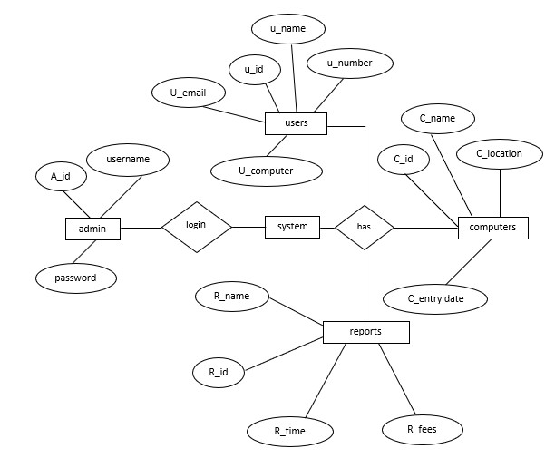

**Figure 2: ER diagram of PC Management System**

## 3.2 System Design

### 3.2.1 System flow chart of PC Management System

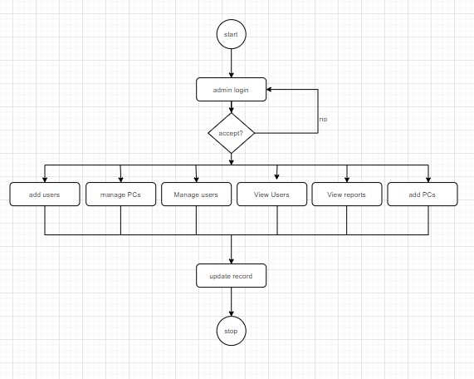

**Figure 3: System Flowchart for PC Management System**

### 3.2.2 Use case diagram

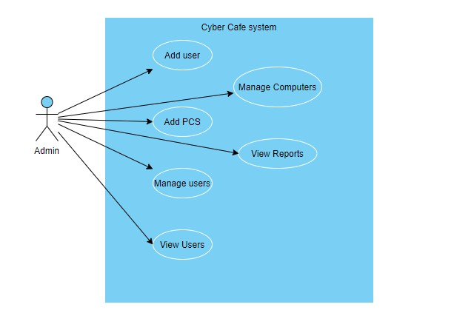

Figure 4: Use Case Diagram for PC Management System

### 3.2.3 Architectural Design

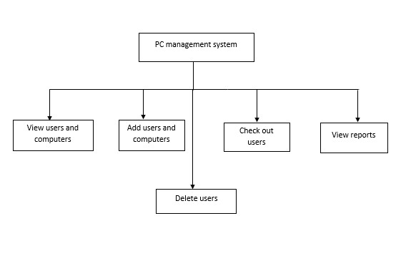

Figure 5: Architectural Design

### 3.2.4 Database Schema Design

Table : tbl_admin

|  |  |
| --- | --- |
| ID | Int() AUTO_INCREMENT PRIMARY KEY |
| Username | Varchar(20) |
| Password | Varchar(20) |
| Email | VarChar(20) |

Table : tbl_computers

|  |  |
| --- | --- |
| Id | Int() AUTO_INCREMENT PRIMARY KEY |
| computername | Varchar(30) |
| computerlocation | Varchar(30) |
| entrydate | Datetime |

Table : tbl_computers

|  |  |
| --- | --- |
| Id | Int() AUTO_INCREMENT PRIMARY KEY |
| Username | Varchar(120) |
| Useraddress | Varchar(200) |
| Mobilenumber | Bigint(10) |
| Email | Varchar(20) |
| Computername | Varchar(20) |
| Intime | Timestamp |
| Status | boolean |

Table : tbl_report

|  |  |
| --- | --- |
| Id | Int() AUTO_INCREMENT PRIMARY KEY |
| Username | Varchar(200) |
| Totaltime | Int() |
| Fees | Int() |

# Chapter 4: Implementation and Testing

## 4.1 Implementation

### 4.1.1 Tools used

Scripting Language: Javascript, PHP,

Database: Xampp 8.0.1

Text Software: Sublime

Frontend Design: CSS

### 4.1.2 Implementation Details of Modules

Various modules are provided in PC management system. They are:

Module1: List computers

In this module, the added computers are listed.

Module2: add computers

In this module, admin can enter the name location of the new computer.

Module3: List Users

In this module, the added users are listed.

Module4: add users

In this module. Admin can add/ enter the name, email. Contact, address and their respective computer.

Module5: checkout users

In this module, admin can checkout the user from their computer.

Module6: delete users

In this module, admin can delete their users from their active users.

Module7: list report

In this module, admin can view their records of their users who have already checked out.

## 4.2 Testing

### 4.2.1 Test Cases for Unit Testing

Table : Test cases for Unit Testing

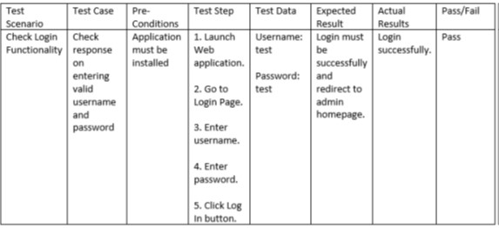

### 4.2.2 Test Cases for System Testing

Table : Test Cases for System Testing

|  |  |  |  |
| --- | --- | --- | --- |
| Test No. | Test | Expected Result | Result |
| 1. | Login | Open home page. | Passed |
| 2. | View computers | List of computer needs to be shown. | Passed |
| 3. | Add computer | Add computer needs to keep the record of computers. | Passed |
| 4. | Users | Find who are using the computers. | Passed |
| 5. | Add Users | User needs to be added for time record. | Passed |
| 6. | Check out User | Check out user panel to be opened and keep record of user and delete the record. | Passed |
| 7. | Report | View record of checked out users. | Passed |

# Chapter 5: Conclusion and Future Recommendations

## 5.1 Lesson Learnt / Expected outcome

After the project is completed the owner is able to manage the computers and the user of the café systematically with the detail of their records including the computer and the user’s login time. The admin will be able to manage the computers of the café.

## 5.2 Conclusion

This project is expected to deliver high performance website which is easy to use where owner can easily add, delete, view their PCs and their users. This project will meet all of its objectives as well as provide good performance.

## 5.3 Future Recommendations

This system can have e-payment gateways meaning pay through different online payment services as any cash transactions nowadays have gone to digital transactions.

Also, it can provide more detailed information on their computers.

# 6 Appendices

**Screenshot**

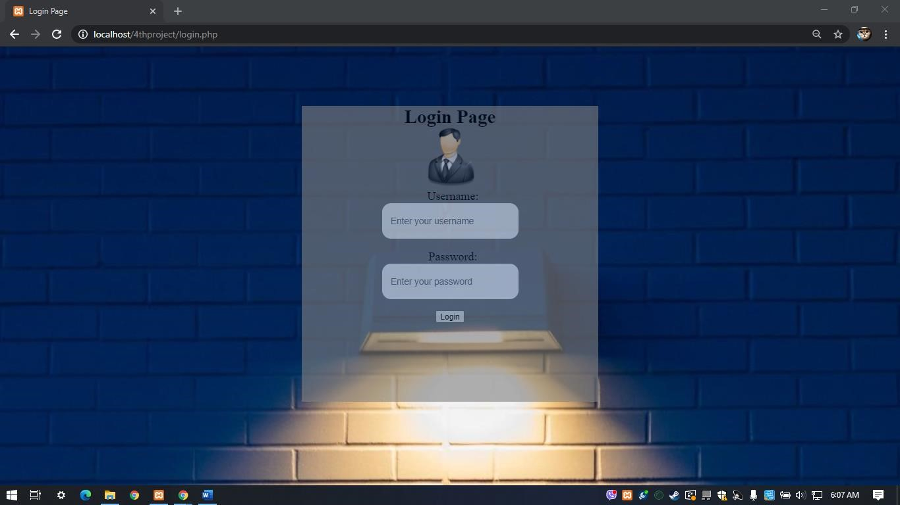

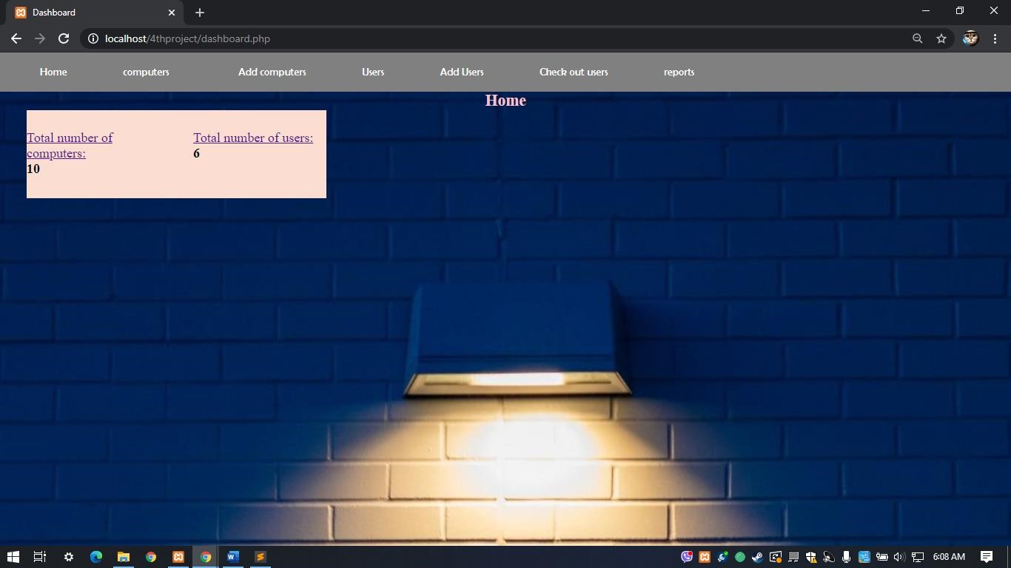

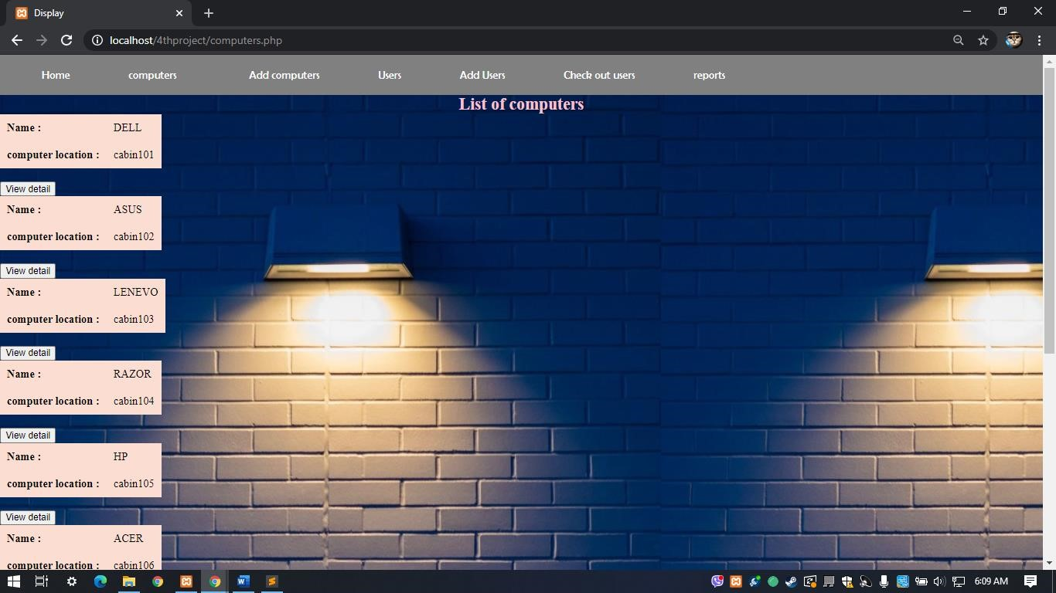

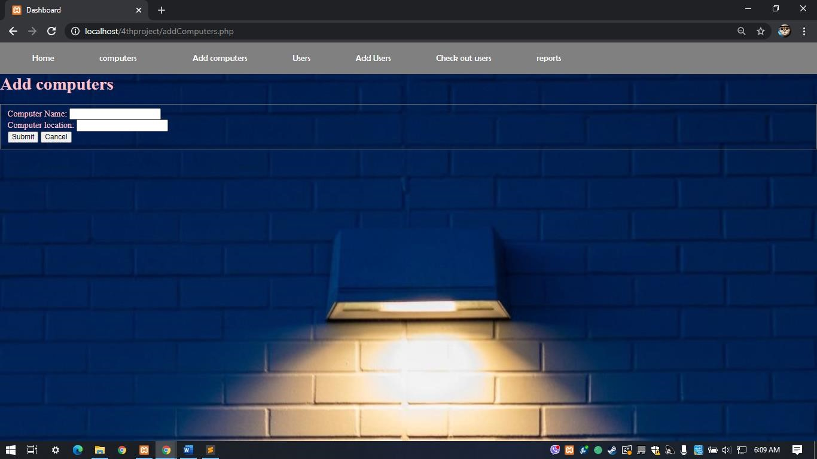

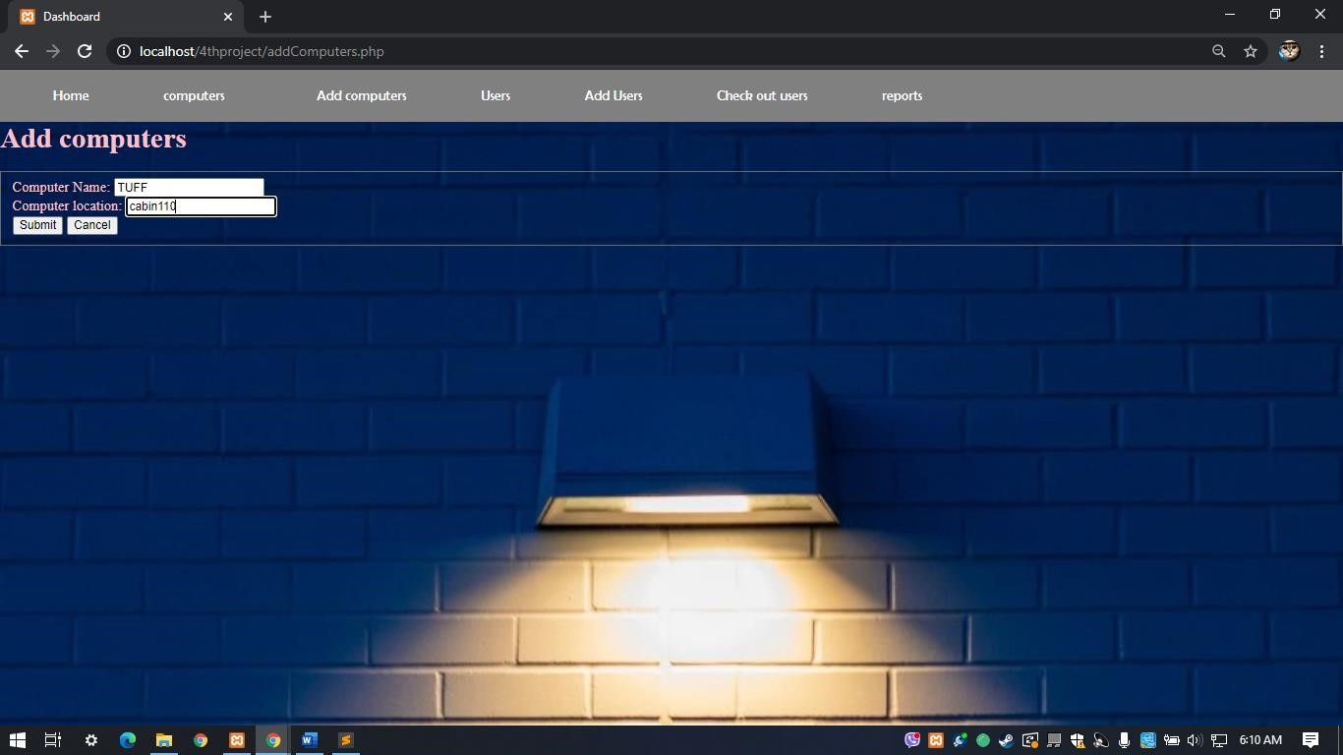

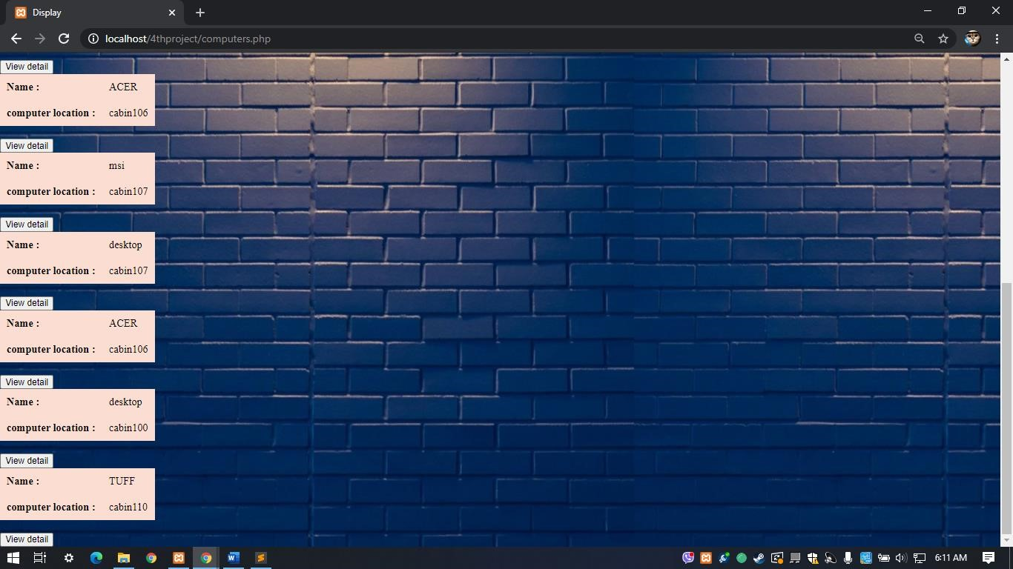

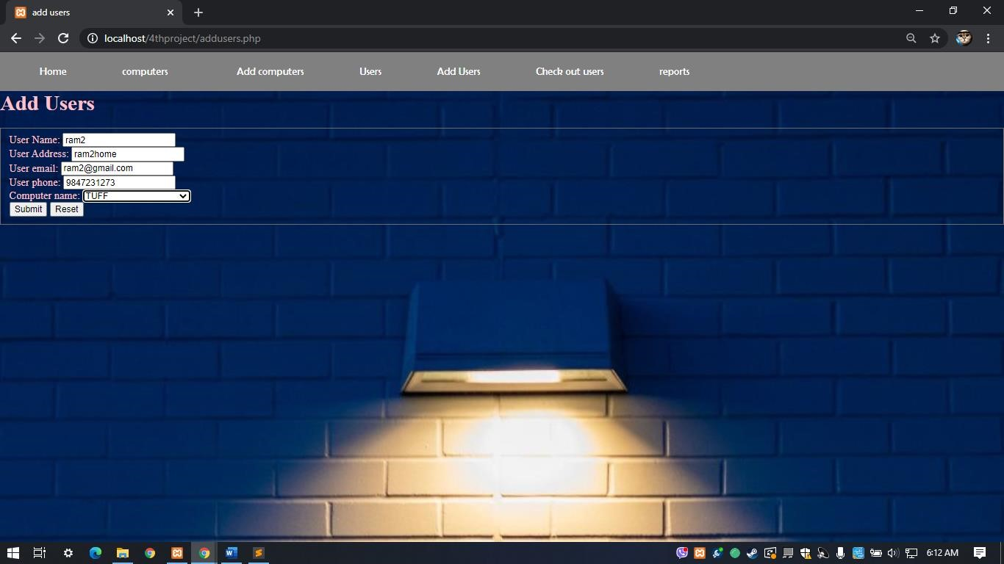

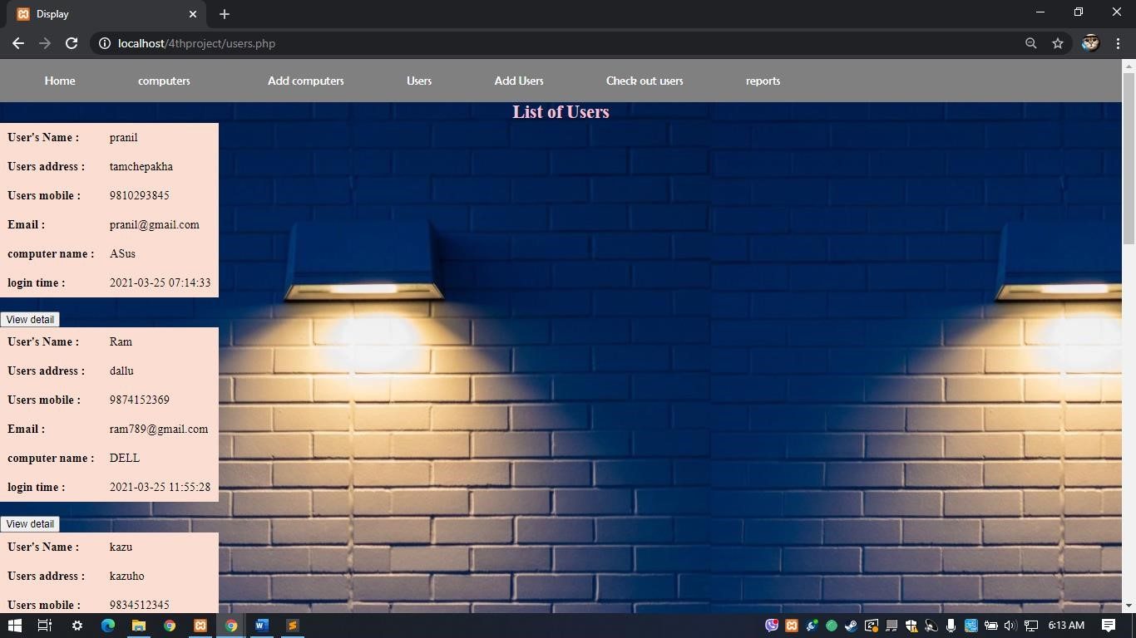

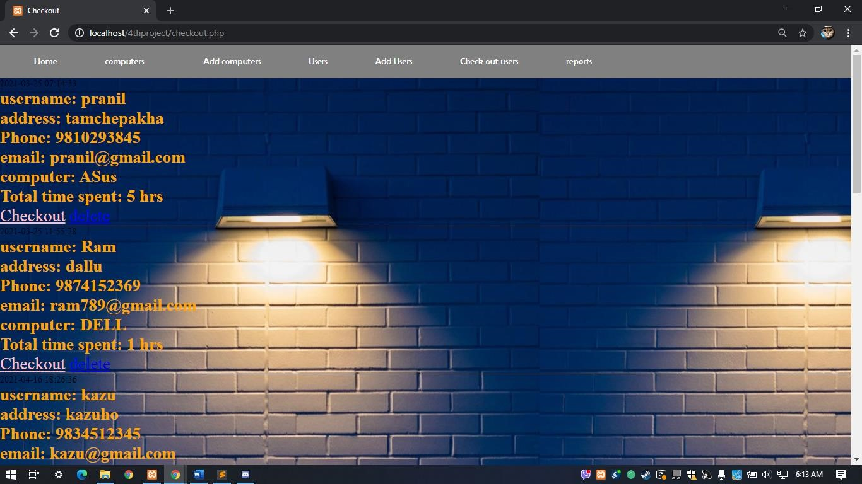

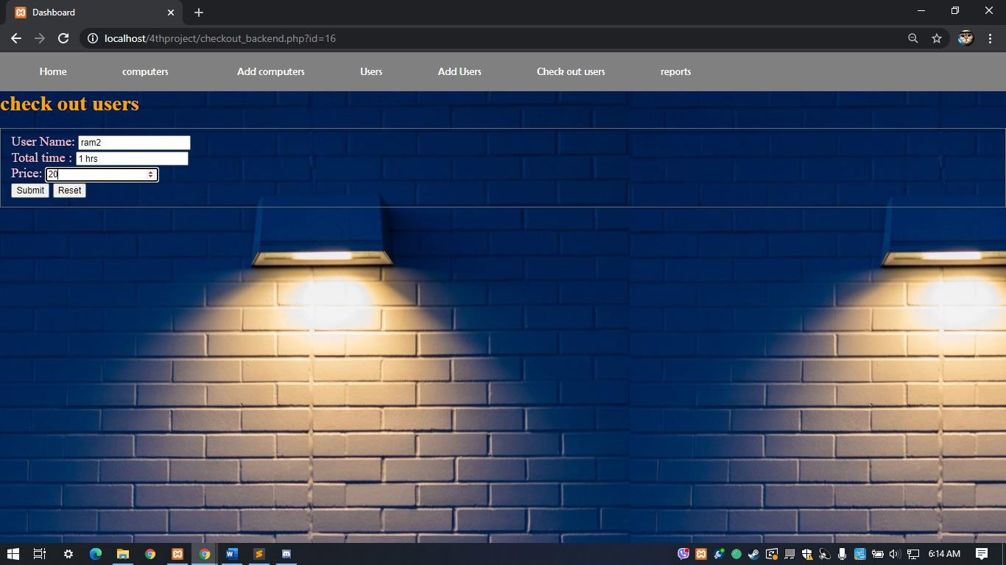

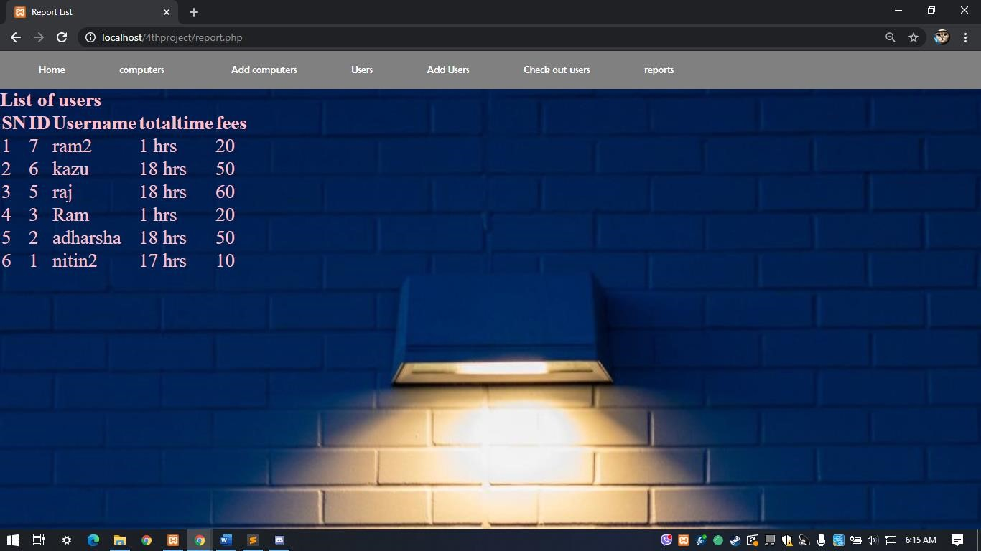

# 7 References

1. "ignousupport," [Online]. Available: https://ignousupport.blogspot.com/p/cybercafe-management-system-project.html. [Accessed 03 2021].
2. "ignoubcafinalyearprojects," [Online]. Available: https://sites.google.com/site/ignoubcafinalyearprojects/project-report/cyber-caffemanagement-system-project-report-1. [Accessed 03 2021].
3. "tutorialspoint," [Online]. Available: https://www.tutorialspoint.com/index.htm.

[Accessed 11 march 2021].

1. "javatpoint," [Online]. Available: https://www.javatpoint.com. [Accessed 11 march 2021].
2. "visual paradigm online," [Online]. Available: https://online.visualparadigm.com/. [Accessed 11 march 2021].
3. "phpgurukul," [Online]. Available: https://phpgurukul.com/cybercafemanagement-system-using-php-and-mysql/. [Accessed 03 2021].